Project Title: End-to-End DevOps Pipeline for a Web Application with CI/CD
GroupName: Group E
Team Members : Jeyashree, Sudhanshu, Manjula,Kumaresan
Terraform
Terraform init
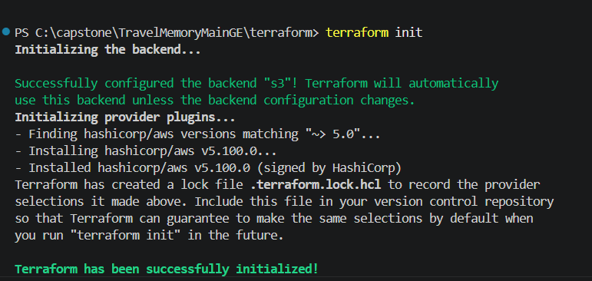
Terraform plan
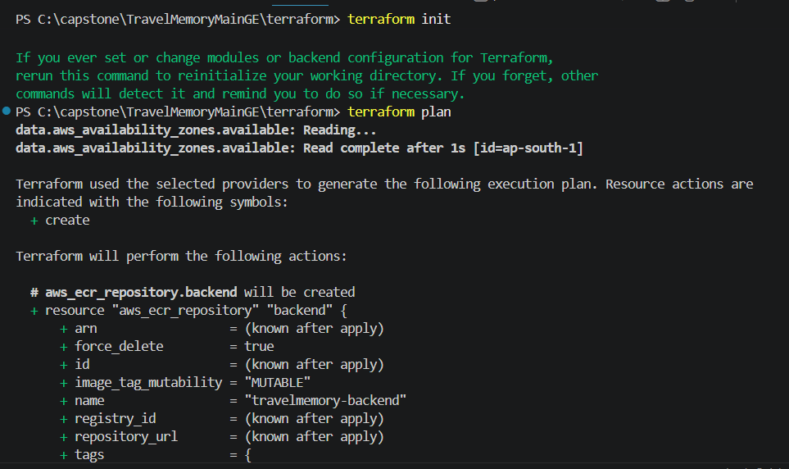

Terraform apply
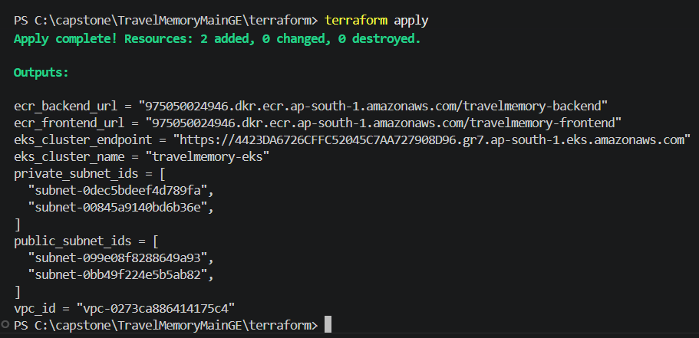
Cluster creation in AWS:
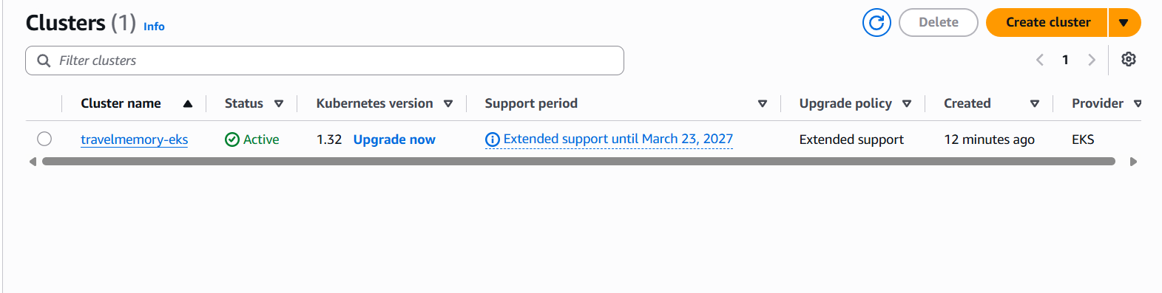
Worker Nodes:
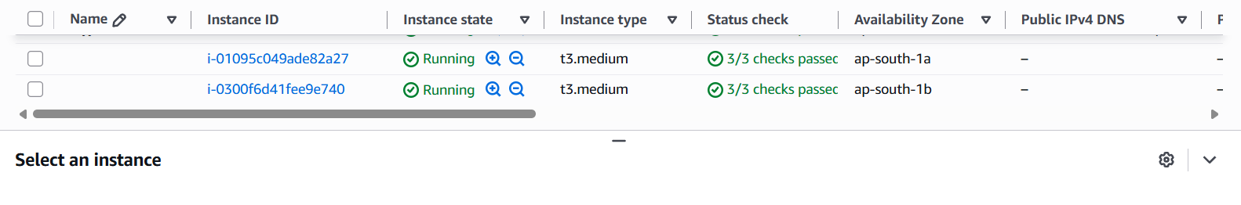Docker images in ECR:
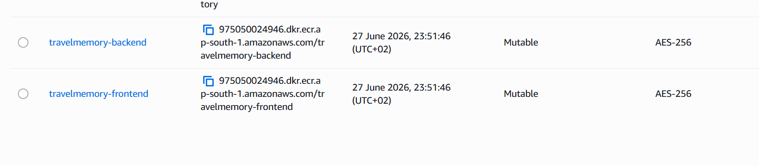
VPC creation:
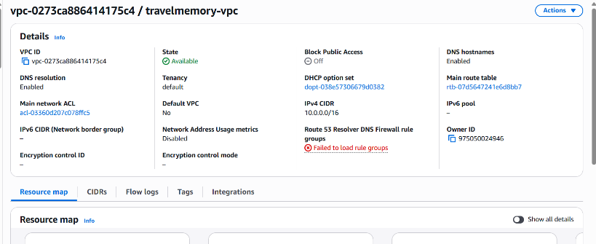
Subnets:
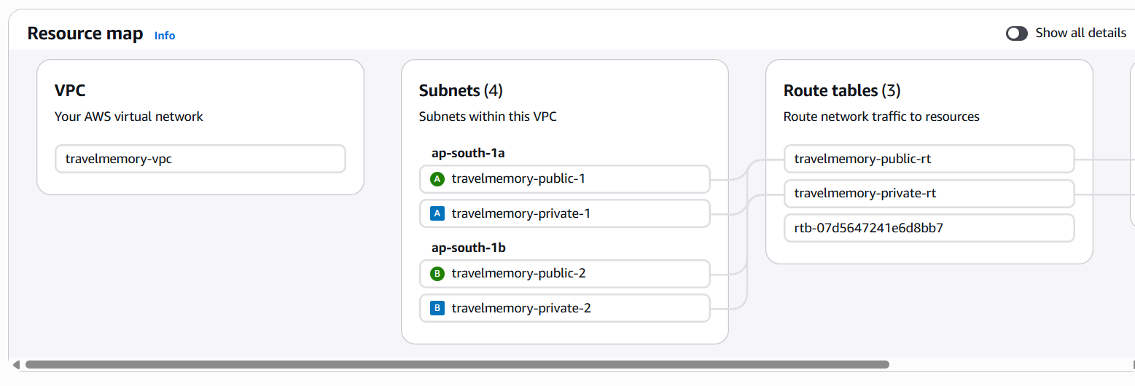
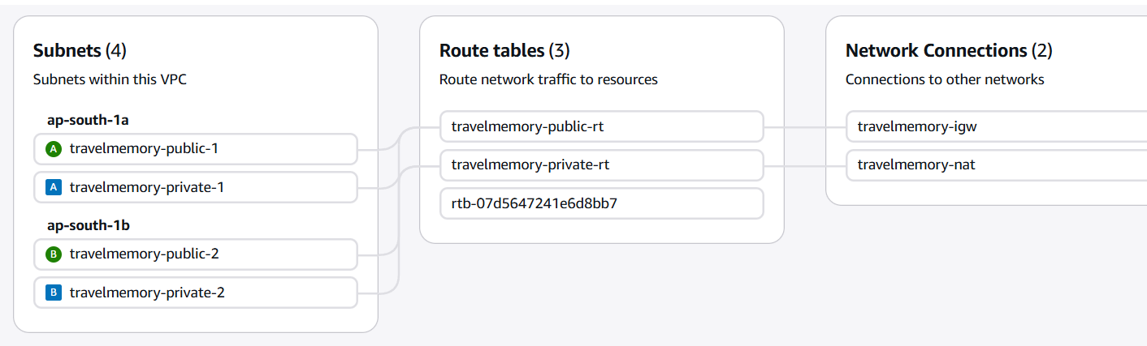

Kubernetes Cluster Deployment:

kubectl get pods -n travelmemory
NAME READY STATUS RESTARTS AGE
backend-78f8c774c5-69874 1/1 Running 0 2d22h
backend-78f8c774c5-j2wwm 1/1 Running 0 2d22h
frontend-597786dc48-b7wzx 1/1 Running 0 2d22h
frontend-597786dc48-rdchc 1/1 Running 0 2d22h

Jenkins pipeline for TravelMemory App:
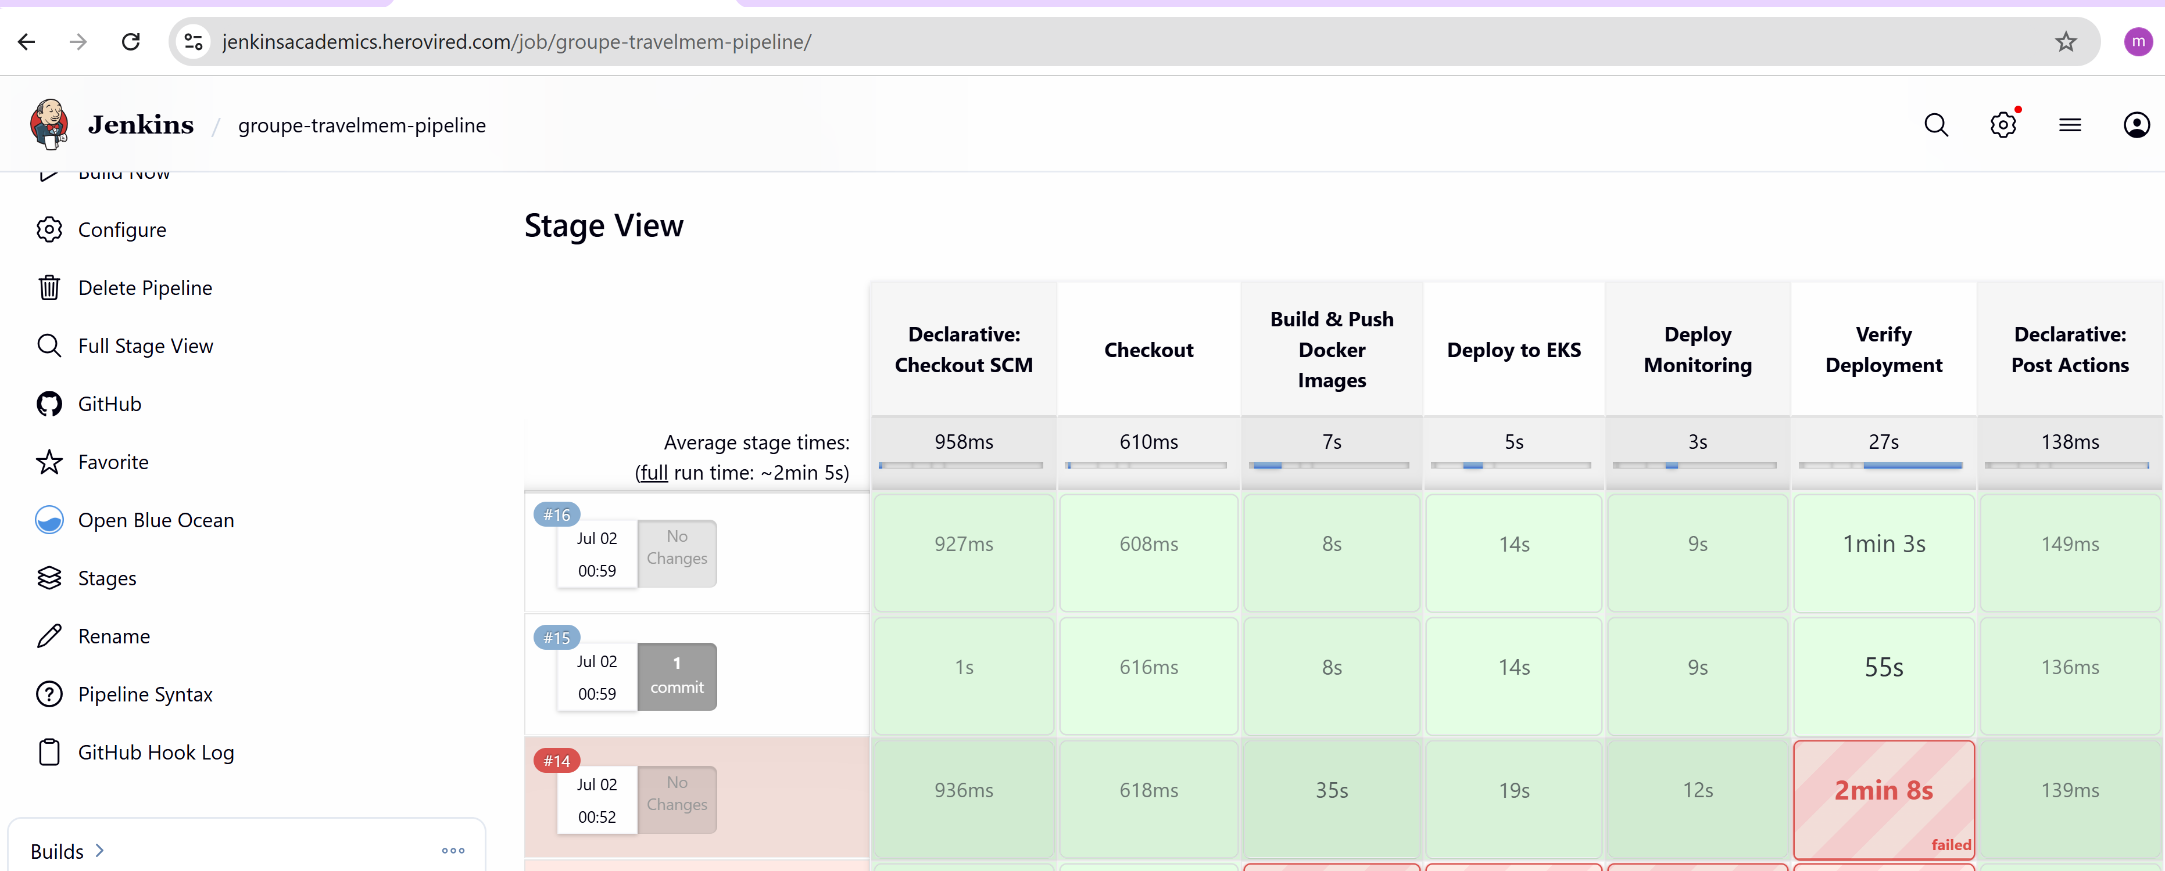

Travel Memory App up and Running:
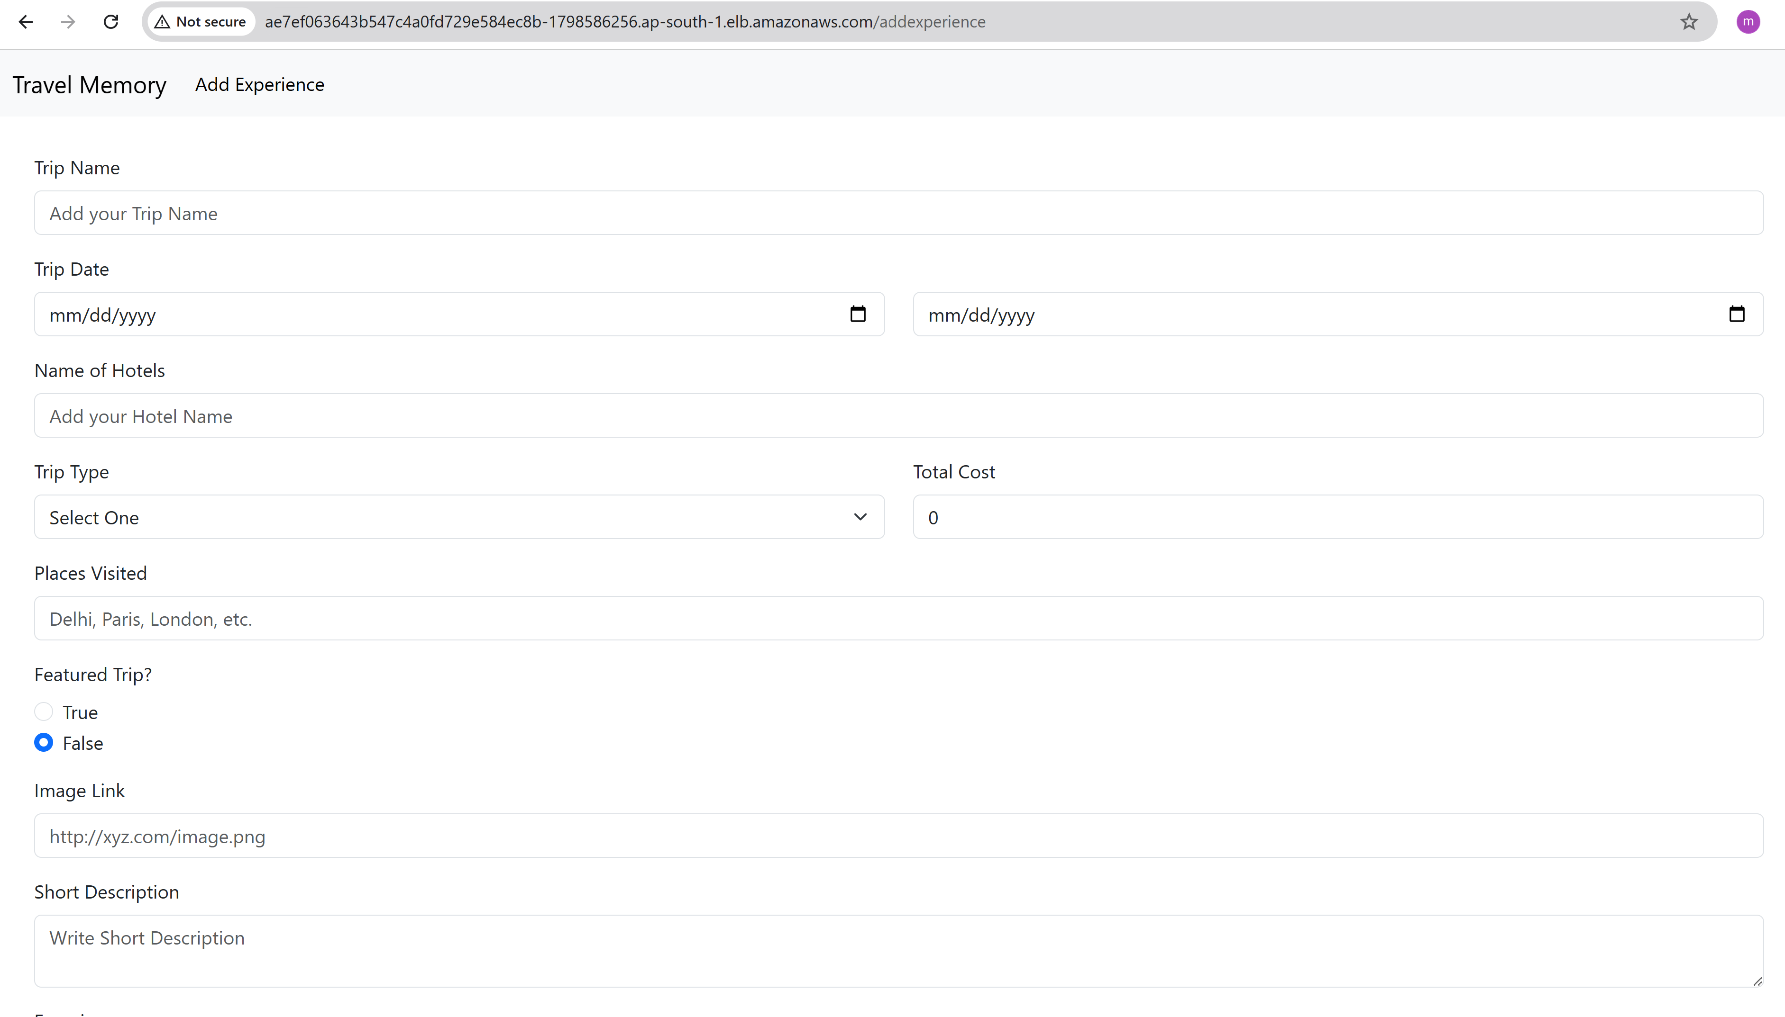

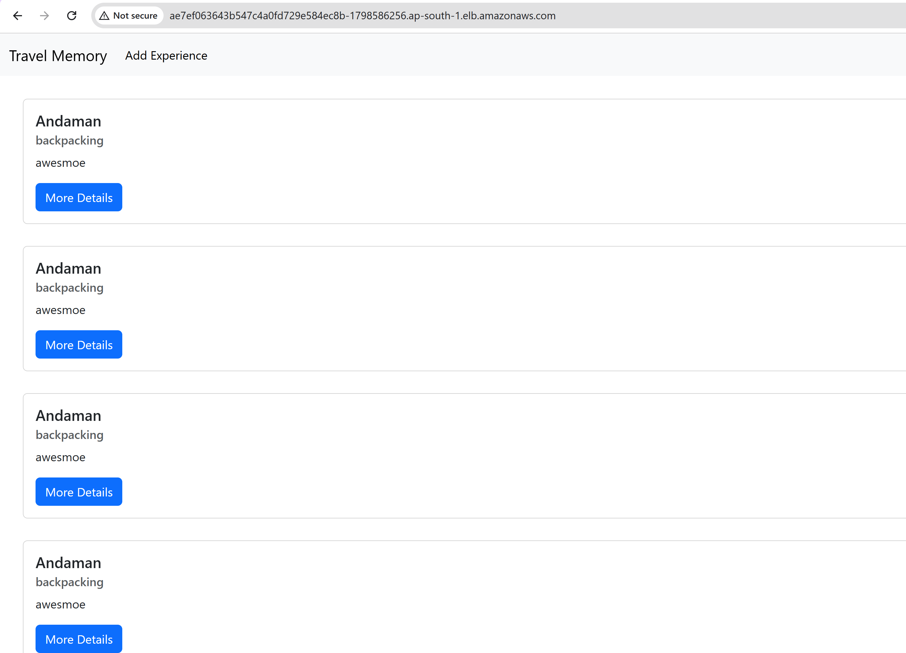

Mongodb Collection Data:
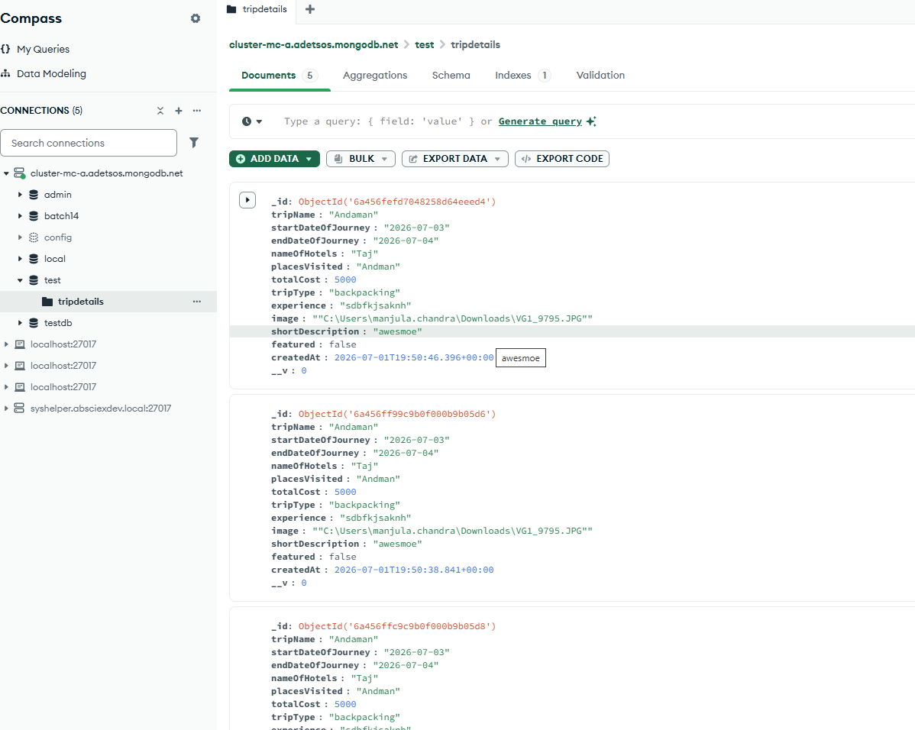
Monitoring and Observability:
Kubernetes cluster monitoring in Prometheus with unhealthy state:
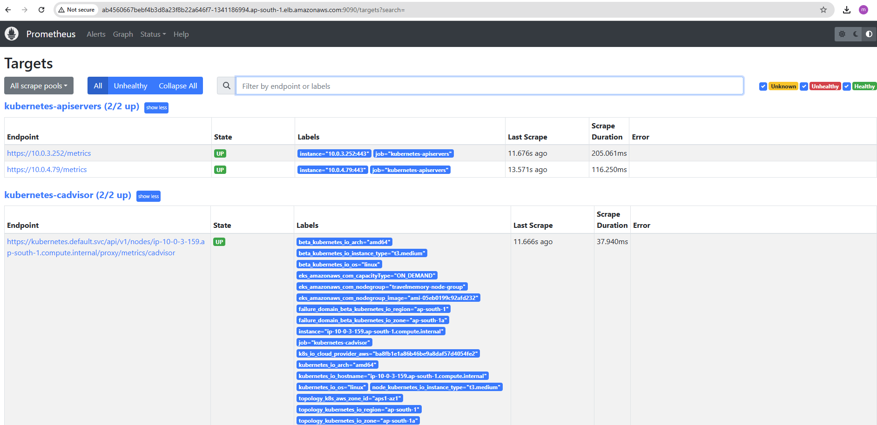
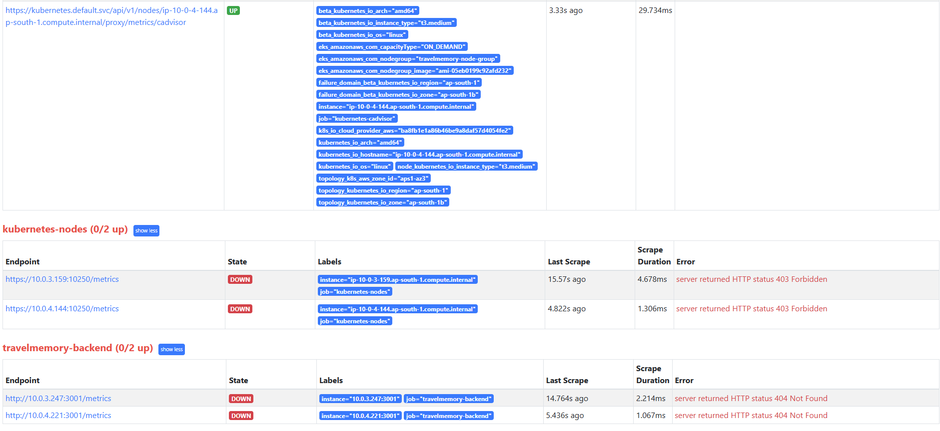
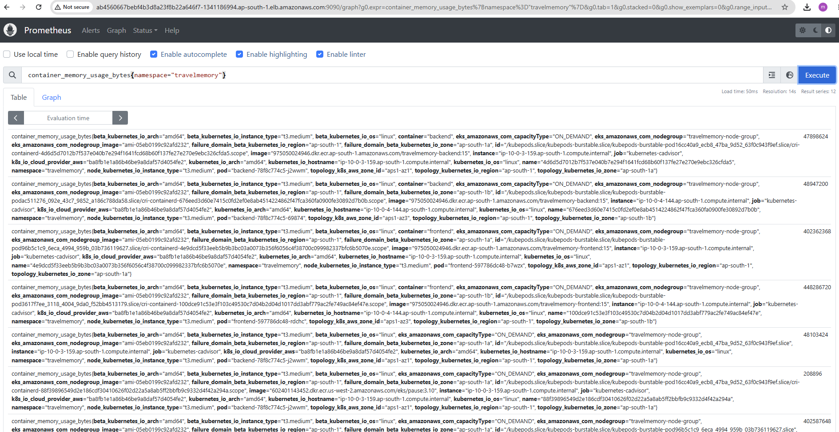

Kubernetes cluster monitoring in Prometheus with healthy state:
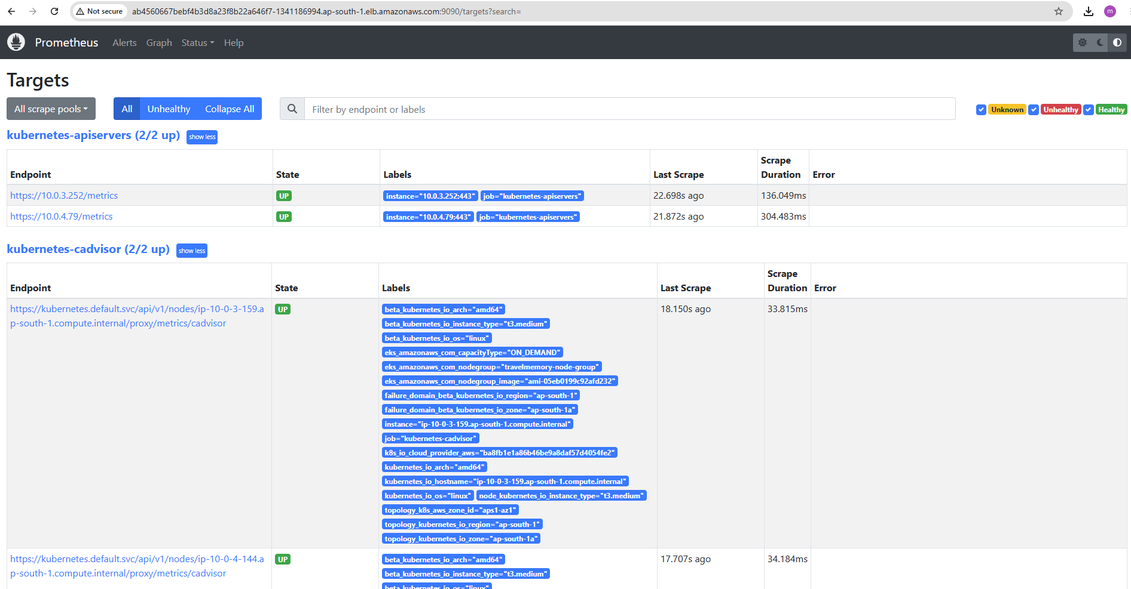

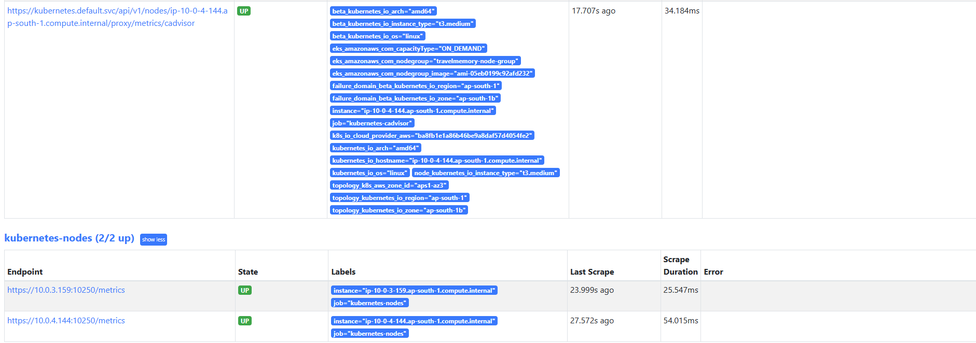

Grafana Dashboard:

