Project TT231 I-Transport version 2.0

Oct 2019 - Deliver on to ITSWC 2019

August 2019 - LTA demo

Upgrading i – transporting System

The document all about to interaction between user and i- transport

**OWA Frontend Interface**

|  |  |
| --- | --- |
| GIS | Graphics Information System |
| BIS | Business Intelligence |
| IR | Incident Record |
| CC | Common Control |
| PMCS | Power Management Control System |

User has the options to create, edit and manipulate these records like Incident Records, work order, technical alarm, and Environmental monitoring list

Panel displays

* PMCS measuring alarms,
* TTD threshold warnings
* Fire alarms
* Accident
* Road Works
* Breakdowns
* Mobile Road Work
* Obstacle
* Heavy Traffic
* Road block
* Unattended vehicle
* Miscellaneous

**Common Control System**

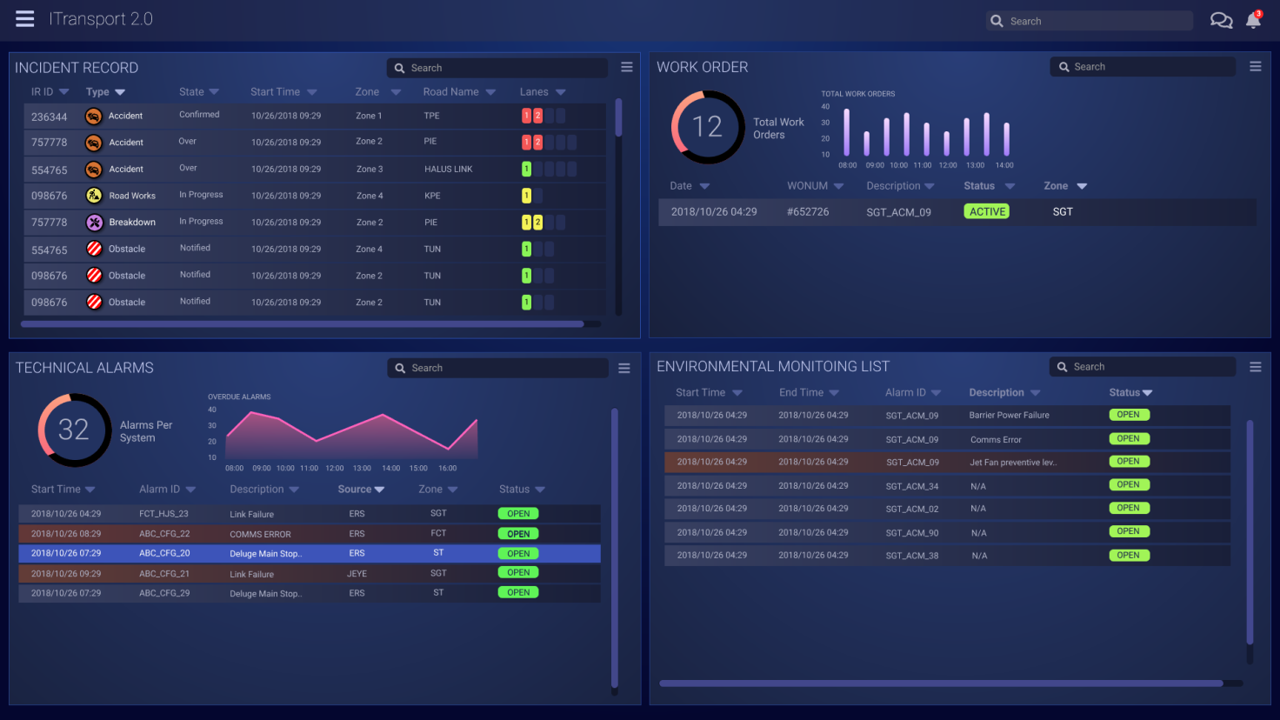

**Events**

Events panel shows all available planned events.

1. Today and 2.Upcoming events like Asia Summit, ABBA Concert etc.,

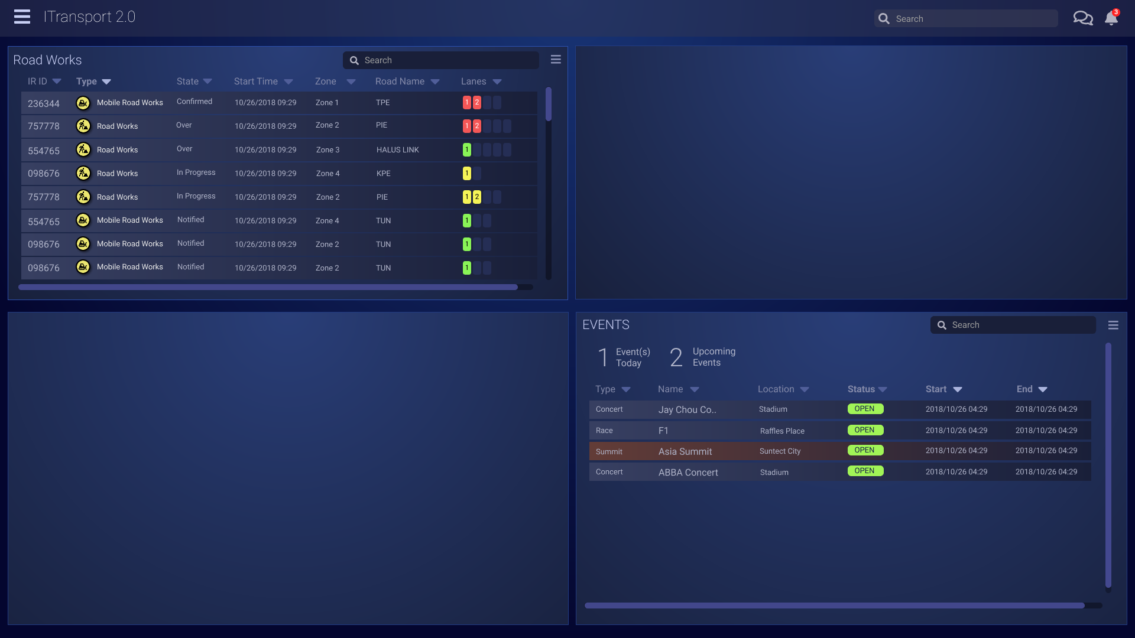

GIS (Graphics Information System) Map shows important event on interactive Map

GIS MAP

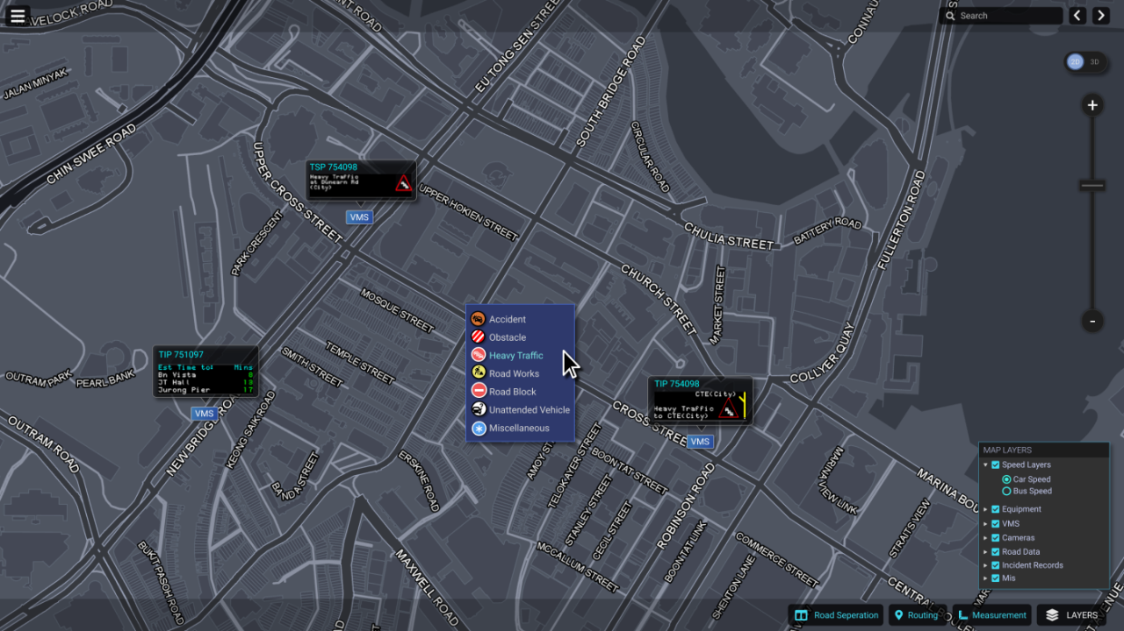

**BIS Real time**

* BIS (Business Intelligence) Real time page displays
* Real time static of live traffic data.
* Customizable with a variety of different charts and statistics

BIS Real time screen

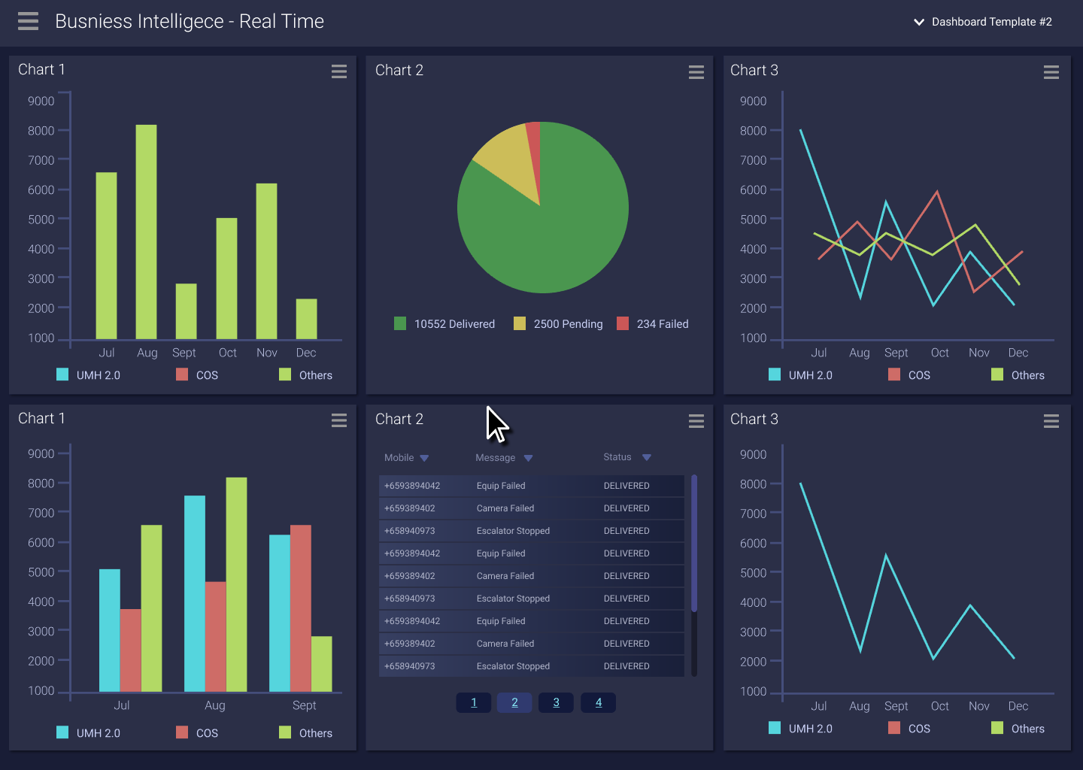

OWA User login

1. Enter user name and password
2. Select Zone Selection
3. Successful user get OWA interface with 3 window GIS, CC, BIS
4. **Common Control System (CC)**

Four Panels will display

1. Panel filtering like sort the zone

2. Merge two panels

3. Split the panel

4. New Technical alarm notification

1. Business Intelligence System (BIS)

* Displays real-time analytics of road conditions
* Other system information
* Customizable chart by the user and saved
* Each panel can be set to a specific chart

1. Incident Record (IR)

* GIS map to reveal a dropdown list of all available IR’s.
* User can create and edit the IR settings like heavy traffic
* To block or unblock the lane.
* To add/delete new lane
* VMS Message - user can multi select the VMS plans
* OBU message
* Record and track all assets on the ground. can type vehicle number display on the map
  1. MRT breakdown IR workflow
* Create MRT Breakdown IF - enter breakdown line
* Enter more detail about breakdown
* Create heavy traffic IR
  1. Mobile Roadwork
* Create a Mobile work
* can able to track the vehicle
  1. Equipment Control Workflow
* Equipment control popup
* EMAS, Monitor, Junction, FCT
* FCT - VMS, Camera, LUS, Jet Fan, Lighting, RBBI
* The Quick Equipment control has 4 main sections, Manual, IR & Events, Time Config & Default Message
  1. Single Equipment Control
  2. Event Workflow
* Ongoing and upcoming event
* User can create the new Event and lane detail
* Add VMS plan
* Two Status : Planned / Approved
* After approving to be implemented
* On event date status as "Live"
  1. Miscellaneous Tools
* Deleting An Event
* Critical junction tool
* VMS Library
* VMS side menu
* VMs Gallery
* VMS Editor
* Pictogram

Incident Type---

Accident

Vehicle Breakdown

Unattended Vehicle

Road Works

Obstacles

Slow Trafiic

Weather

Road Block

Miscellaneous

Diversion

fire

Plant Failure

Reverse Flow

Zone---

Zone 1

Zone 2

Zone 3

Zone 4

Zone 5

CTE Tunnel

FCT

Notification ----

Vehicle Recovery System

LTA Traffic Marshal

EMAS ----

Ventilation

Aircon

Lighting

Drainage

Door & Staircase

Power

Fire Alarm

Call in Alarm

**Key Notes**

1. Login
2. User can view 3 panel display
3. User Create Incident Record (IR) from GIS Panel
   1. Incident Record (Heavy Traffic) saved automatically
   2. Based on the IR to block or unblock the lane. (can create/edit/delete new lane)
   3. Can configure VMS plans, Canning messages, OBU messages, Congestion Routes, Partners & Vehicle Response
   4. User can add more VMS message using ”Add to Plan ” option also you can select multiple vms message
   5. This VMS message display on the GIS Map panel
   6. Implemented and failed status for VMS message. If the status is failed the VMS message send to work order
   7. User can also configure OBU message - 3 regions are identified. Alert, Jam & Guide.

Partners & Vehicle Response allows users to record and track all assets on the ground. Type the vehicle for future track.

1. User Create MRT Breakdown (IR) from GIS Pane
   1. MRT line, start time, end time, alarm, alert, status etc
2. Mobile roadworks IR
   1. Tomorrow …….

**History**

Every user authorized to use Platform Control Mode (PCM) or Fall back Control Mode (FCM).

Authorized Users

Operator

FC

Supervisor

DO

ITSC

Operation Mode

PCM (Platform Control Mode)

FCM (Fall back Control Mode )

Types of records available:

•       Past traffic alerts

•       Past technical alarms

•       Past reading alarms

•        History of operator commands

•       Past incident records

•       Past equipment status

      •       Past work order records

Features:

•      Search and retrieve historical data.

•       Filter the historical data.

•      View GIS for the historical data.

1. Filter by Source

(All, i-transport AID, EMAS AID, SOS phone etc)

1. Filter by Zone

(Zone 1,2... All)

1. Past traffic alerts

**Start Date/Time** – “From and To” -**Search**

3. View GIS

2. Search historical traffic alerts

1. Filter the List

1. Filter the List

1. Filter by Source

2. Filter by Zone

3. Equipment – (EMAS, JEYE, GUDE)

4. Tech Alarm Start DATE/Time

2. Past technical alarms

2. Search historical technical alarms

**Start Date/Time** – “From and To” -**Search**

3. View GIS

3. Reading alarms

**Start Date/Time** – “From and To” -**Search**

3. View GIS

2. Search historical technical alarms

1. Filter the List

1. Equipment – (EMAS, JEYE, GUDE)

1. User ID

2. Command Types (Manual Control, IR Handling, Activate IP etc)

3. **Start Date/Time** – “From and To” -**Search**

1. Search Historical Operator Commands

4. Operator Command Log

2. Operator Commands types

Manual Control commands

• Manual equipment control commands etc.

5. Incident Record

2. Search by historical Incident Record

1. Filter the List

1. Incident Type

2. Notification

3. Zone

1. Search By : Time, IRID, Vehicle Number

2. Start Date/Time Form and To

3. View CCTV, Prioritising and Editing Incident Records

1. CCTV Function

2. Edit Function

3. Priority Function

6. Equipment Status

1. Search Historical Equipment status

1. Start Date/Time Form and To

2. View GIS

1. Start Date/Time Form and To

Filter by Fault Source (EMAS, GLIDE, FCT)

2. Search historical work order

1. Filter the List

7. Work Order