1. **To Get All Customers list**

Request:-

http://localhost:8083/api/getAllCustomers

Response:-

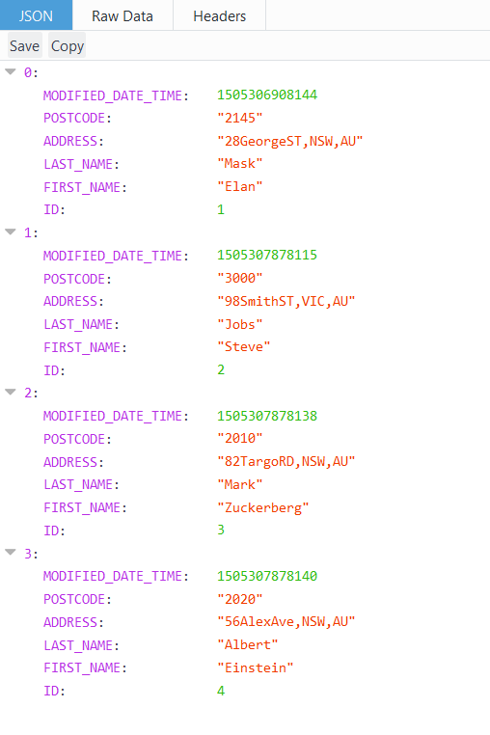

1. **Query for single customer by ID:**

Request:

<http://localhost:8083/api/Customer?ID=2>

Response:

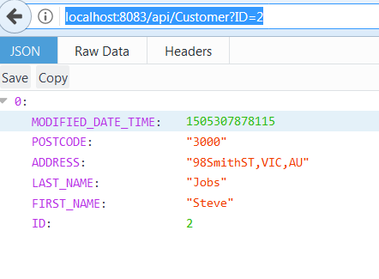

1. **Query for single customer by PostCode:**

Request:

<http://localhost:8083/api/Customer?postCode=2145>

Response:

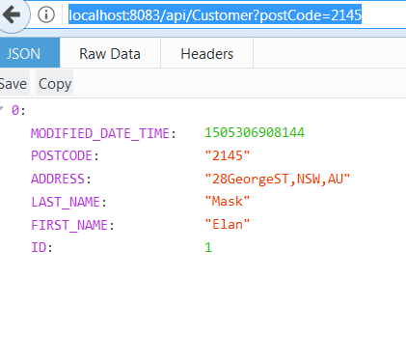

1. **Query for single customer by passing ID in URI:**

Request

<http://localhost:8083/api/1>

Response:

