Manju Mehta Date: December 14, 2015

CS155 (C#/.NET – Text Adventure Game)

Final Project

Story Line:

1. Created several locations (or Cells). Each cell has 3 objects: 2 Cell objects and one event object. The first cell object is the events outcome of completing the event. The second cell is for failing the event.

2) If a player guesses a correct answer to complete an event, he/she moves to the next cell.

3) If a player guesses an incorrect answer to complete an event, he/she is given additional opportunities to guess correct answer.

4) After going through all the locations, puzzle game ends with a message to indicate the final outcome.

Note that there are two possible final outcomes:

1) In case a user completes each event successfully (regardless of number of tries), then the final outcome is a success.

2) If all of the missing letters in all words were not guessed correctly, the final message will display the text accordingly.

See below successful completion of word puzzle:

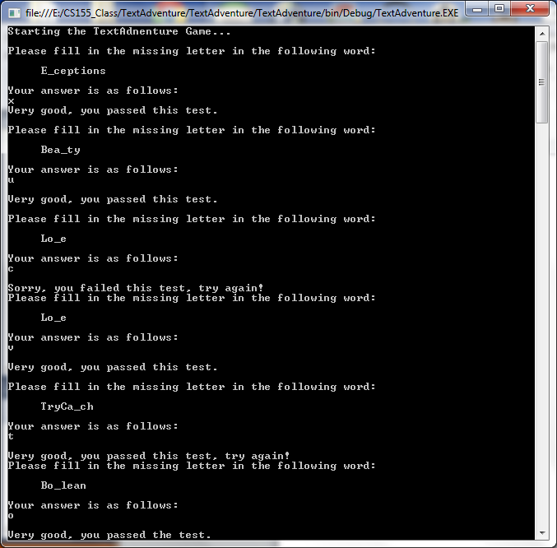

Continuation of above screen

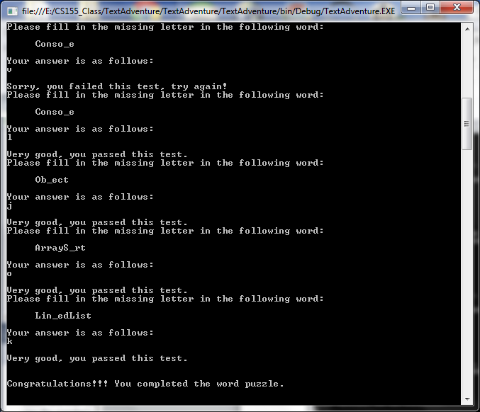

Unsuccessful completion of word puzzle:

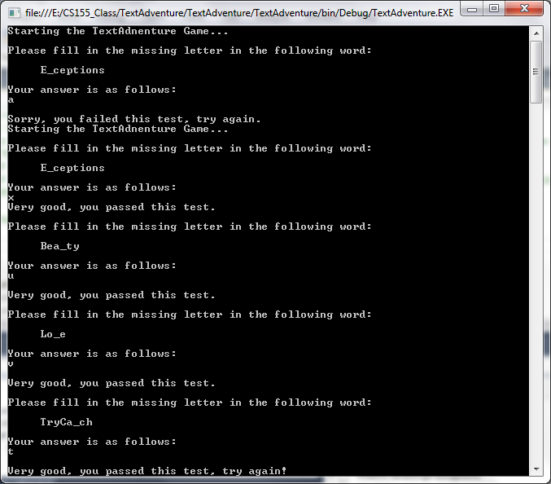

Continuation of the above screen:

