1. Report View

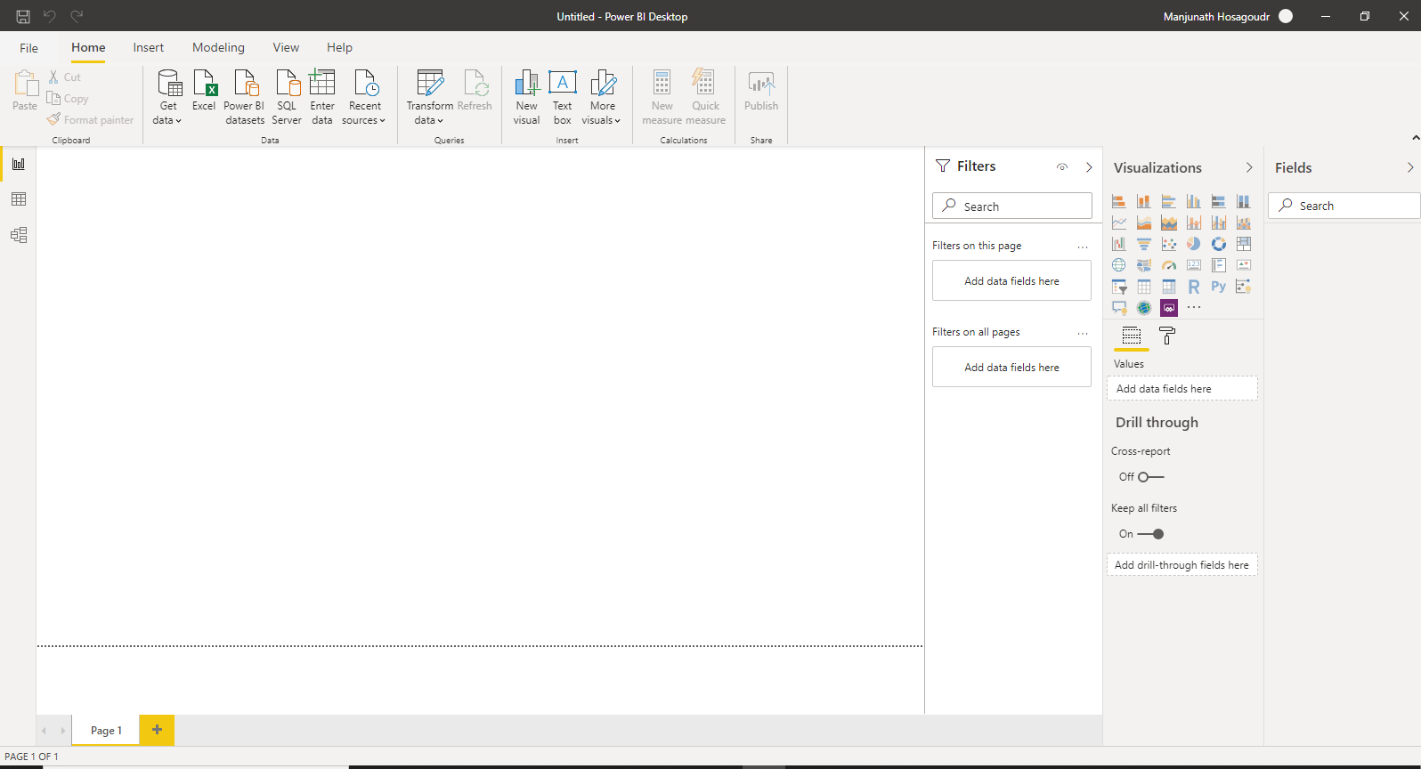
2. Data View

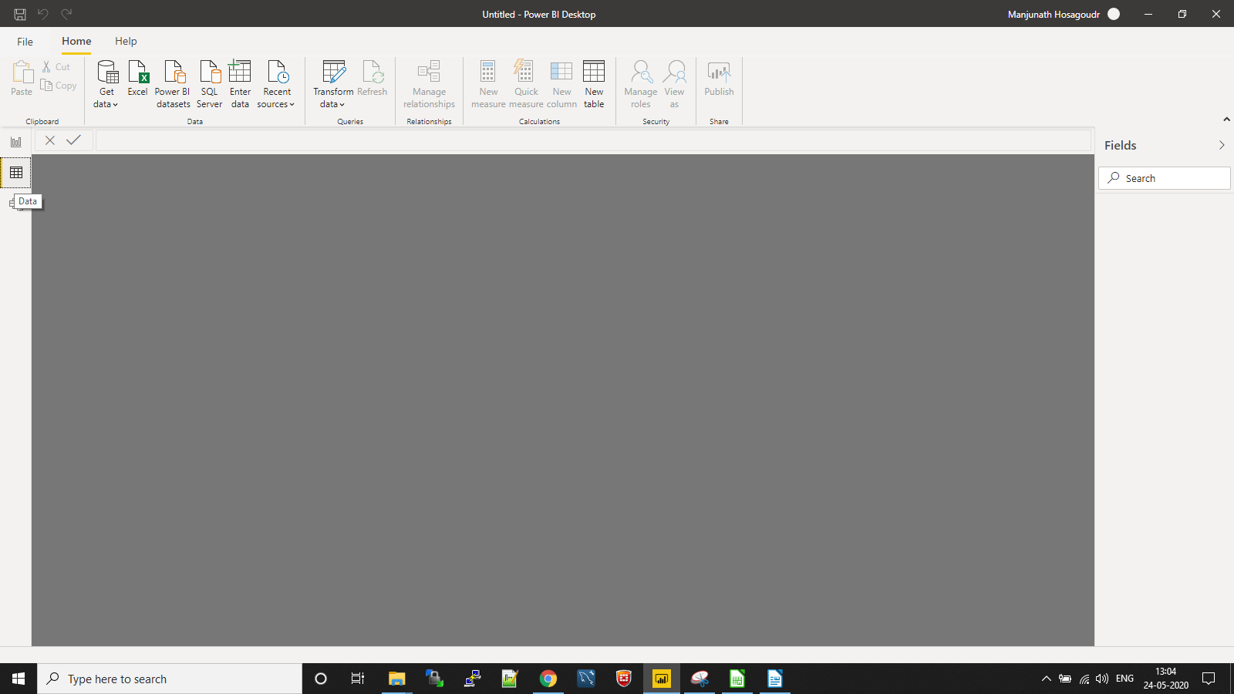
3. Model View

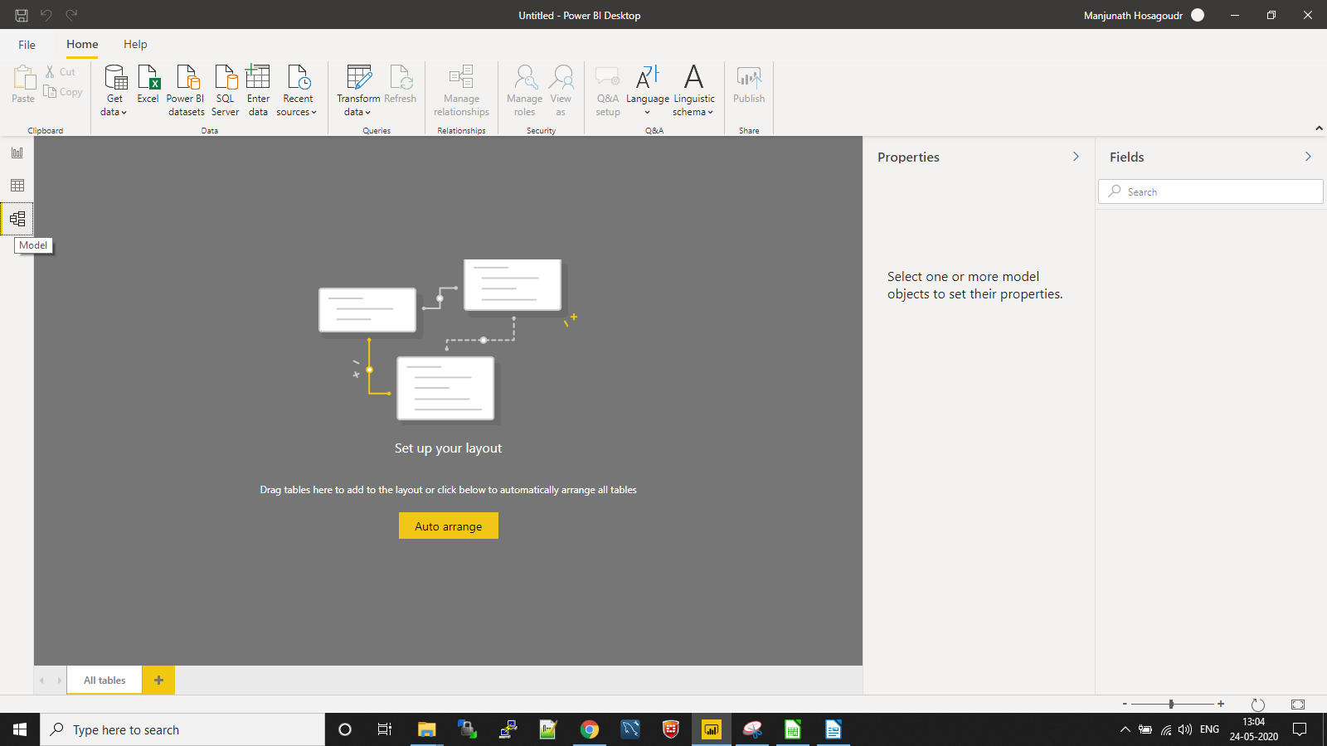

4. Power Query Editor

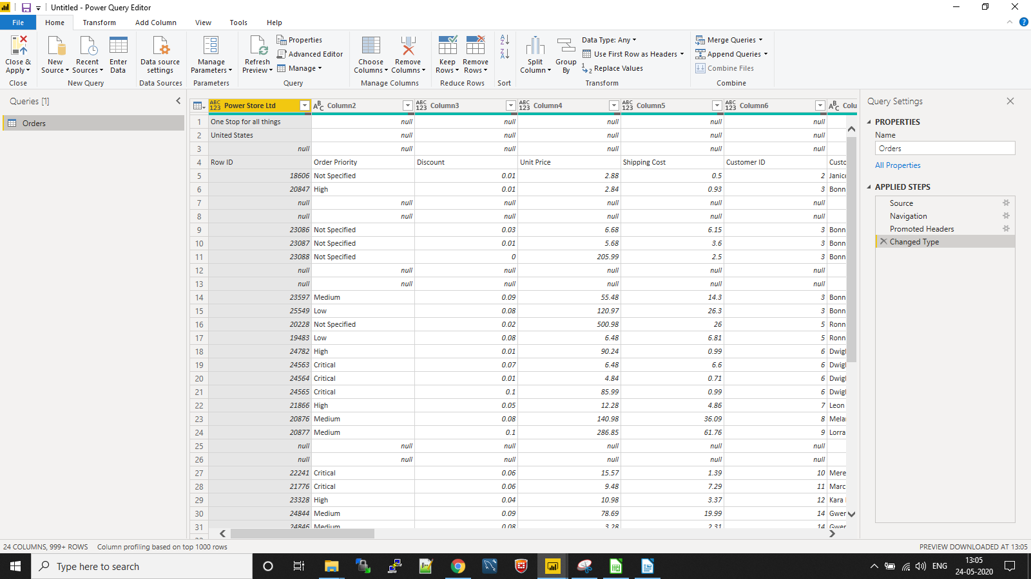

5. Advanced Editor

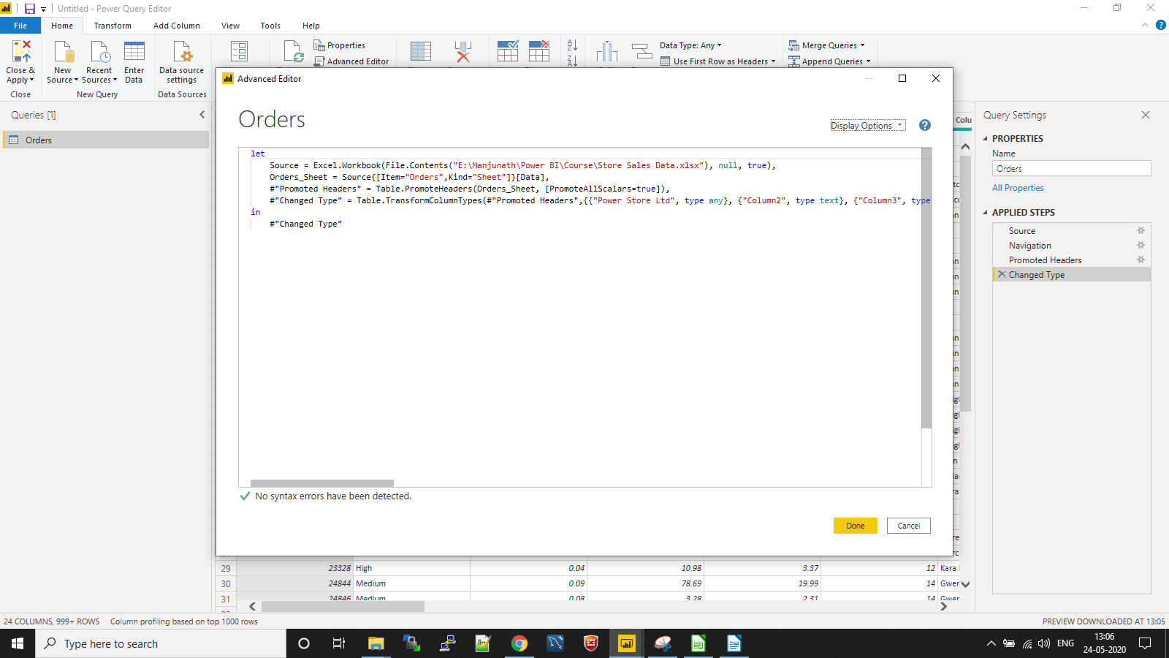

Prepare a document with details of the following along with their price

1. Power BI Desktop
This is windows desktop based application for PCs and desktop for designing of reports by using Data transformation and data modelling.

This is free of cost.

2. Power BI Pro
- Self-service and modern BI in the cloud
- Collaboration, publishing, sharing, and ad-hoc analysis
- Fully managed by Microsoft
- Publish reports to be shared
- Creation of data visualizations, reports, and dashboards

Price : $9.99 Per month

3. Power BI Premium
- Enterprise BI, big data analytics, cloud and on-premises reporting
- Advanced administration and deployment controls
- Incremental data refresh

Price : $4995 Monthly price

