# SAVEETHA SCHOOL OF ENGINEERING

**CAPSTONE PROJECT**

Quality Of Service OSI Layers For Multimedia Applications

**NAME: D. Manjunadha**

**REGISTER NUMBER:192324237**

**COURSE CODE:** CSA0747

**COURSE NAME:** Computer Network for IOT

## INTRODUCTION:

## The rise of multimedia applications, such as video streaming, Voice over IP (VoIP), and online gaming, has created unique challenges for network infrastructure. Unlike traditional data traffic, multimedia applications are highly sensitive to network performance factors such as bandwidth, latency, jitter, and packet loss. Ensuring smooth and reliable delivery of multimedia content requires specific mechanisms at various layers of the OSI (Open Systems Interconnection) model to optimize Quality of Service (QoS).

### Objective:

### Identifying Multimedia Applications and Their Network Requirements

### Defining QoS Policies and Traffic Classification Mechanisms Across OSI Layers

### Implementing Traffic Classification

### Analyzing Network Performance for TCP and UDP

### Fine-tuning QoS Parameters

### LITERATURE REVIEW

### Multimedia applications, such as video streaming, Voice over IP (VoIP), and online gaming, have unique requirements regarding bandwidth, latency, jitter, and packet loss. To optimize performance, these applications rely on robust Quality of Service (QoS) mechanisms. QoS is essential for maintaining the integrity of multimedia transmissions and ensuring that real-time services deliver a seamless user experience. This literature review explores the requirements of multimedia applications, QoS policies, traffic classification mechanisms, and traffic shaping strategies implemented at various OSI layers. Multimedia applications, particularly those that involve real-time communication (e.g., VoIP, video conferencing, online gaming), have strict QoS requirements. Video streaming services like Netflix and YouTube, for instance, require sufficient bandwidth to prevent buffering, while VoIP services such as Skype or Zoom need low latency and jitter to maintain call quality

# METHODOLOGY

**Software:**

* Cisco Packet Tracer

### Network Design:

Network consist of

* + 2 routers
  + 2 switches
  + 2 PC
  + 1 servers

**Network Topology:**

* 2 Routers: Router1 and Router2
* 2 Switches: Switch1 and Switch2
* 2 PCs: PC0 and PC1
* 1 Server: Server1

**Step 1: Physical Connections**

1. Router1 is connected to Switch1, and Router2 is connected to Switch2.
2. Switch1 connects to PC0, and Switch2 connects to PC1.
3. Router2 is also connected to Server1.
4. Router1 and Router2 are connected directly via a point-to-point link.

Step 2: IP Address Allocation

Subnet for Router1, Switch1, and PC0:

* Router1 IP Address: 192.168.10.1
* PC0 IP Address: 192.168.10.2
* Subnet Mask: 255.255.255.0

**Subnet for Router2, Switch2, and PC1:**

* Router2 IP Address: 192.168.20.1
* PC1 IP Address: 192.168.20.2
* Subnet Mask: 255.255.255.0

**Subnet for Router2 and Server1:**

* Router2 (server-facing) IP Address: 192.168.30.1
* Server1 IP Address: 192.168.30.2
* Subnet Mask: 255.255.255.0

**Point-to-Point Connection Between Routers:**

* Router1 (outgoing interface) IP Address: 10.0.0.1
* Router2 (incoming interface) IP Address: 10.0.0.2
* Subnet Mask: 255.255.255.252

**RESULT:**

### 

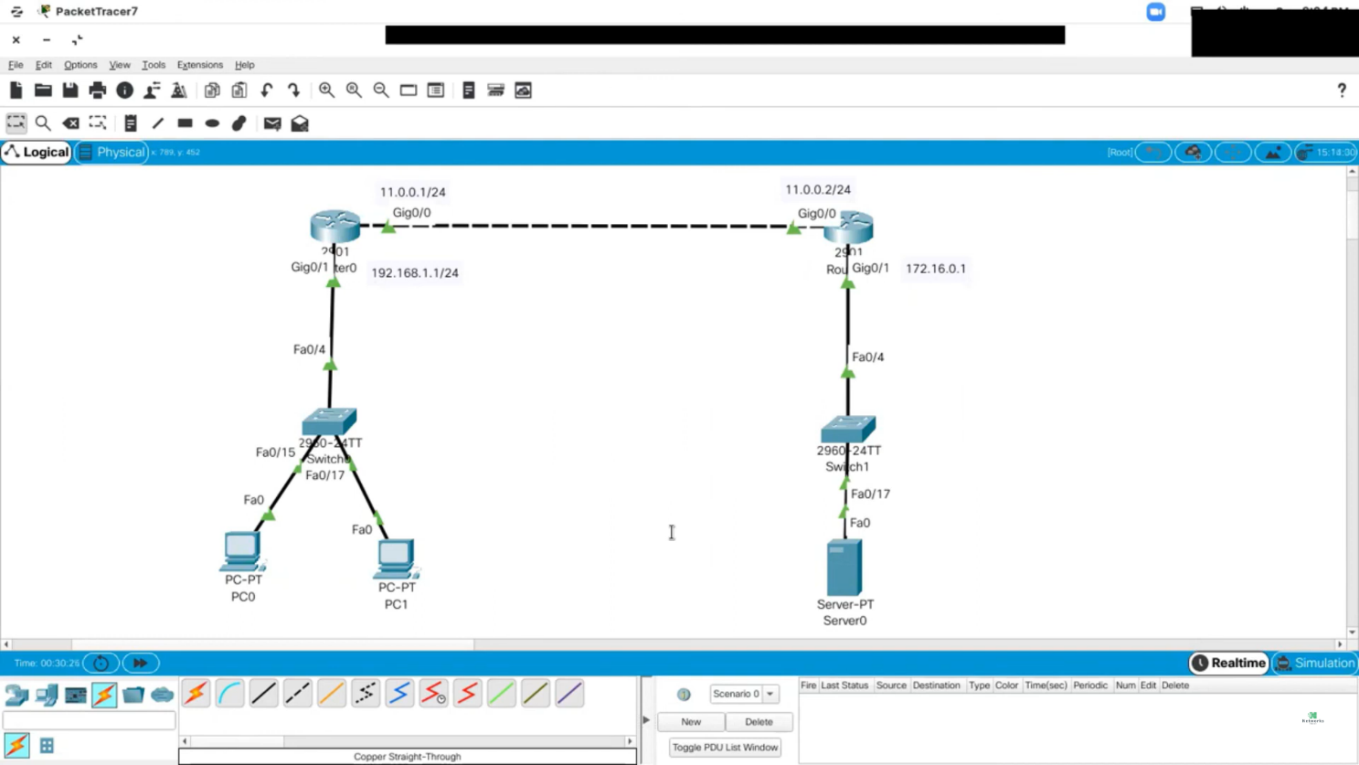

## CONCLUSION:

It sounds like you're wrapping up a discussion or analysis on Quality of Service (QoS). In a conclusion for QoS, you might want to highlight key takeaways such as:

1. **Importance of QoS**: Emphasize why QoS is crucial for ensuring reliable and efficient network performance, particularly in environments where multiple types of traffic are present.
2. **QoS Strategies**: Summarize the strategies or mechanisms implemented, such as traffic shaping, prioritization, or bandwidth allocation, and their effectiveness.
3. **Challenges and Solutions**: Address any challenges faced in implementing QoS and how they were overcome or mitigated.
4. **Future Considerations**: Offer insights into potential future improvements or considerations for QoS, especially in light of evolving technologies and increased demand for network resources.
5. **Impact on Users**: Reflect on how the QoS measures have improved the user experience and satisfaction.