Angular
Angular is an open source platform / framework for building rich web applications. These applications are typically called 'single page applications' and they provide dynamic and interactive functionality to the user right on their web browser.

Written using JavaScript or TypeScript, the applications you can build using Angular makes use of best practices to solve common challenges with web application development. The framework is built to take care of the common needs to web developers and make it easier and quicker to build any client application.

Angular comes in two flavours. Angular 1 (also called AngularJS) and Angular 2+ versions (just called Angular). Angular versions 2+ are entirely different from Angular 1. The courses on this page specify which version of Angular it covers, so make sure you take the course on the version of Angular that you are interested in.

Courses:

Angular 6 Basics
Learn how to use and build applications in the Angular framework. This is a 'from the basics' introduction to Angular that covers various features of the framework, as well as how to create run and deploy a web application with Angular

Angular Components In Depth
This course is a deep dive into components in Angular. Learn about the various features of Angular components and powerful ways of customizing your component's behaviors - Event handling, view children, change detection, content projection and more!

Thinking in AngularJS 1
This course is an introduction to the Angular 1.x framework. Learn to code client side applications in Angular. Get a deep understanding of the fundamental concepts and learn to 'think' in AngularJS.

AngularJS Services In-Depth
Learn about services in AngularJS - an important concept to learn when building client side applications in AngularJS. Learn how to create services, as well as use the existing out-of-the-box services that come with Angular.

Angular 6 Basics

This course covers:

- Understanding the component model approach to building Angular applications
- Creating components and building component trees
- Implementing interactivity by responding to user events
- Building an application using services
- Breaking the Angular application into modules
- Making REST API calls using in-built services
- Implement routing to build multi-view applications

Unit 1: Components
This unit is an introduction to the Angular framework. This covers an introduction to the mental model, setting up Angular and introduces components - the fundamental building blocks of an Angular application.

1.1 Introduction
Welcome to this course. We'll look at what this course covers and how its contents are organized.

Angular Basics

Prerequisite:
- HTML and CSS
- JavaScript / TypeScript

Angular Technologies:

Angular
JavaScript / TypeScript
Angular CLI
Reactive programming, RxJS, Observables, operators
Jasmine, karma
Redux, ngRx

Course Contents:

Unit 1: introduction / setting Up / Components
Unit 2: Templates / Data Binding / Event Handling
Unit 3: Services / DI / Rest API calls
Unit 4: Routing / Wrap up

1.2 Component Based Model
Understand the component-based mental model that's helpful when thinking about Angular application development.

The traditional approach of front end development involves
HTML and CSS
HTML is static portion of your application
And JS is dynamic portion of your application
Now JS is embedded in your HTML
Once HTML load, JS will also load along with html
Now JS will manipulate the DOM. JQuery will also do the same.

HTML ß JS

Example:

if we need to display time on web page
we write html and embed JS to display the time. This is how we broke it down to achieve the display of time.

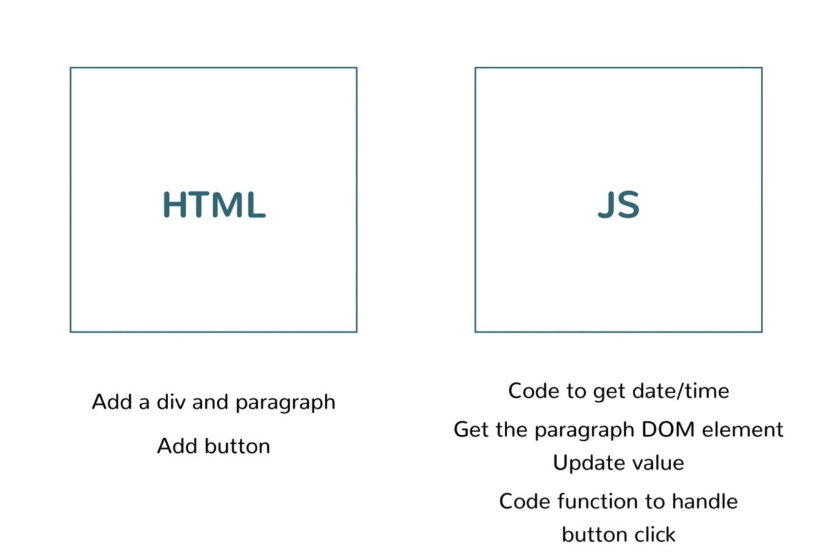

But in Angular we will not have implicit divide like html or JS separate instead it will take Component based approach.

Like., Header component, side bar component, footer and body

Header component knows how to render from some else and it can contain both html and javascript. We will gave a name to header section called header-section. Now we can use this name and tell Angular. Now Angular will render the content and fills this section

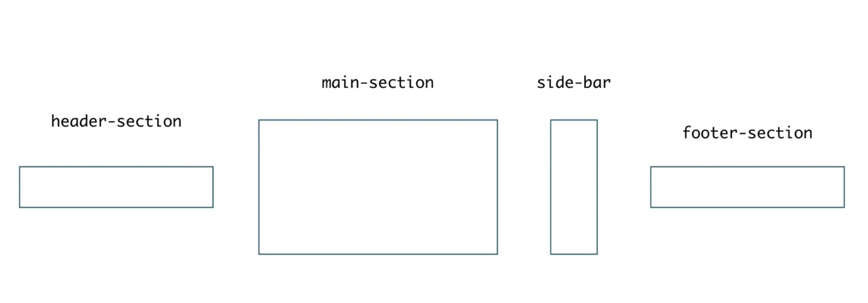

<header-section></<header-section>
<main-section></<main-section>
<side-bar></<side-bar>
<footer-section></<footer-section>

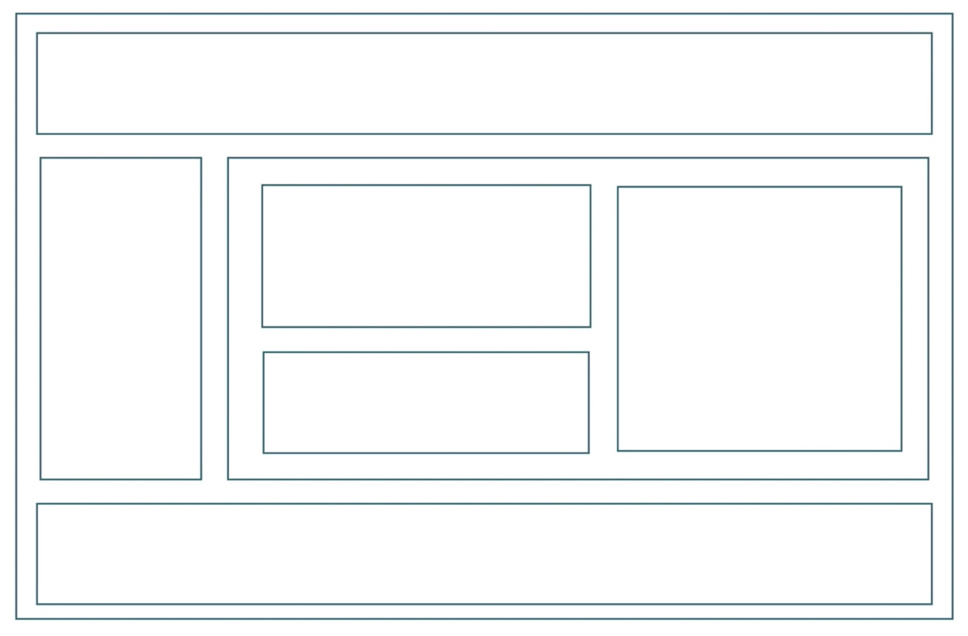

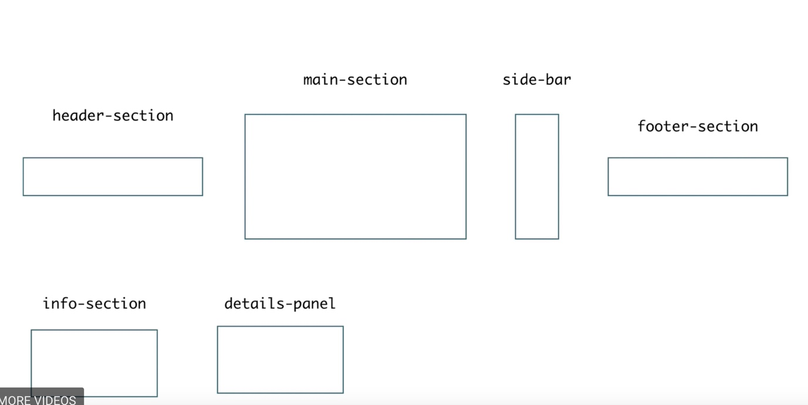

Each section can have sub-components. like main section can have summary and details sub-component.

Now in Angular application there will be Root Component.

Component Tree

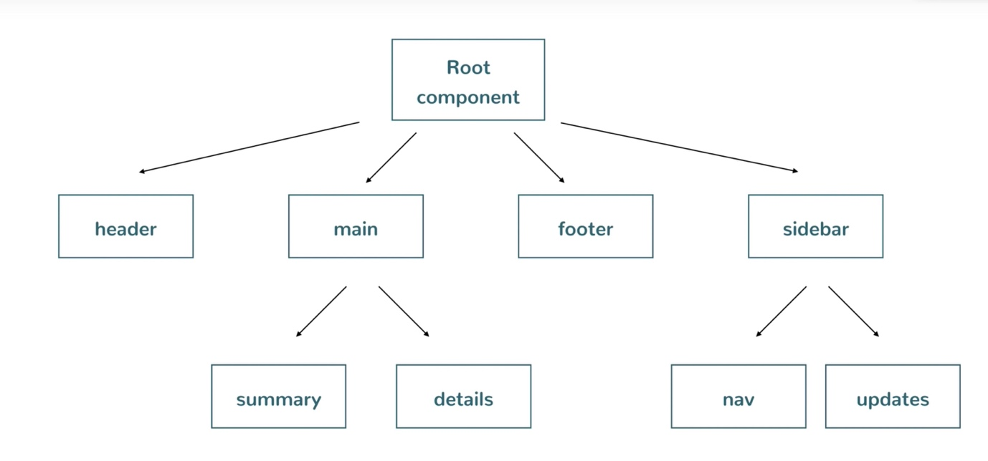

Now to do Time date display page using Angular below is the layout.

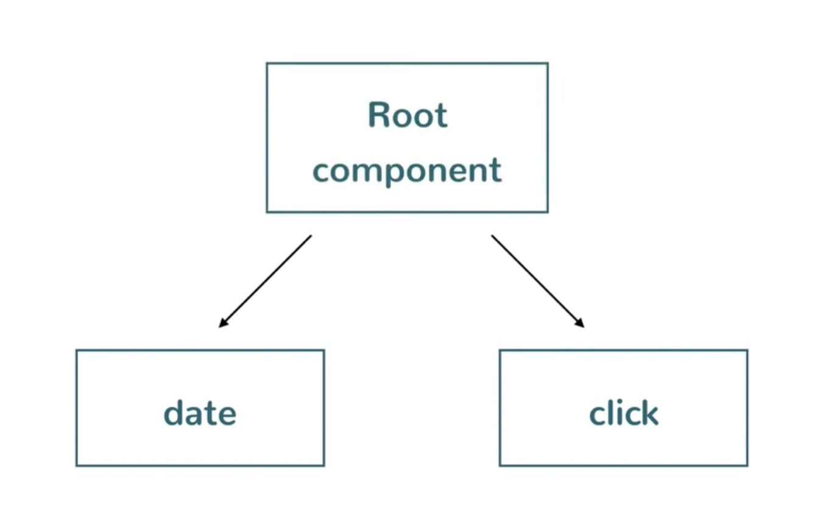

1.3 Setting Up
Let's setup the development environment to run Angular applications. This includes NodeJS, the editor (Visual Studio Code) and the Angular CLI.

Angular CLI - Command-Line-Interface.

Install NodeJS:
Go to nodejs.org and install node js.
To make sure node is installed use command
/> node -v
V9.3.0

/> npm -v
5.5.1

Note:
NPM is package manager for node.

Install Visual Studio Code:
Head to code.visualstudio.com and install.

Install Angular CLI:
There are bunch things need to be done to kick start Angular application
We need more than one file to be organized to start Angular app. So need all the boiler code.

Angular CLI is a utility to generate required files to start Angular application. Like bare bones project.
To install Angular CLI head to http://cli.angular.io site and follow the instructions to install cli
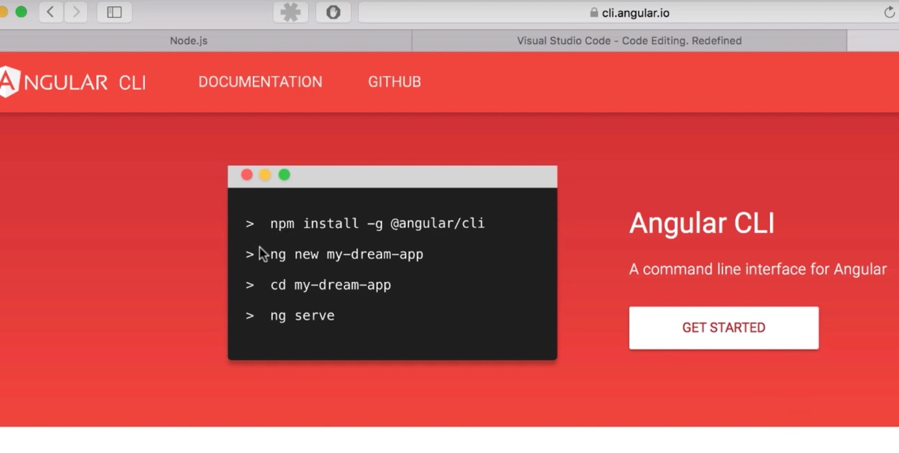
use npm cmd

/> npm install @angular/cli -g

Note:
This is called a 'scoped' package name. These names are of the format @group/package.

‘-g’ option will install globally, you can access from any directory to run angular commands.
Otherwise, it will install in current working directory.

To see Angular version installed, ng version

ng -v
1.6.1

1.4 Creating and running a project
Learn how to use the Angular CLI's `ng new` command to create a new Angular project. Then use the `ng serve` command to run the project and access it in a browser.

/> np new first-project

Now angular gone create the project with required artefacts.
it also happen to be npm project and it also installing npm and installing the dependencies.
We will be using angular library
But angular library should be inside our project.
Usually we need to download the JS file and link it to our html.
But we will not do that we use NPM Route to do this.
NPM route will download the required JavaScript related to Angular and those can included in html.

/> cd first-project

there is bunch of folder created under first-project
package.json – contains list of dependencies
src – contains project sorce file
node_module – required modules/dependencies will the downloaded in this folder

Configure the new project in editor
Click ‘Open Folder’ on welcome page of the IDE.

Now we have just bare bone project and we will see by running it.

In order to serve the code use below command:
/> ng serve

ng serve:
it create http server and host the project you have, then you can access that localhost url and loads the page. then we can make changes in the page.

url will be displayed in the console
http://localhost:4200/

1.5 Introducing the app component
Let's examine the root component of the generated Angular CLI project - the `app` component.

Now how basic structure has generated by angular cli.
Cli has created a root component because anyway the project needs one root component
The root component is place holder for developer to add other sub components.
Now in our starter code the Welcome UI Page which is put by default is what contents of root component.

everything starts from index.html
this html contains
<app-root></app-root>

How to find out where this root component is ?
It is under the directory called /app/
(/src/app/)

This is the single component in this whole project which is available has starting point of the angular cli project
This app contains bunch of files. The html, css and .ts are three files which gives functionality and look and feel.

Remember, the component is the combinations of view and backing logic
View is given by HTML and CSS.
Backing logic is given by .ts file.

In one component in the project is divided into three files html, css and ts file.

What we see in welcome page is mapped in ‘app.component.html’
There is {{title}} the value is coming from typescript file ‘app.component.ts’
It is contains class and inside there is variable called title.

Similarly, if you make any change in ‘app.component.css’ that will be picked
h1{
color: green;
}

So there is one component that is boot strapping the whole thing and that is in app folder. Which involves 3 files.

The last file ‘app.component.spec.ts’ is for unit test.

1.6 Creating your first component
Create a component from scratch using the Angular CLI's `generate` command. Understand what that command does and examine the resulting files.

