Day 1:
Session 1:

Session 2:

Session 3:
Sample rest api – ‘/hello’ – hello world
Sample ‘/users’ rest api with import.sql
Pushed the changes of day-1 to git repo:
https://github.com/manjunath-muniraju/edureka-microservices-ws
project is users:
https://github.com/manjunath-muniraju/edureka-microservices-ws/tree/main/userms

Day 2:
Session 1:
Service registry / Service Discovery
(Netflix Eureka, consul, etc, zookeeper)

Client-side Load Balancer
(Netflix Ribbon, Spring Cloud Load Balancer)

Horizontal scaling is used to achieve distributed architecture

100 ms * 5 instances = 500 instances (this is huge number that we are addressing)
We are looking for horizontal scaling, these service should scale dynamically.
When load increasing, we need to add more instance.
Same instance of ms can run on different ip address or different machine. These increase or decrease based on or depending upon on load and costing.
This kind of dynamic load balancing is not handled by traditional load balancer.
This works most with the static address that we receive for that we service discovery.
For service registry/discovery we have another ms that does service discovery. We build this using spring-cloud.
All the ms will send heartbeat (ping over http) and received by registry ms.
If no heartbeat sent, registry ms will deregister the ms from its list.
The users-ms client will make a call to service registry (like GET instance?name=users-ms) to get list of ip/machine it can used it to make calls to users-ms.
Q doubt) how frequently this GET call happens to get list alive ms instance
These list of available users-ms will be used by load-balancer which is residing inside the users-ms-client to make calls. It uses its cache (GET response object) to get available list of users-ms for its future calls.

Service registry should be highly available in this setup. For that, we can create multiple instances of registry and all instances will be in sync (Peer Aware) with all other nodes.
All ms will be used as round-robin basis by load-balancer by default. But we can change this strategy.

Circuit breaker (Resiliency):
Why do we need circuit breakers
In distributed architecture failure is inevitable, it doesn’t matter how much investment you will make or precaution you take the services will go down that is the reality we have to prepared for that.

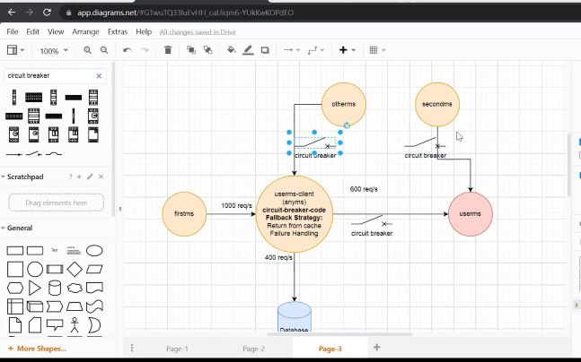

Session 2:
1: hands on:
Adding swagger as new dependency to support API documentation and rest api client (like postman)
https://springdoc.org/
default page after adding swagger dependency:
http://localhost:8080/swagger-ui/index.html
2: hands on:
findById for users
and POST api for users

3: hands on :
creating another app eureka-server for service discover and registry
http://localhost:8761/

4: hands on:
Creating new app for userms-client by adding eureka discover client
Apply similar config of users-client to userms app also
eureka.client.service.defaultZone=http://localhost:8761/eureka
and bring up cloned version of userms with port 8083 and see how horizontal (dynamic) scaling is done
now bring up userms-client also
create new class HttpClientConfig
and create new bean for rest template and make this as Load Balanced
create another class UserClientResource
and call userms via rest call
and make different call for below url and round robin happening for load balancing
http://localhost:8082/users-client/2

