Collections:

Collections - Need of Collection Framework

Arrays

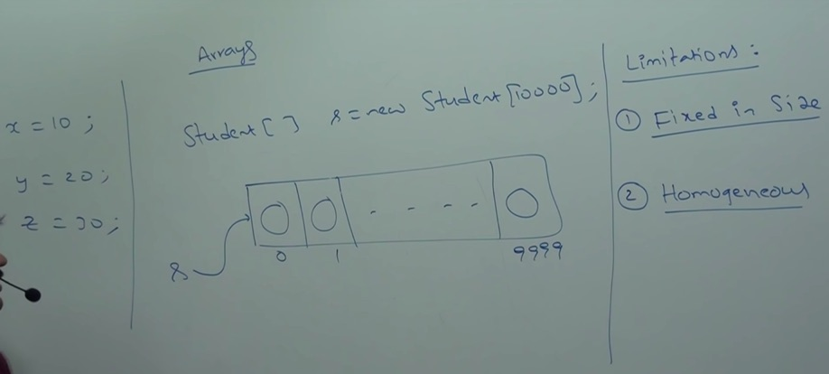

Only homogeneous objects are allowed.

Arrays

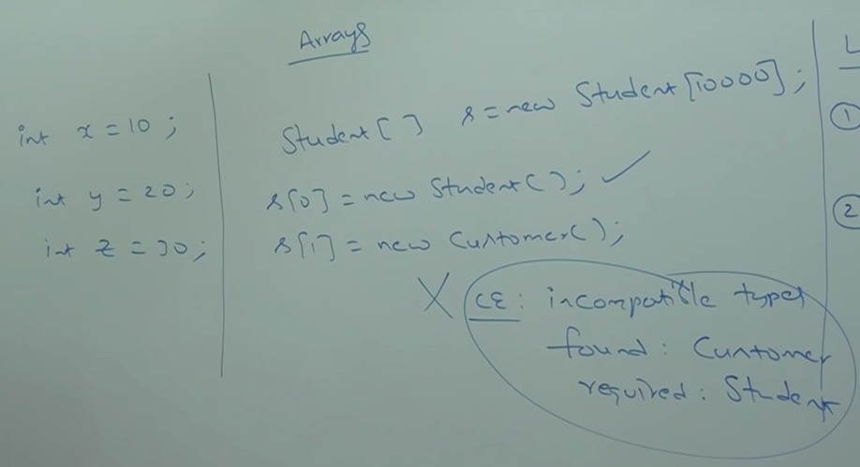

We can overcome homogeneous problem by creating an array of type Objects.

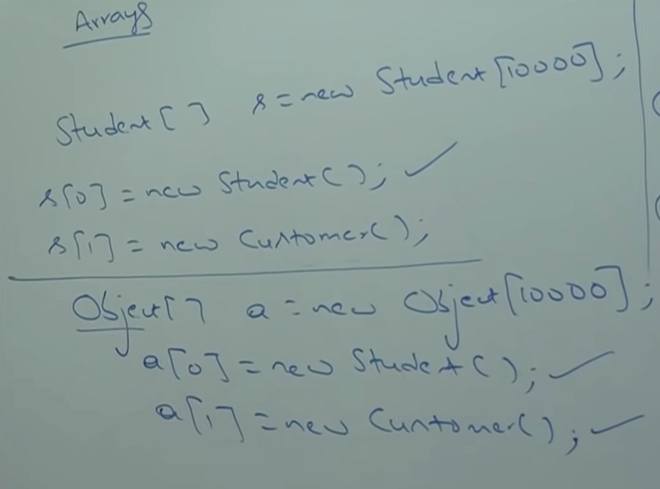

Next to overcome all the limitation of Arrays we need to go for Collections.

Summary:
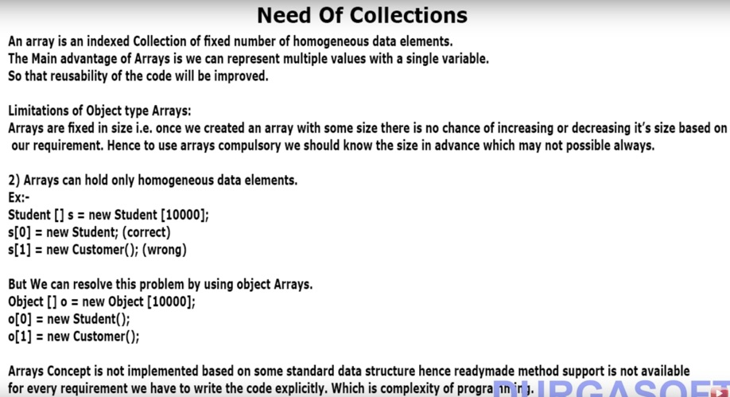

Collections



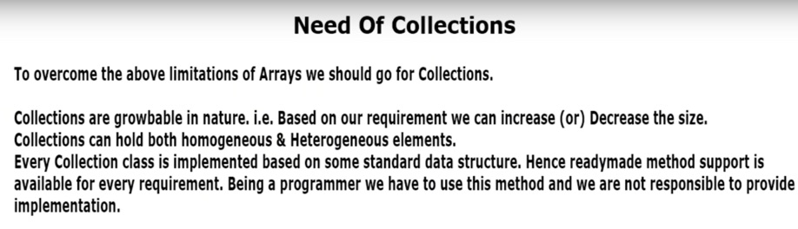

Collections - Difference between Arrays and Collections

Q: upto this class what is recommended, Arrays or Collections

If you know the size, highly recommended is Arrays. Because, in collection we get growable nature which comes with huge cost. If we need to add an element in Array beyond its size it will not allow but in ArrayList it will allow with a cost, it creates huge size of array and it will merge old array and new element and reference variable points to the new array-list. This is a huge performance cost. When crores of objects involve then it might take ages to copy the contents into new array.

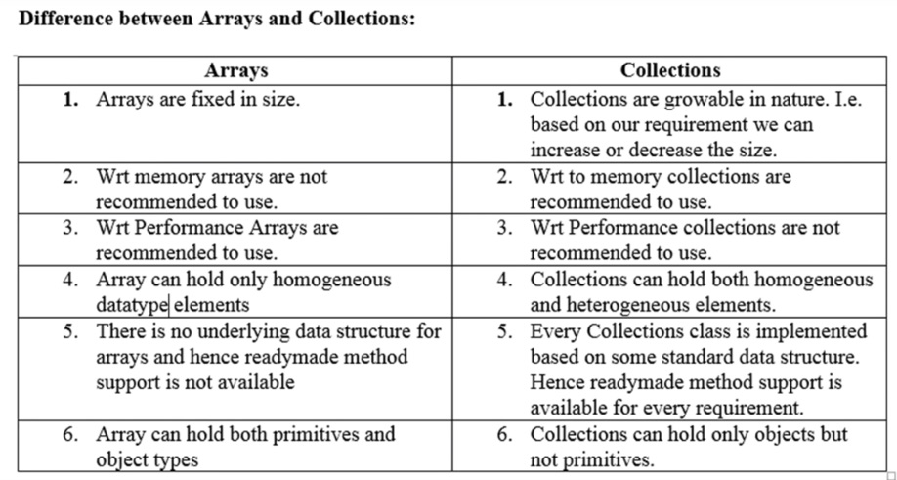

Interview question:
What is difference b/w Arrays and Collections (ArrayList, vector etc) ?

Above table has the answer (Diff b/w Arrays and Collections)

Collection and Collection Framework



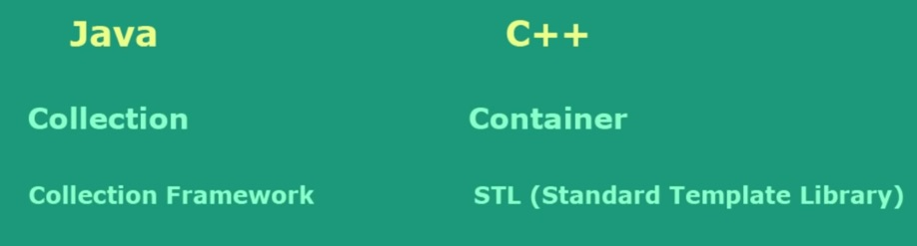

Difference between Collection and Collections (Interview Question)

