Set

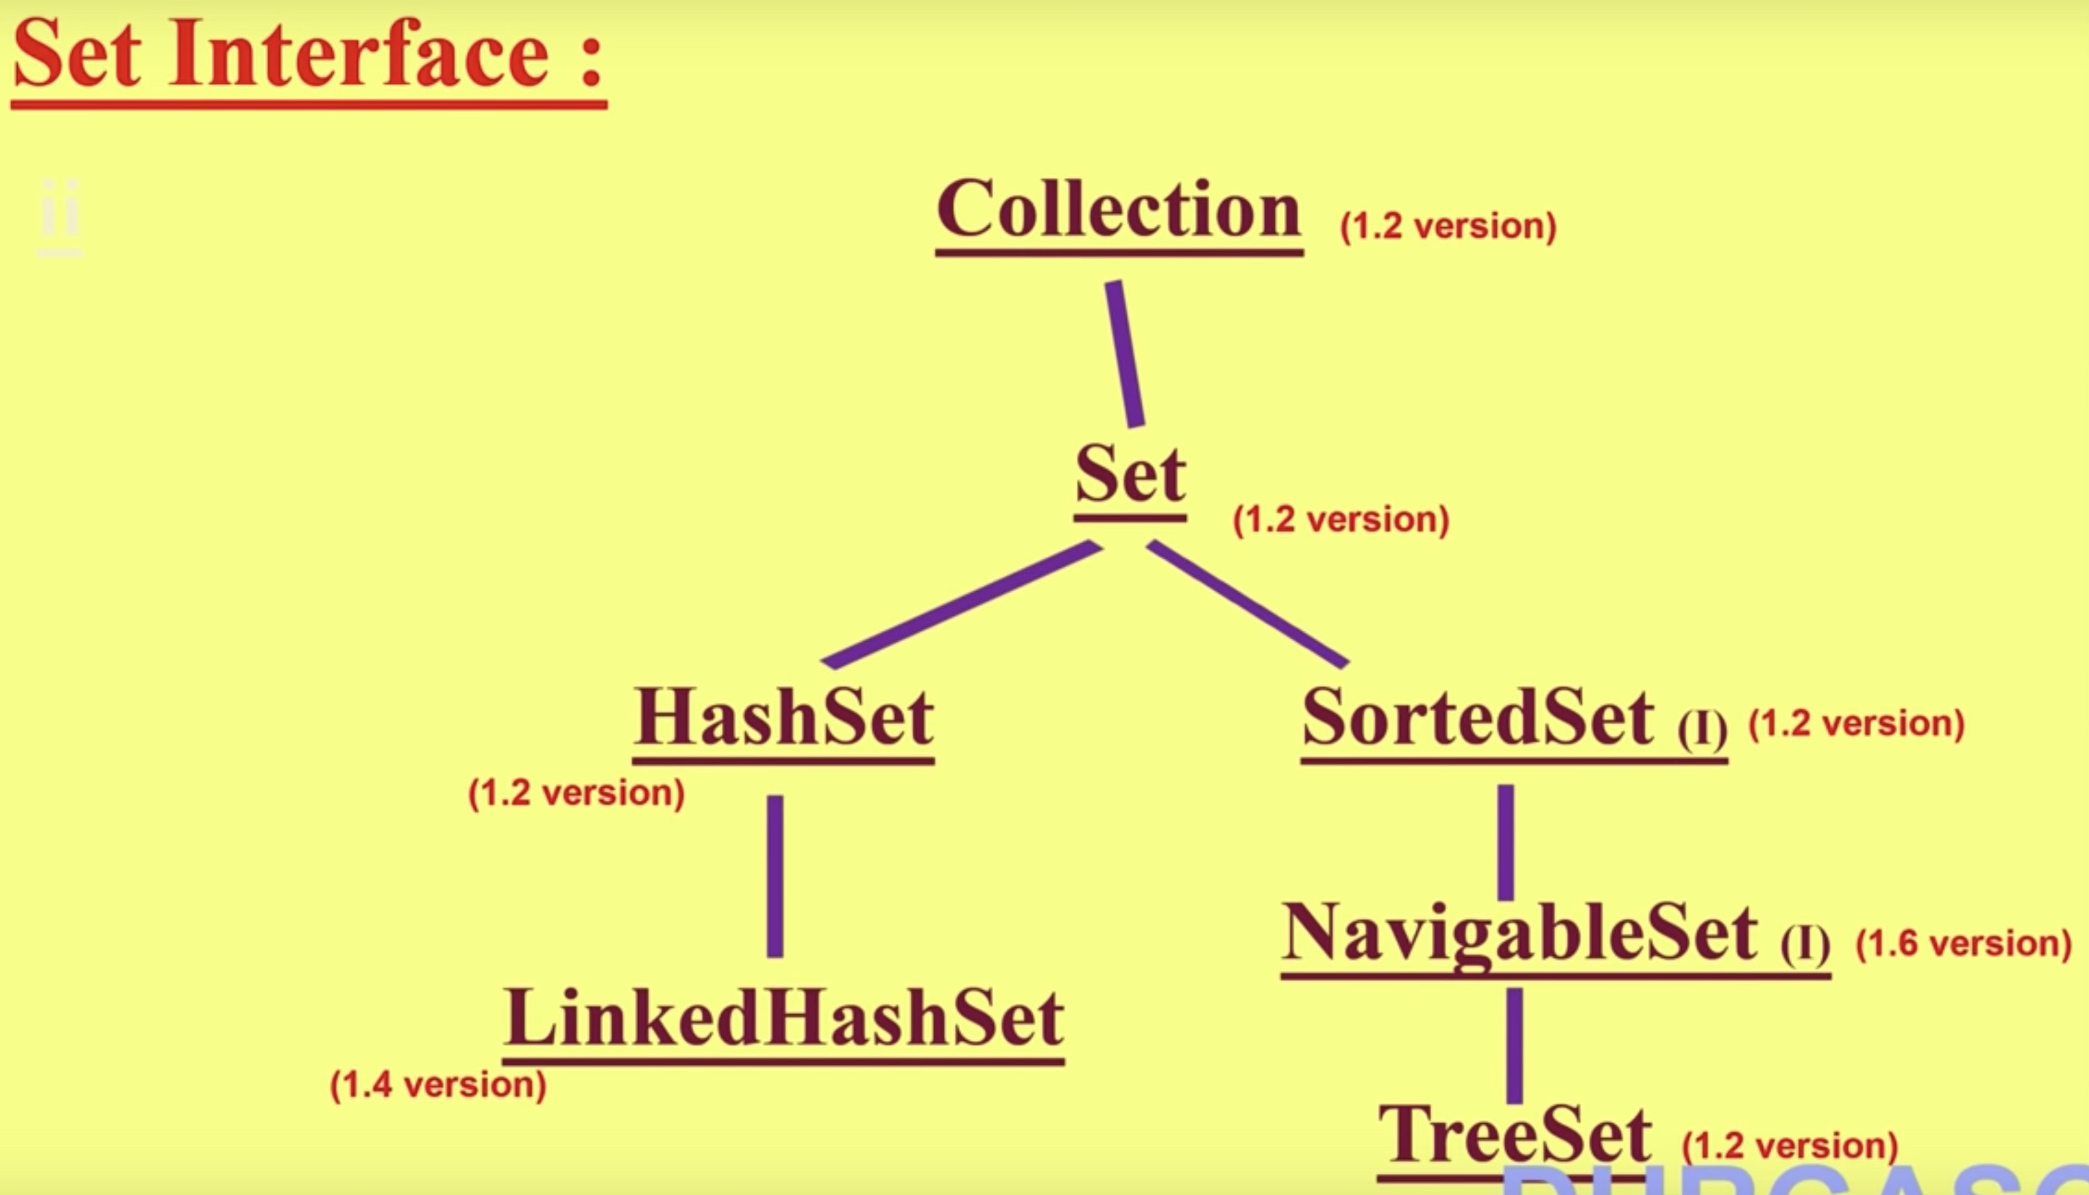

Set

- Set is the child interface of Collection.

- If we want to represent a group of individual objects as a single entity, where duplicates are not allowed and insertion order is not preserved then we should go for Set.

- Set interface doesn't contain any new methods. So we have to use only Collection interface methods.

HashSet

HashSet

- The underlying data structure is Hashtable.
- Duplicates are not allowed. If we are trying to insert duplicates, we won't get any compile time or runtime errors. add() method simply returns false.
- Insertion order is not preserved and all object will be inserted based on hash-code of object.
- Heterogeneous object are allowed.
- ‘null’ insertion is possible.
- implement Serializable and Cloneable interfaces but not RandomAccess.
- HashSet is the best choice, if our frequent operation is Search operation.

Constructors of HashSet

- HashSet h = new HashSet();
- Creates an empty HashSet object with default initial capacity 16 & default Fill Ratio 0.75

- HashSet h = new HashSet(int initialCapacity);
- Creates an empty HashSet object with specified initial capacity & default Fill Ratio 0.75

- HashSet h = new HashSet(int initialCapacity, float loadFactor);
- Creates an empty HashSet object with specified initial capacity & specified Load Factor (or Fill Ratio)

- HashSet h = new HashSet(Collection c);
- For inter conversion between Collection objects.

Load Factor / Fill Ratio:

After loading/filling the object with given/default factor, a new HashSet object will create, that factor is called as Load Factor or Fill Ratio.

HashSet Program Demo

import java.util.*;

class HashSetDemo {
public static void main(String args[]) {
HashSet h = new HashSet();

h.add("B");
h.add("C");
h.add("D");
h.add("Z");
h.add(null);
h.add(10);

System.out.println(h.add("B"));
System.out.println(h);
}
}

Output:

false
[null, D, B, C, 10, Z]

LinkedHashSet

