Three Cursors of Java - Enumeration, Iterator and ListIterator

Enumeration

Three cursors of Java

- If we want to retrieve Objects one by one from the collection then we should go for Cursors.

- There are three types of cursors available in Java
- Enumeration
- Iterator
- ListIterator

Enumeration

- Introduced in 1.0 version (Legacy)
- We can use Enumeration to get objects one by one from the old collection objects (Legacy Collections)
- We can create Enumeration Object by using elements() method of Vector class
public Enumeration elements();

Example:
Vector v = new Vector();
Enumeration e = v.elements();

Methods in Enumeration

- Enumeration defines the following two methods

- public boolean hasMoreElements();
- public Object nextElement();

Enumeration Demo
import java.util.*;

class EnumerationDemo {
public static void main(String args[]) {
Vector v = new Vector();

for(int i = 0; i <= 10; i++) {
v.addElement(i);
}

System.out.println(v);

Enumeration e = v.elements();
while(e.hasMoreElements()) {
Integer i = (Integer) e.nextElement();
if(i%2 == 0) {
System.out.println(i);
}
}

System.out.println(v);
}
}

Output:

[0, 1, 2, 3, 4, 5, 6, 7, 8, 9, 10]
0
2
4
6
8
10
[0, 1, 2, 3, 4, 5, 6, 7, 8, 9, 10]

Limitations of Enumeration

- Enumeration concept is applicable only for legacy classes and hence it is not a universal cursor.
- By using Enumeration we can get only read access and we can’t perform remove operation.

Note:
To overcome above limitations of Enumeration we should go for Iterator.

2. Iterator

Iterator overcomes all limitation of Enumeration.

Iterator

- We can apply Iterator concept for any Collection object hence it is universal cursor.

- By using iterator we can perform both Read and Remove operations.

Iterator
We can create Iterator object by using iterator() method of Collection interface.
public Iterator iterator()

Ex:
Iterator itr = c.iterator();

Here ‘c’ is any collection object

Methods in Iterator

Iterator interface defines the following three methods.
- public boolean hasNext()
- public Object next()
- public void remove()

Remove is extra capability in iterator over enumeration.

Demo program for Iterator

import java.util.*;

class IteratorDemo {
public static void main(String args[]) {
ArrayList al = new ArrayList();

for(int i = 0; i <= 10; i++) {
al.add(i);
}

System.out.println(al);

Iterator itr = al.iterator();
while(itr.hasNext()) {
Integer i = (Integer) itr.next();
if(i%2 == 0) {
System.out.println(i);
} else {
itr.remove();
}
}

System.out.println(al);
}
}

Output:

[0, 1, 2, 3, 4, 5, 6, 7, 8, 9, 10]
0
2
4
6
8
10
[0, 2, 4, 6, 8, 10]

Limitation of Iterator and Enumeration
- By using Iterator and Enumeration we can move only forward direction and we can’t move to the backward direction. And hence these are single direction cursors.

- By using Iterator we can perform only read and remove operation and we can’t perform replacement of new objects.

Note:
To overcome above limitations of Iterator we should go for ListIterator.

Three Cursors of Java ListIterator (Collection Framework)

3.ListIterator

Most powerful cursor is ListIterator.

ListIterator

- By using ListIterator we can move either to the forward direction or to the backward direction, and hence ListIterator is bidirectional cursor.

- By using ListIterator we can perform replacement and addition of new Objects in addition to read and remove operations.

ListIterator

We can create ListIterator Object by using listIterator() method of the List interface.
Public ListIterator listIterator()

Example:
ListIterator itr = l.listIterator();
Where ‘l’ is any List Object

Methods in ListIterator

- ListIterator is child interface of Iterator and hence all methods of iterator by default available to ListIterator.

- ListIterator interface defines the following 9 methods

Forward Direction
- public boolean hasNext()
- public void next()
- public int nextIndex()

Backward Direction
- public boolean hasPrevious()
- public void Previous ()
- public int previousIndex()

Other capability methods
- public void remove()
- public void set(Object new)
- public void add(Object new)

ListIterator Demo
import java.util.*;

class ListIteratorDemo {
public static void main(String args[]) {
LinkedList ll = new LinkedList();

ll.add("Bala");
ll.add("Venki");
ll.add("Chiru");
ll.add("Nag");
System.out.println(ll);

ListIterator litr = ll.listIterator();
while(litr.hasNext()) {
String name = (String) litr.next();
if(name.equals("Venki")) {
litr.remove();
} else if(name.equals("Chiru")) {
litr.set("charan");
} else if(name.equals("Nag")) {
litr.add("Chithu");
}
}
System.out.println(ll);
}
}

Output:

[Bala, Venki, Chiru, Nag]
[Bala, charan, Nag, Chithu]

ListIterator limitation

Note:
ListIterator is most powerful cursor but its limitation is, it is applicable only for List implemented class objects and it is not a universal cursor.

Comparison table of the three Cursors of Java

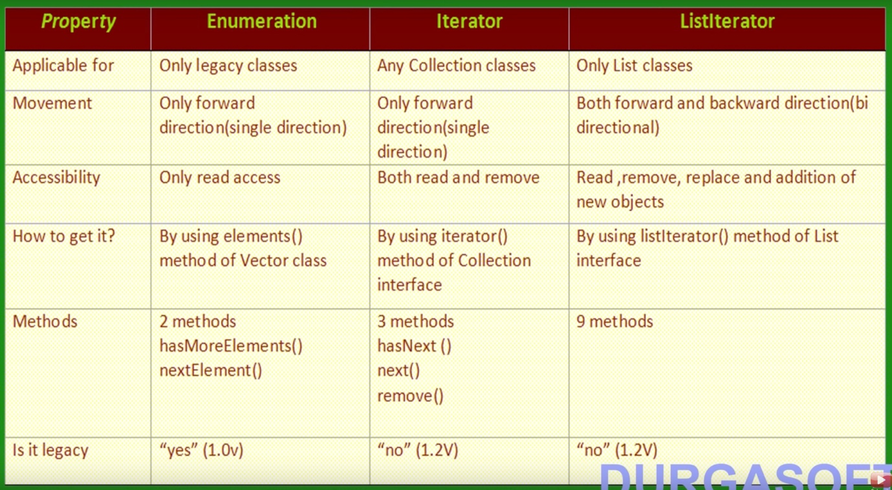

Implementation Classes of the three Cursors of Java

Implementation Classes of the three Cursors
import java.util.*;

class CursorDemo {
public static void main(String args[]) {
Vector v = new Vector();
Enumeration e = v.elements();
Iterator itr = v.iterator();
ListIterator litr = v.listIterator();

System.out.println(e.getClass().getName());
System.out.println(itr.getClass().getName());
System.out.println(litr.getClass().getName());
}
}

Output:

java.util.Vector$1
java.util.Vector$Itr
java.util.Vector$ListItr

Here, java.util.Vector$1 => $ means inner class and 1 means anonymous class. So, elements() method returns anonymous inner class of type Enumeration

Elements() method body in Vector class

/**
* Returns an enumeration of the components of this vector. The
* returned {@code Enumeration} object will generate all items in
* this vector. The first item generated is the item at index {@code 0},
* then the item at index {@code 1}, and so on.
*
* @return an enumeration of the components of this vector
* @see Iterator
*/

public Enumeration<E> elements() {
return new Enumeration<E>() {
int count = 0;

public boolean hasMoreElements() {
return count < elementCount;
}

public E nextElement() {
synchronized (Vector.this) {
if (count < elementCount) {
return elementData(count++);
}
}
throw new NoSuchElementException("Vector Enumeration");
}
};
}

Iterator Implementation inside Vector Class

Itr is inner class.

/**
* Returns an iterator over the elements in this list in proper sequence.
* @return an iterator over the elements in this list in proper sequence
*/

public synchronized Iterator<E> iterator() {
return new Itr();
}

/**
* An optimized version of AbstractList.Itr
*/
private class Itr implements Iterator<E> {
int cursor; // index of next element to return
int lastRet = -1; // index of last element returned; -1 if no such
int expectedModCount = modCount;

public boolean hasNext() {
// Racy but within spec, since modifications are checked
// within or after synchronization in next/previous
return cursor != elementCount;
}

public E next() {
synchronized (Vector.this) {
checkForComodification();
int i = cursor;
if (i >= elementCount)
throw new NoSuchElementException();
cursor = i + 1;
return elementData(lastRet = i);
}
}

public void remove() {
if (lastRet == -1)
throw new IllegalStateException();
synchronized (Vector.this) {
checkForComodification();
Vector.this.remove(lastRet);
expectedModCount = modCount;
}
cursor = lastRet;
lastRet = -1;
}

final void checkForComodification() {
if (modCount != expectedModCount)
throw new ConcurrentModificationException();
}
}

