Unit 1: Introduction to Spring and Dependency Injection

Spring 3.0.5:

Spring Core: Unit 1

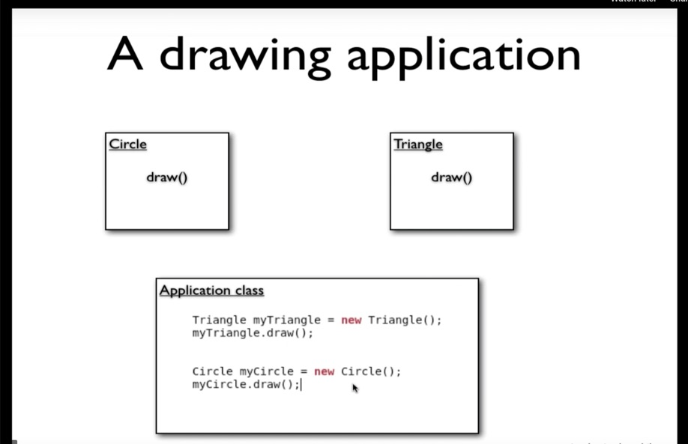

Now we don’t want our Application class not to be tied with Circle or Triangle object.
I need to use polymorphism
That can be achieved by creating some kind of interface class or parent class.
Then at run time we pass the parent class object and call draw method.

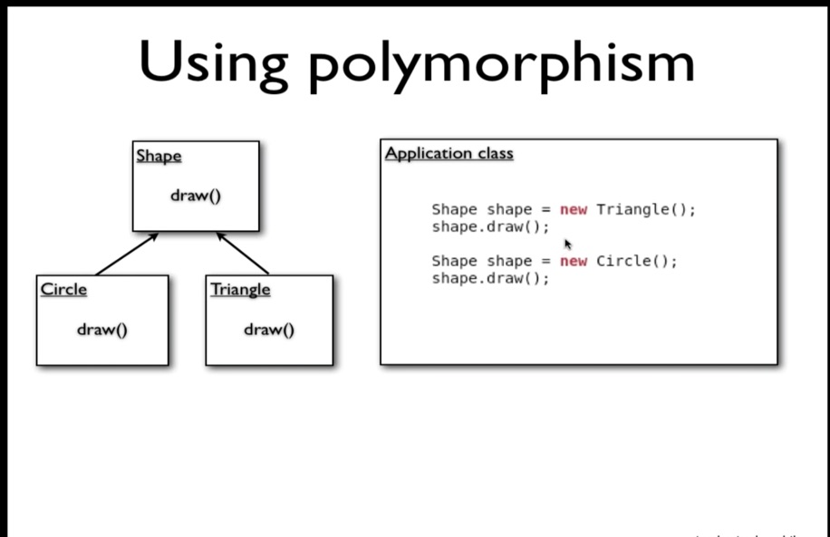

Now instead of calling the class directly, we have created a parent class (handle) called Shape.

The idea is I don’t know which object draw method I am calling at the time of calling draw() from Shape class.

Still this is not completely polymorphism because still I am instantiating Triangle and Circle inside Application class.
So, Application class know if it is a Triangle or Circle. So, we are getting benefit of polymorphism. Because it is still hard coded.

So, we will take step further. Instead of code hard-code. So we create a method which takes Shape class/object and we just call a draw() from Shape object. So, who every calls myDrawMethod(Shape shape) can call with Triangle or Circle object. And, that particular draw() will be invoked. So, now we didn’t hard code Triangle or Circle object inside Application class.

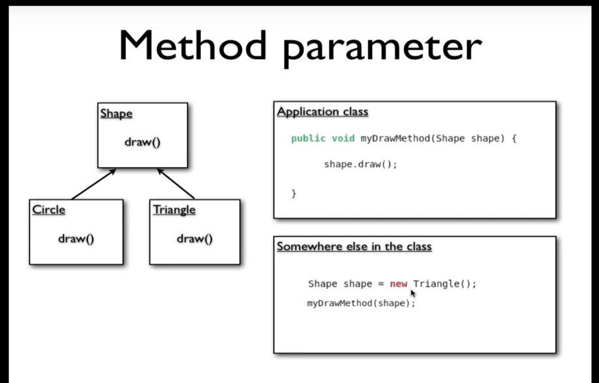

So, from outside world we can call myDrawMethod(Shape s).
Now if new class comes out like Rectangle class then Application class will not get affects or will not get modified.

We will take further, we will ask someone else (class/object) to add this Triangle in Application class

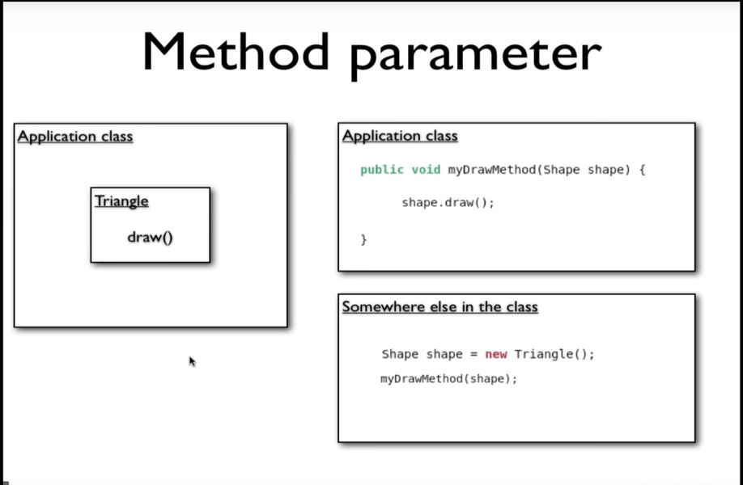

We will create Drawing class.
Here Drawing class doesn’t know what is drawing. It just has shape class and it draws based on whatever shape is been passed.
So, advantage here is Drawing is generic now, later there could be new shape coming and no modification required.

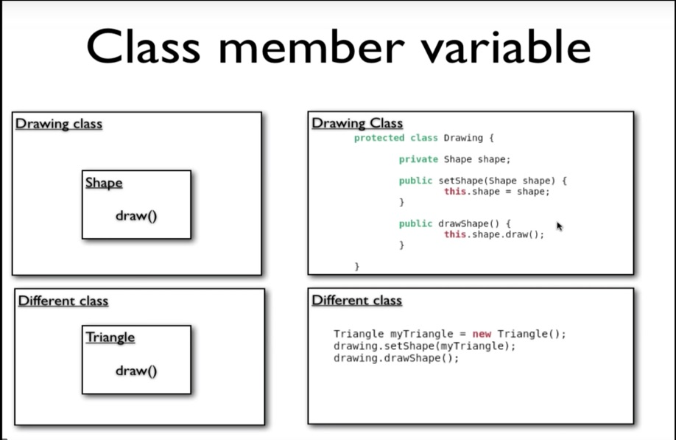

So, Drawing class don’t own relationship of which shape is drawn. It doesn’t own Triangle or Circle. It only owns Shape.

This is called Dependency injection or principle of DI.
Here dependency is injected into drawing class from Different class and not within the drawing class.
So, injection happens from different class all together.
This is principle/concept of DI.

Now, Spring makes it easier to achieve DI.

Fast paced notes:
=========

Factory Pattern – to create object using bean config
To achieve factory pattern, spring has Spring Bean Factory (it is object)
Bean factory reads from spring xml

Ways to load the spring.xml file:

- BeanFactory factory = new XmlBeanFactory(new FileSystemResource(“spring.xml”));
Triange triangle = (Triangle) factory.getBean(“triangle”);

- ApplicationContext context = new ClassPathXmlApplicationContext(“spring.xml”);
Triangle triangle = (Triangle) context.getBean(“Triangle”);

Injection types:

- Property initialization
<bean id=”triangle” class=” org.Triangle”>
<property name=”type” value=”Equilateral” />
</bean>

- Constructor injection
Type 1:
<bean id=”triangle” class=”org.Triangle”>
<constructor-arg value=”Equilateral” />
</bean>

Type 2:
<bean id=”triangle” class=”org.Triangle”>
<constructor-arg type=”int” value=”20” />
</bean>

Type 3:
<bean id=”triangle” class=”org.Triangle”>
<constructor-arg index=”0” value=”20” />
<constructor-arg index=”1” value=” Equilateral” />
</bean>

Injecting Objects:

<beans>
<bean id=”triangle” class=” org.Triangle”>
<property name=”pointA” ref=”point1” />
<property name=”pointB” ref=”point2” />
<property name=”pointC” ref=”point3” />
</bean>

<bean id=”point1” class=”org.Point”>
<property name=”x” value=”0” />
<property name=”y” value=”0” />
</bean>
<bean id=”point2” class=”org.Point”>
<property name=”x” value=”-20” />
<property name=”y” value=”0” />
</bean>
.
.
.
</beans>

Inner Bean:

<beans>
<bean id=”triangle” class=” org.Triangle”>
<property name=”pointA” ref=”point1” />
<property name=”pointB” ref=”point2”>
<bean id=”point2” class=”org.Point”>
<property name=”x” value=”-20” />
<property name=”y” value=”0” />
</bean>
</property>
<property name=”pointC” ref=”point3” />
</bean>

<bean id=”point1” class=”org.Point”>
<property name=”x” value=”0” />
<property name=”y” value=”0” />
</bean>
<bean id=”point2” class=”org.Point”>
<property name=”x” value=”-20” />
<property name=”y” value=”0” />
</bean>
</beans>

Notes:
Inner bean is visible to the property, and hence bean initializes to property element.
For inner bean ‘id’ tag is not required.

Useful when required configuration is limited to one bean and not required elsewhere.

Aliases:

Giving different names to same bean. So that we can refer by alias name.

Type 1:
<alias name=”triangle” alias=”triangle-alias”>

Type 2:

<bean id=”triangle” class=” org.Triangle” name=”triangle-name”>
</bean>
Here, triangle-name will be another name for bean is ‘triangle’.

Good practice is to use ‘id’. So that validator can validate for duplicate id names.
Alias can be used for different purpose if you need to only refer it by another name.

Idref:

Ref tag can refer to name, bean-id or alias.
But if you need to restrict to just bean-id to refer.

Example:
<bean id=”triangle” class=” org.Triangle”>
<property name=”pointA”>
<idref=”point1” />
</ property>
</bean>

Initializing Collections:

<beans>
<bean id=”triangle” class=” org.Triangle”>
<property name=”points”>
<list>
<ref bean=”point1” />
<ref bean=”point2” />
<ref bean=”point3” />
</list>
</property>
</bean>

<bean id=”point1” class=”org.Point”>
<property name=”x” value=”0” />
<property name=”y” value=”0” />
</bean>
<bean id=”point2” class=”org.Point”>
<property name=”x” value=”-20” />
<property name=”y” value=”0” />
</bean>
.
.
.
</beans>

Triangle.java

private List<Point> points;

Similarly, you can do for Set and Map.

Bean Autowiring:

Autowire by :
- byName
- byType (restricted to only one member type in the pojo)

ByName:

<beans>
<bean id=”triangle” class=” org.Triangle” autowire=”byName”>
</bean>

<bean id=”pointA” class=”org.Point”>
<property name=”x” value=”0” />
<property name=”y” value=”0” />
</bean>
<bean id=”pointB” class=”org.Point”>
<property name=”x” value=”-20” />
<property name=”y” value=”0” />
</bean>
.
.
.
</beans>

Triangle.java

Class Triangle {
private Point pointA;
private Point pointB;
private Point pointC;
}

Here, autowiring happens by naming convention of the reference variable name in Triangle class. It matches with other bean with same name in spring.xml file.

ByType:

<beans>
<bean id=”triangle” class=” org.Triangle” autowire=”byType”>
</bean>

<bean id=”pointA” class=”org.Point”>
<property name=”x” value=”0” />
<property name=”y” value=”0” />
</bean>
</bean

Triangle.java

Class Triangle {
private Point pointA;
}

Here, autowiring happens based on matching the type of reference variable type.

In this case it works only for one reference variable type in the Triangle class.
Here if there is more than one ref type in Triangle of same Type, then spring can’t resolve which type in spring config bean to be assigned. That is why it only supports one type.

By constructor:

It is similar to autowire by Type, just that, instead of doing setter injection it will do constructor injection. which matches with the type. The condition here is one bean per type. Otherwise, spring can’t resolve.

Note:
By default, autowire is off.

Autowiring is not good for large application or complex application because while debugging we can’t figure out properly what is bean is referring to which bean. We have to guess what spring is doing which is little overhead.
If it is manual then we can go step by step to debug.

What is Spring?
Spring is lot of things put into one.
Unit 2: Scopes and Lifecycles

2.1 Understanding Bean Scopes

This tutorial covers the concepts of Bean Scopes in Spring. We'll understand when beans are created and how to configure different scopes for the beans.

Bean creation happens while ApplicationContext is been initialized. It won’t get initialized when we make a call to getBean() method.
At the initialization stage of ApplicationContext only all the bean will be created by reading spring.xml file. Then objects will be handled over to the calling client.

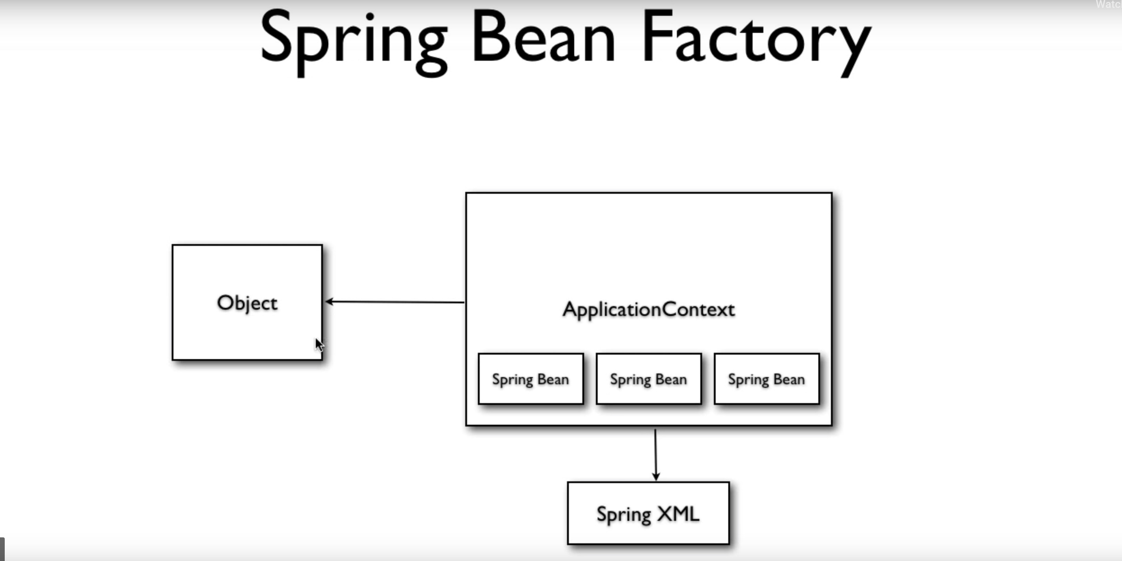

This is default behavior of spring, but we configure it differently using Scopes.

Basic Bean Scopes: two bean scope

- Singleton – only once per Spring container.
- Similar to java singleton but couple of difference are there.
- Spring gives same object/instance by any different calling requests. The same instance goes around.
- By default, all spring bean are singleton.
- We can override other scope by configuring it.
- Here all beans will be created at ApplicationContext initialization time.

- Prototype – new bean created with every request or reference.
- It creates new object for every request/reference.
- It is not only with new request, with every reference using <ref> a new instance will be created.
- Here spring waits for getbean() request or every reference to create the new instance. Just like lazy load.
Eample:
<bean id=”triangle” class=” org.Triangle” name=”triangle-name” scope=”singleton”>
</bean>
<bean id=”triangle” class=” org.Triangle” name=”triangle-name” scope=”prototype”>
</bean>

Note:
Multiple spring container can be run in same JVM. So in the case of singleton bean means it is per spring container instance

Web-aware scope:

There other scopes like Web-aware context Bean Scopes.
It works well with servlets.
For each request a new bean will created to serve the request. For same request the bean will be reused.

Web-aware Context Bean Scopes

- Request - New bean per servlet request

- Session - New bean per session

- Global Session - New bean per global HTTP session (portlet context).

2.2 Using ApplicationContextAware

We'll provide our beans with access to the ApplicationContext object by implementing the ApplicationContextAware interface. We'll also use BeanNameAware interface to get the name of the bean configured in the Spring XML.

Here, Triangle object is dependent on pointA, pointB and pointC objects. Now if triangle is singleton by default its dependents object will also have singleton scope. But if they are marked as prototype then we need to use ApplicationContext getBean() to get new instance to refer somewhere else.

How to make Triangle class to be AppliactionContext and Bean Aware

class Triangle implements ApplicationContextAware, BeanNameAware {
private ApplicationContext context;

public void setApplicationContext(ApplicationContext context) {
this.context = context;
}

public void setBeanName(String beanName) {
System.out.println(“Bean Name: ” + beanName);
}
}

Output:

Bean Name: triangle

Now, we will get context and bean readily available in Triangle object.

2.3 Bean Definition Inheritance
In this tutorial, we'll learn what bean definition inheritance is, and how to configure a parent bean definition and have children beans inherit the bean definitions.

<beans>
<bean id=”parentTriangle” class=” org.Triangle”>
<property name=”pointA” ref=”pointA” />
</bean>

<bean id=”triangle1” class=” org.Triangle” parent=”parentTriangle”>
<property name=”pointB” ref=”pointB” />
<property name=”pointC” ref=”pointC” />

</bean>

<bean id=”triangle2” class=” org.Triangle” parent=”parentTriangle”>
<property name=”pointB” ref=”pointB” />
</bean>

<bean id=”point1” class=”org.Point”>
<property name=”x” value=”0” />
<property name=”y” value=”0” />
</bean>
<bean id=”point2” class=”org.Point”>
<property name=”x” value=”-20” />
<property name=”y” value=”0” />
</bean>
.
.
.
</beans>

Here,
‘triangle1’ bean is child of ‘parentTriangle’ bean. So all the bean definition of ‘parentTriangle’ will be inherited in ‘triangle1’ bean. That is ‘triangle1’ will get pointA along with B and C. And, ‘triangle2’ will get pointA along with pointB.

Another example for List in Inheritance:

<beans>
<bean id=”parentTriangle” class=” org.Triangle”>
<property name=”points”>
<list>
< ref bean=”pointA” />
</list>
</property>
</bean>

<bean id=”triangle1” class=” org.Triangle” parent=”parentTriangle”>
<property name=”points”>
<list merge=”true”>
< ref bean=”pointB” />
</list>
</property>
</bean>

<bean id=”triangle2” class=” org.Triangle” parent=”parentTriangle”>
<property name=”pointB” ref=”pointB” />
</bean>

<bean id=”point1” class=”org.Point”>
<property name=”x” value=”0” />
<property name=”y” value=”0” />
</bean>
<bean id=”point2” class=”org.Point”>
<property name=”x” value=”-20” />
<property name=”y” value=”0” />
</bean>
.
.
.
</beans>

Here, by default ‘triangle1’ list will override parent’s bean ‘parentTriangle’ list.
But if we provide merge=’true’ inside triangle1 bean, then it will merge parent’s list into child’s list.

Abstract bean:

<bean id=”parentTriangle” class=” org.Triangle” abstract=”true”>
<property name=”points”>
<list>
< ref bean=”pointA” />
</list>
</property>
</bean>

Here, ‘parentTriangle’ bean will be abstract, it will be used as a template by inheriting bean.
This abstract bean will never be initialized.

2.4 Lifecycle Callbacks

We'll use two different ways to run methods on initialization and destruction of beans.

- Bean level
- Global level

Bean level:

By implementing InitializingBean ( afterPropertiesSet() )
and DisposableBean ( destroy() ) in Triangle class

ApplicationContext will not close the context. So, context will not get closed while application is shutdown. This can be achieved by AbstractApplicationContext by hooking it with shutdown method.

AbstractApplicationContext context = new ClassPathXmlApplicationCOntext(“spring.xml”);
Context.registerShutdownHook();

DrawingApp.java

class DrawingApp {
AbstractApplicationContext context = new ClassPathXmlApplicationContext(“spring.xml”);

Context.registerShutdownHook();
Trinagle triange = (Triangle) context.getBean(“triangle”);
Triangle.draw();
}

Triangle.java

class Triangle implements InitializingBean, DisposableBean {

private Point pointA;

@override
public void afterPropertiesSet() throws Exception {

S.O.P(“InitializingBean init method called for Triangle”);
}

@override
public void destroy() throws Exception {

S.O.P(“DisposableBean destroy method called for Triangle”);
}
}

So when main() method ends, shutdown hook will get active and calls the call back methods.

Disadvantage of this method or approach is we are tying spring related class to POJO.
Tight coupling is not good.

Now if we don’t want to implement Spring related class into POJO. Means if we don’t want bind your beans to Spring then other approach is configuring callback methods in spring.xml file and providing those method in beans (POJO).

<bean id="triangle" class="lifecycle.callbacks.Triangle" autowire="byName" init-method="myInit" destroy-method="cleanUp">
</bean>

Triangle.java

public void myInit() {
System.out.println("My init method called in Triangle");
}
public void cleanUp() {
System.out.println("My Destroy method called in Triangle");
}

In this case no binding of interfaces into bean class.

Global level:

<beans default-init-method="myInitGlobal" default-destroy-method="cleanUpGlobal">
</beans>

Here, we can have both global level bean callbacks and binding with spring class. Binding with spring class will take priority while execution and later bean level callbacks will execute.

If we have both <beans> and <bean> level call backs, in this case <bean> callbacks will override for that particular bean.

Output:

InitializingBean destroy method called in Triangle
My init method called in Triangle
Point A (0, 0)
Point B (0, -20)
Point C (0, 20)
DisposableBean destroy method called in Triangle
My Destroy method called in Triangle

2.5 Writing a BeanPostProcessor
In this tutorial, we'll understand what a BeanPostProcessor is. We'll also write a BeanPostProcessor that prints a message upon initializing each and every bean in the Spring XML.

DisplayNameBeanPostProcessor.java

public class DisplayNameBeanPostProcessor implements BeanPostProcessor {

@Override

public Object postProcessAfterInitialization(Object bean, String beanName) throws BeansException {

System.out.println("In After init method. Bean name is : " + beanName);

System.out.println("After bean objcet : " + bean);

return bean;

}

@Override

public Object postProcessBeforeInitialization(Object bean, String beanName) throws BeansException {

System.out.println("In Before init method. Bean name is : " + beanName);

System.out.println("Before bean objcet : " + bean);

return bean;

}

}

<beans>

<bean id="triangle" class="beanpostprocessor.Triangle">

<property name="pointA" ref="pointA" />

<property name="pointB" ref="pointB" />

<property name="pointC" ref="pointC" />

</bean>

<bean id="pointA" class="beanpostprocessor.Point">

<property name="x" value="0" />

<property name="y" value="0" />

</bean>

<bean id="pointB" class="beanpostprocessor.Point">

<property name="x" value="0" />

<property name="y" value="-20" />

</bean>

<bean id="pointC" class="beanpostprocessor.Point" >

<property name="x" value="0" />

<property name="y" value="20" />

</bean>

<bean class="beanpostprocessor.DisplayNameBeanPostProcessor" />

</beans>

Output:
In Before init method. Bean name is : pointA
Before bean objcet : beanpostprocessor.Point@96532d6
In After init method. Bean name is : pointA

After bean objcet : beanpostprocessor.Point@96532d6
In Before init method. Bean name is : pointB
Before bean objcet : beanpostprocessor.Point@67b64c45
In After init method. Bean name is : pointB

After bean objcet : beanpostprocessor.Point@67b64c45
In Before init method. Bean name is : pointC
Before bean objcet : beanpostprocessor.Point@4411d970
In After init method. Bean name is : pointC

After bean objcet : beanpostprocessor.Point@4411d970
In Before init method. Bean name is : triangle
Before bean objcet : beanpostprocessor.Triangle@6442b0a6
In After init method. Bean name is : triangle
After bean objcet : beanpostprocessor.Triangle@6442b0a6

Point A (0, 0)
Point B (0, -20)
Point C (0, 20)

Here, we can do some default thing which spring is not doing in preprocessor method on every bean initialization.
But in this case, there is no destroy methods.
This is handy when configuration related code needs to be overridden.

2.6 Writing a BeanFactoryPostProcessor
In this tutorial, we'll learn about and write our own BeanFactoryPostProcessor. We'll also try out a handy BeanFactoryPostProcessor that comes with Spring: the PropertyPlaceholderConfigurer.

This is used when Bean Factory itself is initialized.

MyBeanFactoryPostProcessor.java

public class MyBeanFactoryPostProcessor implements BeanFactoryPostProcessor {

@Override
public void postProcessBeanFactory(ConfigurableListableBeanFactory beanFactory) throws BeansException {
System.out.println("In Bean Factory PP method. Bean Factory name is : " + beanFactory);

}

}

<beans>

<bean id="triangle" class="beanfactorypostprocessor.Triangle">
<property name="pointA" ref="pointA" />
<property name="pointB" ref="pointB" />
<property name="pointC" ref="pointC" />
</bean>

<bean id="pointA" class="beanfactorypostprocessor.Point">
<property name="x" value="0" />
<property name="y" value="0" />
</bean>

<bean class="beanfactorypostprocessor.MyBeanFactoryPostProcessor" />
</beans>

Output:

In Bean Factory PP method. Bean Factory name is : org.springframework.beans.factory.support.DefaultListableBeanFactory@64cee07: defining beans [triangle,pointA,pointB,pointC,beanfactorypostprocessor.MyBeanFactoryPostProcessor#0]; root of factory hierarchy
Jun 12, 2019 6:55:25 PM org.springframework.beans.factory.support.DefaultListableBeanFactory preInstantiateSingletons
INFO: Pre-instantiating singletons in org.springframework.beans.factory.support.DefaultListableBeanFactory@64cee07: defining beans [triangle,pointA,pointB,pointC,beanfactorypostprocessor.MyBeanFactoryPostProcessor#0]; root of factory hierarchy
Point A (0, 0)
Point B (0, -20)
Point C (0, 20)

One example of bean factory PP comes out of the box it is called property placeholder configure.

pointsconfig.properties

pointA.point.x=0
pointA.point.y=0

<beans>
<bean id="triangle" class="beanfactorypostprocessor.Triangle">
<property name="pointA" ref="pointA" />
<property name="pointB" ref="pointB" />
<property name="pointC" ref="pointC" />
</bean>

<bean id="pointA" class="beanfactorypostprocessor.Point">
<property name="x" value="${pointA.point.x}" />
<property name="y" value="${pointA.point.y}" />
</bean>

class="org.springframework.beans.factory.config.PropertyPlaceholderConfigurer" >
<property name="locations" value="pointsconfig.properties" />
</bean>
</beans>

2.7 Coding To Interfaces
When using Spring for dependency injection, it's a good practice to use interfaces for referencing dependencies. In this tutorial, we'll learn how to 'code to interfaces'.

Refer program in Demo project
Unit 3: Annotations and Event Handling

3.1 Introduction to Annotations and the Required Annotation

We can set a bean property as required. So, that at runtime there will be no surprises like null pointer exception.

If required property is not set, then below error will be throw while startup

Initialization of bean failed; nested exception is org.springframework.beans.factory.BeanInitializationException: Property 'center' is required for bean 'circle'

Circle.java

import org.springframework.beans.factory.annotation.Required;

public class Circle implements Shape {

private Point center;

public Point getCenter() {
return center;
}

@Required
public void setCenter(Point center) {
this.center = center;
}

@Override
public void draw() {
System.out.println( "Drawing Circle");
System.out.println( "Point A (" + center.getX() + ", " + center.getY() + ")");

}

}

Spring.xml

<beans>

<bean id="triangle" class="annotationsRequired.Triangle">
<property name="pointA" ref="pointA" />
<property name="pointB" ref="pointB" />
<property name="pointC" ref="pointC" />
</bean>

<bean id="circle" class="annotationsRequired.Circle">
<!-- property name="center" ref="pointA" /-->
</bean>

<bean id="pointA" class="annotationsRequired.Point">
<property name="x" value="0" />
<property name="y" value="0" />
</bean>
<bean id="pointB" class="annotationsRequired.Point">
<property name="x" value="0" />
<property name="y" value="-20" />
</bean>
<bean id="pointC" class="annotationsRequired.Point" >
<property name="x" value="0" />
<property name="y" value="20" />
</bean>

<bean class="org.springframework.beans.factory.annotation.RequiredAnnotationBeanPostProcessor" />

</beans>

3.2 The Autowired Annotation

In this tutorial, we'll use the Autowired annotation to wire up dependencies. We'll learn how to add dependencies by type and name. We'll also use Qualifiers to narrow down dependency contenders.

Circle.java

public class Circle implements Shape {

private Point center;

public Point getCenter() {
return center;
}

@Autowired
@Qualifier("circleRelated")
public void setCenter(Point center) {
this.center = center;
}

@Override
public void draw() {
System.out.println( "Drawing Circle");
System.out.println( "Point A (" + center.getX() + ", " + center.getY() + ")");

}

}

Spring.xml

<?xml version="1.0" encoding="UTF-8"?>

<beans xmlns="http://www.springframework.org/schema/beans"
xmlns:xsi="http://www.w3.org/2001/XMLSchema-instance"
xsi:schemaLocation="http://www.springframework.org/schema/beans http://www.springframework.org/schema/beans/spring-beans.xsd
http://www.springframework.org/schema/context http://www.springframework.org/schema/context/spring-context.xsd"
xmlns:context="http://www.springframework.org/schema/context">

<bean id="circle" class="annotationsAutowired.Circle">

</bean>

<bean id="pointA" class="annotationsAutowired.Point">
<qualifier value="circleRelated"/>
<property name="x" value="0" />
<property name="y" value="0" />
</bean>

<bean id="pointB" class="annotationsAutowired.Point">
<property name="x" value="0" />
<property name="y" value="-20" />
</bean>

<bean id="pointC" class="annotationsAutowired.Point" >
<property name="x" value="0" />
<property name="y" value="20" />
</bean>

<bean class="org.springframework.beans.factory.annotation.AutowiredAnnotationBeanPostProcessor" />

</beans>

Note:
Here we can add <context:annotation-config> tag instead of adding individual *AnnotationBeanPostProcessor.

DrawingApp.java

public class DrawingApp {

public static void main(String[] args) {
ApplicationContext context = new ClassPathXmlApplicationContext("spring-annotations-autowired.xml");

Circle circle = (Circle) context.getBean("circle");
circle.draw();
doDrawing(circle);
}

public static void doDrawing(Shape shape) {
shape.draw();
}

}

3.3 Some JSR-250 Annotations
We'll learn and implement three JSR-250 annotations that Spring supports:Resource, PostConstruct and PreDestroy.

@Resource

Circle.java

@Resource(name = "pointC")
public void setCenter(Point center) {
this.center = center;
}

Spring.xml

<beans xmlns="http://www.springframework.org/schema/beans"
xmlns:xsi="http://www.w3.org/2001/XMLSchema-instance"
xsi:schemaLocation="http://www.springframework.org/schema/beans http://www.springframework.org/schema/beans/spring-beans.xsd
http://www.springframework.org/schema/context http://www.springframework.org/schema/context/spring-context.xsd"
xmlns:context="http://www.springframework.org/schema/context">

<bean id="circle" class="jsr250Annotations.Circle">

</bean>

<bean id="pointA" class="jsr250Annotations.Point">
<property name="x" value="0" />
<property name="y" value="0" />
</bean>

<bean id="pointB" class="jsr250Annotations.Point">
<property name="x" value="0" />
<property name="y" value="-20" />
</bean>

<bean id="pointC" class="jsr250Annotations.Point" >
<property name="x" value="0" />
<property name="y" value="20" />
</bean>

<context:annotation-config />

</beans>

Here, there is special case where if we wont provide name=”pointC” in @Resource then if will try to match by name i.e. center
So, we rename bean name pointC to center and it will initialize automatically.

@PostConstruct and @PreDestroy

Circle.java

@PostConstruct
public void initCircle() {
System.out.println( "Init using Annotations");
}

@PreDestroy
public void destroyCircle() {
System.out.println( "destroy using Annotations");
}

Note:
Without annotation, pre destroy and post construct should have been done in two ways.
One implementing InitializingBean and DisposableBean

Spring.xml

<beans xmlns="http://www.springframework.org/schema/beans"
xmlns:xsi="http://www.w3.org/2001/XMLSchema-instance"
xsi:schemaLocation="http://www.springframework.org/schema/beans http://www.springframework.org/schema/beans/spring-beans.xsd
http://www.springframework.org/schema/context http://www.springframework.org/schema/context/spring-context.xsd"
xmlns:context="http://www.springframework.org/schema/context">

<bean id="circle" class="jsr250Annotations.Circle">

</bean>

<bean id="pointA" class="jsr250Annotations.Point">
<qualifier value="circleRelated"/>
<property name="x" value="0" />
<property name="y" value="0" />
</bean>

<bean id="pointB" class="jsr250Annotations.Point">
<property name="x" value="0" />
<property name="y" value="-20" />
</bean>

<bean id="pointC" class="jsr250Annotations.Point" >
<property name="x" value="0" />
<property name="y" value="20" />
</bean>

<context:annotation-config />

</beans>

DrawingApp.java

AbstractApplicationContext context = new ClassPathXmlApplicationContext("spring-jsr250-annotations.xml");
context.registerShutdownHook(); // Destroy method only.

Output:

Init using Annotations
Drawing Circle
Circle : (0, 20)
destroy using Annotations

3.4 Component and Stereotype Annotations

We'll now use the Component annotation to define Spring beans. We'll also look at some Stereotype annotations.

Component

@Component register the POJO class as a Bean without making any extra configuration in spring.xml file.

Circle.java

@Component
public class Circle implements Shape {
}

Spring.xml

<beans xmlns="http://www.springframework.org/schema/beans"
xmlns:xsi="http://www.w3.org/2001/XMLSchema-instance"
xsi:schemaLocation="http://www.springframework.org/schema/beans http://www.springframework.org/schema/beans/spring-beans.xsd
http://www.springframework.org/schema/context http://www.springframework.org/schema/context/spring-context.xsd"
xmlns:context="http://www.springframework.org/schema/context">

<bean id="pointA" class="component.Point">
<qualifier value="circleRelated"/>
<property name="x" value="0" />
<property name="y" value="0" />
</bean>

<bean id="pointB" class="component.Point">
<property name="x" value="0" />
<property name="y" value="-20" />
</bean>

<bean id="pointC" class="component.Point" >
<property name="x" value="0" />
<property name="y" value="20" />
</bean>

<context:annotation-config />

<context:component-scan base-package="component" />
</beans>

Stereotype:
This provides additional annotation like what should be the role of POJO class in an enterprise application.
It has additional annotations like.,
- @service – this similar the component with additional information saying this is service class.
- @controller – this tells that the class is a controller

3.5 Using MessageSource To Get Text From Property Files

In this tutorial, we'll use the MessageSource interface to retrieve messages out of property files.

DrawingApp.java

public class DrawingApp {

public static void main(String[] args) {
ApplicationContext context = new ClassPathXmlApplicationContext("spring-message-source.xml");

System.out.println(context.getMessage("greeting", null, "Default Greeting!", null));

System.out.println(context.getMessage("no.key", null, "No Key. So, Default Greeting!", null));

Shape shape = (Shape) context.getBean("circle");
shape.draw();

}

}

Mymessage.properties

greeting=Hello!
drawing.circle=Drawing Circle
drawing.point=Circle : Point is: ({0}, {1})

Circle.java

@Component
public class Circle implements Shape {

@Autowired
private Point center;

@Autowired
private MessageSource messageSource;

public MessageSource getMessageSource() {
return messageSource;
}

public void setMessageSource(MessageSource messageSource) {
this.messageSource = messageSource;
}

public Point getCenter() {
return center;
}

public void setCenter(Point center) {
this.center = center;
}

@Override
public void draw() {
System.out.println(this.messageSource.getMessage("drawing.circle", null, "Default Drawing Circle!", null));

System.out.println(this.messageSource.getMessage("drawing.point", new Object[] {center.getX(), center.getY()}, "Default Drawing Point!", null));

System.out.println( "Printing Message from MessageSource: " + this.messageSource.getMessage("greeting", null, "Default Greeting!", null));

}

}

Spring.java

<bean id="center" class="messageSourceDemo.Point">
<property name="x" value="0" />
<property name="y" value="0" />
</bean>

<bean name="messageSource" class="org.springframework.context.support.ResourceBundleMessageSource">
<property name="basenames">
<list>
<value>mymessages</value>
</list>
</property>
</bean>

<context:component-scan base-package="messageSourceDemo" />

3.6 Event Handling in Spring

We'll now look at Spring's support for Event Handling. We'll write an event listener in this tutorial. I'll also show you how to write custom events and publish them anywhere in the code.

To capture Application events below class is enough

@Component
public class MyEventListener implements ApplicationListener {

@Override
public void onApplicationEvent(ApplicationEvent event) {
System.out.println(event.toString());
}
}

Custom Event

