**Release Manual**

ATM Screen Testing Tool

＜Ver. 1.0＞

2020年12月11日

Nichi-In Software Solutions Pvt. Ltd,

ATM Screen Testing Tool

Please find the below steps to setup executable tool.

1. Download the "ATMScreenTestingTool.zip" below link(one drive).
2. <https://nichi0-my.sharepoint.com/:f:/g/personal/giri_nichi_com/EkpQx0lBRWZHrhrH6HZegEABgBKsTFIN5ByEqplPgZWYaw?e=PySeo6>

2. Right click on the " ATMScreenTestingTool.zip " file from the path you shaved and click on "Extract Here". Or save to your preferred path

3. The extracted files will be saved into the " ATMScreenTestingTool " folder in the same directory where the zip file is stored or your selected target folder.

4. “ATMScreenTestingTool” folder should contain below folder structure and files.

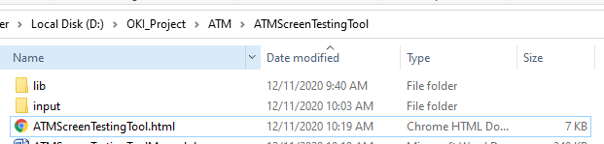

**Note 1:**

Dependency : This require chrome/IE/ mozilla browser needed to be installed .

5. Application File description:

a. **lib** -: contains required file to run the application.

b.ATMScreenTestingTool.html

c. **input**: need to copy below files which needed to be tested.

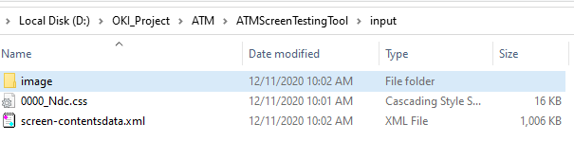

**i. Image** : copy ATM screen images which need to be tested.

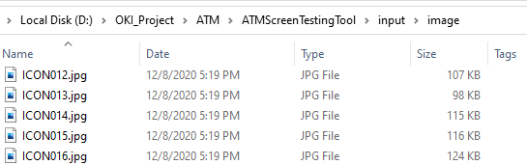

6. Open ATMScreenTestingTool.html from chrome/IE/mozilla

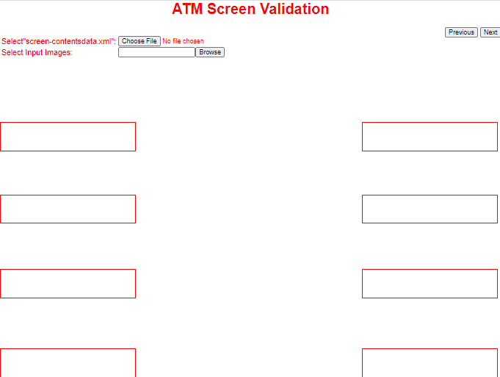

Select screen images from input/image folder that you copied (you can select single or multiple)

Choose the “screen-contentsdata.xml” to assign additional top location adjustment

Default FDK touch area

Use these buttons to slide selected images back and forth

7. Select “screen-contentsdata.xml” to assign additional top location adjustment

>Image after selecting xml.

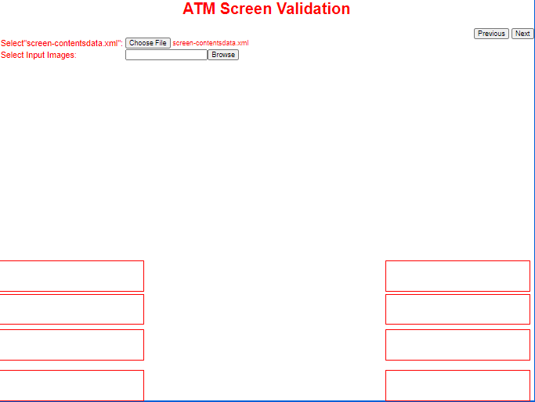

FDK touch are shifted after “screen-contentsdata.xml” selection

FDK touch are shifted after “screen-contentsdata.xml” selection

8. Select input images from browse. To test and use Next Previous button from left top to slide images back and forth.

>View after selecting images which need to be tested.

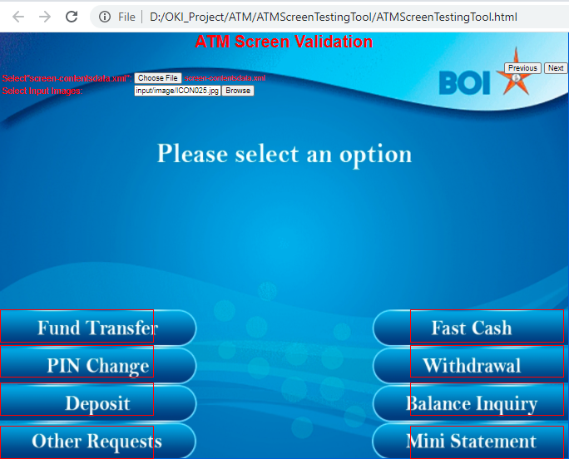

Start of button from image

Start of touch area is in red line

This will help to validate all FDK buttons for selected images.