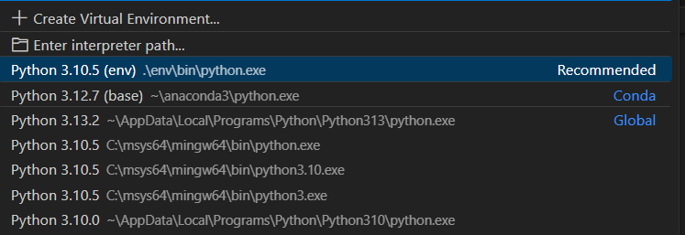  Maxx  9886409812  Skills  • Technology Integration | Professional Summary  Johnathan M. Carter High School English Teacher Phone: +1 555-234-7890 Email: johncarter@example.com  Key improvement areas: Develop or highlight skills like: Child-centered teaching, Play-based learning, Basic numeracy and literacy instruction, Storytelling & phonics, Classroom management for early learners.; Consider obtaining or emphasizing: Diploma in Early Childhood Education, Montessori / Kindergarten Training Certification, Fluency in English and local language.; Add more teaching or leadership experiences related to subject delivery or exam preparation.
Generated by Hirelytic on 2025-12-09T17:43:26.806513+00:00

