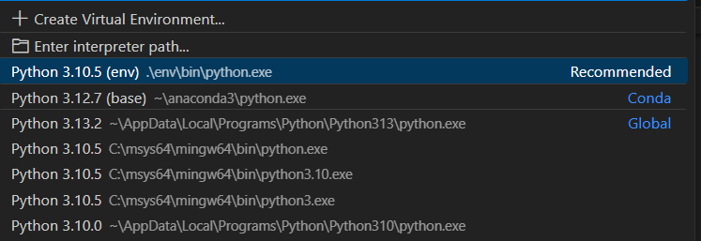  Maxx  9886409812  Skills  • Technology Integration | Professional Summary  Johnathan M. Carter High School English Teacher Phone: +1 555-234-7890 Email: johncarter@example.com  Key improvement areas: Develop or highlight skills like: Advanced subject knowledge, Analytical and conceptual teaching, Practical/lab supervision, Career and academic counseling, Competitive exam orientation (NEET/JEE/CET).; Consider obtaining or emphasizing: M.Sc/M.A in subject specialization, B.Ed or M.Ed preferred, PUC/Junior College teaching certification (if applicable).; Add more teaching or leadership experiences related to subject delivery or exam preparation.
Generated by Hirelytic on 2025-12-07T08:26:30.242751+00:00

