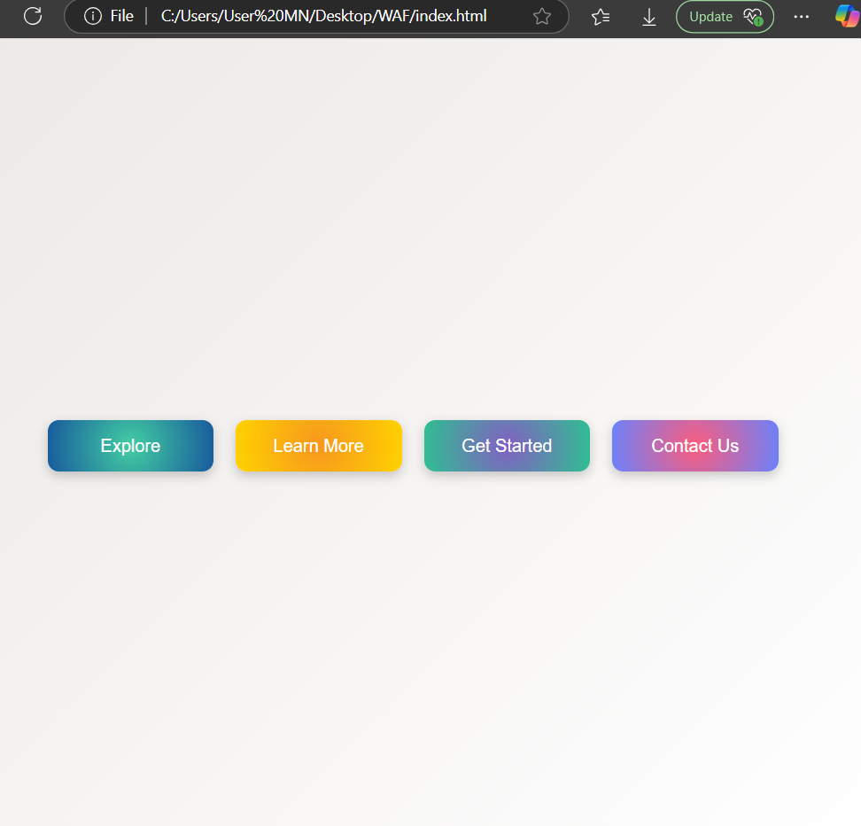  Maxx  maxx@gmail.com | 9886409812  Skills  • Technology Integration | Professional Summary  Johnathan M. Carter High School English Teacher Phone: +1 555-234-7890 Email: johncarter@example.com  Key improvement areas: Develop or highlight skills like: In-depth subject teaching, Competitive exam alignment (NEET/JEE/CET/Commerce competitive exams), Practical/lab supervision (for Science), Career and academic counseling, Research-oriented teaching.; Consider obtaining or emphasizing: Master’s Degree (M.A/M.Sc/M.Com) with minimum 50%, Mandatory B.Ed., Subject specialization expertise.; Add more teaching or leadership experiences related to subject delivery or exam preparation.
Generated by Hirelytic on 2025-12-14T19:28:09.523698+00:00

