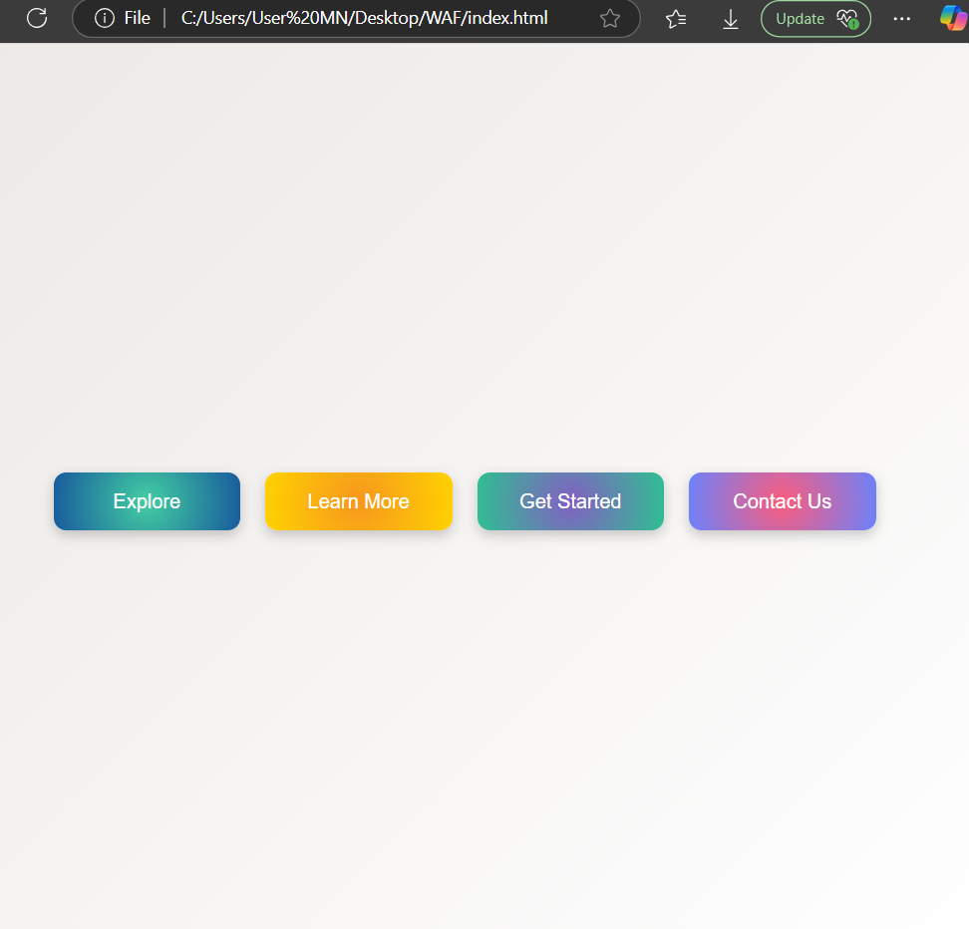  Maxx  maxx@gmail.com | 9886409812  Skills  • Technology Integration | Professional Summary  Johnathan M. Carter High School English Teacher Phone: +1 555-234-7890 Email: johncarter@example.com  Key improvement areas: Develop or highlight skills like: Subject expertise (Math, Science, English, Social Science), Use of digital tools & blended learning, Formative & summative assessments, Project-based learning, Differentiated instruction.; Consider obtaining or emphasizing: Bachelor’s Degree in subject specialization with 50% marks, Mandatory B.Ed., CTET/TET Paper-II qualification.; Add more teaching or leadership experiences related to subject delivery or exam preparation.
Generated by Hirelytic on 2025-12-14T07:40:55.210591+00:00

