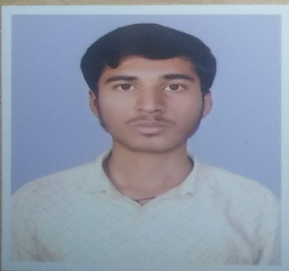Name: MANJUNATH S S

Pursuing Final year B.E in Computer Science and Engineering

Mobile: +91 8884732558

Email: manjuanthsachin@gmail.com

**CAREER OBJECTIVE**

To work in a highly competitive environment with a perfect challenge by contributing the best for the growth of the organization while ensuring growth in personal career.

**EDUCATIONAL QUALIFICATIONS**

|  |  |  |  |  |
| --- | --- | --- | --- | --- |
| **COURSE TITLE** | **UNIVERSITY/INSTITUTION** | **MARKS OBTAINED** | **AGGREGATE** | **YEAR OF PASSING** |
| B.E | AMC ENGINEERING COLLEGE , BANGALORE | - | 6.84 CGPA | 2021 |
| XII/PUC | LORVEN PU COLLEGE,BANGALORE | 390/600 | 65 | 2017 |
| 10th /SSLC | INDIAN PRIMARY AND HIGH SCHOOL,BANGALORE | 535/625 | 85.6 | 2015 |

**CORE COMPETENCIES**

Research skill

Problem solving

Responsibility

**PROJETCS/INTERNSHIPS**

Project 1

Organization : AMC Engineering College

Duration : 2 months

Team size : 4

Project scope : Pharmacy Management System

Role : Programmer

Project 2

Organization : AMC Engineering College

Duration : 2 months

Team size : 3

Project scope : Online Voting System

Role : Frontend designer

**TECHNICAL COMPETENCIES**

Operating systems : Windows .

Programming Languages : Core Java, Basic Python ,HTML and CSS.

Testing skills : Netbeans, Jupyter Notebook.

Other Skills : Microsoft Word.

**EXTRA CURRICULAR ACTIVITIES**

Cricket

Movies

Games

**ACHIEVEMENTS & AWARDS**

Certificate for Java By HackerRank.

Certificate for Python By Cognitive Class.

**PERSONAL DETAILS**

Name : MANJUNATH S S

Father’s Name : SANGAPPA S C

Gender : Male

Nationality : Indian

Date of birth :03/07/1999

Address for communication : #3398 1st Cross Chamundeshwari nagar Begur road

Devarachikknahalli Bangalore 560068.

**DECLARATION**

I here by declare that the information stated and furnished above are true and correct to the best of my knowledge and understanding.