Wireframe Documentation

Analysing Swiggy: Bangalore delivery outlet data

[AUTHOR NAME]

[AUTHOR NAME]

# Contents

1. Dashboard.................................................................................................................. 3

2. Cards.......................................................................................................................... 4

3. Slicers …………………………………………………………........................................................... 5

4. Bar chart of total hotels by location ......................................................................... 6

5. Bar chart of total hotels by Rating …………………….......................................................7

6. Matrix chart ……………………………………........................................................................ 8

7. Pie chart of cuisin....................................................................................................... 9

8. Pie chart of location..................................................................................................10

# Dashboard

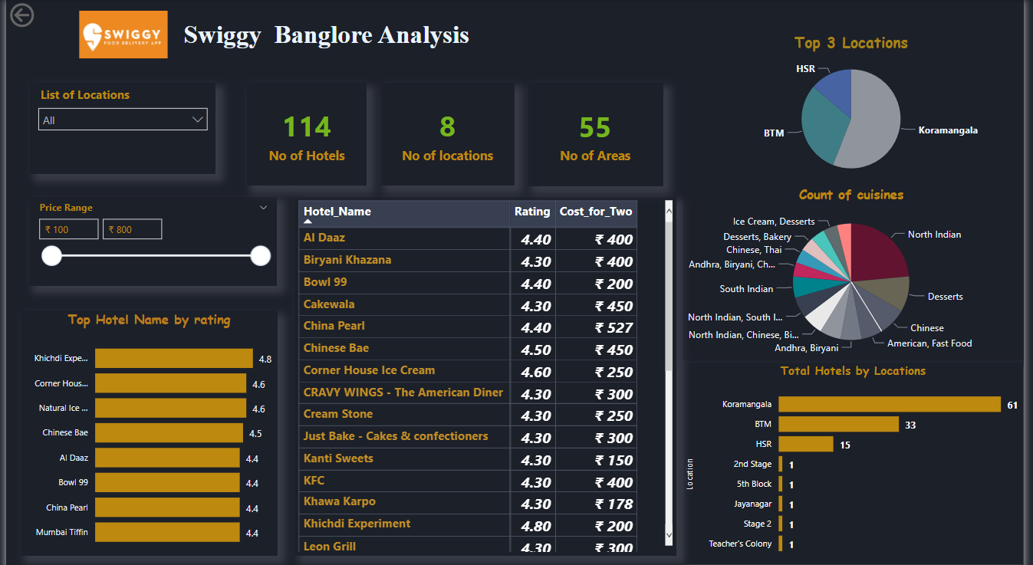

# 2. Cards

The card that shows No of Hotels, Locations and Areas

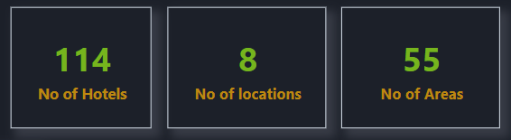

# 3. Slicers

Shows list of locations in Bangalore.

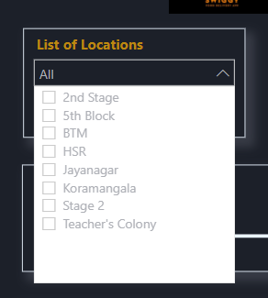

Show the Prince range Bar.

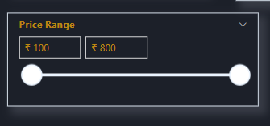

# 3. Bar chart of Total Hotels by Locations.

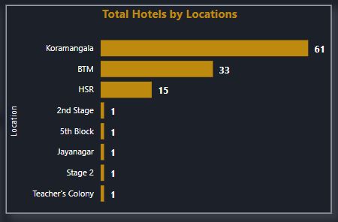

# 4. Bar chart of Total Hotels by Ratings.

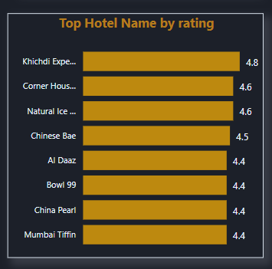

# 5. Matrix which show hotel name, Rating of hotels and Cost for two prices.

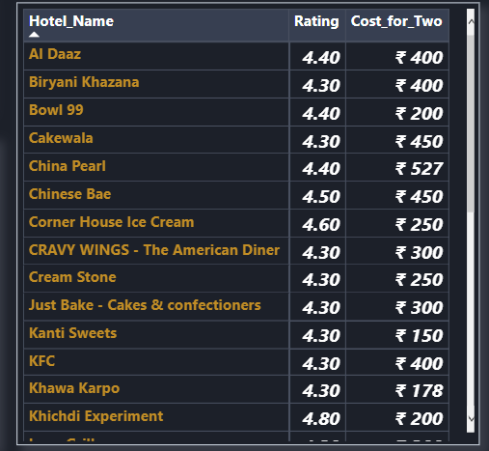

# 6. Pie chart which shows cuisine percentages famous in Bangalore

.

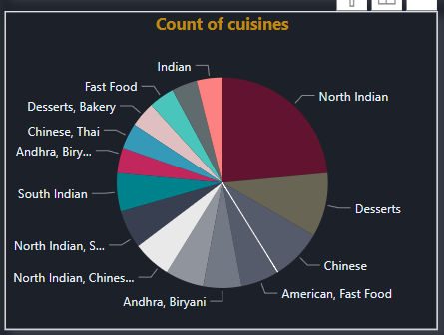

# 7. Pie chart contains Top 3 Locations

