To develop a portal for silk farming information
A Capstone Project Report submitted in partial fulfilment of the requirements for the award of the degree of,
BACHELOR OF TECHNOLOGY
IN
ARTIFICIAL INTELLIGENCE AND DATA SCIENCE

Submitted by:

Manjunath Achari V N | BU21CSEN0600130
K Vamsi | BU21CSEN0600093
C Yogananda | BU21CSEN0600120
K Srinivasulu | BU21CSEN0600095

Under the esteemed guidance of
Dr. Dayananda Lal N
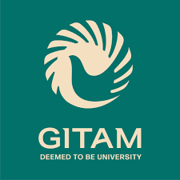
Assistant Professor

Department of Artificial Intelligence & Data Science,
GITAM SCHOOL OF TECHNOLOGY
GANDHI INSTITUTE OF TECHNOLOGY AND MANAGEMENT
(Deemed to be University)
Bengaluru Campus.
April 2025
1
DEPARTMENT OF ARTIFICIAL INTELLIGENCE AND DATA SCIENCE

GITAM SCHOOL OF TECHNOLOGY
GITAM

(Deemed to be University)

DECLARATION

We, hereby declare that the project report entitled “To develop a portal for silk farming information” is an original work done in the Department of Artificial Intelligence And Data Science, GITAM School of Technology, GITAM (Deemed to be University), Bengaluru submitted in partial fulfilment of the requirements for the award of the degree of B.Tech. in Artificial Intelligence And Data Science. The work has not been submitted to any other college or University for the award of any degree.
Date:
Registration No(s).  Manjunath Achari V N  K Vamsi  C Yogananda  K Srinivasulu | Name(s)  BU21CSEN0600130  BU21CSEN0600093  BU21CSEN0600120  BU21CSEN0600095 | Signature(s)

2
DEPARTMENT OF ARTIFICIAL INTELLIGENCE AND DATA SCIENCE

GITAM SCHOOL OF TECHNOLOGY
GITAM

(Deemed to be University)

CERTIFICATE

This is to certify that the project report entitled “To develop a portal for silk farming information” is a bonafide record of work carried out by Manjunath Achari V N (BU21CSEN0600130), K Vamsi (BU21CSEN0600093), C Yogananda (BU21CSEN0600120), K Srinivasulu (BU21CSEN0600095), submitted in partial fulfillment of requirement for the award of degree of Bachelors of Technology in Artificial Intelligence And Data Science.

Project Guide Head of the Department

SIGNATURE OF THE GUIDE SIGNATURE OF THE HOD

Dr. Dayananda Lal N Prof. A. Vadivel
Assistant Professor Professor
3

ACKNOWLEDGEMENT

The satisfaction and euphoria that accompany the successful completion of any task would be incomplete without the mention of the people who made it possible, whose consistent guidance and encouragement crowned our efforts with success.
We consider it our privilege to express our gratitude to all those who guided us in the completion of the project.
We express our gratitude to Director Prof. Basavaraj Gundappa Katageri for having provided us with the golden opportunity to undertake this project work in their esteemed organization.
We sincerely thank Prof. A. Vadivel, HOD, Department of Artificial Intelligence And Data Science, Gandhi Institute of Technology and Management, Bengaluru for the immense support given to us.
We express our gratitude to our project guide Dr. Dayananda Lal N, Assistant Professor, Department of Artificial Intelligence and Data Science, Gandhi Institute of Technology and Management, Bengaluru, for their support, guidance, and suggestions throughout the project work.

Manjunath Achari V N | BU21CSEN0600130
K Vamsi | BU21CSEN0600093
C Yogananda | BU21CSEN0600120
K Srinivasulu | BU21CSEN0600095

4
ABSTRACT

Silk cocoon rearing is a vital part of the silk industry, yet many farmers struggle due to limited access to reliable information. This project aims to develop a user-friendly website tailored specifically for silk cocoon rearing farmers, providing them with up-to-date and accurate information to enhance their farming practices. The website will offer detailed guidance on cocoon rearing techniques, including egg incubation, larval feeding, spinning, and harvesting, along with best practices for maintaining hygiene and ideal environmental conditions. Additionally, it will provide essential information on pest and disease control, covering common silkworm diseases like Grasserie, Flacherie, and Muscardine, along with their prevention and treatment strategies.
The platform will also offer valuable environmental insights, helping farmers understand the ideal climate conditions for silk cocoon production and how seasonal variations impact silkworm rearing. A dedicated market insights section will keep farmers informed about current silk cocoon prices, demand fluctuations, and trading opportunities, ensuring they get the best value for their produce. Furthermore, the website will feature real-time weather updates and government schemes, helping farmers stay informed about subsidies, financial assistance, and policies related to silk farming.
To promote knowledge-sharing, the website will include a community forum where farmers can discuss challenges, share experiences, and find solutions collaboratively. This interactive platform will enable farmers to reduce risks, improve productivity, and increase profitability in silk farming. By integrating rich content, images, and an intuitive design, the website will serve as a comprehensive resource, empowering silk cocoon farmers with the knowledge and tools needed for sustainable and profitable farming.
5

TABLE OF CONTENTS

Title | Page No.
Declaration | 2
Certificate | 3
Acknowledgement | 4
Abstract | 5
Table of Contents | 6
List of Figures | 7
1. INTRODUCTION | 8 - 9
2. LITERATURE SURVEY | 9 - 11
4. PROBLEM STATEMENT | 11 - 12
4.1 Objectives | 11 - 12
5. REQUIREMENT ANALYSICS | 12 - 13
5.1 User needs | 12
5.2 System requirements | 13
6. IMPLEMENTATION | 13 - 14
7. TESTING | 14 - 15
8. EXPERIMENTAL RESULTS | 15 - 17
9. CONCLUSION | 18
REFERENCES | 18
6

LIST OF FIGURES

Fig Title Page No.
  - Homepage 8
  - Best practices, Pest and Disease Control 9
  - Multilingual Support, Chatbot 13
  - Market Insights Section 14
  - Weather Updates 15
  - Government Schemes Page 16
  - Community Forum 17

7

1.INTRODUCTION
Silk cocoon rearing, also known as sericulture, is a significant agricultural practice that contributes to the global silk industry. It involves the cultivation of silkworms to produce silk cocoons, which are then processed to obtain high-quality silk fibers. Silk farming is a major source of livelihood for many rural communities, particularly in countries like India and China, where sericulture has a rich history and plays a crucial role in economic development. However, despite its importance, many farmers engaged in silk cocoon rearing face numerous challenges due to the lack of access to timely and accurate information.

One of the major issues in silk farming is the absence of a centralized and reliable platform that provides essential knowledge about various aspects of cocoon rearing. Farmers often struggle to find information on the best practices for silkworm rearing, pest and disease management, ideal environmental conditions, and market trends. Additionally, unpredictable weather conditions and fluctuating market prices further add to the risks faced by farmers. The lack of awareness about government schemes and financial assistance programs also prevents farmers from taking advantage of available support systems.

To address these challenges, this project aims to develop a user-friendly website specifically designed for silk cocoon rearing farmers. The platform will serve as a one-stop solution, offering detailed guidance on rearing techniques, pest and disease control, weather updates, and real-time market prices. The website will also provide information on government schemes, financial assistance programs, and training sessions that can help farmers enhance their knowledge and improve their farming practices.

One of the key features of the website is the integration of a community forum, where farmers can interact, share their experiences, and discuss solutions to common challenges. This interactive space will enable knowledge-sharing and collaboration among silk farmers, industry experts, and government officials. Additionally, the website will support multiple languages to ensure accessibility for farmers from different regions.

By leveraging digital technology, this project seeks to empower silk cocoon farmers with the necessary tools and information to make informed decisions, optimize their farming practices, and increase profitability. The website will not only enhance productivity but also contribute to the long-term sustainability of the silk farming industry. This report provides a detailed overview of the website’s development process, including requirement analysis, system design, implementation, and testing. The ultimate goal is to modernize sericulture through digital innovation and bridge the information gap that has long hindered the growth of silk farming.

8

Advantages:
- Easy access to silk farming information.
- Real-time updates on weather, market prices, and government schemes.
- Improved farming techniques and productivity.
- Farmers can connect and share experiences in a community forum.
- Reduces risks by providing pest and disease control measures.
- Supports multiple languages for better accessibility.
- Helps farmers benefit from government schemes.
- Increases profitability through better decision-making.
- Mobile-friendly for easy access anytime.
- Encourages digital adoption in silk farming.
Disadvantages:
- Requires internet access, which may not be available in rural areas.
- Some farmers may find it difficult to use technology.
- Information updates may sometimes be delayed.
- Older farmers may prefer traditional methods.
- Technical issues like slow loading or website downtime.
- Limited personal interaction compared to in-person guidance.
- Initial development and maintenance costs.
- Some farmers may already use other sources for information.
- Outdated content can mislead users if not updated regularly.
- Dependence on third-party services for real-time updates.

LITERATURE SURVEY

INTRODUCTION
Sericulture, or silk farming, is an ancient practice that involves the cultivation of silkworms for the production of silk threads, a highly valued natural fiber in the textile industry. Originating in China over 5,000 years ago, sericulture spread to different parts of the world through the Silk Road, and today, it is practiced in over 60 countries. India and China are the leading producers of silk, with sericulture playing a crucial role in rural economies, especially in India.

Despite its significance, silk farming faces several challenges, including disease outbreaks, climate variability, and market fluctuations. One of the major issues is the lack of a centralized information source for farmers regarding best practices, disease management, weather conditions, and market trends. To address this, the development of a silk farming information portal has been proposed. The aim is to enhance productivity, reduce risks, and ensure sustainable silk farming practices.

9

Review Of Existing Survey
[1] The National Remote Sensing Agency (NRSC) conducted extensive studies on land use classification through National Land Use Land Cover Mapping using Multi-temporal Satellite Data (2006) and the Wasteland Atlas of India (2011). These studies played a crucial role in identifying potential areas for silk farming by evaluating factors such as land availability, soil type, and environmental conditions. The findings have been instrumental in planning mulberry plantation expansion and optimizing land use for silk production. Additionally, the Central Silk Board (CSB, 1994) contributed to sericulture research by publishing the Manual of Satellite Remote Sensing Applications for Sericulture Development. This study demonstrated how satellite imaging and Geographic Information System (GIS) technology can assist in identifying suitable regions for sericulture, improving land management, and enhancing silk farming efficiency. These advancements have helped in selecting the best areas for mulberry cultivation, ensuring sustainable sericulture practices.

[2] The field of genetic and biotechnological advancements in sericulture has seen significant progress through research on silkworm productivity and health. Xu & O’brochta (2015), in their study published in the Proceedings of the Royal Society B, explored advanced genetic engineering techniques for Bombyx mori silkworms. Their research introduced gene manipulation technologies aimed at enhancing silk yield and improving disease resistance, thereby increasing overall silkworm productivity. Similarly, Putri et al. (2013), in the Journal of Bioscience and Bioengineering, focused on Current Metabolomics Technological Advances to analyze the nutritional needs of silkworms. Their study highlighted how optimizing the silkworm diet through metabolomics can significantly improve silkworm growth and enhance silk production quality. These biotechnological developments contribute to more efficient and sustainable silk farming practices.
These advancements in biotechnology and genetics are revolutionizing sericulture by enabling more sustainable and high-yield silk farming practices, ensuring long-term benefits for both farmers and the textile industry.

[3] Environmental and soil suitability play a crucial role in the success of sericulture, as the quality of mulberry plants directly impacts silkworm nutrition and silk production. Knief (2014), in a study published in Frontiers in Plant Science, explored plant-microbe interactions and their influence on mulberry plant growth. The research highlighted how beneficial soil microbes enhance nutrient absorption, improve soil fertility, and strengthen plant resistance against diseases, ultimately leading to better-quality mulberry leaves for silkworms.
100

11
The study also emphasized the importance of organic farming techniques, such as biofertilizers and natural soil enhancers, in improving mulberry cultivation while reducing dependency on chemical fertilizers. Additionally, environmental factors like soil texture, drainage capacity, pH levels, and moisture retention significantly affect mulberry growth. Studies conducted under NRDB, NBSSLUP, and SLUSI have analyzed these factors to determine the best locations for mulberry plantations, ensuring optimal conditions for silkworm rearing. Proper land evaluation, combined with sustainable farming methods, can help sericulture farmers enhance productivity while maintaining soil health, making silk farming more efficient and environmentally friendly.

4. PROBLEM STATEMENT
Silk farmers face significant challenges in accessing timely and accurate information about best practices in sericulture. The lack of a centralized platform results in inefficiencies, lower production, and financial losses. Farmers struggle to find reliable information on essential topics such as cocoon rearing techniques, disease prevention, pest control, market trends, and government schemes. Additionally, factors like climate change, soil suitability, and environmental conditions further impact silk production, making it crucial for farmers to have real-time data and expert guidance. The absence of an integrated system that provides weather updates, market prices, and farming techniques limits the ability of farmers to make informed decisions. To address these challenges, this project aims to develop a user-friendly digital platform that offers up-to-date resources, real-time market and weather insights, and a community forum for knowledge exchange. By leveraging modern technology, the proposed solution seeks to empower silk farmers, improve productivity, reduce risks, and ensure sustainability in the silk farming industry.

4.1 Objectives
The primary objective of this project is to develop a comprehensive digital platform that provides essential information and resources to silk farmers, enabling them to improve productivity and sustainability in sericulture. The specific objectives include:
    - To create an online platform that offers real-time and accurate information on silk farming, including cocoon rearing techniques, pest and disease management, and environmental factors affecting production.
    - To provide market insights, including real-time updates on silk cocoon prices, government schemes, and industry trends, helping farmers make informed decisions.

12
    - To facilitate knowledge sharing and networking among silk farmers through community forums and discussion platforms, allowing them to exchange experiences, solutions, and best practices.
    - To integrate technological advancements such as remote sensing, GIS-based mapping, and weather monitoring to help farmers identify the best regions for mulberry cultivation and optimize their farming practices.
    - To enhance accessibility and usability by developing a user-friendly and multilingual interface that caters to farmers across different regions and languages.
    - To support decision-making through AI-based recommendations for disease prevention, environmental impact assessment, and yield optimization.

5. REQUIREMENTS ANALYSIS
The development of the silk farming information portal necessitates a well-defined requirement analysis to ensure its effectiveness and usability. The platform must provide real-time access to essential information on silk farming, including best practices for cocoon rearing, pest control, and disease management. It should offer market price updates, weather forecasts, and government schemes, enabling farmers to make informed decisions. Additionally, the system should feature a community forum for farmers to share experiences, discuss challenges, and seek expert advice. To enhance accessibility, the platform must support multiple languages and offer a user-friendly interface that is compatible with both mobile and desktop devices. The integration of APIs for real-time weather and market data is crucial for keeping users updated. Security measures such as SSL encryption, authentication, and data protection protocols must be implemented to ensure safe access. Scalability is also essential to accommodate a growing number of users and expanding data requirements.

5.1 User Requirements

Silk farmers require a comprehensive digital platform that provides real-time and accurate information on silk farming techniques, pest control, and disease management to improve productivity and efficiency. Access to market price updates for silk cocoons and insights into government schemes is crucial for making informed financial decisions. Additionally, weather forecasts play a vital role in planning and mitigating risks associated with environmental conditions. A community forum will enable farmers to engage in discussions, share experiences, and seek expert advice on best practices. To ensure accessibility across diverse regions, the platform must support multiple languages, including Telugu, Kannada, Hindi, Tamil, and Malayalam, allowing farmers to access information in their preferred language.

13

5.2 System Requirements

The system requirements for the silk farming information portal include a robust hardware and software infrastructure to ensure smooth functionality and scalability. The hardware requirements involve a cloud-based or dedicated web server capable of handling multiple users simultaneously, along with adequate storage for user data, articles, and multimedia content. The system must also have scalable computing resources to manage concurrent user activity efficiently. For software requirements, the platform's frontend will be developed using HTML, CSS, and JavaScript to provide a responsive and user-friendly interface, while the backend will utilize Python/Django or Node.js to manage logic and database operations Additionally, the integration of Weather API and Market API (if available) will provide real-time updates on environmental conditions and silk cocoon prices. Security measures such as SSL encryption, user authentication, and role-based access control will be implemented to protect sensitive data. The network requirements include high-speed internet connectivity to ensure seamless interaction and scalability to accommodate a growing number of users and increasing data volume.

6. IMPLEMENTATION

The implementation of the silk farming information portal involves frontend and backend development, database integration, API connectivity, security measures, and deployment to ensure smooth functionality and accessibility for farmers.

Frontend Development
- The user interface (UI) is built using HTML, CSS, and JavaScript to create a responsive and user-friendly experience.
- Frameworks like React.js or Vue.js may be used for a dynamic and interactive interface.
- The design will include easy navigation, multilingual support, and mobile compatibility for seamless access.

Backend Development
- The backend is developed using Python/Django or Node.js to handle server-side logic and database operations.
- User authentication (login, signup) is implemented to ensure secure access.
- The backend will process data related to silk farming techniques, weather updates, market prices, and user discussions on the forum.

14

6.3 Database Integration
- A MySQL or MongoDB database will be used to store structured information, including user profiles, farming guidelines, weather reports, market price data, and forum discussions.
- The database will be optimized for fast queries and data retrieval.

6.4 API Integration
- A Weather API will be integrated to provide real-time weather forecasts, helping farmers make informed decisions.
- A Market API (if available) will update silk cocoon prices dynamically.
- Language translation APIs will enable multilingual support for better accessibility

This structured implementation ensures that the silk farming information portal is efficient, secure, and accessible, providing farmers with real-time insights and expert knowledge to enhance productivity in sericulture

7. TESTING
To ensure the reliability, functionality, and security of the silk farming information portal, various testing methodologies will be implemented. The testing process includes the following key areas.

7.1 Usability Testing
- Evaluating the user interface (UI) and user experience (UX) for clarity, ease of navigation, and responsiveness across devices.
- Testing for mobile compatibility to ensure farmers can access the portal from smartphones.
7.2 Performance Testing
- Load testing to assess the platform’s ability to handle multiple concurrent users.
- Checking the response time of API calls for weather and market price updates.
- Evaluating the database query performance and retrieval speed for user data and farming resources.
7.3 Formatting & Visuals
- The presentation includes clear images, diagrams, and tables to support the content visually. The slides are well-organized, avoiding excessive text and overcrowding, which enhances comprehension and engagement.

15

7.4 Technical Testing
- Hyperlinks (if present) were tested to ensure they function correctly. Charts and diagrams are properly labeled, making them easy to understand. The Gantt chart, which represents the project timeline, is structured correctly and accurately reflects the planned schedule.

Overall, the presentation maintains high-quality standards in terms of clarity, content accuracy, and visual appeal. Minor refinements, if necessary, can be made to enhance readability further, but the document is well-structured and ready for submission or presentation.

8. EXPERIMENTAL RESULTS

The experimental evaluation of the Silk Farming Information Portal was conducted based on various testing parameters, including functionality, performance, security, and usability. The following results summarize the findings of the testing process

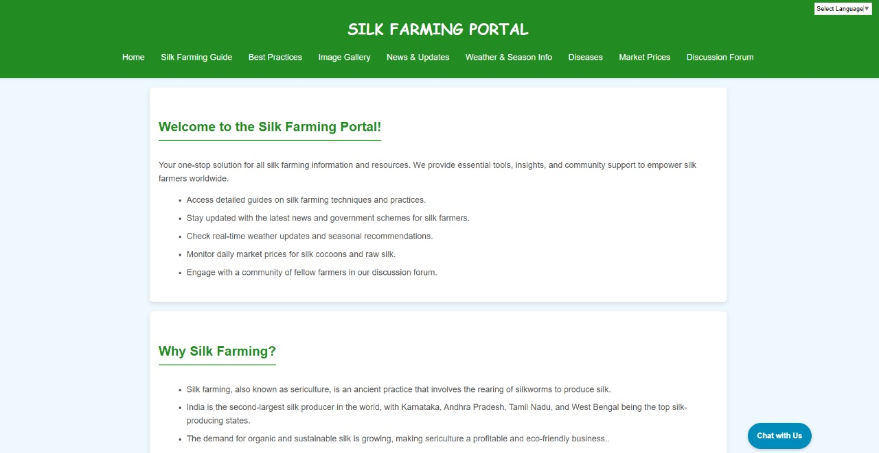

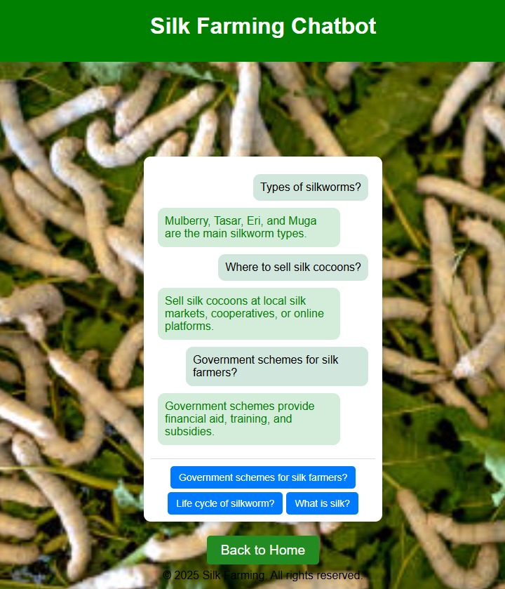
16
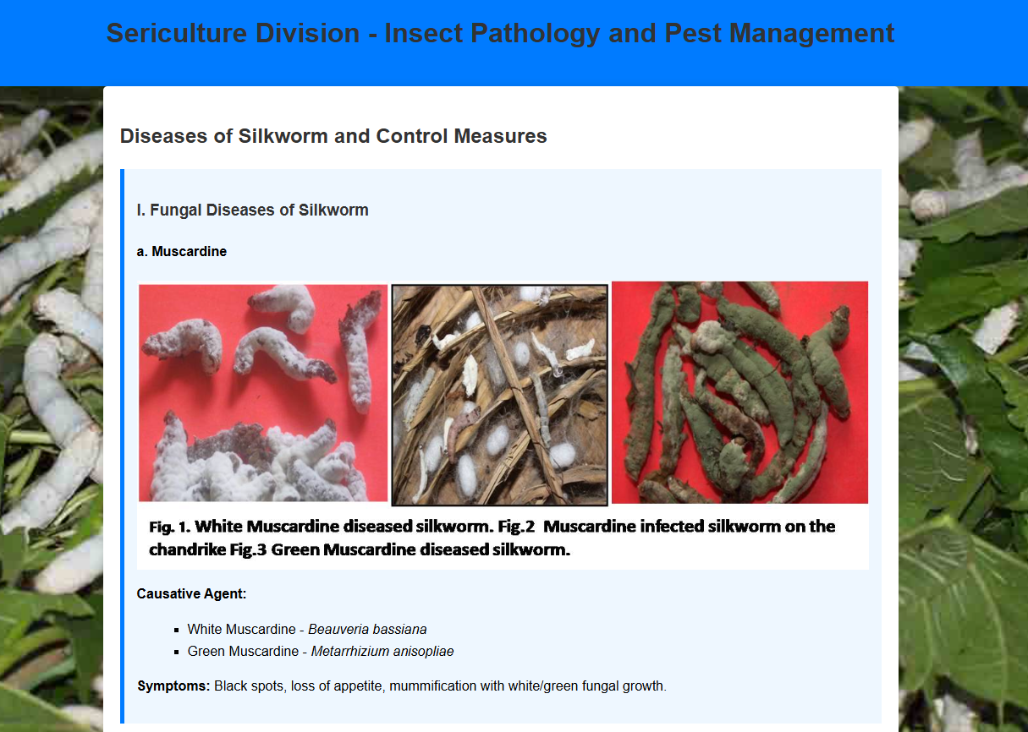
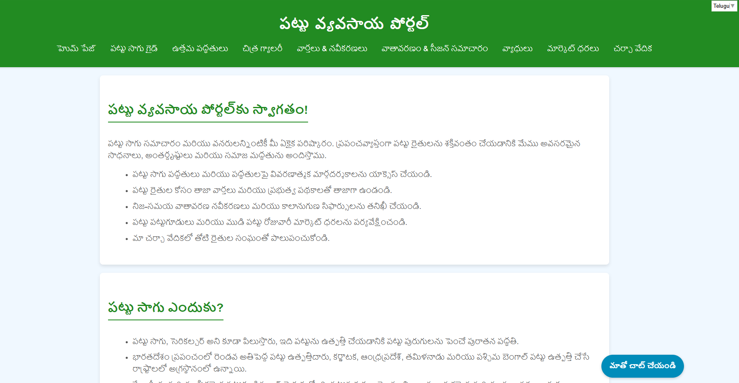
18
9.Conclusion

The development of the Silk Farming Information Portal successfully addresses the needs of silk farmers by integrating real-time information, market insights, weather forecasts, and multilingual support. The portal enhances accessibility, knowledge sharing, and decision-making through a user-friendly interface.
The testing phase validated the platform’s functionality, performance, security, and usability, ensuring seamless navigation and secure data handling. Key achievements include efficient user authentication, smooth API integrations, and a responsive design adaptable to different devices. While the system met most expectations, enhancements such as automated market price updates and further database optimizations can improve its effectiveness.
Overall, the project has proven to be a significant step towards empowering silk farmers with digital solutions, contributing to improved productivity and market connectivity. Future upgrades will focus on refining automation, expanding features, and ensuring continuous improvements based on user feedback.

10. References
Journals
1... NRSC, Manual-National Land Use Land Cover Mapping using Multi-temporal Satellite Data, Land Use Division, National Remote Sensing Agency, Hyderabad, 2006.
NRSC, Wasteland Atlas of India, National Remote Sensing Agen cy, Hyderabad, 2011, pp. 4-14
2.. Xu, H. and O’brochta, D.A. (2015) Advanced technologies for genetically manipulating the silkworm Bombyx mori, a model Lepidopteran insect. Proc. R. Soc. B, 282, 20150487.
Putri, S.P., Yamamoto, S., Tsugawa. et al. (2013) Current metabolomics: technological advances. J. Biosci. Bioeng., 116, 9–16
. Knief, C. (2014) Analysis of plant microbe interactions in the era of next generation sequencing technologies. Front. Plant Sci., 5, 216
3.. CSB (1994), Manual of satellite remote sensing applications for sericulture development, Central Silk Board, Bangalore. FAO (1976). A Framework for Land Evaluation. Soil Bulletin, 32. Food and Agriculture Organization. United Nations.
Rome, Italy.

17

