Business Insights Report
Project: End-to-End Sales Analytics Project
Prepared By: Manjunath Kumbar
Training: Data Analytics
Tools Used: Python, NumPy, Pandas, MySQL, Excel, Power BI
Date: July 2026

1. Introduction
The Sales Analytics project was developed to analyze customer order data and identify useful business insights. The project follows a complete data analytics workflow starting from data validation and preprocessing to visualization, SQL analysis, Excel reporting, and Power BI dashboard creation.
The objective of this project is to transform raw sales data into meaningful information that can support business decision-making.

2. Project Objectives
- Analyze customer sales data.
- Clean and preprocess the dataset.
- Identify sales trends and business patterns.
- Perform statistical analysis.
- Generate reports and dashboards.
- Provide business recommendations based on data.

3. Dataset Description
The project uses two datasets.
Customers Dataset - Contains customer-related information such as:
- Customer ID
- Customer Name
- Region
- Segment
- Join Date
Orders Dataset - Contains order-related information such as:
- Order ID
- Customer ID
- Order Date
- Category
- Sales
- Quantity
- Discount
- Profit
The datasets were merged using the CustomerID field to perform complete sales analysis.
Dataset | Records
Customers | 73
Orders | 509
Final Cleaned Dataset | 504

4. Data Processing
The following preprocessing steps were performed:
- Data validation
- Missing value handling
- Duplicate record removal
- Data merging
- Feature engineering
- Profit Margin calculation
- Profit Per Unit calculation
These steps helped improve the quality and consistency of the dataset before analysis.

5. Exploratory Data Analysis
Several analyses were performed using Python libraries.
The project includes:
- NumPy statistical analysis
- GroupBy analysis
- Pivot table analysis
- Outlier detection
- Correlation analysis
Different visualizations were generated to better understand the sales data and customer behavior.

6. SQL Analysis
SQL was used to perform business analysis on the cleaned dataset.
The following SQL operations were implemented:
- Aggregate Functions
- GROUP BY
- ORDER BY
- JOIN
- HAVING
- CASE Statement
- Subquery
- Common Table Expression (CTE)
- Window Functions
- Ranking Functions
These queries helped analyze customer sales, category performance, and profit distribution.

7. Dashboard
An interactive Power BI dashboard was created to visualize important business metrics.
The dashboard includes:
- Total Sales
- Total Profit
- Total Orders
- Average Sales
- Sales by Region
- Sales by Category
- Monthly Sales Trend
- Profit Distribution
- Sales vs Profit
- Region and Category Filters
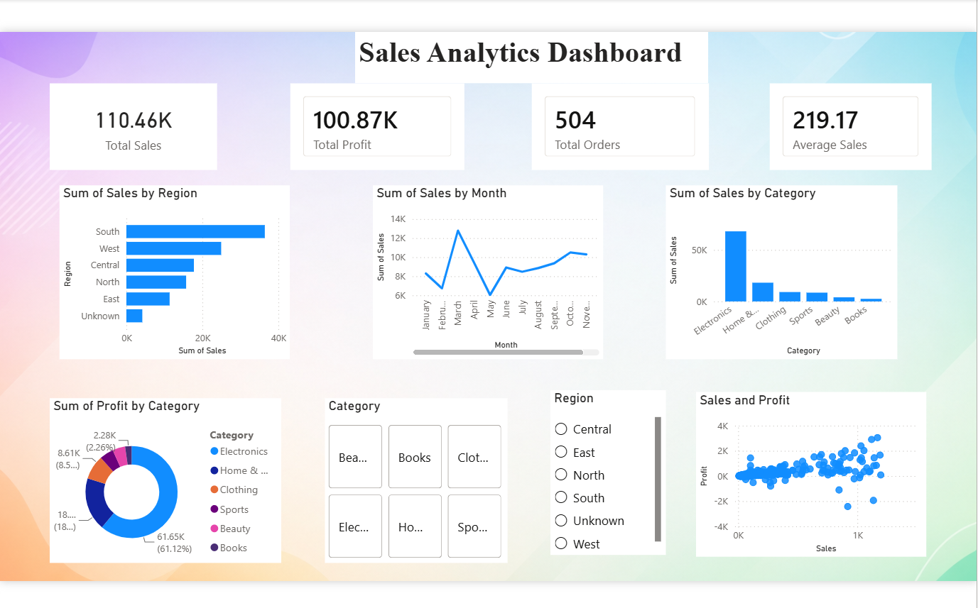 sales-analytics-dashboard.png

8. Key Business Insights
- Electronics category generated the highest sales compared to other categories.
- South region contributed the highest overall sales.
- A small number of orders resulted in negative profit.
- Profit margin differs across product categories.
- Sales trend analysis helps identify high-performing periods.

9. Recommendations
Based on the analysis, the following recommendations can help improve business performance.
- Increase focus on high-performing product categories.
- Review pricing and discount strategies for loss-making orders.
- Plan inventory based on sales trends.
- Monitor regional sales regularly.
- Continue tracking customer purchasing patterns for better decision-making.

10. Conclusion
This project demonstrates a complete end-to-end sales analytics workflow using Python, SQL, Excel, and Power BI. The analysis helped identify sales trends, customer behavior, and category performance. The generated reports and dashboard provide valuable insights that support better business decisions. The project also highlights the importance of data cleaning, visualization, and reporting in real-world analytics.

