GenAcademy Coach Demo Walkthrough
Step-by-step recording prep with PR #22 UI screenshots
Privacy boundary: Do not show raw corpus spans, held-out eval prompts, generated quiz question/option text, .env values, API keys, or full trace JSON. Teach-output screenshots are private-repo demo references for the approved agent harness topic.

Before Recording
Step | Action
1 | Start the local app with PORT=7861 uv run python app.py.
2 | Open http://127.0.0.1:7861 and hard-refresh.
3 | Verify Teach controls appear in one row and Quiz defaults to agent harness, 1 question, answer A.
4 | Keep Redacted metadata collapsed unless you need proof of the safe fields.
5 | Do not run or reveal the held-out test split.

Reference screenshot: clean Teach empty state before any provider call
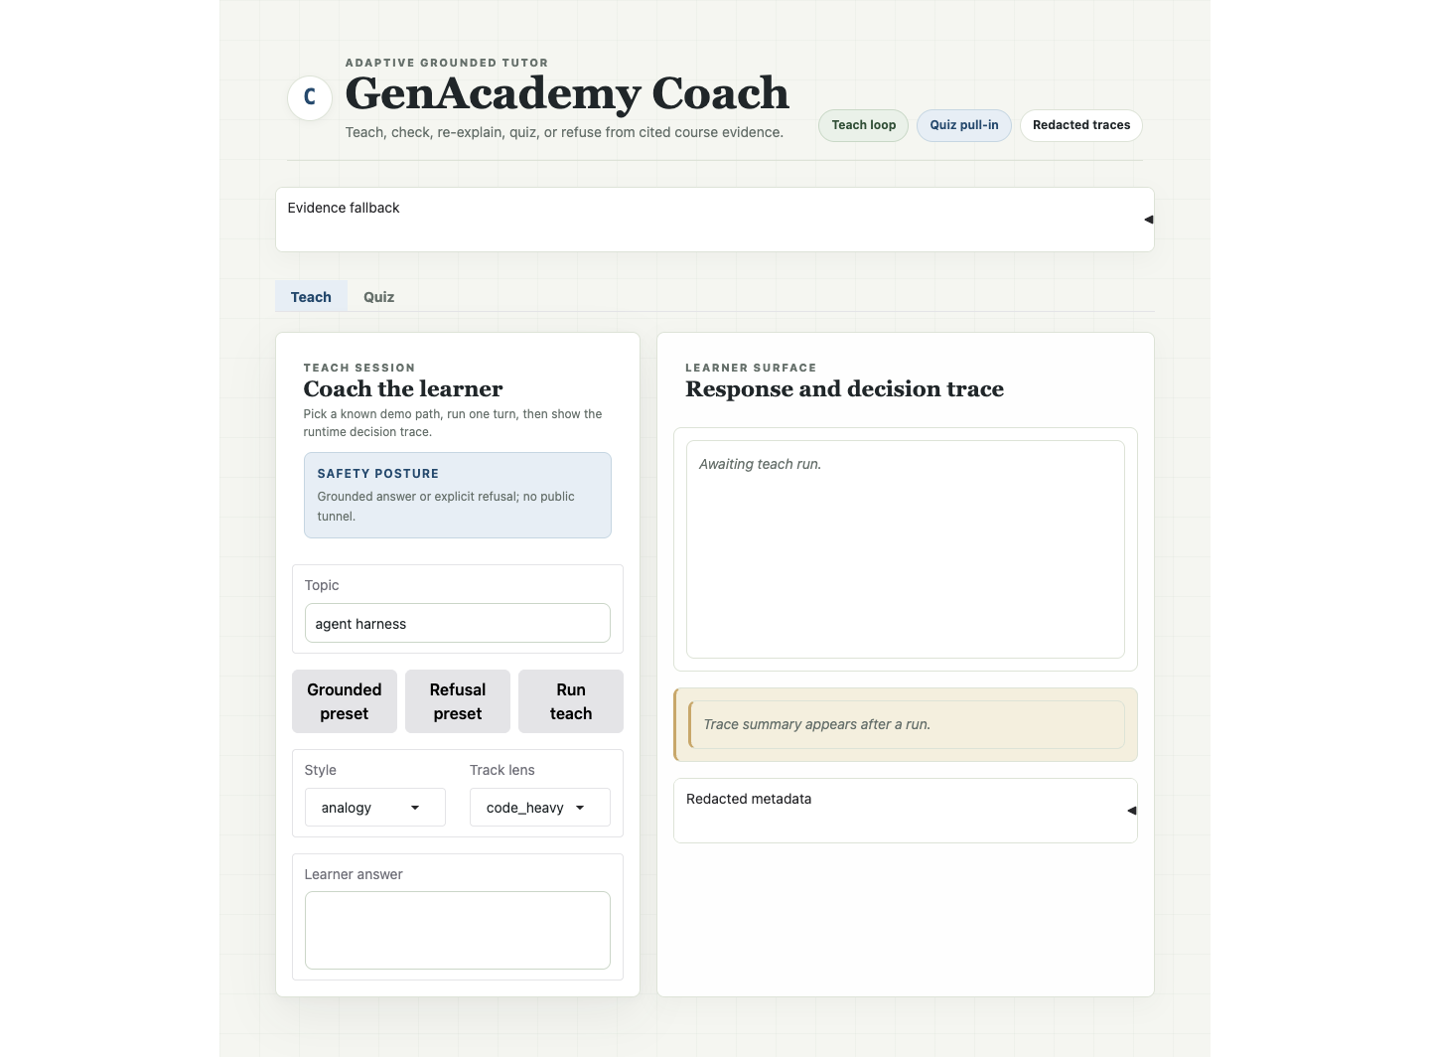

1. Grounded Adaptive Teach Path
Purpose: Show the tutor teaching from cited evidence, checking understanding, then re-explaining after a wrong learner answer.
Reference screenshot: 1. Grounded Adaptive Teach Path
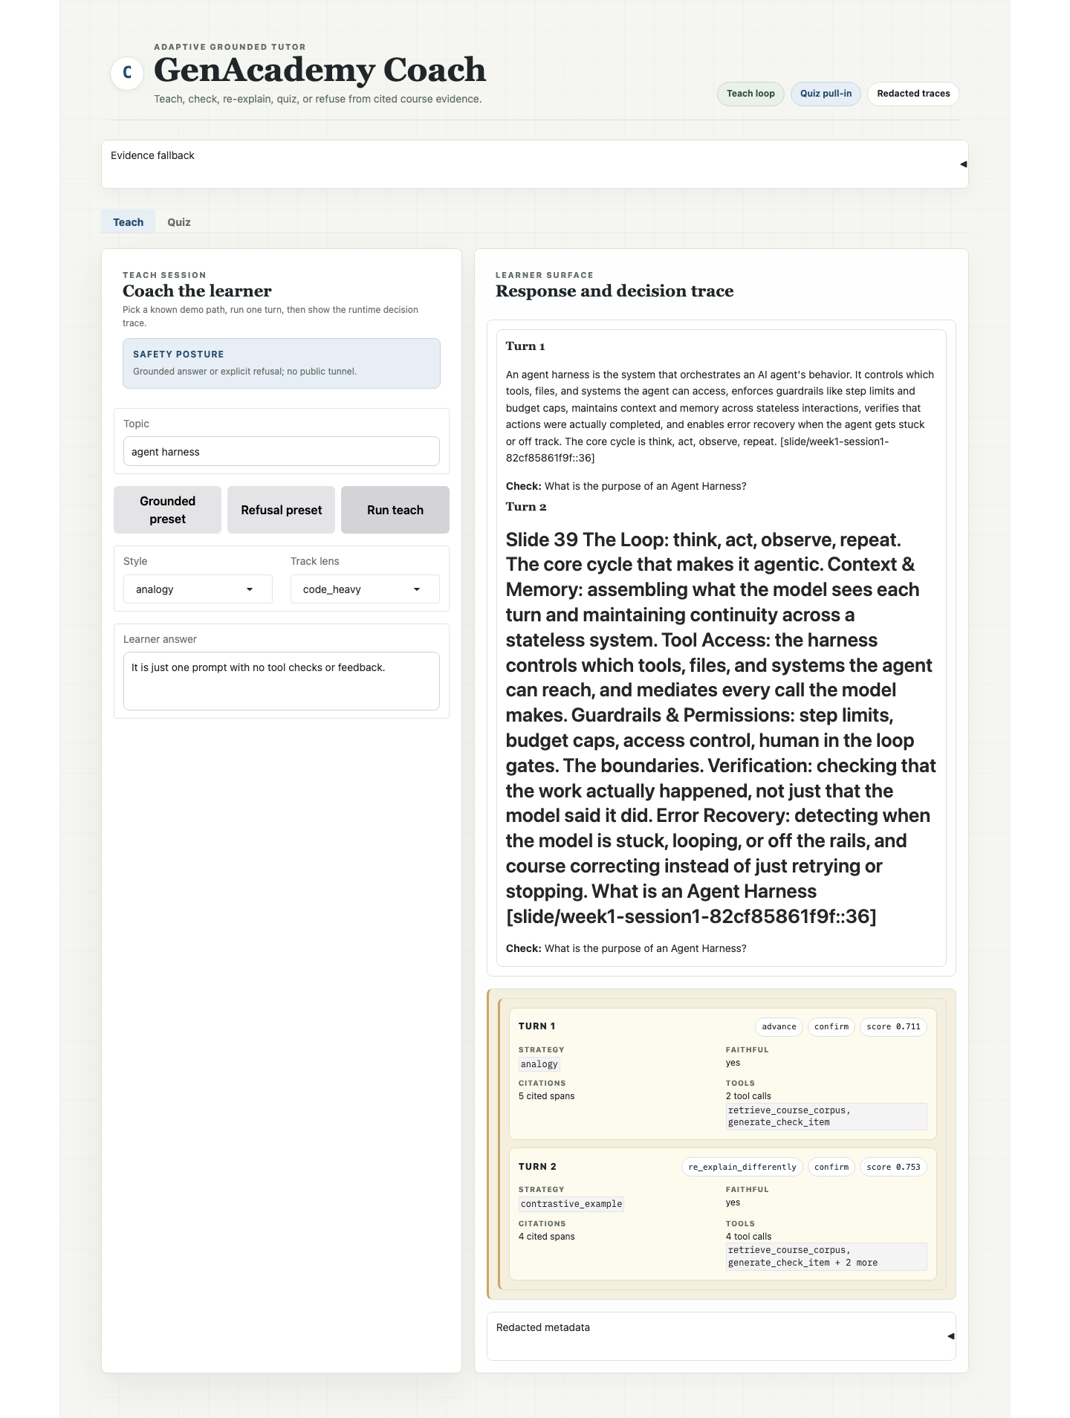

Click Steps
Step | Action
1 | Click Teach.
2 | Click Grounded preset.
3 | Confirm topic agent harness, style analogy, track lens code_heavy, and the wrong learner answer.
4 | Click Run teach.
5 | Wait for Turn 1 and Turn 2 to appear.

Point At On Screen
- Turn 1 grounded explanation and Check prompt.
- Turn 2 re-explanation after the learner answer.
- Trace action chip, especially re_explain_differently.
- Faithful yes, citation count, and tool-call count.

Say
The model chooses the next teaching move at runtime. Python enforces grounding and safety; the trace card makes the adaptation visible.

2. Refusal And Escalation Path
Purpose: Show the integrity path: when the course corpus cannot support an answer, the tutor refuses instead of bluffing.
Reference screenshot: 2. Refusal And Escalation Path
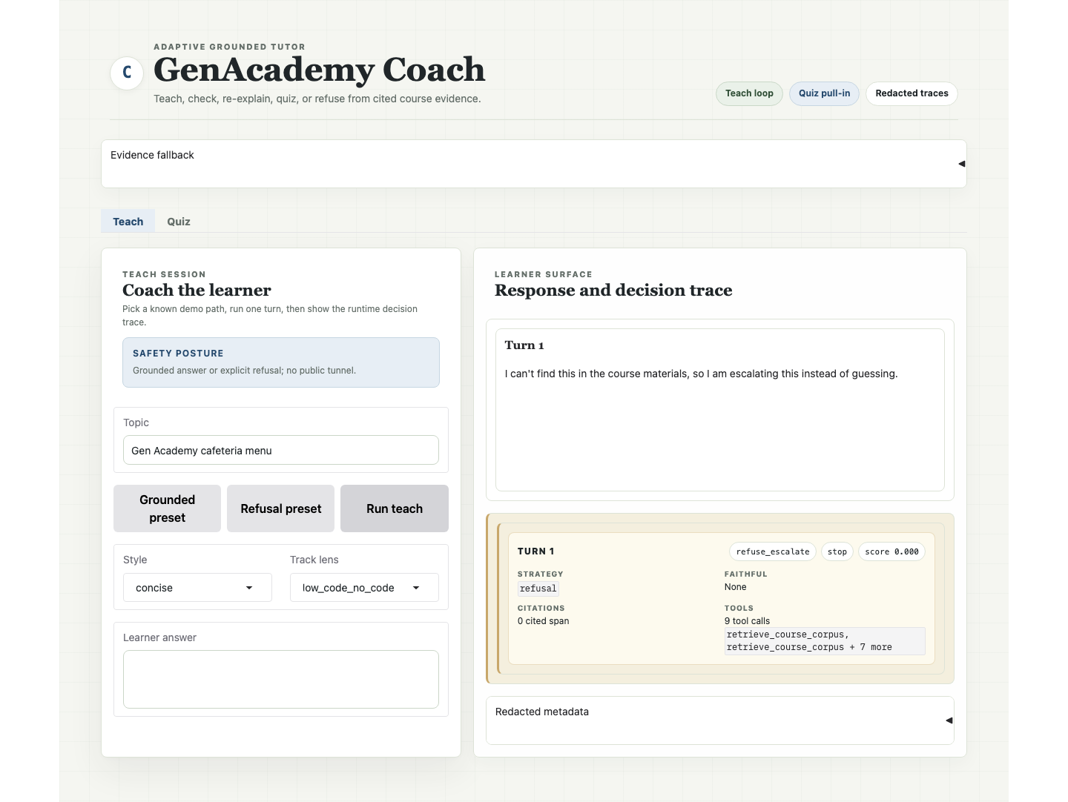

Click Steps
Step | Action
1 | Stay on Teach.
2 | Click Refusal preset.
3 | Confirm topic Gen Academy cafeteria menu and blank learner answer.
4 | Click Run teach.
5 | Show the refusal message and trace card.

Point At On Screen
- Refusal copy in the learner surface.
- refuse_escalate action chip.
- stop band, zero cited spans, and score near zero.
- Redacted metadata remains collapsed.

Say
This is the trust moment. The system fails closed when it cannot cite the course material and queues mentor review instead of using model priors.

3. Grounded Hidden Quiz Path
Purpose: Show Quiz as the first pull-in: generated from retrieved evidence, graded deterministically by Python, with question text hidden for recording privacy.
Reference screenshot: 3. Grounded Hidden Quiz Path
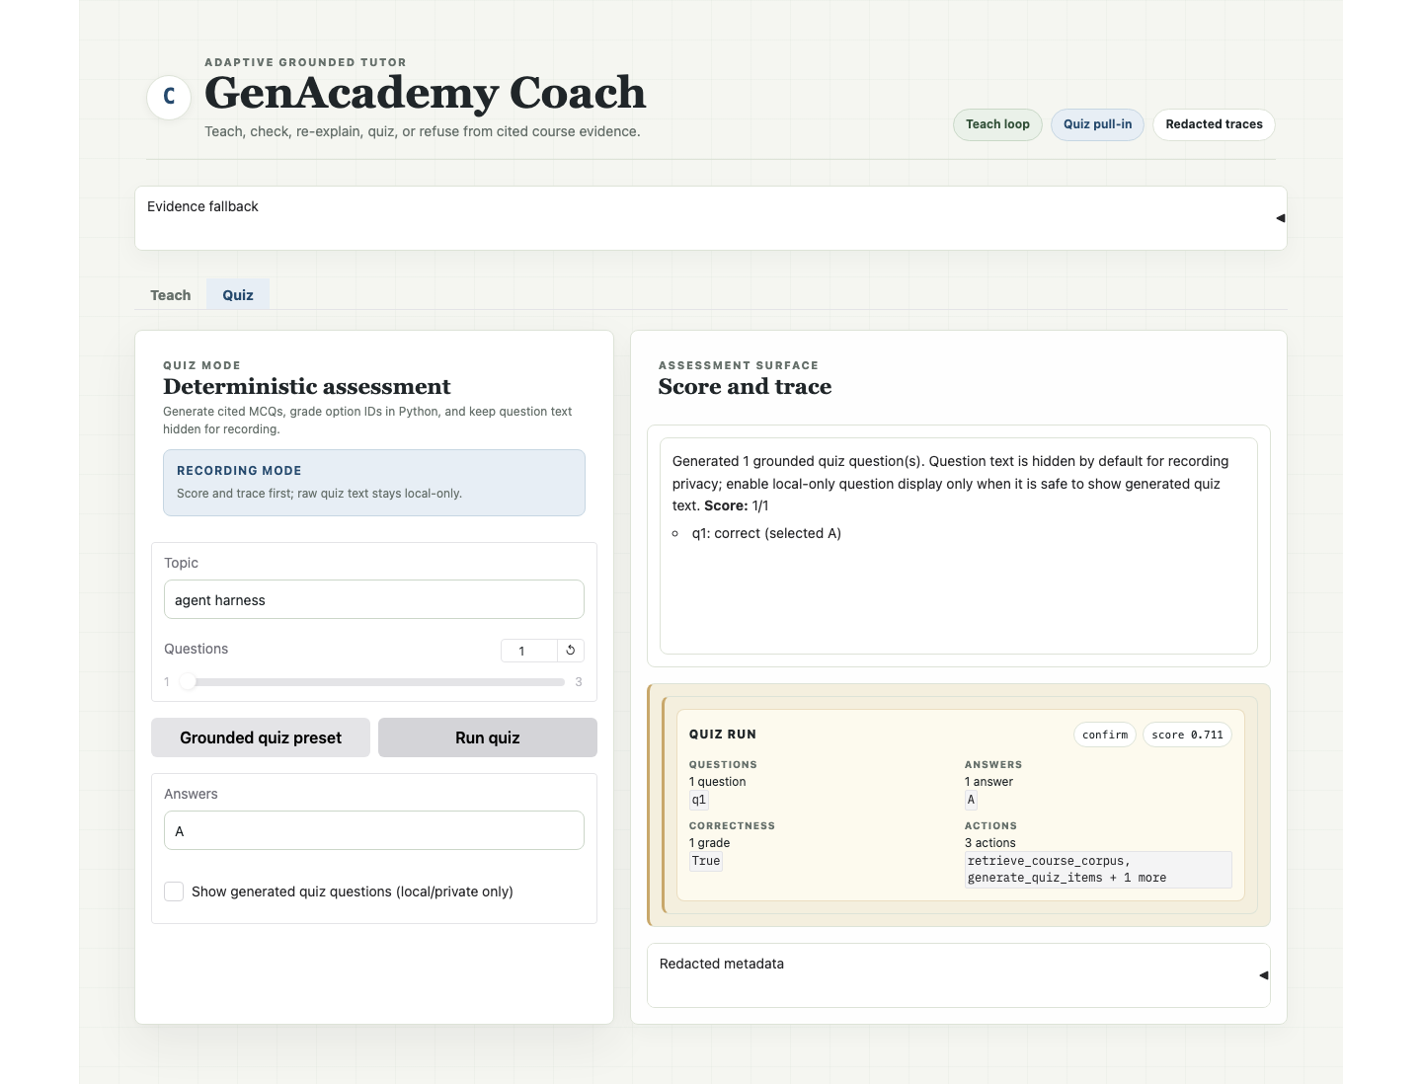

Click Steps
Step | Action
1 | Click Quiz.
2 | Click Grounded quiz preset.
3 | Confirm topic agent harness, Questions = 1, Answers = A.
4 | Confirm Show generated quiz questions is unchecked.
5 | Click Run quiz.

Point At On Screen
- Generated 1 grounded quiz question(s).
- Score 1/1 and selected answer ID A.
- Quiz trace card with question count, answer count, correctness, and actions.
- No generated question or option text is visible.

Say
Quiz is narrower than Teach Mode on purpose. The model drafts a grounded assessment, but Python owns the answer key and grade.

4. Optional Local Reveal Control
Purpose: Show that the UI has a local-only reveal control without committing or recording generated quiz text.
Reference screenshot: 4. Optional Local Reveal Control
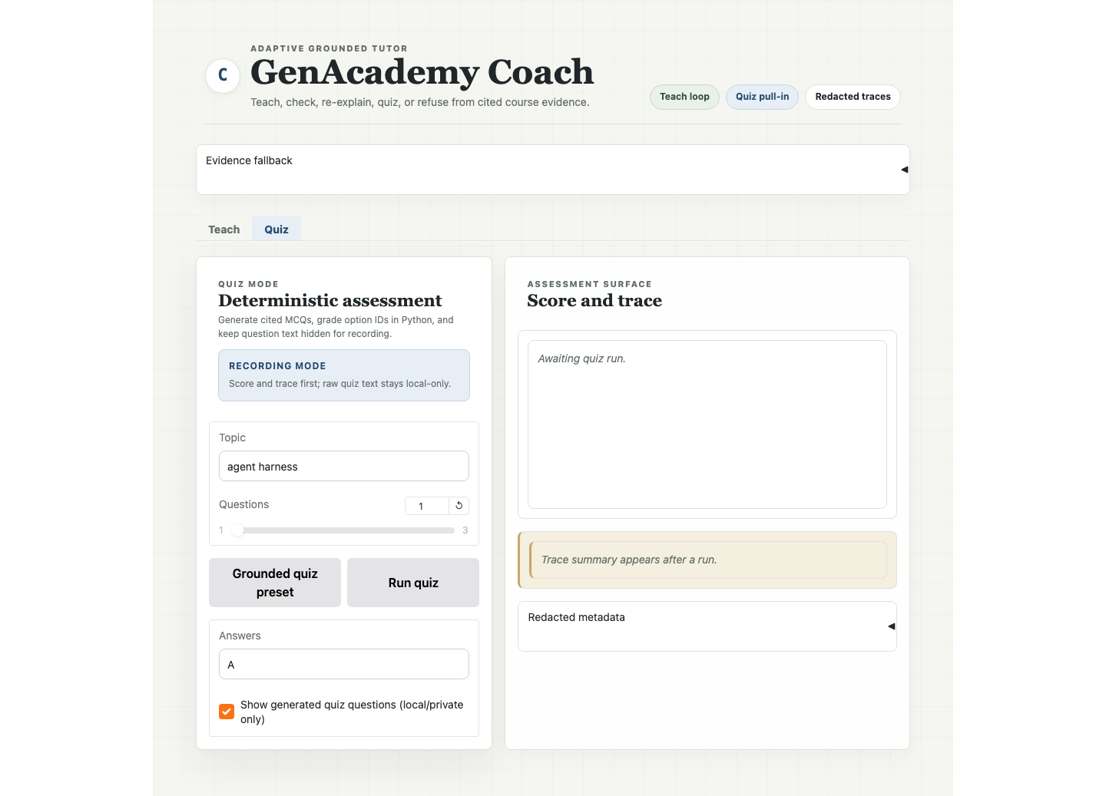

Click Steps
Step | Action
1 | Stay on Quiz.
2 | Check Show generated quiz questions (local/private only).
3 | Do not click Run quiz for a public/shareable screenshot unless the generated text has been reviewed.
4 | Uncheck it again before recording the main demo path.

Point At On Screen
- Checkbox label explicitly says local/private only.
- Assessment surface is still awaiting a run.
- No generated question or option text appears in this committed screenshot.

Say
The reveal exists for local inspection, but the recording path keeps generated quiz text hidden by default.

Fallback Evidence
- Use docs/teach-loop-status.md for redacted eval and trace metadata.
- Use docs/demo-and-deliverables.md for the evidence table.
- Use docs/ui-screenshot-inventory.md for screenshot provenance and privacy labels.
- Use scripts/capture_pr22_ui_screenshots.cjs to regenerate the function-state screenshots locally.

