DM-K3 | Key Checks — No Null / Blank Business Keys
Hub key integrity. Pass criterion: 0 null / blank keys loaded without a default, and a ghost / -1 record present per hub.

Check Overview
Check ID | DM-K3
Category | Key checks
Sign-off criterion | No null / blank business keys
Method | Per hub: count rows with NULL hash key or NULL / blank business key (scoped to the project's RECORD_SOURCE prefix), and check a ghost / -1 record exists.
Pass criteria / tolerance | 0 nulls loaded without default; ghost record exists
Owner | LUMIQ
Vault location | BAGIC_PREPROD_CURATED_DB.BGIL_DATA_MODEL
Maximus RAW | BAGIC_PROD_MIRROR_DB.MAXI_RAW
Opus RAW (test) | BAGIC_PREPROD_CURATED_DB.UTILS
Ghost record definition | hash key = TO_BINARY(REPEAT('0', 32), 'HEX') (automate_dv binary_ghost, md5) OR business key in ('-1', '-2') (automate_dv null_key_required / null_key_optional). Checked on the whole table, not per project: a shared hub needs one ghost row.
placeholder_bk_info | Informational only: business keys equal to ('NULL', 'NONE', 'NA', 'N/A', 'UNKNOWN', '0'). Not part of the pass criterion; review any non-zero count.
Known design gap | Neither project configures ghost records or null-key defaults (no enable_ghost_records, null_key_required or null_columns in any stage). Null source keys are dropped by the hub load instead of being defaulted to -1. ghost_record_status is therefore expected to be FAIL for every hub until a ghost row is added, or this is signed off as a documented exception.

Validation Queries

1. MAXIMUS — HUB_PARTY
Project | MAXIMUS
Hub table | HUB_PARTY
Status | Implemented
Pass criteria | null_key_status = PASS and ghost_record_status = PASS
Result (Pass / Fail / NA) | Fail (ghost record only) — null-key check Pass
Null / blank keys (count) | 0
Ghost record present (Y/N) | N
Remarks | 1,435,135 keys checked; 0 null hash keys, 0 null/blank business keys. Ghost record not present: ghost/-1 records are not implemented in the current model. Null source keys are excluded at load, so no null references exist. Raised as a documented exception. 1 business key = '0' (flagged by placeholder_bk_info): traced to PARTY_DETAIL, PARTY_CODE 0 = 'DIRECT BUSINESS' (organisation, ACTIVE), a genuine source master record referenced by 12 child rows. Valid key, not a ghost record; no action.

SQL query
select 'MAXIMUS' as project, 'HUB_PARTY' as hub,
count_if(startswith(RECORD_SOURCE, 'MAXIMUS_')) as rows_in_scope,
count_if(startswith(RECORD_SOURCE, 'MAXIMUS_') and PARTY_HKEY is null) as null_hkey,
count_if(startswith(RECORD_SOURCE, 'MAXIMUS_') and nullif(trim(PARENT_BK), '') is null) as null_or_blank_bk,
count_if(startswith(RECORD_SOURCE, 'MAXIMUS_') and upper(trim(PARENT_BK)) in ('NULL', 'NONE', 'NA', 'N/A', 'UNKNOWN', '0')) as placeholder_bk_info,
count_if(PARTY_HKEY = TO_BINARY(REPEAT('0', 32), 'HEX') or trim(PARENT_BK) in ('-1', '-2')) as ghost_rows,
iff(null_hkey = 0 and null_or_blank_bk = 0, 'PASS', 'FAIL') as null_key_status,
iff(ghost_rows > 0, 'PASS', 'FAIL') as ghost_record_status
from BAGIC_PREPROD_CURATED_DB.BGIL_DATA_MODEL.HUB_PARTY;
Query output (attach / paste below)
Output:
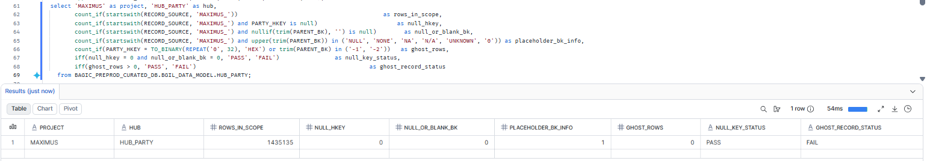

2. MAXIMUS — HUB_STAKE_CODE
Project | MAXIMUS
Hub table | HUB_STAKE_CODE
Status | Implemented
Pass criteria | null_key_status = PASS and ghost_record_status = PASS
Result (Pass / Fail / NA) | Fail (ghost record only) — null-key check Pass
Null / blank keys (count) | 0
Ghost record present (Y/N) | N
Remarks | 7 keys checked; 0 null hash keys, 0 null/blank business keys, 0 placeholder keys. Ghost record not present: ghost/-1 records are not implemented in the current model. Null source keys are excluded at load, so no null references exist. Raised as a documented exception.

Note: Business key column is STAKE_CODE_BK (not PARENT_BK).
SQL query
select 'MAXIMUS' as project, 'HUB_STAKE_CODE' as hub,
count_if(startswith(RECORD_SOURCE, 'MAXIMUS_')) as rows_in_scope,
count_if(startswith(RECORD_SOURCE, 'MAXIMUS_') and STAKE_CODE_HKEY is null) as null_hkey,
count_if(startswith(RECORD_SOURCE, 'MAXIMUS_') and nullif(trim(STAKE_CODE_BK), '') is null) as null_or_blank_bk,
count_if(startswith(RECORD_SOURCE, 'MAXIMUS_') and upper(trim(STAKE_CODE_BK)) in ('NULL', 'NONE', 'NA', 'N/A', 'UNKNOWN', '0')) as placeholder_bk_info,
count_if(STAKE_CODE_HKEY = TO_BINARY(REPEAT('0', 32), 'HEX') or trim(STAKE_CODE_BK) in ('-1', '-2')) as ghost_rows,
iff(null_hkey = 0 and null_or_blank_bk = 0, 'PASS', 'FAIL') as null_key_status,
iff(ghost_rows > 0, 'PASS', 'FAIL') as ghost_record_status
from BAGIC_PREPROD_CURATED_DB.BGIL_DATA_MODEL.HUB_STAKE_CODE;
Query output (attach / paste below)
Output:
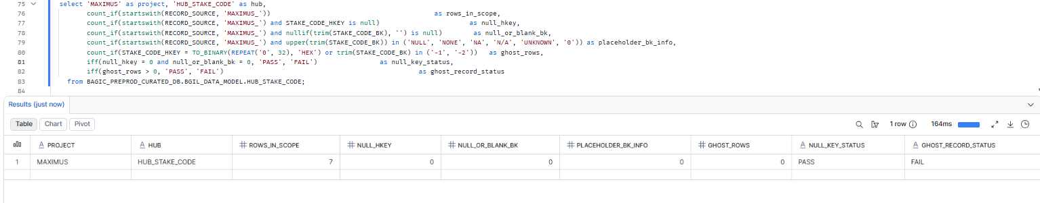

3. MAXIMUS — HUB_LOCATION
Project | MAXIMUS
Hub table | HUB_LOCATION
Status | Implemented
Pass criteria | null_key_status = PASS and ghost_record_status = PASS
Result (Pass / Fail / NA) | Fail (ghost record only), null-key check Pass
Null / blank keys (count) | 0
Ghost record present (Y/N) | N
Remarks | 612,845 keys checked; 0 null hash keys, 0 null/blank business keys, 0 placeholder keys. Initial run found 0 Maximus rows: LOCATION_BK used md5(concat_ws('|', <address parts>)), which is NULL whenever any address part is NULL (RAW trace: PARTY_ADDRESS 1,902,904 / ADDRESS_PROPERTY_PIVOT_VW 1,877,350 / SIMPLE_PROPERTY_PIVOT_VW 1,440,906 rows, 0 with key). Key build made null-safe in the Maximus generator, models regenerated and reloaded; hub now populated. Ghost record not present:

SQL query
select 'MAXIMUS' as project, 'HUB_LOCATION' as hub,
count_if(startswith(RECORD_SOURCE, 'MAXIMUS_')) as rows_in_scope,
count_if(startswith(RECORD_SOURCE, 'MAXIMUS_') and LOCATION_HKEY is null) as null_hkey,
count_if(startswith(RECORD_SOURCE, 'MAXIMUS_') and nullif(trim(PARENT_BK), '') is null) as null_or_blank_bk,
count_if(startswith(RECORD_SOURCE, 'MAXIMUS_') and upper(trim(PARENT_BK)) in ('NULL', 'NONE', 'NA', 'N/A', 'UNKNOWN', '0')) as placeholder_bk_info,
count_if(LOCATION_HKEY = TO_BINARY(REPEAT('0', 32), 'HEX') or trim(PARENT_BK) in ('-1', '-2')) as ghost_rows,
iff(null_hkey = 0 and null_or_blank_bk = 0, 'PASS', 'FAIL') as null_key_status,
iff(ghost_rows > 0, 'PASS', 'FAIL') as ghost_record_status
from BAGIC_PREPROD_CURATED_DB.BGIL_DATA_MODEL.HUB_LOCATION;
Query output (attach / paste below)
Output:
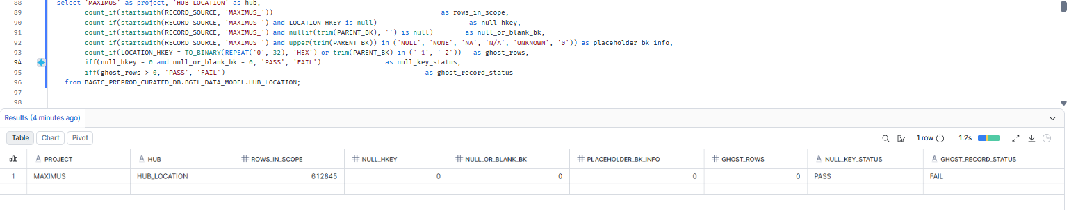

4. MAXIMUS — HUB_PAYMENT_INSTRUMENT
Project | MAXIMUS
Hub table | HUB_PAYMENT_INSTRUMENT
Status | Implemented
Pass criteria | null_key_status = PASS and ghost_record_status = PASS
Result (Pass / Fail / NA) | Fail (ghost record only) — null-key check Pass
Null / blank keys (count) | 0
Ghost record present (Y/N) | N
Remarks | 265,238 keys checked; 0 null hash keys, 0 null/blank business keys, 0 prefix-only keys ('HUB_PAYMENT_INSTRUMENT|' with no FOREIGN_KEY), 0 placeholder keys. Ghost record not present: ghost/-1 records are not implemented in the current model. Null source keys are excluded at load, so no null references exist.

Note: PARENT_BK is stored already prefixed ('HUB_PAYMENT_INSTRUMENT|<FOREIGN_KEY>'); a bare prefix with no key value would be a blank key in effect -- counted in prefix_only_bk.
SQL query
select 'MAXIMUS' as project, 'HUB_PAYMENT_INSTRUMENT' as hub,
count_if(startswith(RECORD_SOURCE, 'MAXIMUS_')) as rows_in_scope,
count_if(startswith(RECORD_SOURCE, 'MAXIMUS_') and PAYMENT_INSTRUMENT_HKEY is null) as null_hkey,
count_if(startswith(RECORD_SOURCE, 'MAXIMUS_') and nullif(trim(PARENT_BK), '') is null) as null_or_blank_bk,
count_if(startswith(RECORD_SOURCE, 'MAXIMUS_') and trim(PARENT_BK) = 'HUB_PAYMENT_INSTRUMENT|') as prefix_only_bk,
count_if(startswith(RECORD_SOURCE, 'MAXIMUS_') and upper(trim(PARENT_BK)) in ('NULL', 'NONE', 'NA', 'N/A', 'UNKNOWN', '0')) as placeholder_bk_info,
count_if(PAYMENT_INSTRUMENT_HKEY = TO_BINARY(REPEAT('0', 32), 'HEX') or trim(PARENT_BK) in ('-1', '-2')) as ghost_rows,
iff(null_hkey = 0 and null_or_blank_bk = 0 and prefix_only_bk = 0, 'PASS', 'FAIL') as null_key_status,
iff(ghost_rows > 0, 'PASS', 'FAIL') as ghost_record_status
from BAGIC_PREPROD_CURATED_DB.BGIL_DATA_MODEL.HUB_PAYMENT_INSTRUMENT;
Query output (attach / paste below)
Output:
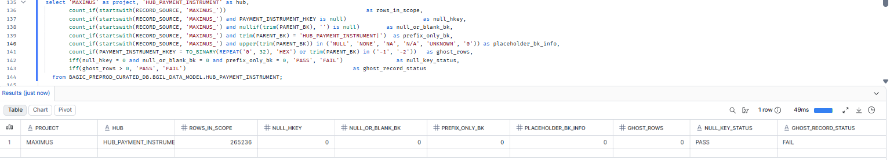

5. MAXIMUS — HUB_PRODUCT
Project | MAXIMUS
Hub table | HUB_PRODUCT
Status | Implemented
Pass criteria | null_key_status = PASS and ghost_record_status = PASS
Result (Pass / Fail / NA) | Fail (ghost record only), null-key check Pass
Null / blank keys (count) | 0
Ghost record present (Y/N) | N
Remarks | 30 keys checked; 0 null hash keys, 0 null/blank business keys, 0 placeholder keys. Source: SIMPLE_PROPERTY_PIVOT_VW.PRODUCT_CODE (16,155 of 1,440,906 rows carry a product code; the rest have none and are excluded at load by design). Cross-check: 35 distinct source codes vs 30 Maximus-sourced hub keys; the 5 extra codes are present in HUB_PRODUCT under an OPUS_ record source (shared hub, first loader wins). No missing keys. Ghost record not present: ghost/-1 records are not implemented in the current model. Null source keys are excluded at load, so no null references exist.

SQL query
select 'MAXIMUS' as project, 'HUB_PRODUCT' as hub,
count_if(startswith(RECORD_SOURCE, 'MAXIMUS_')) as rows_in_scope,
count_if(startswith(RECORD_SOURCE, 'MAXIMUS_') and PRODUCT_HKEY is null) as null_hkey,
count_if(startswith(RECORD_SOURCE, 'MAXIMUS_') and nullif(trim(PARENT_BK), '') is null) as null_or_blank_bk,
count_if(startswith(RECORD_SOURCE, 'MAXIMUS_') and upper(trim(PARENT_BK)) in ('NULL', 'NONE', 'NA', 'N/A', 'UNKNOWN', '0')) as placeholder_bk_info,
count_if(PRODUCT_HKEY = TO_BINARY(REPEAT('0', 32), 'HEX') or trim(PARENT_BK) in ('-1', '-2')) as ghost_rows,
iff(null_hkey = 0 and null_or_blank_bk = 0, 'PASS', 'FAIL') as null_key_status,
iff(ghost_rows > 0, 'PASS', 'FAIL') as ghost_record_status
from BAGIC_PREPROD_CURATED_DB.BGIL_DATA_MODEL.HUB_PRODUCT;
Query output (attach / paste below)
Output:
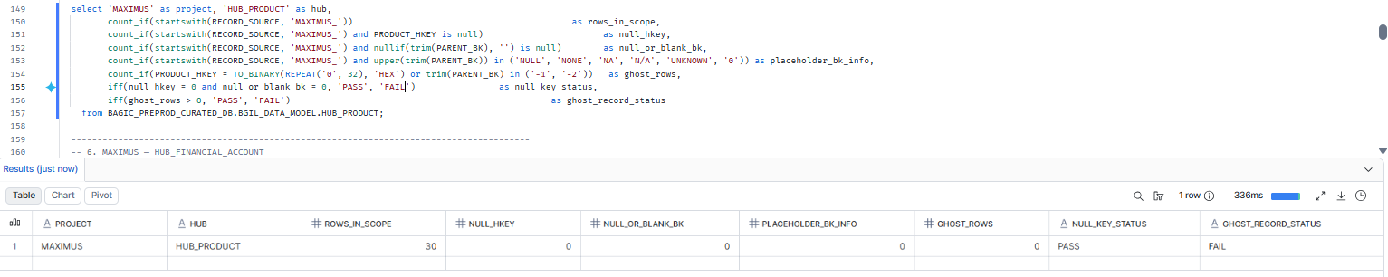

6. MAXIMUS — HUB_FINANCIAL_ACCOUNT
Project | MAXIMUS
Hub table | HUB_FINANCIAL_ACCOUNT
Status | Implemented
Pass criteria | null_key_status = PASS and ghost_record_status = PASS
Result (Pass / Fail / NA) | NA
Null / blank keys (count) | NA
Ghost record present (Y/N) | NA
Remarks | Source record issue

Note: account_code is cast(null) in staging, so this hub should hold no Maximus rows; rows_in_scope = 0 is expected.
SQL query
select 'MAXIMUS' as project, 'HUB_FINANCIAL_ACCOUNT' as hub,
count_if(startswith(RECORD_SOURCE, 'MAXIMUS_')) as rows_in_scope,
count_if(startswith(RECORD_SOURCE, 'MAXIMUS_') and FINANCIAL_ACCOUNT_HKEY is null) as null_hkey,
count_if(startswith(RECORD_SOURCE, 'MAXIMUS_') and nullif(trim(PARENT_BK), '') is null) as null_or_blank_bk,
count_if(startswith(RECORD_SOURCE, 'MAXIMUS_') and upper(trim(PARENT_BK)) in ('NULL', 'NONE', 'NA', 'N/A', 'UNKNOWN', '0')) as placeholder_bk_info,
count_if(FINANCIAL_ACCOUNT_HKEY = TO_BINARY(REPEAT('0', 32), 'HEX') or trim(PARENT_BK) in ('-1', '-2')) as ghost_rows,
iff(null_hkey = 0 and null_or_blank_bk = 0, 'PASS', 'FAIL') as null_key_status,
iff(ghost_rows > 0, 'PASS', 'FAIL') as ghost_record_status
from BAGIC_PREPROD_CURATED_DB.BGIL_DATA_MODEL.HUB_FINANCIAL_ACCOUNT;
Query output (attach / paste below)
Output:
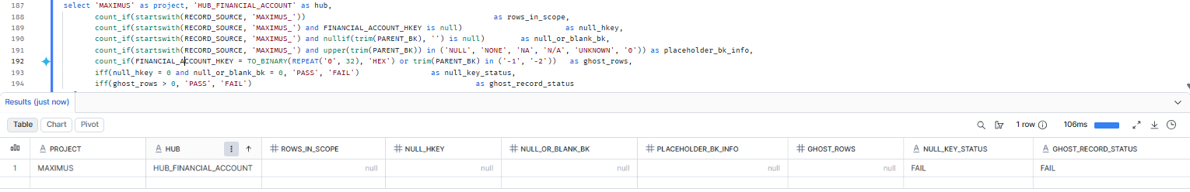

7. MAXIMUS — HUB_DOCUMENT
Project | MAXIMUS
Hub table | HUB_DOCUMENT
Status | Implemented
Pass criteria | null_key_status = PASS and ghost_record_status = PASS
Result (Pass / Fail / NA) | Fail (ghost record only), null-key check Pass
Null / blank keys (count) | 0
Ghost record present (Y/N) | N
Remarks | 89,453 keys checked; 0 null hash keys, 0 null/blank business keys, 0 placeholder keys. Source: DOCUMENT_DETAIL.DOCUMENT_ID. Cross-check: 89,453 distinct source DOCUMENT_IDs = 89,453 hub keys (exact match); 1,415,489 of 1,504,942 source rows have no DOCUMENT_ID and are excluded at load by design. Ghost record not present: ghost/-1 records are not implemented in the current model. Null source keys are excluded at load, so no null references exist.

SQL query
select 'MAXIMUS' as project, 'HUB_DOCUMENT' as hub,
count_if(startswith(RECORD_SOURCE, 'MAXIMUS_')) as rows_in_scope,
count_if(startswith(RECORD_SOURCE, 'MAXIMUS_') and DOCUMENT_HKEY is null) as null_hkey,
count_if(startswith(RECORD_SOURCE, 'MAXIMUS_') and nullif(trim(PARENT_BK), '') is null) as null_or_blank_bk,
count_if(startswith(RECORD_SOURCE, 'MAXIMUS_') and upper(trim(PARENT_BK)) in ('NULL', 'NONE', 'NA', 'N/A', 'UNKNOWN', '0')) as placeholder_bk_info,
count_if(DOCUMENT_HKEY = TO_BINARY(REPEAT('0', 32), 'HEX') or trim(PARENT_BK) in ('-1', '-2')) as ghost_rows,
iff(null_hkey = 0 and null_or_blank_bk = 0, 'PASS', 'FAIL') as null_key_status,
iff(ghost_rows > 0, 'PASS', 'FAIL') as ghost_record_status
from BAGIC_PREPROD_CURATED_DB.BGIL_DATA_MODEL.HUB_DOCUMENT;
Query output (attach / paste below)
Output:
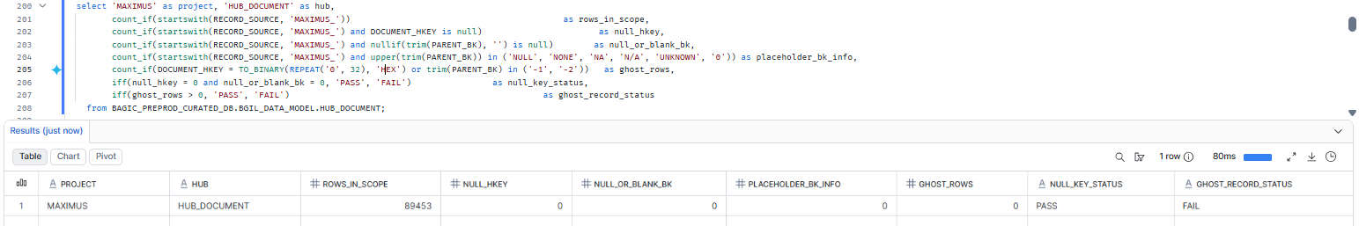

8. MAXIMUS — HUB_POLICY
Project | MAXIMUS
Hub table | HUB_POLICY
Status | Implemented
Pass criteria | null_key_status = PASS and ghost_record_status = PASS
Result (Pass / Fail / NA) | Fail. A placeholder value is loaded as the only business key (ghost record also not present)
Null / blank keys (count) | 1 (placeholder ',', effectively blank)
Ghost record present (Y/N) | N
Remarks | 1 Maximus key in HUB_POLICY, and it is a placeholder: PARENT_BK = ',' (single comma, hex 2C). Source: SIMPLE_PROPERTY_PIVOT_VW.PA_POLICY, where all 2,737 non-empty source rows hold ',' and no real PA policy number is present. The staging layer treats only '' as blank, so ',' is loaded as a business key. Effectively a blank key loaded without a default,.

SQL query
select 'MAXIMUS' as project, 'HUB_POLICY' as hub,
count_if(startswith(RECORD_SOURCE, 'MAXIMUS_')) as rows_in_scope,
count_if(startswith(RECORD_SOURCE, 'MAXIMUS_') and POLICY_HKEY is null) as null_hkey,
count_if(startswith(RECORD_SOURCE, 'MAXIMUS_') and nullif(trim(PARENT_BK), '') is null) as null_or_blank_bk,
count_if(startswith(RECORD_SOURCE, 'MAXIMUS_') and upper(trim(PARENT_BK)) in ('NULL', 'NONE', 'NA', 'N/A', 'UNKNOWN', '0')) as placeholder_bk_info,
count_if(POLICY_HKEY = TO_BINARY(REPEAT('0', 32), 'HEX') or trim(PARENT_BK) in ('-1', '-2')) as ghost_rows,
iff(null_hkey = 0 and null_or_blank_bk = 0, 'PASS', 'FAIL') as null_key_status,
iff(ghost_rows > 0, 'PASS', 'FAIL') as ghost_record_status
from BAGIC_PREPROD_CURATED_DB.BGIL_DATA_MODEL.HUB_POLICY;
Query output (attach / paste below)
Output:
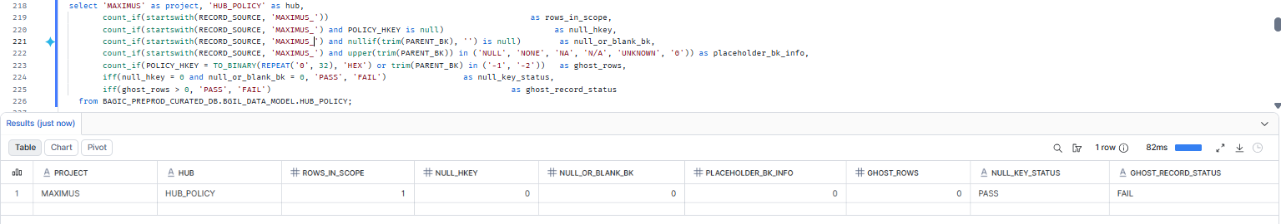

9. MAXIMUS — HUB_DISTRIBUTION_CHANNEL
Project | MAXIMUS
Hub table | HUB_DISTRIBUTION_CHANNEL
Status | Implemented
Pass criteria | null_key_status = PASS and ghost_record_status = PASS
Result (Pass / Fail / NA) | Fail (ghost record only), null-key check Pass
Null / blank keys (count) | 0
Ghost record present (Y/N) | N
Remarks | 15 keys checked; 0 null hash keys, 0 null/blank business keys, 0 placeholder keys. Source: SIMPLE_PROPERTY_PIVOT_VW.AGENT_CHANNEL. Cross-check: 15 distinct source values = 15 hub keys, all IN HUB under MAXIMUS_ record source; all values are genuine channel codes (no symbol-only or placeholder values). Ghost record not present: ghost/-1 records are not implemented in the current model. Null source keys are excluded at load, so no null references exist.

SQL query
select 'MAXIMUS' as project, 'HUB_DISTRIBUTION_CHANNEL' as hub,
count_if(startswith(RECORD_SOURCE, 'MAXIMUS_')) as rows_in_scope,
count_if(startswith(RECORD_SOURCE, 'MAXIMUS_') and DISTRIBUTION_CHANNEL_HKEY is null) as null_hkey,
count_if(startswith(RECORD_SOURCE, 'MAXIMUS_') and nullif(trim(PARENT_BK), '') is null) as null_or_blank_bk,
count_if(startswith(RECORD_SOURCE, 'MAXIMUS_') and upper(trim(PARENT_BK)) in ('NULL', 'NONE', 'NA', 'N/A', 'UNKNOWN', '0')) as placeholder_bk_info,
count_if(DISTRIBUTION_CHANNEL_HKEY = TO_BINARY(REPEAT('0', 32), 'HEX') or trim(PARENT_BK) in ('-1', '-2')) as ghost_rows,
iff(null_hkey = 0 and null_or_blank_bk = 0, 'PASS', 'FAIL') as null_key_status,
iff(ghost_rows > 0, 'PASS', 'FAIL') as ghost_record_status
from BAGIC_PREPROD_CURATED_DB.BGIL_DATA_MODEL.HUB_DISTRIBUTION_CHANNEL;
Query output (attach / paste below)
Output:
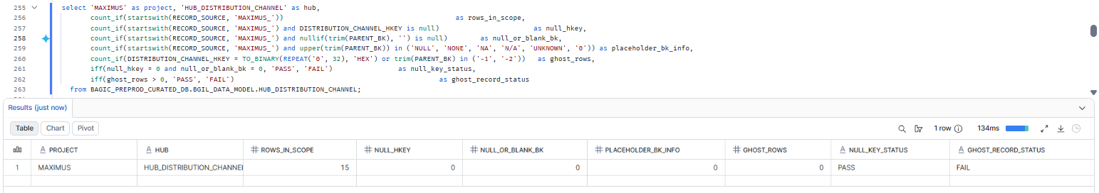

10. MAXIMUS — HUB_ORG_UNIT
Project | MAXIMUS
Hub table | HUB_ORG_UNIT
Status | Implemented
Pass criteria | null_key_status = PASS and ghost_record_status = PASS
Result (Pass / Fail / NA) | Fail (ghost record only), null-key check Pass
Null / blank keys (count) | 0
Ghost record present (Y/N) | N
Remarks | 1 key checked; 0 null hash keys, 0 null/blank business keys, 0 placeholder keys. Source: MULTI_SET_DETAIL_PROPERTY_PIVOT_VW.COMPANY (the second branch, SIMPLE_PROPERTY_PIVOT_VW.branch_code, is hard-coded to NULL in staging and contributes no keys). Cross-check: 1 distinct source value 'BAGIC' (insurer company code, on 204 source rows) = 1 hub key, IN HUB under MAXIMUS_ record source; genuine value.

SQL query
select 'MAXIMUS' as project, 'HUB_ORG_UNIT' as hub,
count_if(startswith(RECORD_SOURCE, 'MAXIMUS_')) as rows_in_scope,
count_if(startswith(RECORD_SOURCE, 'MAXIMUS_') and ORG_UNIT_HKEY is null) as null_hkey,
count_if(startswith(RECORD_SOURCE, 'MAXIMUS_') and nullif(trim(PARENT_BK), '') is null) as null_or_blank_bk,
count_if(startswith(RECORD_SOURCE, 'MAXIMUS_') and upper(trim(PARENT_BK)) in ('NULL', 'NONE', 'NA', 'N/A', 'UNKNOWN', '0')) as placeholder_bk_info,
count_if(ORG_UNIT_HKEY = TO_BINARY(REPEAT('0', 32), 'HEX') or trim(PARENT_BK) in ('-1', '-2')) as ghost_rows,
iff(null_hkey = 0 and null_or_blank_bk = 0, 'PASS', 'FAIL') as null_key_status,
iff(ghost_rows > 0, 'PASS', 'FAIL') as ghost_record_status
from BAGIC_PREPROD_CURATED_DB.BGIL_DATA_MODEL.HUB_ORG_UNIT;
Query output (attach / paste below)
Output:
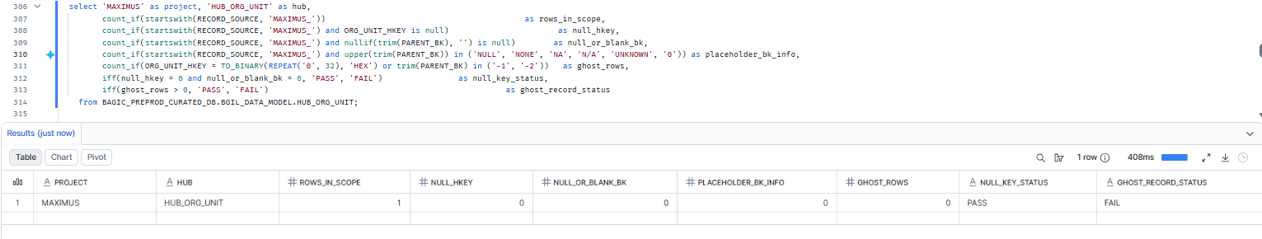

11. OPUS — HUB_PARTY
Project | OPUS
Hub table | HUB_PARTY
Status | Implemented
Pass criteria | null_key_status = PASS and ghost_record_status = PASS
Result (Pass / Fail / NA) | Fail (ghost record only), null-key check Pass
Null / blank keys (count) | 0
Ghost record present (Y/N) | N
Remarks | 8,772,984 keys (OPUS_ rows; Maximus rows in this shared hub are covered in section 1). Findings: 0 null hash keys, 0 null/blank business keys, 0 placeholder keys, 0 symbol-only keys. Source: CP_PARTNERS.PART_ID. Cross-check: 8,772,984 distinct source PART_IDs = 8,772,984 hub keys (exact match). Ghost record: Not present.

SQL query
select 'OPUS' as project, 'HUB_PARTY' as hub,
count_if(startswith(RECORD_SOURCE, 'OPUS_')) as rows_in_scope,
count_if(startswith(RECORD_SOURCE, 'OPUS_') and PARTY_HKEY is null) as null_hkey,
count_if(startswith(RECORD_SOURCE, 'OPUS_') and nullif(trim(PARENT_BK), '') is null) as null_or_blank_bk,
count_if(startswith(RECORD_SOURCE, 'OPUS_') and upper(trim(PARENT_BK)) in ('NULL', 'NONE', 'NA', 'N/A', 'UNKNOWN', '0')) as placeholder_bk_info,
count_if(PARTY_HKEY = TO_BINARY(REPEAT('0', 32), 'HEX') or trim(PARENT_BK) in ('-1', '-2')) as ghost_rows,
iff(null_hkey = 0 and null_or_blank_bk = 0, 'PASS', 'FAIL') as null_key_status,
iff(ghost_rows > 0, 'PASS', 'FAIL') as ghost_record_status
from BAGIC_PREPROD_CURATED_DB.BGIL_DATA_MODEL.HUB_PARTY;
Query output (attach / paste below)
Output:
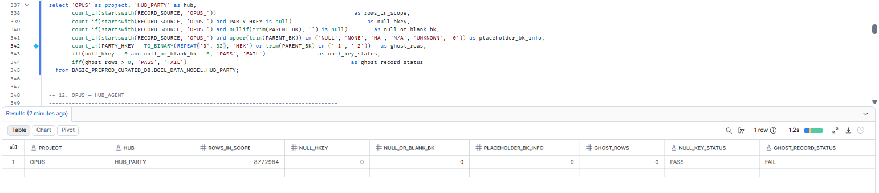

12. OPUS — HUB_AGENT
Project | OPUS
Hub table | HUB_AGENT
Status | Implemented
Pass criteria | null_key_status = PASS and ghost_record_status = PASS
Result (Pass / Fail / NA) | Fail (ghost record only), null-key check Pass
Null / blank keys (count) | 0
Ghost record present (Y/N) | N
Remarks | 12,461 keys (OPUS_ rows). Findings: 0 null hash keys, 0 null/blank business keys, 0 placeholder keys. Source: BJAZ_INTERMEDIARY.INTERMEDIARY_ID. Cross-check: [CROSS-CHECK LINE] Ghost record: Not present. Null source keys are excluded at load, so no null references exist.

SQL query
select 'OPUS' as project, 'HUB_AGENT' as hub,
count_if(startswith(RECORD_SOURCE, 'OPUS_')) as rows_in_scope,
count_if(startswith(RECORD_SOURCE, 'OPUS_') and AGENT_HKEY is null) as null_hkey,
count_if(startswith(RECORD_SOURCE, 'OPUS_') and nullif(trim(PARENT_BK), '') is null) as null_or_blank_bk,
count_if(startswith(RECORD_SOURCE, 'OPUS_') and upper(trim(PARENT_BK)) in ('NULL', 'NONE', 'NA', 'N/A', 'UNKNOWN', '0')) as placeholder_bk_info,
count_if(AGENT_HKEY = TO_BINARY(REPEAT('0', 32), 'HEX') or trim(PARENT_BK) in ('-1', '-2')) as ghost_rows,
iff(null_hkey = 0 and null_or_blank_bk = 0, 'PASS', 'FAIL') as null_key_status,
iff(ghost_rows > 0, 'PASS', 'FAIL') as ghost_record_status
from BAGIC_PREPROD_CURATED_DB.BGIL_DATA_MODEL.HUB_AGENT;
Query output (attach / paste below)
Output:
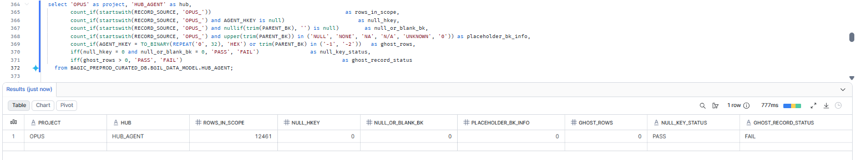

13. OPUS — HUB_AGREEMENT
Project | OPUS
Hub table | HUB_AGREEMENT
Status | Implemented
Pass criteria | null_key_status = PASS and ghost_record_status = PASS
Result (Pass / Fail / NA) | Fail (ghost record only), null-key check Pass
Null / blank keys (count) | 0
Ghost record present (Y/N) | N
Remarks | 12,461 keys (OPUS_ rows). Findings: 0 null hash keys, 0 null/blank business keys, 0 placeholder keys. Source: BJAZ_INTERMEDIARY.INTERMEDIARY_ID. Cross-check: 12,461 keys = HUB_AGENT (section 12), which is built from the same source column (consistent). [SOURCE LINE] Ghost record: Not present.Null source keys are excluded at load

SQL query
select 'OPUS' as project, 'HUB_AGREEMENT' as hub,
count_if(startswith(RECORD_SOURCE, 'OPUS_')) as rows_in_scope,
count_if(startswith(RECORD_SOURCE, 'OPUS_') and AGREEMENT_HKEY is null) as null_hkey,
count_if(startswith(RECORD_SOURCE, 'OPUS_') and nullif(trim(PARENT_BK), '') is null) as null_or_blank_bk,
count_if(startswith(RECORD_SOURCE, 'OPUS_') and upper(trim(PARENT_BK)) in ('NULL', 'NONE', 'NA', 'N/A', 'UNKNOWN', '0')) as placeholder_bk_info,
count_if(AGREEMENT_HKEY = TO_BINARY(REPEAT('0', 32), 'HEX') or trim(PARENT_BK) in ('-1', '-2')) as ghost_rows,
iff(null_hkey = 0 and null_or_blank_bk = 0, 'PASS', 'FAIL') as null_key_status,
iff(ghost_rows > 0, 'PASS', 'FAIL') as ghost_record_status
from BAGIC_PREPROD_CURATED_DB.BGIL_DATA_MODEL.HUB_AGREEMENT;
Query output (attach / paste below)
Output:
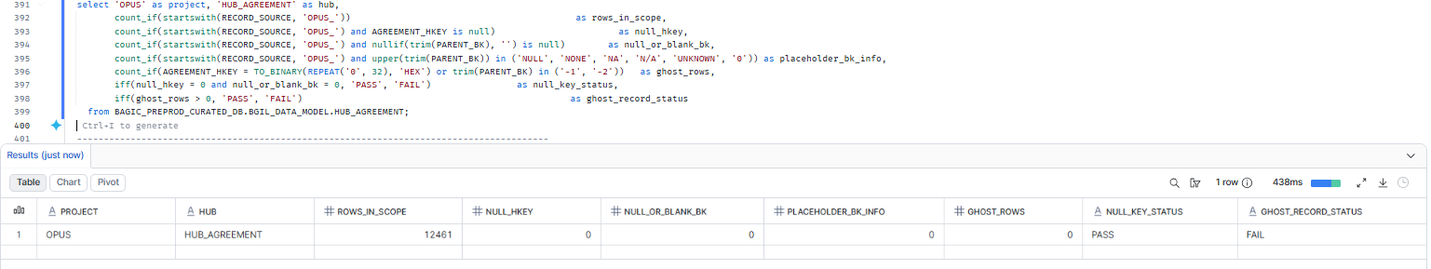

14. OPUS — HUB_CLAIM
Project | OPUS
Hub table | HUB_CLAIM
Status | Implemented
Pass criteria | null_key_status = PASS and ghost_record_status = PASS
Result (Pass / Fail / NA) | Fail (ghost record only), null-key check Pass
Null / blank keys (count) | 0
Ghost record present (Y/N) | N
Remarks | 46,300,891 keys (OPUS_ rows). Findings: 0 null hash keys, 0 null/blank business keys, 0 placeholder keys, 0 symbol-only keys. Source: CLM_INTERESTED_PARTIES.CLAIM_ID. Cross-check: 46,300,891 distinct source CLAIM_IDs = 46,300,891 hub keys (exact match); 100,492,268 source rows (multiple interested parties per claim), 0 with null CLAIM_ID. Ghost record: Not present.Null source keys are excluded at load, so no null references exist.

SQL query
select 'OPUS' as project, 'HUB_CLAIM' as hub,
count_if(startswith(RECORD_SOURCE, 'OPUS_')) as rows_in_scope,
count_if(startswith(RECORD_SOURCE, 'OPUS_') and CLAIM_HKEY is null) as null_hkey,
count_if(startswith(RECORD_SOURCE, 'OPUS_') and nullif(trim(PARENT_BK), '') is null) as null_or_blank_bk,
count_if(startswith(RECORD_SOURCE, 'OPUS_') and upper(trim(PARENT_BK)) in ('NULL', 'NONE', 'NA', 'N/A', 'UNKNOWN', '0')) as placeholder_bk_info,
count_if(CLAIM_HKEY = TO_BINARY(REPEAT('0', 32), 'HEX') or trim(PARENT_BK) in ('-1', '-2')) as ghost_rows,
iff(null_hkey = 0 and null_or_blank_bk = 0, 'PASS', 'FAIL') as null_key_status,
iff(ghost_rows > 0, 'PASS', 'FAIL') as ghost_record_status
from BAGIC_PREPROD_CURATED_DB.BGIL_DATA_MODEL.HUB_CLAIM;
Query output (attach / paste below)
Output:
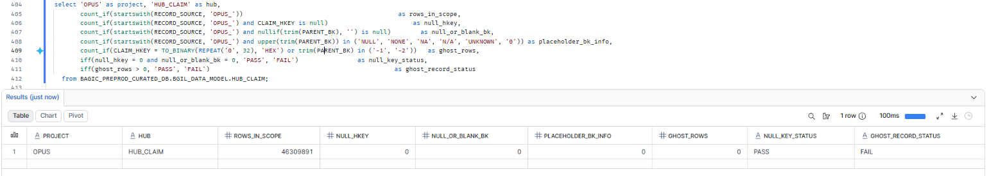

15. OPUS — HUB_DISTRIBUTION_CHANNEL
Project | OPUS
Hub table | HUB_DISTRIBUTION_CHANNEL
Status | Implemented
Pass criteria | null_key_status = PASS and ghost_record_status = PASS
Result (Pass / Fail / NA) | Fail (ghost record only), null-key check Pass
Null / blank keys (count) | 0
Ghost record present (Y/N) | N
Remarks | 12,845 keys (OPUS_ rows). Findings: 0 null hash keys, 0 null/blank business keys. 1 placeholder-like key = '0', traced to BJAZ_CLM_SUPP_EXTN.IMD_CODE (4 supplier rows). IMD code 0 = Direct business (no intermediary), a genuine distribution channel code, consistent with Maximus party 0 = 'DIRECT BUSINESS' (section 1). Valid key; no action. Sources: BJAZ_INTERMEDIARY.INTERMEDIARY_ID and BJAZ_CLM_SUPP_EXTN.IMD_CODE. Cross-check: [CROSS-CHECK LINE] Ghost record: Not present.

SQL query
select 'OPUS' as project, 'HUB_DISTRIBUTION_CHANNEL' as hub,
count_if(startswith(RECORD_SOURCE, 'OPUS_')) as rows_in_scope,
count_if(startswith(RECORD_SOURCE, 'OPUS_') and DISTRIBUTION_CHANNEL_HKEY is null) as null_hkey,
count_if(startswith(RECORD_SOURCE, 'OPUS_') and nullif(trim(PARENT_BK), '') is null) as null_or_blank_bk,
count_if(startswith(RECORD_SOURCE, 'OPUS_') and upper(trim(PARENT_BK)) in ('NULL', 'NONE', 'NA', 'N/A', 'UNKNOWN', '0')) as placeholder_bk_info,
count_if(DISTRIBUTION_CHANNEL_HKEY = TO_BINARY(REPEAT('0', 32), 'HEX') or trim(PARENT_BK) in ('-1', '-2')) as ghost_rows,
iff(null_hkey = 0 and null_or_blank_bk = 0, 'PASS', 'FAIL') as null_key_status,
iff(ghost_rows > 0, 'PASS', 'FAIL') as ghost_record_status
from BAGIC_PREPROD_CURATED_DB.BGIL_DATA_MODEL.HUB_DISTRIBUTION_CHANNEL;
Query output (attach / paste below)
Output:
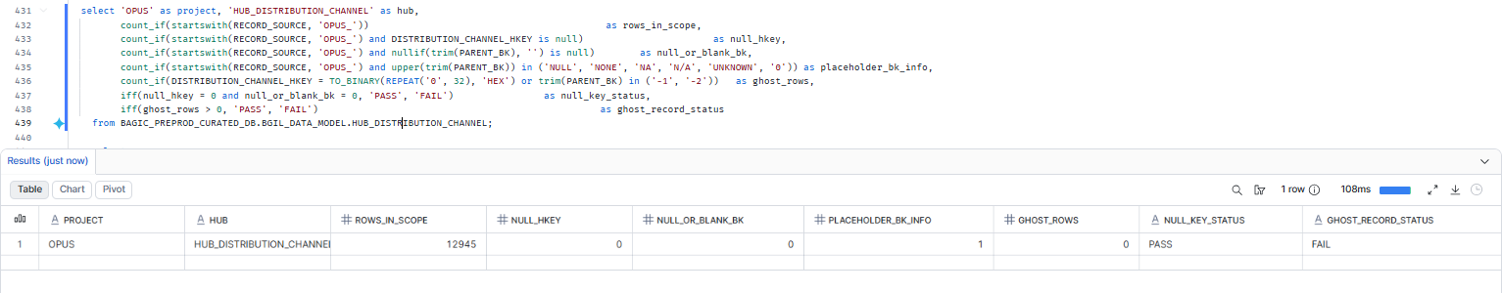

16. OPUS — HUB_LOCATION
Project | OPUS
Hub table | HUB_LOCATION
Status | Implemented
Pass criteria | null_key_status = PASS and ghost_record_status = PASS
Result (Pass / Fail / NA) | Fail (ghost record only), null-key check Pass
Null / blank keys (count) | 0
Ghost record present (Y/N) | N
Remarks | 13600536 keys (OPUS_ rows; Maximus rows in this shared hub covered in section 3). Findings: 0 null hash keys, 0 null/blank business keys, 0 placeholder keys, 0 symbol-only keys. Sources (11): AZBJ_ADDRESS_EXTN.ADD_ID, BJAZ_CLM_SUPP_EXTN.BILLING_LOC and LOCATION_CODE, BJAZ_PINCODE.PINCODE, BJAZ_PINCODE_MASTER.PINCODE, CP_ADDRESSES.ADD_ID, AZBJ_PARTNER_EXTN.MAIL_ADD_ID, BJAZ_CP_ADDRESS_LINK.ADD_ID, CLM_SUPPLIERS.LOC_CODE, CP_PARTNERS.ADD_ID, OCP_INTERESTED_PARTIES.MAILING_ADDRESS_ID. Cross-check (on hash keys): 13,000,556 distinct source keys = 13,000,556 hub keys (exact match); 0 unexpected hub keys, 0 duplicate hub keys. Ghost record: Not present.

SQL query
select 'OPUS' as project, 'HUB_LOCATION' as hub,
count_if(startswith(RECORD_SOURCE, 'OPUS_')) as rows_in_scope,
count_if(startswith(RECORD_SOURCE, 'OPUS_') and LOCATION_HKEY is null) as null_hkey,
count_if(startswith(RECORD_SOURCE, 'OPUS_') and nullif(trim(PARENT_BK), '') is null) as null_or_blank_bk,
count_if(startswith(RECORD_SOURCE, 'OPUS_') and upper(trim(PARENT_BK)) in ('NULL', 'NONE', 'NA', 'N/A', 'UNKNOWN', '0')) as placeholder_bk_info,
count_if(LOCATION_HKEY = TO_BINARY(REPEAT('0', 32), 'HEX') or trim(PARENT_BK) in ('-1', '-2')) as ghost_rows,
iff(null_hkey = 0 and null_or_blank_bk = 0, 'PASS', 'FAIL') as null_key_status,
iff(ghost_rows > 0, 'PASS', 'FAIL') as ghost_record_status
from BAGIC_PREPROD_CURATED_DB.BGIL_DATA_MODEL.HUB_LOCATION;
Query output (attach / paste below)
Output:
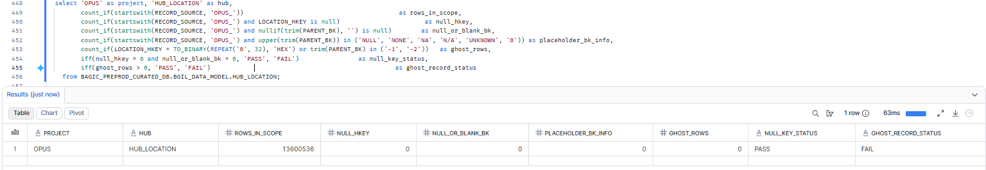

17. OPUS — HUB_POLICY
Project | OPUS
Hub table | HUB_POLICY
Status | Implemented
Pass criteria | null_key_status = PASS and ghost_record_status = PASS
Result (Pass / Fail / NA) | Fail. Placeholder values are loaded as business keys (ghost record also not present)
Null / blank keys (count) | 4 (placeholders 'NA', 'null', '....', '......', effectively blank)
Ghost record present (Y/N) | N
Remarks | ,355,792 keys (OPUS_ rows). Findings: 0 null hash keys, 0 null/blank business keys; 4 placeholder keys loaded, all from BJAZ_HCF_MEMBER_DTLS (RECORD_SOURCE OPUS_BJAZ_HCF_MEMBER_DTLS, loaded 2026-09-30): 'NA' (6 source rows) and 'null' (1 source row, literal text) in POLICY_NUMBER, plus 2 dot-only values '....' (hex 2E2E2E2E) and '......' (hex 2E2E2E2E2E2E). None is a real policy number. Staging treats only '' as blank, so placeholders were loaded as keys. Fails DM-K3 (blank keys loaded without a default).

SQL query
select 'OPUS' as project, 'HUB_POLICY' as hub,
count_if(startswith(RECORD_SOURCE, 'OPUS_')) as rows_in_scope,
count_if(startswith(RECORD_SOURCE, 'OPUS_') and POLICY_HKEY is null) as null_hkey,
count_if(startswith(RECORD_SOURCE, 'OPUS_') and nullif(trim(PARENT_BK), '') is null) as null_or_blank_bk,
count_if(startswith(RECORD_SOURCE, 'OPUS_') and upper(trim(PARENT_BK)) in ('NULL', 'NONE', 'NA', 'N/A', 'UNKNOWN', '0')) as placeholder_bk_info,
count_if(POLICY_HKEY = TO_BINARY(REPEAT('0', 32), 'HEX') or trim(PARENT_BK) in ('-1', '-2')) as ghost_rows,
iff(null_hkey = 0 and null_or_blank_bk = 0, 'PASS', 'FAIL') as null_key_status,
iff(ghost_rows > 0, 'PASS', 'FAIL') as ghost_record_status
from BAGIC_PREPROD_CURATED_DB.BGIL_DATA_MODEL.HUB_POLICY;
Query output (attach / paste below)
Output:
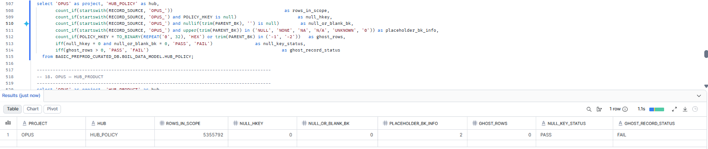

18. OPUS — HUB_PRODUCT
Project | OPUS
Hub table | HUB_PRODUCT
Status | Implemented
Pass criteria | null_key_status = PASS and ghost_record_status = PASS
Result (Pass / Fail / NA) | Fail (ghost record only), null-key check Pass
Null / blank keys (count) | 0
Ghost record present (Y/N) | N
Remarks | 258 keys (OPUS_ rows; Maximus rows in this shared hub covered in section 5). Findings: 0 null hash keys, 0 null/blank business keys, 0 placeholder keys. Sources (3): BJAZ_CTNGY_FF_DTLS_EXTN.SCHEME_CODE, BJAZ_CTNGY_PA_MEM_DTLS.SCHEME_CODE, BJAZ_HM_MEMBER_DTLS.PRODUCT_CODE. Cross-check: [CROSS-CHECK LINE] Ghost record: Not present

SQL query
select 'OPUS' as project, 'HUB_PRODUCT' as hub,
count_if(startswith(RECORD_SOURCE, 'OPUS_')) as rows_in_scope,
count_if(startswith(RECORD_SOURCE, 'OPUS_') and PRODUCT_HKEY is null) as null_hkey,
count_if(startswith(RECORD_SOURCE, 'OPUS_') and nullif(trim(PARENT_BK), '') is null) as null_or_blank_bk,
count_if(startswith(RECORD_SOURCE, 'OPUS_') and upper(trim(PARENT_BK)) in ('NULL', 'NONE', 'NA', 'N/A', 'UNKNOWN', '0')) as placeholder_bk_info,
count_if(PRODUCT_HKEY = TO_BINARY(REPEAT('0', 32), 'HEX') or trim(PARENT_BK) in ('-1', '-2')) as ghost_rows,
iff(null_hkey = 0 and null_or_blank_bk = 0, 'PASS', 'FAIL') as null_key_status,
iff(ghost_rows > 0, 'PASS', 'FAIL') as ghost_record_status
from BAGIC_PREPROD_CURATED_DB.BGIL_DATA_MODEL.HUB_PRODUCT;
Query output (attach / paste below)
Output:
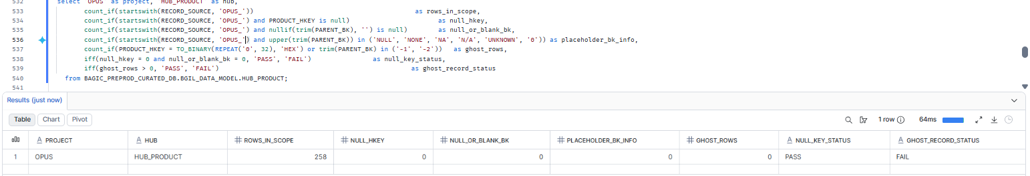

19. OPUS — HUB_RISK_OBJECT
Project | OPUS
Hub table | HUB_RISK_OBJECT
Status | Implemented
Pass criteria | null_key_status = PASS and ghost_record_status = PASS
Result (Pass / Fail / NA) | Fail.A placeholder value is loaded as a business key (ghost record also not present)
Null / blank keys (count) | 1 (placeholder '0', effectively blank)
Ghost record present (Y/N) | N
Remarks | Checked: 46,309,873 keys (OPUS_ rows). Findings: 0 null hash keys, 0 null/blank business keys, 0 symbol-only keys. 1 placeholder-like key = '0', traced to CLM_INTERESTED_PARTIES.INS_OBJ_UID (16 source rows)Fails DM-K3 (blank key loaded without a default). Fix: treat INS_OBJ_UID = '0' as NULL in OPUS staging (stg2_hub_clm_interested_parties__risk_object), then reload. Cross-check (on hash keys): 46,309,873 distinct source keys = 46,309,873 hub keys (exact match); 0 source keys missing from hub.

SQL query
select 'OPUS' as project, 'HUB_RISK_OBJECT' as hub,
count_if(startswith(RECORD_SOURCE, 'OPUS_')) as rows_in_scope,
count_if(startswith(RECORD_SOURCE, 'OPUS_') and RISK_OBJECT_HKEY is null) as null_hkey,
count_if(startswith(RECORD_SOURCE, 'OPUS_') and nullif(trim(PARENT_BK), '') is null) as null_or_blank_bk,
count_if(startswith(RECORD_SOURCE, 'OPUS_') and upper(trim(PARENT_BK)) in ('NULL', 'NONE', 'NA', 'N/A', 'UNKNOWN', '0')) as placeholder_bk_info,
count_if(RISK_OBJECT_HKEY = TO_BINARY(REPEAT('0', 32), 'HEX') or trim(PARENT_BK) in ('-1', '-2')) as ghost_rows,
iff(null_hkey = 0 and null_or_blank_bk = 0, 'PASS', 'FAIL') as null_key_status,
iff(ghost_rows > 0, 'PASS', 'FAIL') as ghost_record_status
from BAGIC_PREPROD_CURATED_DB.BGIL_DATA_MODEL.HUB_RISK_OBJECT;
Query output (attach / paste below)
Output:
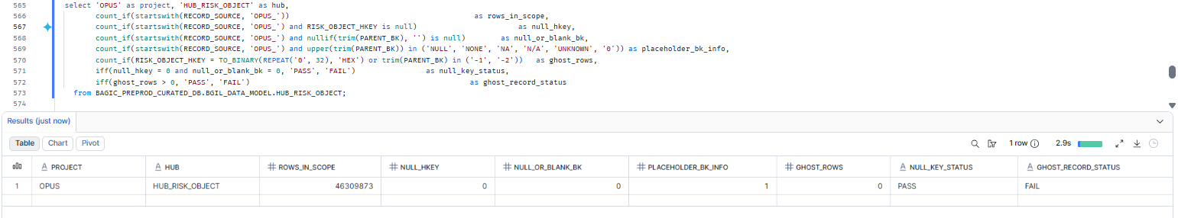

20. MAXIMUS + OPUS — Null / blank key detail (all hubs)
Project | MAXIMUS + OPUS
Hub table | Null / blank key detail (all hubs)
Status | Drill-down
Pass criteria | 0 rows returned
Result (Pass / Fail / NA) | Pass
Rows returned (count) | 0
Remarks | Drill-down across all 19 hub sections: 0 rows with a NULL hash key or NULL/blank business key, consistent with null_key_status = PASS in every section. Placeholder-value keys (non-blank text or punctuation used for "no value") are not NULL and are reported in their own sections (8, 17, 19).

Note: Drill-down evidence, not a separate criterion. Expected 0 rows when every null_key_status above is PASS.
SQL query
-- Lists every null / blank key row behind a FAIL in sections 1-19.
select 'MAXIMUS' as project, 'HUB_PARTY' as hub, PARTY_HKEY as hkey, PARENT_BK as bk, RECORD_SOURCE, LOAD_DATETIME
from BAGIC_PREPROD_CURATED_DB.BGIL_DATA_MODEL.HUB_PARTY
where startswith(RECORD_SOURCE, 'MAXIMUS_') and (PARTY_HKEY is null or nullif(trim(PARENT_BK), '') is null)
union all
select 'MAXIMUS' as project, 'HUB_STAKE_CODE' as hub, STAKE_CODE_HKEY as hkey, STAKE_CODE_BK as bk, RECORD_SOURCE, LOAD_DATETIME
from BAGIC_PREPROD_CURATED_DB.BGIL_DATA_MODEL.HUB_STAKE_CODE
where startswith(RECORD_SOURCE, 'MAXIMUS_') and (STAKE_CODE_HKEY is null or nullif(trim(STAKE_CODE_BK), '') is null)
union all
select 'MAXIMUS' as project, 'HUB_LOCATION' as hub, LOCATION_HKEY as hkey, PARENT_BK as bk, RECORD_SOURCE, LOAD_DATETIME
from BAGIC_PREPROD_CURATED_DB.BGIL_DATA_MODEL.HUB_LOCATION
where startswith(RECORD_SOURCE, 'MAXIMUS_') and (LOCATION_HKEY is null or nullif(trim(PARENT_BK), '') is null)
union all
select 'MAXIMUS' as project, 'HUB_PAYMENT_INSTRUMENT' as hub, PAYMENT_INSTRUMENT_HKEY as hkey, PARENT_BK as bk, RECORD_SOURCE, LOAD_DATETIME
from BAGIC_PREPROD_CURATED_DB.BGIL_DATA_MODEL.HUB_PAYMENT_INSTRUMENT
where startswith(RECORD_SOURCE, 'MAXIMUS_') and (PAYMENT_INSTRUMENT_HKEY is null or nullif(trim(PARENT_BK), '') is null)
union all
select 'MAXIMUS' as project, 'HUB_PRODUCT' as hub, PRODUCT_HKEY as hkey, PARENT_BK as bk, RECORD_SOURCE, LOAD_DATETIME
from BAGIC_PREPROD_CURATED_DB.BGIL_DATA_MODEL.HUB_PRODUCT
where startswith(RECORD_SOURCE, 'MAXIMUS_') and (PRODUCT_HKEY is null or nullif(trim(PARENT_BK), '') is null)
union all
select 'MAXIMUS' as project, 'HUB_FINANCIAL_ACCOUNT' as hub, FINANCIAL_ACCOUNT_HKEY as hkey, PARENT_BK as bk, RECORD_SOURCE, LOAD_DATETIME
from BAGIC_PREPROD_CURATED_DB.BGIL_DATA_MODEL.HUB_FINANCIAL_ACCOUNT
where startswith(RECORD_SOURCE, 'MAXIMUS_') and (FINANCIAL_ACCOUNT_HKEY is null or nullif(trim(PARENT_BK), '') is null)
union all
select 'MAXIMUS' as project, 'HUB_DOCUMENT' as hub, DOCUMENT_HKEY as hkey, PARENT_BK as bk, RECORD_SOURCE, LOAD_DATETIME
from BAGIC_PREPROD_CURATED_DB.BGIL_DATA_MODEL.HUB_DOCUMENT
where startswith(RECORD_SOURCE, 'MAXIMUS_') and (DOCUMENT_HKEY is null or nullif(trim(PARENT_BK), '') is null)
union all
select 'MAXIMUS' as project, 'HUB_POLICY' as hub, POLICY_HKEY as hkey, PARENT_BK as bk, RECORD_SOURCE, LOAD_DATETIME
from BAGIC_PREPROD_CURATED_DB.BGIL_DATA_MODEL.HUB_POLICY
where startswith(RECORD_SOURCE, 'MAXIMUS_') and (POLICY_HKEY is null or nullif(trim(PARENT_BK), '') is null)
union all
select 'MAXIMUS' as project, 'HUB_DISTRIBUTION_CHANNEL' as hub, DISTRIBUTION_CHANNEL_HKEY as hkey, PARENT_BK as bk, RECORD_SOURCE, LOAD_DATETIME
from BAGIC_PREPROD_CURATED_DB.BGIL_DATA_MODEL.HUB_DISTRIBUTION_CHANNEL
where startswith(RECORD_SOURCE, 'MAXIMUS_') and (DISTRIBUTION_CHANNEL_HKEY is null or nullif(trim(PARENT_BK), '') is null)
union all
select 'MAXIMUS' as project, 'HUB_ORG_UNIT' as hub, ORG_UNIT_HKEY as hkey, PARENT_BK as bk, RECORD_SOURCE, LOAD_DATETIME
from BAGIC_PREPROD_CURATED_DB.BGIL_DATA_MODEL.HUB_ORG_UNIT
where startswith(RECORD_SOURCE, 'MAXIMUS_') and (ORG_UNIT_HKEY is null or nullif(trim(PARENT_BK), '') is null)
union all
select 'OPUS' as project, 'HUB_PARTY' as hub, PARTY_HKEY as hkey, PARENT_BK as bk, RECORD_SOURCE, LOAD_DATETIME
from BAGIC_PREPROD_CURATED_DB.BGIL_DATA_MODEL.HUB_PARTY
where startswith(RECORD_SOURCE, 'OPUS_') and (PARTY_HKEY is null or nullif(trim(PARENT_BK), '') is null)
union all
select 'OPUS' as project, 'HUB_AGENT' as hub, AGENT_HKEY as hkey, PARENT_BK as bk, RECORD_SOURCE, LOAD_DATETIME
from BAGIC_PREPROD_CURATED_DB.BGIL_DATA_MODEL.HUB_AGENT
where startswith(RECORD_SOURCE, 'OPUS_') and (AGENT_HKEY is null or nullif(trim(PARENT_BK), '') is null)
union all
select 'OPUS' as project, 'HUB_AGREEMENT' as hub, AGREEMENT_HKEY as hkey, PARENT_BK as bk, RECORD_SOURCE, LOAD_DATETIME
from BAGIC_PREPROD_CURATED_DB.BGIL_DATA_MODEL.HUB_AGREEMENT
where startswith(RECORD_SOURCE, 'OPUS_') and (AGREEMENT_HKEY is null or nullif(trim(PARENT_BK), '') is null)
union all
select 'OPUS' as project, 'HUB_CLAIM' as hub, CLAIM_HKEY as hkey, PARENT_BK as bk, RECORD_SOURCE, LOAD_DATETIME
from BAGIC_PREPROD_CURATED_DB.BGIL_DATA_MODEL.HUB_CLAIM
where startswith(RECORD_SOURCE, 'OPUS_') and (CLAIM_HKEY is null or nullif(trim(PARENT_BK), '') is null)
union all
select 'OPUS' as project, 'HUB_DISTRIBUTION_CHANNEL' as hub, DISTRIBUTION_CHANNEL_HKEY as hkey, PARENT_BK as bk, RECORD_SOURCE, LOAD_DATETIME
from BAGIC_PREPROD_CURATED_DB.BGIL_DATA_MODEL.HUB_DISTRIBUTION_CHANNEL
where startswith(RECORD_SOURCE, 'OPUS_') and (DISTRIBUTION_CHANNEL_HKEY is null or nullif(trim(PARENT_BK), '') is null)
union all
select 'OPUS' as project, 'HUB_LOCATION' as hub, LOCATION_HKEY as hkey, PARENT_BK as bk, RECORD_SOURCE, LOAD_DATETIME
from BAGIC_PREPROD_CURATED_DB.BGIL_DATA_MODEL.HUB_LOCATION
where startswith(RECORD_SOURCE, 'OPUS_') and (LOCATION_HKEY is null or nullif(trim(PARENT_BK), '') is null)
union all
select 'OPUS' as project, 'HUB_POLICY' as hub, POLICY_HKEY as hkey, PARENT_BK as bk, RECORD_SOURCE, LOAD_DATETIME
from BAGIC_PREPROD_CURATED_DB.BGIL_DATA_MODEL.HUB_POLICY
where startswith(RECORD_SOURCE, 'OPUS_') and (POLICY_HKEY is null or nullif(trim(PARENT_BK), '') is null)
union all
select 'OPUS' as project, 'HUB_PRODUCT' as hub, PRODUCT_HKEY as hkey, PARENT_BK as bk, RECORD_SOURCE, LOAD_DATETIME
from BAGIC_PREPROD_CURATED_DB.BGIL_DATA_MODEL.HUB_PRODUCT
where startswith(RECORD_SOURCE, 'OPUS_') and (PRODUCT_HKEY is null or nullif(trim(PARENT_BK), '') is null)
union all
select 'OPUS' as project, 'HUB_RISK_OBJECT' as hub, RISK_OBJECT_HKEY as hkey, PARENT_BK as bk, RECORD_SOURCE, LOAD_DATETIME
from BAGIC_PREPROD_CURATED_DB.BGIL_DATA_MODEL.HUB_RISK_OBJECT
where startswith(RECORD_SOURCE, 'OPUS_') and (RISK_OBJECT_HKEY is null or nullif(trim(PARENT_BK), '') is null)
order by project, hub;
Query output (attach / paste below)
Output:
