DM-T2 | Load Audit — Hash Key Integrity (DV2.0) (MAXIMUS)
Hash keys generated consistently; no null hash keys; no unexpected collisions. Pass criterion: 0 null; 0 unexpected collisions.

Check Overview
Check ID | DM-T2
Category | Load audit
Sign-off criterion | Hash key integrity (DV2.0)
Method | (a) hash column types; (b) per table: null / wrong-length hash keys, hub key recomputed from the stored business key, hub and link collisions
Evidence required | Hash null / collision query
Pass criteria / tolerance | 0 null; 0 unexpected collisions
Owner | LUMIQ
Vault location | BAGIC_PREPROD_CURATED_DB.BGIL_DATA_MODEL
Maximus RAW | BAGIC_PROD_MIRROR_DB.MAXI_RAW
Opus RAW (test) | BAGIC_PREPROD_CURATED_DB.UTILS (prod: BAGIC_PROD_MIRROR_DB.OPUS_GG_DWHSTAGE)
Scope | Every hub, link and satellite the project's models load (standard + augmented). Rows scoped by the project's RECORD_SOURCE prefix (OBJECT satellites: RECORD_SOURCE = project). Shared physical tables appear in both project files, each checking its own rows; rows owned by neither are listed by the DM-K2 ownership sweep.
Hash key formula | MD5_BINARY(NULLIF(UPPER(TRIM(CAST(<NK> AS VARCHAR))), '')) -- BINARY(16), automate_dv 0.11.5 default
Project in this file | MAXIMUS

Revision notes
• Generated 2026-10-13 from the current maximus_partner_dv_dbt models by validation/tools/gen_dm_t.py.
• This file: MAXIMUS only -- 10 hubs, 3 links, 98 satellites. The other project is in the sibling file.

Results summary
# | Project | Satellite | Status | Result | Failing rows
1 | MAXIMUS | Hash column types (all tables) | Implemented
2 | MAXIMUS | HUB HUB_DISTRIBUTION_CHANNEL [Partner LOB] | Implemented
3 | MAXIMUS | HUB HUB_DOCUMENT [Partner LOB] | Implemented
4 | MAXIMUS | HUB HUB_FINANCIAL_ACCOUNT [Partner LOB] | Implemented
5 | MAXIMUS | HUB HUB_LOCATION [Partner LOB] | Implemented
6 | MAXIMUS | HUB HUB_ORG_UNIT [Partner LOB] | Implemented
7 | MAXIMUS | HUB HUB_PARTY [Partner LOB] | Implemented
8 | MAXIMUS | HUB HUB_PAYMENT_INSTRUMENT [Partner LOB] | Implemented
9 | MAXIMUS | HUB HUB_POLICY [Partner LOB] | Implemented
10 | MAXIMUS | HUB HUB_PRODUCT [Partner LOB] | Implemented
11 | MAXIMUS | HUB HUB_STAKE_CODE | Implemented
12 | MAXIMUS | LINK LNK_PARTY_LOCATION [Partner LOB] | Implemented
13 | MAXIMUS | LINK LNK_PARTY_RELATIONSHIP [Partner LOB] | Implemented
14 | MAXIMUS | LINK LNK_PARTY_ROLE [Partner LOB] | Implemented
15 | MAXIMUS | SATELLITE SAT_AUG_COMMON_ADDRESS [Partner LOB] | Implemented
16 | MAXIMUS | SATELLITE SAT_AUG_COMMON_ADMIN_GEOGRAPHY [Partner LOB] | Implemented
17 | MAXIMUS | SATELLITE SAT_AUG_COMMON_CLASSIFICATION [Partner LOB] | Implemented
18 | MAXIMUS | SATELLITE SAT_AUG_COMMON_COMMUNICATION_PREFERENCE [Partner LOB] | Implemented
19 | MAXIMUS | SATELLITE SAT_AUG_COMMON_CONTACT [Partner LOB] | Implemented
20 | MAXIMUS | SATELLITE SAT_AUG_COMMON_GEO [Partner LOB] | Implemented
21 | MAXIMUS | SATELLITE SAT_AUG_INSTRUMENT_DEFINITION [Partner LOB] | Implemented
22 | MAXIMUS | SATELLITE SAT_AUG_LNK_PARTY_ROLE_CORE [Partner LOB] | Implemented
23 | MAXIMUS | SATELLITE SAT_AUG_LNK_ROLE_AGENT [Partner LOB] | Implemented
24 | MAXIMUS | SATELLITE SAT_AUG_LNK_ROLE_CUSTOMER [Partner LOB] | Implemented
25 | MAXIMUS | SATELLITE SAT_AUG_LNK_ROLE_NOMINEE_BENEFICIARY [Partner LOB] | Implemented
26 | MAXIMUS | SATELLITE SAT_AUG_LNK_ROLE_PROVIDER [Partner LOB] | Implemented
27 | MAXIMUS | SATELLITE SAT_AUG_LNK_ROLE_SURVEYOR [Partner LOB] | Implemented
28 | MAXIMUS | SATELLITE SAT_AUG_PARTY_AGENT_PRODUCTION | Implemented
29 | MAXIMUS | SATELLITE SAT_AUG_PARTY_AMENDMENT_ENDORSEMENT | Implemented
30 | MAXIMUS | SATELLITE SAT_AUG_PARTY_BANKING [Partner LOB] | Implemented
31 | MAXIMUS | SATELLITE SAT_AUG_PARTY_CLAIM_HISTORY | Implemented
32 | MAXIMUS | SATELLITE SAT_AUG_PARTY_CONTACT_ADDRESS_LINK [Partner LOB] | Implemented
33 | MAXIMUS | SATELLITE SAT_AUG_PARTY_CORRESPONDENCE | Implemented
34 | MAXIMUS | SATELLITE SAT_AUG_PARTY_CREDIT_CONTROL_PAYMENT_TERMS | Implemented
35 | MAXIMUS | SATELLITE SAT_AUG_PARTY_DIGITAL_IDENTITY [Partner LOB] | Implemented
36 | MAXIMUS | SATELLITE SAT_AUG_PARTY_DRIVING | Implemented
37 | MAXIMUS | SATELLITE SAT_AUG_PARTY_EMPLOYMENT [Partner LOB] | Implemented
38 | MAXIMUS | SATELLITE SAT_AUG_PARTY_FINANCIAL_PROFILE [Partner LOB] | Implemented
39 | MAXIMUS | SATELLITE SAT_AUG_PARTY_FRAUD_PROFILE [Partner LOB] | Implemented
40 | MAXIMUS | SATELLITE SAT_AUG_PARTY_GROUP_SCHEME | Implemented
41 | MAXIMUS | SATELLITE SAT_AUG_PARTY_HEALTH_PROFILE [Partner LOB] | Implemented
42 | MAXIMUS | SATELLITE SAT_AUG_PARTY_HIERARCHY [Partner LOB] | Implemented
43 | MAXIMUS | SATELLITE SAT_AUG_PARTY_IDENTIFICATION [Partner LOB] | Implemented
44 | MAXIMUS | SATELLITE SAT_AUG_PARTY_IDENTITY [Partner LOB] | Implemented
45 | MAXIMUS | SATELLITE SAT_AUG_PARTY_INDIVIDUAL_DEMOGRAPHICS [Partner LOB] | Implemented
46 | MAXIMUS | SATELLITE SAT_AUG_PARTY_INTERACTION | Implemented
47 | MAXIMUS | SATELLITE SAT_AUG_PARTY_KYC [Partner LOB] | Implemented
48 | MAXIMUS | SATELLITE SAT_AUG_PARTY_LEGAL_PANEL [Partner LOB] | Implemented
49 | MAXIMUS | SATELLITE SAT_AUG_PARTY_LEGAL_PANEL_ROLE_LINE | Implemented
50 | MAXIMUS | SATELLITE SAT_AUG_PARTY_MARKETING | Implemented
51 | MAXIMUS | SATELLITE SAT_AUG_PARTY_ONBOARDING_JOURNEY [Partner LOB] | Implemented
52 | MAXIMUS | SATELLITE SAT_AUG_PARTY_ORGANISATION_PROFILE [Partner LOB] | Implemented
53 | MAXIMUS | SATELLITE SAT_AUG_PARTY_ORG_DIRECTORS [Partner LOB] | Implemented
54 | MAXIMUS | SATELLITE SAT_AUG_PARTY_PAYOUT_PROFILE [Partner LOB] | Implemented
55 | MAXIMUS | SATELLITE SAT_AUG_PARTY_PREFERENCE_PROFILE | Implemented
56 | MAXIMUS | SATELLITE SAT_AUG_PARTY_PROVIDER_CAPABILITY [Partner LOB] | Implemented
57 | MAXIMUS | SATELLITE SAT_AUG_PARTY_RECORD_REMARKS | Implemented
58 | MAXIMUS | SATELLITE SAT_AUG_PARTY_RELATIONSHIP_PROFILE [Partner LOB] | Implemented
59 | MAXIMUS | SATELLITE SAT_AUG_PARTY_SERVICE_ENGAGEMENT_TERMS | Implemented
60 | MAXIMUS | SATELLITE SAT_AUG_PARTY_SOURCE_PROPERTY_SET_RECORD_GOVERNANCE | Implemented
61 | MAXIMUS | SATELLITE SAT_AUG_PARTY_SUSPENSION_NEGATIVE_ACTION | Implemented
62 | MAXIMUS | SATELLITE SAT_AUG_PARTY_VEHICLE_OWNER | Implemented
63 | MAXIMUS | SATELLITE SAT_AUG_PROVIDER_BANKING [Partner LOB] | Implemented
64 | MAXIMUS | SATELLITE SAT_AUG_PROVIDER_QUALITY [Partner LOB] | Implemented
65 | MAXIMUS | SATELLITE SAT_AUG_PROVIDER_TARIFF [Partner LOB] | Implemented
66 | MAXIMUS | SATELLITE SAT_CHANNEL_DEFINITION [Partner LOB] | Implemented
67 | MAXIMUS | SATELLITE SAT_COMMON_ADDRESS [Partner LOB] | Implemented
68 | MAXIMUS | SATELLITE SAT_COMMON_ADMIN_GEOGRAPHY [Partner LOB] | Implemented
69 | MAXIMUS | SATELLITE SAT_COMMON_CLASSIFICATION [Partner LOB] | Implemented
70 | MAXIMUS | SATELLITE SAT_COMMON_COMMUNICATION_PREFERENCE [Partner LOB] | Implemented
71 | MAXIMUS | SATELLITE SAT_COMMON_CONSENT [Partner LOB] | Implemented
72 | MAXIMUS | SATELLITE SAT_COMMON_CONTACT [Partner LOB] | Implemented
73 | MAXIMUS | SATELLITE SAT_COMMON_GEO [Partner LOB] | Implemented
74 | MAXIMUS | SATELLITE SAT_DOCUMENT_DEFINITION [Partner LOB] | Implemented
75 | MAXIMUS | SATELLITE SAT_INSTRUMENT_DEFINITION [Partner LOB] | Implemented
76 | MAXIMUS | SATELLITE SAT_LNK_PARTY_ROLE_CORE [Partner LOB] | Implemented
77 | MAXIMUS | SATELLITE SAT_LNK_ROLE_AGENT [Partner LOB] | Implemented
78 | MAXIMUS | SATELLITE SAT_LNK_ROLE_CUSTOMER [Partner LOB] | Implemented
79 | MAXIMUS | SATELLITE SAT_LNK_ROLE_EMPLOYEE [Partner LOB] | Implemented
80 | MAXIMUS | SATELLITE SAT_LNK_ROLE_INVESTIGATOR [Partner LOB] | Implemented
81 | MAXIMUS | SATELLITE SAT_LNK_ROLE_NOMINEE_BENEFICIARY [Partner LOB] | Implemented
82 | MAXIMUS | SATELLITE SAT_LNK_ROLE_PROVIDER [Partner LOB] | Implemented
83 | MAXIMUS | SATELLITE SAT_LNK_ROLE_SURVEYOR [Partner LOB] | Implemented
84 | MAXIMUS | SATELLITE SAT_LOCATION_PROFILE [Partner LOB] | Implemented
85 | MAXIMUS | SATELLITE SAT_ORG_UNIT_DEFINITION [Partner LOB] | Implemented
86 | MAXIMUS | SATELLITE SAT_ORG_UNIT_LICENCE [Partner LOB] | Implemented
87 | MAXIMUS | SATELLITE SAT_PARTY_AGENT_LICENCE_LINE [Partner LOB] | Implemented
88 | MAXIMUS | SATELLITE SAT_PARTY_AML_SCREENING [Partner LOB] | Implemented
89 | MAXIMUS | SATELLITE SAT_PARTY_BANKING [Partner LOB] | Implemented
90 | MAXIMUS | SATELLITE SAT_PARTY_CONSENT_MANDATE [Partner LOB] | Implemented
91 | MAXIMUS | SATELLITE SAT_PARTY_CONTACT_ADDRESS_LINK [Partner LOB] | Implemented
92 | MAXIMUS | SATELLITE SAT_PARTY_DIGITAL_IDENTITY [Partner LOB] | Implemented
93 | MAXIMUS | SATELLITE SAT_PARTY_EMPLOYMENT [Partner LOB] | Implemented
94 | MAXIMUS | SATELLITE SAT_PARTY_FINANCIAL_PROFILE [Partner LOB] | Implemented
95 | MAXIMUS | SATELLITE SAT_PARTY_FRAUD_PROFILE [Partner LOB] | Implemented
96 | MAXIMUS | SATELLITE SAT_PARTY_HEALTH_PROFILE [Partner LOB] | Implemented
97 | MAXIMUS | SATELLITE SAT_PARTY_HIERARCHY [Partner LOB] | Implemented
98 | MAXIMUS | SATELLITE SAT_PARTY_IDENTIFICATION [Partner LOB] | Implemented
99 | MAXIMUS | SATELLITE SAT_PARTY_IDENTITY [Partner LOB] | Implemented
100 | MAXIMUS | SATELLITE SAT_PARTY_INDIVIDUAL_DEMOGRAPHICS [Partner LOB] | Implemented
101 | MAXIMUS | SATELLITE SAT_PARTY_KYC [Partner LOB] | Implemented
102 | MAXIMUS | SATELLITE SAT_PARTY_LEGAL_PANEL [Partner LOB] | Implemented
103 | MAXIMUS | SATELLITE SAT_PARTY_ONBOARDING_JOURNEY [Partner LOB] | Implemented
104 | MAXIMUS | SATELLITE SAT_PARTY_ORGANISATION_PROFILE [Partner LOB] | Implemented
105 | MAXIMUS | SATELLITE SAT_PARTY_ORG_DIRECTORS [Partner LOB] | Implemented
106 | MAXIMUS | SATELLITE SAT_PARTY_PAYOUT_PROFILE [Partner LOB] | Implemented
107 | MAXIMUS | SATELLITE SAT_PARTY_PROVIDER_CAPABILITY [Partner LOB] | Implemented
108 | MAXIMUS | SATELLITE SAT_PARTY_RELATIONSHIP_PROFILE [Partner LOB] | Implemented
109 | MAXIMUS | SATELLITE SAT_PRODUCT_DEFINITION [Partner LOB] | Implemented
110 | MAXIMUS | SATELLITE SAT_PROVIDER_BANKING [Partner LOB] | Implemented
111 | MAXIMUS | SATELLITE SAT_PROVIDER_QUALITY [Partner LOB] | Implemented
112 | MAXIMUS | SATELLITE SAT_PROVIDER_TARIFF [Partner LOB] | Implemented

Validation Queries

1. MAXIMUS — Hash column types (all tables)
Project | MAXIMUS
Satellite | Hash column types (all tables)
Status | Implemented
Pass criteria | every row status = PASS (BINARY(16))
Result (Pass / Fail / NA) | Pass
Rows with status = FAIL (count)
Remarks

Note: Every *_HKEY and HASHDIFF column of the project's hubs, links and satellites must be BINARY(16) (MD5_BINARY).
SQL query
select 'MAXIMUS' as project, table_name, column_name, data_type, character_maximum_length as byte_length,
iff(data_type = 'BINARY' and character_maximum_length = 16, 'PASS', 'FAIL') as status
from BAGIC_PREPROD_CURATED_DB.INFORMATION_SCHEMA.COLUMNS
where table_schema = 'BGIL_DATA_MODEL'
and table_name in ('HUB_DISTRIBUTION_CHANNEL', 'HUB_DOCUMENT', 'HUB_FINANCIAL_ACCOUNT', 'HUB_LOCATION', 'HUB_ORG_UNIT', 'HUB_PARTY', 'HUB_PAYMENT_INSTRUMENT', 'HUB_POLICY', 'HUB_PRODUCT', 'HUB_STAKE_CODE', 'LNK_PARTY_LOCATION', 'LNK_PARTY_RELATIONSHIP', 'LNK_PARTY_ROLE', 'SAT_AUG_COMMON_ADDRESS', 'SAT_AUG_COMMON_ADMIN_GEOGRAPHY', 'SAT_AUG_COMMON_CLASSIFICATION', 'SAT_AUG_COMMON_COMMUNICATION_PREFERENCE', 'SAT_AUG_COMMON_CONTACT', 'SAT_AUG_COMMON_GEO', 'SAT_AUG_INSTRUMENT_DEFINITION', 'SAT_AUG_LNK_PARTY_ROLE_CORE', 'SAT_AUG_LNK_ROLE_AGENT', 'SAT_AUG_LNK_ROLE_CUSTOMER', 'SAT_AUG_LNK_ROLE_NOMINEE_BENEFICIARY', 'SAT_AUG_LNK_ROLE_PROVIDER', 'SAT_AUG_LNK_ROLE_SURVEYOR', 'SAT_AUG_PARTY_AGENT_PRODUCTION', 'SAT_AUG_PARTY_AMENDMENT_ENDORSEMENT', 'SAT_AUG_PARTY_BANKING', 'SAT_AUG_PARTY_CLAIM_HISTORY', 'SAT_AUG_PARTY_CONTACT_ADDRESS_LINK', 'SAT_AUG_PARTY_CORRESPONDENCE', 'SAT_AUG_PARTY_CREDIT_CONTROL_PAYMENT_TERMS', 'SAT_AUG_PARTY_DIGITAL_IDENTITY', 'SAT_AUG_PARTY_DRIVING', 'SAT_AUG_PARTY_EMPLOYMENT', 'SAT_AUG_PARTY_FINANCIAL_PROFILE', 'SAT_AUG_PARTY_FRAUD_PROFILE', 'SAT_AUG_PARTY_GROUP_SCHEME', 'SAT_AUG_PARTY_HEALTH_PROFILE', 'SAT_AUG_PARTY_HIERARCHY', 'SAT_AUG_PARTY_IDENTIFICATION', 'SAT_AUG_PARTY_IDENTITY', 'SAT_AUG_PARTY_INDIVIDUAL_DEMOGRAPHICS', 'SAT_AUG_PARTY_INTERACTION', 'SAT_AUG_PARTY_KYC', 'SAT_AUG_PARTY_LEGAL_PANEL', 'SAT_AUG_PARTY_LEGAL_PANEL_ROLE_LINE', 'SAT_AUG_PARTY_MARKETING', 'SAT_AUG_PARTY_ONBOARDING_JOURNEY', 'SAT_AUG_PARTY_ORGANISATION_PROFILE', 'SAT_AUG_PARTY_ORG_DIRECTORS', 'SAT_AUG_PARTY_PAYOUT_PROFILE', 'SAT_AUG_PARTY_PREFERENCE_PROFILE', 'SAT_AUG_PARTY_PROVIDER_CAPABILITY', 'SAT_AUG_PARTY_RECORD_REMARKS', 'SAT_AUG_PARTY_RELATIONSHIP_PROFILE', 'SAT_AUG_PARTY_SERVICE_ENGAGEMENT_TERMS', 'SAT_AUG_PARTY_SOURCE_PROPERTY_SET_RECORD_GOVERNANCE', 'SAT_AUG_PARTY_SUSPENSION_NEGATIVE_ACTION', 'SAT_AUG_PARTY_VEHICLE_OWNER', 'SAT_AUG_PROVIDER_BANKING', 'SAT_AUG_PROVIDER_QUALITY', 'SAT_AUG_PROVIDER_TARIFF', 'SAT_CHANNEL_DEFINITION', 'SAT_COMMON_ADDRESS', 'SAT_COMMON_ADMIN_GEOGRAPHY', 'SAT_COMMON_CLASSIFICATION', 'SAT_COMMON_COMMUNICATION_PREFERENCE', 'SAT_COMMON_CONSENT', 'SAT_COMMON_CONTACT', 'SAT_COMMON_GEO', 'SAT_DOCUMENT_DEFINITION', 'SAT_INSTRUMENT_DEFINITION', 'SAT_LNK_PARTY_ROLE_CORE', 'SAT_LNK_ROLE_AGENT', 'SAT_LNK_ROLE_CUSTOMER', 'SAT_LNK_ROLE_EMPLOYEE', 'SAT_LNK_ROLE_INVESTIGATOR', 'SAT_LNK_ROLE_NOMINEE_BENEFICIARY', 'SAT_LNK_ROLE_PROVIDER', 'SAT_LNK_ROLE_SURVEYOR', 'SAT_LOCATION_PROFILE', 'SAT_ORG_UNIT_DEFINITION', 'SAT_ORG_UNIT_LICENCE', 'SAT_PARTY_AGENT_LICENCE_LINE', 'SAT_PARTY_AML_SCREENING', 'SAT_PARTY_BANKING', 'SAT_PARTY_CONSENT_MANDATE', 'SAT_PARTY_CONTACT_ADDRESS_LINK', 'SAT_PARTY_DIGITAL_IDENTITY', 'SAT_PARTY_EMPLOYMENT', 'SAT_PARTY_FINANCIAL_PROFILE', 'SAT_PARTY_FRAUD_PROFILE', 'SAT_PARTY_HEALTH_PROFILE', 'SAT_PARTY_HIERARCHY', 'SAT_PARTY_IDENTIFICATION', 'SAT_PARTY_IDENTITY', 'SAT_PARTY_INDIVIDUAL_DEMOGRAPHICS', 'SAT_PARTY_KYC', 'SAT_PARTY_LEGAL_PANEL', 'SAT_PARTY_ONBOARDING_JOURNEY', 'SAT_PARTY_ORGANISATION_PROFILE', 'SAT_PARTY_ORG_DIRECTORS', 'SAT_PARTY_PAYOUT_PROFILE', 'SAT_PARTY_PROVIDER_CAPABILITY', 'SAT_PARTY_RELATIONSHIP_PROFILE', 'SAT_PRODUCT_DEFINITION', 'SAT_PROVIDER_BANKING', 'SAT_PROVIDER_QUALITY', 'SAT_PROVIDER_TARIFF')
and (column_name like '%\\_HKEY' escape '\\' or column_name like 'HASHDIFF%')
order by iff(status = 'FAIL', 0, 1), table_name, column_name;
Query output (attach / paste below)
Output:
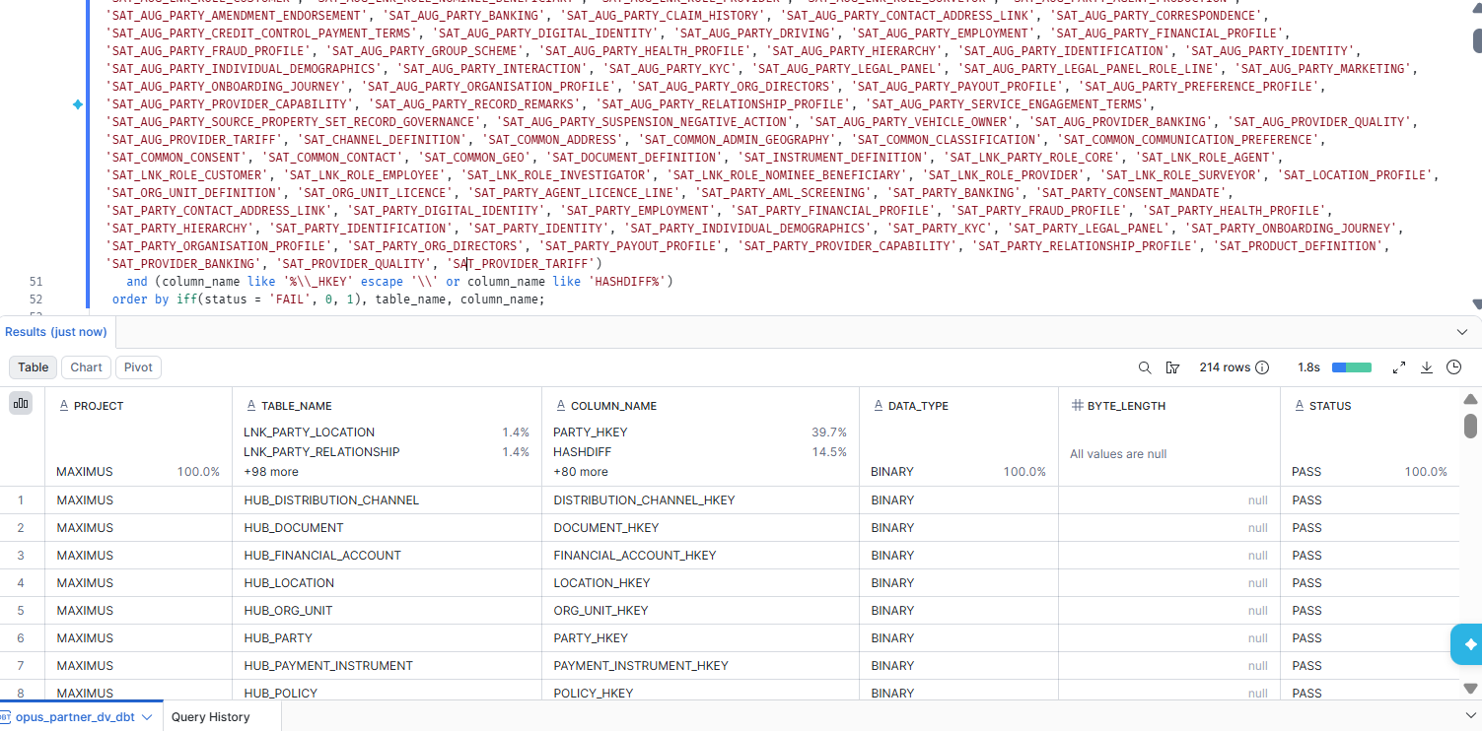

2. MAXIMUS — HUB HUB_DISTRIBUTION_CHANNEL [Partner LOB]
Project | MAXIMUS
Satellite | HUB HUB_DISTRIBUTION_CHANNEL [Partner LOB]
Status | Implemented
Pass criteria | status = PASS
Result (Pass / Fail / NA) | Pass
Rows with status = FAIL (count)
Remarks

Note: Recompute: MD5_BINARY(NULLIF(UPPER(TRIM(CAST('HUB_DISTRIBUTION_CHANNEL|' || PARENT_BK AS VARCHAR))), '')) must equal DISTRIBUTION_CHANNEL_HKEY. collisions = hash keys carrying more than one PARENT_BK. Overlaps DM-K3 (nulls) and DM-K4 (uniqueness) but adds the recompute and length checks.
SQL query
with c as (
select DISTRIBUTION_CHANNEL_HKEY as hkey, count(distinct PARENT_BK) as bks
from BAGIC_PREPROD_CURATED_DB.BGIL_DATA_MODEL.HUB_DISTRIBUTION_CHANNEL where startswith(RECORD_SOURCE, 'MAXIMUS_') group by DISTRIBUTION_CHANNEL_HKEY having count(distinct PARENT_BK) > 1
)
select 'MAXIMUS' as project, 'hub' as table_type, 'HUB_DISTRIBUTION_CHANNEL' as table_name,
count(*) as rows_in_scope,
count_if(DISTRIBUTION_CHANNEL_HKEY is null) as null_hkey,
count_if(DISTRIBUTION_CHANNEL_HKEY is not null and length(DISTRIBUTION_CHANNEL_HKEY) <> 16) as wrong_length_hkey,
count_if(DISTRIBUTION_CHANNEL_HKEY is not null and PARENT_BK is not null and DISTRIBUTION_CHANNEL_HKEY <> MD5_BINARY(NULLIF(UPPER(TRIM(CAST('HUB_DISTRIBUTION_CHANNEL|' || PARENT_BK AS VARCHAR))), ''))) as hkey_not_recomputable,
(select count(*) from c) as collisions,
iff(null_hkey = 0 and wrong_length_hkey = 0 and coalesce(hkey_not_recomputable, 0) = 0 and collisions = 0, 'PASS', 'FAIL') as status
from BAGIC_PREPROD_CURATED_DB.BGIL_DATA_MODEL.HUB_DISTRIBUTION_CHANNEL
where startswith(RECORD_SOURCE, 'MAXIMUS_');
Query output (attach / paste below)
Output:
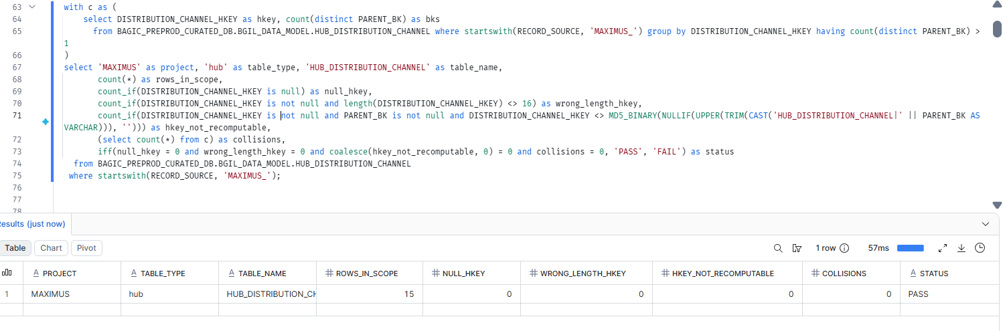

3. MAXIMUS — HUB HUB_DOCUMENT [Partner LOB]
Project | MAXIMUS
Satellite | HUB HUB_DOCUMENT [Partner LOB]
Status | Implemented
Pass criteria | status = PASS
Result (Pass / Fail / NA) | Pass
Rows with status = FAIL (count)
Remarks

Note: Recompute: MD5_BINARY(NULLIF(UPPER(TRIM(CAST('HUB_DOCUMENT|' || PARENT_BK AS VARCHAR))), '')) must equal DOCUMENT_HKEY. collisions = hash keys carrying more than one PARENT_BK. Overlaps DM-K3 (nulls) and DM-K4 (uniqueness) but adds the recompute and length checks.
SQL query
with c as (
select DOCUMENT_HKEY as hkey, count(distinct PARENT_BK) as bks
from BAGIC_PREPROD_CURATED_DB.BGIL_DATA_MODEL.HUB_DOCUMENT where startswith(RECORD_SOURCE, 'MAXIMUS_') group by DOCUMENT_HKEY having count(distinct PARENT_BK) > 1
)
select 'MAXIMUS' as project, 'hub' as table_type, 'HUB_DOCUMENT' as table_name,
count(*) as rows_in_scope,
count_if(DOCUMENT_HKEY is null) as null_hkey,
count_if(DOCUMENT_HKEY is not null and length(DOCUMENT_HKEY) <> 16) as wrong_length_hkey,
count_if(DOCUMENT_HKEY is not null and PARENT_BK is not null and DOCUMENT_HKEY <> MD5_BINARY(NULLIF(UPPER(TRIM(CAST('HUB_DOCUMENT|' || PARENT_BK AS VARCHAR))), ''))) as hkey_not_recomputable,
(select count(*) from c) as collisions,
iff(null_hkey = 0 and wrong_length_hkey = 0 and coalesce(hkey_not_recomputable, 0) = 0 and collisions = 0, 'PASS', 'FAIL') as status
from BAGIC_PREPROD_CURATED_DB.BGIL_DATA_MODEL.HUB_DOCUMENT
where startswith(RECORD_SOURCE, 'MAXIMUS_');
Query output (attach / paste below)
Output:
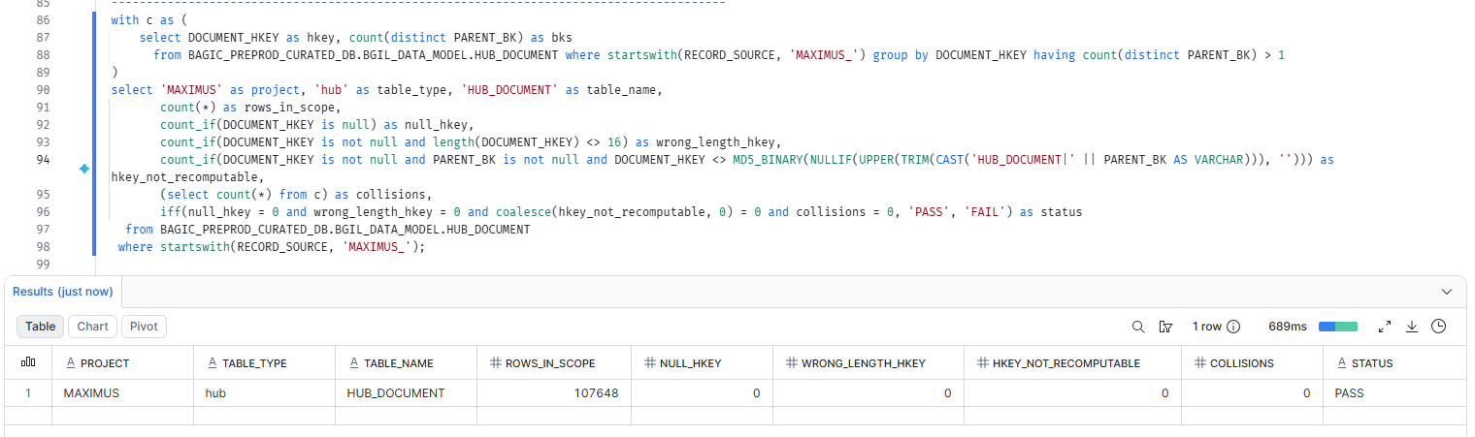

4. MAXIMUS — HUB HUB_FINANCIAL_ACCOUNT [Partner LOB]
Project | MAXIMUS
Satellite | HUB HUB_FINANCIAL_ACCOUNT [Partner LOB]
Status | Implemented
Pass criteria | status = PASS
Result (Pass / Fail / NA) | Fail(Due to Source data null)
Rows with status = FAIL (count)
Remarks | Due to null at source for agent_code column.

Note: Recompute: n/a (feeds use more than one NK prefix) must equal FINANCIAL_ACCOUNT_HKEY. collisions = hash keys carrying more than one PARENT_BK. Overlaps DM-K3 (nulls) and DM-K4 (uniqueness) but adds the recompute and length checks.
SQL query
with c as (
select FINANCIAL_ACCOUNT_HKEY as hkey, count(distinct PARENT_BK) as bks
from BAGIC_PREPROD_CURATED_DB.BGIL_DATA_MODEL.HUB_FINANCIAL_ACCOUNT where startswith(RECORD_SOURCE, 'MAXIMUS_') group by FINANCIAL_ACCOUNT_HKEY having count(distinct PARENT_BK) > 1
)
select 'MAXIMUS' as project, 'hub' as table_type, 'HUB_FINANCIAL_ACCOUNT' as table_name,
count(*) as rows_in_scope,
count_if(FINANCIAL_ACCOUNT_HKEY is null) as null_hkey,
count_if(FINANCIAL_ACCOUNT_HKEY is not null and length(FINANCIAL_ACCOUNT_HKEY) <> 16) as wrong_length_hkey,
null as hkey_not_recomputable,
(select count(*) from c) as collisions,
iff(null_hkey = 0 and wrong_length_hkey = 0 and coalesce(hkey_not_recomputable, 0) = 0 and collisions = 0, 'PASS', 'FAIL') as status
from BAGIC_PREPROD_CURATED_DB.BGIL_DATA_MODEL.HUB_FINANCIAL_ACCOUNT
where startswith(RECORD_SOURCE, 'MAXIMUS_');
Query output (attach / paste below)
Output:
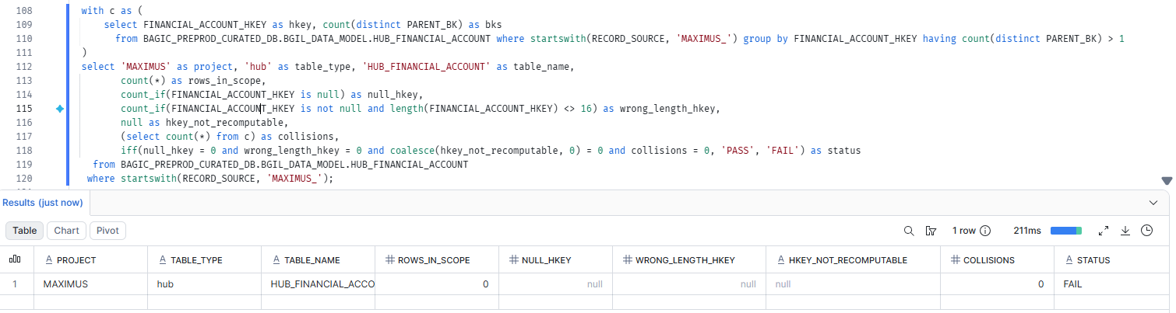

5. MAXIMUS — HUB HUB_LOCATION [Partner LOB]
Project | MAXIMUS
Satellite | HUB HUB_LOCATION [Partner LOB]
Status | Implemented
Pass criteria | status = PASS
Result (Pass / Fail / NA) | Pass
Rows with status = FAIL (count)
Remarks

Note: Recompute: MD5_BINARY(NULLIF(UPPER(TRIM(CAST('HUB_LOCATION|' || PARENT_BK AS VARCHAR))), '')) must equal LOCATION_HKEY. collisions = hash keys carrying more than one PARENT_BK. Overlaps DM-K3 (nulls) and DM-K4 (uniqueness) but adds the recompute and length checks.
SQL query
with c as (
select LOCATION_HKEY as hkey, count(distinct PARENT_BK) as bks
from BAGIC_PREPROD_CURATED_DB.BGIL_DATA_MODEL.HUB_LOCATION where startswith(RECORD_SOURCE, 'MAXIMUS_') group by LOCATION_HKEY having count(distinct PARENT_BK) > 1
)
select 'MAXIMUS' as project, 'hub' as table_type, 'HUB_LOCATION' as table_name,
count(*) as rows_in_scope,
count_if(LOCATION_HKEY is null) as null_hkey,
count_if(LOCATION_HKEY is not null and length(LOCATION_HKEY) <> 16) as wrong_length_hkey,
count_if(LOCATION_HKEY is not null and PARENT_BK is not null and LOCATION_HKEY <> MD5_BINARY(NULLIF(UPPER(TRIM(CAST('HUB_LOCATION|' || PARENT_BK AS VARCHAR))), ''))) as hkey_not_recomputable,
(select count(*) from c) as collisions,
iff(null_hkey = 0 and wrong_length_hkey = 0 and coalesce(hkey_not_recomputable, 0) = 0 and collisions = 0, 'PASS', 'FAIL') as status
from BAGIC_PREPROD_CURATED_DB.BGIL_DATA_MODEL.HUB_LOCATION
where startswith(RECORD_SOURCE, 'MAXIMUS_');
Query output (attach / paste below)
Output:
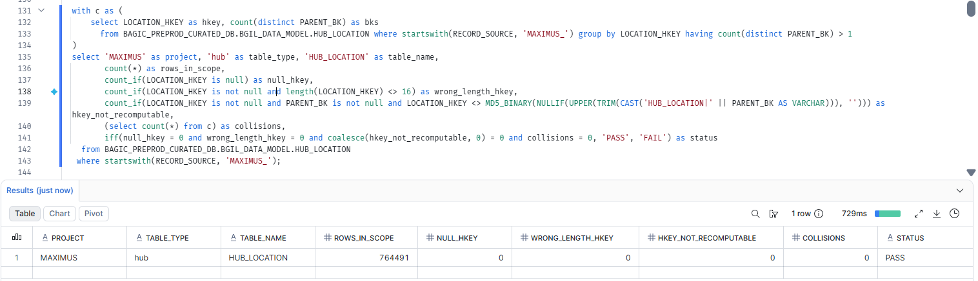

6. MAXIMUS — HUB HUB_ORG_UNIT [Partner LOB]
Project | MAXIMUS
Satellite | HUB HUB_ORG_UNIT [Partner LOB]
Status | Implemented
Pass criteria | status = PASS
Result (Pass / Fail / NA) | Pass
Rows with status = FAIL (count)
Remarks

Note: Recompute: MD5_BINARY(NULLIF(UPPER(TRIM(CAST('HUB_ORG_UNIT|' || PARENT_BK AS VARCHAR))), '')) must equal ORG_UNIT_HKEY. collisions = hash keys carrying more than one PARENT_BK. Overlaps DM-K3 (nulls) and DM-K4 (uniqueness) but adds the recompute and length checks.
SQL query
with c as (
select ORG_UNIT_HKEY as hkey, count(distinct PARENT_BK) as bks
from BAGIC_PREPROD_CURATED_DB.BGIL_DATA_MODEL.HUB_ORG_UNIT where startswith(RECORD_SOURCE, 'MAXIMUS_') group by ORG_UNIT_HKEY having count(distinct PARENT_BK) > 1
)
select 'MAXIMUS' as project, 'hub' as table_type, 'HUB_ORG_UNIT' as table_name,
count(*) as rows_in_scope,
count_if(ORG_UNIT_HKEY is null) as null_hkey,
count_if(ORG_UNIT_HKEY is not null and length(ORG_UNIT_HKEY) <> 16) as wrong_length_hkey,
count_if(ORG_UNIT_HKEY is not null and PARENT_BK is not null and ORG_UNIT_HKEY <> MD5_BINARY(NULLIF(UPPER(TRIM(CAST('HUB_ORG_UNIT|' || PARENT_BK AS VARCHAR))), ''))) as hkey_not_recomputable,
(select count(*) from c) as collisions,
iff(null_hkey = 0 and wrong_length_hkey = 0 and coalesce(hkey_not_recomputable, 0) = 0 and collisions = 0, 'PASS', 'FAIL') as status
from BAGIC_PREPROD_CURATED_DB.BGIL_DATA_MODEL.HUB_ORG_UNIT
where startswith(RECORD_SOURCE, 'MAXIMUS_');
Query output (attach / paste below)
Output:
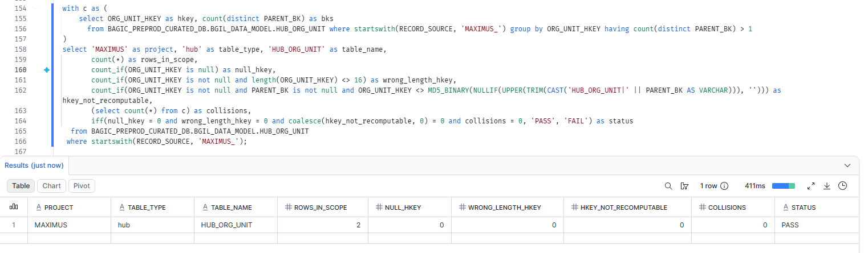

7. MAXIMUS — HUB HUB_PARTY [Partner LOB]
Project | MAXIMUS
Satellite | HUB HUB_PARTY [Partner LOB]
Status | Implemented
Pass criteria | status = PASS
Result (Pass / Fail / NA) | Pass
Rows with status = FAIL (count)
Remarks

Note: Recompute: MD5_BINARY(NULLIF(UPPER(TRIM(CAST('HUB_PARTY|' || PARENT_BK AS VARCHAR))), '')) must equal PARTY_HKEY. collisions = hash keys carrying more than one PARENT_BK. Overlaps DM-K3 (nulls) and DM-K4 (uniqueness) but adds the recompute and length checks.
SQL query
with c as (
select PARTY_HKEY as hkey, count(distinct PARENT_BK) as bks
from BAGIC_PREPROD_CURATED_DB.BGIL_DATA_MODEL.HUB_PARTY where startswith(RECORD_SOURCE, 'MAXIMUS_') group by PARTY_HKEY having count(distinct PARENT_BK) > 1
)
select 'MAXIMUS' as project, 'hub' as table_type, 'HUB_PARTY' as table_name,
count(*) as rows_in_scope,
count_if(PARTY_HKEY is null) as null_hkey,
count_if(PARTY_HKEY is not null and length(PARTY_HKEY) <> 16) as wrong_length_hkey,
count_if(PARTY_HKEY is not null and PARENT_BK is not null and PARTY_HKEY <> MD5_BINARY(NULLIF(UPPER(TRIM(CAST('HUB_PARTY|' || PARENT_BK AS VARCHAR))), ''))) as hkey_not_recomputable,
(select count(*) from c) as collisions,
iff(null_hkey = 0 and wrong_length_hkey = 0 and coalesce(hkey_not_recomputable, 0) = 0 and collisions = 0, 'PASS', 'FAIL') as status
from BAGIC_PREPROD_CURATED_DB.BGIL_DATA_MODEL.HUB_PARTY
where startswith(RECORD_SOURCE, 'MAXIMUS_');
Query output (attach / paste below)
Output:
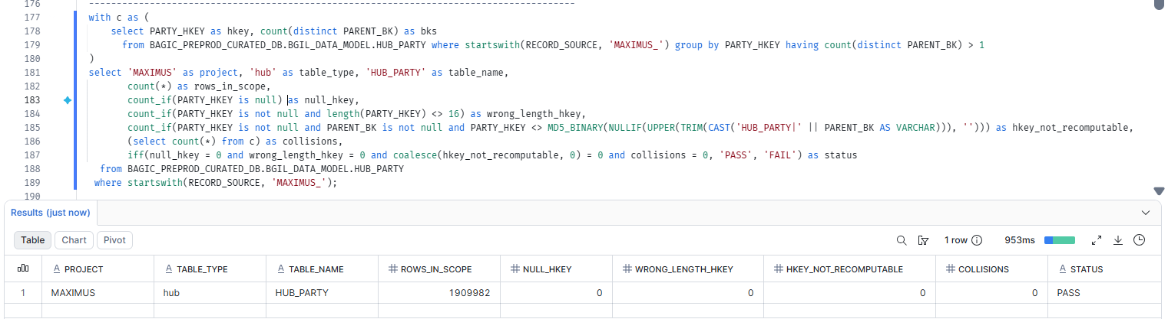

8. MAXIMUS — HUB HUB_PAYMENT_INSTRUMENT [Partner LOB]
Project | MAXIMUS
Satellite | HUB HUB_PAYMENT_INSTRUMENT [Partner LOB]
Status | Implemented
Pass criteria | status = PASS
Result (Pass / Fail / NA) | Pass
Rows with status = FAIL (count)
Remarks

Note: Recompute: MD5_BINARY(NULLIF(UPPER(TRIM(CAST('HUB_PAYMENT_INSTRUMENT|' || PARENT_BK AS VARCHAR))), '')) must equal PAYMENT_INSTRUMENT_HKEY. collisions = hash keys carrying more than one PARENT_BK. Overlaps DM-K3 (nulls) and DM-K4 (uniqueness) but adds the recompute and length checks.
SQL query
with c as (
select PAYMENT_INSTRUMENT_HKEY as hkey, count(distinct PARENT_BK) as bks
from BAGIC_PREPROD_CURATED_DB.BGIL_DATA_MODEL.HUB_PAYMENT_INSTRUMENT where startswith(RECORD_SOURCE, 'MAXIMUS_') group by PAYMENT_INSTRUMENT_HKEY having count(distinct PARENT_BK) > 1
)
select 'MAXIMUS' as project, 'hub' as table_type, 'HUB_PAYMENT_INSTRUMENT' as table_name,
count(*) as rows_in_scope,
count_if(PAYMENT_INSTRUMENT_HKEY is null) as null_hkey,
count_if(PAYMENT_INSTRUMENT_HKEY is not null and length(PAYMENT_INSTRUMENT_HKEY) <> 16) as wrong_length_hkey,
count_if(PAYMENT_INSTRUMENT_HKEY is not null and PARENT_BK is not null and PAYMENT_INSTRUMENT_HKEY <> MD5_BINARY(NULLIF(UPPER(TRIM(CAST('HUB_PAYMENT_INSTRUMENT|' || PARENT_BK AS VARCHAR))), ''))) as hkey_not_recomputable,
(select count(*) from c) as collisions,
iff(null_hkey = 0 and wrong_length_hkey = 0 and coalesce(hkey_not_recomputable, 0) = 0 and collisions = 0, 'PASS', 'FAIL') as status
from BAGIC_PREPROD_CURATED_DB.BGIL_DATA_MODEL.HUB_PAYMENT_INSTRUMENT
where startswith(RECORD_SOURCE, 'MAXIMUS_');
Query output (attach / paste below)
Output:
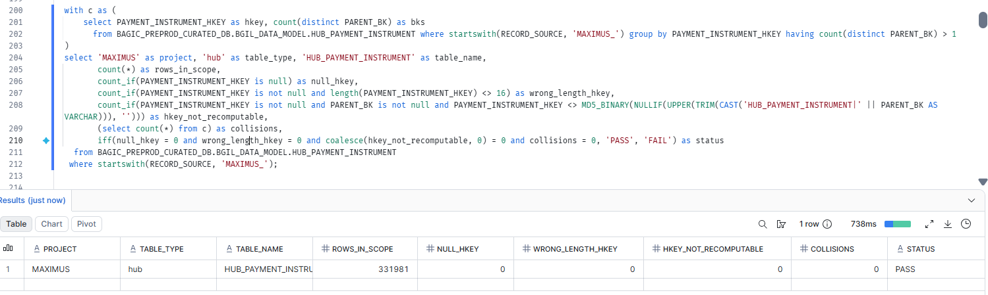

9. MAXIMUS — HUB HUB_POLICY [Partner LOB]
Project | MAXIMUS
Satellite | HUB HUB_POLICY [Partner LOB]
Status | Implemented
Pass criteria | status = PASS
Result (Pass / Fail / NA) | Pass
Rows with status = FAIL (count)
Remarks

Note: Recompute: MD5_BINARY(NULLIF(UPPER(TRIM(CAST('HUB_POLICY|' || PARENT_BK AS VARCHAR))), '')) must equal POLICY_HKEY. collisions = hash keys carrying more than one PARENT_BK. Overlaps DM-K3 (nulls) and DM-K4 (uniqueness) but adds the recompute and length checks.
SQL query
with c as (
select POLICY_HKEY as hkey, count(distinct PARENT_BK) as bks
from BAGIC_PREPROD_CURATED_DB.BGIL_DATA_MODEL.HUB_POLICY where startswith(RECORD_SOURCE, 'MAXIMUS_') group by POLICY_HKEY having count(distinct PARENT_BK) > 1
)
select 'MAXIMUS' as project, 'hub' as table_type, 'HUB_POLICY' as table_name,
count(*) as rows_in_scope,
count_if(POLICY_HKEY is null) as null_hkey,
count_if(POLICY_HKEY is not null and length(POLICY_HKEY) <> 16) as wrong_length_hkey,
count_if(POLICY_HKEY is not null and PARENT_BK is not null and POLICY_HKEY <> MD5_BINARY(NULLIF(UPPER(TRIM(CAST('HUB_POLICY|' || PARENT_BK AS VARCHAR))), ''))) as hkey_not_recomputable,
(select count(*) from c) as collisions,
iff(null_hkey = 0 and wrong_length_hkey = 0 and coalesce(hkey_not_recomputable, 0) = 0 and collisions = 0, 'PASS', 'FAIL') as status
from BAGIC_PREPROD_CURATED_DB.BGIL_DATA_MODEL.HUB_POLICY
where startswith(RECORD_SOURCE, 'MAXIMUS_');
Query output (attach / paste below)
Output:
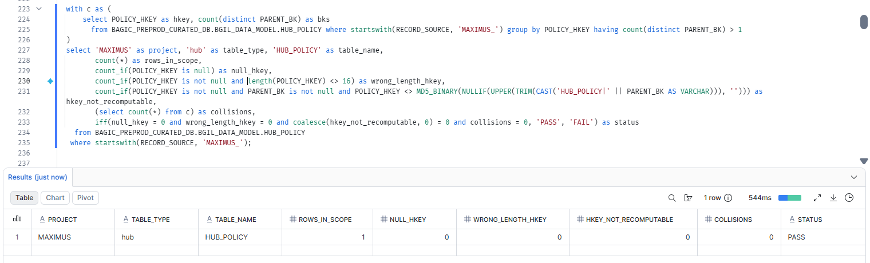

10. MAXIMUS — HUB HUB_PRODUCT [Partner LOB]
Project | MAXIMUS
Satellite | HUB HUB_PRODUCT [Partner LOB]
Status | Implemented
Pass criteria | status = PASS
Result (Pass / Fail / NA) | Pass
Rows with status = FAIL (count)
Remarks

Note: Recompute: MD5_BINARY(NULLIF(UPPER(TRIM(CAST('HUB_PRODUCT|' || PARENT_BK AS VARCHAR))), '')) must equal PRODUCT_HKEY. collisions = hash keys carrying more than one PARENT_BK. Overlaps DM-K3 (nulls) and DM-K4 (uniqueness) but adds the recompute and length checks.
SQL query
with c as (
select PRODUCT_HKEY as hkey, count(distinct PARENT_BK) as bks
from BAGIC_PREPROD_CURATED_DB.BGIL_DATA_MODEL.HUB_PRODUCT where startswith(RECORD_SOURCE, 'MAXIMUS_') group by PRODUCT_HKEY having count(distinct PARENT_BK) > 1
)
select 'MAXIMUS' as project, 'hub' as table_type, 'HUB_PRODUCT' as table_name,
count(*) as rows_in_scope,
count_if(PRODUCT_HKEY is null) as null_hkey,
count_if(PRODUCT_HKEY is not null and length(PRODUCT_HKEY) <> 16) as wrong_length_hkey,
count_if(PRODUCT_HKEY is not null and PARENT_BK is not null and PRODUCT_HKEY <> MD5_BINARY(NULLIF(UPPER(TRIM(CAST('HUB_PRODUCT|' || PARENT_BK AS VARCHAR))), ''))) as hkey_not_recomputable,
(select count(*) from c) as collisions,
iff(null_hkey = 0 and wrong_length_hkey = 0 and coalesce(hkey_not_recomputable, 0) = 0 and collisions = 0, 'PASS', 'FAIL') as status
from BAGIC_PREPROD_CURATED_DB.BGIL_DATA_MODEL.HUB_PRODUCT
where startswith(RECORD_SOURCE, 'MAXIMUS_');
Query output (attach / paste below)
Output:
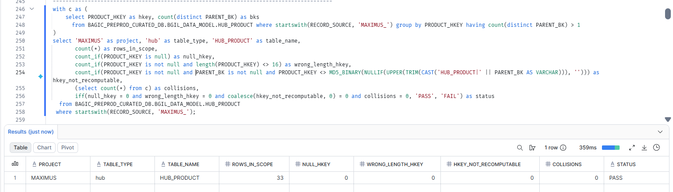

11. MAXIMUS — HUB HUB_STAKE_CODE
Project | MAXIMUS
Satellite | HUB HUB_STAKE_CODE
Status | Implemented
Pass criteria | status = PASS
Result (Pass / Fail / NA)
Rows with status = FAIL (count)
Remarks

Note: Recompute: MD5_BINARY(NULLIF(UPPER(TRIM(CAST('HUB_STAKE_CODE|' || STAKE_CODE_BK AS VARCHAR))), '')) must equal STAKE_CODE_HKEY. collisions = hash keys carrying more than one STAKE_CODE_BK. Overlaps DM-K3 (nulls) and DM-K4 (uniqueness) but adds the recompute and length checks.
SQL query
with c as (
select STAKE_CODE_HKEY as hkey, count(distinct STAKE_CODE_BK) as bks
from BAGIC_PREPROD_CURATED_DB.BGIL_DATA_MODEL.HUB_STAKE_CODE where startswith(RECORD_SOURCE, 'MAXIMUS_') group by STAKE_CODE_HKEY having count(distinct STAKE_CODE_BK) > 1
)
select 'MAXIMUS' as project, 'hub' as table_type, 'HUB_STAKE_CODE' as table_name,
count(*) as rows_in_scope,
count_if(STAKE_CODE_HKEY is null) as null_hkey,
count_if(STAKE_CODE_HKEY is not null and length(STAKE_CODE_HKEY) <> 16) as wrong_length_hkey,
count_if(STAKE_CODE_HKEY is not null and STAKE_CODE_BK is not null and STAKE_CODE_HKEY <> MD5_BINARY(NULLIF(UPPER(TRIM(CAST('HUB_STAKE_CODE|' || STAKE_CODE_BK AS VARCHAR))), ''))) as hkey_not_recomputable,
(select count(*) from c) as collisions,
iff(null_hkey = 0 and wrong_length_hkey = 0 and coalesce(hkey_not_recomputable, 0) = 0 and collisions = 0, 'PASS', 'FAIL') as status
from BAGIC_PREPROD_CURATED_DB.BGIL_DATA_MODEL.HUB_STAKE_CODE
where startswith(RECORD_SOURCE, 'MAXIMUS_');
Query output (attach / paste below)
Output:

12. MAXIMUS — LINK LNK_PARTY_LOCATION [Partner LOB]
Project | MAXIMUS
Satellite | LINK LNK_PARTY_LOCATION [Partner LOB]
Status | Implemented
Pass criteria | status = PASS
Result (Pass / Fail / NA) | Pass
Rows with status = FAIL (count)
Remarks | Incremental run completed; rows now load.

Note: FK hash keys PARTY_HKEY, LOCATION_HKEY. collisions = one link hash key with more than one FK combination (the link key no longer identifies one relationship).
SQL query
with c as (
select PARTY_LOCATION_HKEY as hkey from BAGIC_PREPROD_CURATED_DB.BGIL_DATA_MODEL.LNK_PARTY_LOCATION where startswith(RECORD_SOURCE, 'MAXIMUS_')
group by PARTY_LOCATION_HKEY having count(distinct coalesce(to_varchar(PARTY_HKEY, 'HEX'), '^^') || '|' || coalesce(to_varchar(LOCATION_HKEY, 'HEX'), '^^')) > 1
)
select 'MAXIMUS' as project, 'link' as table_type, 'LNK_PARTY_LOCATION' as table_name,
count(*) as rows_in_scope,
count_if(PARTY_LOCATION_HKEY is null) as null_hkey,
count_if(PARTY_HKEY is null) + count_if(LOCATION_HKEY is null) as null_fk_hkeys,
count_if(length(PARTY_LOCATION_HKEY) <> 16 or length(PARTY_HKEY) <> 16 or length(LOCATION_HKEY) <> 16) as wrong_length_hkey,
(select count(*) from c) as collisions,
iff(null_hkey = 0 and null_fk_hkeys = 0 and wrong_length_hkey = 0 and collisions = 0, 'PASS', 'FAIL') as status
from BAGIC_PREPROD_CURATED_DB.BGIL_DATA_MODEL.LNK_PARTY_LOCATION
where startswith(RECORD_SOURCE, 'MAXIMUS_');
Query output (attach / paste below)
Output:
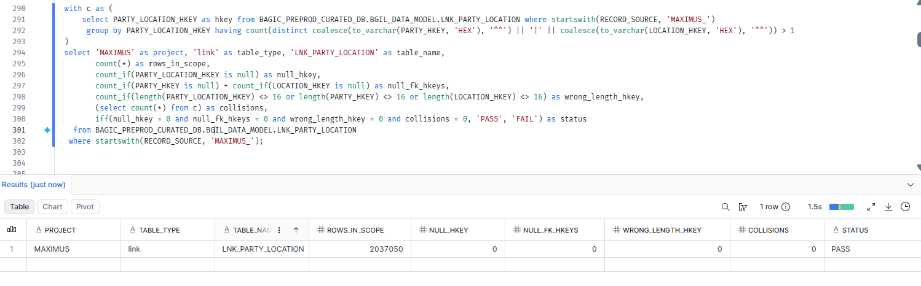

13. MAXIMUS — LINK LNK_PARTY_RELATIONSHIP [Partner LOB]
Project | MAXIMUS
Satellite | LINK LNK_PARTY_RELATIONSHIP [Partner LOB]
Status | Implemented
Pass criteria | status = PASS
Result (Pass / Fail / NA) | Pass
Rows with status = FAIL (count)
Remarks

Note: FK hash keys PARTY_HKEY, RELATED_PARTY_HKEY. collisions = one link hash key with more than one FK combination (the link key no longer identifies one relationship).
SQL query
with c as (
select PARTY_RELATIONSHIP_HKEY as hkey from BAGIC_PREPROD_CURATED_DB.BGIL_DATA_MODEL.LNK_PARTY_RELATIONSHIP where startswith(RECORD_SOURCE, 'MAXIMUS_')
group by PARTY_RELATIONSHIP_HKEY having count(distinct coalesce(to_varchar(PARTY_HKEY, 'HEX'), '^^') || '|' || coalesce(to_varchar(RELATED_PARTY_HKEY, 'HEX'), '^^')) > 1
)
select 'MAXIMUS' as project, 'link' as table_type, 'LNK_PARTY_RELATIONSHIP' as table_name,
count(*) as rows_in_scope,
count_if(PARTY_RELATIONSHIP_HKEY is null) as null_hkey,
count_if(PARTY_HKEY is null) + count_if(RELATED_PARTY_HKEY is null) as null_fk_hkeys,
count_if(length(PARTY_RELATIONSHIP_HKEY) <> 16 or length(PARTY_HKEY) <> 16 or length(RELATED_PARTY_HKEY) <> 16) as wrong_length_hkey,
(select count(*) from c) as collisions,
iff(null_hkey = 0 and null_fk_hkeys = 0 and wrong_length_hkey = 0 and collisions = 0, 'PASS', 'FAIL') as status
from BAGIC_PREPROD_CURATED_DB.BGIL_DATA_MODEL.LNK_PARTY_RELATIONSHIP
where startswith(RECORD_SOURCE, 'MAXIMUS_');
Query output (attach / paste below)
Output:
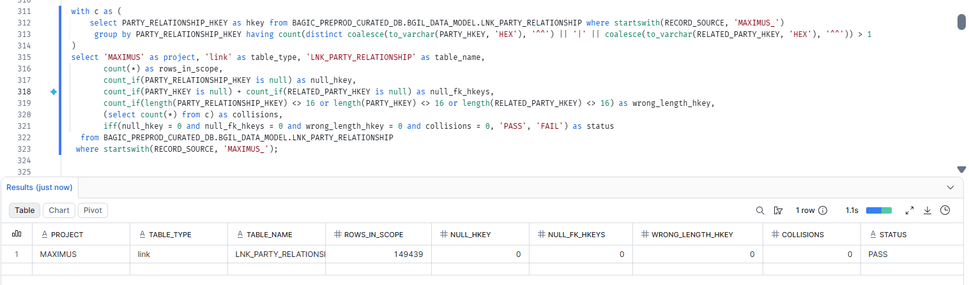

14. MAXIMUS — LINK LNK_PARTY_ROLE [Partner LOB]
Project | MAXIMUS
Satellite | LINK LNK_PARTY_ROLE [Partner LOB]
Status | Implemented
Pass criteria | status = PASS
Result (Pass / Fail / NA) | Fail(Due to source null)
Rows with status = FAIL (count)
Remarks | Null at source table stg_maximus__pd_prop_sp_pv for column bagic_employee_code

Note: FK hash keys PARTY_HKEY. collisions = one link hash key with more than one FK combination (the link key no longer identifies one relationship).
SQL query
with c as (
select PARTY_ROLE_HKEY as hkey from BAGIC_PREPROD_CURATED_DB.BGIL_DATA_MODEL.LNK_PARTY_ROLE where startswith(RECORD_SOURCE, 'MAXIMUS_')
group by PARTY_ROLE_HKEY having count(distinct coalesce(to_varchar(PARTY_HKEY, 'HEX'), '^^')) > 1
)
select 'MAXIMUS' as project, 'link' as table_type, 'LNK_PARTY_ROLE' as table_name,
count(*) as rows_in_scope,
count_if(PARTY_ROLE_HKEY is null) as null_hkey,
count_if(PARTY_HKEY is null) as null_fk_hkeys,
count_if(length(PARTY_ROLE_HKEY) <> 16 or length(PARTY_HKEY) <> 16) as wrong_length_hkey,
(select count(*) from c) as collisions,
iff(null_hkey = 0 and null_fk_hkeys = 0 and wrong_length_hkey = 0 and collisions = 0, 'PASS', 'FAIL') as status
from BAGIC_PREPROD_CURATED_DB.BGIL_DATA_MODEL.LNK_PARTY_ROLE
where startswith(RECORD_SOURCE, 'MAXIMUS_');
Query output (attach / paste below)
Output:
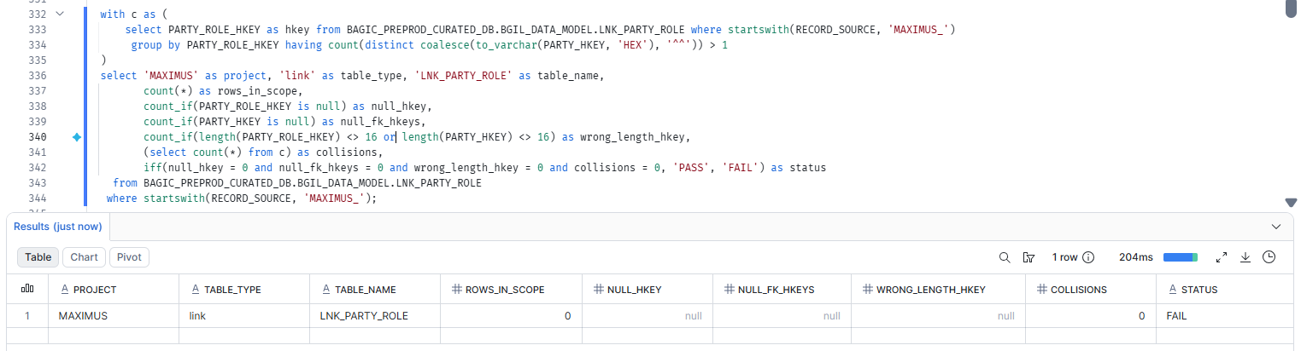

15. MAXIMUS — SATELLITE SAT_AUG_COMMON_ADDRESS [Partner LOB]
Project | MAXIMUS
Satellite | SATELLITE SAT_AUG_COMMON_ADDRESS [Partner LOB]
Status | Implemented
Pass criteria | status = PASS
Result (Pass / Fail / NA) | Fail(Due to source issue)
Rows with status = FAIL (count)
Remarks | Null at source table stg_maximus__pd_prop_sp_pv for column bagic_employee_code

Note: Satellite hash key and HASHDIFF populated and 16 bytes. HASHDIFF correctness itself is DM-H1 (a).
SQL query
select 'MAXIMUS' as project, 'satellite' as table_type, 'SAT_AUG_COMMON_ADDRESS' as table_name,
count(*) as rows_in_scope,
count_if(LOCATION_HKEY is null) as null_hkey,
count_if(LOCATION_HKEY is not null and length(LOCATION_HKEY) <> 16) as wrong_length_hkey,
count_if(HASHDIFF_AUG_COMMON_ADDRESS is null) as null_hashdiff,
iff(null_hkey = 0 and wrong_length_hkey = 0 and null_hashdiff = 0, 'PASS', 'FAIL') as status
from BAGIC_PREPROD_CURATED_DB.BGIL_DATA_MODEL.SAT_AUG_COMMON_ADDRESS
where startswith(RECORD_SOURCE, 'MAXIMUS_');
Query output (attach / paste below)
Output:
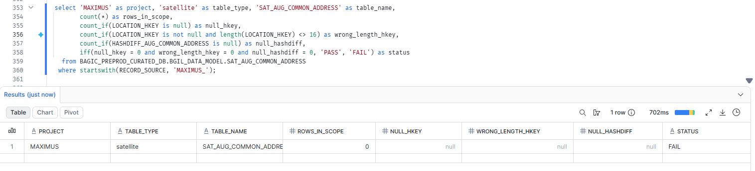

16. MAXIMUS — SATELLITE SAT_AUG_COMMON_ADMIN_GEOGRAPHY [Partner LOB]
Project | MAXIMUS
Satellite | SATELLITE SAT_AUG_COMMON_ADMIN_GEOGRAPHY [Partner LOB]
Status | Implemented
Pass criteria | status = PASS
Result (Pass / Fail / NA) | Fail(Due to source issue)
Rows with status = FAIL (count)
Remarks | Null at source table stg_maximus__pd_prop_sp_pv for its columns

Note: Satellite hash key and HASHDIFF populated and 16 bytes. HASHDIFF correctness itself is DM-H1 (a).
SQL query
select 'MAXIMUS' as project, 'satellite' as table_type, 'SAT_AUG_COMMON_ADMIN_GEOGRAPHY' as table_name,
count(*) as rows_in_scope,
count_if(LOCATION_HKEY is null) as null_hkey,
count_if(LOCATION_HKEY is not null and length(LOCATION_HKEY) <> 16) as wrong_length_hkey,
count_if(HASHDIFF_AUG_COMMON_ADMIN_GEOGRAPHY is null) as null_hashdiff,
iff(null_hkey = 0 and wrong_length_hkey = 0 and null_hashdiff = 0, 'PASS', 'FAIL') as status
from BAGIC_PREPROD_CURATED_DB.BGIL_DATA_MODEL.SAT_AUG_COMMON_ADMIN_GEOGRAPHY
where startswith(RECORD_SOURCE, 'MAXIMUS_');
Query output (attach / paste below)
Output:
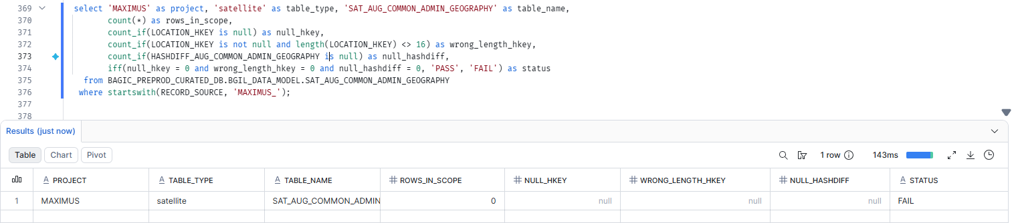

17. MAXIMUS — SATELLITE SAT_AUG_COMMON_CLASSIFICATION [Partner LOB]
Project | MAXIMUS
Satellite | SATELLITE SAT_AUG_COMMON_CLASSIFICATION [Partner LOB]
Status | Implemented
Pass criteria | status = PASS
Result (Pass / Fail / NA) | Fail(Due to source fail)
Rows with status = FAIL (count)
Remarks | Null at source table stg_maximus__pd_prop_sp_pv for case when columns

Note: Satellite hash key and HASHDIFF populated and 16 bytes. HASHDIFF correctness itself is DM-H1 (a).
SQL query
select 'MAXIMUS' as project, 'satellite' as table_type, 'SAT_AUG_COMMON_CLASSIFICATION' as table_name,
count(*) as rows_in_scope,
count_if(PARTY_HKEY is null) as null_hkey,
count_if(PARTY_HKEY is not null and length(PARTY_HKEY) <> 16) as wrong_length_hkey,
count_if(HASHDIFF_AUG_COMMON_CLASSIFICATION is null) as null_hashdiff,
iff(null_hkey = 0 and wrong_length_hkey = 0 and null_hashdiff = 0, 'PASS', 'FAIL') as status
from BAGIC_PREPROD_CURATED_DB.BGIL_DATA_MODEL.SAT_AUG_COMMON_CLASSIFICATION
where startswith(RECORD_SOURCE, 'MAXIMUS_');
Query output (attach / paste below)
Output:
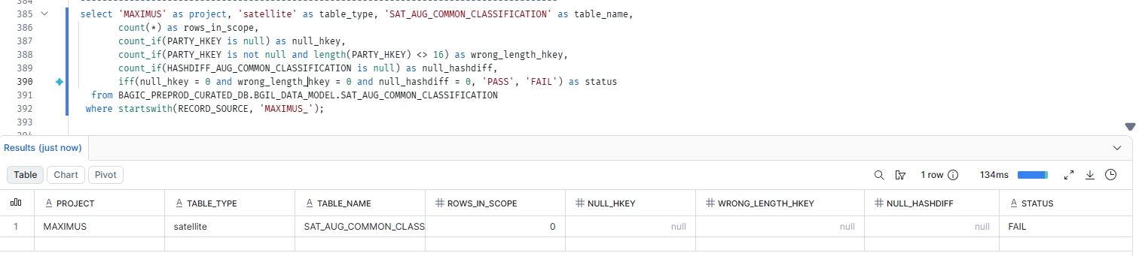

18. MAXIMUS — SATELLITE SAT_AUG_COMMON_COMMUNICATION_PREFERENCE [Partner LOB]
Project | MAXIMUS
Satellite | SATELLITE SAT_AUG_COMMON_COMMUNICATION_PREFERENCE [Partner LOB]
Status | Implemented
Pass criteria | status = PASS
Result (Pass / Fail / NA) | Fail(Due to source fail)
Rows with status = FAIL (count)
Remarks | Null at source table stg_maximus__pd_prop_sp_pv for case when columns

Note: Satellite hash key and HASHDIFF populated and 16 bytes. HASHDIFF correctness itself is DM-H1 (a).
SQL query
select 'MAXIMUS' as project, 'satellite' as table_type, 'SAT_AUG_COMMON_COMMUNICATION_PREFERENCE' as table_name,
count(*) as rows_in_scope,
count_if(PARTY_HKEY is null) as null_hkey,
count_if(PARTY_HKEY is not null and length(PARTY_HKEY) <> 16) as wrong_length_hkey,
count_if(HASHDIFF_AUG_COMMON_COMMUNICATION_PREFERENCE is null) as null_hashdiff,
iff(null_hkey = 0 and wrong_length_hkey = 0 and null_hashdiff = 0, 'PASS', 'FAIL') as status
from BAGIC_PREPROD_CURATED_DB.BGIL_DATA_MODEL.SAT_AUG_COMMON_COMMUNICATION_PREFERENCE
where startswith(RECORD_SOURCE, 'MAXIMUS_');
Query output (attach / paste below)
Output:
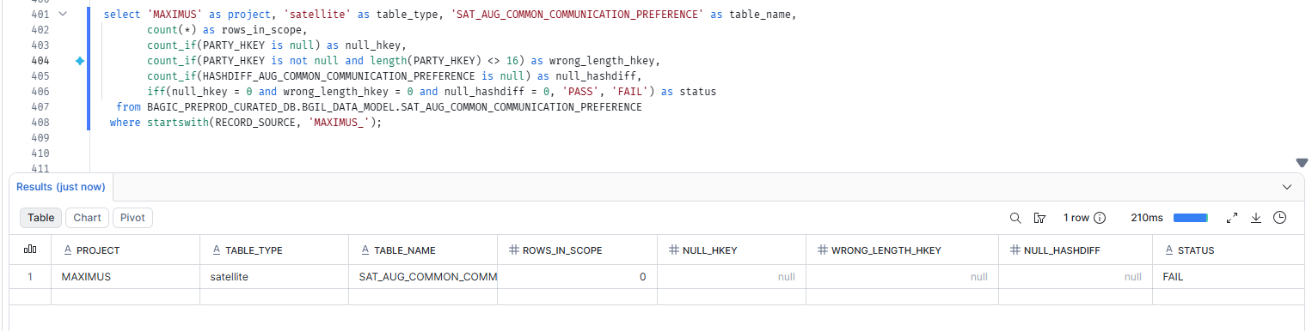

19. MAXIMUS — SATELLITE SAT_AUG_COMMON_CONTACT [Partner LOB]
Project | MAXIMUS
Satellite | SATELLITE SAT_AUG_COMMON_CONTACT [Partner LOB]
Status | Implemented
Pass criteria | status = PASS
Result (Pass / Fail / NA) | Fail(Due to source issue)
Rows with status = FAIL (count)
Remarks | Null at source table stg_maximus__pd_prop_sp_pv for its columns

Note: Satellite hash key and HASHDIFF populated and 16 bytes. HASHDIFF correctness itself is DM-H1 (a).
SQL query
select 'MAXIMUS' as project, 'satellite' as table_type, 'SAT_AUG_COMMON_CONTACT' as table_name,
count(*) as rows_in_scope,
count_if(PARTY_HKEY is null) as null_hkey,
count_if(PARTY_HKEY is not null and length(PARTY_HKEY) <> 16) as wrong_length_hkey,
count_if(HASHDIFF_AUG_COMMON_CONTACT is null) as null_hashdiff,
iff(null_hkey = 0 and wrong_length_hkey = 0 and null_hashdiff = 0, 'PASS', 'FAIL') as status
from BAGIC_PREPROD_CURATED_DB.BGIL_DATA_MODEL.SAT_AUG_COMMON_CONTACT
where startswith(RECORD_SOURCE, 'MAXIMUS_');
Query output (attach / paste below)
Output:

20. MAXIMUS — SATELLITE SAT_AUG_COMMON_GEO [Partner LOB]
Project | MAXIMUS
Satellite | SATELLITE SAT_AUG_COMMON_GEO [Partner LOB]
Status | Implemented
Pass criteria | status = PASS
Result (Pass / Fail / NA) | Pass
Rows with status = FAIL (count)
Remarks

Note: Satellite hash key and HASHDIFF populated and 16 bytes. HASHDIFF correctness itself is DM-H1 (a).
SQL query
select 'MAXIMUS' as project, 'satellite' as table_type, 'SAT_AUG_COMMON_GEO' as table_name,
count(*) as rows_in_scope,
count_if(LOCATION_HKEY is null) as null_hkey,
count_if(LOCATION_HKEY is not null and length(LOCATION_HKEY) <> 16) as wrong_length_hkey,
count_if(HASHDIFF_AUG_COMMON_GEO is null) as null_hashdiff,
iff(null_hkey = 0 and wrong_length_hkey = 0 and null_hashdiff = 0, 'PASS', 'FAIL') as status
from BAGIC_PREPROD_CURATED_DB.BGIL_DATA_MODEL.SAT_AUG_COMMON_GEO
where startswith(RECORD_SOURCE, 'MAXIMUS_');
Query output (attach / paste below)
Output:
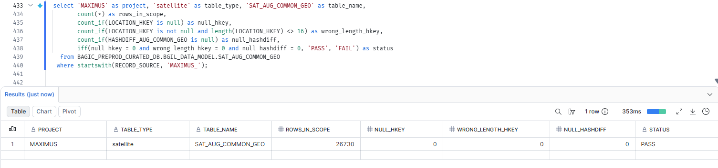

21. MAXIMUS — SATELLITE SAT_AUG_INSTRUMENT_DEFINITION [Partner LOB]
Project | MAXIMUS
Satellite | SATELLITE SAT_AUG_INSTRUMENT_DEFINITION [Partner LOB]
Status | Implemented
Pass criteria | status = PASS
Result (Pass / Fail / NA) | Pass
Rows with status = FAIL (count)
Remarks

Note: Satellite hash key and HASHDIFF populated and 16 bytes. HASHDIFF correctness itself is DM-H1 (a).
SQL query
select 'MAXIMUS' as project, 'satellite' as table_type, 'SAT_AUG_INSTRUMENT_DEFINITION' as table_name,
count(*) as rows_in_scope,
count_if(PAYMENT_INSTRUMENT_HKEY is null) as null_hkey,
count_if(PAYMENT_INSTRUMENT_HKEY is not null and length(PAYMENT_INSTRUMENT_HKEY) <> 16) as wrong_length_hkey,
count_if(HASHDIFF_AUG_INSTRUMENT_DEFINITION is null) as null_hashdiff,
iff(null_hkey = 0 and wrong_length_hkey = 0 and null_hashdiff = 0, 'PASS', 'FAIL') as status
from BAGIC_PREPROD_CURATED_DB.BGIL_DATA_MODEL.SAT_AUG_INSTRUMENT_DEFINITION
where startswith(RECORD_SOURCE, 'MAXIMUS_');
Query output (attach / paste below)
Output:
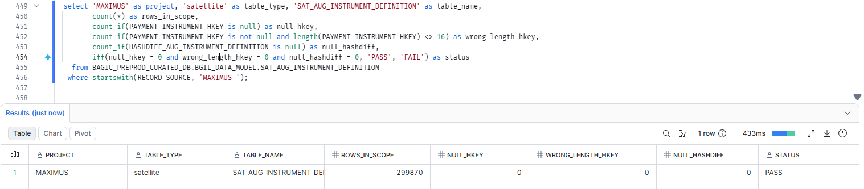

22. MAXIMUS — SATELLITE SAT_AUG_LNK_PARTY_ROLE_CORE [Partner LOB]
Project | MAXIMUS
Satellite | SATELLITE SAT_AUG_LNK_PARTY_ROLE_CORE [Partner LOB]
Status | Implemented
Pass criteria | status = PASS
Result (Pass / Fail / NA) | Fail(Due to source issue)
Rows with status = FAIL (count)
Remarks | Null at source table stg_maximus__pd_prop_sp_pv for its columns

Note: Satellite hash key and HASHDIFF populated and 16 bytes. HASHDIFF correctness itself is DM-H1 (a).
SQL query
select 'MAXIMUS' as project, 'satellite' as table_type, 'SAT_AUG_LNK_PARTY_ROLE_CORE' as table_name,
count(*) as rows_in_scope,
count_if(PARTY_HKEY is null) as null_hkey,
count_if(PARTY_HKEY is not null and length(PARTY_HKEY) <> 16) as wrong_length_hkey,
count_if(HASHDIFF_AUG_LNK_PARTY_ROLE_CORE is null) as null_hashdiff,
iff(null_hkey = 0 and wrong_length_hkey = 0 and null_hashdiff = 0, 'PASS', 'FAIL') as status
from BAGIC_PREPROD_CURATED_DB.BGIL_DATA_MODEL.SAT_AUG_LNK_PARTY_ROLE_CORE
where startswith(RECORD_SOURCE, 'MAXIMUS_');
Query output (attach / paste below)
Output:

23. MAXIMUS — SATELLITE SAT_AUG_LNK_ROLE_AGENT [Partner LOB]
Project | MAXIMUS
Satellite | SATELLITE SAT_AUG_LNK_ROLE_AGENT [Partner LOB]
Status | Implemented
Pass criteria | status = PASS
Result (Pass / Fail / NA) | Fail(Due to source issue)
Rows with status = FAIL (count)
Remarks | Null at source table stg_maximus__pd_prop_sp_pv for its columns

Note: Satellite hash key and HASHDIFF populated and 16 bytes. HASHDIFF correctness itself is DM-H1 (a).
SQL query
select 'MAXIMUS' as project, 'satellite' as table_type, 'SAT_AUG_LNK_ROLE_AGENT' as table_name,
count(*) as rows_in_scope,
count_if(PARTY_HKEY is null) as null_hkey,
count_if(PARTY_HKEY is not null and length(PARTY_HKEY) <> 16) as wrong_length_hkey,
count_if(HASHDIFF is null) as null_hashdiff,
iff(null_hkey = 0 and wrong_length_hkey = 0 and null_hashdiff = 0, 'PASS', 'FAIL') as status
from BAGIC_PREPROD_CURATED_DB.BGIL_DATA_MODEL.SAT_AUG_LNK_ROLE_AGENT
where startswith(RECORD_SOURCE, 'MAXIMUS_');
Query output (attach / paste below)
Output:

24. MAXIMUS — SATELLITE SAT_AUG_LNK_ROLE_CUSTOMER [Partner LOB]
Project | MAXIMUS
Satellite | SATELLITE SAT_AUG_LNK_ROLE_CUSTOMER [Partner LOB]
Status | Implemented
Pass criteria | status = PASS
Result (Pass / Fail / NA) | Fail(Due to source issue)
Rows with status = FAIL (count)
Remarks | Null at source table stg_maximus__pd_prop_sp_pv for its columns

Note: Satellite hash key and HASHDIFF populated and 16 bytes. HASHDIFF correctness itself is DM-H1 (a).
SQL query
select 'MAXIMUS' as project, 'satellite' as table_type, 'SAT_AUG_LNK_ROLE_CUSTOMER' as table_name,
count(*) as rows_in_scope,
count_if(PARTY_HKEY is null) as null_hkey,
count_if(PARTY_HKEY is not null and length(PARTY_HKEY) <> 16) as wrong_length_hkey,
count_if(HASHDIFF is null) as null_hashdiff,
iff(null_hkey = 0 and wrong_length_hkey = 0 and null_hashdiff = 0, 'PASS', 'FAIL') as status
from BAGIC_PREPROD_CURATED_DB.BGIL_DATA_MODEL.SAT_AUG_LNK_ROLE_CUSTOMER
where startswith(RECORD_SOURCE, 'MAXIMUS_');
Query output (attach / paste below)
Output:
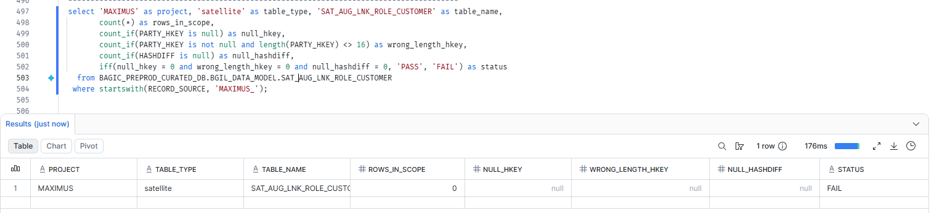

25. MAXIMUS — SATELLITE SAT_AUG_LNK_ROLE_NOMINEE_BENEFICIARY [Partner LOB]
Project | MAXIMUS
Satellite | SATELLITE SAT_AUG_LNK_ROLE_NOMINEE_BENEFICIARY [Partner LOB]
Status | Implemented
Pass criteria | status = PASS
Result (Pass / Fail / NA) | Fail(Due to source issue)
Rows with status = FAIL (count)
Remarks | Null at source table stg_maximus__pd_prop_sp_pv for its columns

Note: Satellite hash key and HASHDIFF populated and 16 bytes. HASHDIFF correctness itself is DM-H1 (a).
SQL query
select 'MAXIMUS' as project, 'satellite' as table_type, 'SAT_AUG_LNK_ROLE_NOMINEE_BENEFICIARY' as table_name,
count(*) as rows_in_scope,
count_if(PARTY_HKEY is null) as null_hkey,
count_if(PARTY_HKEY is not null and length(PARTY_HKEY) <> 16) as wrong_length_hkey,
count_if(HASHDIFF_AUG_LNK_ROLE_NOMINEE_BENEFICIARY is null) as null_hashdiff,
iff(null_hkey = 0 and wrong_length_hkey = 0 and null_hashdiff = 0, 'PASS', 'FAIL') as status
from BAGIC_PREPROD_CURATED_DB.BGIL_DATA_MODEL.SAT_AUG_LNK_ROLE_NOMINEE_BENEFICIARY
where startswith(RECORD_SOURCE, 'MAXIMUS_');
Query output (attach / paste below)
Output:

26. MAXIMUS — SATELLITE SAT_AUG_LNK_ROLE_PROVIDER [Partner LOB]
Project | MAXIMUS
Satellite | SATELLITE SAT_AUG_LNK_ROLE_PROVIDER [Partner LOB]
Status | Implemented
Pass criteria | status = PASS
Result (Pass / Fail / NA) | Fail(Due to source issue)
Rows with status = FAIL (count)
Remarks | Null at source table stg_maximus__pd_prop_sp_pv for its columns

Note: Satellite hash key and HASHDIFF populated and 16 bytes. HASHDIFF correctness itself is DM-H1 (a).
SQL query
select 'MAXIMUS' as project, 'satellite' as table_type, 'SAT_AUG_LNK_ROLE_PROVIDER' as table_name,
count(*) as rows_in_scope,
count_if(PARTY_HKEY is null) as null_hkey,
count_if(PARTY_HKEY is not null and length(PARTY_HKEY) <> 16) as wrong_length_hkey,
count_if(HASHDIFF is null) as null_hashdiff,
iff(null_hkey = 0 and wrong_length_hkey = 0 and null_hashdiff = 0, 'PASS', 'FAIL') as status
from BAGIC_PREPROD_CURATED_DB.BGIL_DATA_MODEL.SAT_AUG_LNK_ROLE_PROVIDER
where startswith(RECORD_SOURCE, 'MAXIMUS_');
Query output (attach / paste below)
Output:
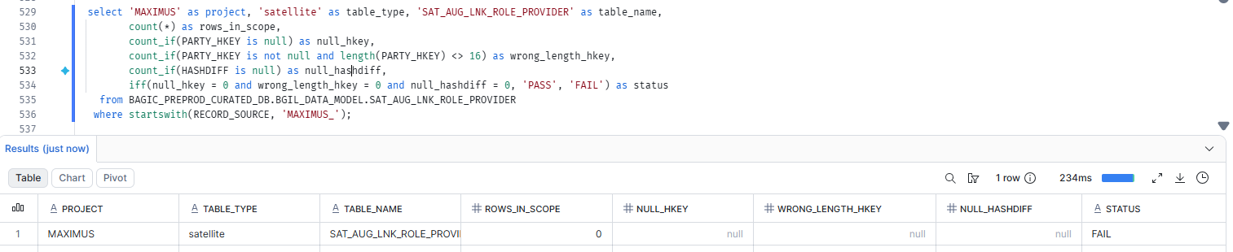

27. MAXIMUS — SATELLITE SAT_AUG_LNK_ROLE_SURVEYOR [Partner LOB]
Project | MAXIMUS
Satellite | SATELLITE SAT_AUG_LNK_ROLE_SURVEYOR [Partner LOB]
Status | Implemented
Pass criteria | status = PASS
Result (Pass / Fail / NA) | Fail(Due to source issue)
Rows with status = FAIL (count)
Remarks | Null at source table stg_maximus__pd_prop_sp_pv for its columns

Note: Satellite hash key and HASHDIFF populated and 16 bytes. HASHDIFF correctness itself is DM-H1 (a).
SQL query
select 'MAXIMUS' as project, 'satellite' as table_type, 'SAT_AUG_LNK_ROLE_SURVEYOR' as table_name,
count(*) as rows_in_scope,
count_if(PARTY_HKEY is null) as null_hkey,
count_if(PARTY_HKEY is not null and length(PARTY_HKEY) <> 16) as wrong_length_hkey,
count_if(HASHDIFF is null) as null_hashdiff,
iff(null_hkey = 0 and wrong_length_hkey = 0 and null_hashdiff = 0, 'PASS', 'FAIL') as status
from BAGIC_PREPROD_CURATED_DB.BGIL_DATA_MODEL.SAT_AUG_LNK_ROLE_SURVEYOR
where startswith(RECORD_SOURCE, 'MAXIMUS_');
Query output (attach / paste below)
Output:
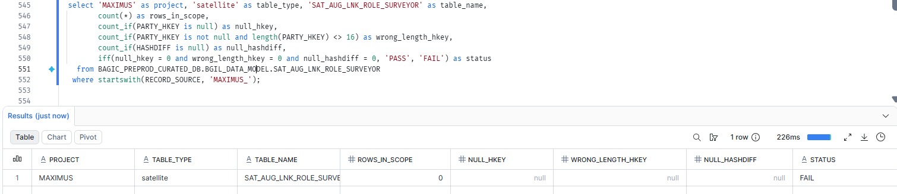

28. MAXIMUS — SATELLITE SAT_AUG_PARTY_AGENT_PRODUCTION
Project | MAXIMUS
Satellite | SATELLITE SAT_AUG_PARTY_AGENT_PRODUCTION
Status | Implemented
Pass criteria | status = PASS
Result (Pass / Fail / NA)
Rows with status = FAIL (count)
Remarks

Note: Satellite hash key and HASHDIFF populated and 16 bytes. HASHDIFF correctness itself is DM-H1 (a).
SQL query
select 'MAXIMUS' as project, 'satellite' as table_type, 'SAT_AUG_PARTY_AGENT_PRODUCTION' as table_name,
count(*) as rows_in_scope,
count_if(PARTY_HKEY is null) as null_hkey,
count_if(PARTY_HKEY is not null and length(PARTY_HKEY) <> 16) as wrong_length_hkey,
count_if(HASHDIFF_AUG_PARTY_AGENT_PRODUCTION is null) as null_hashdiff,
iff(null_hkey = 0 and wrong_length_hkey = 0 and null_hashdiff = 0, 'PASS', 'FAIL') as status
from BAGIC_PREPROD_CURATED_DB.BGIL_DATA_MODEL.SAT_AUG_PARTY_AGENT_PRODUCTION
where startswith(RECORD_SOURCE, 'MAXIMUS_');
Query output (attach / paste below)
Output:

29. MAXIMUS — SATELLITE SAT_AUG_PARTY_AMENDMENT_ENDORSEMENT
Project | MAXIMUS
Satellite | SATELLITE SAT_AUG_PARTY_AMENDMENT_ENDORSEMENT
Status | Implemented
Pass criteria | status = PASS
Result (Pass / Fail / NA)
Rows with status = FAIL (count)
Remarks

Note: Satellite hash key and HASHDIFF populated and 16 bytes. HASHDIFF correctness itself is DM-H1 (a).
SQL query
select 'MAXIMUS' as project, 'satellite' as table_type, 'SAT_AUG_PARTY_AMENDMENT_ENDORSEMENT' as table_name,
count(*) as rows_in_scope,
count_if(PARTY_HKEY is null) as null_hkey,
count_if(PARTY_HKEY is not null and length(PARTY_HKEY) <> 16) as wrong_length_hkey,
count_if(HASHDIFF_AUG_PARTY_AMENDMENT_ENDORSEMENT is null) as null_hashdiff,
iff(null_hkey = 0 and wrong_length_hkey = 0 and null_hashdiff = 0, 'PASS', 'FAIL') as status
from BAGIC_PREPROD_CURATED_DB.BGIL_DATA_MODEL.SAT_AUG_PARTY_AMENDMENT_ENDORSEMENT
where startswith(RECORD_SOURCE, 'MAXIMUS_');
Query output (attach / paste below)
Output:

30. MAXIMUS — SATELLITE SAT_AUG_PARTY_BANKING [Partner LOB]
Project | MAXIMUS
Satellite | SATELLITE SAT_AUG_PARTY_BANKING [Partner LOB]
Status | Implemented
Pass criteria | status = PASS
Result (Pass / Fail / NA) | Pass
Rows with status = FAIL (count)
Remarks

Note: Satellite hash key and HASHDIFF populated and 16 bytes. HASHDIFF correctness itself is DM-H1 (a).
SQL query
select 'MAXIMUS' as project, 'satellite' as table_type, 'SAT_AUG_PARTY_BANKING' as table_name,
count(*) as rows_in_scope,
count_if(PARTY_HKEY is null) as null_hkey,
count_if(PARTY_HKEY is not null and length(PARTY_HKEY) <> 16) as wrong_length_hkey,
count_if(HASHDIFF_AUG_PARTY_BANKING is null) as null_hashdiff,
iff(null_hkey = 0 and wrong_length_hkey = 0 and null_hashdiff = 0, 'PASS', 'FAIL') as status
from BAGIC_PREPROD_CURATED_DB.BGIL_DATA_MODEL.SAT_AUG_PARTY_BANKING
where startswith(RECORD_SOURCE, 'MAXIMUS_');
Query output (attach / paste below)
Output:
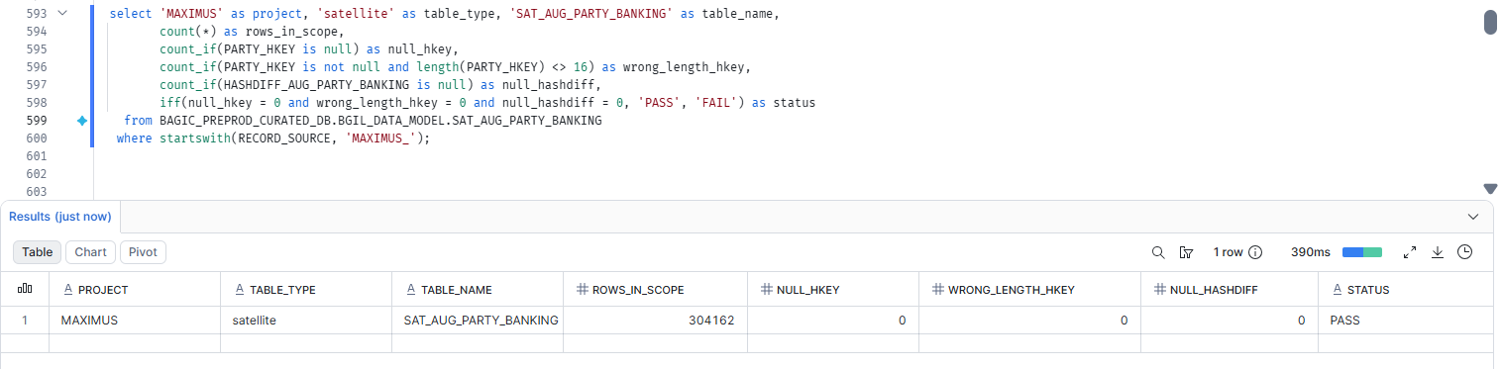

31. MAXIMUS — SATELLITE SAT_AUG_PARTY_CLAIM_HISTORY
Project | MAXIMUS
Satellite | SATELLITE SAT_AUG_PARTY_CLAIM_HISTORY
Status | Implemented
Pass criteria | status = PASS
Result (Pass / Fail / NA)
Rows with status = FAIL (count)
Remarks

Note: Satellite hash key and HASHDIFF populated and 16 bytes. HASHDIFF correctness itself is DM-H1 (a).
SQL query
select 'MAXIMUS' as project, 'satellite' as table_type, 'SAT_AUG_PARTY_CLAIM_HISTORY' as table_name,
count(*) as rows_in_scope,
count_if(PARTY_HKEY is null) as null_hkey,
count_if(PARTY_HKEY is not null and length(PARTY_HKEY) <> 16) as wrong_length_hkey,
count_if(HASHDIFF_AUG_PARTY_CLAIM_HISTORY is null) as null_hashdiff,
iff(null_hkey = 0 and wrong_length_hkey = 0 and null_hashdiff = 0, 'PASS', 'FAIL') as status
from BAGIC_PREPROD_CURATED_DB.BGIL_DATA_MODEL.SAT_AUG_PARTY_CLAIM_HISTORY
where startswith(RECORD_SOURCE, 'MAXIMUS_');
Query output (attach / paste below)
Output:

32. MAXIMUS — SATELLITE SAT_AUG_PARTY_CONTACT_ADDRESS_LINK [Partner LOB]
Project | MAXIMUS
Satellite | SATELLITE SAT_AUG_PARTY_CONTACT_ADDRESS_LINK [Partner LOB]
Status | Implemented
Pass criteria | status = PASS
Result (Pass / Fail / NA) | Fail(Due to source issue)
Rows with status = FAIL (count)
Remarks | Null at source table stg_maximus__pd_prop_sp_pv for its columns

Note: Satellite hash key and HASHDIFF populated and 16 bytes. HASHDIFF correctness itself is DM-H1 (a).
SQL query
select 'MAXIMUS' as project, 'satellite' as table_type, 'SAT_AUG_PARTY_CONTACT_ADDRESS_LINK' as table_name,
count(*) as rows_in_scope,
count_if(PARTY_HKEY is null) as null_hkey,
count_if(PARTY_HKEY is not null and length(PARTY_HKEY) <> 16) as wrong_length_hkey,
count_if(HASHDIFF_AUG_PARTY_CONTACT_ADDRESS_LINK is null) as null_hashdiff,
iff(null_hkey = 0 and wrong_length_hkey = 0 and null_hashdiff = 0, 'PASS', 'FAIL') as status
from BAGIC_PREPROD_CURATED_DB.BGIL_DATA_MODEL.SAT_AUG_PARTY_CONTACT_ADDRESS_LINK
where startswith(RECORD_SOURCE, 'MAXIMUS_');
Query output (attach / paste below)
Output:

33. MAXIMUS — SATELLITE SAT_AUG_PARTY_CORRESPONDENCE
Project | MAXIMUS
Satellite | SATELLITE SAT_AUG_PARTY_CORRESPONDENCE
Status | Implemented
Pass criteria | status = PASS
Result (Pass / Fail / NA)
Rows with status = FAIL (count)
Remarks

Note: Satellite hash key and HASHDIFF populated and 16 bytes. HASHDIFF correctness itself is DM-H1 (a).
SQL query
select 'MAXIMUS' as project, 'satellite' as table_type, 'SAT_AUG_PARTY_CORRESPONDENCE' as table_name,
count(*) as rows_in_scope,
count_if(PARTY_HKEY is null) as null_hkey,
count_if(PARTY_HKEY is not null and length(PARTY_HKEY) <> 16) as wrong_length_hkey,
count_if(HASHDIFF_AUG_PARTY_CORRESPONDENCE is null) as null_hashdiff,
iff(null_hkey = 0 and wrong_length_hkey = 0 and null_hashdiff = 0, 'PASS', 'FAIL') as status
from BAGIC_PREPROD_CURATED_DB.BGIL_DATA_MODEL.SAT_AUG_PARTY_CORRESPONDENCE
where startswith(RECORD_SOURCE, 'MAXIMUS_');
Query output (attach / paste below)
Output:

34. MAXIMUS — SATELLITE SAT_AUG_PARTY_CREDIT_CONTROL_PAYMENT_TERMS
Project | MAXIMUS
Satellite | SATELLITE SAT_AUG_PARTY_CREDIT_CONTROL_PAYMENT_TERMS
Status | Implemented
Pass criteria | status = PASS
Result (Pass / Fail / NA)
Rows with status = FAIL (count)
Remarks

Note: Satellite hash key and HASHDIFF populated and 16 bytes. HASHDIFF correctness itself is DM-H1 (a).
SQL query
select 'MAXIMUS' as project, 'satellite' as table_type, 'SAT_AUG_PARTY_CREDIT_CONTROL_PAYMENT_TERMS' as table_name,
count(*) as rows_in_scope,
count_if(PARTY_HKEY is null) as null_hkey,
count_if(PARTY_HKEY is not null and length(PARTY_HKEY) <> 16) as wrong_length_hkey,
count_if(HASHDIFF_AUG_PARTY_CREDIT_CONTROL_PAYMENT_TERMS is null) as null_hashdiff,
iff(null_hkey = 0 and wrong_length_hkey = 0 and null_hashdiff = 0, 'PASS', 'FAIL') as status
from BAGIC_PREPROD_CURATED_DB.BGIL_DATA_MODEL.SAT_AUG_PARTY_CREDIT_CONTROL_PAYMENT_TERMS
where startswith(RECORD_SOURCE, 'MAXIMUS_');
Query output (attach / paste below)
Output:

35. MAXIMUS — SATELLITE SAT_AUG_PARTY_DIGITAL_IDENTITY [Partner LOB]
Project | MAXIMUS
Satellite | SATELLITE SAT_AUG_PARTY_DIGITAL_IDENTITY [Partner LOB]
Status | Implemented
Pass criteria | status = PASS
Result (Pass / Fail / NA) | Fail(Due to source issue)
Rows with status = FAIL (count)
Remarks | Null at source table stg_maximus__pd_prop_sp_pv for its columns

Note: Satellite hash key and HASHDIFF populated and 16 bytes. HASHDIFF correctness itself is DM-H1 (a).
SQL query
select 'MAXIMUS' as project, 'satellite' as table_type, 'SAT_AUG_PARTY_DIGITAL_IDENTITY' as table_name,
count(*) as rows_in_scope,
count_if(PARTY_HKEY is null) as null_hkey,
count_if(PARTY_HKEY is not null and length(PARTY_HKEY) <> 16) as wrong_length_hkey,
count_if(HASHDIFF_AUG_PARTY_DIGITAL_IDENTITY is null) as null_hashdiff,
iff(null_hkey = 0 and wrong_length_hkey = 0 and null_hashdiff = 0, 'PASS', 'FAIL') as status
from BAGIC_PREPROD_CURATED_DB.BGIL_DATA_MODEL.SAT_AUG_PARTY_DIGITAL_IDENTITY
where startswith(RECORD_SOURCE, 'MAXIMUS_');
Query output (attach / paste below)
Output:

36. MAXIMUS — SATELLITE SAT_AUG_PARTY_DRIVING
Project | MAXIMUS
Satellite | SATELLITE SAT_AUG_PARTY_DRIVING
Status | Implemented
Pass criteria | status = PASS
Result (Pass / Fail / NA)
Rows with status = FAIL (count)
Remarks

Note: Satellite hash key and HASHDIFF populated and 16 bytes. HASHDIFF correctness itself is DM-H1 (a).
SQL query
select 'MAXIMUS' as project, 'satellite' as table_type, 'SAT_AUG_PARTY_DRIVING' as table_name,
count(*) as rows_in_scope,
count_if(PARTY_HKEY is null) as null_hkey,
count_if(PARTY_HKEY is not null and length(PARTY_HKEY) <> 16) as wrong_length_hkey,
count_if(HASHDIFF_AUG_PARTY_DRIVING is null) as null_hashdiff,
iff(null_hkey = 0 and wrong_length_hkey = 0 and null_hashdiff = 0, 'PASS', 'FAIL') as status
from BAGIC_PREPROD_CURATED_DB.BGIL_DATA_MODEL.SAT_AUG_PARTY_DRIVING
where startswith(RECORD_SOURCE, 'MAXIMUS_');
Query output (attach / paste below)
Output:

37. MAXIMUS — SATELLITE SAT_AUG_PARTY_EMPLOYMENT [Partner LOB]
Project | MAXIMUS
Satellite | SATELLITE SAT_AUG_PARTY_EMPLOYMENT [Partner LOB]
Status | Implemented
Pass criteria | status = PASS
Result (Pass / Fail / NA) | Fail(Due to source issue)
Rows with status = FAIL (count)
Remarks | Null at source table stg_maximus__pd_prop_sp_pv for its columns

Note: Satellite hash key and HASHDIFF populated and 16 bytes. HASHDIFF correctness itself is DM-H1 (a).
SQL query
select 'MAXIMUS' as project, 'satellite' as table_type, 'SAT_AUG_PARTY_EMPLOYMENT' as table_name,
count(*) as rows_in_scope,
count_if(PARTY_HKEY is null) as null_hkey,
count_if(PARTY_HKEY is not null and length(PARTY_HKEY) <> 16) as wrong_length_hkey,
count_if(HASHDIFF_AUG_PARTY_EMPLOYMENT is null) as null_hashdiff,
iff(null_hkey = 0 and wrong_length_hkey = 0 and null_hashdiff = 0, 'PASS', 'FAIL') as status
from BAGIC_PREPROD_CURATED_DB.BGIL_DATA_MODEL.SAT_AUG_PARTY_EMPLOYMENT
where startswith(RECORD_SOURCE, 'MAXIMUS_');
Query output (attach / paste below)
Output:

38. MAXIMUS — SATELLITE SAT_AUG_PARTY_FINANCIAL_PROFILE [Partner LOB]
Project | MAXIMUS
Satellite | SATELLITE SAT_AUG_PARTY_FINANCIAL_PROFILE [Partner LOB]
Status | Implemented
Pass criteria | status = PASS
Result (Pass / Fail / NA) | Fail(Due to source issue)
Rows with status = FAIL (count)
Remarks | Null at source table stg_maximus__pd_prop_sp_pv for its columns

Note: Satellite hash key and HASHDIFF populated and 16 bytes. HASHDIFF correctness itself is DM-H1 (a).
SQL query
select 'MAXIMUS' as project, 'satellite' as table_type, 'SAT_AUG_PARTY_FINANCIAL_PROFILE' as table_name,
count(*) as rows_in_scope,
count_if(PARTY_HKEY is null) as null_hkey,
count_if(PARTY_HKEY is not null and length(PARTY_HKEY) <> 16) as wrong_length_hkey,
count_if(HASHDIFF_AUG_PARTY_FINANCIAL_PROFILE is null) as null_hashdiff,
iff(null_hkey = 0 and wrong_length_hkey = 0 and null_hashdiff = 0, 'PASS', 'FAIL') as status
from BAGIC_PREPROD_CURATED_DB.BGIL_DATA_MODEL.SAT_AUG_PARTY_FINANCIAL_PROFILE
where startswith(RECORD_SOURCE, 'MAXIMUS_');
Query output (attach / paste below)
Output:

39. MAXIMUS — SATELLITE SAT_AUG_PARTY_FRAUD_PROFILE [Partner LOB]
Project | MAXIMUS
Satellite | SATELLITE SAT_AUG_PARTY_FRAUD_PROFILE [Partner LOB]
Status | Implemented
Pass criteria | status = PASS
Result (Pass / Fail / NA) | Fail(Due to source issue)
Rows with status = FAIL (count)
Remarks | Null at source table stg_maximus__pd_prop_sp_pv for its columns

Note: Satellite hash key and HASHDIFF populated and 16 bytes. HASHDIFF correctness itself is DM-H1 (a).
SQL query
select 'MAXIMUS' as project, 'satellite' as table_type, 'SAT_AUG_PARTY_FRAUD_PROFILE' as table_name,
count(*) as rows_in_scope,
count_if(PARTY_HKEY is null) as null_hkey,
count_if(PARTY_HKEY is not null and length(PARTY_HKEY) <> 16) as wrong_length_hkey,
count_if(HASHDIFF_AUG_PARTY_FRAUD_PROFILE is null) as null_hashdiff,
iff(null_hkey = 0 and wrong_length_hkey = 0 and null_hashdiff = 0, 'PASS', 'FAIL') as status
from BAGIC_PREPROD_CURATED_DB.BGIL_DATA_MODEL.SAT_AUG_PARTY_FRAUD_PROFILE
where startswith(RECORD_SOURCE, 'MAXIMUS_');
Query output (attach / paste below)
Output:

40. MAXIMUS — SATELLITE SAT_AUG_PARTY_GROUP_SCHEME
Project | MAXIMUS
Satellite | SATELLITE SAT_AUG_PARTY_GROUP_SCHEME
Status | Implemented
Pass criteria | status = PASS
Result (Pass / Fail / NA)
Rows with status = FAIL (count)
Remarks

Note: Satellite hash key and HASHDIFF populated and 16 bytes. HASHDIFF correctness itself is DM-H1 (a).
SQL query
select 'MAXIMUS' as project, 'satellite' as table_type, 'SAT_AUG_PARTY_GROUP_SCHEME' as table_name,
count(*) as rows_in_scope,
count_if(PARTY_HKEY is null) as null_hkey,
count_if(PARTY_HKEY is not null and length(PARTY_HKEY) <> 16) as wrong_length_hkey,
count_if(HASHDIFF_AUG_PARTY_GROUP_SCHEME is null) as null_hashdiff,
iff(null_hkey = 0 and wrong_length_hkey = 0 and null_hashdiff = 0, 'PASS', 'FAIL') as status
from BAGIC_PREPROD_CURATED_DB.BGIL_DATA_MODEL.SAT_AUG_PARTY_GROUP_SCHEME
where startswith(RECORD_SOURCE, 'MAXIMUS_');
Query output (attach / paste below)
Output:

41. MAXIMUS — SATELLITE SAT_AUG_PARTY_HEALTH_PROFILE [Partner LOB]
Project | MAXIMUS
Satellite | SATELLITE SAT_AUG_PARTY_HEALTH_PROFILE [Partner LOB]
Status | Implemented
Pass criteria | status = PASS
Result (Pass / Fail / NA) | Fail(Due to source issue)
Rows with status = FAIL (count)
Remarks | Null at source table stg_maximus__pd_prop_sp_pv for its columns

Note: Satellite hash key and HASHDIFF populated and 16 bytes. HASHDIFF correctness itself is DM-H1 (a).
SQL query
select 'MAXIMUS' as project, 'satellite' as table_type, 'SAT_AUG_PARTY_HEALTH_PROFILE' as table_name,
count(*) as rows_in_scope,
count_if(PARTY_HKEY is null) as null_hkey,
count_if(PARTY_HKEY is not null and length(PARTY_HKEY) <> 16) as wrong_length_hkey,
count_if(HASHDIFF_AUG_PARTY_HEALTH_PROFILE is null) as null_hashdiff,
iff(null_hkey = 0 and wrong_length_hkey = 0 and null_hashdiff = 0, 'PASS', 'FAIL') as status
from BAGIC_PREPROD_CURATED_DB.BGIL_DATA_MODEL.SAT_AUG_PARTY_HEALTH_PROFILE
where startswith(RECORD_SOURCE, 'MAXIMUS_');
Query output (attach / paste below)
Output:

42. MAXIMUS — SATELLITE SAT_AUG_PARTY_HIERARCHY [Partner LOB]
Project | MAXIMUS
Satellite | SATELLITE SAT_AUG_PARTY_HIERARCHY [Partner LOB]
Status | Implemented
Pass criteria | status = PASS
Result (Pass / Fail / NA) | Fail(Due to source issue)
Rows with status = FAIL (count)
Remarks | Null at source table stg_maximus__pd_prop_sp_pv for its columns

Note: Satellite hash key and HASHDIFF populated and 16 bytes. HASHDIFF correctness itself is DM-H1 (a).
SQL query
select 'MAXIMUS' as project, 'satellite' as table_type, 'SAT_AUG_PARTY_HIERARCHY' as table_name,
count(*) as rows_in_scope,
count_if(PARTY_HKEY is null) as null_hkey,
count_if(PARTY_HKEY is not null and length(PARTY_HKEY) <> 16) as wrong_length_hkey,
count_if(HASHDIFF_AUG_PARTY_HIERARCHY is null) as null_hashdiff,
iff(null_hkey = 0 and wrong_length_hkey = 0 and null_hashdiff = 0, 'PASS', 'FAIL') as status
from BAGIC_PREPROD_CURATED_DB.BGIL_DATA_MODEL.SAT_AUG_PARTY_HIERARCHY
where startswith(RECORD_SOURCE, 'MAXIMUS_');
Query output (attach / paste below)
Output:

43. MAXIMUS — SATELLITE SAT_AUG_PARTY_IDENTIFICATION [Partner LOB]
Project | MAXIMUS
Satellite | SATELLITE SAT_AUG_PARTY_IDENTIFICATION [Partner LOB]
Status | Implemented
Pass criteria | status = PASS
Result (Pass / Fail / NA) | Pass
Rows with status = FAIL (count)
Remarks

Note: Satellite hash key and HASHDIFF populated and 16 bytes. HASHDIFF correctness itself is DM-H1 (a).
SQL query
select 'MAXIMUS' as project, 'satellite' as table_type, 'SAT_AUG_PARTY_IDENTIFICATION' as table_name,
count(*) as rows_in_scope,
count_if(PARTY_HKEY is null) as null_hkey,
count_if(PARTY_HKEY is not null and length(PARTY_HKEY) <> 16) as wrong_length_hkey,
count_if(HASHDIFF_AUG_PARTY_IDENTIFICATION is null) as null_hashdiff,
iff(null_hkey = 0 and wrong_length_hkey = 0 and null_hashdiff = 0, 'PASS', 'FAIL') as status
from BAGIC_PREPROD_CURATED_DB.BGIL_DATA_MODEL.SAT_AUG_PARTY_IDENTIFICATION
where startswith(RECORD_SOURCE, 'MAXIMUS_');
Query output (attach / paste below)
Output:
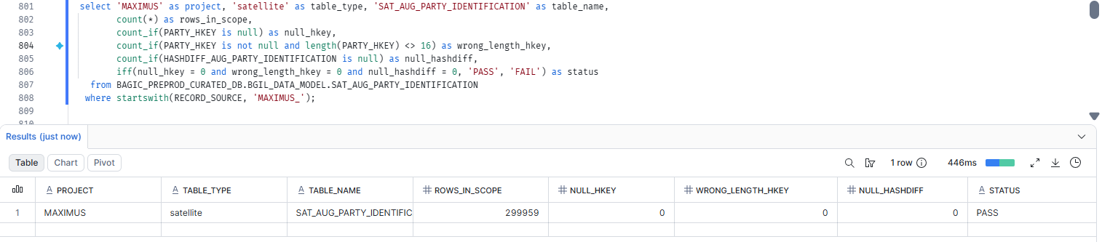

44. MAXIMUS — SATELLITE SAT_AUG_PARTY_IDENTITY [Partner LOB]
Project | MAXIMUS
Satellite | SATELLITE SAT_AUG_PARTY_IDENTITY [Partner LOB]
Status | Implemented
Pass criteria | status = PASS
Result (Pass / Fail / NA) | Pass
Rows with status = FAIL (count)
Remarks

Note: Satellite hash key and HASHDIFF populated and 16 bytes. HASHDIFF correctness itself is DM-H1 (a).
SQL query
select 'MAXIMUS' as project, 'satellite' as table_type, 'SAT_AUG_PARTY_IDENTITY' as table_name,
count(*) as rows_in_scope,
count_if(PARTY_HKEY is null) as null_hkey,
count_if(PARTY_HKEY is not null and length(PARTY_HKEY) <> 16) as wrong_length_hkey,
count_if(HASHDIFF_AUG_PARTY_IDENTITY is null) as null_hashdiff,
iff(null_hkey = 0 and wrong_length_hkey = 0 and null_hashdiff = 0, 'PASS', 'FAIL') as status
from BAGIC_PREPROD_CURATED_DB.BGIL_DATA_MODEL.SAT_AUG_PARTY_IDENTITY
where startswith(RECORD_SOURCE, 'MAXIMUS_');
Query output (attach / paste below)
Output:
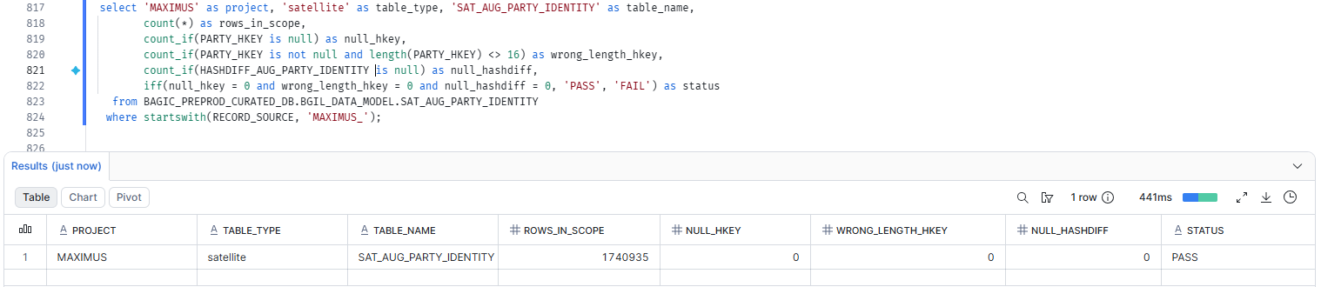

45. MAXIMUS — SATELLITE SAT_AUG_PARTY_INDIVIDUAL_DEMOGRAPHICS [Partner LOB]
Project | MAXIMUS
Satellite | SATELLITE SAT_AUG_PARTY_INDIVIDUAL_DEMOGRAPHICS [Partner LOB]
Status | Implemented
Pass criteria | status = PASS
Result (Pass / Fail / NA) | Pass
Rows with status = FAIL (count)
Remarks

Note: Satellite hash key and HASHDIFF populated and 16 bytes. HASHDIFF correctness itself is DM-H1 (a).
SQL query
select 'MAXIMUS' as project, 'satellite' as table_type, 'SAT_AUG_PARTY_INDIVIDUAL_DEMOGRAPHICS' as table_name,
count(*) as rows_in_scope,
count_if(PARTY_HKEY is null) as null_hkey,
count_if(PARTY_HKEY is not null and length(PARTY_HKEY) <> 16) as wrong_length_hkey,
count_if(HASHDIFF_AUG_PARTY_INDIVIDUAL_DEMOGRAPHICS is null) as null_hashdiff,
iff(null_hkey = 0 and wrong_length_hkey = 0 and null_hashdiff = 0, 'PASS', 'FAIL') as status
from BAGIC_PREPROD_CURATED_DB.BGIL_DATA_MODEL.SAT_AUG_PARTY_INDIVIDUAL_DEMOGRAPHICS
where startswith(RECORD_SOURCE, 'MAXIMUS_');
Query output (attach / paste below)
Output:
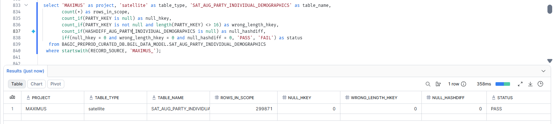

46. MAXIMUS — SATELLITE SAT_AUG_PARTY_INTERACTION
Project | MAXIMUS
Satellite | SATELLITE SAT_AUG_PARTY_INTERACTION
Status | Implemented
Pass criteria | status = PASS
Result (Pass / Fail / NA)
Rows with status = FAIL (count)
Remarks

Note: Satellite hash key and HASHDIFF populated and 16 bytes. HASHDIFF correctness itself is DM-H1 (a).
SQL query
select 'MAXIMUS' as project, 'satellite' as table_type, 'SAT_AUG_PARTY_INTERACTION' as table_name,
count(*) as rows_in_scope,
count_if(PARTY_HKEY is null) as null_hkey,
count_if(PARTY_HKEY is not null and length(PARTY_HKEY) <> 16) as wrong_length_hkey,
count_if(HASHDIFF_AUG_PARTY_INTERACTION is null) as null_hashdiff,
iff(null_hkey = 0 and wrong_length_hkey = 0 and null_hashdiff = 0, 'PASS', 'FAIL') as status
from BAGIC_PREPROD_CURATED_DB.BGIL_DATA_MODEL.SAT_AUG_PARTY_INTERACTION
where startswith(RECORD_SOURCE, 'MAXIMUS_');
Query output (attach / paste below)
Output:

47. MAXIMUS — SATELLITE SAT_AUG_PARTY_KYC [Partner LOB]
Project | MAXIMUS
Satellite | SATELLITE SAT_AUG_PARTY_KYC [Partner LOB]
Status | Implemented
Pass criteria | status = PASS
Result (Pass / Fail / NA) | Fail(Due to source issue)
Rows with status = FAIL (count)
Remarks | Null at source table stg_maximus__pd_prop_sp_pv for its columns

Note: Satellite hash key and HASHDIFF populated and 16 bytes. HASHDIFF correctness itself is DM-H1 (a).
SQL query
select 'MAXIMUS' as project, 'satellite' as table_type, 'SAT_AUG_PARTY_KYC' as table_name,
count(*) as rows_in_scope,
count_if(PARTY_HKEY is null) as null_hkey,
count_if(PARTY_HKEY is not null and length(PARTY_HKEY) <> 16) as wrong_length_hkey,
count_if(HASHDIFF_AUG_PARTY_KYC is null) as null_hashdiff,
iff(null_hkey = 0 and wrong_length_hkey = 0 and null_hashdiff = 0, 'PASS', 'FAIL') as status
from BAGIC_PREPROD_CURATED_DB.BGIL_DATA_MODEL.SAT_AUG_PARTY_KYC
where startswith(RECORD_SOURCE, 'MAXIMUS_');
Query output (attach / paste below)
Output:

48. MAXIMUS — SATELLITE SAT_AUG_PARTY_LEGAL_PANEL [Partner LOB]
Project | MAXIMUS
Satellite | SATELLITE SAT_AUG_PARTY_LEGAL_PANEL [Partner LOB]
Status | Implemented
Pass criteria | status = PASS
Result (Pass / Fail / NA) | Fail(Due to source issue)
Rows with status = FAIL (count)
Remarks | Null at source table stg_maximus__pd_prop_sp_pv for its columns

Note: Satellite hash key and HASHDIFF populated and 16 bytes. HASHDIFF correctness itself is DM-H1 (a).
SQL query
select 'MAXIMUS' as project, 'satellite' as table_type, 'SAT_AUG_PARTY_LEGAL_PANEL' as table_name,
count(*) as rows_in_scope,
count_if(PARTY_HKEY is null) as null_hkey,
count_if(PARTY_HKEY is not null and length(PARTY_HKEY) <> 16) as wrong_length_hkey,
count_if(HASHDIFF_AUG_PARTY_LEGAL_PANEL is null) as null_hashdiff,
iff(null_hkey = 0 and wrong_length_hkey = 0 and null_hashdiff = 0, 'PASS', 'FAIL') as status
from BAGIC_PREPROD_CURATED_DB.BGIL_DATA_MODEL.SAT_AUG_PARTY_LEGAL_PANEL
where startswith(RECORD_SOURCE, 'MAXIMUS_');
Query output (attach / paste below)
Output:

49. MAXIMUS — SATELLITE SAT_AUG_PARTY_LEGAL_PANEL_ROLE_LINE
Project | MAXIMUS
Satellite | SATELLITE SAT_AUG_PARTY_LEGAL_PANEL_ROLE_LINE
Status | Implemented
Pass criteria | status = PASS
Result (Pass / Fail / NA)
Rows with status = FAIL (count)
Remarks

Note: Satellite hash key and HASHDIFF populated and 16 bytes. HASHDIFF correctness itself is DM-H1 (a).
SQL query
select 'MAXIMUS' as project, 'satellite' as table_type, 'SAT_AUG_PARTY_LEGAL_PANEL_ROLE_LINE' as table_name,
count(*) as rows_in_scope,
count_if(PARTY_HKEY is null) as null_hkey,
count_if(PARTY_HKEY is not null and length(PARTY_HKEY) <> 16) as wrong_length_hkey,
count_if(HASHDIFF_AUG_PARTY_LEGAL_PANEL_ROLE_LINE is null) as null_hashdiff,
iff(null_hkey = 0 and wrong_length_hkey = 0 and null_hashdiff = 0, 'PASS', 'FAIL') as status
from BAGIC_PREPROD_CURATED_DB.BGIL_DATA_MODEL.SAT_AUG_PARTY_LEGAL_PANEL_ROLE_LINE
where startswith(RECORD_SOURCE, 'MAXIMUS_');
Query output (attach / paste below)
Output:

50. MAXIMUS — SATELLITE SAT_AUG_PARTY_MARKETING
Project | MAXIMUS
Satellite | SATELLITE SAT_AUG_PARTY_MARKETING
Status | Implemented
Pass criteria | status = PASS
Result (Pass / Fail / NA)
Rows with status = FAIL (count)
Remarks

Note: Satellite hash key and HASHDIFF populated and 16 bytes. HASHDIFF correctness itself is DM-H1 (a).
SQL query
select 'MAXIMUS' as project, 'satellite' as table_type, 'SAT_AUG_PARTY_MARKETING' as table_name,
count(*) as rows_in_scope,
count_if(PARTY_HKEY is null) as null_hkey,
count_if(PARTY_HKEY is not null and length(PARTY_HKEY) <> 16) as wrong_length_hkey,
count_if(HASHDIFF_AUG_PARTY_MARKETING is null) as null_hashdiff,
iff(null_hkey = 0 and wrong_length_hkey = 0 and null_hashdiff = 0, 'PASS', 'FAIL') as status
from BAGIC_PREPROD_CURATED_DB.BGIL_DATA_MODEL.SAT_AUG_PARTY_MARKETING
where startswith(RECORD_SOURCE, 'MAXIMUS_');
Query output (attach / paste below)
Output:

51. MAXIMUS — SATELLITE SAT_AUG_PARTY_ONBOARDING_JOURNEY [Partner LOB]
Project | MAXIMUS
Satellite | SATELLITE SAT_AUG_PARTY_ONBOARDING_JOURNEY [Partner LOB]
Status | Implemented
Pass criteria | status = PASS
Result (Pass / Fail / NA) | Fail(Due to source issue)
Rows with status = FAIL (count)
Remarks | Null at source table stg_maximus__pd_prop_sp_pv for its columns

Note: Satellite hash key and HASHDIFF populated and 16 bytes. HASHDIFF correctness itself is DM-H1 (a).
SQL query
select 'MAXIMUS' as project, 'satellite' as table_type, 'SAT_AUG_PARTY_ONBOARDING_JOURNEY' as table_name,
count(*) as rows_in_scope,
count_if(PARTY_HKEY is null) as null_hkey,
count_if(PARTY_HKEY is not null and length(PARTY_HKEY) <> 16) as wrong_length_hkey,
count_if(HASHDIFF_AUG_PARTY_ONBOARDING_JOURNEY is null) as null_hashdiff,
iff(null_hkey = 0 and wrong_length_hkey = 0 and null_hashdiff = 0, 'PASS', 'FAIL') as status
from BAGIC_PREPROD_CURATED_DB.BGIL_DATA_MODEL.SAT_AUG_PARTY_ONBOARDING_JOURNEY
where startswith(RECORD_SOURCE, 'MAXIMUS_');
Query output (attach / paste below)
Output:

52. MAXIMUS — SATELLITE SAT_AUG_PARTY_ORGANISATION_PROFILE [Partner LOB]
Project | MAXIMUS
Satellite | SATELLITE SAT_AUG_PARTY_ORGANISATION_PROFILE [Partner LOB]
Status | Implemented
Pass criteria | status = PASS
Result (Pass / Fail / NA) | Fail(Due to source issue)
Rows with status = FAIL (count)
Remarks | Null at source table stg_maximus__pd_prop_sp_pv for its columns

Note: Satellite hash key and HASHDIFF populated and 16 bytes. HASHDIFF correctness itself is DM-H1 (a).
SQL query
select 'MAXIMUS' as project, 'satellite' as table_type, 'SAT_AUG_PARTY_ORGANISATION_PROFILE' as table_name,
count(*) as rows_in_scope,
count_if(PARTY_HKEY is null) as null_hkey,
count_if(PARTY_HKEY is not null and length(PARTY_HKEY) <> 16) as wrong_length_hkey,
count_if(HASHDIFF_AUG_PARTY_ORGANISATION_PROFILE is null) as null_hashdiff,
iff(null_hkey = 0 and wrong_length_hkey = 0 and null_hashdiff = 0, 'PASS', 'FAIL') as status
from BAGIC_PREPROD_CURATED_DB.BGIL_DATA_MODEL.SAT_AUG_PARTY_ORGANISATION_PROFILE
where startswith(RECORD_SOURCE, 'MAXIMUS_');
Query output (attach / paste below)
Output:

53. MAXIMUS — SATELLITE SAT_AUG_PARTY_ORG_DIRECTORS [Partner LOB]
Project | MAXIMUS
Satellite | SATELLITE SAT_AUG_PARTY_ORG_DIRECTORS [Partner LOB]
Status | Implemented
Pass criteria | status = PASS
Result (Pass / Fail / NA) | Fail(Due to source issue)
Rows with status = FAIL (count)
Remarks | Null at source table stg_maximus__pd_prop_sp_pv for its columns

Note: Satellite hash key and HASHDIFF populated and 16 bytes. HASHDIFF correctness itself is DM-H1 (a).
SQL query
select 'MAXIMUS' as project, 'satellite' as table_type, 'SAT_AUG_PARTY_ORG_DIRECTORS' as table_name,
count(*) as rows_in_scope,
count_if(PARTY_HKEY is null) as null_hkey,
count_if(PARTY_HKEY is not null and length(PARTY_HKEY) <> 16) as wrong_length_hkey,
count_if(HASHDIFF_AUG_PARTY_ORG_DIRECTORS is null) as null_hashdiff,
iff(null_hkey = 0 and wrong_length_hkey = 0 and null_hashdiff = 0, 'PASS', 'FAIL') as status
from BAGIC_PREPROD_CURATED_DB.BGIL_DATA_MODEL.SAT_AUG_PARTY_ORG_DIRECTORS
where startswith(RECORD_SOURCE, 'MAXIMUS_');
Query output (attach / paste below)
Output:

54. MAXIMUS — SATELLITE SAT_AUG_PARTY_PAYOUT_PROFILE [Partner LOB]
Project | MAXIMUS
Satellite | SATELLITE SAT_AUG_PARTY_PAYOUT_PROFILE [Partner LOB]
Status | Implemented
Pass criteria | status = PASS
Result (Pass / Fail / NA) | Pass
Rows with status = FAIL (count)
Remarks

Note: Satellite hash key and HASHDIFF populated and 16 bytes. HASHDIFF correctness itself is DM-H1 (a).
SQL query
select 'MAXIMUS' as project, 'satellite' as table_type, 'SAT_AUG_PARTY_PAYOUT_PROFILE' as table_name,
count(*) as rows_in_scope,
count_if(PARTY_HKEY is null) as null_hkey,
count_if(PARTY_HKEY is not null and length(PARTY_HKEY) <> 16) as wrong_length_hkey,
count_if(HASHDIFF_AUG_PARTY_PAYOUT_PROFILE is null) as null_hashdiff,
iff(null_hkey = 0 and wrong_length_hkey = 0 and null_hashdiff = 0, 'PASS', 'FAIL') as status
from BAGIC_PREPROD_CURATED_DB.BGIL_DATA_MODEL.SAT_AUG_PARTY_PAYOUT_PROFILE
where startswith(RECORD_SOURCE, 'MAXIMUS_');
Query output (attach / paste below)
Output:

55. MAXIMUS — SATELLITE SAT_AUG_PARTY_PREFERENCE_PROFILE
Project | MAXIMUS
Satellite | SATELLITE SAT_AUG_PARTY_PREFERENCE_PROFILE
Status | Implemented
Pass criteria | status = PASS
Result (Pass / Fail / NA)
Rows with status = FAIL (count)
Remarks

Note: Satellite hash key and HASHDIFF populated and 16 bytes. HASHDIFF correctness itself is DM-H1 (a).
SQL query
select 'MAXIMUS' as project, 'satellite' as table_type, 'SAT_AUG_PARTY_PREFERENCE_PROFILE' as table_name,
count(*) as rows_in_scope,
count_if(PARTY_HKEY is null) as null_hkey,
count_if(PARTY_HKEY is not null and length(PARTY_HKEY) <> 16) as wrong_length_hkey,
count_if(HASHDIFF_AUG_PARTY_PREFERENCE_PROFILE is null) as null_hashdiff,
iff(null_hkey = 0 and wrong_length_hkey = 0 and null_hashdiff = 0, 'PASS', 'FAIL') as status
from BAGIC_PREPROD_CURATED_DB.BGIL_DATA_MODEL.SAT_AUG_PARTY_PREFERENCE_PROFILE
where startswith(RECORD_SOURCE, 'MAXIMUS_');
Query output (attach / paste below)
Output:

56. MAXIMUS — SATELLITE SAT_AUG_PARTY_PROVIDER_CAPABILITY [Partner LOB]
Project | MAXIMUS
Satellite | SATELLITE SAT_AUG_PARTY_PROVIDER_CAPABILITY [Partner LOB]
Status | Implemented
Pass criteria | status = PASS
Result (Pass / Fail / NA) | Fail(Due to source issue)
Rows with status = FAIL (count)
Remarks | Null at source table stg_maximus__pd_prop_sp_pv for its columns

Note: Satellite hash key and HASHDIFF populated and 16 bytes. HASHDIFF correctness itself is DM-H1 (a).
SQL query
select 'MAXIMUS' as project, 'satellite' as table_type, 'SAT_AUG_PARTY_PROVIDER_CAPABILITY' as table_name,
count(*) as rows_in_scope,
count_if(PARTY_HKEY is null) as null_hkey,
count_if(PARTY_HKEY is not null and length(PARTY_HKEY) <> 16) as wrong_length_hkey,
count_if(HASHDIFF_AUG_PARTY_PROVIDER_CAPABILITY is null) as null_hashdiff,
iff(null_hkey = 0 and wrong_length_hkey = 0 and null_hashdiff = 0, 'PASS', 'FAIL') as status
from BAGIC_PREPROD_CURATED_DB.BGIL_DATA_MODEL.SAT_AUG_PARTY_PROVIDER_CAPABILITY
where startswith(RECORD_SOURCE, 'MAXIMUS_');
Query output (attach / paste below)
Output:

57. MAXIMUS — SATELLITE SAT_AUG_PARTY_RECORD_REMARKS
Project | MAXIMUS
Satellite | SATELLITE SAT_AUG_PARTY_RECORD_REMARKS
Status | Implemented
Pass criteria | status = PASS
Result (Pass / Fail / NA)
Rows with status = FAIL (count)
Remarks

Note: Satellite hash key and HASHDIFF populated and 16 bytes. HASHDIFF correctness itself is DM-H1 (a).
SQL query
select 'MAXIMUS' as project, 'satellite' as table_type, 'SAT_AUG_PARTY_RECORD_REMARKS' as table_name,
count(*) as rows_in_scope,
count_if(PARTY_HKEY is null) as null_hkey,
count_if(PARTY_HKEY is not null and length(PARTY_HKEY) <> 16) as wrong_length_hkey,
count_if(HASHDIFF_AUG_PARTY_RECORD_REMARKS is null) as null_hashdiff,
iff(null_hkey = 0 and wrong_length_hkey = 0 and null_hashdiff = 0, 'PASS', 'FAIL') as status
from BAGIC_PREPROD_CURATED_DB.BGIL_DATA_MODEL.SAT_AUG_PARTY_RECORD_REMARKS
where startswith(RECORD_SOURCE, 'MAXIMUS_');
Query output (attach / paste below)
Output:

58. MAXIMUS — SATELLITE SAT_AUG_PARTY_RELATIONSHIP_PROFILE [Partner LOB]
Project | MAXIMUS
Satellite | SATELLITE SAT_AUG_PARTY_RELATIONSHIP_PROFILE [Partner LOB]
Status | Implemented
Pass criteria | status = PASS
Result (Pass / Fail / NA) | Fail(Due to source issue)
Rows with status = FAIL (count)
Remarks | Null at source table stg_maximus__pd_prop_sp_pv for its columns

Note: Satellite hash key and HASHDIFF populated and 16 bytes. HASHDIFF correctness itself is DM-H1 (a).
SQL query
select 'MAXIMUS' as project, 'satellite' as table_type, 'SAT_AUG_PARTY_RELATIONSHIP_PROFILE' as table_name,
count(*) as rows_in_scope,
count_if(PARTY_HKEY is null) as null_hkey,
count_if(PARTY_HKEY is not null and length(PARTY_HKEY) <> 16) as wrong_length_hkey,
count_if(HASHDIFF_AUG_PARTY_RELATIONSHIP_PROFILE is null) as null_hashdiff,
iff(null_hkey = 0 and wrong_length_hkey = 0 and null_hashdiff = 0, 'PASS', 'FAIL') as status
from BAGIC_PREPROD_CURATED_DB.BGIL_DATA_MODEL.SAT_AUG_PARTY_RELATIONSHIP_PROFILE
where startswith(RECORD_SOURCE, 'MAXIMUS_');
Query output (attach / paste below)
Output:

59. MAXIMUS — SATELLITE SAT_AUG_PARTY_SERVICE_ENGAGEMENT_TERMS
Project | MAXIMUS
Satellite | SATELLITE SAT_AUG_PARTY_SERVICE_ENGAGEMENT_TERMS
Status | Implemented
Pass criteria | status = PASS
Result (Pass / Fail / NA)
Rows with status = FAIL (count)
Remarks

Note: Satellite hash key and HASHDIFF populated and 16 bytes. HASHDIFF correctness itself is DM-H1 (a).
SQL query
select 'MAXIMUS' as project, 'satellite' as table_type, 'SAT_AUG_PARTY_SERVICE_ENGAGEMENT_TERMS' as table_name,
count(*) as rows_in_scope,
count_if(PARTY_HKEY is null) as null_hkey,
count_if(PARTY_HKEY is not null and length(PARTY_HKEY) <> 16) as wrong_length_hkey,
count_if(HASHDIFF_AUG_PARTY_SERVICE_ENGAGEMENT_TERMS is null) as null_hashdiff,
iff(null_hkey = 0 and wrong_length_hkey = 0 and null_hashdiff = 0, 'PASS', 'FAIL') as status
from BAGIC_PREPROD_CURATED_DB.BGIL_DATA_MODEL.SAT_AUG_PARTY_SERVICE_ENGAGEMENT_TERMS
where startswith(RECORD_SOURCE, 'MAXIMUS_');
Query output (attach / paste below)
Output:

60. MAXIMUS — SATELLITE SAT_AUG_PARTY_SOURCE_PROPERTY_SET_RECORD_GOVERNANCE
Project | MAXIMUS
Satellite | SATELLITE SAT_AUG_PARTY_SOURCE_PROPERTY_SET_RECORD_GOVERNANCE
Status | Implemented
Pass criteria | status = PASS
Result (Pass / Fail / NA)
Rows with status = FAIL (count)
Remarks

Note: Satellite hash key and HASHDIFF populated and 16 bytes. HASHDIFF correctness itself is DM-H1 (a).
SQL query
select 'MAXIMUS' as project, 'satellite' as table_type, 'SAT_AUG_PARTY_SOURCE_PROPERTY_SET_RECORD_GOVERNANCE' as table_name,
count(*) as rows_in_scope,
count_if(PARTY_HKEY is null) as null_hkey,
count_if(PARTY_HKEY is not null and length(PARTY_HKEY) <> 16) as wrong_length_hkey,
count_if(HASHDIFF_AUG_PARTY_SOURCE_PROPERTY_SET_RECORD_GOVERNANCE is null) as null_hashdiff,
iff(null_hkey = 0 and wrong_length_hkey = 0 and null_hashdiff = 0, 'PASS', 'FAIL') as status
from BAGIC_PREPROD_CURATED_DB.BGIL_DATA_MODEL.SAT_AUG_PARTY_SOURCE_PROPERTY_SET_RECORD_GOVERNANCE
where startswith(RECORD_SOURCE, 'MAXIMUS_');
Query output (attach / paste below)
Output:

61. MAXIMUS — SATELLITE SAT_AUG_PARTY_SUSPENSION_NEGATIVE_ACTION
Project | MAXIMUS
Satellite | SATELLITE SAT_AUG_PARTY_SUSPENSION_NEGATIVE_ACTION
Status | Implemented
Pass criteria | status = PASS
Result (Pass / Fail / NA)
Rows with status = FAIL (count)
Remarks

Note: Satellite hash key and HASHDIFF populated and 16 bytes. HASHDIFF correctness itself is DM-H1 (a).
SQL query
select 'MAXIMUS' as project, 'satellite' as table_type, 'SAT_AUG_PARTY_SUSPENSION_NEGATIVE_ACTION' as table_name,
count(*) as rows_in_scope,
count_if(PARTY_HKEY is null) as null_hkey,
count_if(PARTY_HKEY is not null and length(PARTY_HKEY) <> 16) as wrong_length_hkey,
count_if(HASHDIFF_AUG_PARTY_SUSPENSION_NEGATIVE_ACTION is null) as null_hashdiff,
iff(null_hkey = 0 and wrong_length_hkey = 0 and null_hashdiff = 0, 'PASS', 'FAIL') as status
from BAGIC_PREPROD_CURATED_DB.BGIL_DATA_MODEL.SAT_AUG_PARTY_SUSPENSION_NEGATIVE_ACTION
where startswith(RECORD_SOURCE, 'MAXIMUS_');
Query output (attach / paste below)
Output:

62. MAXIMUS — SATELLITE SAT_AUG_PARTY_VEHICLE_OWNER
Project | MAXIMUS
Satellite | SATELLITE SAT_AUG_PARTY_VEHICLE_OWNER
Status | Implemented
Pass criteria | status = PASS
Result (Pass / Fail / NA)
Rows with status = FAIL (count)
Remarks

Note: Satellite hash key and HASHDIFF populated and 16 bytes. HASHDIFF correctness itself is DM-H1 (a).
SQL query
select 'MAXIMUS' as project, 'satellite' as table_type, 'SAT_AUG_PARTY_VEHICLE_OWNER' as table_name,
count(*) as rows_in_scope,
count_if(PARTY_HKEY is null) as null_hkey,
count_if(PARTY_HKEY is not null and length(PARTY_HKEY) <> 16) as wrong_length_hkey,
count_if(HASHDIFF_AUG_PARTY_VEHICLE_OWNER is null) as null_hashdiff,
iff(null_hkey = 0 and wrong_length_hkey = 0 and null_hashdiff = 0, 'PASS', 'FAIL') as status
from BAGIC_PREPROD_CURATED_DB.BGIL_DATA_MODEL.SAT_AUG_PARTY_VEHICLE_OWNER
where startswith(RECORD_SOURCE, 'MAXIMUS_');
Query output (attach / paste below)
Output:

63. MAXIMUS — SATELLITE SAT_AUG_PROVIDER_BANKING [Partner LOB]
Project | MAXIMUS
Satellite | SATELLITE SAT_AUG_PROVIDER_BANKING [Partner LOB]
Status | Implemented
Pass criteria | status = PASS
Result (Pass / Fail / NA) | Fail(Due to source issue)
Rows with status = FAIL (count)
Remarks | Null at source table stg_maximus__pd_prop_sp_pv for its columns

Note: Satellite hash key and HASHDIFF populated and 16 bytes. HASHDIFF correctness itself is DM-H1 (a).
SQL query
select 'MAXIMUS' as project, 'satellite' as table_type, 'SAT_AUG_PROVIDER_BANKING' as table_name,
count(*) as rows_in_scope,
count_if(PARTY_HKEY is null) as null_hkey,
count_if(PARTY_HKEY is not null and length(PARTY_HKEY) <> 16) as wrong_length_hkey,
count_if(HASHDIFF_AUG_PROVIDER_BANKING is null) as null_hashdiff,
iff(null_hkey = 0 and wrong_length_hkey = 0 and null_hashdiff = 0, 'PASS', 'FAIL') as status
from BAGIC_PREPROD_CURATED_DB.BGIL_DATA_MODEL.SAT_AUG_PROVIDER_BANKING
where startswith(RECORD_SOURCE, 'MAXIMUS_');
Query output (attach / paste below)
Output:

64. MAXIMUS — SATELLITE SAT_AUG_PROVIDER_QUALITY [Partner LOB]
Project | MAXIMUS
Satellite | SATELLITE SAT_AUG_PROVIDER_QUALITY [Partner LOB]
Status | Implemented
Pass criteria | status = PASS
Result (Pass / Fail / NA) | Fail(Due to source issue)
Rows with status = FAIL (count)
Remarks | Null at source table stg_maximus__pd_prop_sp_pv for its columns

Note: Satellite hash key and HASHDIFF populated and 16 bytes. HASHDIFF correctness itself is DM-H1 (a).
SQL query
select 'MAXIMUS' as project, 'satellite' as table_type, 'SAT_AUG_PROVIDER_QUALITY' as table_name,
count(*) as rows_in_scope,
count_if(PARTY_HKEY is null) as null_hkey,
count_if(PARTY_HKEY is not null and length(PARTY_HKEY) <> 16) as wrong_length_hkey,
count_if(HASHDIFF_AUG_PROVIDER_QUALITY is null) as null_hashdiff,
iff(null_hkey = 0 and wrong_length_hkey = 0 and null_hashdiff = 0, 'PASS', 'FAIL') as status
from BAGIC_PREPROD_CURATED_DB.BGIL_DATA_MODEL.SAT_AUG_PROVIDER_QUALITY
where startswith(RECORD_SOURCE, 'MAXIMUS_');
Query output (attach / paste below)
Output:

65. MAXIMUS — SATELLITE SAT_AUG_PROVIDER_TARIFF [Partner LOB]
Project | MAXIMUS
Satellite | SATELLITE SAT_AUG_PROVIDER_TARIFF [Partner LOB]
Status | Implemented
Pass criteria | status = PASS
Result (Pass / Fail / NA) | Fail(Due to source issue)
Rows with status = FAIL (count)
Remarks | Null at source table stg_maximus__pd_prop_sp_pv for its columns

Note: Satellite hash key and HASHDIFF populated and 16 bytes. HASHDIFF correctness itself is DM-H1 (a).
SQL query
select 'MAXIMUS' as project, 'satellite' as table_type, 'SAT_AUG_PROVIDER_TARIFF' as table_name,
count(*) as rows_in_scope,
count_if(PARTY_HKEY is null) as null_hkey,
count_if(PARTY_HKEY is not null and length(PARTY_HKEY) <> 16) as wrong_length_hkey,
count_if(HASHDIFF_AUG_PROVIDER_TARIFF is null) as null_hashdiff,
iff(null_hkey = 0 and wrong_length_hkey = 0 and null_hashdiff = 0, 'PASS', 'FAIL') as status
from BAGIC_PREPROD_CURATED_DB.BGIL_DATA_MODEL.SAT_AUG_PROVIDER_TARIFF
where startswith(RECORD_SOURCE, 'MAXIMUS_');
Query output (attach / paste below)
Output:

66. MAXIMUS — SATELLITE SAT_CHANNEL_DEFINITION [Partner LOB]
Project | MAXIMUS
Satellite | SATELLITE SAT_CHANNEL_DEFINITION [Partner LOB]
Status | Implemented
Pass criteria | status = PASS
Result (Pass / Fail / NA) | Pass
Rows with status = FAIL (count)
Remarks

Note: Satellite hash key and HASHDIFF populated and 16 bytes. HASHDIFF correctness itself is DM-H1 (a).
SQL query
select 'MAXIMUS' as project, 'satellite' as table_type, 'SAT_CHANNEL_DEFINITION' as table_name,
count(*) as rows_in_scope,
count_if(DISTRIBUTION_CHANNEL_HKEY is null) as null_hkey,
count_if(DISTRIBUTION_CHANNEL_HKEY is not null and length(DISTRIBUTION_CHANNEL_HKEY) <> 16) as wrong_length_hkey,
count_if(HASHDIFF_CHANNEL_DEFINITION is null) as null_hashdiff,
iff(null_hkey = 0 and wrong_length_hkey = 0 and null_hashdiff = 0, 'PASS', 'FAIL') as status
from BAGIC_PREPROD_CURATED_DB.BGIL_DATA_MODEL.SAT_CHANNEL_DEFINITION
where startswith(RECORD_SOURCE, 'MAXIMUS_');
Query output (attach / paste below)
Output:
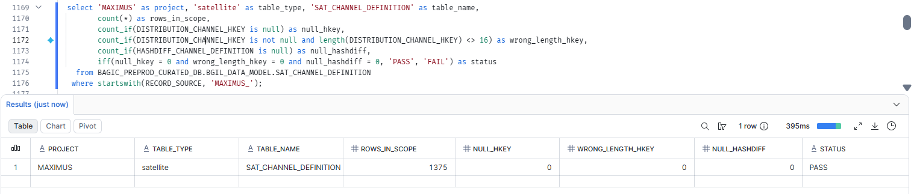

67. MAXIMUS — SATELLITE SAT_COMMON_ADDRESS [Partner LOB]
Project | MAXIMUS
Satellite | SATELLITE SAT_COMMON_ADDRESS [Partner LOB]
Status | Implemented
Pass criteria | status = PASS
Result (Pass / Fail / NA) | Pass
Rows with status = FAIL (count)
Remarks

Note: Satellite hash key and HASHDIFF populated and 16 bytes. HASHDIFF correctness itself is DM-H1 (a).
SQL query
select 'MAXIMUS' as project, 'satellite' as table_type, 'SAT_COMMON_ADDRESS' as table_name,
count(*) as rows_in_scope,
count_if(LOCATION_HKEY is null) as null_hkey,
count_if(LOCATION_HKEY is not null and length(LOCATION_HKEY) <> 16) as wrong_length_hkey,
count_if(HASHDIFF is null) as null_hashdiff,
iff(null_hkey = 0 and wrong_length_hkey = 0 and null_hashdiff = 0, 'PASS', 'FAIL') as status
from BAGIC_PREPROD_CURATED_DB.BGIL_DATA_MODEL.SAT_COMMON_ADDRESS
where startswith(RECORD_SOURCE, 'MAXIMUS_');
Query output (attach / paste below)
Output:
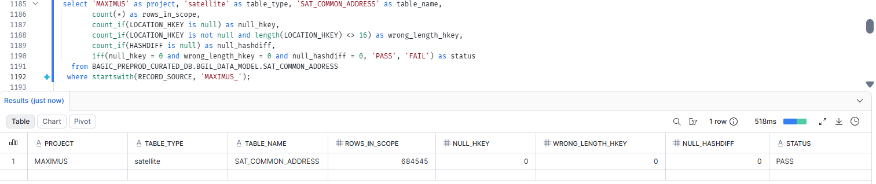

68. MAXIMUS — SATELLITE SAT_COMMON_ADMIN_GEOGRAPHY [Partner LOB]
Project | MAXIMUS
Satellite | SATELLITE SAT_COMMON_ADMIN_GEOGRAPHY [Partner LOB]
Status | Implemented
Pass criteria | status = PASS
Result (Pass / Fail / NA) | Fail(Due to source issue)
Rows with status = FAIL (count)
Remarks | Null at source table stg_maximus__pd_prop_sp_pv for its columns

Note: Satellite hash key and HASHDIFF populated and 16 bytes. HASHDIFF correctness itself is DM-H1 (a).
SQL query
select 'MAXIMUS' as project, 'satellite' as table_type, 'SAT_COMMON_ADMIN_GEOGRAPHY' as table_name,
count(*) as rows_in_scope,
count_if(LOCATION_HKEY is null) as null_hkey,
count_if(LOCATION_HKEY is not null and length(LOCATION_HKEY) <> 16) as wrong_length_hkey,
count_if(HASHDIFF is null) as null_hashdiff,
iff(null_hkey = 0 and wrong_length_hkey = 0 and null_hashdiff = 0, 'PASS', 'FAIL') as status
from BAGIC_PREPROD_CURATED_DB.BGIL_DATA_MODEL.SAT_COMMON_ADMIN_GEOGRAPHY
where startswith(RECORD_SOURCE, 'MAXIMUS_');
Query output (attach / paste below)
Output:

69. MAXIMUS — SATELLITE SAT_COMMON_CLASSIFICATION [Partner LOB]
Project | MAXIMUS
Satellite | SATELLITE SAT_COMMON_CLASSIFICATION [Partner LOB]
Status | Implemented
Pass criteria | status = PASS
Result (Pass / Fail / NA) | Fail(Due to source issue)
Rows with status = FAIL (count)
Remarks | Null at source table stg_maximus__pd_prop_sp_pv for its columns

Note: Satellite hash key and HASHDIFF populated and 16 bytes. HASHDIFF correctness itself is DM-H1 (a).
SQL query
select 'MAXIMUS' as project, 'satellite' as table_type, 'SAT_COMMON_CLASSIFICATION' as table_name,
count(*) as rows_in_scope,
count_if(PARTY_HKEY is null) as null_hkey,
count_if(PARTY_HKEY is not null and length(PARTY_HKEY) <> 16) as wrong_length_hkey,
count_if(HASHDIFF is null) as null_hashdiff,
iff(null_hkey = 0 and wrong_length_hkey = 0 and null_hashdiff = 0, 'PASS', 'FAIL') as status
from BAGIC_PREPROD_CURATED_DB.BGIL_DATA_MODEL.SAT_COMMON_CLASSIFICATION
where startswith(RECORD_SOURCE, 'MAXIMUS_');
Query output (attach / paste below)
Output:

70. MAXIMUS — SATELLITE SAT_COMMON_COMMUNICATION_PREFERENCE [Partner LOB]
Project | MAXIMUS
Satellite | SATELLITE SAT_COMMON_COMMUNICATION_PREFERENCE [Partner LOB]
Status | Implemented
Pass criteria | status = PASS
Result (Pass / Fail / NA) | Fail(Due to source issue)
Rows with status = FAIL (count)
Remarks | Null at source table stg_maximus__pd_prop_sp_pv for its columns

Note: Satellite hash key and HASHDIFF populated and 16 bytes. HASHDIFF correctness itself is DM-H1 (a).
SQL query
select 'MAXIMUS' as project, 'satellite' as table_type, 'SAT_COMMON_COMMUNICATION_PREFERENCE' as table_name,
count(*) as rows_in_scope,
count_if(PARTY_HKEY is null) as null_hkey,
count_if(PARTY_HKEY is not null and length(PARTY_HKEY) <> 16) as wrong_length_hkey,
count_if(HASHDIFF is null) as null_hashdiff,
iff(null_hkey = 0 and wrong_length_hkey = 0 and null_hashdiff = 0, 'PASS', 'FAIL') as status
from BAGIC_PREPROD_CURATED_DB.BGIL_DATA_MODEL.SAT_COMMON_COMMUNICATION_PREFERENCE
where startswith(RECORD_SOURCE, 'MAXIMUS_');
Query output (attach / paste below)
Output:

71. MAXIMUS — SATELLITE SAT_COMMON_CONSENT [Partner LOB]
Project | MAXIMUS
Satellite | SATELLITE SAT_COMMON_CONSENT [Partner LOB]
Status | Implemented
Pass criteria | status = PASS
Result (Pass / Fail / NA) | Fail(Due to source issue)
Rows with status = FAIL (count)
Remarks | Null at source table stg_maximus__pd_prop_sp_pv for its columns

Note: Satellite hash key and HASHDIFF populated and 16 bytes. HASHDIFF correctness itself is DM-H1 (a).
SQL query
select 'MAXIMUS' as project, 'satellite' as table_type, 'SAT_COMMON_CONSENT' as table_name,
count(*) as rows_in_scope,
count_if(PARTY_HKEY is null) as null_hkey,
count_if(PARTY_HKEY is not null and length(PARTY_HKEY) <> 16) as wrong_length_hkey,
count_if(HASHDIFF is null) as null_hashdiff,
iff(null_hkey = 0 and wrong_length_hkey = 0 and null_hashdiff = 0, 'PASS', 'FAIL') as status
from BAGIC_PREPROD_CURATED_DB.BGIL_DATA_MODEL.SAT_COMMON_CONSENT
where startswith(RECORD_SOURCE, 'MAXIMUS_');
Query output (attach / paste below)
Output:

72. MAXIMUS — SATELLITE SAT_COMMON_CONTACT [Partner LOB]
Project | MAXIMUS
Satellite | SATELLITE SAT_COMMON_CONTACT [Partner LOB]
Status | Implemented
Pass criteria | status = PASS
Result (Pass / Fail / NA) | Pass
Rows with status = FAIL (count)
Remarks

Note: Satellite hash key and HASHDIFF populated and 16 bytes. HASHDIFF correctness itself is DM-H1 (a).
SQL query
select 'MAXIMUS' as project, 'satellite' as table_type, 'SAT_COMMON_CONTACT' as table_name,
count(*) as rows_in_scope,
count_if(PARTY_HKEY is null) as null_hkey,
count_if(PARTY_HKEY is not null and length(PARTY_HKEY) <> 16) as wrong_length_hkey,
count_if(HASHDIFF is null) as null_hashdiff,
iff(null_hkey = 0 and wrong_length_hkey = 0 and null_hashdiff = 0, 'PASS', 'FAIL') as status
from BAGIC_PREPROD_CURATED_DB.BGIL_DATA_MODEL.SAT_COMMON_CONTACT
where RECORD_SOURCE = 'MAXIMUS';
Query output (attach / paste below)
Output:
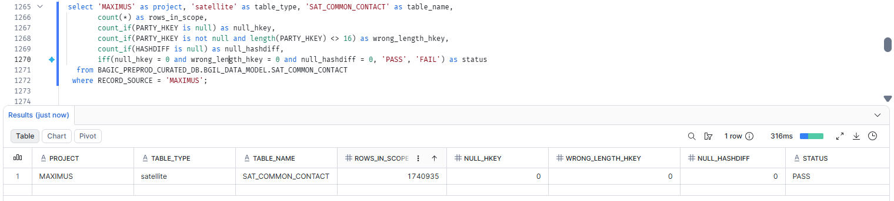

73. MAXIMUS — SATELLITE SAT_COMMON_GEO [Partner LOB]
Project | MAXIMUS
Satellite | SATELLITE SAT_COMMON_GEO [Partner LOB]
Status | Implemented
Pass criteria | status = PASS
Result (Pass / Fail / NA) | Pass
Rows with status = FAIL (count)
Remarks

Note: Satellite hash key and HASHDIFF populated and 16 bytes. HASHDIFF correctness itself is DM-H1 (a).
SQL query
select 'MAXIMUS' as project, 'satellite' as table_type, 'SAT_COMMON_GEO' as table_name,
count(*) as rows_in_scope,
count_if(LOCATION_HKEY is null) as null_hkey,
count_if(LOCATION_HKEY is not null and length(LOCATION_HKEY) <> 16) as wrong_length_hkey,
count_if(HASHDIFF is null) as null_hashdiff,
iff(null_hkey = 0 and wrong_length_hkey = 0 and null_hashdiff = 0, 'PASS', 'FAIL') as status
from BAGIC_PREPROD_CURATED_DB.BGIL_DATA_MODEL.SAT_COMMON_GEO
where startswith(RECORD_SOURCE, 'MAXIMUS_');
Query output (attach / paste below)
Output:
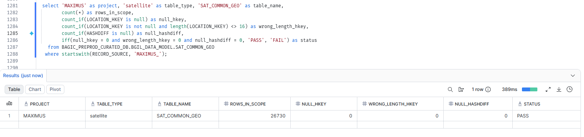

74. MAXIMUS — SATELLITE SAT_DOCUMENT_DEFINITION [Partner LOB]
Project | MAXIMUS
Satellite | SATELLITE SAT_DOCUMENT_DEFINITION [Partner LOB]
Status | Implemented
Pass criteria | status = PASS
Result (Pass / Fail / NA) | Pass
Rows with status = FAIL (count)
Remarks

Note: Satellite hash key and HASHDIFF populated and 16 bytes. HASHDIFF correctness itself is DM-H1 (a).
SQL query
select 'MAXIMUS' as project, 'satellite' as table_type, 'SAT_DOCUMENT_DEFINITION' as table_name,
count(*) as rows_in_scope,
count_if(DOCUMENT_HKEY is null) as null_hkey,
count_if(DOCUMENT_HKEY is not null and length(DOCUMENT_HKEY) <> 16) as wrong_length_hkey,
count_if(HASHDIFF is null) as null_hashdiff,
iff(null_hkey = 0 and wrong_length_hkey = 0 and null_hashdiff = 0, 'PASS', 'FAIL') as status
from BAGIC_PREPROD_CURATED_DB.BGIL_DATA_MODEL.SAT_DOCUMENT_DEFINITION
where startswith(RECORD_SOURCE, 'MAXIMUS_');
Query output (attach / paste below)
Output:
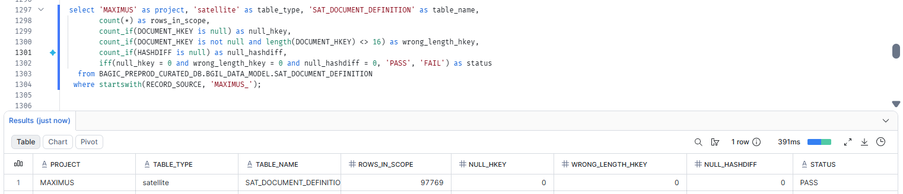

75. MAXIMUS — SATELLITE SAT_INSTRUMENT_DEFINITION [Partner LOB]
Project | MAXIMUS
Satellite | SATELLITE SAT_INSTRUMENT_DEFINITION [Partner LOB]
Status | Implemented
Pass criteria | status = PASS
Result (Pass / Fail / NA) | Pass
Rows with status = FAIL (count)
Remarks

Note: Satellite hash key and HASHDIFF populated and 16 bytes. HASHDIFF correctness itself is DM-H1 (a).
SQL query
select 'MAXIMUS' as project, 'satellite' as table_type, 'SAT_INSTRUMENT_DEFINITION' as table_name,
count(*) as rows_in_scope,
count_if(PAYMENT_INSTRUMENT_HKEY is null) as null_hkey,
count_if(PAYMENT_INSTRUMENT_HKEY is not null and length(PAYMENT_INSTRUMENT_HKEY) <> 16) as wrong_length_hkey,
count_if(HASHDIFF_INSTRUMENT_DEFINITION is null) as null_hashdiff,
iff(null_hkey = 0 and wrong_length_hkey = 0 and null_hashdiff = 0, 'PASS', 'FAIL') as status
from BAGIC_PREPROD_CURATED_DB.BGIL_DATA_MODEL.SAT_INSTRUMENT_DEFINITION
where startswith(RECORD_SOURCE, 'MAXIMUS_');
Query output (attach / paste below)
Output:
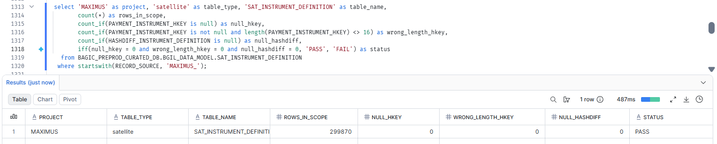

76. MAXIMUS — SATELLITE SAT_LNK_PARTY_ROLE_CORE [Partner LOB]
Project | MAXIMUS
Satellite | SATELLITE SAT_LNK_PARTY_ROLE_CORE [Partner LOB]
Status | Implemented
Pass criteria | status = PASS
Result (Pass / Fail / NA) | Fail(Due to source issue)
Rows with status = FAIL (count)
Remarks | Column missing from source stg_maximus__pd_prop_msdp_pv; stg_maximus__pd_prop_sp_pv missing columns (date_of_joiningdfadvocate, date_of_joininghcadvocate, date_of_joiningstadvocate, cancel_on).

Note: Satellite hash key and HASHDIFF populated and 16 bytes. HASHDIFF correctness itself is DM-H1 (a).
SQL query
select 'MAXIMUS' as project, 'satellite' as table_type, 'SAT_LNK_PARTY_ROLE_CORE' as table_name,
count(*) as rows_in_scope,
count_if(PARTY_HKEY is null) as null_hkey,
count_if(PARTY_HKEY is not null and length(PARTY_HKEY) <> 16) as wrong_length_hkey,
count_if(HASHDIFF is null) as null_hashdiff,
iff(null_hkey = 0 and wrong_length_hkey = 0 and null_hashdiff = 0, 'PASS', 'FAIL') as status
from BAGIC_PREPROD_CURATED_DB.BGIL_DATA_MODEL.SAT_LNK_PARTY_ROLE_CORE
where startswith(RECORD_SOURCE, 'MAXIMUS_');
Query output (attach / paste below)
Output:

77. MAXIMUS — SATELLITE SAT_LNK_ROLE_AGENT [Partner LOB]
Project | MAXIMUS
Satellite | SATELLITE SAT_LNK_ROLE_AGENT [Partner LOB]
Status | Implemented
Pass criteria | status = PASS
Result (Pass / Fail / NA) | Fail(Due to source issue)
Rows with status = FAIL (count)
Remarks | Null at source table stg_maximus__pd_prop_sp_pv for its columns

Note: Satellite hash key and HASHDIFF populated and 16 bytes. HASHDIFF correctness itself is DM-H1 (a).
SQL query
select 'MAXIMUS' as project, 'satellite' as table_type, 'SAT_LNK_ROLE_AGENT' as table_name,
count(*) as rows_in_scope,
count_if(PARTY_HKEY is null) as null_hkey,
count_if(PARTY_HKEY is not null and length(PARTY_HKEY) <> 16) as wrong_length_hkey,
count_if(HASHDIFF is null) as null_hashdiff,
iff(null_hkey = 0 and wrong_length_hkey = 0 and null_hashdiff = 0, 'PASS', 'FAIL') as status
from BAGIC_PREPROD_CURATED_DB.BGIL_DATA_MODEL.SAT_LNK_ROLE_AGENT
where startswith(RECORD_SOURCE, 'MAXIMUS_');
Query output (attach / paste below)
Output:

78. MAXIMUS — SATELLITE SAT_LNK_ROLE_CUSTOMER [Partner LOB]
Project | MAXIMUS
Satellite | SATELLITE SAT_LNK_ROLE_CUSTOMER [Partner LOB]
Status | Implemented
Pass criteria | status = PASS
Result (Pass / Fail / NA) | Fail(Due to source issue)
Rows with status = FAIL (count)
Remarks | Null at source table stg_maximus__pd_prop_sp_pv for its columns

Note: Satellite hash key and HASHDIFF populated and 16 bytes. HASHDIFF correctness itself is DM-H1 (a).
SQL query
select 'MAXIMUS' as project, 'satellite' as table_type, 'SAT_LNK_ROLE_CUSTOMER' as table_name,
count(*) as rows_in_scope,
count_if(PARTY_HKEY is null) as null_hkey,
count_if(PARTY_HKEY is not null and length(PARTY_HKEY) <> 16) as wrong_length_hkey,
count_if(HASHDIFF is null) as null_hashdiff,
iff(null_hkey = 0 and wrong_length_hkey = 0 and null_hashdiff = 0, 'PASS', 'FAIL') as status
from BAGIC_PREPROD_CURATED_DB.BGIL_DATA_MODEL.SAT_LNK_ROLE_CUSTOMER
where startswith(RECORD_SOURCE, 'MAXIMUS_');
Query output (attach / paste below)
Output:

79. MAXIMUS — SATELLITE SAT_LNK_ROLE_EMPLOYEE [Partner LOB]
Project | MAXIMUS
Satellite | SATELLITE SAT_LNK_ROLE_EMPLOYEE [Partner LOB]
Status | Implemented
Pass criteria | status = PASS
Result (Pass / Fail / NA) | Pass
Rows with status = FAIL (count)
Remarks

Note: Satellite hash key and HASHDIFF populated and 16 bytes. HASHDIFF correctness itself is DM-H1 (a).
SQL query
select 'MAXIMUS' as project, 'satellite' as table_type, 'SAT_LNK_ROLE_EMPLOYEE' as table_name,
count(*) as rows_in_scope,
count_if(PARTY_ROLE_HKEY is null) as null_hkey,
count_if(PARTY_ROLE_HKEY is not null and length(PARTY_ROLE_HKEY) <> 16) as wrong_length_hkey,
count_if(HASHDIFF_LNK_ROLE_EMPLOYEE is null) as null_hashdiff,
iff(null_hkey = 0 and wrong_length_hkey = 0 and null_hashdiff = 0, 'PASS', 'FAIL') as status
from BAGIC_PREPROD_CURATED_DB.BGIL_DATA_MODEL.SAT_LNK_ROLE_EMPLOYEE
where startswith(RECORD_SOURCE, 'MAXIMUS_');
Query output (attach / paste below)
Output:
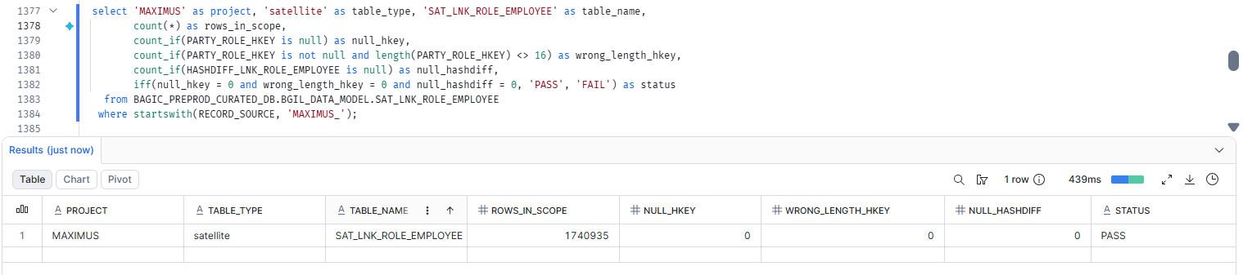

80. MAXIMUS — SATELLITE SAT_LNK_ROLE_INVESTIGATOR [Partner LOB]
Project | MAXIMUS
Satellite | SATELLITE SAT_LNK_ROLE_INVESTIGATOR [Partner LOB]
Status | Implemented
Pass criteria | status = PASS
Result (Pass / Fail / NA) | Pass
Rows with status = FAIL (count)
Remarks

Note: Satellite hash key and HASHDIFF populated and 16 bytes. HASHDIFF correctness itself is DM-H1 (a).
SQL query
select 'MAXIMUS' as project, 'satellite' as table_type, 'SAT_LNK_ROLE_INVESTIGATOR' as table_name,
count(*) as rows_in_scope,
count_if(PARTY_ROLE_HKEY is null) as null_hkey,
count_if(PARTY_ROLE_HKEY is not null and length(PARTY_ROLE_HKEY) <> 16) as wrong_length_hkey,
count_if(HASHDIFF_LNK_ROLE_INVESTIGATOR is null) as null_hashdiff,
iff(null_hkey = 0 and wrong_length_hkey = 0 and null_hashdiff = 0, 'PASS', 'FAIL') as status
from BAGIC_PREPROD_CURATED_DB.BGIL_DATA_MODEL.SAT_LNK_ROLE_INVESTIGATOR
where startswith(RECORD_SOURCE, 'MAXIMUS_');
Query output (attach / paste below)
Output:
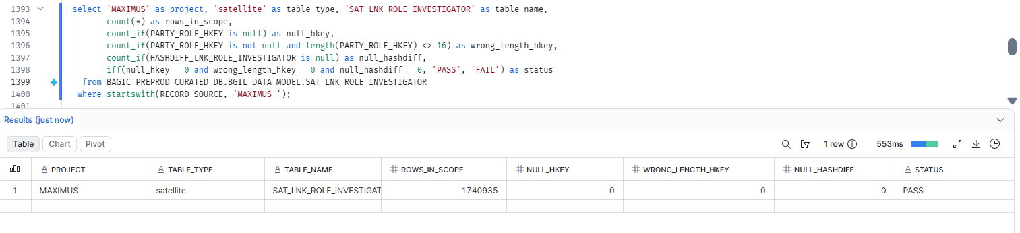

81. MAXIMUS — SATELLITE SAT_LNK_ROLE_NOMINEE_BENEFICIARY [Partner LOB]
Project | MAXIMUS
Satellite | SATELLITE SAT_LNK_ROLE_NOMINEE_BENEFICIARY [Partner LOB]
Status | Implemented
Pass criteria | status = PASS
Result (Pass / Fail / NA) | Fail(Due to source issue)
Rows with status = FAIL (count)
Remarks | Null at source table stg_maximus__pd_prop_sp_pv for its columns

Note: Satellite hash key and HASHDIFF populated and 16 bytes. HASHDIFF correctness itself is DM-H1 (a).
SQL query
select 'MAXIMUS' as project, 'satellite' as table_type, 'SAT_LNK_ROLE_NOMINEE_BENEFICIARY' as table_name,
count(*) as rows_in_scope,
count_if(PARTY_HKEY is null) as null_hkey,
count_if(PARTY_HKEY is not null and length(PARTY_HKEY) <> 16) as wrong_length_hkey,
count_if(HASHDIFF is null) as null_hashdiff,
iff(null_hkey = 0 and wrong_length_hkey = 0 and null_hashdiff = 0, 'PASS', 'FAIL') as status
from BAGIC_PREPROD_CURATED_DB.BGIL_DATA_MODEL.SAT_LNK_ROLE_NOMINEE_BENEFICIARY
where startswith(RECORD_SOURCE, 'MAXIMUS_');
Query output (attach / paste below)
Output:

82. MAXIMUS — SATELLITE SAT_LNK_ROLE_PROVIDER [Partner LOB]
Project | MAXIMUS
Satellite | SATELLITE SAT_LNK_ROLE_PROVIDER [Partner LOB]
Status | Implemented
Pass criteria | status = PASS
Result (Pass / Fail / NA) | Fail(Due to source issue)
Rows with status = FAIL (count)
Remarks | Null at source table stg_maximus__pd_prop_sp_pv for its columns

Note: Satellite hash key and HASHDIFF populated and 16 bytes. HASHDIFF correctness itself is DM-H1 (a).
SQL query
select 'MAXIMUS' as project, 'satellite' as table_type, 'SAT_LNK_ROLE_PROVIDER' as table_name,
count(*) as rows_in_scope,
count_if(PARTY_HKEY is null) as null_hkey,
count_if(PARTY_HKEY is not null and length(PARTY_HKEY) <> 16) as wrong_length_hkey,
count_if(HASHDIFF is null) as null_hashdiff,
iff(null_hkey = 0 and wrong_length_hkey = 0 and null_hashdiff = 0, 'PASS', 'FAIL') as status
from BAGIC_PREPROD_CURATED_DB.BGIL_DATA_MODEL.SAT_LNK_ROLE_PROVIDER
where startswith(RECORD_SOURCE, 'MAXIMUS_');
Query output (attach / paste below)
Output:

83. MAXIMUS — SATELLITE SAT_LNK_ROLE_SURVEYOR [Partner LOB]
Project | MAXIMUS
Satellite | SATELLITE SAT_LNK_ROLE_SURVEYOR [Partner LOB]
Status | Implemented
Pass criteria | status = PASS
Result (Pass / Fail / NA) | Fail(Due to source issue)
Rows with status = FAIL (count)
Remarks | Null at source table stg_maximus__pd_prop_sp_pv for its columns

Note: Satellite hash key and HASHDIFF populated and 16 bytes. HASHDIFF correctness itself is DM-H1 (a).
SQL query
select 'MAXIMUS' as project, 'satellite' as table_type, 'SAT_LNK_ROLE_SURVEYOR' as table_name,
count(*) as rows_in_scope,
count_if(PARTY_HKEY is null) as null_hkey,
count_if(PARTY_HKEY is not null and length(PARTY_HKEY) <> 16) as wrong_length_hkey,
count_if(HASHDIFF is null) as null_hashdiff,
iff(null_hkey = 0 and wrong_length_hkey = 0 and null_hashdiff = 0, 'PASS', 'FAIL') as status
from BAGIC_PREPROD_CURATED_DB.BGIL_DATA_MODEL.SAT_LNK_ROLE_SURVEYOR
where startswith(RECORD_SOURCE, 'MAXIMUS_');
Query output (attach / paste below)
Output:

84. MAXIMUS — SATELLITE SAT_LOCATION_PROFILE [Partner LOB]
Project | MAXIMUS
Satellite | SATELLITE SAT_LOCATION_PROFILE [Partner LOB]
Status | Implemented
Pass criteria | status = PASS
Result (Pass / Fail / NA) | Pass
Rows with status = FAIL (count)
Remarks

Note: Satellite hash key and HASHDIFF populated and 16 bytes. HASHDIFF correctness itself is DM-H1 (a).
SQL query
select 'MAXIMUS' as project, 'satellite' as table_type, 'SAT_LOCATION_PROFILE' as table_name,
count(*) as rows_in_scope,
count_if(LOCATION_HKEY is null) as null_hkey,
count_if(LOCATION_HKEY is not null and length(LOCATION_HKEY) <> 16) as wrong_length_hkey,
count_if(HASHDIFF_LOCATION_PROFILE is null) as null_hashdiff,
iff(null_hkey = 0 and wrong_length_hkey = 0 and null_hashdiff = 0, 'PASS', 'FAIL') as status
from BAGIC_PREPROD_CURATED_DB.BGIL_DATA_MODEL.SAT_LOCATION_PROFILE
where startswith(RECORD_SOURCE, 'MAXIMUS_');
Query output (attach / paste below)
Output:
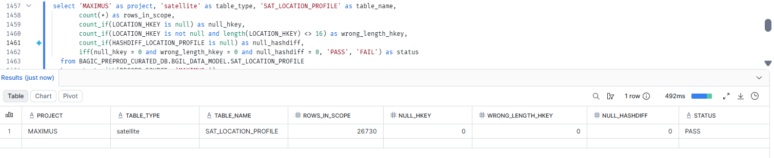

85. MAXIMUS — SATELLITE SAT_ORG_UNIT_DEFINITION [Partner LOB]
Project | MAXIMUS
Satellite | SATELLITE SAT_ORG_UNIT_DEFINITION [Partner LOB]
Status | Implemented
Pass criteria | status = PASS
Result (Pass / Fail / NA) | Fail(Due to source issue)
Rows with status = FAIL (count)
Remarks | Null at source table stg_maximus__pd_prop_sp_pv for its columns

Note: Satellite hash key and HASHDIFF populated and 16 bytes. HASHDIFF correctness itself is DM-H1 (a).
SQL query
select 'MAXIMUS' as project, 'satellite' as table_type, 'SAT_ORG_UNIT_DEFINITION' as table_name,
count(*) as rows_in_scope,
count_if(ORG_UNIT_HKEY is null) as null_hkey,
count_if(ORG_UNIT_HKEY is not null and length(ORG_UNIT_HKEY) <> 16) as wrong_length_hkey,
count_if(HASHDIFF_ORG_UNIT_DEFINITION is null) as null_hashdiff,
iff(null_hkey = 0 and wrong_length_hkey = 0 and null_hashdiff = 0, 'PASS', 'FAIL') as status
from BAGIC_PREPROD_CURATED_DB.BGIL_DATA_MODEL.SAT_ORG_UNIT_DEFINITION
where startswith(RECORD_SOURCE, 'MAXIMUS_');
Query output (attach / paste below)
Output:

86. MAXIMUS — SATELLITE SAT_ORG_UNIT_LICENCE [Partner LOB]
Project | MAXIMUS
Satellite | SATELLITE SAT_ORG_UNIT_LICENCE [Partner LOB]
Status | Implemented
Pass criteria | status = PASS
Result (Pass / Fail / NA) | Fail(Due to source issue)
Rows with status = FAIL (count)
Remarks | Null at source table stg_maximus__pd_prop_sp_pv for its columns

Note: Satellite hash key and HASHDIFF populated and 16 bytes. HASHDIFF correctness itself is DM-H1 (a).
SQL query
select 'MAXIMUS' as project, 'satellite' as table_type, 'SAT_ORG_UNIT_LICENCE' as table_name,
count(*) as rows_in_scope,
count_if(ORG_UNIT_HKEY is null) as null_hkey,
count_if(ORG_UNIT_HKEY is not null and length(ORG_UNIT_HKEY) <> 16) as wrong_length_hkey,
count_if(HASHDIFF_ORG_UNIT_LICENCE is null) as null_hashdiff,
iff(null_hkey = 0 and wrong_length_hkey = 0 and null_hashdiff = 0, 'PASS', 'FAIL') as status
from BAGIC_PREPROD_CURATED_DB.BGIL_DATA_MODEL.SAT_ORG_UNIT_LICENCE
where startswith(RECORD_SOURCE, 'MAXIMUS_');
Query output (attach / paste below)
Output:

87. MAXIMUS — SATELLITE SAT_PARTY_AGENT_LICENCE_LINE [Partner LOB]
Project | MAXIMUS
Satellite | SATELLITE SAT_PARTY_AGENT_LICENCE_LINE [Partner LOB]
Status | Implemented
Pass criteria | status = PASS
Result (Pass / Fail / NA) | Pass
Rows with status = FAIL (count)
Remarks

Note: Satellite hash key and HASHDIFF populated and 16 bytes. HASHDIFF correctness itself is DM-H1 (a).
SQL query
select 'MAXIMUS' as project, 'satellite' as table_type, 'SAT_PARTY_AGENT_LICENCE_LINE' as table_name,
count(*) as rows_in_scope,
count_if(PARTY_HKEY is null) as null_hkey,
count_if(PARTY_HKEY is not null and length(PARTY_HKEY) <> 16) as wrong_length_hkey,
count_if(HASHDIFF_PARTY_AGENT_LICENCE_LINE is null) as null_hashdiff,
iff(null_hkey = 0 and wrong_length_hkey = 0 and null_hashdiff = 0, 'PASS', 'FAIL') as status
from BAGIC_PREPROD_CURATED_DB.BGIL_DATA_MODEL.SAT_PARTY_AGENT_LICENCE_LINE
where startswith(RECORD_SOURCE, 'MAXIMUS_');
Query output (attach / paste below)
Output:
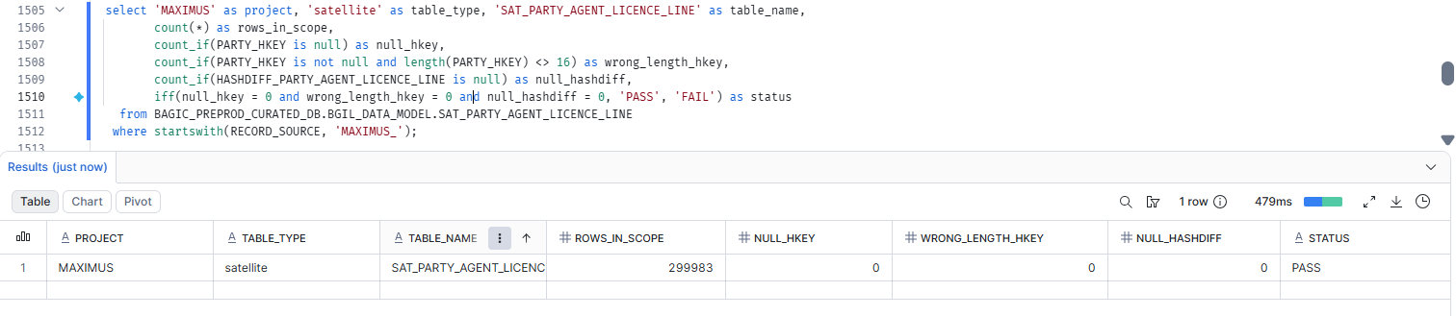

88. MAXIMUS — SATELLITE SAT_PARTY_AML_SCREENING [Partner LOB]
Project | MAXIMUS
Satellite | SATELLITE SAT_PARTY_AML_SCREENING [Partner LOB]
Status | Implemented
Pass criteria | status = PASS
Result (Pass / Fail / NA) | Fail(Due to source issue)
Rows with status = FAIL (count)
Remarks | Null at source table stg_maximus__pd_prop_sp_pv for its columns

Note: Satellite hash key and HASHDIFF populated and 16 bytes. HASHDIFF correctness itself is DM-H1 (a).
SQL query
select 'MAXIMUS' as project, 'satellite' as table_type, 'SAT_PARTY_AML_SCREENING' as table_name,
count(*) as rows_in_scope,
count_if(PARTY_HKEY is null) as null_hkey,
count_if(PARTY_HKEY is not null and length(PARTY_HKEY) <> 16) as wrong_length_hkey,
count_if(HASHDIFF is null) as null_hashdiff,
iff(null_hkey = 0 and wrong_length_hkey = 0 and null_hashdiff = 0, 'PASS', 'FAIL') as status
from BAGIC_PREPROD_CURATED_DB.BGIL_DATA_MODEL.SAT_PARTY_AML_SCREENING
where startswith(RECORD_SOURCE, 'MAXIMUS_');
Query output (attach / paste below)
Output:

89. MAXIMUS — SATELLITE SAT_PARTY_BANKING [Partner LOB]
Project | MAXIMUS
Satellite | SATELLITE SAT_PARTY_BANKING [Partner LOB]
Status | Implemented
Pass criteria | status = PASS
Result (Pass / Fail / NA) | Pass
Rows with status = FAIL (count)
Remarks

Note: Satellite hash key and HASHDIFF populated and 16 bytes. HASHDIFF correctness itself is DM-H1 (a).
SQL query
select 'MAXIMUS' as project, 'satellite' as table_type, 'SAT_PARTY_BANKING' as table_name,
count(*) as rows_in_scope,
count_if(PARTY_HKEY is null) as null_hkey,
count_if(PARTY_HKEY is not null and length(PARTY_HKEY) <> 16) as wrong_length_hkey,
count_if(HASHDIFF is null) as null_hashdiff,
iff(null_hkey = 0 and wrong_length_hkey = 0 and null_hashdiff = 0, 'PASS', 'FAIL') as status
from BAGIC_PREPROD_CURATED_DB.BGIL_DATA_MODEL.SAT_PARTY_BANKING
where startswith(RECORD_SOURCE, 'MAXIMUS_');
Query output (attach / paste below)
Output:
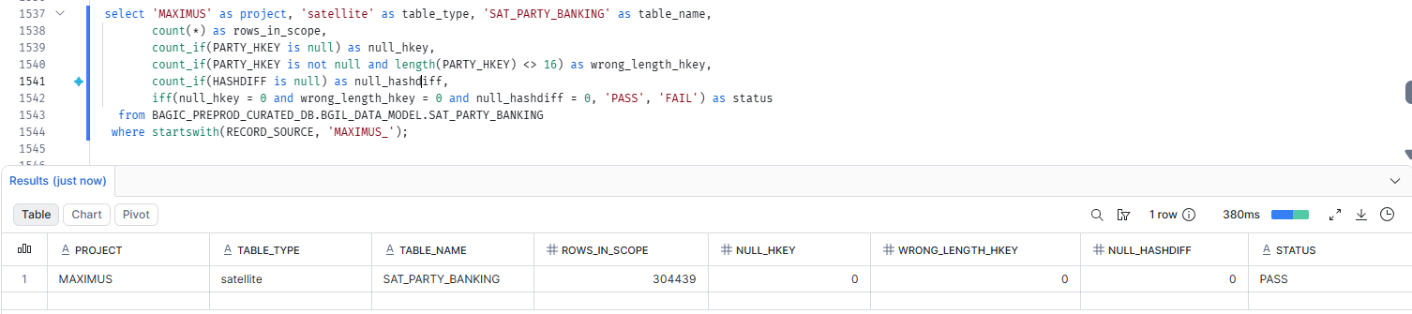

90. MAXIMUS — SATELLITE SAT_PARTY_CONSENT_MANDATE [Partner LOB]
Project | MAXIMUS
Satellite | SATELLITE SAT_PARTY_CONSENT_MANDATE [Partner LOB]
Status | Implemented
Pass criteria | status = PASS
Result (Pass / Fail / NA) | Pass
Rows with status = FAIL (count)
Remarks

Note: Satellite hash key and HASHDIFF populated and 16 bytes. HASHDIFF correctness itself is DM-H1 (a).
SQL query
select 'MAXIMUS' as project, 'satellite' as table_type, 'SAT_PARTY_CONSENT_MANDATE' as table_name,
count(*) as rows_in_scope,
count_if(PARTY_HKEY is null) as null_hkey,
count_if(PARTY_HKEY is not null and length(PARTY_HKEY) <> 16) as wrong_length_hkey,
count_if(HASHDIFF_PARTY_CONSENT_MANDATE is null) as null_hashdiff,
iff(null_hkey = 0 and wrong_length_hkey = 0 and null_hashdiff = 0, 'PASS', 'FAIL') as status
from BAGIC_PREPROD_CURATED_DB.BGIL_DATA_MODEL.SAT_PARTY_CONSENT_MANDATE
where startswith(RECORD_SOURCE, 'MAXIMUS_');
Query output (attach / paste below)
Output:
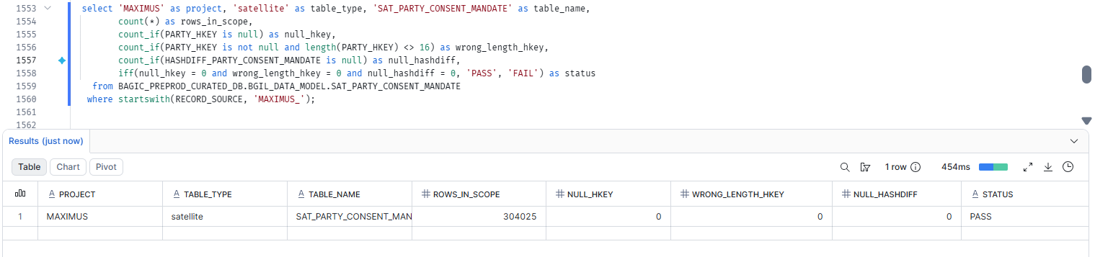

91. MAXIMUS — SATELLITE SAT_PARTY_CONTACT_ADDRESS_LINK [Partner LOB]
Project | MAXIMUS
Satellite | SATELLITE SAT_PARTY_CONTACT_ADDRESS_LINK [Partner LOB]
Status | Implemented
Pass criteria | status = PASS
Result (Pass / Fail / NA) | Pass
Rows with status = FAIL (count)
Remarks

Note: Satellite hash key and HASHDIFF populated and 16 bytes. HASHDIFF correctness itself is DM-H1 (a).
SQL query
select 'MAXIMUS' as project, 'satellite' as table_type, 'SAT_PARTY_CONTACT_ADDRESS_LINK' as table_name,
count(*) as rows_in_scope,
count_if(PARTY_LOCATION_HKEY is null) as null_hkey,
count_if(PARTY_LOCATION_HKEY is not null and length(PARTY_LOCATION_HKEY) <> 16) as wrong_length_hkey,
count_if(HASHDIFF is null) as null_hashdiff,
iff(null_hkey = 0 and wrong_length_hkey = 0 and null_hashdiff = 0, 'PASS', 'FAIL') as status
from BAGIC_PREPROD_CURATED_DB.BGIL_DATA_MODEL.SAT_PARTY_CONTACT_ADDRESS_LINK
where startswith(RECORD_SOURCE, 'MAXIMUS_');
Query output (attach / paste below)
Output:
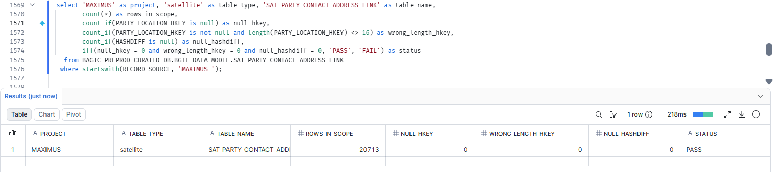

92. MAXIMUS — SATELLITE SAT_PARTY_DIGITAL_IDENTITY [Partner LOB]
Project | MAXIMUS
Satellite | SATELLITE SAT_PARTY_DIGITAL_IDENTITY [Partner LOB]
Status | Implemented
Pass criteria | status = PASS
Result (Pass / Fail / NA) | Fail(Due to source issue)
Rows with status = FAIL (count)
Remarks | Null at source tables stg_maximus__pd_prop_msdp_pv and stg_maximus__pd_prop_sp_pv for its columns

Note: Satellite hash key and HASHDIFF populated and 16 bytes. HASHDIFF correctness itself is DM-H1 (a).
SQL query
select 'MAXIMUS' as project, 'satellite' as table_type, 'SAT_PARTY_DIGITAL_IDENTITY' as table_name,
count(*) as rows_in_scope,
count_if(PARTY_HKEY is null) as null_hkey,
count_if(PARTY_HKEY is not null and length(PARTY_HKEY) <> 16) as wrong_length_hkey,
count_if(HASHDIFF_PARTY_DIGITAL_IDENTITY is null) as null_hashdiff,
iff(null_hkey = 0 and wrong_length_hkey = 0 and null_hashdiff = 0, 'PASS', 'FAIL') as status
from BAGIC_PREPROD_CURATED_DB.BGIL_DATA_MODEL.SAT_PARTY_DIGITAL_IDENTITY
where startswith(RECORD_SOURCE, 'MAXIMUS_');
Query output (attach / paste below)
Output:

93. MAXIMUS — SATELLITE SAT_PARTY_EMPLOYMENT [Partner LOB]
Project | MAXIMUS
Satellite | SATELLITE SAT_PARTY_EMPLOYMENT [Partner LOB]
Status | Implemented
Pass criteria | status = PASS
Result (Pass / Fail / NA) | Fail(Due to source issue)
Rows with status = FAIL (count)
Remarks | Null at source table stg_maximus__pd_prop_sp_pv for its columns

Note: Satellite hash key and HASHDIFF populated and 16 bytes. HASHDIFF correctness itself is DM-H1 (a).
SQL query
select 'MAXIMUS' as project, 'satellite' as table_type, 'SAT_PARTY_EMPLOYMENT' as table_name,
count(*) as rows_in_scope,
count_if(PARTY_HKEY is null) as null_hkey,
count_if(PARTY_HKEY is not null and length(PARTY_HKEY) <> 16) as wrong_length_hkey,
count_if(HASHDIFF is null) as null_hashdiff,
iff(null_hkey = 0 and wrong_length_hkey = 0 and null_hashdiff = 0, 'PASS', 'FAIL') as status
from BAGIC_PREPROD_CURATED_DB.BGIL_DATA_MODEL.SAT_PARTY_EMPLOYMENT
where startswith(RECORD_SOURCE, 'MAXIMUS_');
Query output (attach / paste below)
Output:

94. MAXIMUS — SATELLITE SAT_PARTY_FINANCIAL_PROFILE [Partner LOB]
Project | MAXIMUS
Satellite | SATELLITE SAT_PARTY_FINANCIAL_PROFILE [Partner LOB]
Status | Implemented
Pass criteria | status = PASS
Result (Pass / Fail / NA) | Fail(Due to source issue)
Rows with status = FAIL (count)
Remarks | Null at source table stg_maximus__pd_prop_sp_pv for its columns

Note: Satellite hash key and HASHDIFF populated and 16 bytes. HASHDIFF correctness itself is DM-H1 (a).
SQL query
select 'MAXIMUS' as project, 'satellite' as table_type, 'SAT_PARTY_FINANCIAL_PROFILE' as table_name,
count(*) as rows_in_scope,
count_if(PARTY_HKEY is null) as null_hkey,
count_if(PARTY_HKEY is not null and length(PARTY_HKEY) <> 16) as wrong_length_hkey,
count_if(HASHDIFF_PARTY_FINANCIAL_PROFILE is null) as null_hashdiff,
iff(null_hkey = 0 and wrong_length_hkey = 0 and null_hashdiff = 0, 'PASS', 'FAIL') as status
from BAGIC_PREPROD_CURATED_DB.BGIL_DATA_MODEL.SAT_PARTY_FINANCIAL_PROFILE
where startswith(RECORD_SOURCE, 'MAXIMUS_');
Query output (attach / paste below)
Output:

95. MAXIMUS — SATELLITE SAT_PARTY_FRAUD_PROFILE [Partner LOB]
Project | MAXIMUS
Satellite | SATELLITE SAT_PARTY_FRAUD_PROFILE [Partner LOB]
Status | Implemented
Pass criteria | status = PASS
Result (Pass / Fail / NA) | Fail(Due to source issue)
Rows with status = FAIL (count)
Remarks | Null at source table stg_maximus__pd_prop_sp_pv for its columns

Note: Satellite hash key and HASHDIFF populated and 16 bytes. HASHDIFF correctness itself is DM-H1 (a).
SQL query
select 'MAXIMUS' as project, 'satellite' as table_type, 'SAT_PARTY_FRAUD_PROFILE' as table_name,
count(*) as rows_in_scope,
count_if(PARTY_HKEY is null) as null_hkey,
count_if(PARTY_HKEY is not null and length(PARTY_HKEY) <> 16) as wrong_length_hkey,
count_if(HASHDIFF_PARTY_FRAUD_PROFILE is null) as null_hashdiff,
iff(null_hkey = 0 and wrong_length_hkey = 0 and null_hashdiff = 0, 'PASS', 'FAIL') as status
from BAGIC_PREPROD_CURATED_DB.BGIL_DATA_MODEL.SAT_PARTY_FRAUD_PROFILE
where startswith(RECORD_SOURCE, 'MAXIMUS_');
Query output (attach / paste below)
Output:

96. MAXIMUS — SATELLITE SAT_PARTY_HEALTH_PROFILE [Partner LOB]
Project | MAXIMUS
Satellite | SATELLITE SAT_PARTY_HEALTH_PROFILE [Partner LOB]
Status | Implemented
Pass criteria | status = PASS
Result (Pass / Fail / NA) | Fail(Due to source issue)
Rows with status = FAIL (count)
Remarks | Null at source table stg_maximus__pd_prop_sp_pv for its columns

Note: Satellite hash key and HASHDIFF populated and 16 bytes. HASHDIFF correctness itself is DM-H1 (a).
SQL query
select 'MAXIMUS' as project, 'satellite' as table_type, 'SAT_PARTY_HEALTH_PROFILE' as table_name,
count(*) as rows_in_scope,
count_if(PARTY_HKEY is null) as null_hkey,
count_if(PARTY_HKEY is not null and length(PARTY_HKEY) <> 16) as wrong_length_hkey,
count_if(HASHDIFF is null) as null_hashdiff,
iff(null_hkey = 0 and wrong_length_hkey = 0 and null_hashdiff = 0, 'PASS', 'FAIL') as status
from BAGIC_PREPROD_CURATED_DB.BGIL_DATA_MODEL.SAT_PARTY_HEALTH_PROFILE
where startswith(RECORD_SOURCE, 'MAXIMUS_');
Query output (attach / paste below)
Output:

97. MAXIMUS — SATELLITE SAT_PARTY_HIERARCHY [Partner LOB]
Project | MAXIMUS
Satellite | SATELLITE SAT_PARTY_HIERARCHY [Partner LOB]
Status | Implemented
Pass criteria | status = PASS
Result (Pass / Fail / NA) | Pass
Rows with status = FAIL (count)
Remarks

Note: Satellite hash key and HASHDIFF populated and 16 bytes. HASHDIFF correctness itself is DM-H1 (a).
SQL query
select 'MAXIMUS' as project, 'satellite' as table_type, 'SAT_PARTY_HIERARCHY' as table_name,
count(*) as rows_in_scope,
count_if(PARTY_HKEY is null) as null_hkey,
count_if(PARTY_HKEY is not null and length(PARTY_HKEY) <> 16) as wrong_length_hkey,
count_if(HASHDIFF_PARTY_HIERARCHY is null) as null_hashdiff,
iff(null_hkey = 0 and wrong_length_hkey = 0 and null_hashdiff = 0, 'PASS', 'FAIL') as status
from BAGIC_PREPROD_CURATED_DB.BGIL_DATA_MODEL.SAT_PARTY_HIERARCHY
where startswith(RECORD_SOURCE, 'MAXIMUS_');
Query output (attach / paste below)
Output:
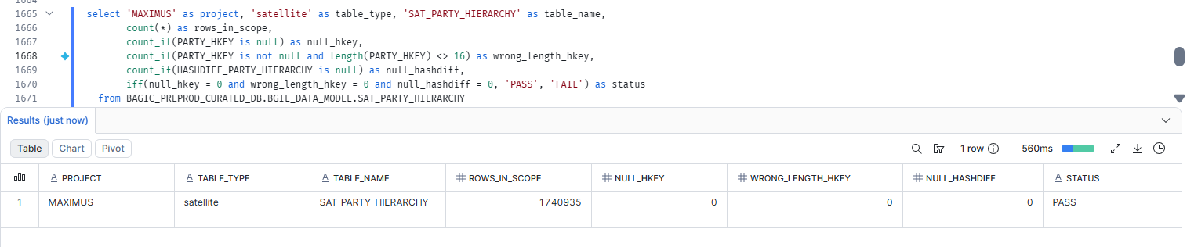

98. MAXIMUS — SATELLITE SAT_PARTY_IDENTIFICATION [Partner LOB]
Project | MAXIMUS
Satellite | SATELLITE SAT_PARTY_IDENTIFICATION [Partner LOB]
Status | Implemented
Pass criteria | status = PASS
Result (Pass / Fail / NA) | Fail(Due to source issue)
Rows with status = FAIL (count)
Remarks | Column missing from source stg_maximus__pd_prop_sp_pv and stg_maximus__pd_prop_msdp_pv.

Note: Satellite hash key and HASHDIFF populated and 16 bytes. HASHDIFF correctness itself is DM-H1 (a).
SQL query
select 'MAXIMUS' as project, 'satellite' as table_type, 'SAT_PARTY_IDENTIFICATION' as table_name,
count(*) as rows_in_scope,
count_if(PARTY_HKEY is null) as null_hkey,
count_if(PARTY_HKEY is not null and length(PARTY_HKEY) <> 16) as wrong_length_hkey,
count_if(HASHDIFF is null) as null_hashdiff,
iff(null_hkey = 0 and wrong_length_hkey = 0 and null_hashdiff = 0, 'PASS', 'FAIL') as status
from BAGIC_PREPROD_CURATED_DB.BGIL_DATA_MODEL.SAT_PARTY_IDENTIFICATION
where RECORD_SOURCE = 'MAXIMUS';
Query output (attach / paste below)
Output:

99. MAXIMUS — SATELLITE SAT_PARTY_IDENTITY [Partner LOB]
Project | MAXIMUS
Satellite | SATELLITE SAT_PARTY_IDENTITY [Partner LOB]
Status | Implemented
Pass criteria | status = PASS
Result (Pass / Fail / NA) | Pass
Rows with status = FAIL (count)
Remarks

Note: Satellite hash key and HASHDIFF populated and 16 bytes. HASHDIFF correctness itself is DM-H1 (a).
SQL query
select 'MAXIMUS' as project, 'satellite' as table_type, 'SAT_PARTY_IDENTITY' as table_name,
count(*) as rows_in_scope,
count_if(PARTY_HKEY is null) as null_hkey,
count_if(PARTY_HKEY is not null and length(PARTY_HKEY) <> 16) as wrong_length_hkey,
count_if(HASHDIFF is null) as null_hashdiff,
iff(null_hkey = 0 and wrong_length_hkey = 0 and null_hashdiff = 0, 'PASS', 'FAIL') as status
from BAGIC_PREPROD_CURATED_DB.BGIL_DATA_MODEL.SAT_PARTY_IDENTITY
where startswith(RECORD_SOURCE, 'MAXIMUS_');
Query output (attach / paste below)
Output:
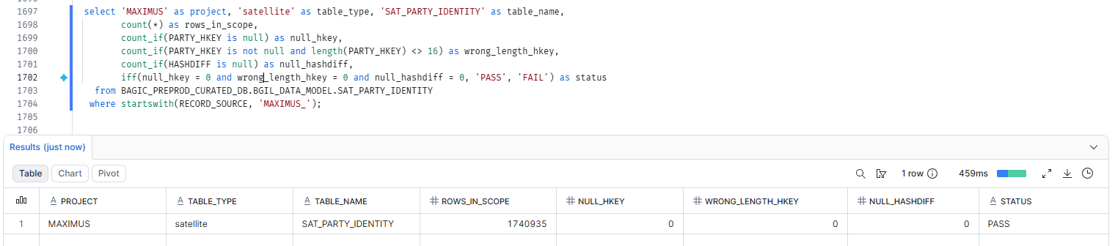

100. MAXIMUS — SATELLITE SAT_PARTY_INDIVIDUAL_DEMOGRAPHICS [Partner LOB]
Project | MAXIMUS
Satellite | SATELLITE SAT_PARTY_INDIVIDUAL_DEMOGRAPHICS [Partner LOB]
Status | Implemented
Pass criteria | status = PASS
Result (Pass / Fail / NA) | Pass
Rows with status = FAIL (count)
Remarks

Note: Satellite hash key and HASHDIFF populated and 16 bytes. HASHDIFF correctness itself is DM-H1 (a).
SQL query
select 'MAXIMUS' as project, 'satellite' as table_type, 'SAT_PARTY_INDIVIDUAL_DEMOGRAPHICS' as table_name,
count(*) as rows_in_scope,
count_if(PARTY_HKEY is null) as null_hkey,
count_if(PARTY_HKEY is not null and length(PARTY_HKEY) <> 16) as wrong_length_hkey,
count_if(HASHDIFF is null) as null_hashdiff,
iff(null_hkey = 0 and wrong_length_hkey = 0 and null_hashdiff = 0, 'PASS', 'FAIL') as status
from BAGIC_PREPROD_CURATED_DB.BGIL_DATA_MODEL.SAT_PARTY_INDIVIDUAL_DEMOGRAPHICS
where startswith(RECORD_SOURCE, 'MAXIMUS_');
Query output (attach / paste below)
Output:
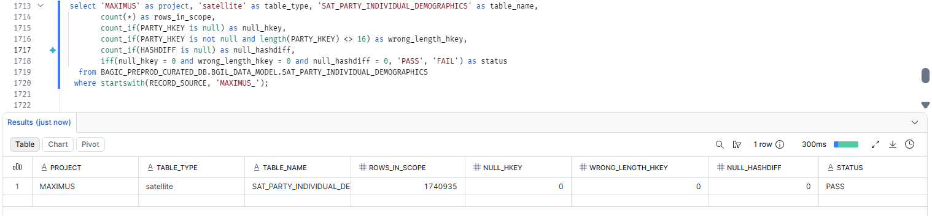

101. MAXIMUS — SATELLITE SAT_PARTY_KYC [Partner LOB]
Project | MAXIMUS
Satellite | SATELLITE SAT_PARTY_KYC [Partner LOB]
Status | Implemented
Pass criteria | status = PASS
Result (Pass / Fail / NA) | Fail(Due to source issue)
Rows with status = FAIL (count)
Remarks | Null at source table stg_maximus__pd_prop_sp_pv for its columns

Note: Satellite hash key and HASHDIFF populated and 16 bytes. HASHDIFF correctness itself is DM-H1 (a).
SQL query
select 'MAXIMUS' as project, 'satellite' as table_type, 'SAT_PARTY_KYC' as table_name,
count(*) as rows_in_scope,
count_if(PARTY_HKEY is null) as null_hkey,
count_if(PARTY_HKEY is not null and length(PARTY_HKEY) <> 16) as wrong_length_hkey,
count_if(HASHDIFF is null) as null_hashdiff,
iff(null_hkey = 0 and wrong_length_hkey = 0 and null_hashdiff = 0, 'PASS', 'FAIL') as status
from BAGIC_PREPROD_CURATED_DB.BGIL_DATA_MODEL.SAT_PARTY_KYC
where startswith(RECORD_SOURCE, 'MAXIMUS_');
Query output (attach / paste below)
Output:

102. MAXIMUS — SATELLITE SAT_PARTY_LEGAL_PANEL [Partner LOB]
Project | MAXIMUS
Satellite | SATELLITE SAT_PARTY_LEGAL_PANEL [Partner LOB]
Status | Implemented
Pass criteria | status = PASS
Result (Pass / Fail / NA) | Fail(Due to source issue)
Rows with status = FAIL (count)
Remarks | Null at source table stg_maximus__pd_prop_sp_pv for its columns

Note: Satellite hash key and HASHDIFF populated and 16 bytes. HASHDIFF correctness itself is DM-H1 (a).
SQL query
select 'MAXIMUS' as project, 'satellite' as table_type, 'SAT_PARTY_LEGAL_PANEL' as table_name,
count(*) as rows_in_scope,
count_if(PARTY_HKEY is null) as null_hkey,
count_if(PARTY_HKEY is not null and length(PARTY_HKEY) <> 16) as wrong_length_hkey,
count_if(HASHDIFF_PARTY_LEGAL_PANEL is null) as null_hashdiff,
iff(null_hkey = 0 and wrong_length_hkey = 0 and null_hashdiff = 0, 'PASS', 'FAIL') as status
from BAGIC_PREPROD_CURATED_DB.BGIL_DATA_MODEL.SAT_PARTY_LEGAL_PANEL
where startswith(RECORD_SOURCE, 'MAXIMUS_');
Query output (attach / paste below)
Output:

103. MAXIMUS — SATELLITE SAT_PARTY_ONBOARDING_JOURNEY [Partner LOB]
Project | MAXIMUS
Satellite | SATELLITE SAT_PARTY_ONBOARDING_JOURNEY [Partner LOB]
Status | Implemented
Pass criteria | status = PASS
Result (Pass / Fail / NA) | Fail(Due to source issue)
Rows with status = FAIL (count)
Remarks | Null at source table stg_maximus__pd_prop_sp_pv for its columns

Note: Satellite hash key and HASHDIFF populated and 16 bytes. HASHDIFF correctness itself is DM-H1 (a).
SQL query
select 'MAXIMUS' as project, 'satellite' as table_type, 'SAT_PARTY_ONBOARDING_JOURNEY' as table_name,
count(*) as rows_in_scope,
count_if(PARTY_HKEY is null) as null_hkey,
count_if(PARTY_HKEY is not null and length(PARTY_HKEY) <> 16) as wrong_length_hkey,
count_if(HASHDIFF_PARTY_ONBOARDING_JOURNEY is null) as null_hashdiff,
iff(null_hkey = 0 and wrong_length_hkey = 0 and null_hashdiff = 0, 'PASS', 'FAIL') as status
from BAGIC_PREPROD_CURATED_DB.BGIL_DATA_MODEL.SAT_PARTY_ONBOARDING_JOURNEY
where startswith(RECORD_SOURCE, 'MAXIMUS_');
Query output (attach / paste below)
Output:

104. MAXIMUS — SATELLITE SAT_PARTY_ORGANISATION_PROFILE [Partner LOB]
Project | MAXIMUS
Satellite | SATELLITE SAT_PARTY_ORGANISATION_PROFILE [Partner LOB]
Status | Implemented
Pass criteria | status = PASS
Result (Pass / Fail / NA) | Pass
Rows with status = FAIL (count)
Remarks

Note: Satellite hash key and HASHDIFF populated and 16 bytes. HASHDIFF correctness itself is DM-H1 (a).
SQL query
select 'MAXIMUS' as project, 'satellite' as table_type, 'SAT_PARTY_ORGANISATION_PROFILE' as table_name,
count(*) as rows_in_scope,
count_if(PARTY_HKEY is null) as null_hkey,
count_if(PARTY_HKEY is not null and length(PARTY_HKEY) <> 16) as wrong_length_hkey,
count_if(HASHDIFF is null) as null_hashdiff,
iff(null_hkey = 0 and wrong_length_hkey = 0 and null_hashdiff = 0, 'PASS', 'FAIL') as status
from BAGIC_PREPROD_CURATED_DB.BGIL_DATA_MODEL.SAT_PARTY_ORGANISATION_PROFILE
where startswith(RECORD_SOURCE, 'MAXIMUS_');
Query output (attach / paste below)
Output:
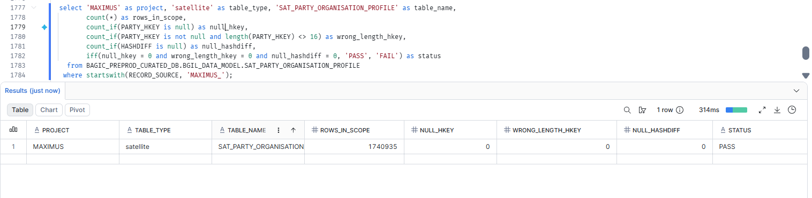

105. MAXIMUS — SATELLITE SAT_PARTY_ORG_DIRECTORS [Partner LOB]
Project | MAXIMUS
Satellite | SATELLITE SAT_PARTY_ORG_DIRECTORS [Partner LOB]
Status | Implemented
Pass criteria | status = PASS
Result (Pass / Fail / NA) | Fail(Due to source issue)
Rows with status = FAIL (count)
Remarks | Null at source table stg_maximus__pd_prop_sp_pv for its columns

Note: Satellite hash key and HASHDIFF populated and 16 bytes. HASHDIFF correctness itself is DM-H1 (a).
SQL query
select 'MAXIMUS' as project, 'satellite' as table_type, 'SAT_PARTY_ORG_DIRECTORS' as table_name,
count(*) as rows_in_scope,
count_if(PARTY_HKEY is null) as null_hkey,
count_if(PARTY_HKEY is not null and length(PARTY_HKEY) <> 16) as wrong_length_hkey,
count_if(HASHDIFF_PARTY_ORG_DIRECTORS is null) as null_hashdiff,
iff(null_hkey = 0 and wrong_length_hkey = 0 and null_hashdiff = 0, 'PASS', 'FAIL') as status
from BAGIC_PREPROD_CURATED_DB.BGIL_DATA_MODEL.SAT_PARTY_ORG_DIRECTORS
where startswith(RECORD_SOURCE, 'MAXIMUS_');
Query output (attach / paste below)
Output:

106. MAXIMUS — SATELLITE SAT_PARTY_PAYOUT_PROFILE [Partner LOB]
Project | MAXIMUS
Satellite | SATELLITE SAT_PARTY_PAYOUT_PROFILE [Partner LOB]
Status | Implemented
Pass criteria | status = PASS
Result (Pass / Fail / NA) | Pass
Rows with status = FAIL (count)
Remarks

Note: Satellite hash key and HASHDIFF populated and 16 bytes. HASHDIFF correctness itself is DM-H1 (a).
SQL query
select 'MAXIMUS' as project, 'satellite' as table_type, 'SAT_PARTY_PAYOUT_PROFILE' as table_name,
count(*) as rows_in_scope,
count_if(PARTY_HKEY is null) as null_hkey,
count_if(PARTY_HKEY is not null and length(PARTY_HKEY) <> 16) as wrong_length_hkey,
count_if(HASHDIFF_PARTY_PAYOUT_PROFILE is null) as null_hashdiff,
iff(null_hkey = 0 and wrong_length_hkey = 0 and null_hashdiff = 0, 'PASS', 'FAIL') as status
from BAGIC_PREPROD_CURATED_DB.BGIL_DATA_MODEL.SAT_PARTY_PAYOUT_PROFILE
where startswith(RECORD_SOURCE, 'MAXIMUS_');
Query output (attach / paste below)
Output:
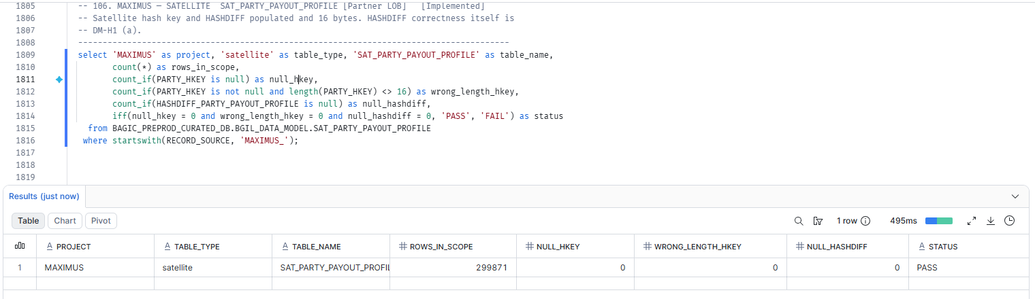

107. MAXIMUS — SATELLITE SAT_PARTY_PROVIDER_CAPABILITY [Partner LOB]
Project | MAXIMUS
Satellite | SATELLITE SAT_PARTY_PROVIDER_CAPABILITY [Partner LOB]
Status | Implemented
Pass criteria | status = PASS
Result (Pass / Fail / NA) | Fail(Due to source issue)
Rows with status = FAIL (count)
Remarks | Null at source table stg_maximus__pd_prop_sp_pv for its columns

Note: Satellite hash key and HASHDIFF populated and 16 bytes. HASHDIFF correctness itself is DM-H1 (a).
SQL query
select 'MAXIMUS' as project, 'satellite' as table_type, 'SAT_PARTY_PROVIDER_CAPABILITY' as table_name,
count(*) as rows_in_scope,
count_if(PARTY_HKEY is null) as null_hkey,
count_if(PARTY_HKEY is not null and length(PARTY_HKEY) <> 16) as wrong_length_hkey,
count_if(HASHDIFF_PARTY_PROVIDER_CAPABILITY is null) as null_hashdiff,
iff(null_hkey = 0 and wrong_length_hkey = 0 and null_hashdiff = 0, 'PASS', 'FAIL') as status
from BAGIC_PREPROD_CURATED_DB.BGIL_DATA_MODEL.SAT_PARTY_PROVIDER_CAPABILITY
where startswith(RECORD_SOURCE, 'MAXIMUS_');
Query output (attach / paste below)
Output:

108. MAXIMUS — SATELLITE SAT_PARTY_RELATIONSHIP_PROFILE [Partner LOB]
Project | MAXIMUS
Satellite | SATELLITE SAT_PARTY_RELATIONSHIP_PROFILE [Partner LOB]
Status | Implemented
Pass criteria | status = PASS
Result (Pass / Fail / NA) | Fail(Due to source issue)
Rows with status = FAIL (count)
Remarks | Null at source table stg_maximus__pd_prop_sp_pv for its columns

Note: Satellite hash key and HASHDIFF populated and 16 bytes. HASHDIFF correctness itself is DM-H1 (a).
SQL query
select 'MAXIMUS' as project, 'satellite' as table_type, 'SAT_PARTY_RELATIONSHIP_PROFILE' as table_name,
count(*) as rows_in_scope,
count_if(PARTY_HKEY is null) as null_hkey,
count_if(PARTY_HKEY is not null and length(PARTY_HKEY) <> 16) as wrong_length_hkey,
count_if(HASHDIFF_PARTY_RELATIONSHIP_PROFILE is null) as null_hashdiff,
iff(null_hkey = 0 and wrong_length_hkey = 0 and null_hashdiff = 0, 'PASS', 'FAIL') as status
from BAGIC_PREPROD_CURATED_DB.BGIL_DATA_MODEL.SAT_PARTY_RELATIONSHIP_PROFILE
where startswith(RECORD_SOURCE, 'MAXIMUS_');
Query output (attach / paste below)
Output:

109. MAXIMUS — SATELLITE SAT_PRODUCT_DEFINITION [Partner LOB]
Project | MAXIMUS
Satellite | SATELLITE SAT_PRODUCT_DEFINITION [Partner LOB]
Status | Implemented
Pass criteria | status = PASS
Result (Pass / Fail / NA) | Pass
Rows with status = FAIL (count)
Remarks

Note: Satellite hash key and HASHDIFF populated and 16 bytes. HASHDIFF correctness itself is DM-H1 (a).
SQL query
select 'MAXIMUS' as project, 'satellite' as table_type, 'SAT_PRODUCT_DEFINITION' as table_name,
count(*) as rows_in_scope,
count_if(PRODUCT_HKEY is null) as null_hkey,
count_if(PRODUCT_HKEY is not null and length(PRODUCT_HKEY) <> 16) as wrong_length_hkey,
count_if(HASHDIFF is null) as null_hashdiff,
iff(null_hkey = 0 and wrong_length_hkey = 0 and null_hashdiff = 0, 'PASS', 'FAIL') as status
from BAGIC_PREPROD_CURATED_DB.BGIL_DATA_MODEL.SAT_PRODUCT_DEFINITION
where startswith(RECORD_SOURCE, 'MAXIMUS_');
Query output (attach / paste below)
Output:
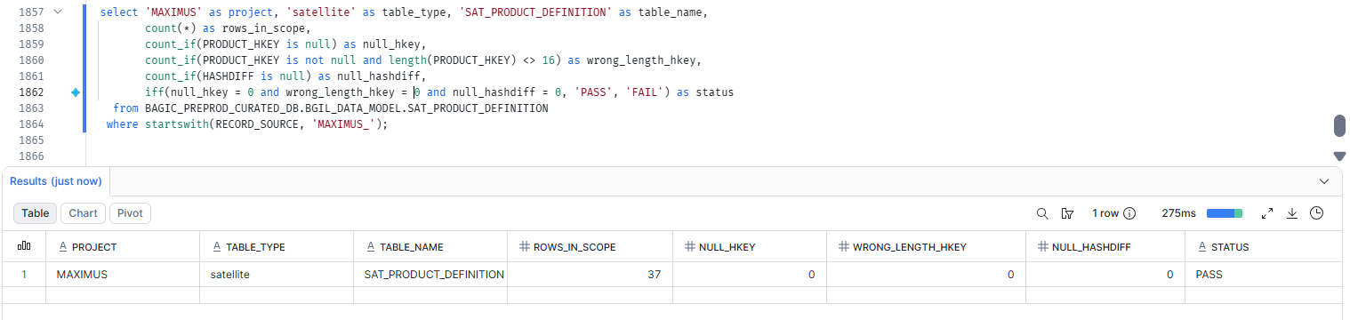

110. MAXIMUS — SATELLITE SAT_PROVIDER_BANKING [Partner LOB]
Project | MAXIMUS
Satellite | SATELLITE SAT_PROVIDER_BANKING [Partner LOB]
Status | Implemented
Pass criteria | status = PASS
Result (Pass / Fail / NA) | Fail(Due to source issue)
Rows with status = FAIL (count)
Remarks | Null at source table stg_maximus__pd_prop_sp_pv for its columns

Note: Satellite hash key and HASHDIFF populated and 16 bytes. HASHDIFF correctness itself is DM-H1 (a).
SQL query
select 'MAXIMUS' as project, 'satellite' as table_type, 'SAT_PROVIDER_BANKING' as table_name,
count(*) as rows_in_scope,
count_if(PARTY_HKEY is null) as null_hkey,
count_if(PARTY_HKEY is not null and length(PARTY_HKEY) <> 16) as wrong_length_hkey,
count_if(HASHDIFF is null) as null_hashdiff,
iff(null_hkey = 0 and wrong_length_hkey = 0 and null_hashdiff = 0, 'PASS', 'FAIL') as status
from BAGIC_PREPROD_CURATED_DB.BGIL_DATA_MODEL.SAT_PROVIDER_BANKING
where startswith(RECORD_SOURCE, 'MAXIMUS_');
Query output (attach / paste below)
Output:

111. MAXIMUS — SATELLITE SAT_PROVIDER_QUALITY [Partner LOB]
Project | MAXIMUS
Satellite | SATELLITE SAT_PROVIDER_QUALITY [Partner LOB]
Status | Implemented
Pass criteria | status = PASS
Result (Pass / Fail / NA) | Fail(Due to source issue)
Rows with status = FAIL (count)
Remarks | Null at source table stg_maximus__pd_prop_sp_pv for its columns

Note: Satellite hash key and HASHDIFF populated and 16 bytes. HASHDIFF correctness itself is DM-H1 (a).
SQL query
select 'MAXIMUS' as project, 'satellite' as table_type, 'SAT_PROVIDER_QUALITY' as table_name,
count(*) as rows_in_scope,
count_if(PARTY_HKEY is null) as null_hkey,
count_if(PARTY_HKEY is not null and length(PARTY_HKEY) <> 16) as wrong_length_hkey,
count_if(HASHDIFF_PROVIDER_QUALITY is null) as null_hashdiff,
iff(null_hkey = 0 and wrong_length_hkey = 0 and null_hashdiff = 0, 'PASS', 'FAIL') as status
from BAGIC_PREPROD_CURATED_DB.BGIL_DATA_MODEL.SAT_PROVIDER_QUALITY
where startswith(RECORD_SOURCE, 'MAXIMUS_');
Query output (attach / paste below)
Output:

112. MAXIMUS — SATELLITE SAT_PROVIDER_TARIFF [Partner LOB]
Project | MAXIMUS
Satellite | SATELLITE SAT_PROVIDER_TARIFF [Partner LOB]
Status | Implemented
Pass criteria | status = PASS
Result (Pass / Fail / NA) | Fail(Due to source issue)
Rows with status = FAIL (count)
Remarks | Null at source table stg_maximus__pd_prop_sp_pv for its columns

Note: Satellite hash key and HASHDIFF populated and 16 bytes. HASHDIFF correctness itself is DM-H1 (a).
SQL query
select 'MAXIMUS' as project, 'satellite' as table_type, 'SAT_PROVIDER_TARIFF' as table_name,
count(*) as rows_in_scope,
count_if(PARTY_HKEY is null) as null_hkey,
count_if(PARTY_HKEY is not null and length(PARTY_HKEY) <> 16) as wrong_length_hkey,
count_if(HASHDIFF is null) as null_hashdiff,
iff(null_hkey = 0 and wrong_length_hkey = 0 and null_hashdiff = 0, 'PASS', 'FAIL') as status
from BAGIC_PREPROD_CURATED_DB.BGIL_DATA_MODEL.SAT_PROVIDER_TARIFF
where startswith(RECORD_SOURCE, 'MAXIMUS_');
Query output (attach / paste below)
Output:

