DM-T2 | Load Audit — Hash Key Integrity (DV2.0) (OPUS)
Hash keys generated consistently; no null hash keys; no unexpected collisions. Pass criterion: 0 null; 0 unexpected collisions.

Check Overview
Check ID | DM-T2
Category | Load audit
Sign-off criterion | Hash key integrity (DV2.0)
Method | (a) hash column types; (b) per table: null / wrong-length hash keys, hub key recomputed from the stored business key, hub and link collisions
Evidence required | Hash null / collision query
Pass criteria / tolerance | 0 null; 0 unexpected collisions
Owner | LUMIQ
Vault location | BAGIC_PREPROD_CURATED_DB.BGIL_DATA_MODEL
Maximus RAW | BAGIC_PROD_MIRROR_DB.MAXI_RAW
Opus RAW (test) | BAGIC_PREPROD_CURATED_DB.UTILS (prod: BAGIC_PROD_MIRROR_DB.OPUS_GG_DWHSTAGE)
Scope | Every hub, link and satellite the project's models load (standard + augmented). Rows scoped by the project's RECORD_SOURCE prefix (OBJECT satellites: RECORD_SOURCE = project). Shared physical tables appear in both project files, each checking its own rows; rows owned by neither are listed by the DM-K2 ownership sweep.
Hash key formula | MD5_BINARY(NULLIF(UPPER(TRIM(CAST(<NK> AS VARCHAR))), '')) -- BINARY(16), automate_dv 0.11.5 default
Project in this file | OPUS

Revision notes
• Generated 2026-10-13 from the current opus_partner_dv_dbt models by validation/tools/gen_dm_t.py.
• This file: OPUS only -- 11 hubs, 3 links, 59 satellites. The other project is in the sibling file.

Results summary
# | Project | Satellite | Status | Result | Failing rows
1 | OPUS | Hash column types (all tables) | Implemented
2 | OPUS | HUB HUB_AGENT | Implemented
3 | OPUS | HUB HUB_AGREEMENT | Implemented
4 | OPUS | HUB HUB_CLAIM [Partner LOB] | Implemented
5 | OPUS | HUB HUB_DISTRIBUTION_CHANNEL | Implemented
6 | OPUS | HUB HUB_DOCUMENT [Partner LOB] | Implemented
7 | OPUS | HUB HUB_LOCATION [Partner LOB] | Implemented
8 | OPUS | HUB HUB_ORG_UNIT [Partner LOB] | Implemented
9 | OPUS | HUB HUB_PARTY [Partner LOB] | Implemented
10 | OPUS | HUB HUB_POLICY [Partner LOB] | Implemented
11 | OPUS | HUB HUB_PRODUCT | Implemented
12 | OPUS | HUB HUB_RISK_OBJECT [Partner LOB] | Implemented
13 | OPUS | LINK LNK_CLAIM_PARTY | Implemented
14 | OPUS | LINK LNK_PARTY_LOCATION | Implemented
15 | OPUS | LINK LNK_POLICY_PARTY | Implemented
16 | OPUS | SATELLITE SAT_AGREEMENT_COMMERCIAL_TERMS [Partner LOB] | Implemented
17 | OPUS | SATELLITE SAT_AGREEMENT_DEFINITION [Partner LOB] | Implemented
18 | OPUS | SATELLITE SAT_AUG_AFFINITY_MEMBERSHIP | Implemented
19 | OPUS | SATELLITE SAT_AUG_AGREEMENT | Implemented
20 | OPUS | SATELLITE SAT_AUG_CHANNEL | Implemented
21 | OPUS | SATELLITE SAT_AUG_KYC_DOCUMENT | Implemented
22 | OPUS | SATELLITE SAT_AUG_KYC_LOCATION | Implemented
23 | OPUS | SATELLITE SAT_AUG_KYC_PARTY | Implemented
24 | OPUS | SATELLITE SAT_AUG_KYC_POLICY | Implemented
25 | OPUS | SATELLITE SAT_AUG_LAWYER_ADVOCATE_ROLE | Implemented
26 | OPUS | SATELLITE SAT_AUG_LNK_ROLE_AGENT [Partner LOB] | Implemented
27 | OPUS | SATELLITE SAT_AUG_LNK_ROLE_CUSTOMER [Partner LOB] | Implemented
28 | OPUS | SATELLITE SAT_AUG_LNK_ROLE_PROVIDER [Partner LOB] | Implemented
29 | OPUS | SATELLITE SAT_AUG_LNK_ROLE_SURVEYOR [Partner LOB] | Implemented
30 | OPUS | SATELLITE SAT_AUG_LOCATION | Implemented
31 | OPUS | SATELLITE SAT_AUG_PARTY | Implemented
32 | OPUS | SATELLITE SAT_AUG_POLICY | Implemented
33 | OPUS | SATELLITE SAT_COMMON_ADDRESS [Partner LOB] | Implemented
34 | OPUS | SATELLITE SAT_COMMON_ADMIN_GEOGRAPHY | Implemented
35 | OPUS | SATELLITE SAT_COMMON_CLASSIFICATION [Partner LOB] | Implemented
36 | OPUS | SATELLITE SAT_COMMON_COMMUNICATION_PREFERENCE [Partner LOB] | Implemented
37 | OPUS | SATELLITE SAT_COMMON_CONSENT [Partner LOB] | Implemented
38 | OPUS | SATELLITE SAT_COMMON_CONTACT [Partner LOB] | Implemented
39 | OPUS | SATELLITE SAT_COMMON_GEO [Partner LOB] | Implemented
40 | OPUS | SATELLITE SAT_DOCUMENT_DEFINITION [Partner LOB] | Implemented
41 | OPUS | SATELLITE SAT_LNK_CLAIM_PARTY_ROLE | Implemented
42 | OPUS | SATELLITE SAT_LNK_PARTY_ROLE_CORE [Partner LOB] | Implemented
43 | OPUS | SATELLITE SAT_LNK_POLICY_PARTY_ROLE [Partner LOB] | Implemented
44 | OPUS | SATELLITE SAT_LNK_ROLE_AGENT [Partner LOB] | Implemented
45 | OPUS | SATELLITE SAT_LNK_ROLE_CUSTOMER [Partner LOB] | Implemented
46 | OPUS | SATELLITE SAT_LNK_ROLE_NOMINEE_BENEFICIARY | Implemented
47 | OPUS | SATELLITE SAT_LNK_ROLE_PROVIDER [Partner LOB] | Implemented
48 | OPUS | SATELLITE SAT_LNK_ROLE_SURVEYOR [Partner LOB] | Implemented
49 | OPUS | SATELLITE SAT_PARTY_AML_SCREENING [Partner LOB] | Implemented
50 | OPUS | SATELLITE SAT_PARTY_BANKING [Partner LOB] | Implemented
51 | OPUS | SATELLITE SAT_PARTY_CLAIM_HISTORY | Implemented
52 | OPUS | SATELLITE SAT_PARTY_CONTACT_ADDRESS_LINK [Partner LOB] | Implemented
53 | OPUS | SATELLITE SAT_PARTY_EMPLOYMENT [Partner LOB] | Implemented
54 | OPUS | SATELLITE SAT_PARTY_GROUP_CENSUS [Partner LOB] | Implemented
55 | OPUS | SATELLITE SAT_PARTY_GROUP_HOUSEHOLD [Partner LOB] | Implemented
56 | OPUS | SATELLITE SAT_PARTY_HEALTH_PROFILE [Partner LOB] | Implemented
57 | OPUS | SATELLITE SAT_PARTY_IDENTIFICATION [Partner LOB] | Implemented
58 | OPUS | SATELLITE SAT_PARTY_IDENTITY [Partner LOB] | Implemented
59 | OPUS | SATELLITE SAT_PARTY_INDIVIDUAL_DEMOGRAPHICS [Partner LOB] | Implemented
60 | OPUS | SATELLITE SAT_PARTY_KYC [Partner LOB] | Implemented
61 | OPUS | SATELLITE SAT_PARTY_KYC_REFERENCE [Partner LOB] | Implemented
62 | OPUS | SATELLITE SAT_PARTY_ORGANISATION_PROFILE [Partner LOB] | Implemented
63 | OPUS | SATELLITE SAT_PARTY_VEHICLE_PRIOR_INSURANCE | Implemented
64 | OPUS | SATELLITE SAT_POLICY_BONUS_TRACKING | Implemented
65 | OPUS | SATELLITE SAT_POLICY_CERTIFICATE | Implemented
66 | OPUS | SATELLITE SAT_POLICY_CLASSIFICATION [Partner LOB] | Implemented
67 | OPUS | SATELLITE SAT_POLICY_COVERAGE_SCHEDULE | Implemented
68 | OPUS | SATELLITE SAT_POLICY_ENDORSEMENT | Implemented
69 | OPUS | SATELLITE SAT_POLICY_HEADER [Partner LOB] | Implemented
70 | OPUS | SATELLITE SAT_POLICY_PREMIUM_HEAD | Implemented
71 | OPUS | SATELLITE SAT_POLICY_PREMIUM_SUMMARY [Partner LOB] | Implemented
72 | OPUS | SATELLITE SAT_PRODUCT_DEFINITION | Implemented
73 | OPUS | SATELLITE SAT_PROVIDER_BANKING [Partner LOB] | Implemented
74 | OPUS | SATELLITE SAT_PROVIDER_TARIFF [Partner LOB] | Implemented

Validation Queries

1. OPUS — Hash column types (all tables)
Project | OPUS
Satellite | Hash column types (all tables)
Status | Implemented
Pass criteria | every row status = PASS (BINARY(16))
Result (Pass / Fail / NA) | Pass
Rows with status = FAIL (count)
Remarks

Note: Every *_HKEY and HASHDIFF column of the project's hubs, links and satellites must be BINARY(16) (MD5_BINARY).
SQL query
select 'OPUS' as project, table_name, column_name, data_type, character_maximum_length as byte_length,
iff(data_type = 'BINARY', 'PASS', 'FAIL') as status
from BAGIC_PREPROD_CURATED_DB.INFORMATION_SCHEMA.COLUMNS
where table_schema = 'BGIL_DATA_MODEL'
and table_name in ('HUB_AGENT', 'HUB_AGREEMENT', 'HUB_CLAIM', 'HUB_DISTRIBUTION_CHANNEL', 'HUB_DOCUMENT', 'HUB_LOCATION', 'HUB_ORG_UNIT', 'HUB_PARTY', 'HUB_POLICY', 'HUB_PRODUCT', 'HUB_RISK_OBJECT', 'LNK_CLAIM_PARTY', 'LNK_PARTY_LOCATION', 'LNK_POLICY_PARTY', 'SAT_AGREEMENT_COMMERCIAL_TERMS', 'SAT_AGREEMENT_DEFINITION', 'SAT_AUG_AFFINITY_MEMBERSHIP', 'SAT_AUG_AGREEMENT', 'SAT_AUG_CHANNEL', 'SAT_AUG_KYC_DOCUMENT', 'SAT_AUG_KYC_LOCATION', 'SAT_AUG_KYC_PARTY', 'SAT_AUG_KYC_POLICY', 'SAT_AUG_LAWYER_ADVOCATE_ROLE', 'SAT_AUG_LNK_ROLE_AGENT', 'SAT_AUG_LNK_ROLE_CUSTOMER', 'SAT_AUG_LNK_ROLE_PROVIDER', 'SAT_AUG_LNK_ROLE_SURVEYOR', 'SAT_AUG_LOCATION', 'SAT_AUG_PARTY', 'SAT_AUG_POLICY', 'SAT_COMMON_ADDRESS', 'SAT_COMMON_ADMIN_GEOGRAPHY', 'SAT_COMMON_CLASSIFICATION', 'SAT_COMMON_COMMUNICATION_PREFERENCE', 'SAT_COMMON_CONSENT', 'SAT_COMMON_CONTACT', 'SAT_COMMON_GEO', 'SAT_DOCUMENT_DEFINITION', 'SAT_LNK_CLAIM_PARTY_ROLE', 'SAT_LNK_PARTY_ROLE_CORE', 'SAT_LNK_POLICY_PARTY_ROLE', 'SAT_LNK_ROLE_AGENT', 'SAT_LNK_ROLE_CUSTOMER', 'SAT_LNK_ROLE_NOMINEE_BENEFICIARY', 'SAT_LNK_ROLE_PROVIDER', 'SAT_LNK_ROLE_SURVEYOR', 'SAT_PARTY_AML_SCREENING', 'SAT_PARTY_BANKING', 'SAT_PARTY_CLAIM_HISTORY', 'SAT_PARTY_CONTACT_ADDRESS_LINK', 'SAT_PARTY_EMPLOYMENT', 'SAT_PARTY_GROUP_CENSUS', 'SAT_PARTY_GROUP_HOUSEHOLD', 'SAT_PARTY_HEALTH_PROFILE', 'SAT_PARTY_IDENTIFICATION', 'SAT_PARTY_IDENTITY', 'SAT_PARTY_INDIVIDUAL_DEMOGRAPHICS', 'SAT_PARTY_KYC', 'SAT_PARTY_KYC_REFERENCE', 'SAT_PARTY_ORGANISATION_PROFILE', 'SAT_PARTY_VEHICLE_PRIOR_INSURANCE', 'SAT_POLICY_BONUS_TRACKING', 'SAT_POLICY_CERTIFICATE', 'SAT_POLICY_CLASSIFICATION', 'SAT_POLICY_COVERAGE_SCHEDULE', 'SAT_POLICY_ENDORSEMENT', 'SAT_POLICY_HEADER', 'SAT_POLICY_PREMIUM_HEAD', 'SAT_POLICY_PREMIUM_SUMMARY', 'SAT_PRODUCT_DEFINITION', 'SAT_PROVIDER_BANKING', 'SAT_PROVIDER_TARIFF')
and (column_name like '%\\_HKEY' escape '\\' or column_name like 'HASHDIFF%')
order by iff(status = 'FAIL', 0, 1), table_name, column_name;
Query output (attach / paste below)
Output:
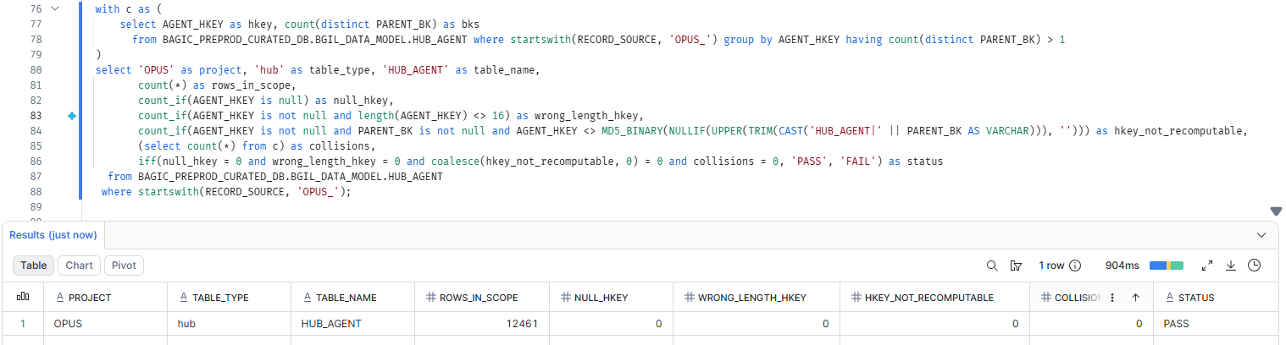

2. OPUS — HUB HUB_AGENT
Project | OPUS
Satellite | HUB HUB_AGENT
Status | Implemented
Pass criteria | status = PASS
Result (Pass / Fail / NA)
Rows with status = FAIL (count)
Remarks

Note: Recompute: MD5_BINARY(NULLIF(UPPER(TRIM(CAST('HUB_AGENT|' || PARENT_BK AS VARCHAR))), '')) must equal AGENT_HKEY. collisions = hash keys carrying more than one PARENT_BK. Overlaps DM-K3 (nulls) and DM-K4 (uniqueness) but adds the recompute and length checks.
SQL query
with c as (
select AGENT_HKEY as hkey, count(distinct PARENT_BK) as bks
from BAGIC_PREPROD_CURATED_DB.BGIL_DATA_MODEL.HUB_AGENT where startswith(RECORD_SOURCE, 'OPUS_') group by AGENT_HKEY having count(distinct PARENT_BK) > 1
)
select 'OPUS' as project, 'hub' as table_type, 'HUB_AGENT' as table_name,
count(*) as rows_in_scope,
count_if(AGENT_HKEY is null) as null_hkey,
count_if(AGENT_HKEY is not null and length(AGENT_HKEY) <> 16) as wrong_length_hkey,
count_if(AGENT_HKEY is not null and PARENT_BK is not null and AGENT_HKEY <> MD5_BINARY(NULLIF(UPPER(TRIM(CAST('HUB_AGENT|' || PARENT_BK AS VARCHAR))), ''))) as hkey_not_recomputable,
(select count(*) from c) as collisions,
iff(null_hkey = 0 and wrong_length_hkey = 0 and coalesce(hkey_not_recomputable, 0) = 0 and collisions = 0, 'PASS', 'FAIL') as status
from BAGIC_PREPROD_CURATED_DB.BGIL_DATA_MODEL.HUB_AGENT
where startswith(RECORD_SOURCE, 'OPUS_');
Query output (attach / paste below)
Output:

3. OPUS — HUB HUB_AGREEMENT
Project | OPUS
Satellite | HUB HUB_AGREEMENT
Status | Implemented
Pass criteria | status = PASS
Result (Pass / Fail / NA)
Rows with status = FAIL (count)
Remarks

Note: Recompute: MD5_BINARY(NULLIF(UPPER(TRIM(CAST('HUB_AGREEMENT|' || PARENT_BK AS VARCHAR))), '')) must equal AGREEMENT_HKEY. collisions = hash keys carrying more than one PARENT_BK. Overlaps DM-K3 (nulls) and DM-K4 (uniqueness) but adds the recompute and length checks.
SQL query
with c as (
select AGREEMENT_HKEY as hkey, count(distinct PARENT_BK) as bks
from BAGIC_PREPROD_CURATED_DB.BGIL_DATA_MODEL.HUB_AGREEMENT where startswith(RECORD_SOURCE, 'OPUS_') group by AGREEMENT_HKEY having count(distinct PARENT_BK) > 1
)
select 'OPUS' as project, 'hub' as table_type, 'HUB_AGREEMENT' as table_name,
count(*) as rows_in_scope,
count_if(AGREEMENT_HKEY is null) as null_hkey,
count_if(AGREEMENT_HKEY is not null and length(AGREEMENT_HKEY) <> 16) as wrong_length_hkey,
count_if(AGREEMENT_HKEY is not null and PARENT_BK is not null and AGREEMENT_HKEY <> MD5_BINARY(NULLIF(UPPER(TRIM(CAST('HUB_AGREEMENT|' || PARENT_BK AS VARCHAR))), ''))) as hkey_not_recomputable,
(select count(*) from c) as collisions,
iff(null_hkey = 0 and wrong_length_hkey = 0 and coalesce(hkey_not_recomputable, 0) = 0 and collisions = 0, 'PASS', 'FAIL') as status
from BAGIC_PREPROD_CURATED_DB.BGIL_DATA_MODEL.HUB_AGREEMENT
where startswith(RECORD_SOURCE, 'OPUS_');
Query output (attach / paste below)
Output:

4. OPUS — HUB HUB_CLAIM [Partner LOB]
Project | OPUS
Satellite | HUB HUB_CLAIM [Partner LOB]
Status | Implemented
Pass criteria | status = PASS
Result (Pass / Fail / NA) | Pass
Rows with status = FAIL (count)
Remarks

Note: Recompute: MD5_BINARY(NULLIF(UPPER(TRIM(CAST('HUB_CLAIM|' || PARENT_BK AS VARCHAR))), '')) must equal CLAIM_HKEY. collisions = hash keys carrying more than one PARENT_BK. Overlaps DM-K3 (nulls) and DM-K4 (uniqueness) but adds the recompute and length checks.
SQL query
with c as (
select CLAIM_HKEY as hkey, count(distinct PARENT_BK) as bks
from BAGIC_PREPROD_CURATED_DB.BGIL_DATA_MODEL.HUB_CLAIM where startswith(RECORD_SOURCE, 'OPUS_') group by CLAIM_HKEY having count(distinct PARENT_BK) > 1
)
select 'OPUS' as project, 'hub' as table_type, 'HUB_CLAIM' as table_name,
count(*) as rows_in_scope,
count_if(CLAIM_HKEY is null) as null_hkey,
count_if(CLAIM_HKEY is not null and length(CLAIM_HKEY) <> 16) as wrong_length_hkey,
count_if(CLAIM_HKEY is not null and PARENT_BK is not null and CLAIM_HKEY <> MD5_BINARY(NULLIF(UPPER(TRIM(CAST('HUB_CLAIM|' || PARENT_BK AS VARCHAR))), ''))) as hkey_not_recomputable,
(select count(*) from c) as collisions,
iff(null_hkey = 0 and wrong_length_hkey = 0 and coalesce(hkey_not_recomputable, 0) = 0 and collisions = 0, 'PASS', 'FAIL') as status
from BAGIC_PREPROD_CURATED_DB.BGIL_DATA_MODEL.HUB_CLAIM
where startswith(RECORD_SOURCE, 'OPUS_');
Query output (attach / paste below)
Output:
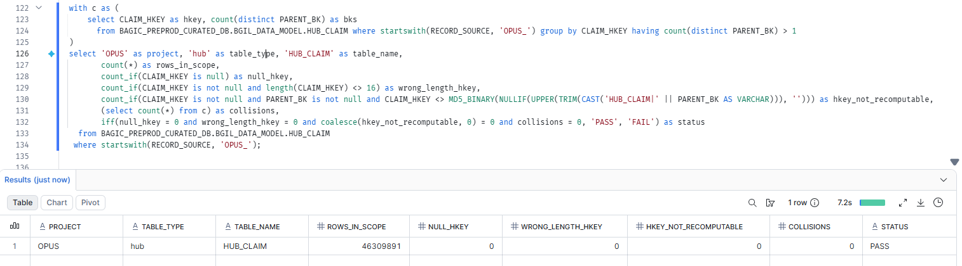

5. OPUS — HUB HUB_DISTRIBUTION_CHANNEL[Partner LOB]
Project | OPUS
Satellite | HUB HUB_DISTRIBUTION_CHANNEL
Status | Implemented
Pass criteria | status = PASS
Result (Pass / Fail / NA) | Pass
Rows with status = FAIL (count)
Remarks

Note: Recompute: MD5_BINARY(NULLIF(UPPER(TRIM(CAST('HUB_DISTRIBUTION_CHANNEL|' || PARENT_BK AS VARCHAR))), '')) must equal DISTRIBUTION_CHANNEL_HKEY. collisions = hash keys carrying more than one PARENT_BK. Overlaps DM-K3 (nulls) and DM-K4 (uniqueness) but adds the recompute and length checks.
SQL query
with c as (
select DISTRIBUTION_CHANNEL_HKEY as hkey, count(distinct PARENT_BK) as bks
from BAGIC_PREPROD_CURATED_DB.BGIL_DATA_MODEL.HUB_DISTRIBUTION_CHANNEL where startswith(RECORD_SOURCE, 'OPUS_') group by DISTRIBUTION_CHANNEL_HKEY having count(distinct PARENT_BK) > 1
)
select 'OPUS' as project, 'hub' as table_type, 'HUB_DISTRIBUTION_CHANNEL' as table_name,
count(*) as rows_in_scope,
count_if(DISTRIBUTION_CHANNEL_HKEY is null) as null_hkey,
count_if(DISTRIBUTION_CHANNEL_HKEY is not null and length(DISTRIBUTION_CHANNEL_HKEY) <> 16) as wrong_length_hkey,
count_if(DISTRIBUTION_CHANNEL_HKEY is not null and PARENT_BK is not null and DISTRIBUTION_CHANNEL_HKEY <> MD5_BINARY(NULLIF(UPPER(TRIM(CAST('HUB_DISTRIBUTION_CHANNEL|' || PARENT_BK AS VARCHAR))), ''))) as hkey_not_recomputable,
(select count(*) from c) as collisions,
iff(null_hkey = 0 and wrong_length_hkey = 0 and coalesce(hkey_not_recomputable, 0) = 0 and collisions = 0, 'PASS', 'FAIL') as status
from BAGIC_PREPROD_CURATED_DB.BGIL_DATA_MODEL.HUB_DISTRIBUTION_CHANNEL
where startswith(RECORD_SOURCE, 'OPUS_');
Query output (attach / paste below)
Output:
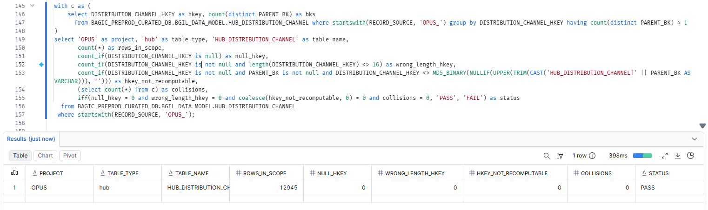

6. OPUS — HUB HUB_DOCUMENT [Partner LOB]
Project | OPUS
Satellite | HUB HUB_DOCUMENT [Partner LOB]
Status | Implemented
Pass criteria | status = PASS
Result (Pass / Fail / NA) | Pass
Rows with status = FAIL (count)
Remarks

Note: Recompute: MD5_BINARY(NULLIF(UPPER(TRIM(CAST('HUB_DOCUMENT|' || PARENT_BK AS VARCHAR))), '')) must equal DOCUMENT_HKEY. collisions = hash keys carrying more than one PARENT_BK. Overlaps DM-K3 (nulls) and DM-K4 (uniqueness) but adds the recompute and length checks.
SQL query
with c as (
select DOCUMENT_HKEY as hkey, count(distinct PARENT_BK) as bks
from BAGIC_PREPROD_CURATED_DB.BGIL_DATA_MODEL.HUB_DOCUMENT where startswith(RECORD_SOURCE, 'OPUS_') group by DOCUMENT_HKEY having count(distinct PARENT_BK) > 1
)
select 'OPUS' as project, 'hub' as table_type, 'HUB_DOCUMENT' as table_name,
count(*) as rows_in_scope,
count_if(DOCUMENT_HKEY is null) as null_hkey,
count_if(DOCUMENT_HKEY is not null and length(DOCUMENT_HKEY) <> 16) as wrong_length_hkey,
count_if(DOCUMENT_HKEY is not null and PARENT_BK is not null and DOCUMENT_HKEY <> MD5_BINARY(NULLIF(UPPER(TRIM(CAST('HUB_DOCUMENT|' || PARENT_BK AS VARCHAR))), ''))) as hkey_not_recomputable,
(select count(*) from c) as collisions,
iff(null_hkey = 0 and wrong_length_hkey = 0 and coalesce(hkey_not_recomputable, 0) = 0 and collisions = 0, 'PASS', 'FAIL') as status
from BAGIC_PREPROD_CURATED_DB.BGIL_DATA_MODEL.HUB_DOCUMENT
where startswith(RECORD_SOURCE, 'OPUS_');
Query output (attach / paste below)
Output:
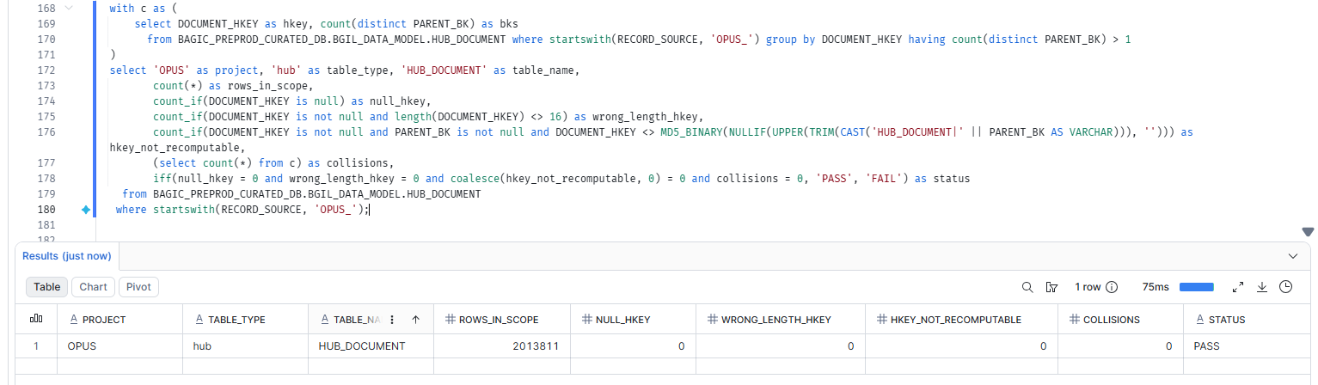

7. OPUS — HUB HUB_LOCATION [Partner LOB]
Project | OPUS
Satellite | HUB HUB_LOCATION [Partner LOB]
Status | Implemented
Pass criteria | status = PASS
Result (Pass / Fail / NA) | Pass
Rows with status = FAIL (count)
Remarks

Note: Recompute: MD5_BINARY(NULLIF(UPPER(TRIM(CAST('HUB_LOCATION|' || PARENT_BK AS VARCHAR))), '')) must equal LOCATION_HKEY. collisions = hash keys carrying more than one PARENT_BK. Overlaps DM-K3 (nulls) and DM-K4 (uniqueness) but adds the recompute and length checks.
SQL query
with c as (
select LOCATION_HKEY as hkey, count(distinct PARENT_BK) as bks
from BAGIC_PREPROD_CURATED_DB.BGIL_DATA_MODEL.HUB_LOCATION where startswith(RECORD_SOURCE, 'OPUS_') group by LOCATION_HKEY having count(distinct PARENT_BK) > 1
)
select 'OPUS' as project, 'hub' as table_type, 'HUB_LOCATION' as table_name,
count(*) as rows_in_scope,
count_if(LOCATION_HKEY is null) as null_hkey,
count_if(LOCATION_HKEY is not null and length(LOCATION_HKEY) <> 16) as wrong_length_hkey,
count_if(LOCATION_HKEY is not null and PARENT_BK is not null and LOCATION_HKEY <> MD5_BINARY(NULLIF(UPPER(TRIM(CAST('HUB_LOCATION|' || PARENT_BK AS VARCHAR))), ''))) as hkey_not_recomputable,
(select count(*) from c) as collisions,
iff(null_hkey = 0 and wrong_length_hkey = 0 and coalesce(hkey_not_recomputable, 0) = 0 and collisions = 0, 'PASS', 'FAIL') as status
from BAGIC_PREPROD_CURATED_DB.BGIL_DATA_MODEL.HUB_LOCATION
where startswith(RECORD_SOURCE, 'OPUS_');
Query output (attach / paste below)
Output:
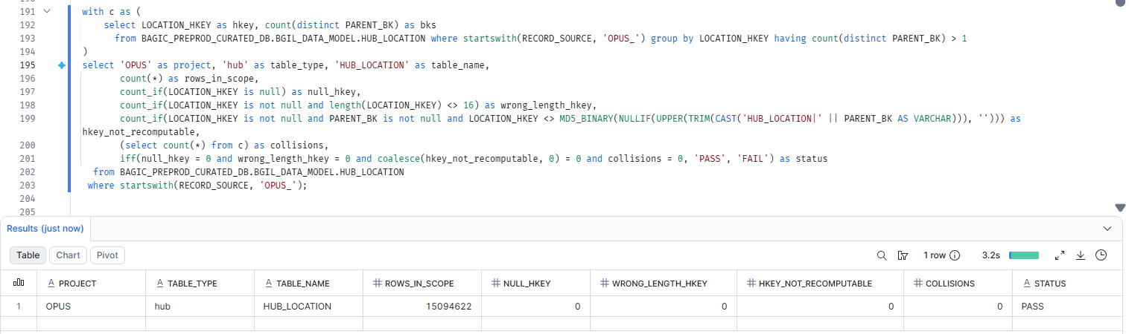

8. OPUS — HUB HUB_ORG_UNIT [Partner LOB]
Project | OPUS
Satellite | HUB HUB_ORG_UNIT [Partner LOB]
Status | Implemented
Pass criteria | status = PASS
Result (Pass / Fail / NA) | Pass
Rows with status = FAIL (count)
Remarks

Note: Recompute: MD5_BINARY(NULLIF(UPPER(TRIM(CAST('HUB_ORG_UNIT|' || PARENT_BK AS VARCHAR))), '')) must equal ORG_UNIT_HKEY. collisions = hash keys carrying more than one PARENT_BK. Overlaps DM-K3 (nulls) and DM-K4 (uniqueness) but adds the recompute and length checks.
SQL query
with c as (
select ORG_UNIT_HKEY as hkey, count(distinct PARENT_BK) as bks
from BAGIC_PREPROD_CURATED_DB.BGIL_DATA_MODEL.HUB_ORG_UNIT where startswith(RECORD_SOURCE, 'OPUS_') group by ORG_UNIT_HKEY having count(distinct PARENT_BK) > 1
)
select 'OPUS' as project, 'hub' as table_type, 'HUB_ORG_UNIT' as table_name,
count(*) as rows_in_scope,
count_if(ORG_UNIT_HKEY is null) as null_hkey,
count_if(ORG_UNIT_HKEY is not null and length(ORG_UNIT_HKEY) <> 16) as wrong_length_hkey,
count_if(ORG_UNIT_HKEY is not null and PARENT_BK is not null and ORG_UNIT_HKEY <> MD5_BINARY(NULLIF(UPPER(TRIM(CAST('HUB_ORG_UNIT|' || PARENT_BK AS VARCHAR))), ''))) as hkey_not_recomputable,
(select count(*) from c) as collisions,
iff(null_hkey = 0 and wrong_length_hkey = 0 and coalesce(hkey_not_recomputable, 0) = 0 and collisions = 0, 'PASS', 'FAIL') as status
from BAGIC_PREPROD_CURATED_DB.BGIL_DATA_MODEL.HUB_ORG_UNIT
where startswith(RECORD_SOURCE, 'OPUS_');
Query output (attach / paste below)
Output:
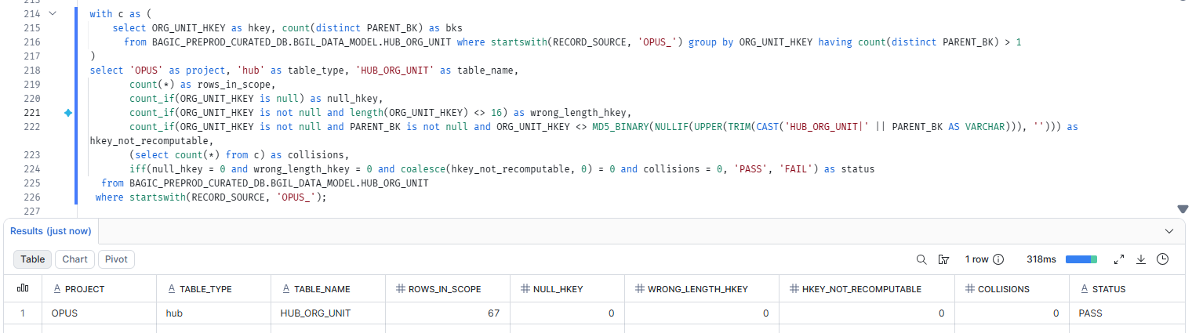

9. OPUS — HUB HUB_PARTY [Partner LOB]
Project | OPUS
Satellite | HUB HUB_PARTY [Partner LOB]
Status | Implemented
Pass criteria | status = PASS
Result (Pass / Fail / NA) | Pass
Rows with status = FAIL (count)
Remarks

Note: Recompute: MD5_BINARY(NULLIF(UPPER(TRIM(CAST('HUB_PARTY|' || PARENT_BK AS VARCHAR))), '')) must equal PARTY_HKEY. collisions = hash keys carrying more than one PARENT_BK. Overlaps DM-K3 (nulls) and DM-K4 (uniqueness) but adds the recompute and length checks.
SQL query
with c as (
select PARTY_HKEY as hkey, count(distinct PARENT_BK) as bks
from BAGIC_PREPROD_CURATED_DB.BGIL_DATA_MODEL.HUB_PARTY where startswith(RECORD_SOURCE, 'OPUS_') group by PARTY_HKEY having count(distinct PARENT_BK) > 1
)
select 'OPUS' as project, 'hub' as table_type, 'HUB_PARTY' as table_name,
count(*) as rows_in_scope,
count_if(PARTY_HKEY is null) as null_hkey,
count_if(PARTY_HKEY is not null and length(PARTY_HKEY) <> 16) as wrong_length_hkey,
count_if(PARTY_HKEY is not null and PARENT_BK is not null and PARTY_HKEY <> MD5_BINARY(NULLIF(UPPER(TRIM(CAST('HUB_PARTY|' || PARENT_BK AS VARCHAR))), ''))) as hkey_not_recomputable,
(select count(*) from c) as collisions,
iff(null_hkey = 0 and wrong_length_hkey = 0 and coalesce(hkey_not_recomputable, 0) = 0 and collisions = 0, 'PASS', 'FAIL') as status
from BAGIC_PREPROD_CURATED_DB.BGIL_DATA_MODEL.HUB_PARTY
where startswith(RECORD_SOURCE, 'OPUS_');
Query output (attach / paste below)
Output:
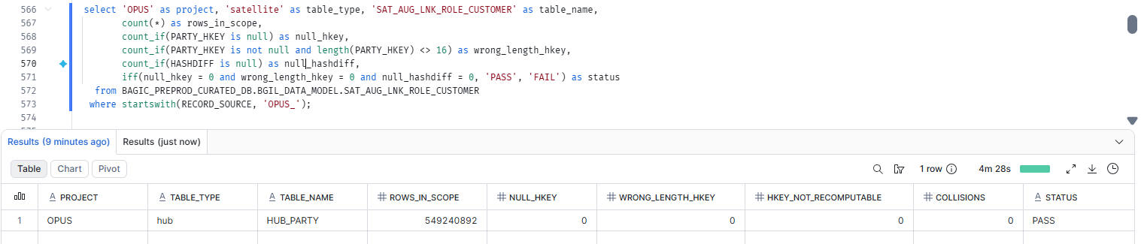

10. OPUS — HUB HUB_POLICY [Partner LOB]
Project | OPUS
Satellite | HUB HUB_POLICY [Partner LOB]
Status | Implemented
Pass criteria | status = PASS
Result (Pass / Fail / NA) | Pass
Rows with status = FAIL (count)
Remarks

Note: Recompute: MD5_BINARY(NULLIF(UPPER(TRIM(CAST('HUB_POLICY|' || PARENT_BK AS VARCHAR))), '')) must equal POLICY_HKEY. collisions = hash keys carrying more than one PARENT_BK. Overlaps DM-K3 (nulls) and DM-K4 (uniqueness) but adds the recompute and length checks.
SQL query
with c as (
select POLICY_HKEY as hkey, count(distinct PARENT_BK) as bks
from BAGIC_PREPROD_CURATED_DB.BGIL_DATA_MODEL.HUB_POLICY where startswith(RECORD_SOURCE, 'OPUS_') group by POLICY_HKEY having count(distinct PARENT_BK) > 1
)
select 'OPUS' as project, 'hub' as table_type, 'HUB_POLICY' as table_name,
count(*) as rows_in_scope,
count_if(POLICY_HKEY is null) as null_hkey,
count_if(POLICY_HKEY is not null and length(POLICY_HKEY) <> 16) as wrong_length_hkey,
count_if(POLICY_HKEY is not null and PARENT_BK is not null and POLICY_HKEY <> MD5_BINARY(NULLIF(UPPER(TRIM(CAST('HUB_POLICY|' || PARENT_BK AS VARCHAR))), ''))) as hkey_not_recomputable,
(select count(*) from c) as collisions,
iff(null_hkey = 0 and wrong_length_hkey = 0 and coalesce(hkey_not_recomputable, 0) = 0 and collisions = 0, 'PASS', 'FAIL') as status
from BAGIC_PREPROD_CURATED_DB.BGIL_DATA_MODEL.HUB_POLICY
where startswith(RECORD_SOURCE, 'OPUS_');
Query output (attach / paste below)
Output:
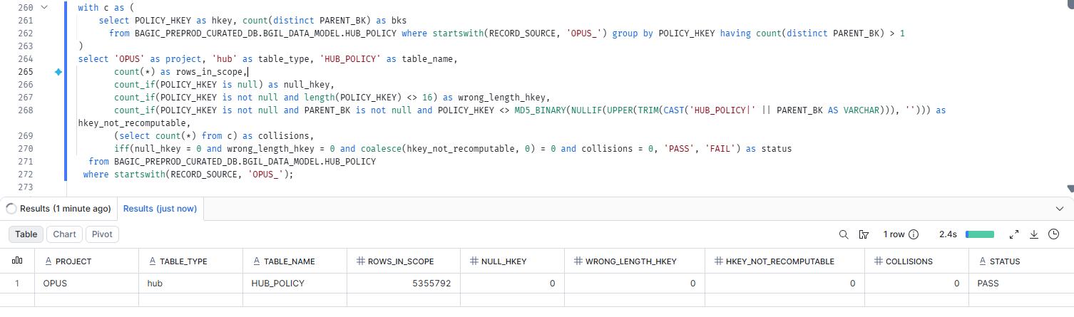

11. OPUS — HUB HUB_PRODUCT
Project | OPUS
Satellite | HUB HUB_PRODUCT
Status | Implemented
Pass criteria | status = PASS
Result (Pass / Fail / NA)
Rows with status = FAIL (count)
Remarks

Note: Recompute: MD5_BINARY(NULLIF(UPPER(TRIM(CAST('HUB_PRODUCT|' || PARENT_BK AS VARCHAR))), '')) must equal PRODUCT_HKEY. collisions = hash keys carrying more than one PARENT_BK. Overlaps DM-K3 (nulls) and DM-K4 (uniqueness) but adds the recompute and length checks.
SQL query
with c as (
select PRODUCT_HKEY as hkey, count(distinct PARENT_BK) as bks
from BAGIC_PREPROD_CURATED_DB.BGIL_DATA_MODEL.HUB_PRODUCT where startswith(RECORD_SOURCE, 'OPUS_') group by PRODUCT_HKEY having count(distinct PARENT_BK) > 1
)
select 'OPUS' as project, 'hub' as table_type, 'HUB_PRODUCT' as table_name,
count(*) as rows_in_scope,
count_if(PRODUCT_HKEY is null) as null_hkey,
count_if(PRODUCT_HKEY is not null and length(PRODUCT_HKEY) <> 16) as wrong_length_hkey,
count_if(PRODUCT_HKEY is not null and PARENT_BK is not null and PRODUCT_HKEY <> MD5_BINARY(NULLIF(UPPER(TRIM(CAST('HUB_PRODUCT|' || PARENT_BK AS VARCHAR))), ''))) as hkey_not_recomputable,
(select count(*) from c) as collisions,
iff(null_hkey = 0 and wrong_length_hkey = 0 and coalesce(hkey_not_recomputable, 0) = 0 and collisions = 0, 'PASS', 'FAIL') as status
from BAGIC_PREPROD_CURATED_DB.BGIL_DATA_MODEL.HUB_PRODUCT
where startswith(RECORD_SOURCE, 'OPUS_');
Query output (attach / paste below)
Output:

12. OPUS — HUB HUB_RISK_OBJECT [Partner LOB]
Project | OPUS
Satellite | HUB HUB_RISK_OBJECT [Partner LOB]
Status | Implemented
Pass criteria | status = PASS
Result (Pass / Fail / NA) | Pass
Rows with status = FAIL (count)
Remarks

Note: Recompute: MD5_BINARY(NULLIF(UPPER(TRIM(CAST('HUB_RISK_OBJECT|' || PARENT_BK AS VARCHAR))), '')) must equal RISK_OBJECT_HKEY. collisions = hash keys carrying more than one PARENT_BK. Overlaps DM-K3 (nulls) and DM-K4 (uniqueness) but adds the recompute and length checks.
SQL query
with c as (
select RISK_OBJECT_HKEY as hkey, count(distinct PARENT_BK) as bks
from BAGIC_PREPROD_CURATED_DB.BGIL_DATA_MODEL.HUB_RISK_OBJECT where startswith(RECORD_SOURCE, 'OPUS_') group by RISK_OBJECT_HKEY having count(distinct PARENT_BK) > 1
)
select 'OPUS' as project, 'hub' as table_type, 'HUB_RISK_OBJECT' as table_name,
count(*) as rows_in_scope,
count_if(RISK_OBJECT_HKEY is null) as null_hkey,
count_if(RISK_OBJECT_HKEY is not null and length(RISK_OBJECT_HKEY) <> 16) as wrong_length_hkey,
count_if(RISK_OBJECT_HKEY is not null and PARENT_BK is not null and RISK_OBJECT_HKEY <> MD5_BINARY(NULLIF(UPPER(TRIM(CAST('HUB_RISK_OBJECT|' || PARENT_BK AS VARCHAR))), ''))) as hkey_not_recomputable,
(select count(*) from c) as collisions,
iff(null_hkey = 0 and wrong_length_hkey = 0 and coalesce(hkey_not_recomputable, 0) = 0 and collisions = 0, 'PASS', 'FAIL') as status
from BAGIC_PREPROD_CURATED_DB.BGIL_DATA_MODEL.HUB_RISK_OBJECT
where startswith(RECORD_SOURCE, 'OPUS_');
Query output (attach / paste below)
Output:
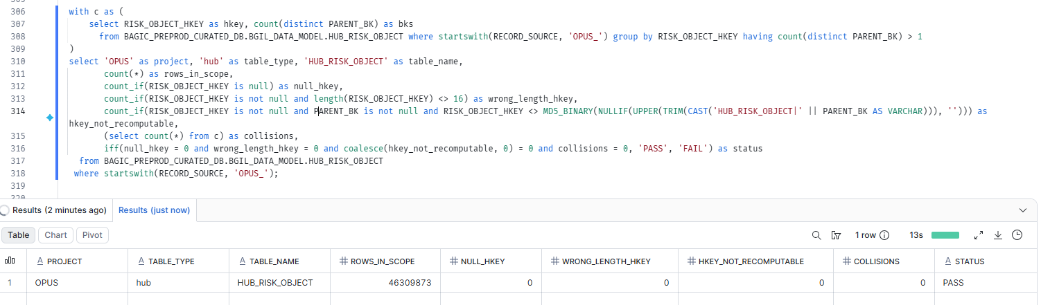

13. OPUS — LINK LNK_CLAIM_PARTY
Project | OPUS
Satellite | LINK LNK_CLAIM_PARTY
Status | Implemented
Pass criteria | status = PASS
Result (Pass / Fail / NA)
Rows with status = FAIL (count)
Remarks

Note: FK hash keys PARTY_HKEY, CLAIM_HKEY. collisions = one link hash key with more than one FK combination (the link key no longer identifies one relationship).
SQL query
with c as (
select CLAIM_PARTY_HKEY as hkey from BAGIC_PREPROD_CURATED_DB.BGIL_DATA_MODEL.LNK_CLAIM_PARTY where startswith(RECORD_SOURCE, 'OPUS_')
group by CLAIM_PARTY_HKEY having count(distinct coalesce(to_varchar(PARTY_HKEY, 'HEX'), '^^') || '|' || coalesce(to_varchar(CLAIM_HKEY, 'HEX'), '^^')) > 1
)
select 'OPUS' as project, 'link' as table_type, 'LNK_CLAIM_PARTY' as table_name,
count(*) as rows_in_scope,
count_if(CLAIM_PARTY_HKEY is null) as null_hkey,
count_if(PARTY_HKEY is null) + count_if(CLAIM_HKEY is null) as null_fk_hkeys,
count_if(length(CLAIM_PARTY_HKEY) <> 16 or length(PARTY_HKEY) <> 16 or length(CLAIM_HKEY) <> 16) as wrong_length_hkey,
(select count(*) from c) as collisions,
iff(null_hkey = 0 and null_fk_hkeys = 0 and wrong_length_hkey = 0 and collisions = 0, 'PASS', 'FAIL') as status
from BAGIC_PREPROD_CURATED_DB.BGIL_DATA_MODEL.LNK_CLAIM_PARTY
where startswith(RECORD_SOURCE, 'OPUS_');
Query output (attach / paste below)
Output:

14. OPUS — LINK LNK_PARTY_LOCATION
Project | OPUS
Satellite | LINK LNK_PARTY_LOCATION
Status | Implemented
Pass criteria | status = PASS
Result (Pass / Fail / NA)
Rows with status = FAIL (count)
Remarks

Note: FK hash keys PARTY_HKEY, LOCATION_HKEY. collisions = one link hash key with more than one FK combination (the link key no longer identifies one relationship).
SQL query
with c as (
select PARTY_LOCATION_HKEY as hkey from BAGIC_PREPROD_CURATED_DB.BGIL_DATA_MODEL.LNK_PARTY_LOCATION where startswith(RECORD_SOURCE, 'OPUS_')
group by PARTY_LOCATION_HKEY having count(distinct coalesce(to_varchar(PARTY_HKEY, 'HEX'), '^^') || '|' || coalesce(to_varchar(LOCATION_HKEY, 'HEX'), '^^')) > 1
)
select 'OPUS' as project, 'link' as table_type, 'LNK_PARTY_LOCATION' as table_name,
count(*) as rows_in_scope,
count_if(PARTY_LOCATION_HKEY is null) as null_hkey,
count_if(PARTY_HKEY is null) + count_if(LOCATION_HKEY is null) as null_fk_hkeys,
count_if(length(PARTY_LOCATION_HKEY) <> 16 or length(PARTY_HKEY) <> 16 or length(LOCATION_HKEY) <> 16) as wrong_length_hkey,
(select count(*) from c) as collisions,
iff(null_hkey = 0 and null_fk_hkeys = 0 and wrong_length_hkey = 0 and collisions = 0, 'PASS', 'FAIL') as status
from BAGIC_PREPROD_CURATED_DB.BGIL_DATA_MODEL.LNK_PARTY_LOCATION
where startswith(RECORD_SOURCE, 'OPUS_');
Query output (attach / paste below)
Output:

15. OPUS — LINK LNK_POLICY_PARTY
Project | OPUS
Satellite | LINK LNK_POLICY_PARTY
Status | Implemented
Pass criteria | status = PASS
Result (Pass / Fail / NA)
Rows with status = FAIL (count)
Remarks

Note: FK hash keys PARTY_HKEY, POLICY_HKEY. collisions = one link hash key with more than one FK combination (the link key no longer identifies one relationship).
SQL query
with c as (
select POLICY_PARTY_HKEY as hkey from BAGIC_PREPROD_CURATED_DB.BGIL_DATA_MODEL.LNK_POLICY_PARTY where startswith(RECORD_SOURCE, 'OPUS_')
group by POLICY_PARTY_HKEY having count(distinct coalesce(to_varchar(PARTY_HKEY, 'HEX'), '^^') || '|' || coalesce(to_varchar(POLICY_HKEY, 'HEX'), '^^')) > 1
)
select 'OPUS' as project, 'link' as table_type, 'LNK_POLICY_PARTY' as table_name,
count(*) as rows_in_scope,
count_if(POLICY_PARTY_HKEY is null) as null_hkey,
count_if(PARTY_HKEY is null) + count_if(POLICY_HKEY is null) as null_fk_hkeys,
count_if(length(POLICY_PARTY_HKEY) <> 16 or length(PARTY_HKEY) <> 16 or length(POLICY_HKEY) <> 16) as wrong_length_hkey,
(select count(*) from c) as collisions,
iff(null_hkey = 0 and null_fk_hkeys = 0 and wrong_length_hkey = 0 and collisions = 0, 'PASS', 'FAIL') as status
from BAGIC_PREPROD_CURATED_DB.BGIL_DATA_MODEL.LNK_POLICY_PARTY
where startswith(RECORD_SOURCE, 'OPUS_');
Query output (attach / paste below)
Output:

16. OPUS — SATELLITE SAT_AGREEMENT_COMMERCIAL_TERMS [Partner LOB]
Project | OPUS
Satellite | SATELLITE SAT_AGREEMENT_COMMERCIAL_TERMS [Partner LOB]
Status | Implemented
Pass criteria | status = PASS
Result (Pass / Fail / NA) | Pass
Rows with status = FAIL (count)
Remarks

Note: Satellite hash key and HASHDIFF populated and 16 bytes. HASHDIFF correctness itself is DM-H1 (a).
SQL query
select 'OPUS' as project, 'satellite' as table_type, 'SAT_AGREEMENT_COMMERCIAL_TERMS' as table_name,
count(*) as rows_in_scope,
count_if(AGREEMENT_HKEY is null) as null_hkey,
count_if(AGREEMENT_HKEY is not null and length(AGREEMENT_HKEY) <> 16) as wrong_length_hkey,
count_if(HASHDIFF is null) as null_hashdiff,
iff(null_hkey = 0 and wrong_length_hkey = 0 and null_hashdiff = 0, 'PASS', 'FAIL') as status
from BAGIC_PREPROD_CURATED_DB.BGIL_DATA_MODEL.SAT_AGREEMENT_COMMERCIAL_TERMS
where startswith(RECORD_SOURCE, 'OPUS_');
Query output (attach / paste below)
Output:
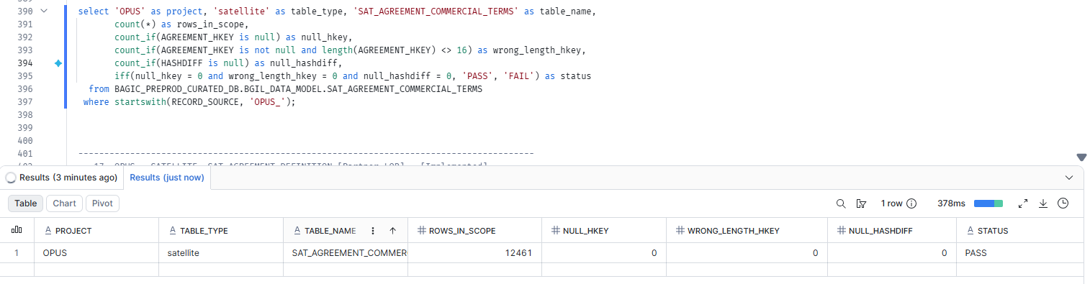

17. OPUS — SATELLITE SAT_AGREEMENT_DEFINITION [Partner LOB]
Project | OPUS
Satellite | SATELLITE SAT_AGREEMENT_DEFINITION [Partner LOB]
Status | Implemented
Pass criteria | status = PASS
Result (Pass / Fail / NA) | Pass
Rows with status = FAIL (count)
Remarks

Note: Satellite hash key and HASHDIFF populated and 16 bytes. HASHDIFF correctness itself is DM-H1 (a).
SQL query
select 'OPUS' as project, 'satellite' as table_type, 'SAT_AGREEMENT_DEFINITION' as table_name,
count(*) as rows_in_scope,
count_if(AGREEMENT_HKEY is null) as null_hkey,
count_if(AGREEMENT_HKEY is not null and length(AGREEMENT_HKEY) <> 16) as wrong_length_hkey,
count_if(HASHDIFF is null) as null_hashdiff,
iff(null_hkey = 0 and wrong_length_hkey = 0 and null_hashdiff = 0, 'PASS', 'FAIL') as status
from BAGIC_PREPROD_CURATED_DB.BGIL_DATA_MODEL.SAT_AGREEMENT_DEFINITION
where startswith(RECORD_SOURCE, 'OPUS_');
Query output (attach / paste below)
Output:
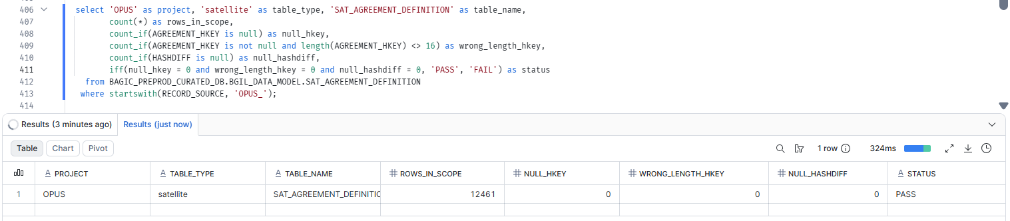

18. OPUS — SATELLITE SAT_AUG_AFFINITY_MEMBERSHIP
Project | OPUS
Satellite | SATELLITE SAT_AUG_AFFINITY_MEMBERSHIP
Status | Implemented
Pass criteria | status = PASS
Result (Pass / Fail / NA)
Rows with status = FAIL (count)
Remarks

Note: Satellite hash key and HASHDIFF populated and 16 bytes. HASHDIFF correctness itself is DM-H1 (a).
SQL query
select 'OPUS' as project, 'satellite' as table_type, 'SAT_AUG_AFFINITY_MEMBERSHIP' as table_name,
count(*) as rows_in_scope,
count_if(PARTY_HKEY is null) as null_hkey,
count_if(PARTY_HKEY is not null and length(PARTY_HKEY) <> 16) as wrong_length_hkey,
count_if(HASHDIFF is null) as null_hashdiff,
iff(null_hkey = 0 and wrong_length_hkey = 0 and null_hashdiff = 0, 'PASS', 'FAIL') as status
from BAGIC_PREPROD_CURATED_DB.BGIL_DATA_MODEL.SAT_AUG_AFFINITY_MEMBERSHIP
where startswith(RECORD_SOURCE, 'OPUS_');
Query output (attach / paste below)
Output:

19. OPUS — SATELLITE SAT_AUG_AGREEMENT
Project | OPUS
Satellite | SATELLITE SAT_AUG_AGREEMENT
Status | Implemented
Pass criteria | status = PASS
Result (Pass / Fail / NA)
Rows with status = FAIL (count)
Remarks

Note: Satellite hash key and HASHDIFF populated and 16 bytes. HASHDIFF correctness itself is DM-H1 (a).
SQL query
select 'OPUS' as project, 'satellite' as table_type, 'SAT_AUG_AGREEMENT' as table_name,
count(*) as rows_in_scope,
count_if(AGREEMENT_HKEY is null) as null_hkey,
count_if(AGREEMENT_HKEY is not null and length(AGREEMENT_HKEY) <> 16) as wrong_length_hkey,
count_if(HASHDIFF is null) as null_hashdiff,
iff(null_hkey = 0 and wrong_length_hkey = 0 and null_hashdiff = 0, 'PASS', 'FAIL') as status
from BAGIC_PREPROD_CURATED_DB.BGIL_DATA_MODEL.SAT_AUG_AGREEMENT
where startswith(RECORD_SOURCE, 'OPUS_');
Query output (attach / paste below)
Output:

20. OPUS — SATELLITE SAT_AUG_CHANNEL[Partner LOB]
Project | OPUS
Satellite | SATELLITE SAT_AUG_CHANNEL
Status | Implemented
Pass criteria | status = PASS
Result (Pass / Fail / NA) | Pass
Rows with status = FAIL (count)
Remarks

Note: Satellite hash key and HASHDIFF populated and 16 bytes. HASHDIFF correctness itself is DM-H1 (a).
SQL query
select 'OPUS' as project, 'satellite' as table_type, 'SAT_AUG_CHANNEL' as table_name,
count(*) as rows_in_scope,
count_if(DISTRIBUTION_CHANNEL_HKEY is null) as null_hkey,
count_if(DISTRIBUTION_CHANNEL_HKEY is not null and length(DISTRIBUTION_CHANNEL_HKEY) <> 16) as wrong_length_hkey,
count_if(HASHDIFF is null) as null_hashdiff,
iff(null_hkey = 0 and wrong_length_hkey = 0 and null_hashdiff = 0, 'PASS', 'FAIL') as status
from BAGIC_PREPROD_CURATED_DB.BGIL_DATA_MODEL.SAT_AUG_CHANNEL
where startswith(RECORD_SOURCE, 'OPUS_');
Query output (attach / paste below)
Output:
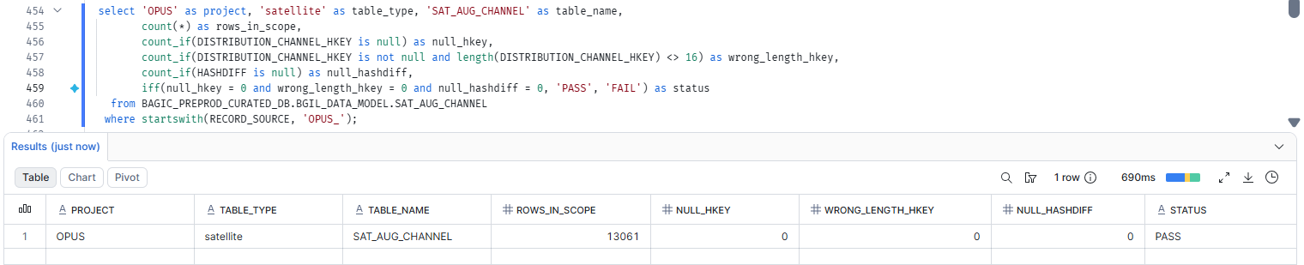

21. OPUS — SATELLITE SAT_AUG_KYC_DOCUMENT[Partner LOB]
Project | OPUS
Satellite | SATELLITE SAT_AUG_KYC_DOCUMENT
Status | Implemented
Pass criteria | status = PASS
Result (Pass / Fail / NA) | Pass
Rows with status = FAIL (count)
Remarks

Note: Satellite hash key and HASHDIFF populated and 16 bytes. HASHDIFF correctness itself is DM-H1 (a).
SQL query
select 'OPUS' as project, 'satellite' as table_type, 'SAT_AUG_KYC_DOCUMENT' as table_name,
count(*) as rows_in_scope,
count_if(DOCUMENT_HKEY is null) as null_hkey,
count_if(DOCUMENT_HKEY is not null and length(DOCUMENT_HKEY) <> 16) as wrong_length_hkey,
count_if(HASHDIFF is null) as null_hashdiff,
iff(null_hkey = 0 and wrong_length_hkey = 0 and null_hashdiff = 0, 'PASS', 'FAIL') as status
from BAGIC_PREPROD_CURATED_DB.BGIL_DATA_MODEL.SAT_AUG_KYC_DOCUMENT
where startswith(RECORD_SOURCE, 'OPUS_');
Query output (attach / paste below)
Output:
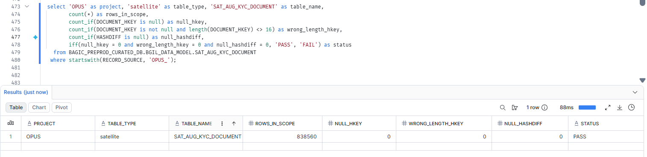

22. OPUS — SATELLITE SAT_AUG_KYC_LOCATION
Project | OPUS
Satellite | SATELLITE SAT_AUG_KYC_LOCATION
Status | Implemented
Pass criteria | status = PASS
Result (Pass / Fail / NA)
Rows with status = FAIL (count)
Remarks

Note: Satellite hash key and HASHDIFF populated and 16 bytes. HASHDIFF correctness itself is DM-H1 (a).
SQL query
select 'OPUS' as project, 'satellite' as table_type, 'SAT_AUG_KYC_LOCATION' as table_name,
count(*) as rows_in_scope,
count_if(LOCATION_HKEY is null) as null_hkey,
count_if(LOCATION_HKEY is not null and length(LOCATION_HKEY) <> 16) as wrong_length_hkey,
count_if(HASHDIFF is null) as null_hashdiff,
iff(null_hkey = 0 and wrong_length_hkey = 0 and null_hashdiff = 0, 'PASS', 'FAIL') as status
from BAGIC_PREPROD_CURATED_DB.BGIL_DATA_MODEL.SAT_AUG_KYC_LOCATION
where startswith(RECORD_SOURCE, 'OPUS_');
Query output (attach / paste below)
Output:

23. OPUS — SATELLITE SAT_AUG_KYC_PARTY[PARTNER LOB]
Project | OPUS
Satellite | SATELLITE SAT_AUG_KYC_PARTY
Status | Implemented
Pass criteria | status = PASS
Result (Pass / Fail / NA) | fAIL
Rows with status = FAIL (count)
Remarks

Note: Satellite hash key and HASHDIFF populated and 16 bytes. HASHDIFF correctness itself is DM-H1 (a).
SQL query
select 'OPUS' as project, 'satellite' as table_type, 'SAT_AUG_KYC_PARTY' as table_name,
count(*) as rows_in_scope,
count_if(PARTY_HKEY is null) as null_hkey,
count_if(PARTY_HKEY is not null and length(PARTY_HKEY) <> 16) as wrong_length_hkey,
count_if(HASHDIFF is null) as null_hashdiff,
iff(null_hkey = 0 and wrong_length_hkey = 0 and null_hashdiff = 0, 'PASS', 'FAIL') as status
from BAGIC_PREPROD_CURATED_DB.BGIL_DATA_MODEL.SAT_AUG_KYC_PARTY
where startswith(RECORD_SOURCE, 'OPUS_');
Query output (attach / paste below)
Output:
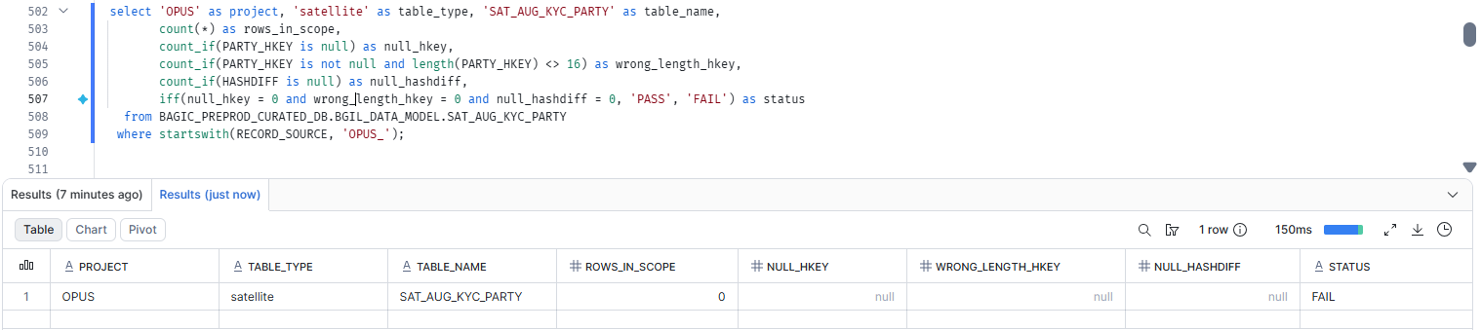

24. OPUS — SATELLITE SAT_AUG_KYC_POLICY
Project | OPUS
Satellite | SATELLITE SAT_AUG_KYC_POLICY
Status | Implemented
Pass criteria | status = PASS
Result (Pass / Fail / NA)
Rows with status = FAIL (count)
Remarks

Note: Satellite hash key and HASHDIFF populated and 16 bytes. HASHDIFF correctness itself is DM-H1 (a).
SQL query
select 'OPUS' as project, 'satellite' as table_type, 'SAT_AUG_KYC_POLICY' as table_name,
count(*) as rows_in_scope,
count_if(POLICY_HKEY is null) as null_hkey,
count_if(POLICY_HKEY is not null and length(POLICY_HKEY) <> 16) as wrong_length_hkey,
count_if(HASHDIFF is null) as null_hashdiff,
iff(null_hkey = 0 and wrong_length_hkey = 0 and null_hashdiff = 0, 'PASS', 'FAIL') as status
from BAGIC_PREPROD_CURATED_DB.BGIL_DATA_MODEL.SAT_AUG_KYC_POLICY
where startswith(RECORD_SOURCE, 'OPUS_');
Query output (attach / paste below)
Output:

25. OPUS — SATELLITE SAT_AUG_LAWYER_ADVOCATE_ROLE
Project | OPUS
Satellite | SATELLITE SAT_AUG_LAWYER_ADVOCATE_ROLE
Status | Implemented
Pass criteria | status = PASS
Result (Pass / Fail / NA)
Rows with status = FAIL (count)
Remarks

Note: Satellite hash key and HASHDIFF populated and 16 bytes. HASHDIFF correctness itself is DM-H1 (a).
SQL query
select 'OPUS' as project, 'satellite' as table_type, 'SAT_AUG_LAWYER_ADVOCATE_ROLE' as table_name,
count(*) as rows_in_scope,
count_if(PARTY_HKEY is null) as null_hkey,
count_if(PARTY_HKEY is not null and length(PARTY_HKEY) <> 16) as wrong_length_hkey,
count_if(HASHDIFF is null) as null_hashdiff,
iff(null_hkey = 0 and wrong_length_hkey = 0 and null_hashdiff = 0, 'PASS', 'FAIL') as status
from BAGIC_PREPROD_CURATED_DB.BGIL_DATA_MODEL.SAT_AUG_LAWYER_ADVOCATE_ROLE
where startswith(RECORD_SOURCE, 'OPUS_');
Query output (attach / paste below)
Output:

26. OPUS — SATELLITE SAT_AUG_LNK_ROLE_AGENT [Partner LOB]
Project | OPUS
Satellite | SATELLITE SAT_AUG_LNK_ROLE_AGENT [Partner LOB]
Status | Implemented
Pass criteria | status = PASS
Result (Pass / Fail / NA) | Pass
Rows with status = FAIL (count)
Remarks

Note: Satellite hash key and HASHDIFF populated and 16 bytes. HASHDIFF correctness itself is DM-H1 (a).
SQL query
select 'OPUS' as project, 'satellite' as table_type, 'SAT_AUG_LNK_ROLE_AGENT' as table_name,
count(*) as rows_in_scope,
count_if(PARTY_HKEY is null) as null_hkey,
count_if(PARTY_HKEY is not null and length(PARTY_HKEY) <> 16) as wrong_length_hkey,
count_if(HASHDIFF is null) as null_hashdiff,
iff(null_hkey = 0 and wrong_length_hkey = 0 and null_hashdiff = 0, 'PASS', 'FAIL') as status
from BAGIC_PREPROD_CURATED_DB.BGIL_DATA_MODEL.SAT_AUG_LNK_ROLE_AGENT
where startswith(RECORD_SOURCE, 'OPUS_');
Query output (attach / paste below)
Output:
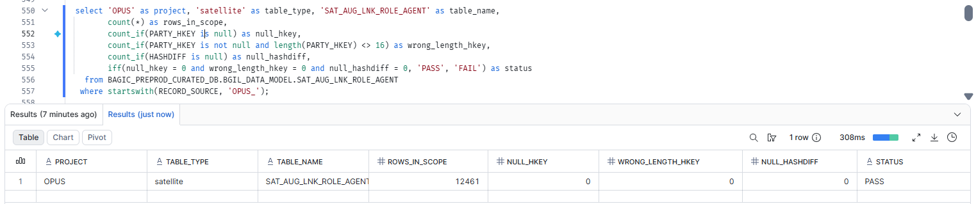

27. OPUS — SATELLITE SAT_AUG_LNK_ROLE_CUSTOMER [Partner LOB]
Project | OPUS
Satellite | SATELLITE SAT_AUG_LNK_ROLE_CUSTOMER [Partner LOB]
Status | Implemented
Pass criteria | status = PASS
Result (Pass / Fail / NA) | Pass
Rows with status = FAIL (count)
Remarks

Note: Satellite hash key and HASHDIFF populated and 16 bytes. HASHDIFF correctness itself is DM-H1 (a).
SQL query
select 'OPUS' as project, 'satellite' as table_type, 'SAT_AUG_LNK_ROLE_CUSTOMER' as table_name,
count(*) as rows_in_scope,
count_if(PARTY_HKEY is null) as null_hkey,
count_if(PARTY_HKEY is not null and length(PARTY_HKEY) <> 16) as wrong_length_hkey,
count_if(HASHDIFF is null) as null_hashdiff,
iff(null_hkey = 0 and wrong_length_hkey = 0 and null_hashdiff = 0, 'PASS', 'FAIL') as status
from BAGIC_PREPROD_CURATED_DB.BGIL_DATA_MODEL.SAT_AUG_LNK_ROLE_CUSTOMER
where startswith(RECORD_SOURCE, 'OPUS_');
Query output (attach / paste below)
Output:
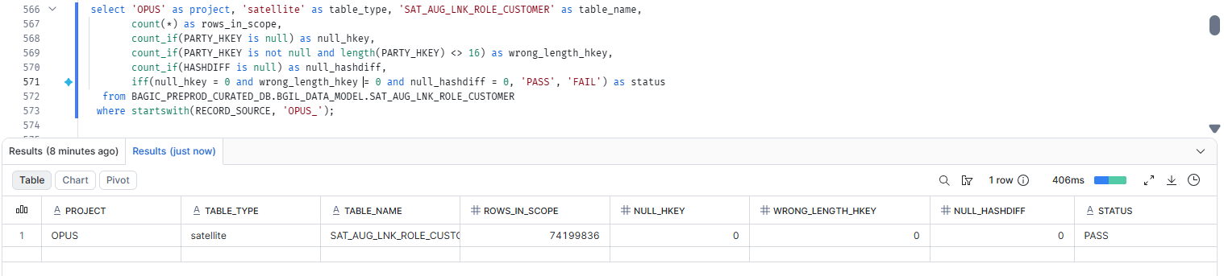

28. OPUS — SATELLITE SAT_AUG_LNK_ROLE_PROVIDER [Partner LOB]
Project | OPUS
Satellite | SATELLITE SAT_AUG_LNK_ROLE_PROVIDER [Partner LOB]
Status | Implemented
Pass criteria | status = PASS
Result (Pass / Fail / NA) | Pass
Rows with status = FAIL (count)
Remarks

Note: Satellite hash key and HASHDIFF populated and 16 bytes. HASHDIFF correctness itself is DM-H1 (a).
SQL query
select 'OPUS' as project, 'satellite' as table_type, 'SAT_AUG_LNK_ROLE_PROVIDER' as table_name,
count(*) as rows_in_scope,
count_if(PARTY_HKEY is null) as null_hkey,
count_if(PARTY_HKEY is not null and length(PARTY_HKEY) <> 16) as wrong_length_hkey,
count_if(HASHDIFF is null) as null_hashdiff,
iff(null_hkey = 0 and wrong_length_hkey = 0 and null_hashdiff = 0, 'PASS', 'FAIL') as status
from BAGIC_PREPROD_CURATED_DB.BGIL_DATA_MODEL.SAT_AUG_LNK_ROLE_PROVIDER
where startswith(RECORD_SOURCE, 'OPUS_');
Query output (attach / paste below)
Output:
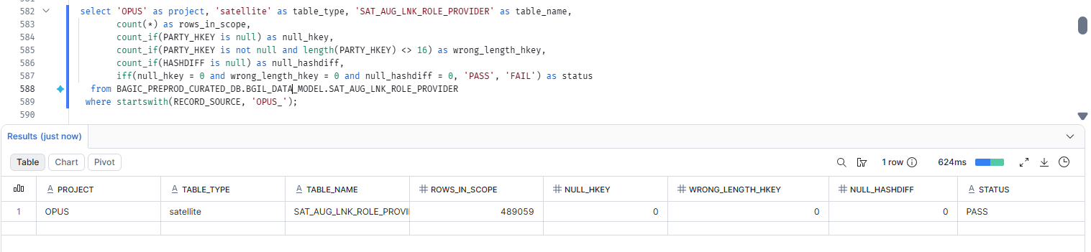

29. OPUS — SATELLITE SAT_AUG_LNK_ROLE_SURVEYOR [Partner LOB]
Project | OPUS
Satellite | SATELLITE SAT_AUG_LNK_ROLE_SURVEYOR [Partner LOB]
Status | Implemented
Pass criteria | status = PASS
Result (Pass / Fail / NA) | Pass
Rows with status = FAIL (count)
Remarks

Note: Satellite hash key and HASHDIFF populated and 16 bytes. HASHDIFF correctness itself is DM-H1 (a).
SQL query
select 'OPUS' as project, 'satellite' as table_type, 'SAT_AUG_LNK_ROLE_SURVEYOR' as table_name,
count(*) as rows_in_scope,
count_if(PARTY_HKEY is null) as null_hkey,
count_if(PARTY_HKEY is not null and length(PARTY_HKEY) <> 16) as wrong_length_hkey,
count_if(HASHDIFF is null) as null_hashdiff,
iff(null_hkey = 0 and wrong_length_hkey = 0 and null_hashdiff = 0, 'PASS', 'FAIL') as status
from BAGIC_PREPROD_CURATED_DB.BGIL_DATA_MODEL.SAT_AUG_LNK_ROLE_SURVEYOR
where startswith(RECORD_SOURCE, 'OPUS_');
Query output (attach / paste below)
Output:
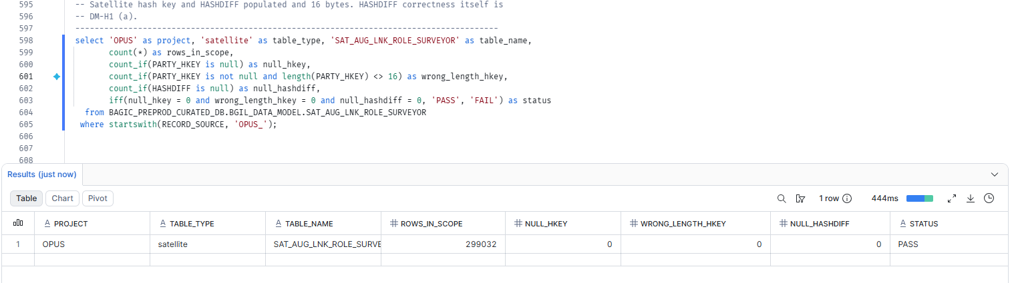

30. OPUS — SATELLITE SAT_AUG_LOCATION
Project | OPUS
Satellite | SATELLITE SAT_AUG_LOCATION
Status | Implemented
Pass criteria | status = PASS
Result (Pass / Fail / NA)
Rows with status = FAIL (count)
Remarks

Note: Satellite hash key and HASHDIFF populated and 16 bytes. HASHDIFF correctness itself is DM-H1 (a).
SQL query
select 'OPUS' as project, 'satellite' as table_type, 'SAT_AUG_LOCATION' as table_name,
count(*) as rows_in_scope,
count_if(LOCATION_HKEY is null) as null_hkey,
count_if(LOCATION_HKEY is not null and length(LOCATION_HKEY) <> 16) as wrong_length_hkey,
count_if(HASHDIFF is null) as null_hashdiff,
iff(null_hkey = 0 and wrong_length_hkey = 0 and null_hashdiff = 0, 'PASS', 'FAIL') as status
from BAGIC_PREPROD_CURATED_DB.BGIL_DATA_MODEL.SAT_AUG_LOCATION
where startswith(RECORD_SOURCE, 'OPUS_');
Query output (attach / paste below)
Output:

31. OPUS — SATELLITE SAT_AUG_PARTY[Partner Lob]
Project | OPUS
Satellite | SATELLITE SAT_AUG_PARTY
Status | Implemented
Pass criteria | status = PASS
Result (Pass / Fail / NA) | Fail
Rows with status = FAIL (count)
Remarks

Note: Satellite hash key and HASHDIFF populated and 16 bytes. HASHDIFF correctness itself is DM-H1 (a).
SQL query
select 'OPUS' as project, 'satellite' as table_type, 'SAT_AUG_PARTY' as table_name,
count(*) as rows_in_scope,
count_if(PARTY_HKEY is null) as null_hkey,
count_if(PARTY_HKEY is not null and length(PARTY_HKEY) <> 16) as wrong_length_hkey,
count_if(HASHDIFF is null) as null_hashdiff,
iff(null_hkey = 0 and wrong_length_hkey = 0 and null_hashdiff = 0, 'PASS', 'FAIL') as status
from BAGIC_PREPROD_CURATED_DB.BGIL_DATA_MODEL.SAT_AUG_PARTY
where startswith(RECORD_SOURCE, 'OPUS_');
Query output (attach / paste below)
Output:
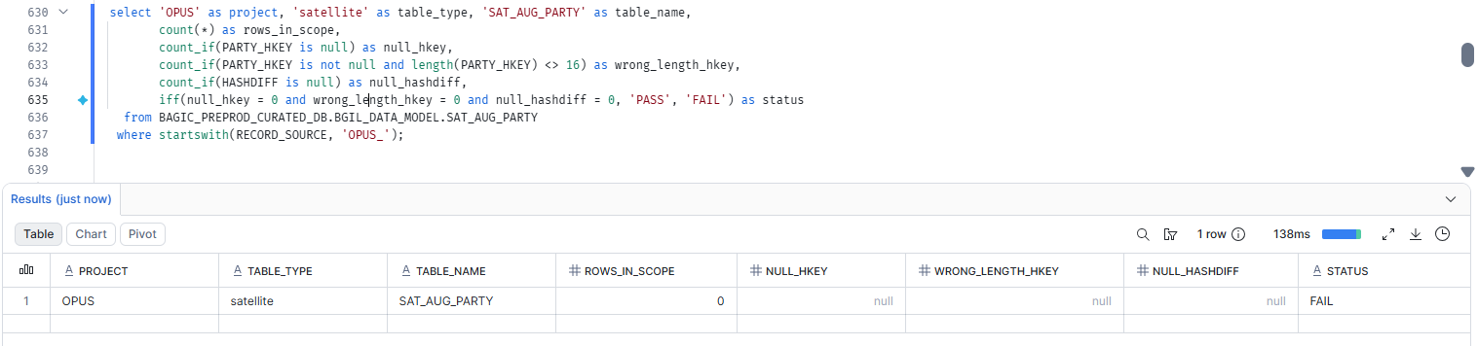

32. OPUS — SATELLITE SAT_AUG_POLICY
Project | OPUS
Satellite | SATELLITE SAT_AUG_POLICY
Status | Implemented
Pass criteria | status = PASS
Result (Pass / Fail / NA)
Rows with status = FAIL (count)
Remarks

Note: Satellite hash key and HASHDIFF populated and 16 bytes. HASHDIFF correctness itself is DM-H1 (a).
SQL query
select 'OPUS' as project, 'satellite' as table_type, 'SAT_AUG_POLICY' as table_name,
count(*) as rows_in_scope,
count_if(POLICY_HKEY is null) as null_hkey,
count_if(POLICY_HKEY is not null and length(POLICY_HKEY) <> 16) as wrong_length_hkey,
count_if(HASHDIFF is null) as null_hashdiff,
iff(null_hkey = 0 and wrong_length_hkey = 0 and null_hashdiff = 0, 'PASS', 'FAIL') as status
from BAGIC_PREPROD_CURATED_DB.BGIL_DATA_MODEL.SAT_AUG_POLICY
where startswith(RECORD_SOURCE, 'OPUS_');
Query output (attach / paste below)
Output:

33. OPUS — SATELLITE SAT_COMMON_ADDRESS [Partner LOB]
Project | OPUS
Satellite | SATELLITE SAT_COMMON_ADDRESS [Partner LOB]
Status | Implemented
Pass criteria | status = PASS
Result (Pass / Fail / NA) | Pass
Rows with status = FAIL (count)
Remarks

Note: Satellite hash key and HASHDIFF populated and 16 bytes. HASHDIFF correctness itself is DM-H1 (a).
SQL query
select 'OPUS' as project, 'satellite' as table_type, 'SAT_COMMON_ADDRESS' as table_name,
count(*) as rows_in_scope,
count_if(LOCATION_HKEY is null) as null_hkey,
count_if(LOCATION_HKEY is not null and length(LOCATION_HKEY) <> 16) as wrong_length_hkey,
count_if(HASHDIFF is null) as null_hashdiff,
iff(null_hkey = 0 and wrong_length_hkey = 0 and null_hashdiff = 0, 'PASS', 'FAIL') as status
from BAGIC_PREPROD_CURATED_DB.BGIL_DATA_MODEL.SAT_COMMON_ADDRESS
where startswith(RECORD_SOURCE, 'OPUS_');
Query output (attach / paste below)
Output:
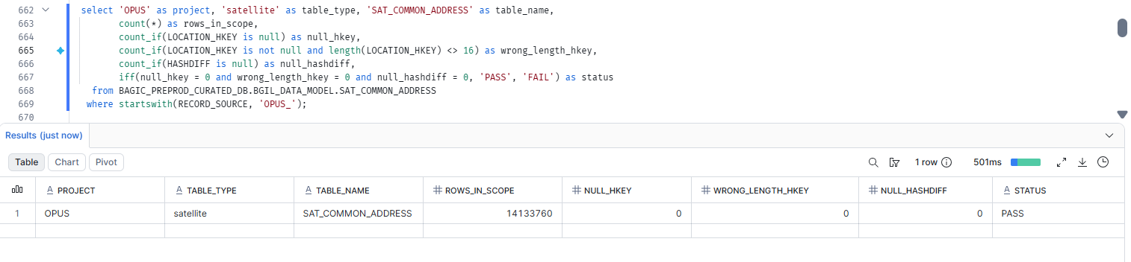

34. OPUS — SATELLITE SAT_COMMON_ADMIN_GEOGRAPHY
Project | OPUS
Satellite | SATELLITE SAT_COMMON_ADMIN_GEOGRAPHY
Status | Implemented
Pass criteria | status = PASS
Result (Pass / Fail / NA)
Rows with status = FAIL (count)
Remarks

Note: Satellite hash key and HASHDIFF populated and 16 bytes. HASHDIFF correctness itself is DM-H1 (a).
SQL query
select 'OPUS' as project, 'satellite' as table_type, 'SAT_COMMON_ADMIN_GEOGRAPHY' as table_name,
count(*) as rows_in_scope,
count_if(LOCATION_HKEY is null) as null_hkey,
count_if(LOCATION_HKEY is not null and length(LOCATION_HKEY) <> 16) as wrong_length_hkey,
count_if(HASHDIFF is null) as null_hashdiff,
iff(null_hkey = 0 and wrong_length_hkey = 0 and null_hashdiff = 0, 'PASS', 'FAIL') as status
from BAGIC_PREPROD_CURATED_DB.BGIL_DATA_MODEL.SAT_COMMON_ADMIN_GEOGRAPHY
where startswith(RECORD_SOURCE, 'OPUS_');
Query output (attach / paste below)
Output:

35. OPUS — SATELLITE SAT_COMMON_CLASSIFICATION [Partner LOB]
Project | OPUS
Satellite | SATELLITE SAT_COMMON_CLASSIFICATION [Partner LOB]
Status | Implemented
Pass criteria | status = PASS
Result (Pass / Fail / NA) | Pass
Rows with status = FAIL (count)
Remarks

Note: Satellite hash key and HASHDIFF populated and 16 bytes. HASHDIFF correctness itself is DM-H1 (a).
SQL query
select 'OPUS' as project, 'satellite' as table_type, 'SAT_COMMON_CLASSIFICATION' as table_name,
count(*) as rows_in_scope,
count_if(PARTY_HKEY is null) as null_hkey,
count_if(PARTY_HKEY is not null and length(PARTY_HKEY) <> 16) as wrong_length_hkey,
count_if(HASHDIFF is null) as null_hashdiff,
iff(null_hkey = 0 and wrong_length_hkey = 0 and null_hashdiff = 0, 'PASS', 'FAIL') as status
from BAGIC_PREPROD_CURATED_DB.BGIL_DATA_MODEL.SAT_COMMON_CLASSIFICATION
where startswith(RECORD_SOURCE, 'OPUS_');
Query output (attach / paste below)
Output:
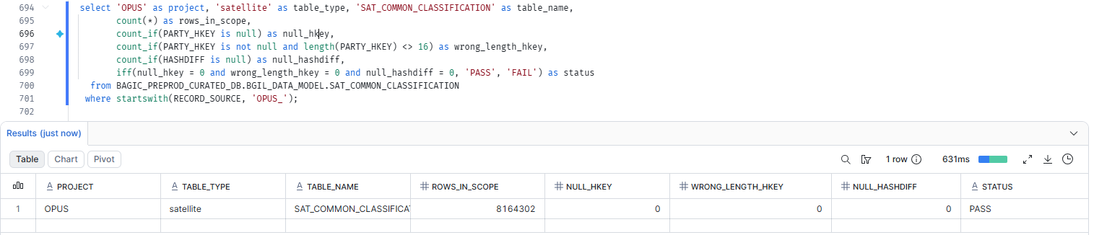

36. OPUS — SATELLITE SAT_COMMON_COMMUNICATION_PREFERENCE [Partner LOB]
Project | OPUS
Satellite | SATELLITE SAT_COMMON_COMMUNICATION_PREFERENCE [Partner LOB]
Status | Implemented
Pass criteria | status = PASS
Result (Pass / Fail / NA) | Pass
Rows with status = FAIL (count)
Remarks

Note: Satellite hash key and HASHDIFF populated and 16 bytes. HASHDIFF correctness itself is DM-H1 (a).
SQL query
select 'OPUS' as project, 'satellite' as table_type, 'SAT_COMMON_COMMUNICATION_PREFERENCE' as table_name,
count(*) as rows_in_scope,
count_if(PARTY_HKEY is null) as null_hkey,
count_if(PARTY_HKEY is not null and length(PARTY_HKEY) <> 16) as wrong_length_hkey,
count_if(HASHDIFF is null) as null_hashdiff,
iff(null_hkey = 0 and wrong_length_hkey = 0 and null_hashdiff = 0, 'PASS', 'FAIL') as status
from BAGIC_PREPROD_CURATED_DB.BGIL_DATA_MODEL.SAT_COMMON_COMMUNICATION_PREFERENCE
where startswith(RECORD_SOURCE, 'OPUS_');
Query output (attach / paste below)
Output:
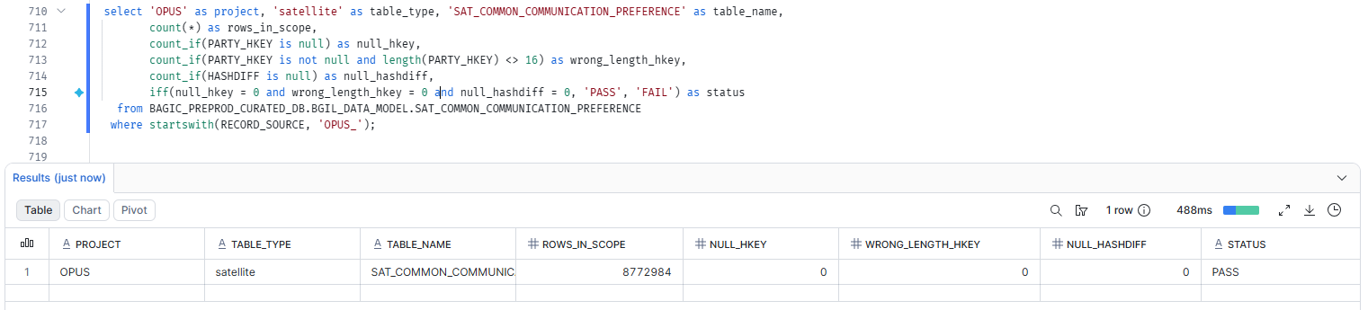

37. OPUS — SATELLITE SAT_COMMON_CONSENT [Partner LOB]
Project | OPUS
Satellite | SATELLITE SAT_COMMON_CONSENT [Partner LOB]
Status | Implemented
Pass criteria | status = PASS
Result (Pass / Fail / NA) | Pass
Rows with status = FAIL (count)
Remarks

Note: Satellite hash key and HASHDIFF populated and 16 bytes. HASHDIFF correctness itself is DM-H1 (a).
SQL query
select 'OPUS' as project, 'satellite' as table_type, 'SAT_COMMON_CONSENT' as table_name,
count(*) as rows_in_scope,
count_if(PARTY_HKEY is null) as null_hkey,
count_if(PARTY_HKEY is not null and length(PARTY_HKEY) <> 16) as wrong_length_hkey,
count_if(HASHDIFF is null) as null_hashdiff,
iff(null_hkey = 0 and wrong_length_hkey = 0 and null_hashdiff = 0, 'PASS', 'FAIL') as status
from BAGIC_PREPROD_CURATED_DB.BGIL_DATA_MODEL.SAT_COMMON_CONSENT
where startswith(RECORD_SOURCE, 'OPUS_');
Query output (attach / paste below)
Output:
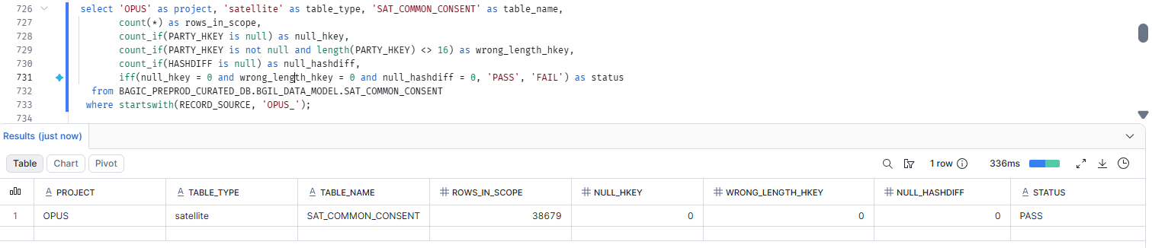

38. OPUS — SATELLITE SAT_COMMON_CONTACT [Partner LOB]
Project | OPUS
Satellite | SATELLITE SAT_COMMON_CONTACT [Partner LOB]
Status | Implemented
Pass criteria | status = PASS
Result (Pass / Fail / NA) | Pass
Rows with status = FAIL (count)
Remarks

Note: Satellite hash key and HASHDIFF populated and 16 bytes. HASHDIFF correctness itself is DM-H1 (a).
SQL query
select 'OPUS' as project, 'satellite' as table_type, 'SAT_COMMON_CONTACT' as table_name,
count(*) as rows_in_scope,
count_if(PARTY_HKEY is null) as null_hkey,
count_if(PARTY_HKEY is not null and length(PARTY_HKEY) <> 16) as wrong_length_hkey,
count_if(HASHDIFF is null) as null_hashdiff,
iff(null_hkey = 0 and wrong_length_hkey = 0 and null_hashdiff = 0, 'PASS', 'FAIL') as status
from BAGIC_PREPROD_CURATED_DB.BGIL_DATA_MODEL.SAT_COMMON_CONTACT
where RECORD_SOURCE = 'OPUS';
Query output (attach / paste below)
Output:
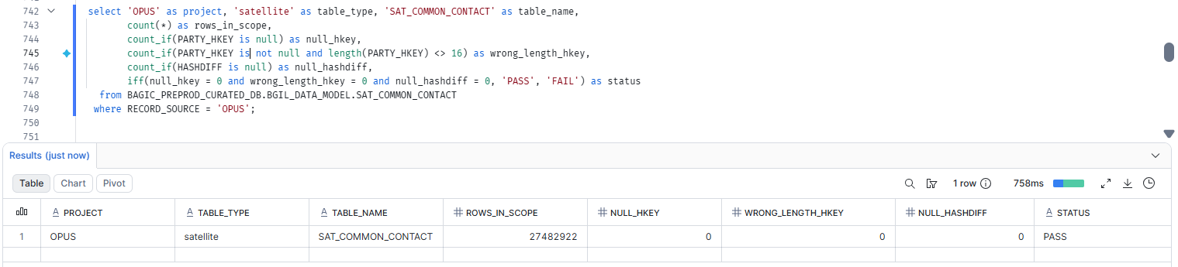

39. OPUS — SATELLITE SAT_COMMON_GEO [Partner LOB]
Project | OPUS
Satellite | SATELLITE SAT_COMMON_GEO [Partner LOB]
Status | Implemented
Pass criteria | status = PASS
Result (Pass / Fail / NA) | Pass
Rows with status = FAIL (count)
Remarks

Note: Satellite hash key and HASHDIFF populated and 16 bytes. HASHDIFF correctness itself is DM-H1 (a).
SQL query
select 'OPUS' as project, 'satellite' as table_type, 'SAT_COMMON_GEO' as table_name,
count(*) as rows_in_scope,
count_if(LOCATION_HKEY is null) as null_hkey,
count_if(LOCATION_HKEY is not null and length(LOCATION_HKEY) <> 16) as wrong_length_hkey,
count_if(HASHDIFF is null) as null_hashdiff,
iff(null_hkey = 0 and wrong_length_hkey = 0 and null_hashdiff = 0, 'PASS', 'FAIL') as status
from BAGIC_PREPROD_CURATED_DB.BGIL_DATA_MODEL.SAT_COMMON_GEO
where startswith(RECORD_SOURCE, 'OPUS_');
Query output (attach / paste below)
Output:
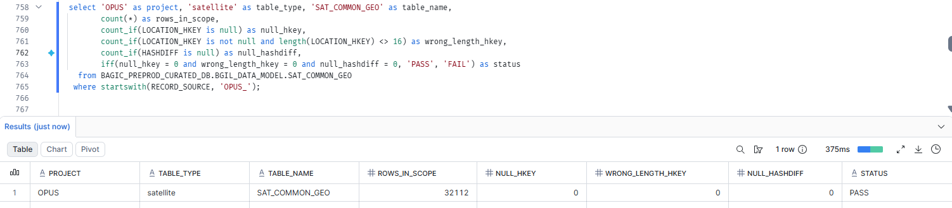

40. OPUS — SATELLITE SAT_DOCUMENT_DEFINITION [Partner LOB]
Project | OPUS
Satellite | SATELLITE SAT_DOCUMENT_DEFINITION [Partner LOB]
Status | Implemented
Pass criteria | status = PASS
Result (Pass / Fail / NA) | Pass
Rows with status = FAIL (count)
Remarks

Note: Satellite hash key and HASHDIFF populated and 16 bytes. HASHDIFF correctness itself is DM-H1 (a).
SQL query
select 'OPUS' as project, 'satellite' as table_type, 'SAT_DOCUMENT_DEFINITION' as table_name,
count(*) as rows_in_scope,
count_if(DOCUMENT_HKEY is null) as null_hkey,
count_if(DOCUMENT_HKEY is not null and length(DOCUMENT_HKEY) <> 16) as wrong_length_hkey,
count_if(HASHDIFF is null) as null_hashdiff,
iff(null_hkey = 0 and wrong_length_hkey = 0 and null_hashdiff = 0, 'PASS', 'FAIL') as status
from BAGIC_PREPROD_CURATED_DB.BGIL_DATA_MODEL.SAT_DOCUMENT_DEFINITION
where startswith(RECORD_SOURCE, 'OPUS_');
Query output (attach / paste below)
Output:
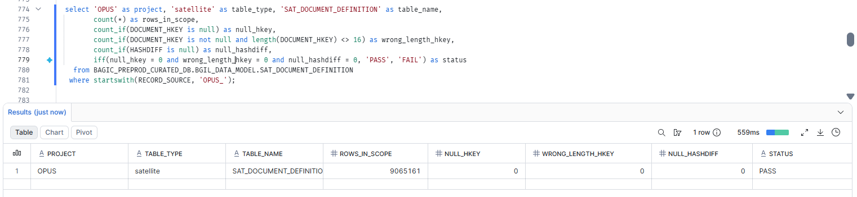

41. OPUS — SATELLITE SAT_LNK_CLAIM_PARTY_ROLE
Project | OPUS
Satellite | SATELLITE SAT_LNK_CLAIM_PARTY_ROLE
Status | Implemented
Pass criteria | status = PASS
Result (Pass / Fail / NA)
Rows with status = FAIL (count)
Remarks

Note: Satellite hash key and HASHDIFF populated and 16 bytes. HASHDIFF correctness itself is DM-H1 (a).
SQL query
select 'OPUS' as project, 'satellite' as table_type, 'SAT_LNK_CLAIM_PARTY_ROLE' as table_name,
count(*) as rows_in_scope,
count_if(CLAIM_PARTY_HKEY is null) as null_hkey,
count_if(CLAIM_PARTY_HKEY is not null and length(CLAIM_PARTY_HKEY) <> 16) as wrong_length_hkey,
count_if(HASHDIFF is null) as null_hashdiff,
iff(null_hkey = 0 and wrong_length_hkey = 0 and null_hashdiff = 0, 'PASS', 'FAIL') as status
from BAGIC_PREPROD_CURATED_DB.BGIL_DATA_MODEL.SAT_LNK_CLAIM_PARTY_ROLE
where startswith(RECORD_SOURCE, 'OPUS_');
Query output (attach / paste below)
Output:

42. OPUS — SATELLITE SAT_LNK_PARTY_ROLE_CORE [Partner LOB]
Project | OPUS
Satellite | SATELLITE SAT_LNK_PARTY_ROLE_CORE [Partner LOB]
Status | Implemented
Pass criteria | status = PASS
Result (Pass / Fail / NA) | Fail(Due to Mapping)
Rows with status = FAIL (count)
Remarks | In stg2_sat_bjaz_t_kyc_ocr__policy_premium_summary table its taking stg_partner__bjaz_t_kyc_ocr and in logic its referring case when upper(trim(field_type)) like 'POLICY%' then trim(field_value) end where no record at source.

Note: Satellite hash key and HASHDIFF populated and 16 bytes. HASHDIFF correctness itself is DM-H1 (a).
SQL query
select 'OPUS' as project, 'satellite' as table_type, 'SAT_LNK_PARTY_ROLE_CORE' as table_name,
count(*) as rows_in_scope,
count_if(PARTY_HKEY is null) as null_hkey,
count_if(PARTY_HKEY is not null and length(PARTY_HKEY) <> 16) as wrong_length_hkey,
count_if(HASHDIFF is null) as null_hashdiff,
iff(null_hkey = 0 and wrong_length_hkey = 0 and null_hashdiff = 0, 'PASS', 'FAIL') as status
from BAGIC_PREPROD_CURATED_DB.BGIL_DATA_MODEL.SAT_LNK_PARTY_ROLE_CORE
where startswith(RECORD_SOURCE, 'OPUS_');
Query output (attach / paste below)
Output:
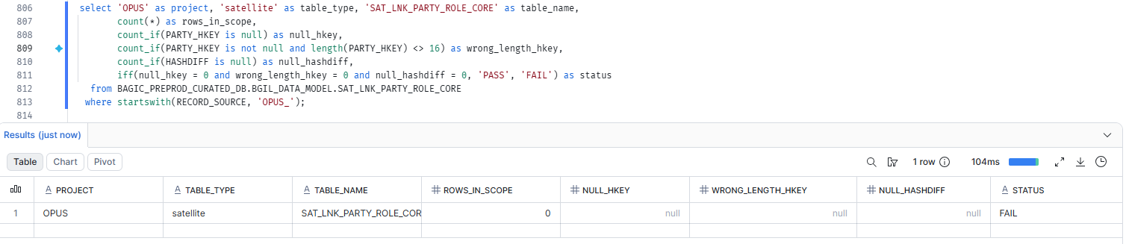

43. OPUS — SATELLITE SAT_LNK_POLICY_PARTY_ROLE [Partner LOB]
Project | OPUS
Satellite | SATELLITE SAT_LNK_POLICY_PARTY_ROLE [Partner LOB]
Status | Implemented
Pass criteria | status = PASS
Result (Pass / Fail / NA) | Pass
Rows with status = FAIL (count)
Remarks

Note: Satellite hash key and HASHDIFF populated and 16 bytes. HASHDIFF correctness itself is DM-H1 (a).
SQL query
select 'OPUS' as project, 'satellite' as table_type, 'SAT_LNK_POLICY_PARTY_ROLE' as table_name,
count(*) as rows_in_scope,
count_if(POLICY_PARTY_HKEY is null) as null_hkey,
count_if(POLICY_PARTY_HKEY is not null and length(POLICY_PARTY_HKEY) <> 16) as wrong_length_hkey,
count_if(HASHDIFF is null) as null_hashdiff,
iff(null_hkey = 0 and wrong_length_hkey = 0 and null_hashdiff = 0, 'PASS', 'FAIL') as status
from BAGIC_PREPROD_CURATED_DB.BGIL_DATA_MODEL.SAT_LNK_POLICY_PARTY_ROLE
where startswith(RECORD_SOURCE, 'OPUS_');
Query output (attach / paste below)
Output:
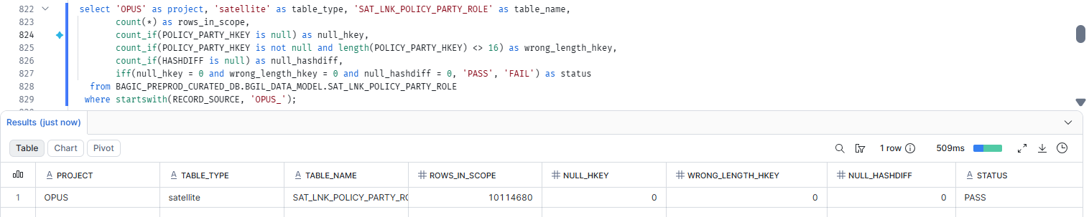

44. OPUS — SATELLITE SAT_LNK_ROLE_AGENT [Partner LOB]
Project | OPUS
Satellite | SATELLITE SAT_LNK_ROLE_AGENT [Partner LOB]
Status | Implemented
Pass criteria | status = PASS
Result (Pass / Fail / NA) | Pass
Rows with status = FAIL (count)
Remarks

Note: Satellite hash key and HASHDIFF populated and 16 bytes. HASHDIFF correctness itself is DM-H1 (a).
SQL query
select 'OPUS' as project, 'satellite' as table_type, 'SAT_LNK_ROLE_AGENT' as table_name,
count(*) as rows_in_scope,
count_if(PARTY_HKEY is null) as null_hkey,
count_if(PARTY_HKEY is not null and length(PARTY_HKEY) <> 16) as wrong_length_hkey,
count_if(HASHDIFF is null) as null_hashdiff,
iff(null_hkey = 0 and wrong_length_hkey = 0 and null_hashdiff = 0, 'PASS', 'FAIL') as status
from BAGIC_PREPROD_CURATED_DB.BGIL_DATA_MODEL.SAT_LNK_ROLE_AGENT
where startswith(RECORD_SOURCE, 'OPUS_');
Query output (attach / paste below)
Output:
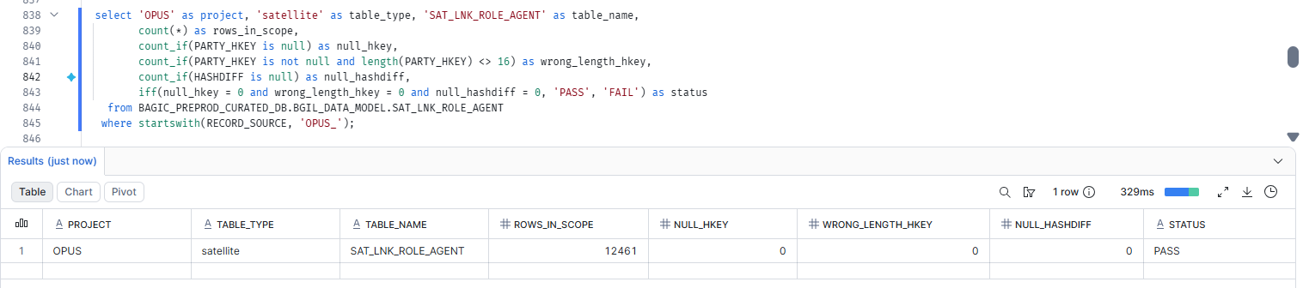

45. OPUS — SATELLITE SAT_LNK_ROLE_CUSTOMER [Partner LOB]
Project | OPUS
Satellite | SATELLITE SAT_LNK_ROLE_CUSTOMER [Partner LOB]
Status | Implemented
Pass criteria | status = PASS
Result (Pass / Fail / NA) | Pass
Rows with status = FAIL (count)
Remarks

Note: Satellite hash key and HASHDIFF populated and 16 bytes. HASHDIFF correctness itself is DM-H1 (a).
SQL query
select 'OPUS' as project, 'satellite' as table_type, 'SAT_LNK_ROLE_CUSTOMER' as table_name,
count(*) as rows_in_scope,
count_if(PARTY_HKEY is null) as null_hkey,
count_if(PARTY_HKEY is not null and length(PARTY_HKEY) <> 16) as wrong_length_hkey,
count_if(HASHDIFF is null) as null_hashdiff,
iff(null_hkey = 0 and wrong_length_hkey = 0 and null_hashdiff = 0, 'PASS', 'FAIL') as status
from BAGIC_PREPROD_CURATED_DB.BGIL_DATA_MODEL.SAT_LNK_ROLE_CUSTOMER
where startswith(RECORD_SOURCE, 'OPUS_');
Query output (attach / paste below)
Output:
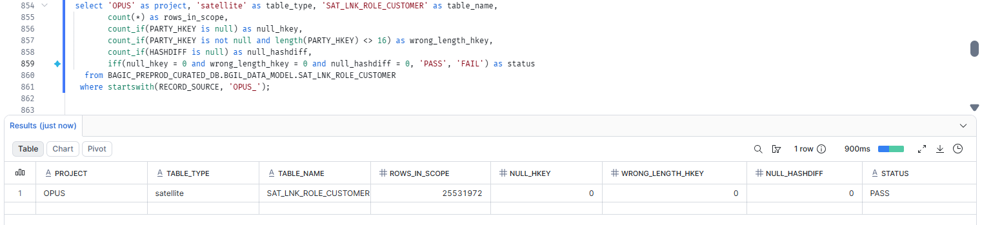

46. OPUS — SATELLITE SAT_LNK_ROLE_NOMINEE_BENEFICIARY
Project | OPUS
Satellite | SATELLITE SAT_LNK_ROLE_NOMINEE_BENEFICIARY
Status | Implemented
Pass criteria | status = PASS
Result (Pass / Fail / NA)
Rows with status = FAIL (count)
Remarks

Note: Satellite hash key and HASHDIFF populated and 16 bytes. HASHDIFF correctness itself is DM-H1 (a).
SQL query
select 'OPUS' as project, 'satellite' as table_type, 'SAT_LNK_ROLE_NOMINEE_BENEFICIARY' as table_name,
count(*) as rows_in_scope,
count_if(PARTY_HKEY is null) as null_hkey,
count_if(PARTY_HKEY is not null and length(PARTY_HKEY) <> 16) as wrong_length_hkey,
count_if(HASHDIFF is null) as null_hashdiff,
iff(null_hkey = 0 and wrong_length_hkey = 0 and null_hashdiff = 0, 'PASS', 'FAIL') as status
from BAGIC_PREPROD_CURATED_DB.BGIL_DATA_MODEL.SAT_LNK_ROLE_NOMINEE_BENEFICIARY
where startswith(RECORD_SOURCE, 'OPUS_');
Query output (attach / paste below)
Output:

47. OPUS — SATELLITE SAT_LNK_ROLE_PROVIDER [Partner LOB]
Project | OPUS
Satellite | SATELLITE SAT_LNK_ROLE_PROVIDER [Partner LOB]
Status | Implemented
Pass criteria | status = PASS
Result (Pass / Fail / NA) | Pass
Rows with status = FAIL (count)
Remarks

Note: Satellite hash key and HASHDIFF populated and 16 bytes. HASHDIFF correctness itself is DM-H1 (a).
SQL query
select 'OPUS' as project, 'satellite' as table_type, 'SAT_LNK_ROLE_PROVIDER' as table_name,
count(*) as rows_in_scope,
count_if(PARTY_HKEY is null) as null_hkey,
count_if(PARTY_HKEY is not null and length(PARTY_HKEY) <> 16) as wrong_length_hkey,
count_if(HASHDIFF is null) as null_hashdiff,
iff(null_hkey = 0 and wrong_length_hkey = 0 and null_hashdiff = 0, 'PASS', 'FAIL') as status
from BAGIC_PREPROD_CURATED_DB.BGIL_DATA_MODEL.SAT_LNK_ROLE_PROVIDER
where startswith(RECORD_SOURCE, 'OPUS_');
Query output (attach / paste below)
Output:
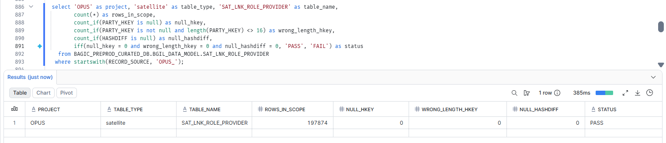

48. OPUS — SATELLITE SAT_LNK_ROLE_SURVEYOR [Partner LOB]
Project | OPUS
Satellite | SATELLITE SAT_LNK_ROLE_SURVEYOR [Partner LOB]
Status | Implemented
Pass criteria | status = PASS
Result (Pass / Fail / NA) | Pass
Rows with status = FAIL (count)
Remarks

Note: Satellite hash key and HASHDIFF populated and 16 bytes. HASHDIFF correctness itself is DM-H1 (a).
SQL query
select 'OPUS' as project, 'satellite' as table_type, 'SAT_LNK_ROLE_SURVEYOR' as table_name,
count(*) as rows_in_scope,
count_if(PARTY_HKEY is null) as null_hkey,
count_if(PARTY_HKEY is not null and length(PARTY_HKEY) <> 16) as wrong_length_hkey,
count_if(HASHDIFF is null) as null_hashdiff,
iff(null_hkey = 0 and wrong_length_hkey = 0 and null_hashdiff = 0, 'PASS', 'FAIL') as status
from BAGIC_PREPROD_CURATED_DB.BGIL_DATA_MODEL.SAT_LNK_ROLE_SURVEYOR
where startswith(RECORD_SOURCE, 'OPUS_');
Query output (attach / paste below)
Output:

49. OPUS — SATELLITE SAT_PARTY_AML_SCREENING [Partner LOB]
Project | OPUS
Satellite | SATELLITE SAT_PARTY_AML_SCREENING [Partner LOB]
Status | Implemented
Pass criteria | status = PASS
Result (Pass / Fail / NA) | Pass
Rows with status = FAIL (count)
Remarks

Note: Satellite hash key and HASHDIFF populated and 16 bytes. HASHDIFF correctness itself is DM-H1 (a).
SQL query
select 'OPUS' as project, 'satellite' as table_type, 'SAT_PARTY_AML_SCREENING' as table_name,
count(*) as rows_in_scope,
count_if(PARTY_HKEY is null) as null_hkey,
count_if(PARTY_HKEY is not null and length(PARTY_HKEY) <> 16) as wrong_length_hkey,
count_if(HASHDIFF is null) as null_hashdiff,
iff(null_hkey = 0 and wrong_length_hkey = 0 and null_hashdiff = 0, 'PASS', 'FAIL') as status
from BAGIC_PREPROD_CURATED_DB.BGIL_DATA_MODEL.SAT_PARTY_AML_SCREENING
where startswith(RECORD_SOURCE, 'OPUS_');
Query output (attach / paste below)
Output:
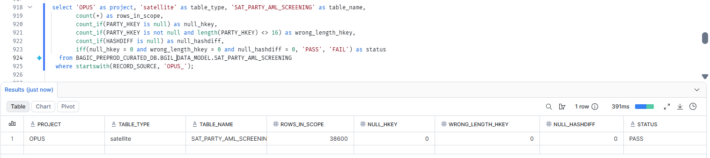

50. OPUS — SATELLITE SAT_PARTY_BANKING [Partner LOB]
Project | OPUS
Satellite | SATELLITE SAT_PARTY_BANKING [Partner LOB]
Status | Implemented
Pass criteria | status = PASS
Result (Pass / Fail / NA) | pass
Rows with status = FAIL (count)
Remarks

Note: Satellite hash key and HASHDIFF populated and 16 bytes. HASHDIFF correctness itself is DM-H1 (a).
SQL query
select 'OPUS' as project, 'satellite' as table_type, 'SAT_PARTY_BANKING' as table_name,
count(*) as rows_in_scope,
count_if(PARTY_HKEY is null) as null_hkey,
count_if(PARTY_HKEY is not null and length(PARTY_HKEY) <> 16) as wrong_length_hkey,
count_if(HASHDIFF is null) as null_hashdiff,
iff(null_hkey = 0 and wrong_length_hkey = 0 and null_hashdiff = 0, 'PASS', 'FAIL') as status
from BAGIC_PREPROD_CURATED_DB.BGIL_DATA_MODEL.SAT_PARTY_BANKING
where startswith(RECORD_SOURCE, 'OPUS_');
Query output (attach / paste below)
Output:
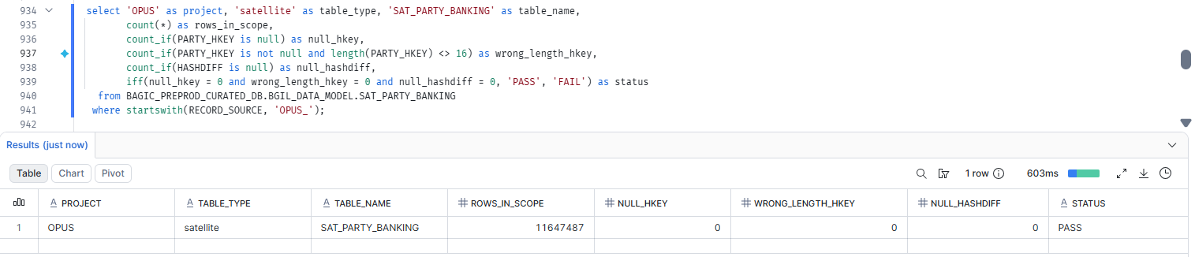

51. OPUS — SATELLITE SAT_PARTY_CLAIM_HISTORY
Project | OPUS
Satellite | SATELLITE SAT_PARTY_CLAIM_HISTORY
Status | Implemented
Pass criteria | status = PASS
Result (Pass / Fail / NA)
Rows with status = FAIL (count)
Remarks

Note: Satellite hash key and HASHDIFF populated and 16 bytes. HASHDIFF correctness itself is DM-H1 (a).
SQL query
select 'OPUS' as project, 'satellite' as table_type, 'SAT_PARTY_CLAIM_HISTORY' as table_name,
count(*) as rows_in_scope,
count_if(PARTY_HKEY is null) as null_hkey,
count_if(PARTY_HKEY is not null and length(PARTY_HKEY) <> 16) as wrong_length_hkey,
count_if(HASHDIFF is null) as null_hashdiff,
iff(null_hkey = 0 and wrong_length_hkey = 0 and null_hashdiff = 0, 'PASS', 'FAIL') as status
from BAGIC_PREPROD_CURATED_DB.BGIL_DATA_MODEL.SAT_PARTY_CLAIM_HISTORY
where startswith(RECORD_SOURCE, 'OPUS_');
Query output (attach / paste below)
Output:

52. OPUS — SATELLITE SAT_PARTY_CONTACT_ADDRESS_LINK [Partner LOB]
Project | OPUS
Satellite | SATELLITE SAT_PARTY_CONTACT_ADDRESS_LINK [Partner LOB]
Status | Implemented
Pass criteria | status = PASS
Result (Pass / Fail / NA) | Pass
Rows with status = FAIL (count)
Remarks

Note: Satellite hash key and HASHDIFF populated and 16 bytes. HASHDIFF correctness itself is DM-H1 (a).
SQL query
select 'OPUS' as project, 'satellite' as table_type, 'SAT_PARTY_CONTACT_ADDRESS_LINK' as table_name,
count(*) as rows_in_scope,
count_if(PARTY_LOCATION_HKEY is null) as null_hkey,
count_if(PARTY_LOCATION_HKEY is not null and length(PARTY_LOCATION_HKEY) <> 16) as wrong_length_hkey,
count_if(HASHDIFF is null) as null_hashdiff,
iff(null_hkey = 0 and wrong_length_hkey = 0 and null_hashdiff = 0, 'PASS', 'FAIL') as status
from BAGIC_PREPROD_CURATED_DB.BGIL_DATA_MODEL.SAT_PARTY_CONTACT_ADDRESS_LINK
where startswith(RECORD_SOURCE, 'OPUS_');
Query output (attach / paste below)
Output:
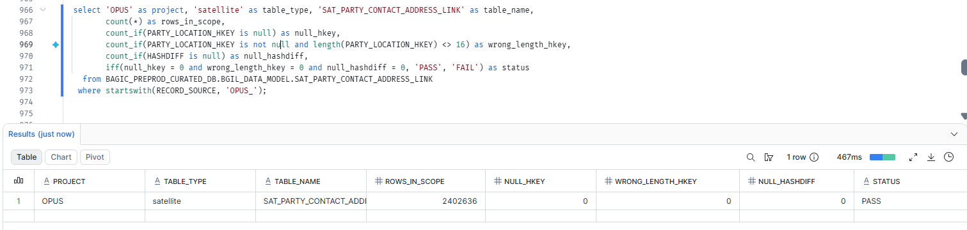

53. OPUS — SATELLITE SAT_PARTY_EMPLOYMENT [Partner LOB]
Project | OPUS
Satellite | SATELLITE SAT_PARTY_EMPLOYMENT [Partner LOB]
Status | Implemented
Pass criteria | status = PASS
Result (Pass / Fail / NA) | Pass
Rows with status = FAIL (count)
Remarks

Note: Satellite hash key and HASHDIFF populated and 16 bytes. HASHDIFF correctness itself is DM-H1 (a).
SQL query
select 'OPUS' as project, 'satellite' as table_type, 'SAT_PARTY_EMPLOYMENT' as table_name,
count(*) as rows_in_scope,
count_if(PARTY_HKEY is null) as null_hkey,
count_if(PARTY_HKEY is not null and length(PARTY_HKEY) <> 16) as wrong_length_hkey,
count_if(HASHDIFF is null) as null_hashdiff,
iff(null_hkey = 0 and wrong_length_hkey = 0 and null_hashdiff = 0, 'PASS', 'FAIL') as status
from BAGIC_PREPROD_CURATED_DB.BGIL_DATA_MODEL.SAT_PARTY_EMPLOYMENT
where startswith(RECORD_SOURCE, 'OPUS_');
Query output (attach / paste below)
Output:
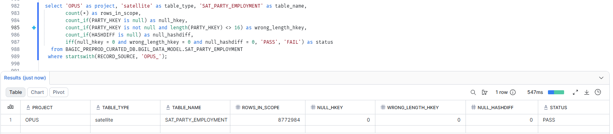

54. OPUS — SATELLITE SAT_PARTY_GROUP_CENSUS [Partner LOB]
Project | OPUS
Satellite | SATELLITE SAT_PARTY_GROUP_CENSUS [Partner LOB]
Status | Implemented
Pass criteria | status = PASS
Result (Pass / Fail / NA) | Pass
Rows with status = FAIL (count)
Remarks

Note: Satellite hash key and HASHDIFF populated and 16 bytes. HASHDIFF correctness itself is DM-H1 (a).
SQL query
select 'OPUS' as project, 'satellite' as table_type, 'SAT_PARTY_GROUP_CENSUS' as table_name,
count(*) as rows_in_scope,
count_if(PARTY_HKEY is null) as null_hkey,
count_if(PARTY_HKEY is not null and length(PARTY_HKEY) <> 16) as wrong_length_hkey,
count_if(HASHDIFF is null) as null_hashdiff,
iff(null_hkey = 0 and wrong_length_hkey = 0 and null_hashdiff = 0, 'PASS', 'FAIL') as status
from BAGIC_PREPROD_CURATED_DB.BGIL_DATA_MODEL.SAT_PARTY_GROUP_CENSUS
where startswith(RECORD_SOURCE, 'OPUS_');
Query output (attach / paste below)
Output:
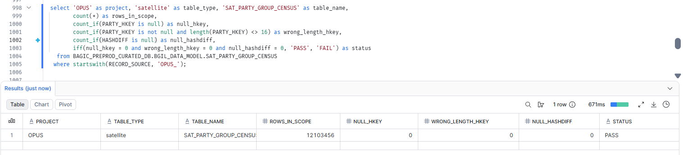

55. OPUS — SATELLITE SAT_PARTY_GROUP_HOUSEHOLD [Partner LOB]
Project | OPUS
Satellite | SATELLITE SAT_PARTY_GROUP_HOUSEHOLD [Partner LOB]
Status | Implemented
Pass criteria | status = PASS
Result (Pass / Fail / NA) | Pass
Rows with status = FAIL (count)
Remarks

Note: Satellite hash key and HASHDIFF populated and 16 bytes. HASHDIFF correctness itself is DM-H1 (a).
SQL query
select 'OPUS' as project, 'satellite' as table_type, 'SAT_PARTY_GROUP_HOUSEHOLD' as table_name,
count(*) as rows_in_scope,
count_if(PARTY_HKEY is null) as null_hkey,
count_if(PARTY_HKEY is not null and length(PARTY_HKEY) <> 16) as wrong_length_hkey,
count_if(HASHDIFF is null) as null_hashdiff,
iff(null_hkey = 0 and wrong_length_hkey = 0 and null_hashdiff = 0, 'PASS', 'FAIL') as status
from BAGIC_PREPROD_CURATED_DB.BGIL_DATA_MODEL.SAT_PARTY_GROUP_HOUSEHOLD
where startswith(RECORD_SOURCE, 'OPUS_');
Query output (attach / paste below)
Output:
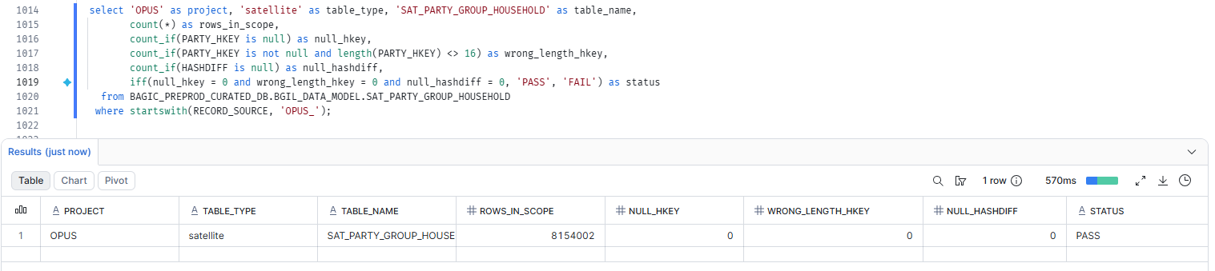

56. OPUS — SATELLITE SAT_PARTY_HEALTH_PROFILE [Partner LOB]
Project | OPUS
Satellite | SATELLITE SAT_PARTY_HEALTH_PROFILE [Partner LOB]
Status | Implemented
Pass criteria | status = PASS
Result (Pass / Fail / NA) | Pass
Rows with status = FAIL (count)
Remarks

Note: Satellite hash key and HASHDIFF populated and 16 bytes. HASHDIFF correctness itself is DM-H1 (a).
SQL query
select 'OPUS' as project, 'satellite' as table_type, 'SAT_PARTY_HEALTH_PROFILE' as table_name,
count(*) as rows_in_scope,
count_if(PARTY_HKEY is null) as null_hkey,
count_if(PARTY_HKEY is not null and length(PARTY_HKEY) <> 16) as wrong_length_hkey,
count_if(HASHDIFF is null) as null_hashdiff,
iff(null_hkey = 0 and wrong_length_hkey = 0 and null_hashdiff = 0, 'PASS', 'FAIL') as status
from BAGIC_PREPROD_CURATED_DB.BGIL_DATA_MODEL.SAT_PARTY_HEALTH_PROFILE
where startswith(RECORD_SOURCE, 'OPUS_');
Query output (attach / paste below)
Output:
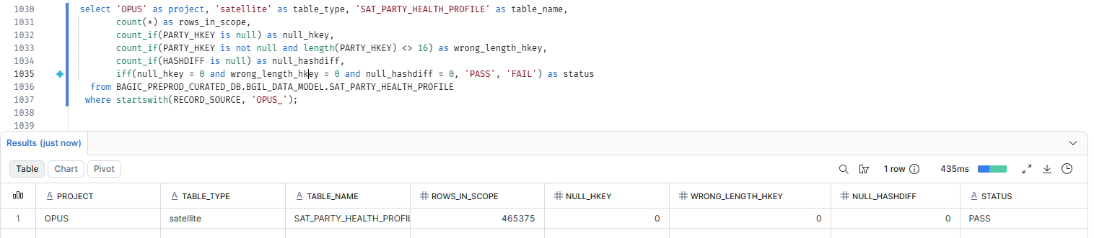

57. OPUS — SATELLITE SAT_PARTY_IDENTIFICATION [Partner LOB]
Project | OPUS
Satellite | SATELLITE SAT_PARTY_IDENTIFICATION [Partner LOB]
Status | Implemented
Pass criteria | status = PASS
Result (Pass / Fail / NA) | Pass
Rows with status = FAIL (count)
Remarks

Note: Satellite hash key and HASHDIFF populated and 16 bytes. HASHDIFF correctness itself is DM-H1 (a).
SQL query
select 'OPUS' as project, 'satellite' as table_type, 'SAT_PARTY_IDENTIFICATION' as table_name,
count(*) as rows_in_scope,
count_if(PARTY_HKEY is null) as null_hkey,
count_if(PARTY_HKEY is not null and length(PARTY_HKEY) <> 16) as wrong_length_hkey,
count_if(HASHDIFF is null) as null_hashdiff,
iff(null_hkey = 0 and wrong_length_hkey = 0 and null_hashdiff = 0, 'PASS', 'FAIL') as status
from BAGIC_PREPROD_CURATED_DB.BGIL_DATA_MODEL.SAT_PARTY_IDENTIFICATION
where RECORD_SOURCE = 'OPUS';
Query output (attach / paste below)
Output:
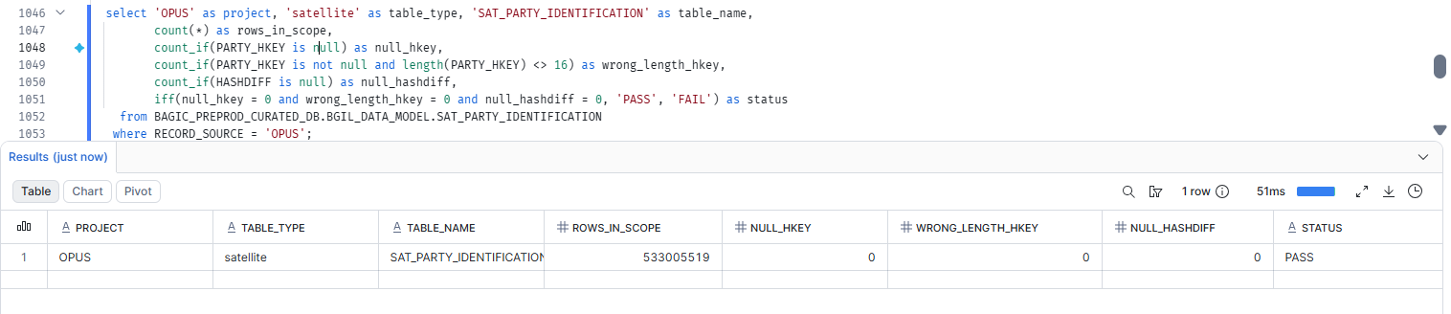

58. OPUS — SATELLITE SAT_PARTY_IDENTITY [Partner LOB]
Project | OPUS
Satellite | SATELLITE SAT_PARTY_IDENTITY [Partner LOB]
Status | Implemented
Pass criteria | status = PASS
Result (Pass / Fail / NA) | Pass
Rows with status = FAIL (count)
Remarks

Note: Satellite hash key and HASHDIFF populated and 16 bytes. HASHDIFF correctness itself is DM-H1 (a).
SQL query
select 'OPUS' as project, 'satellite' as table_type, 'SAT_PARTY_IDENTITY' as table_name,
count(*) as rows_in_scope,
count_if(PARTY_HKEY is null) as null_hkey,
count_if(PARTY_HKEY is not null and length(PARTY_HKEY) <> 16) as wrong_length_hkey,
count_if(HASHDIFF is null) as null_hashdiff,
iff(null_hkey = 0 and wrong_length_hkey = 0 and null_hashdiff = 0, 'PASS', 'FAIL') as status
from BAGIC_PREPROD_CURATED_DB.BGIL_DATA_MODEL.SAT_PARTY_IDENTITY
where startswith(RECORD_SOURCE, 'OPUS_');
Query output (attach / paste below)
Output:
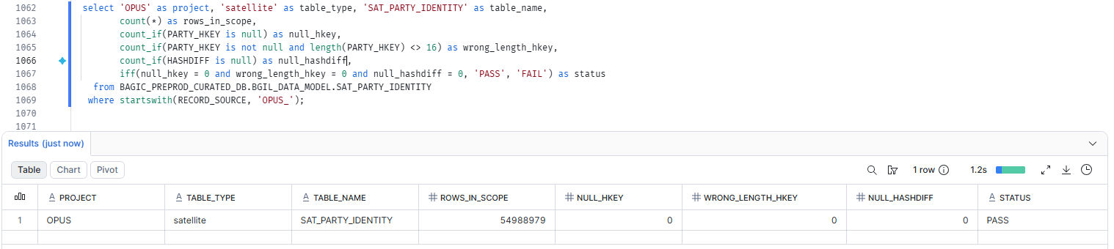

59. OPUS — SATELLITE SAT_PARTY_INDIVIDUAL_DEMOGRAPHICS [Partner LOB]
Project | OPUS
Satellite | SATELLITE SAT_PARTY_INDIVIDUAL_DEMOGRAPHICS [Partner LOB]
Status | Implemented
Pass criteria | status = PASS
Result (Pass / Fail / NA) | Pass
Rows with status = FAIL (count)
Remarks

Note: Satellite hash key and HASHDIFF populated and 16 bytes. HASHDIFF correctness itself is DM-H1 (a).
SQL query
select 'OPUS' as project, 'satellite' as table_type, 'SAT_PARTY_INDIVIDUAL_DEMOGRAPHICS' as table_name,
count(*) as rows_in_scope,
count_if(PARTY_HKEY is null) as null_hkey,
count_if(PARTY_HKEY is not null and length(PARTY_HKEY) <> 16) as wrong_length_hkey,
count_if(HASHDIFF is null) as null_hashdiff,
iff(null_hkey = 0 and wrong_length_hkey = 0 and null_hashdiff = 0, 'PASS', 'FAIL') as status
from BAGIC_PREPROD_CURATED_DB.BGIL_DATA_MODEL.SAT_PARTY_INDIVIDUAL_DEMOGRAPHICS
where startswith(RECORD_SOURCE, 'OPUS_');
Query output (attach / paste below)
Output:
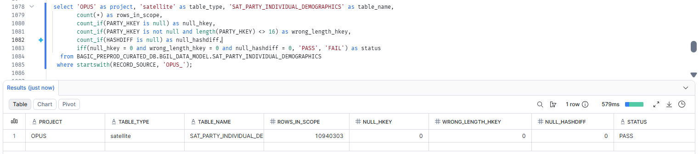

60. OPUS — SATELLITE SAT_PARTY_KYC [Partner LOB]
Project | OPUS
Satellite | SATELLITE SAT_PARTY_KYC [Partner LOB]
Status | Implemented
Pass criteria | status = PASS
Result (Pass / Fail / NA) | Pass
Rows with status = FAIL (count)
Remarks

Note: Satellite hash key and HASHDIFF populated and 16 bytes. HASHDIFF correctness itself is DM-H1 (a).
SQL query
select 'OPUS' as project, 'satellite' as table_type, 'SAT_PARTY_KYC' as table_name,
count(*) as rows_in_scope,
count_if(PARTY_HKEY is null) as null_hkey,
count_if(PARTY_HKEY is not null and length(PARTY_HKEY) <> 16) as wrong_length_hkey,
count_if(HASHDIFF is null) as null_hashdiff,
iff(null_hkey = 0 and wrong_length_hkey = 0 and null_hashdiff = 0, 'PASS', 'FAIL') as status
from BAGIC_PREPROD_CURATED_DB.BGIL_DATA_MODEL.SAT_PARTY_KYC
where startswith(RECORD_SOURCE, 'OPUS_');
Query output (attach / paste below)
Output:
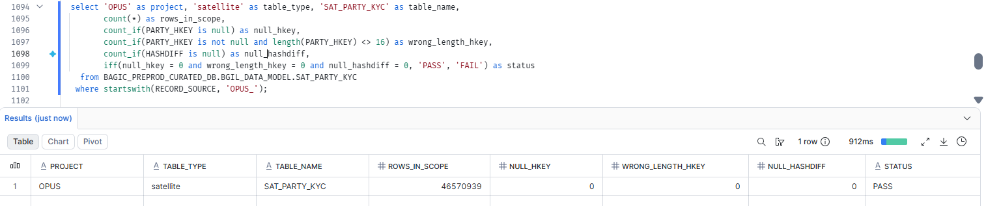

61. OPUS — SATELLITE SAT_PARTY_KYC_REFERENCE [Partner LOB]
Project | OPUS
Satellite | SATELLITE SAT_PARTY_KYC_REFERENCE [Partner LOB]
Status | Implemented
Pass criteria | status = PASS
Result (Pass / Fail / NA) | Pass
Rows with status = FAIL (count)
Remarks

Note: Satellite hash key and HASHDIFF populated and 16 bytes. HASHDIFF correctness itself is DM-H1 (a).
SQL query
select 'OPUS' as project, 'satellite' as table_type, 'SAT_PARTY_KYC_REFERENCE' as table_name,
count(*) as rows_in_scope,
count_if(PARTY_HKEY is null) as null_hkey,
count_if(PARTY_HKEY is not null and length(PARTY_HKEY) <> 16) as wrong_length_hkey,
count_if(HASHDIFF is null) as null_hashdiff,
iff(null_hkey = 0 and wrong_length_hkey = 0 and null_hashdiff = 0, 'PASS', 'FAIL') as status
from BAGIC_PREPROD_CURATED_DB.BGIL_DATA_MODEL.SAT_PARTY_KYC_REFERENCE
where startswith(RECORD_SOURCE, 'OPUS_');
Query output (attach / paste below)
Output:
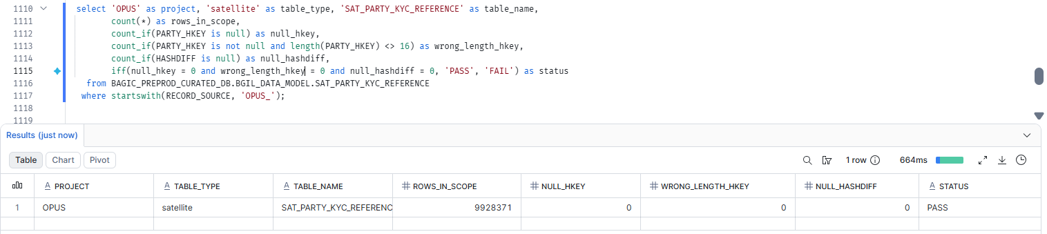

62. OPUS — SATELLITE SAT_PARTY_ORGANISATION_PROFILE [Partner LOB]
Project | OPUS
Satellite | SATELLITE SAT_PARTY_ORGANISATION_PROFILE [Partner LOB]
Status | Implemented
Pass criteria | status = PASS
Result (Pass / Fail / NA) | Pass
Rows with status = FAIL (count)
Remarks

Note: Satellite hash key and HASHDIFF populated and 16 bytes. HASHDIFF correctness itself is DM-H1 (a).
SQL query
select 'OPUS' as project, 'satellite' as table_type, 'SAT_PARTY_ORGANISATION_PROFILE' as table_name,
count(*) as rows_in_scope,
count_if(PARTY_HKEY is null) as null_hkey,
count_if(PARTY_HKEY is not null and length(PARTY_HKEY) <> 16) as wrong_length_hkey,
count_if(HASHDIFF is null) as null_hashdiff,
iff(null_hkey = 0 and wrong_length_hkey = 0 and null_hashdiff = 0, 'PASS', 'FAIL') as status
from BAGIC_PREPROD_CURATED_DB.BGIL_DATA_MODEL.SAT_PARTY_ORGANISATION_PROFILE
where startswith(RECORD_SOURCE, 'OPUS_');
Query output (attach / paste below)
Output:
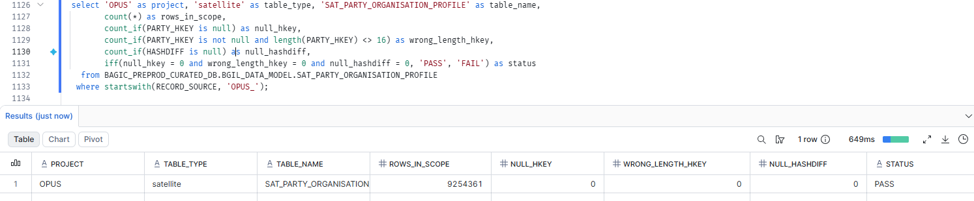

63. OPUS — SATELLITE SAT_PARTY_VEHICLE_PRIOR_INSURANCE
Project | OPUS
Satellite | SATELLITE SAT_PARTY_VEHICLE_PRIOR_INSURANCE
Status | Implemented
Pass criteria | status = PASS
Result (Pass / Fail / NA)
Rows with status = FAIL (count)
Remarks

Note: Satellite hash key and HASHDIFF populated and 16 bytes. HASHDIFF correctness itself is DM-H1 (a).
SQL query
select 'OPUS' as project, 'satellite' as table_type, 'SAT_PARTY_VEHICLE_PRIOR_INSURANCE' as table_name,
count(*) as rows_in_scope,
count_if(PARTY_HKEY is null) as null_hkey,
count_if(PARTY_HKEY is not null and length(PARTY_HKEY) <> 16) as wrong_length_hkey,
count_if(HASHDIFF is null) as null_hashdiff,
iff(null_hkey = 0 and wrong_length_hkey = 0 and null_hashdiff = 0, 'PASS', 'FAIL') as status
from BAGIC_PREPROD_CURATED_DB.BGIL_DATA_MODEL.SAT_PARTY_VEHICLE_PRIOR_INSURANCE
where startswith(RECORD_SOURCE, 'OPUS_');
Query output (attach / paste below)
Output:

64. OPUS — SATELLITE SAT_POLICY_BONUS_TRACKING
Project | OPUS
Satellite | SATELLITE SAT_POLICY_BONUS_TRACKING
Status | Implemented
Pass criteria | status = PASS
Result (Pass / Fail / NA)
Rows with status = FAIL (count)
Remarks

Note: Satellite hash key and HASHDIFF populated and 16 bytes. HASHDIFF correctness itself is DM-H1 (a).
SQL query
select 'OPUS' as project, 'satellite' as table_type, 'SAT_POLICY_BONUS_TRACKING' as table_name,
count(*) as rows_in_scope,
count_if(POLICY_HKEY is null) as null_hkey,
count_if(POLICY_HKEY is not null and length(POLICY_HKEY) <> 16) as wrong_length_hkey,
count_if(HASHDIFF is null) as null_hashdiff,
iff(null_hkey = 0 and wrong_length_hkey = 0 and null_hashdiff = 0, 'PASS', 'FAIL') as status
from BAGIC_PREPROD_CURATED_DB.BGIL_DATA_MODEL.SAT_POLICY_BONUS_TRACKING
where startswith(RECORD_SOURCE, 'OPUS_');
Query output (attach / paste below)
Output:

65. OPUS — SATELLITE SAT_POLICY_CERTIFICATE
Project | OPUS
Satellite | SATELLITE SAT_POLICY_CERTIFICATE
Status | Implemented
Pass criteria | status = PASS
Result (Pass / Fail / NA)
Rows with status = FAIL (count)
Remarks

Note: Satellite hash key and HASHDIFF populated and 16 bytes. HASHDIFF correctness itself is DM-H1 (a).
SQL query
select 'OPUS' as project, 'satellite' as table_type, 'SAT_POLICY_CERTIFICATE' as table_name,
count(*) as rows_in_scope,
count_if(POLICY_HKEY is null) as null_hkey,
count_if(POLICY_HKEY is not null and length(POLICY_HKEY) <> 16) as wrong_length_hkey,
count_if(HASHDIFF is null) as null_hashdiff,
iff(null_hkey = 0 and wrong_length_hkey = 0 and null_hashdiff = 0, 'PASS', 'FAIL') as status
from BAGIC_PREPROD_CURATED_DB.BGIL_DATA_MODEL.SAT_POLICY_CERTIFICATE
where startswith(RECORD_SOURCE, 'OPUS_');
Query output (attach / paste below)
Output:

66. OPUS — SATELLITE SAT_POLICY_CLASSIFICATION [Partner LOB]
Project | OPUS
Satellite | SATELLITE SAT_POLICY_CLASSIFICATION [Partner LOB]
Status | Implemented
Pass criteria | status = PASS
Result (Pass / Fail / NA) | Fail(Due to Mapping)
Rows with status = FAIL (count)
Remarks | SAT_POLICY_CLASSIFICATION returns 0 rows — empty by construction, not a load defect. All 4 stg2 feeds (KYC_DETAILS, KYC_INCOMING, KYC_POA_DOCUMENT, KYC_POI_DOCUMENT) anchor HUB_POLICY via case when field_type like 'POLICY%', but these KYC sources only carry field_type values PROPOSAL_NUMBER / PARTNER_ID / EZEETAB_REF_ID — zero POLICY matches — so POLICY_HKEY is NULL on every row and all rows drop on src_pk IS NOT NULL. Payload (CLASSIFICATIONVALUE ← business_type) is populated; only the policy anchor key is unresolvable. Needs a mapper decision: re-anchor on PROPOSAL_NUMBER or drop from OPUS scope.

Note: Satellite hash key and HASHDIFF populated and 16 bytes. HASHDIFF correctness itself is DM-H1 (a).
SQL query
select 'OPUS' as project, 'satellite' as table_type, 'SAT_POLICY_CLASSIFICATION' as table_name,
count(*) as rows_in_scope,
count_if(POLICY_HKEY is null) as null_hkey,
count_if(POLICY_HKEY is not null and length(POLICY_HKEY) <> 16) as wrong_length_hkey,
count_if(HASHDIFF is null) as null_hashdiff,
iff(null_hkey = 0 and wrong_length_hkey = 0 and null_hashdiff = 0, 'PASS', 'FAIL') as status
from BAGIC_PREPROD_CURATED_DB.BGIL_DATA_MODEL.SAT_POLICY_CLASSIFICATION
where startswith(RECORD_SOURCE, 'OPUS_');
Query output (attach / paste below)
Output:
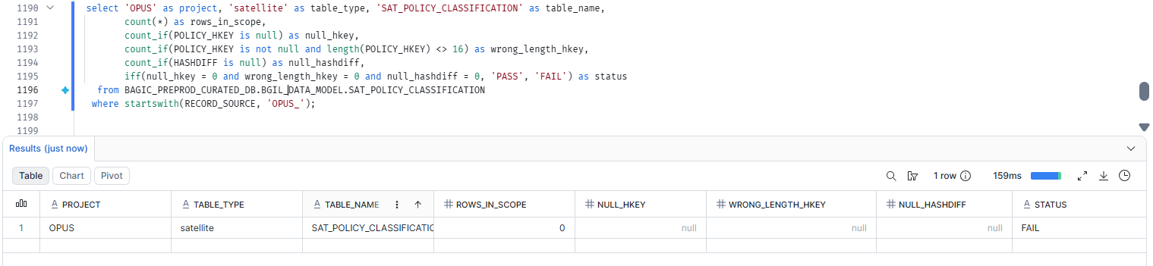

67. OPUS — SATELLITE SAT_POLICY_COVERAGE_SCHEDULE
Project | OPUS
Satellite | SATELLITE SAT_POLICY_COVERAGE_SCHEDULE
Status | Implemented
Pass criteria | status = PASS
Result (Pass / Fail / NA)
Rows with status = FAIL (count)
Remarks

Note: Satellite hash key and HASHDIFF populated and 16 bytes. HASHDIFF correctness itself is DM-H1 (a).
SQL query
select 'OPUS' as project, 'satellite' as table_type, 'SAT_POLICY_COVERAGE_SCHEDULE' as table_name,
count(*) as rows_in_scope,
count_if(POLICY_HKEY is null) as null_hkey,
count_if(POLICY_HKEY is not null and length(POLICY_HKEY) <> 16) as wrong_length_hkey,
count_if(HASHDIFF is null) as null_hashdiff,
iff(null_hkey = 0 and wrong_length_hkey = 0 and null_hashdiff = 0, 'PASS', 'FAIL') as status
from BAGIC_PREPROD_CURATED_DB.BGIL_DATA_MODEL.SAT_POLICY_COVERAGE_SCHEDULE
where startswith(RECORD_SOURCE, 'OPUS_');
Query output (attach / paste below)
Output:

68. OPUS — SATELLITE SAT_POLICY_ENDORSEMENT
Project | OPUS
Satellite | SATELLITE SAT_POLICY_ENDORSEMENT
Status | Implemented
Pass criteria | status = PASS
Result (Pass / Fail / NA)
Rows with status = FAIL (count)
Remarks

Note: Satellite hash key and HASHDIFF populated and 16 bytes. HASHDIFF correctness itself is DM-H1 (a).
SQL query
select 'OPUS' as project, 'satellite' as table_type, 'SAT_POLICY_ENDORSEMENT' as table_name,
count(*) as rows_in_scope,
count_if(POLICY_HKEY is null) as null_hkey,
count_if(POLICY_HKEY is not null and length(POLICY_HKEY) <> 16) as wrong_length_hkey,
count_if(HASHDIFF is null) as null_hashdiff,
iff(null_hkey = 0 and wrong_length_hkey = 0 and null_hashdiff = 0, 'PASS', 'FAIL') as status
from BAGIC_PREPROD_CURATED_DB.BGIL_DATA_MODEL.SAT_POLICY_ENDORSEMENT
where startswith(RECORD_SOURCE, 'OPUS_');
Query output (attach / paste below)
Output:

69. OPUS — SATELLITE SAT_POLICY_HEADER [Partner LOB]
Project | OPUS
Satellite | SATELLITE SAT_POLICY_HEADER [Partner LOB]
Status | Implemented
Pass criteria | status = PASS
Result (Pass / Fail / NA) | Pass
Rows with status = FAIL (count)
Remarks

Note: Satellite hash key and HASHDIFF populated and 16 bytes. HASHDIFF correctness itself is DM-H1 (a).
SQL query
select 'OPUS' as project, 'satellite' as table_type, 'SAT_POLICY_HEADER' as table_name,
count(*) as rows_in_scope,
count_if(POLICY_HKEY is null) as null_hkey,
count_if(POLICY_HKEY is not null and length(POLICY_HKEY) <> 16) as wrong_length_hkey,
count_if(HASHDIFF is null) as null_hashdiff,
iff(null_hkey = 0 and wrong_length_hkey = 0 and null_hashdiff = 0, 'PASS', 'FAIL') as status
from BAGIC_PREPROD_CURATED_DB.BGIL_DATA_MODEL.SAT_POLICY_HEADER
where startswith(RECORD_SOURCE, 'OPUS_');
Query output (attach / paste below)
Output:
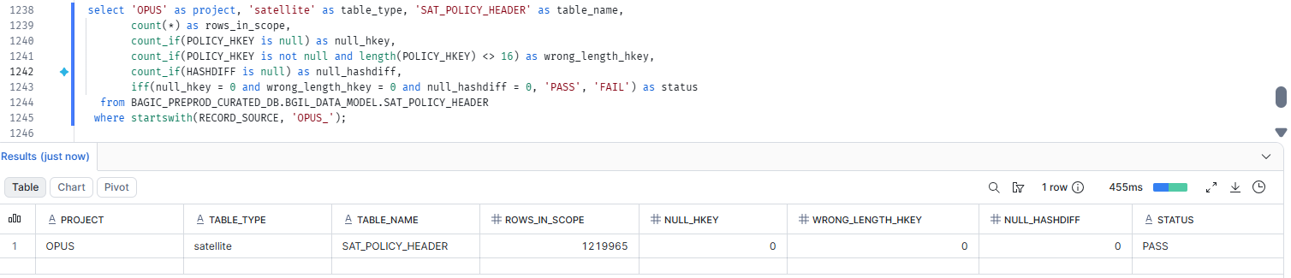

70. OPUS — SATELLITE SAT_POLICY_PREMIUM_HEAD
Project | OPUS
Satellite | SATELLITE SAT_POLICY_PREMIUM_HEAD
Status | Implemented
Pass criteria | status = PASS
Result (Pass / Fail / NA)
Rows with status = FAIL (count)
Remarks

Note: Satellite hash key and HASHDIFF populated and 16 bytes. HASHDIFF correctness itself is DM-H1 (a).
SQL query
select 'OPUS' as project, 'satellite' as table_type, 'SAT_POLICY_PREMIUM_HEAD' as table_name,
count(*) as rows_in_scope,
count_if(POLICY_HKEY is null) as null_hkey,
count_if(POLICY_HKEY is not null and length(POLICY_HKEY) <> 16) as wrong_length_hkey,
count_if(HASHDIFF is null) as null_hashdiff,
iff(null_hkey = 0 and wrong_length_hkey = 0 and null_hashdiff = 0, 'PASS', 'FAIL') as status
from BAGIC_PREPROD_CURATED_DB.BGIL_DATA_MODEL.SAT_POLICY_PREMIUM_HEAD
where startswith(RECORD_SOURCE, 'OPUS_');
Query output (attach / paste below)
Output:

71. OPUS — SATELLITE SAT_POLICY_PREMIUM_SUMMARY [Partner LOB]
Project | OPUS
Satellite | SATELLITE SAT_POLICY_PREMIUM_SUMMARY [Partner LOB]
Status | Implemented
Pass criteria | status = PASS
Result (Pass / Fail / NA) | Fail
Rows with status = FAIL (count) | Fail(Due to Mapping)
Remarks | Same field_type like 'POLICY%' anchor on KYC_INCOMING/OCR → key null. Plus payload GROSSPREMIUM ← premium_amount, which doesn't exist in source (hardcoded NULL)

Note: Satellite hash key and HASHDIFF populated and 16 bytes. HASHDIFF correctness itself is DM-H1 (a).
SQL query
select 'OPUS' as project, 'satellite' as table_type, 'SAT_POLICY_PREMIUM_SUMMARY' as table_name,
count(*) as rows_in_scope,
count_if(POLICY_HKEY is null) as null_hkey,
count_if(POLICY_HKEY is not null and length(POLICY_HKEY) <> 16) as wrong_length_hkey,
count_if(HASHDIFF is null) as null_hashdiff,
iff(null_hkey = 0 and wrong_length_hkey = 0 and null_hashdiff = 0, 'PASS', 'FAIL') as status
from BAGIC_PREPROD_CURATED_DB.BGIL_DATA_MODEL.SAT_POLICY_PREMIUM_SUMMARY
where startswith(RECORD_SOURCE, 'OPUS_');
Query output (attach / paste below)
Output:
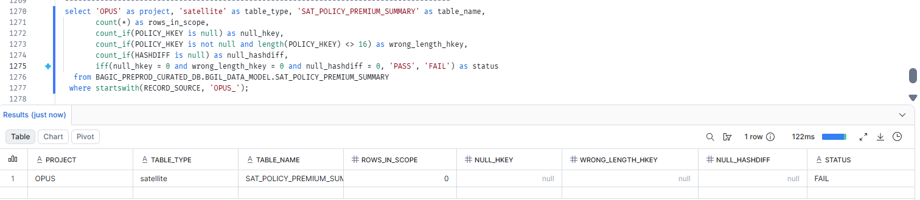

72. OPUS — SATELLITE SAT_PRODUCT_DEFINITION
Project | OPUS
Satellite | SATELLITE SAT_PRODUCT_DEFINITION
Status | Implemented
Pass criteria | status = PASS
Result (Pass / Fail / NA)
Rows with status = FAIL (count)
Remarks

Note: Satellite hash key and HASHDIFF populated and 16 bytes. HASHDIFF correctness itself is DM-H1 (a).
SQL query
select 'OPUS' as project, 'satellite' as table_type, 'SAT_PRODUCT_DEFINITION' as table_name,
count(*) as rows_in_scope,
count_if(PRODUCT_HKEY is null) as null_hkey,
count_if(PRODUCT_HKEY is not null and length(PRODUCT_HKEY) <> 16) as wrong_length_hkey,
count_if(HASHDIFF is null) as null_hashdiff,
iff(null_hkey = 0 and wrong_length_hkey = 0 and null_hashdiff = 0, 'PASS', 'FAIL') as status
from BAGIC_PREPROD_CURATED_DB.BGIL_DATA_MODEL.SAT_PRODUCT_DEFINITION
where startswith(RECORD_SOURCE, 'OPUS_');
Query output (attach / paste below)
Output:

73. OPUS — SATELLITE SAT_PROVIDER_BANKING [Partner LOB]
Project | OPUS
Satellite | SATELLITE SAT_PROVIDER_BANKING [Partner LOB]
Status | Implemented
Pass criteria | status = PASS
Result (Pass / Fail / NA) | Pass
Rows with status = FAIL (count)
Remarks

Note: Satellite hash key and HASHDIFF populated and 16 bytes. HASHDIFF correctness itself is DM-H1 (a).
SQL query
select 'OPUS' as project, 'satellite' as table_type, 'SAT_PROVIDER_BANKING' as table_name,
count(*) as rows_in_scope,
count_if(PARTY_HKEY is null) as null_hkey,
count_if(PARTY_HKEY is not null and length(PARTY_HKEY) <> 16) as wrong_length_hkey,
count_if(HASHDIFF is null) as null_hashdiff,
iff(null_hkey = 0 and wrong_length_hkey = 0 and null_hashdiff = 0, 'PASS', 'FAIL') as status
from BAGIC_PREPROD_CURATED_DB.BGIL_DATA_MODEL.SAT_PROVIDER_BANKING
where startswith(RECORD_SOURCE, 'OPUS_');
Query output (attach / paste below)
Output:
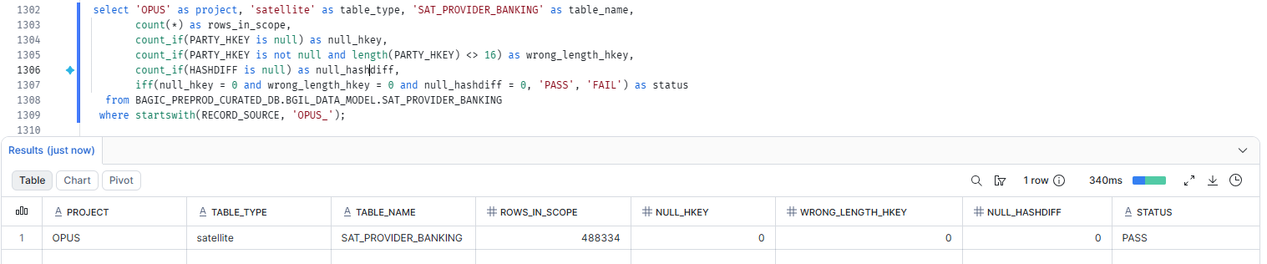

74. OPUS — SATELLITE SAT_PROVIDER_TARIFF [Partner LOB]
Project | OPUS
Satellite | SATELLITE SAT_PROVIDER_TARIFF [Partner LOB]
Status | Implemented
Pass criteria | status = PASS
Result (Pass / Fail / NA) | Pass
Rows with status = FAIL (count)
Remarks

Note: Satellite hash key and HASHDIFF populated and 16 bytes. HASHDIFF correctness itself is DM-H1 (a).
SQL query
select 'OPUS' as project, 'satellite' as table_type, 'SAT_PROVIDER_TARIFF' as table_name,
count(*) as rows_in_scope,
count_if(PARTY_HKEY is null) as null_hkey,
count_if(PARTY_HKEY is not null and length(PARTY_HKEY) <> 16) as wrong_length_hkey,
count_if(HASHDIFF is null) as null_hashdiff,
iff(null_hkey = 0 and wrong_length_hkey = 0 and null_hashdiff = 0, 'PASS', 'FAIL') as status
from BAGIC_PREPROD_CURATED_DB.BGIL_DATA_MODEL.SAT_PROVIDER_TARIFF
where startswith(RECORD_SOURCE, 'OPUS_');
Query output (attach / paste below)
Output:
