DM-K4 | Key Checks — Business Key Uniqueness
Hub grain integrity: no duplicate business keys within a hub. Pass criterion: 0 rows returned (hub row count = distinct business keys).

Check Overview
Check ID | DM-K4
Category | Key checks
Sign-off criterion | Business key uniqueness
Method | Group hub by hash key; any hash key with count(*) > 1 is a grain violation
Pass criteria / tolerance | Hub row count = distinct business keys (0 duplicate rows)
Owner | LUMIQ
Vault location | BAGIC_PREPROD_CURATED_DB.BGIL_DATA_MODEL
Scope | Runs on the hub tables only. Hubs are shared between projects; each hub is checked once.
Interpreting a hit | row_count > 1 & distinct_bk = 1 = duplicate load; distinct_bk > 1 = hash collision

Revision notes
• Regenerated 2026-10-09 from the current opus_partner_dv_dbt and maximus_partner_dv_dbt models; previous results (rows, screenshots, Pass/Fail) are cleared and must be re-run.
• Scope: 10 MAXIMUS hubs + 11 OPUS hubs = 21 project-hub sections (14 physical hub tables).
• OPUS new hubs: HUB_DOCUMENT (3 KYC branches) and HUB_ORG_UNIT (10 KYC branches).
• OPUS HUB_PARTY: CP_PARTNERS plus 17 KYC key branches (PAN:/GSTIN:/LICENCE:/PASSPORT:/VOTER:/CKYC:/CATEGORY:INPUT key forms).
• OPUS HUB_POLICY (27 RAW branches incl. KYC POLICY% field_value and the stitch_policy_header / stitch_policy_bonus_tracking keys), HUB_LOCATION (19 branches incl. stitch_common_address and the KYC composite address keys) and HUB_PRODUCT (stitch_product_definition) are now fully implemented -- no TODO branches remain.
• MAXIMUS: RAW table ..._SIMPLE_PROPERTY_PIVOT_VW (no _2_1 suffix) after the RECORD_SOURCE fix; HUB_PARTY hubfeed branches resolve to 7 RAW keys; HUB_FINANCIAL_ACCOUNT remains NA (account_code not mapped).
• Hash reproduced exactly as automate_dv 0.11.5 does: MD5_BINARY(NULLIF(UPPER(TRIM(CAST(<NK> AS VARCHAR))), '')).
• Excluded (loads nothing): disabled placeholder stg2_hub_bjaz_t_kyc_details__party__kyc_subject; MAXIMUS branch_code (ORG_UNIT) and account_code (FINANCIAL_ACCOUNT) are cast(null) in staging.

Results summary
# | Project | Hub | Status | Result | Rows / diff
1 | SHARED | HUB_PARTY | Implemented
2 | SHARED | HUB_STAKE_CODE | Implemented
3 | SHARED | HUB_LOCATION | Implemented
4 | SHARED | HUB_PAYMENT_INSTRUMENT | Implemented
5 | SHARED | HUB_PRODUCT | Implemented
6 | SHARED | HUB_FINANCIAL_ACCOUNT | Implemented
7 | SHARED | HUB_DOCUMENT | Implemented
8 | SHARED | HUB_POLICY | Implemented
9 | SHARED | HUB_DISTRIBUTION_CHANNEL | Implemented
10 | SHARED | HUB_ORG_UNIT | Implemented
11 | SHARED | HUB_AGENT | Implemented
12 | SHARED | HUB_AGREEMENT | Implemented
13 | SHARED | HUB_CLAIM | Implemented
14 | SHARED | HUB_RISK_OBJECT | Implemented
15 | SHARED | Same business key under more than one hash key | Informational

Validation Queries

1. SHARED — HUB_PARTY
Project | SHARED
Hub table | HUB_PARTY
Status | Implemented
Pass criteria | 0 rows returned
Result (Pass / Fail / NA) | Pass
Rows returned (count) | 0
Remarks

Note: (hash key PARTY_HKEY, business key PARENT_BK). Loaded by: MAXIMUS, OPUS.
SQL query
select 'HUB_PARTY' as hub, PARTY_HKEY as hash_key,
count(*) as row_count, count(distinct PARENT_BK) as distinct_bk,
min(PARENT_BK) as sample_bk, listagg(distinct RECORD_SOURCE, ', ') as record_sources
from BAGIC_PREPROD_CURATED_DB.BGIL_DATA_MODEL.HUB_PARTY
group by PARTY_HKEY
having count(*) > 1
order by row_count desc;
Query output (attach / paste below)
Output:
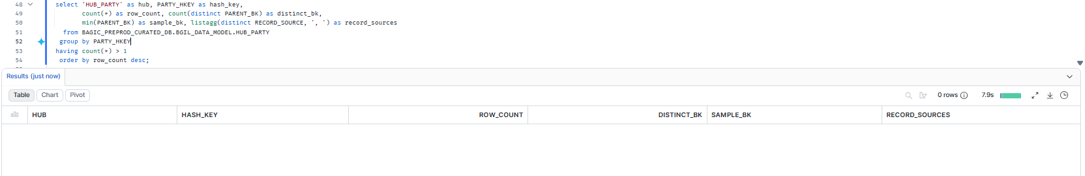

2. SHARED — HUB_STAKE_CODE
Project | SHARED
Hub table | HUB_STAKE_CODE
Status | Implemented
Pass criteria | 0 rows returned
Result (Pass / Fail / NA) | Pass
Rows returned (count) | 0
Remarks

Note: (hash key STAKE_CODE_HKEY, business key STAKE_CODE_BK). Loaded by: MAXIMUS.
SQL query
select 'HUB_STAKE_CODE' as hub, STAKE_CODE_HKEY as hash_key,
count(*) as row_count, count(distinct STAKE_CODE_BK) as distinct_bk,
min(STAKE_CODE_BK) as sample_bk, listagg(distinct RECORD_SOURCE, ', ') as record_sources
from BAGIC_PREPROD_CURATED_DB.BGIL_DATA_MODEL.HUB_STAKE_CODE
group by STAKE_CODE_HKEY
having count(*) > 1
order by row_count desc;
Query output (attach / paste below)
Output:
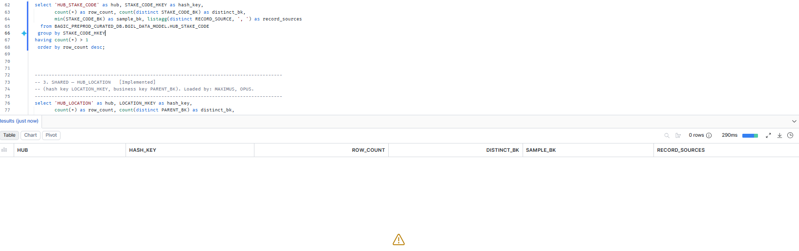

3. SHARED — HUB_LOCATION
Project | SHARED
Hub table | HUB_LOCATION
Status | Implemented
Pass criteria | 0 rows returned
Result (Pass / Fail / NA) | Pass
Rows returned (count) | 0
Remarks

Note: (hash key LOCATION_HKEY, business key PARENT_BK). Loaded by: MAXIMUS, OPUS.
SQL query
select 'HUB_LOCATION' as hub, LOCATION_HKEY as hash_key,
count(*) as row_count, count(distinct PARENT_BK) as distinct_bk,
min(PARENT_BK) as sample_bk, listagg(distinct RECORD_SOURCE, ', ') as record_sources
from BAGIC_PREPROD_CURATED_DB.BGIL_DATA_MODEL.HUB_LOCATION
group by LOCATION_HKEY
having count(*) > 1
order by row_count desc;
Query output (attach / paste below)
Output:
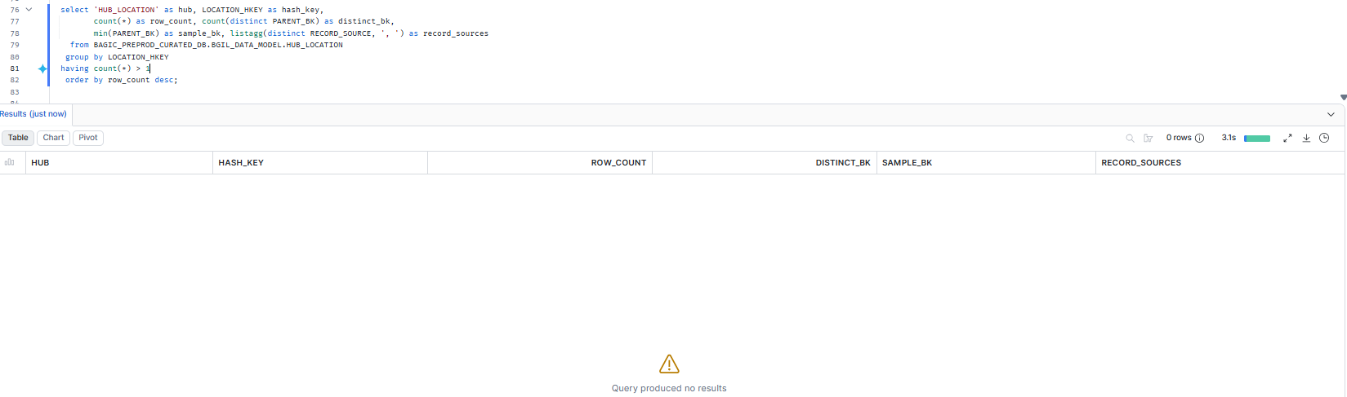

4. SHARED — HUB_PAYMENT_INSTRUMENT
Project | SHARED
Hub table | HUB_PAYMENT_INSTRUMENT
Status | Implemented
Pass criteria | 0 rows returned
Result (Pass / Fail / NA) | Pass
Rows returned (count) | 0
Remarks

Note: (hash key PAYMENT_INSTRUMENT_HKEY, business key PARENT_BK). Loaded by: MAXIMUS.
SQL query
select 'HUB_PAYMENT_INSTRUMENT' as hub, PAYMENT_INSTRUMENT_HKEY as hash_key,
count(*) as row_count, count(distinct PARENT_BK) as distinct_bk,
min(PARENT_BK) as sample_bk, listagg(distinct RECORD_SOURCE, ', ') as record_sources
from BAGIC_PREPROD_CURATED_DB.BGIL_DATA_MODEL.HUB_PAYMENT_INSTRUMENT
group by PAYMENT_INSTRUMENT_HKEY
having count(*) > 1
order by row_count desc;
Query output (attach / paste below)
Output:
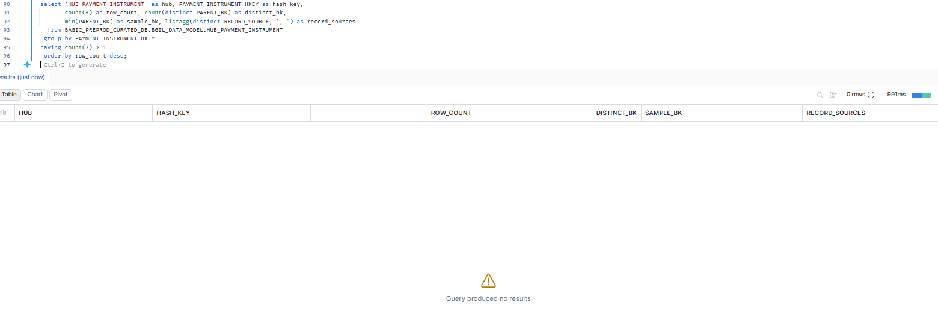

5. SHARED — HUB_PRODUCT
Project | SHARED
Hub table | HUB_PRODUCT
Status | Implemented
Pass criteria | 0 rows returned
Result (Pass / Fail / NA) | Pass
Rows returned (count) | 0
Remarks

Note: (hash key PRODUCT_HKEY, business key PARENT_BK). Loaded by: MAXIMUS, OPUS.
SQL query
select 'HUB_PRODUCT' as hub, PRODUCT_HKEY as hash_key,
count(*) as row_count, count(distinct PARENT_BK) as distinct_bk,
min(PARENT_BK) as sample_bk, listagg(distinct RECORD_SOURCE, ', ') as record_sources
from BAGIC_PREPROD_CURATED_DB.BGIL_DATA_MODEL.HUB_PRODUCT
group by PRODUCT_HKEY
having count(*) > 1
order by row_count desc;
Query output (attach / paste below)
Output:
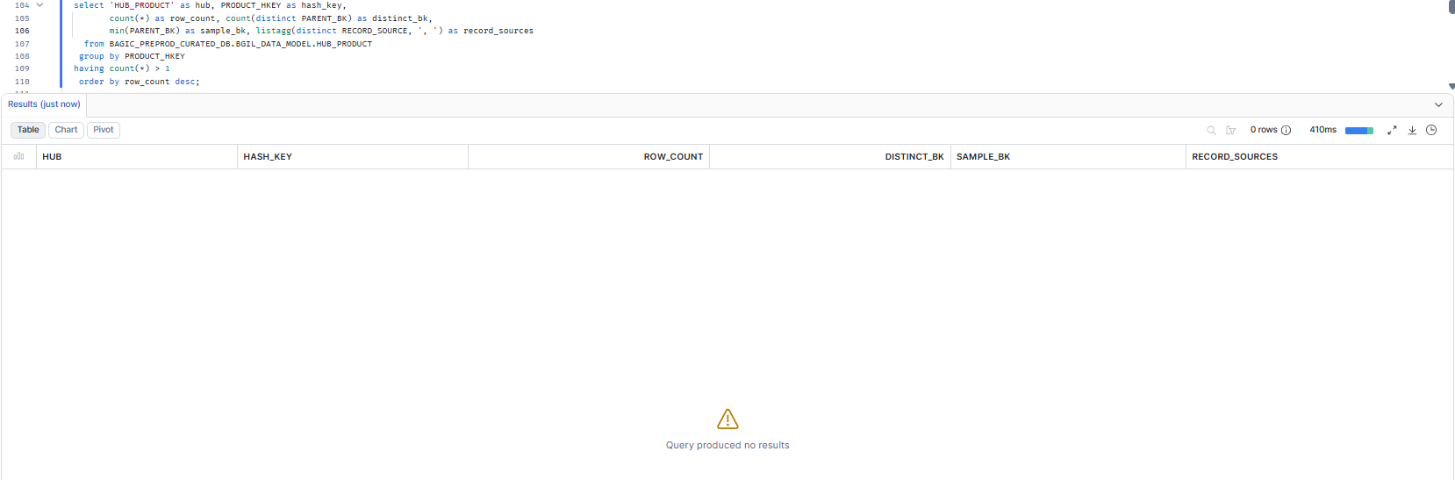

6. SHARED — HUB_FINANCIAL_ACCOUNT
Project | SHARED
Hub table | HUB_FINANCIAL_ACCOUNT
Status | Implemented
Pass criteria | 0 rows returned
Result (Pass / Fail / NA) | Pass
Rows returned (count) | 0
Remarks

Note: (hash key FINANCIAL_ACCOUNT_HKEY, business key PARENT_BK). Loaded by: MAXIMUS.
SQL query
select 'HUB_FINANCIAL_ACCOUNT' as hub, FINANCIAL_ACCOUNT_HKEY as hash_key,
count(*) as row_count, count(distinct PARENT_BK) as distinct_bk,
min(PARENT_BK) as sample_bk, listagg(distinct RECORD_SOURCE, ', ') as record_sources
from BAGIC_PREPROD_CURATED_DB.BGIL_DATA_MODEL.HUB_FINANCIAL_ACCOUNT
group by FINANCIAL_ACCOUNT_HKEY
having count(*) > 1
order by row_count desc;
Query output (attach / paste below)
Output:
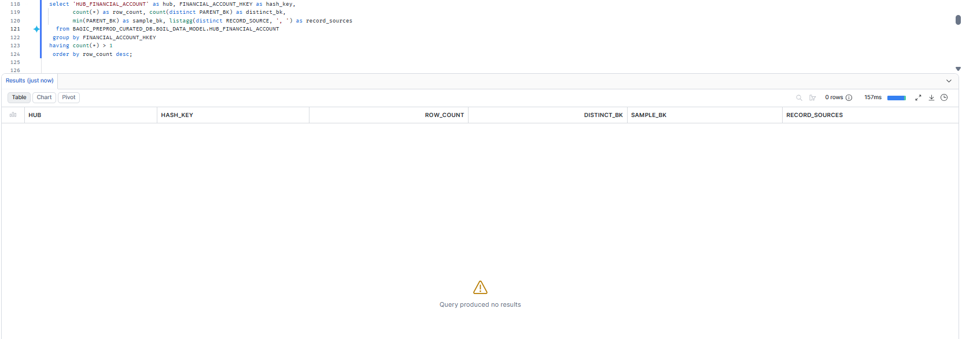

7. SHARED — HUB_DOCUMENT
Project | SHARED
Hub table | HUB_DOCUMENT
Status | Implemented
Pass criteria | 0 rows returned
Result (Pass / Fail / NA) | Pass
Rows returned (count) | 0
Remarks

Note: (hash key DOCUMENT_HKEY, business key PARENT_BK). Loaded by: MAXIMUS, OPUS.
SQL query
select 'HUB_DOCUMENT' as hub, DOCUMENT_HKEY as hash_key,
count(*) as row_count, count(distinct PARENT_BK) as distinct_bk,
min(PARENT_BK) as sample_bk, listagg(distinct RECORD_SOURCE, ', ') as record_sources
from BAGIC_PREPROD_CURATED_DB.BGIL_DATA_MODEL.HUB_DOCUMENT
group by DOCUMENT_HKEY
having count(*) > 1
order by row_count desc;
Query output (attach / paste below)
Output:
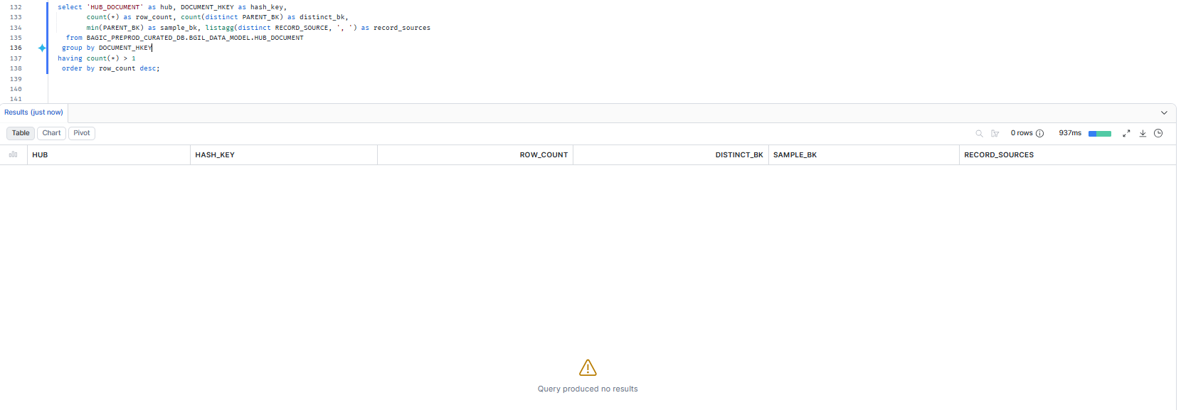

8. SHARED — HUB_POLICY
Project | SHARED
Hub table | HUB_POLICY
Status | Implemented
Pass criteria | 0 rows returned
Result (Pass / Fail / NA) | Pass
Rows returned (count) | 0
Remarks

Note: (hash key POLICY_HKEY, business key PARENT_BK). Loaded by: MAXIMUS, OPUS.
SQL query
select 'HUB_POLICY' as hub, POLICY_HKEY as hash_key,
count(*) as row_count, count(distinct PARENT_BK) as distinct_bk,
min(PARENT_BK) as sample_bk, listagg(distinct RECORD_SOURCE, ', ') as record_sources
from BAGIC_PREPROD_CURATED_DB.BGIL_DATA_MODEL.HUB_POLICY
group by POLICY_HKEY
having count(*) > 1
order by row_count desc;
Query output (attach / paste below)
Output:
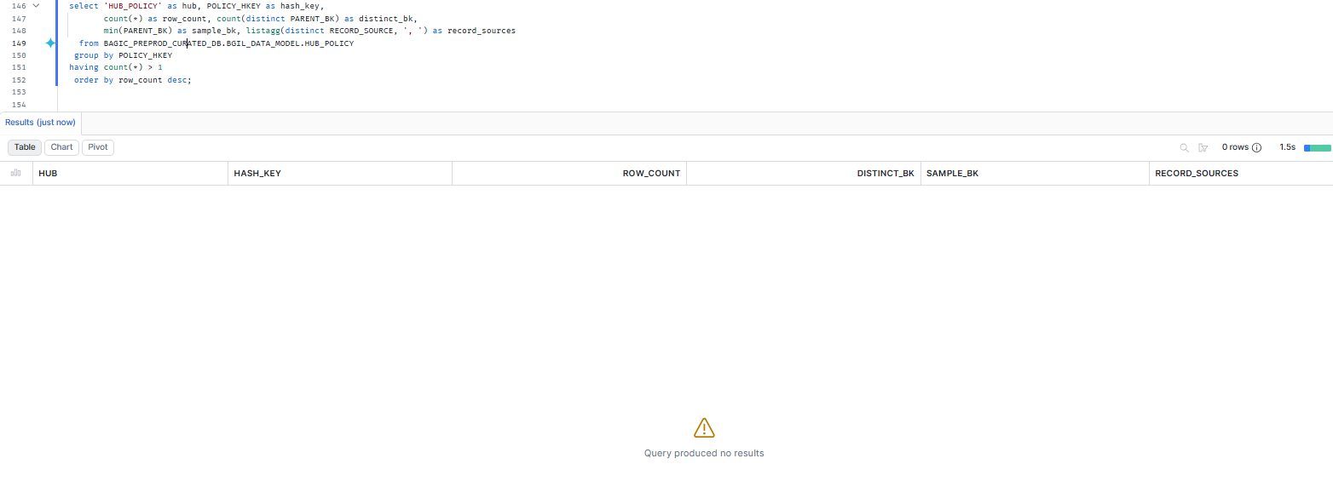

9. SHARED — HUB_DISTRIBUTION_CHANNEL
Project | SHARED
Hub table | HUB_DISTRIBUTION_CHANNEL
Status | Implemented
Pass criteria | 0 rows returned
Result (Pass / Fail / NA) | Pass
Rows returned (count) | 0
Remarks

Note: (hash key DISTRIBUTION_CHANNEL_HKEY, business key PARENT_BK). Loaded by: MAXIMUS, OPUS.
SQL query
select 'HUB_DISTRIBUTION_CHANNEL' as hub, DISTRIBUTION_CHANNEL_HKEY as hash_key,
count(*) as row_count, count(distinct PARENT_BK) as distinct_bk,
min(PARENT_BK) as sample_bk, listagg(distinct RECORD_SOURCE, ', ') as record_sources
from BAGIC_PREPROD_CURATED_DB.BGIL_DATA_MODEL.HUB_DISTRIBUTION_CHANNEL
group by DISTRIBUTION_CHANNEL_HKEY
having count(*) > 1
order by row_count desc;
Query output (attach / paste below)
Output:
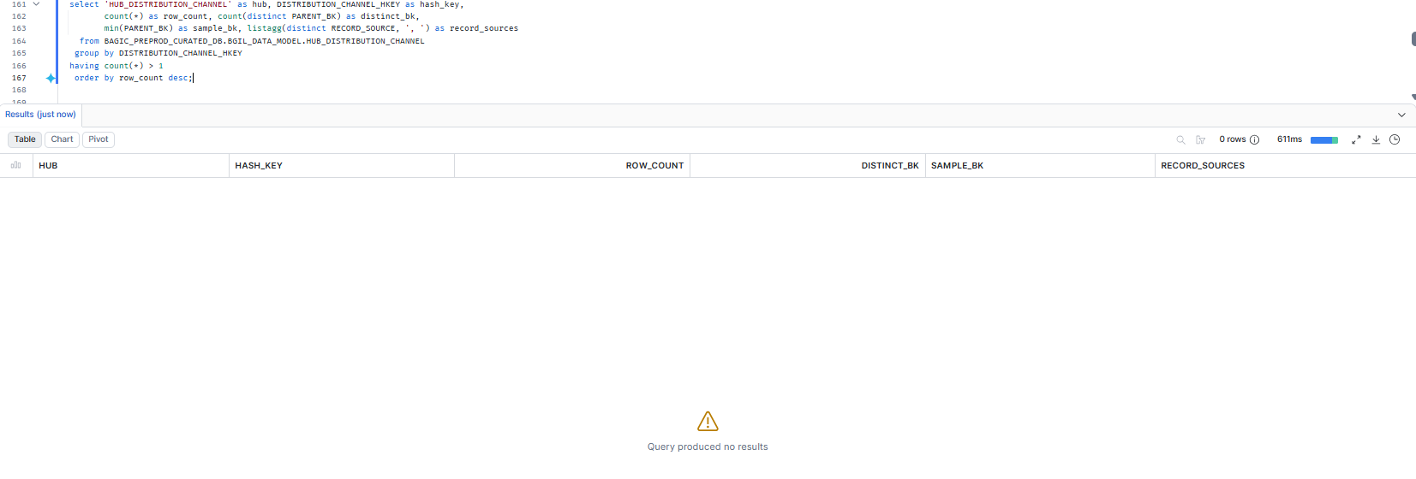

10. SHARED — HUB_ORG_UNIT
Project | SHARED
Hub table | HUB_ORG_UNIT
Status | Implemented
Pass criteria | 0 rows returned
Result (Pass / Fail / NA) | Pass
Rows returned (count) | 0
Remarks

Note: (hash key ORG_UNIT_HKEY, business key PARENT_BK). Loaded by: MAXIMUS, OPUS.
SQL query
select 'HUB_ORG_UNIT' as hub, ORG_UNIT_HKEY as hash_key,
count(*) as row_count, count(distinct PARENT_BK) as distinct_bk,
min(PARENT_BK) as sample_bk, listagg(distinct RECORD_SOURCE, ', ') as record_sources
from BAGIC_PREPROD_CURATED_DB.BGIL_DATA_MODEL.HUB_ORG_UNIT
group by ORG_UNIT_HKEY
having count(*) > 1
order by row_count desc;
Query output (attach / paste below)
Output:
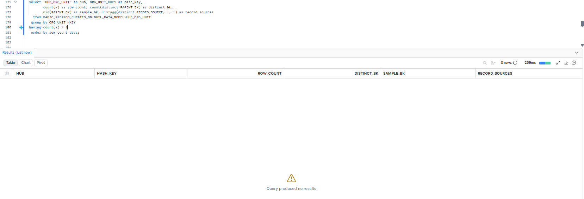

11. SHARED — HUB_AGENT
Project | SHARED
Hub table | HUB_AGENT
Status | Implemented
Pass criteria | 0 rows returned
Result (Pass / Fail / NA) | Pass
Rows returned (count) | 0
Remarks

Note: (hash key AGENT_HKEY, business key PARENT_BK). Loaded by: OPUS.
SQL query
select 'HUB_AGENT' as hub, AGENT_HKEY as hash_key,
count(*) as row_count, count(distinct PARENT_BK) as distinct_bk,
min(PARENT_BK) as sample_bk, listagg(distinct RECORD_SOURCE, ', ') as record_sources
from BAGIC_PREPROD_CURATED_DB.BGIL_DATA_MODEL.HUB_AGENT
group by AGENT_HKEY
having count(*) > 1
order by row_count desc;
Query output (attach / paste below)
Output:
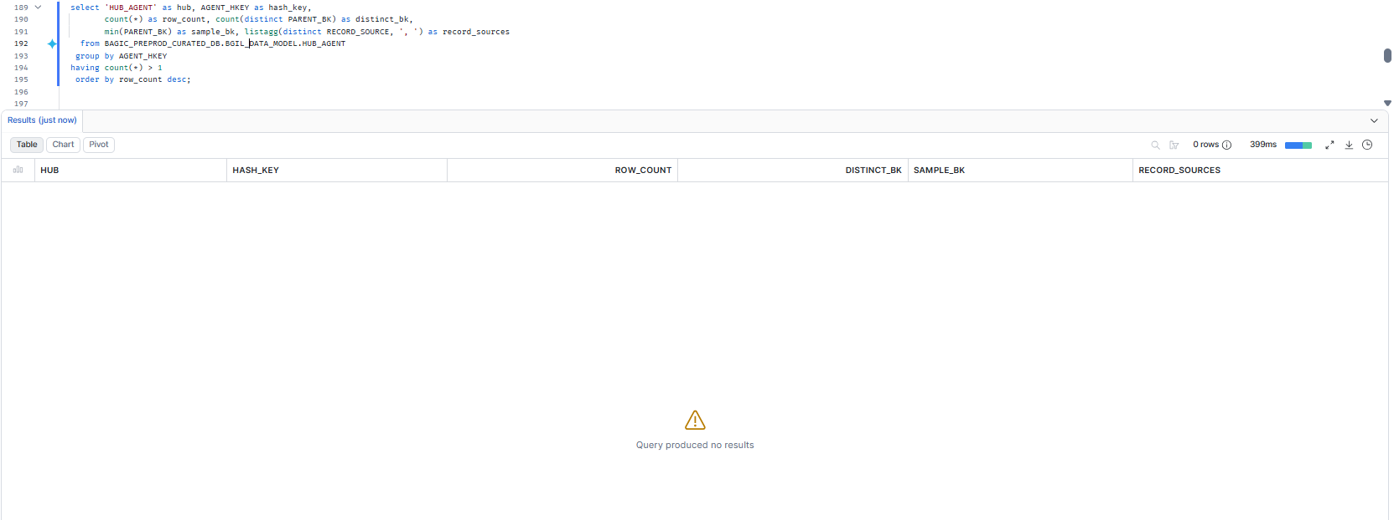

12. SHARED — HUB_AGREEMENT
Project | SHARED
Hub table | HUB_AGREEMENT
Status | Implemented
Pass criteria | 0 rows returned
Result (Pass / Fail / NA) | Pass
Rows returned (count) | 0
Remarks

Note: (hash key AGREEMENT_HKEY, business key PARENT_BK). Loaded by: OPUS.
SQL query
select 'HUB_AGREEMENT' as hub, AGREEMENT_HKEY as hash_key,
count(*) as row_count, count(distinct PARENT_BK) as distinct_bk,
min(PARENT_BK) as sample_bk, listagg(distinct RECORD_SOURCE, ', ') as record_sources
from BAGIC_PREPROD_CURATED_DB.BGIL_DATA_MODEL.HUB_AGREEMENT
group by AGREEMENT_HKEY
having count(*) > 1
order by row_count desc;
Query output (attach / paste below)
Output:
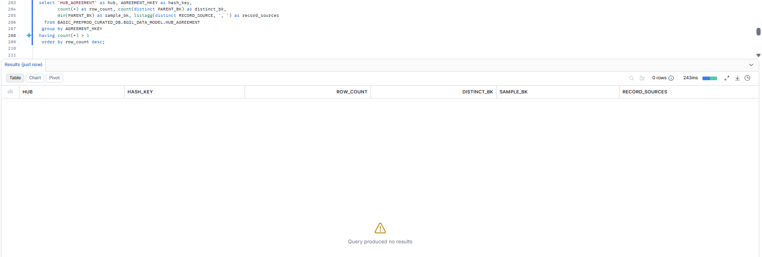

13. SHARED — HUB_CLAIM
Project | SHARED
Hub table | HUB_CLAIM
Status | Implemented
Pass criteria | 0 rows returned
Result (Pass / Fail / NA) | Pass
Rows returned (count) | 0
Remarks

Note: (hash key CLAIM_HKEY, business key PARENT_BK). Loaded by: OPUS.
SQL query
select 'HUB_CLAIM' as hub, CLAIM_HKEY as hash_key,
count(*) as row_count, count(distinct PARENT_BK) as distinct_bk,
min(PARENT_BK) as sample_bk, listagg(distinct RECORD_SOURCE, ', ') as record_sources
from BAGIC_PREPROD_CURATED_DB.BGIL_DATA_MODEL.HUB_CLAIM
group by CLAIM_HKEY
having count(*) > 1
order by row_count desc;
Query output (attach / paste below)
Output:
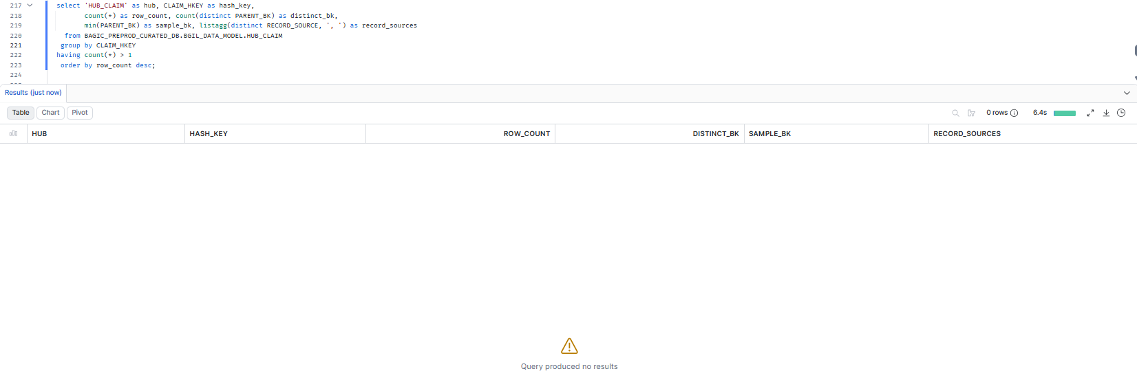

14. SHARED — HUB_RISK_OBJECT
Project | SHARED
Hub table | HUB_RISK_OBJECT
Status | Implemented
Pass criteria | 0 rows returned
Result (Pass / Fail / NA) | Pass
Rows returned (count) | 0
Remarks

Note: (hash key RISK_OBJECT_HKEY, business key PARENT_BK). Loaded by: OPUS.
SQL query
select 'HUB_RISK_OBJECT' as hub, RISK_OBJECT_HKEY as hash_key,
count(*) as row_count, count(distinct PARENT_BK) as distinct_bk,
min(PARENT_BK) as sample_bk, listagg(distinct RECORD_SOURCE, ', ') as record_sources
from BAGIC_PREPROD_CURATED_DB.BGIL_DATA_MODEL.HUB_RISK_OBJECT
group by RISK_OBJECT_HKEY
having count(*) > 1
order by row_count desc;
Query output (attach / paste below)
Output:
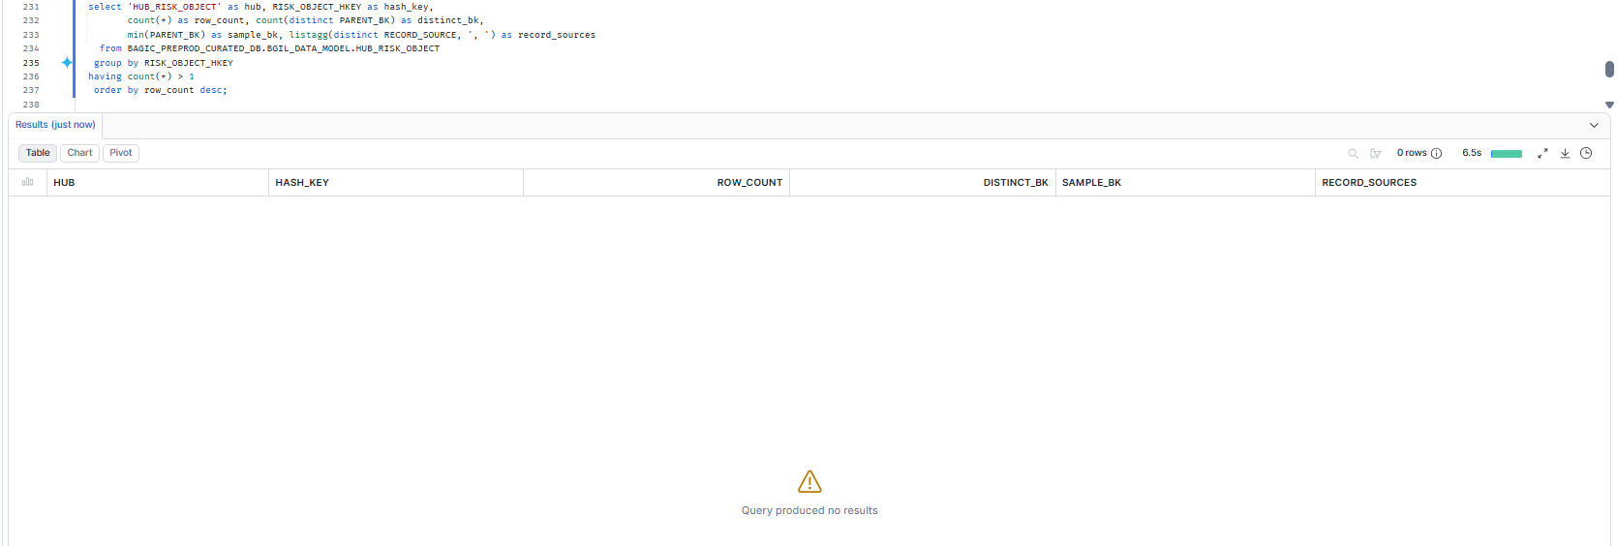

15. SHARED — Same business key under more than one hash key
Project | SHARED
Hub table | Same business key under more than one hash key
Status | Informational
Pass criteria | 0 rows
Result (Pass / Fail / NA)
Rows returned (count)
Remarks

Note: Not part of the K4 pass criterion. The hash is UPPER(TRIM(<NK>)), so case variants already collapse; a hit means two loaders hash the SAME business key with a different NK prefix (e.g. a double-prefixed NK), which splits one entity across hub rows in the shared vault.
SQL query
with all_rows as (
select 'HUB_PARTY' as hub, PARENT_BK as bk, PARTY_HKEY as hkey, RECORD_SOURCE from BAGIC_PREPROD_CURATED_DB.BGIL_DATA_MODEL.HUB_PARTY
union all
select 'HUB_STAKE_CODE' as hub, STAKE_CODE_BK as bk, STAKE_CODE_HKEY as hkey, RECORD_SOURCE from BAGIC_PREPROD_CURATED_DB.BGIL_DATA_MODEL.HUB_STAKE_CODE
union all
select 'HUB_LOCATION' as hub, PARENT_BK as bk, LOCATION_HKEY as hkey, RECORD_SOURCE from BAGIC_PREPROD_CURATED_DB.BGIL_DATA_MODEL.HUB_LOCATION
union all
select 'HUB_PAYMENT_INSTRUMENT' as hub, PARENT_BK as bk, PAYMENT_INSTRUMENT_HKEY as hkey, RECORD_SOURCE from BAGIC_PREPROD_CURATED_DB.BGIL_DATA_MODEL.HUB_PAYMENT_INSTRUMENT
union all
select 'HUB_PRODUCT' as hub, PARENT_BK as bk, PRODUCT_HKEY as hkey, RECORD_SOURCE from BAGIC_PREPROD_CURATED_DB.BGIL_DATA_MODEL.HUB_PRODUCT
union all
select 'HUB_FINANCIAL_ACCOUNT' as hub, PARENT_BK as bk, FINANCIAL_ACCOUNT_HKEY as hkey, RECORD_SOURCE from BAGIC_PREPROD_CURATED_DB.BGIL_DATA_MODEL.HUB_FINANCIAL_ACCOUNT
union all
select 'HUB_DOCUMENT' as hub, PARENT_BK as bk, DOCUMENT_HKEY as hkey, RECORD_SOURCE from BAGIC_PREPROD_CURATED_DB.BGIL_DATA_MODEL.HUB_DOCUMENT
union all
select 'HUB_POLICY' as hub, PARENT_BK as bk, POLICY_HKEY as hkey, RECORD_SOURCE from BAGIC_PREPROD_CURATED_DB.BGIL_DATA_MODEL.HUB_POLICY
union all
select 'HUB_DISTRIBUTION_CHANNEL' as hub, PARENT_BK as bk, DISTRIBUTION_CHANNEL_HKEY as hkey, RECORD_SOURCE from BAGIC_PREPROD_CURATED_DB.BGIL_DATA_MODEL.HUB_DISTRIBUTION_CHANNEL
union all
select 'HUB_ORG_UNIT' as hub, PARENT_BK as bk, ORG_UNIT_HKEY as hkey, RECORD_SOURCE from BAGIC_PREPROD_CURATED_DB.BGIL_DATA_MODEL.HUB_ORG_UNIT
union all
select 'HUB_AGENT' as hub, PARENT_BK as bk, AGENT_HKEY as hkey, RECORD_SOURCE from BAGIC_PREPROD_CURATED_DB.BGIL_DATA_MODEL.HUB_AGENT
union all
select 'HUB_AGREEMENT' as hub, PARENT_BK as bk, AGREEMENT_HKEY as hkey, RECORD_SOURCE from BAGIC_PREPROD_CURATED_DB.BGIL_DATA_MODEL.HUB_AGREEMENT
union all
select 'HUB_CLAIM' as hub, PARENT_BK as bk, CLAIM_HKEY as hkey, RECORD_SOURCE from BAGIC_PREPROD_CURATED_DB.BGIL_DATA_MODEL.HUB_CLAIM
union all
select 'HUB_RISK_OBJECT' as hub, PARENT_BK as bk, RISK_OBJECT_HKEY as hkey, RECORD_SOURCE from BAGIC_PREPROD_CURATED_DB.BGIL_DATA_MODEL.HUB_RISK_OBJECT
)
select hub, bk, count(distinct hkey) as distinct_hkeys,
listagg(distinct RECORD_SOURCE, ', ') as record_sources
from all_rows
where bk is not null
group by hub, bk
having count(distinct hkey) > 1
order by distinct_hkeys desc, hub, bk;
Query output (attach / paste below)
Output:
