DM-K2 | Key Checks — No Extra / Unexpected Keys
Hub key reconciliation (hub → raw source). Pass criterion: 0 rows returned (0 unexpected business keys).

Check Overview
Check ID | DM-K2
Category | Key checks
Sign-off criterion | No extra / unexpected keys
Method | Anti-join: HUB → RAW source table (reconciled against RAW tables, not views). Every hub business key must be producible from the SF Mirror source.
Pass criteria / tolerance | 0 unexpected keys
Owner | LUMIQ
Vault location | BAGIC_PREPROD_CURATED_DB.BGIL_DATA_MODEL
Maximus RAW | BAGIC_PROD_MIRROR_DB.MAXI_RAW
Opus RAW (test) | BAGIC_PREPROD_CURATED_DB.UTILS
Hash key formula | MD5_BINARY(NULLIF(UPPER(TRIM(CAST(<NK> AS VARCHAR))), '')) — stored as BINARY(16); <NK> = 'HUB_<ENTITY>|' || <key> (automate_dv 0.11.5 default)
Scope (shared vault) | Hub rows filtered by RECORD_SOURCE prefix: MAXIMUS_ rows checked against Maximus RAW, OPUS_ rows against Opus RAW. Section 20 lists rows owned by neither.
Query output columns | project, hub, unexpected_bk, unexpected_hkey, RECORD_SOURCE

Validation Queries

1. MAXIMUS — HUB_PARTY
Project | MAXIMUS
Hub table | HUB_PARTY
Status | Implemented
Pass criteria | 0 rows returned
Result (Pass / Fail / NA) | Pass
Rows returned (count) | 0

Note: All 15 hubfeed_party branches resolve to these 7 raw key columns. SIMPLE_PROPERTY_PIVOT_VW (stage + every sp_pv unpivot) keys on BAGIC_EMPLOYEE_CODE, not FOREIGN_KEY.
SQL query
with maxi_hub_party_src as (
select MD5_BINARY(NULLIF(UPPER(TRIM('HUB_PARTY|' || nullif(trim(to_varchar(PARTY_CODE)), ''))), '')) as hkey
from BAGIC_PROD_MIRROR_DB.MAXI_RAW.BUSINESS_PARTNERS_VW_DATA_PARTY_DETAIL
union
select MD5_BINARY(NULLIF(UPPER(TRIM('HUB_PARTY|' || nullif(trim(to_varchar(FOREIGN_KEY)), ''))), ''))
from BAGIC_PROD_MIRROR_DB.MAXI_RAW.BUSINESS_PARTNERS_VW_DATA_PARTY_DETAIL_PARTY_ADDRESS
union
select MD5_BINARY(NULLIF(UPPER(TRIM('HUB_PARTY|' || nullif(trim(to_varchar(FOREIGN_KEY)), ''))), ''))
from BAGIC_PROD_MIRROR_DB.MAXI_RAW.BUSINESS_PARTNERS_VW_DATA_PARTY_DETAIL_PARTY_ADDRESS_ADDRESS_PROPERTY_PIVOT_VW
union
select MD5_BINARY(NULLIF(UPPER(TRIM('HUB_PARTY|' || nullif(trim(to_varchar(FOREIGN_KEY)), ''))), ''))
from BAGIC_PROD_MIRROR_DB.MAXI_RAW.BUSINESS_PARTNERS_VW_DATA_PARTY_DETAIL_PARTY_PROPERTY_MULTI_SET_PROPERTY_MULTI_SET_DETAIL_PROPERTY_PIVOT_VW
union
select MD5_BINARY(NULLIF(UPPER(TRIM('HUB_PARTY|' || nullif(trim(to_varchar(FOREIGN_KEY)), ''))), ''))
from BAGIC_PROD_MIRROR_DB.MAXI_RAW.BUSINESS_PARTNERS_VW_DATA_PARTY_DETAIL_PARTY_RELATION
union
select MD5_BINARY(NULLIF(UPPER(TRIM('HUB_PARTY|' || nullif(trim(to_varchar(FOREIGN_KEY)), ''))), ''))
from BAGIC_PROD_MIRROR_DB.MAXI_RAW.BUSINESS_PARTNERS_VW_DATA_PARTY_DETAIL_RELATED_PARTY
union
select MD5_BINARY(NULLIF(UPPER(TRIM('HUB_PARTY|' || nullif(trim(to_varchar(BAGIC_EMPLOYEE_CODE)), ''))), ''))
from BAGIC_PROD_MIRROR_DB.MAXI_RAW.BUSINESS_PARTNERS_VW_DATA_PARTY_DETAIL_PARTY_PROPERTY_SIMPLE_PROPERTY_PIVOT_VW
)
select 'MAXIMUS' as project, 'HUB_PARTY' as hub,
h.PARENT_BK as unexpected_bk, h.PARTY_HKEY as unexpected_hkey, h.RECORD_SOURCE
from BAGIC_PREPROD_CURATED_DB.BGIL_DATA_MODEL.HUB_PARTY h
where startswith(h.RECORD_SOURCE, 'MAXIMUS_')
and not exists (select 1 from maxi_hub_party_src s where s.hkey = h.PARTY_HKEY);
Query output (attach / paste below)
Output:
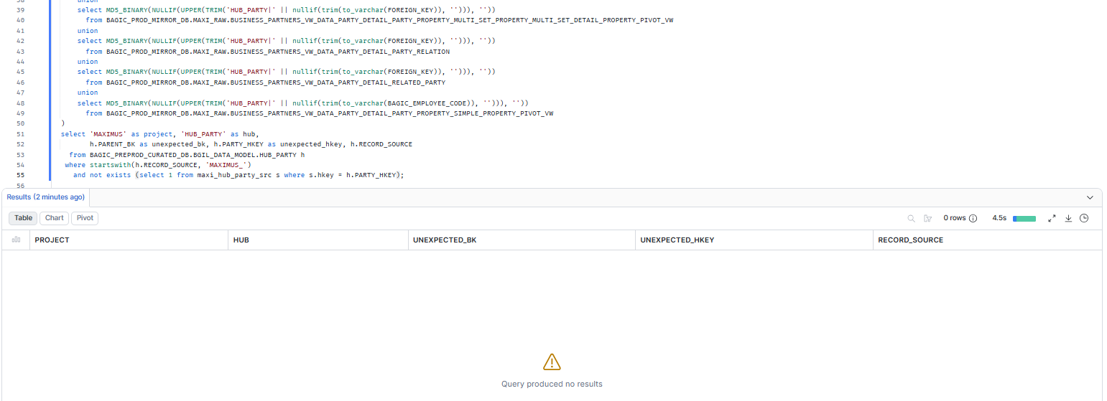

2. MAXIMUS — HUB_STAKE_CODE
Project | MAXIMUS
Hub table | HUB_STAKE_CODE
Status | Implemented
Pass criteria | 0 rows returned
Result (Pass / Fail / NA) | Pass
Rows returned (count) | 0

Note: Business key column is STAKE_CODE_BK (not PARENT_BK) in this hub.
SQL query
with maxi_hub_stake_code_src as (
select MD5_BINARY(NULLIF(UPPER(TRIM('HUB_STAKE_CODE|' || nullif(trim(to_varchar(STAKE_CODE)), ''))), '')) as hkey
from BAGIC_PROD_MIRROR_DB.MAXI_RAW.BUSINESS_PARTNERS_VW_DATA_PARTY_DETAIL_RELATED_PARTY
)
select 'MAXIMUS' as project, 'HUB_STAKE_CODE' as hub,
h.STAKE_CODE_BK as unexpected_bk, h.STAKE_CODE_HKEY as unexpected_hkey, h.RECORD_SOURCE
from BAGIC_PREPROD_CURATED_DB.BGIL_DATA_MODEL.HUB_STAKE_CODE h
where startswith(h.RECORD_SOURCE, 'MAXIMUS_')
and not exists (select 1 from maxi_hub_stake_code_src s where s.hkey = h.STAKE_CODE_HKEY);
Query output (attach / paste below)
Output:
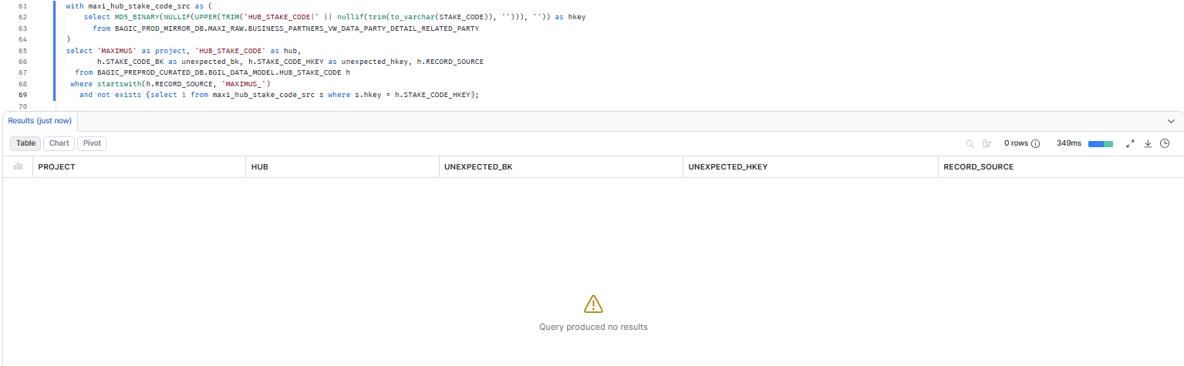

3. MAXIMUS — HUB_LOCATION
Project | MAXIMUS
Hub table | HUB_LOCATION
Status | Implemented
Pass criteria | 0 rows returned
Result (Pass / Fail / NA) | Pass
Rows returned (count) | 0

Note: COMPOSITE KEY: LOCATION_BK = md5(concat_ws('|', ...)) over address columns. Column list and order copied exactly from the LOCATION_BK derived column of stg2_mp__pd_addr, stg2_mp__pd_party_addr_prop_pv and stg2_mp__pd_prop_sp_pv. concat_ws returns NULL if any part is NULL, so such rows produce no hub key (same as the model).
SQL query
with maxi_hub_location_src as (
select MD5_BINARY(NULLIF(UPPER(TRIM('HUB_LOCATION|' || md5(concat_ws('|',
upper(nullif(trim(to_varchar(ADDRESS1)), '')),
upper(nullif(trim(to_varchar(ADDRESS2)), '')),
upper(nullif(trim(to_varchar(ADDRESS3)), '')),
upper(nullif(trim(to_varchar(CITY)), '')),
upper(nullif(trim(to_varchar(DISTRICT)), '')),
upper(nullif(trim(to_varchar(STATE)), '')),
upper(nullif(trim(to_varchar(PINCODE)), '')),
upper(nullif(trim(to_varchar(COUNTRY)), '')))))), '')) as hkey
from BAGIC_PROD_MIRROR_DB.MAXI_RAW.BUSINESS_PARTNERS_VW_DATA_PARTY_DETAIL_PARTY_ADDRESS
union
select MD5_BINARY(NULLIF(UPPER(TRIM('HUB_LOCATION|' || md5(concat_ws('|',
upper(nullif(trim(to_varchar(LAND_MARK)), '')),
upper(nullif(trim(to_varchar(AREA)), '')),
upper(nullif(trim(to_varchar(POST_OFFICE)), '')),
upper(nullif(trim(to_varchar(CITY)), '')),
upper(nullif(trim(to_varchar(STATE)), '')),
upper(nullif(trim(to_varchar(PINCODE)), '')))))), ''))
from BAGIC_PROD_MIRROR_DB.MAXI_RAW.BUSINESS_PARTNERS_VW_DATA_PARTY_DETAIL_PARTY_ADDRESS_ADDRESS_PROPERTY_PIVOT_VW
union
select MD5_BINARY(NULLIF(UPPER(TRIM('HUB_LOCATION|' || md5(concat_ws('|',
upper(nullif(trim(to_varchar(OUR_OFFICE_ADDRESS)), '')),
upper(nullif(trim(to_varchar(CURRENT_PERMANENT_OVERSEAS_ADDRESS_LINE_2)), '')),
upper(nullif(trim(to_varchar(CURRENT_PERMANENT_OVERSEAS_ADDRESS_LINE_3)), '')),
upper(nullif(trim(to_varchar(CURRENT_PERMANENT_OVERSEAS_ADDRESS_CITY_TOWN_VILLAGE)), '')),
upper(nullif(trim(to_varchar(CORRESPONDENCE_LOCAL_ADDRESS_DISTRICT)), '')),
upper(nullif(trim(to_varchar(CURRENT_PERMANENT_OVERSEAS_ADDRESS_STATE_UT)), '')),
upper(nullif(trim(to_varchar(LOCAL_ADDRESS_PIN_CODE)), '')),
upper(nullif(trim(to_varchar(CURRENT_PERMANENT_OVERSEAS_ADDRESS_COUNTRY)), '')))))), ''))
from BAGIC_PROD_MIRROR_DB.MAXI_RAW.BUSINESS_PARTNERS_VW_DATA_PARTY_DETAIL_PARTY_PROPERTY_SIMPLE_PROPERTY_PIVOT_VW
)
select 'MAXIMUS' as project, 'HUB_LOCATION' as hub,
h.PARENT_BK as unexpected_bk, h.LOCATION_HKEY as unexpected_hkey, h.RECORD_SOURCE
from BAGIC_PREPROD_CURATED_DB.BGIL_DATA_MODEL.HUB_LOCATION h
where startswith(h.RECORD_SOURCE, 'MAXIMUS_')
and not exists (select 1 from maxi_hub_location_src s where s.hkey = h.LOCATION_HKEY);
Query output (attach / paste below)
Output:
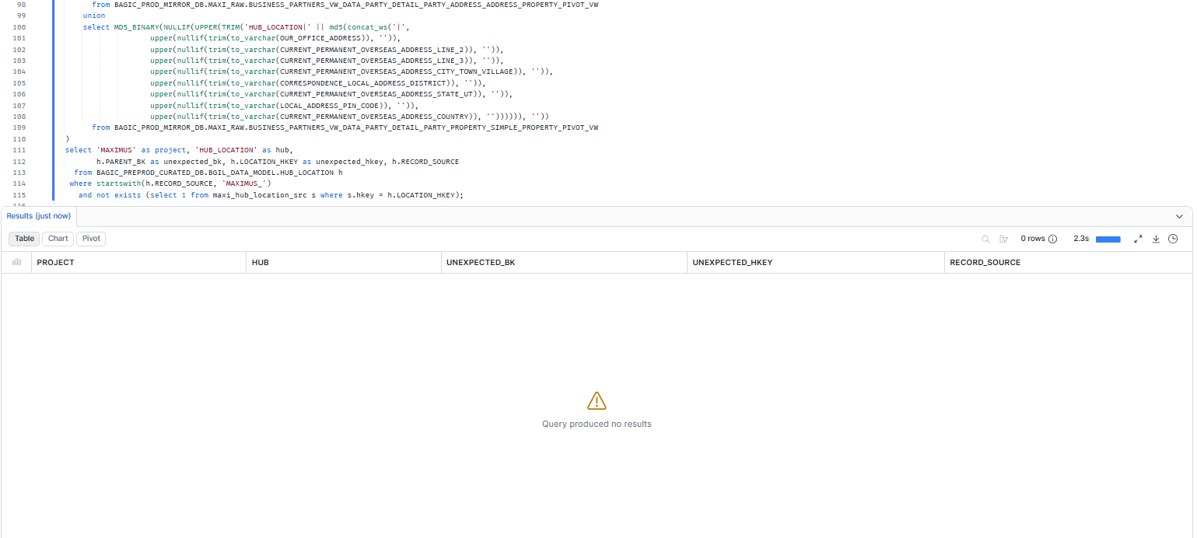

4. MAXIMUS — HUB_PAYMENT_INSTRUMENT
Project | MAXIMUS
Hub table | HUB_PAYMENT_INSTRUMENT
Status | Implemented
Pass criteria | 0 rows returned
Result (Pass / Fail / NA) | Pass
Rows returned (count) | 0

Note: PAYMENT_INSTRUMENT_BK is already prefixed in stg2_mp__pd_prop_msdp_pv, so the NK is double-prefixed ('HUB_PAYMENT_INSTRUMENT|HUB_PAYMENT_INSTRUMENT|<FOREIGN_KEY>'). Reproduced here.
SQL query
with maxi_hub_payment_instrument_src as (
select MD5_BINARY(NULLIF(UPPER(TRIM('HUB_PAYMENT_INSTRUMENT|' || 'HUB_PAYMENT_INSTRUMENT|' || nullif(trim(to_varchar(FOREIGN_KEY)), ''))), '')) as hkey
from BAGIC_PROD_MIRROR_DB.MAXI_RAW.BUSINESS_PARTNERS_VW_DATA_PARTY_DETAIL_PARTY_PROPERTY_MULTI_SET_PROPERTY_MULTI_SET_DETAIL_PROPERTY_PIVOT_VW
)
select 'MAXIMUS' as project, 'HUB_PAYMENT_INSTRUMENT' as hub,
h.PARENT_BK as unexpected_bk, h.PAYMENT_INSTRUMENT_HKEY as unexpected_hkey, h.RECORD_SOURCE
from BAGIC_PREPROD_CURATED_DB.BGIL_DATA_MODEL.HUB_PAYMENT_INSTRUMENT h
where startswith(h.RECORD_SOURCE, 'MAXIMUS_')
and not exists (select 1 from maxi_hub_payment_instrument_src s where s.hkey = h.PAYMENT_INSTRUMENT_HKEY);
Query output (attach / paste below)
Output:
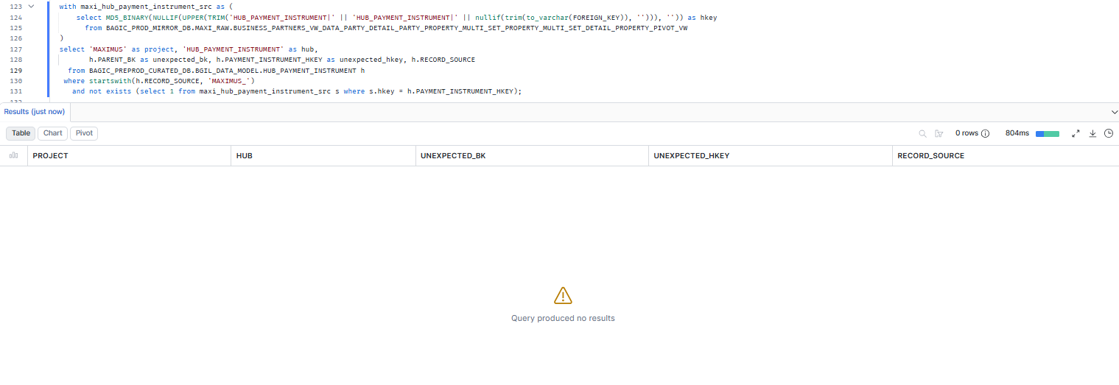

5. MAXIMUS — HUB_PRODUCT
Project | MAXIMUS
Hub table | HUB_PRODUCT
Status | Implemented
Pass criteria | 0 rows returned
Result (Pass / Fail / NA) | Pass
Rows returned (count) | 0

SQL query
with maxi_hub_product_src as (
select MD5_BINARY(NULLIF(UPPER(TRIM('HUB_PRODUCT|' || nullif(trim(to_varchar(PRODUCT_CODE)), ''))), '')) as hkey
from BAGIC_PROD_MIRROR_DB.MAXI_RAW.BUSINESS_PARTNERS_VW_DATA_PARTY_DETAIL_PARTY_PROPERTY_SIMPLE_PROPERTY_PIVOT_VW
)
select 'MAXIMUS' as project, 'HUB_PRODUCT' as hub,
h.PARENT_BK as unexpected_bk, h.PRODUCT_HKEY as unexpected_hkey, h.RECORD_SOURCE
from BAGIC_PREPROD_CURATED_DB.BGIL_DATA_MODEL.HUB_PRODUCT h
where startswith(h.RECORD_SOURCE, 'MAXIMUS_')
and not exists (select 1 from maxi_hub_product_src s where s.hkey = h.PRODUCT_HKEY);
Query output (attach / paste below)
Output:
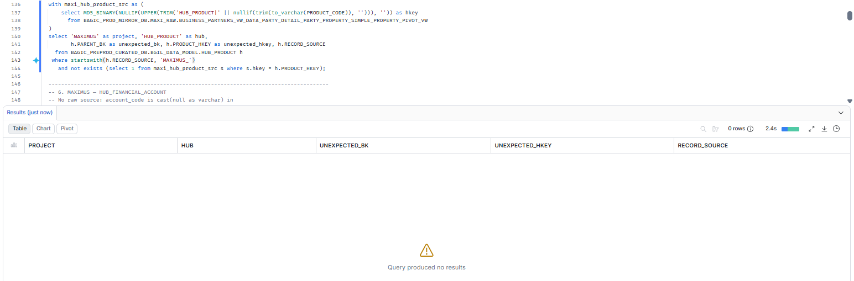

6. MAXIMUS — HUB_FINANCIAL_ACCOUNT
Project | MAXIMUS
Hub table | HUB_FINANCIAL_ACCOUNT
Status | Implemented
Pass criteria | 0 rows returned
Result (Pass / Fail / NA) | Pass
Rows returned (count) | 0

Note: No raw source: account_code is cast(null as varchar) in stg_maximus__pd_prop_msdp_pv, so the model cannot produce a key. Expected 0 Maximus rows; ANY row returned is an unexpected key.
SQL query
-- No raw source can produce this key (see note): every row is unexpected.
select 'MAXIMUS' as project, 'HUB_FINANCIAL_ACCOUNT' as hub,
h.PARENT_BK as unexpected_bk, h.FINANCIAL_ACCOUNT_HKEY as unexpected_hkey, h.RECORD_SOURCE
from BAGIC_PREPROD_CURATED_DB.BGIL_DATA_MODEL.HUB_FINANCIAL_ACCOUNT h
where startswith(h.RECORD_SOURCE, 'MAXIMUS_');
Query output (attach / paste below)
Output:
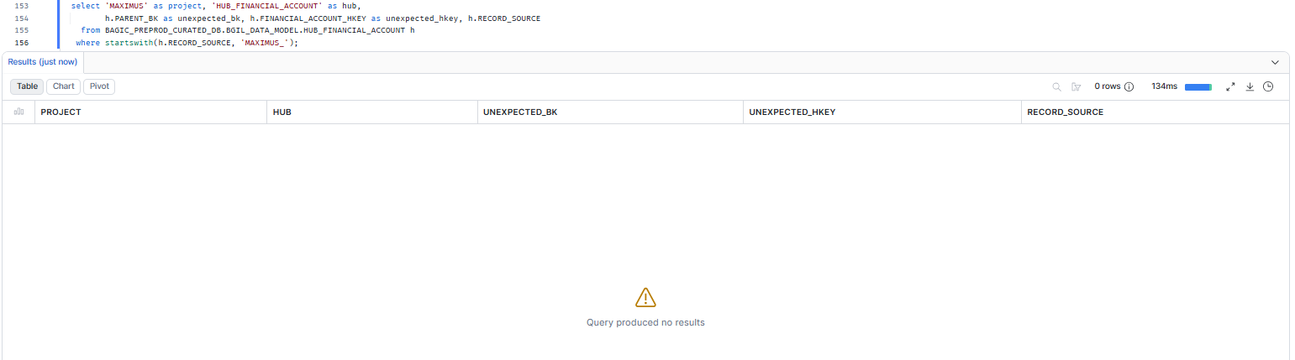

7. MAXIMUS — HUB_DOCUMENT
Project | MAXIMUS
Hub table | HUB_DOCUMENT
Status | Implemented
Pass criteria | 0 rows returned
Result (Pass / Fail / NA) | Pass
Rows returned (count) | 0

SQL query
with maxi_hub_document_src as (
select MD5_BINARY(NULLIF(UPPER(TRIM('HUB_DOCUMENT|' || nullif(trim(to_varchar(DOCUMENT_ID)), ''))), '')) as hkey
from BAGIC_PROD_MIRROR_DB.MAXI_RAW.BUSINESS_PARTNERS_VW_DATA_PARTY_DETAIL_DOCUMENT_DETAIL
)
select 'MAXIMUS' as project, 'HUB_DOCUMENT' as hub,
h.PARENT_BK as unexpected_bk, h.DOCUMENT_HKEY as unexpected_hkey, h.RECORD_SOURCE
from BAGIC_PREPROD_CURATED_DB.BGIL_DATA_MODEL.HUB_DOCUMENT h
where startswith(h.RECORD_SOURCE, 'MAXIMUS_')
and not exists (select 1 from maxi_hub_document_src s where s.hkey = h.DOCUMENT_HKEY);
Query output (attach / paste below)
Output:
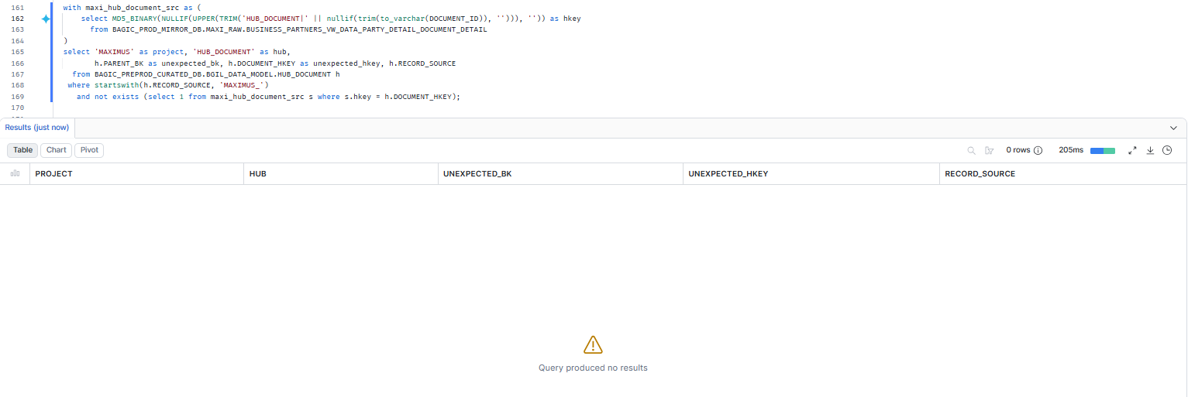

8. MAXIMUS — HUB_POLICY
Project | MAXIMUS
Hub table | HUB_POLICY
Status | Implemented
Pass criteria | 0 rows returned
Result (Pass / Fail / NA) | Pass
Rows returned (count) | 0

SQL query
with maxi_hub_policy_src as (
select MD5_BINARY(NULLIF(UPPER(TRIM('HUB_POLICY|' || nullif(trim(to_varchar(PA_POLICY)), ''))), '')) as hkey
from BAGIC_PROD_MIRROR_DB.MAXI_RAW.BUSINESS_PARTNERS_VW_DATA_PARTY_DETAIL_PARTY_PROPERTY_SIMPLE_PROPERTY_PIVOT_VW
)
select 'MAXIMUS' as project, 'HUB_POLICY' as hub,
h.PARENT_BK as unexpected_bk, h.POLICY_HKEY as unexpected_hkey, h.RECORD_SOURCE
from BAGIC_PREPROD_CURATED_DB.BGIL_DATA_MODEL.HUB_POLICY h
where startswith(h.RECORD_SOURCE, 'MAXIMUS_')
and not exists (select 1 from maxi_hub_policy_src s where s.hkey = h.POLICY_HKEY);
Query output (attach / paste below)
Output:
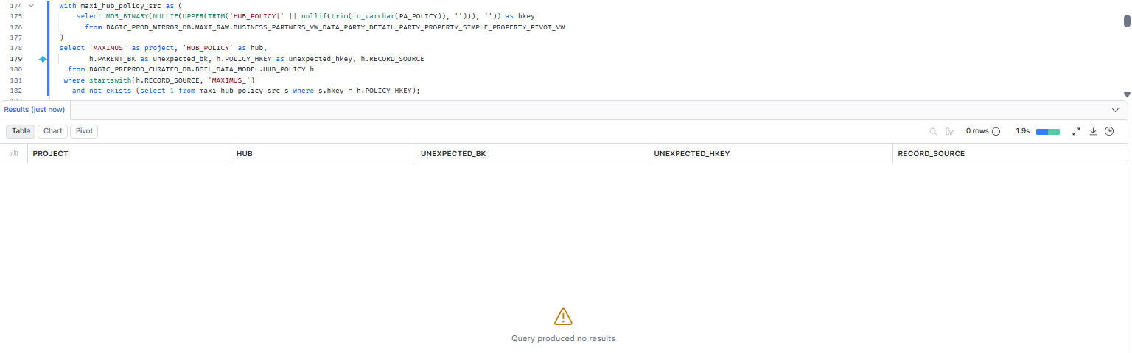

9. MAXIMUS — HUB_DISTRIBUTION_CHANNEL
Project | MAXIMUS
Hub table | HUB_DISTRIBUTION_CHANNEL
Status | Implemented
Pass criteria | 0 rows returned
Result (Pass / Fail / NA) | Pass
Rows returned (count) | 0

SQL query
with maxi_hub_distribution_channel_src as (
select MD5_BINARY(NULLIF(UPPER(TRIM('HUB_DISTRIBUTION_CHANNEL|' || nullif(trim(to_varchar(AGENT_CHANNEL)), ''))), '')) as hkey
from BAGIC_PROD_MIRROR_DB.MAXI_RAW.BUSINESS_PARTNERS_VW_DATA_PARTY_DETAIL_PARTY_PROPERTY_SIMPLE_PROPERTY_PIVOT_VW
)
select 'MAXIMUS' as project, 'HUB_DISTRIBUTION_CHANNEL' as hub,
h.PARENT_BK as unexpected_bk, h.DISTRIBUTION_CHANNEL_HKEY as unexpected_hkey, h.RECORD_SOURCE
from BAGIC_PREPROD_CURATED_DB.BGIL_DATA_MODEL.HUB_DISTRIBUTION_CHANNEL h
where startswith(h.RECORD_SOURCE, 'MAXIMUS_')
and not exists (select 1 from maxi_hub_distribution_channel_src s where s.hkey = h.DISTRIBUTION_CHANNEL_HKEY);
Query output (attach / paste below)
Output:
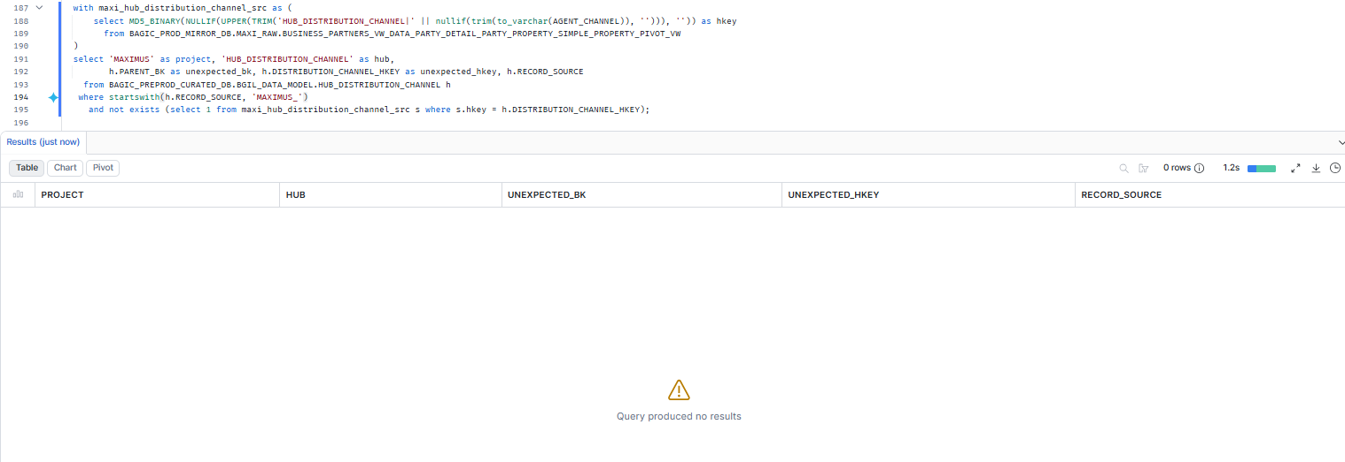

10. MAXIMUS — HUB_ORG_UNIT
Project | MAXIMUS
Hub table | HUB_ORG_UNIT
Status | Implemented
Pass criteria | 0 rows returned
Result (Pass / Fail / NA) | Pass
Rows returned (count) | 0

Note: The second branch (SIMPLE_PROPERTY_PIVOT_VW.branch_code) is cast(null) in staging and contributes no keys, so only COMPANY is a legitimate source.
SQL query
with maxi_hub_org_unit_src as (
select MD5_BINARY(NULLIF(UPPER(TRIM('HUB_ORG_UNIT|' || nullif(trim(to_varchar(COMPANY)), ''))), '')) as hkey
from BAGIC_PROD_MIRROR_DB.MAXI_RAW.BUSINESS_PARTNERS_VW_DATA_PARTY_DETAIL_PARTY_PROPERTY_MULTI_SET_PROPERTY_MULTI_SET_DETAIL_PROPERTY_PIVOT_VW
)
select 'MAXIMUS' as project, 'HUB_ORG_UNIT' as hub,
h.PARENT_BK as unexpected_bk, h.ORG_UNIT_HKEY as unexpected_hkey, h.RECORD_SOURCE
from BAGIC_PREPROD_CURATED_DB.BGIL_DATA_MODEL.HUB_ORG_UNIT h
where startswith(h.RECORD_SOURCE, 'MAXIMUS_')
and not exists (select 1 from maxi_hub_org_unit_src s where s.hkey = h.ORG_UNIT_HKEY);
Query output (attach / paste below)
Output:
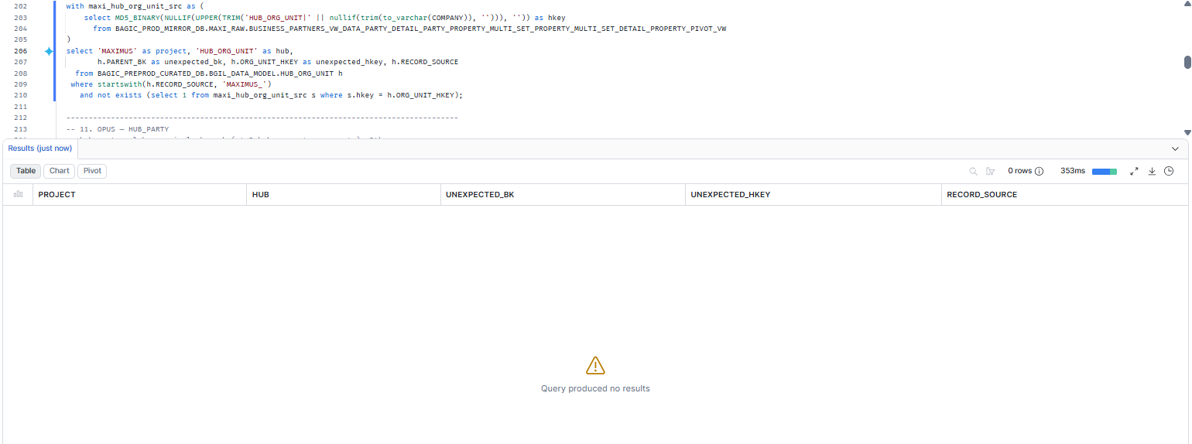

11. OPUS — HUB_PARTY
Project | OPUS
Hub table | HUB_PARTY
Status | Implemented
Pass criteria | 0 rows returned
Result (Pass / Fail / NA) | Pass
Rows returned (count) | 0

Note: hub_party.sql has a single branch (stg2_hub_cp_partners__party). Other stg2_hub_*__party stages exist but do not feed the hub, so they are not legitimate sources here.
SQL query
with opus_hub_party_src as (
select MD5_BINARY(NULLIF(UPPER(TRIM('HUB_PARTY|' || nullif(trim("PART_ID"::varchar), ''))), '')) as hkey
from BAGIC_PREPROD_CURATED_DB.UTILS.CP_PARTNERS
)
select 'OPUS' as project, 'HUB_PARTY' as hub,
h.PARENT_BK as unexpected_bk, h.PARTY_HKEY as unexpected_hkey, h.RECORD_SOURCE
from BAGIC_PREPROD_CURATED_DB.BGIL_DATA_MODEL.HUB_PARTY h
where startswith(h.RECORD_SOURCE, 'OPUS_')
and not exists (select 1 from opus_hub_party_src s where s.hkey = h.PARTY_HKEY);
Query output (attach / paste below)
Output:
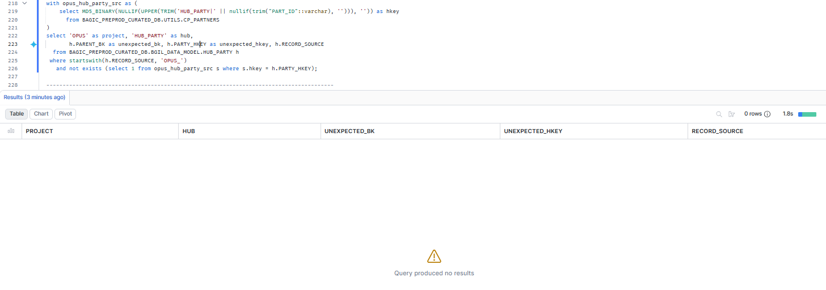

12. OPUS — HUB_AGENT
Project | OPUS
Hub table | HUB_AGENT
Status | Implemented
Pass criteria | 0 rows returned
Result (Pass / Fail / NA) | Pass
Rows returned (count) | 0

SQL query
with opus_hub_agent_src as (
select MD5_BINARY(NULLIF(UPPER(TRIM('HUB_AGENT|' || nullif(trim("INTERMEDIARY_ID"::varchar), ''))), '')) as hkey
from BAGIC_PREPROD_CURATED_DB.UTILS.BJAZ_INTERMEDIARY
)
select 'OPUS' as project, 'HUB_AGENT' as hub,
h.PARENT_BK as unexpected_bk, h.AGENT_HKEY as unexpected_hkey, h.RECORD_SOURCE
from BAGIC_PREPROD_CURATED_DB.BGIL_DATA_MODEL.HUB_AGENT h
where startswith(h.RECORD_SOURCE, 'OPUS_')
and not exists (select 1 from opus_hub_agent_src s where s.hkey = h.AGENT_HKEY);
Query output (attach / paste below)
Output:
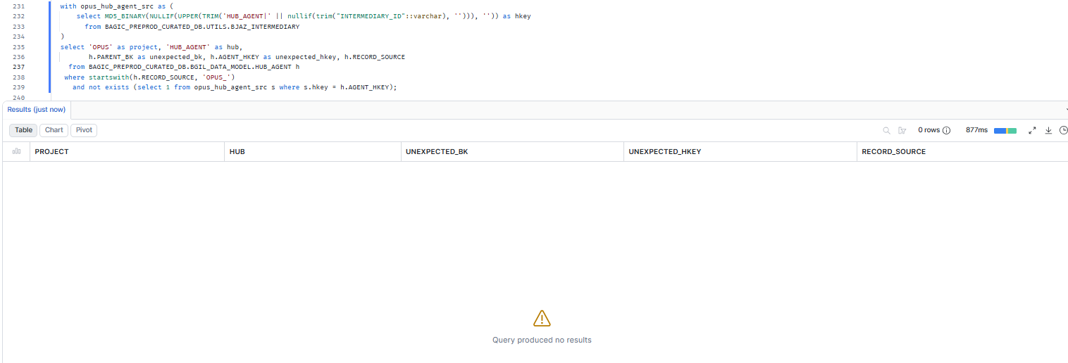

13. OPUS — HUB_AGREEMENT
Project | OPUS
Hub table | HUB_AGREEMENT
Status | Implemented
Pass criteria | 0 rows returned
Result (Pass / Fail / NA) | Pass
Rows returned (count) | 0

SQL query
with opus_hub_agreement_src as (
select MD5_BINARY(NULLIF(UPPER(TRIM('HUB_AGREEMENT|' || nullif(trim("INTERMEDIARY_ID"::varchar), ''))), '')) as hkey
from BAGIC_PREPROD_CURATED_DB.UTILS.BJAZ_INTERMEDIARY
)
select 'OPUS' as project, 'HUB_AGREEMENT' as hub,
h.PARENT_BK as unexpected_bk, h.AGREEMENT_HKEY as unexpected_hkey, h.RECORD_SOURCE
from BAGIC_PREPROD_CURATED_DB.BGIL_DATA_MODEL.HUB_AGREEMENT h
where startswith(h.RECORD_SOURCE, 'OPUS_')
and not exists (select 1 from opus_hub_agreement_src s where s.hkey = h.AGREEMENT_HKEY);
Query output (attach / paste below)
Output:
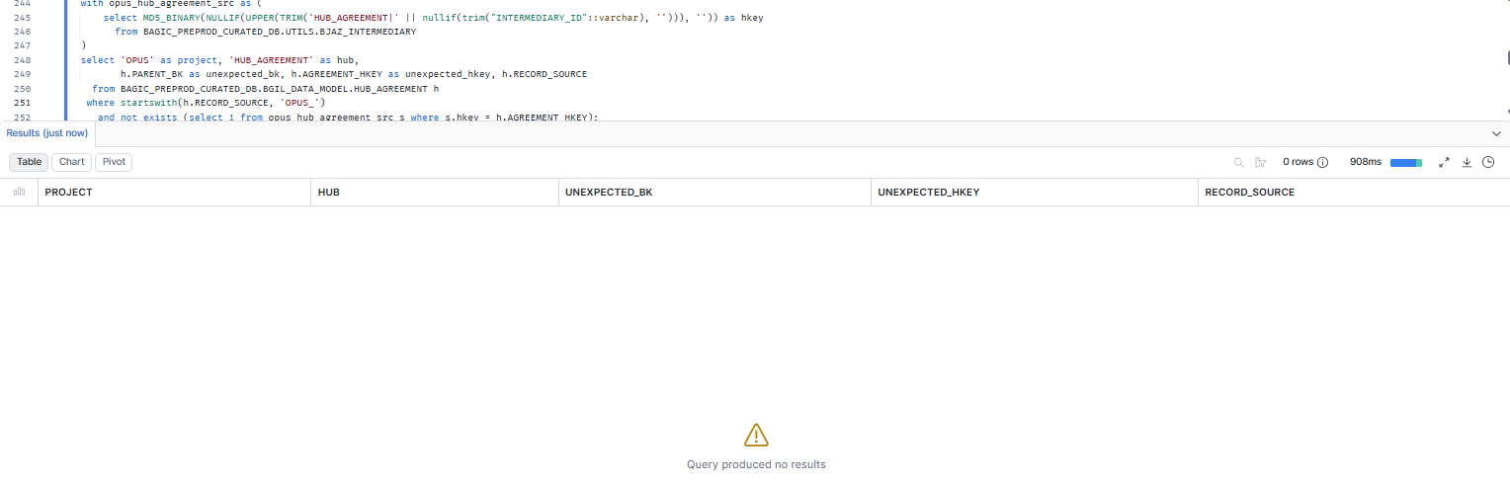

14. OPUS — HUB_CLAIM
Project | OPUS
Hub table | HUB_CLAIM
Status | Implemented
Pass criteria | 0 rows returned
Result (Pass / Fail / NA) | Pass
Rows returned (count) | 0

SQL query
with opus_hub_claim_src as (
select MD5_BINARY(NULLIF(UPPER(TRIM('HUB_CLAIM|' || nullif(trim("CLAIM_ID"::varchar), ''))), '')) as hkey
from BAGIC_PREPROD_CURATED_DB.UTILS.CLM_INTERESTED_PARTIES
)
select 'OPUS' as project, 'HUB_CLAIM' as hub,
h.PARENT_BK as unexpected_bk, h.CLAIM_HKEY as unexpected_hkey, h.RECORD_SOURCE
from BAGIC_PREPROD_CURATED_DB.BGIL_DATA_MODEL.HUB_CLAIM h
where startswith(h.RECORD_SOURCE, 'OPUS_')
and not exists (select 1 from opus_hub_claim_src s where s.hkey = h.CLAIM_HKEY);
Query output (attach / paste below)
Output:
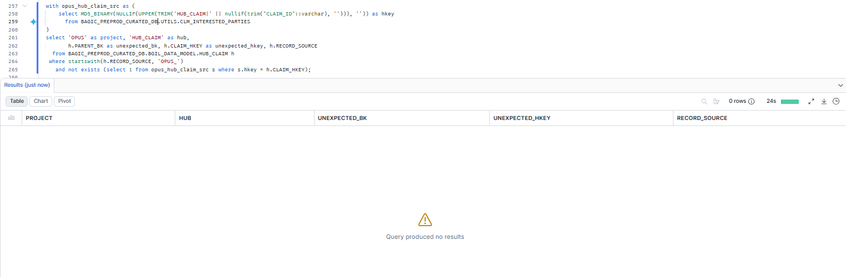

15. OPUS — HUB_DISTRIBUTION_CHANNEL
Project | OPUS
Hub table | HUB_DISTRIBUTION_CHANNEL
Status | Implemented
Pass criteria | 0 rows returned
Result (Pass / Fail / NA) | Pass
Rows returned (count) | 0

Note: Both branches of hub_distribution_channel.sql are included. stg2_hub_bjaz_clm_supp_extn__distribution_channel keys on IMD_CODE; leaving it out would false-flag every IMD_CODE key as unexpected.
SQL query
with opus_hub_distribution_channel_src as (
select MD5_BINARY(NULLIF(UPPER(TRIM('HUB_DISTRIBUTION_CHANNEL|' || nullif(trim("INTERMEDIARY_ID"::varchar), ''))), '')) as hkey
from BAGIC_PREPROD_CURATED_DB.UTILS.BJAZ_INTERMEDIARY
union
select MD5_BINARY(NULLIF(UPPER(TRIM('HUB_DISTRIBUTION_CHANNEL|' || nullif(trim("IMD_CODE"::varchar), ''))), ''))
from BAGIC_PREPROD_CURATED_DB.UTILS.BJAZ_CLM_SUPP_EXTN
)
select 'OPUS' as project, 'HUB_DISTRIBUTION_CHANNEL' as hub,
h.PARENT_BK as unexpected_bk, h.DISTRIBUTION_CHANNEL_HKEY as unexpected_hkey, h.RECORD_SOURCE
from BAGIC_PREPROD_CURATED_DB.BGIL_DATA_MODEL.HUB_DISTRIBUTION_CHANNEL h
where startswith(h.RECORD_SOURCE, 'OPUS_')
and not exists (select 1 from opus_hub_distribution_channel_src s where s.hkey = h.DISTRIBUTION_CHANNEL_HKEY);
Query output (attach / paste below)
Output:
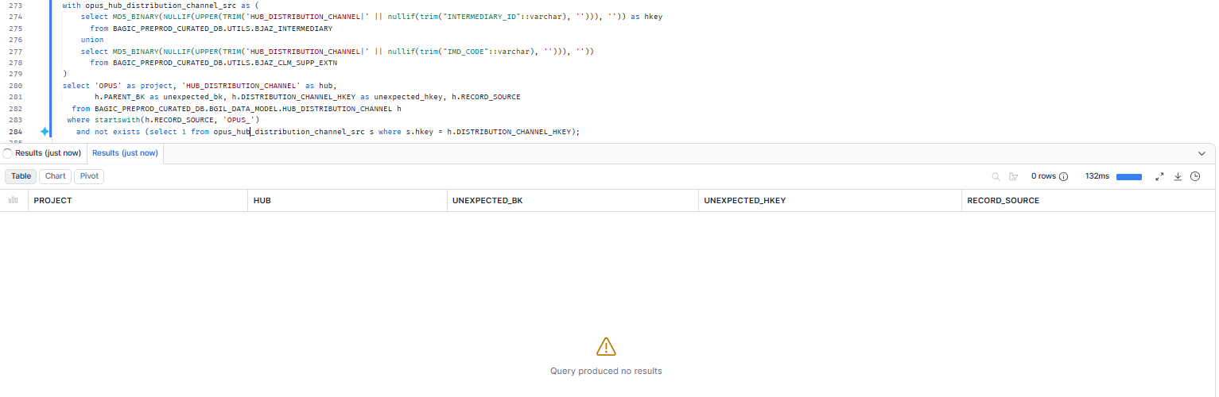

16. OPUS — HUB_LOCATION
Project | OPUS
Hub table | HUB_LOCATION
Status | Implemented
Pass criteria | 0 rows returned
Result (Pass / Fail / NA) | Pass
Rows returned (count) | 0

Note: First 5 sources are the stitch_common_address branches (single-column key_column per source, not composite); remaining 6 are the direct stg2_hub_*__location branches. Stitch views are watermark-windowed, so raw tables are used instead.
SQL query
with opus_hub_location_src as (
select MD5_BINARY(NULLIF(UPPER(TRIM('HUB_LOCATION|' || nullif(trim("ADD_ID"::varchar), ''))), '')) as hkey
from BAGIC_PREPROD_CURATED_DB.UTILS.AZBJ_ADDRESS_EXTN
union
select MD5_BINARY(NULLIF(UPPER(TRIM('HUB_LOCATION|' || nullif(trim("BILLING_LOC"::varchar), ''))), ''))
from BAGIC_PREPROD_CURATED_DB.UTILS.BJAZ_CLM_SUPP_EXTN
union
select MD5_BINARY(NULLIF(UPPER(TRIM('HUB_LOCATION|' || nullif(trim("PINCODE"::varchar), ''))), ''))
from BAGIC_PREPROD_CURATED_DB.UTILS.BJAZ_PINCODE
union
select MD5_BINARY(NULLIF(UPPER(TRIM('HUB_LOCATION|' || nullif(trim("PINCODE"::varchar), ''))), ''))
from BAGIC_PREPROD_CURATED_DB.UTILS.BJAZ_PINCODE_MASTER
union
select MD5_BINARY(NULLIF(UPPER(TRIM('HUB_LOCATION|' || nullif(trim("ADD_ID"::varchar), ''))), ''))
from BAGIC_PREPROD_CURATED_DB.UTILS.CP_ADDRESSES
union
select MD5_BINARY(NULLIF(UPPER(TRIM('HUB_LOCATION|' || nullif(trim("MAIL_ADD_ID"::varchar), ''))), ''))
from BAGIC_PREPROD_CURATED_DB.UTILS.AZBJ_PARTNER_EXTN
union
select MD5_BINARY(NULLIF(UPPER(TRIM('HUB_LOCATION|' || nullif(trim("LOCATION_CODE"::varchar), ''))), ''))
from BAGIC_PREPROD_CURATED_DB.UTILS.BJAZ_CLM_SUPP_EXTN
union
select MD5_BINARY(NULLIF(UPPER(TRIM('HUB_LOCATION|' || nullif(trim("ADD_ID"::varchar), ''))), ''))
from BAGIC_PREPROD_CURATED_DB.UTILS.BJAZ_CP_ADDRESS_LINK
union
select MD5_BINARY(NULLIF(UPPER(TRIM('HUB_LOCATION|' || nullif(trim("LOC_CODE"::varchar), ''))), ''))
from BAGIC_PREPROD_CURATED_DB.UTILS.CLM_SUPPLIERS
union
select MD5_BINARY(NULLIF(UPPER(TRIM('HUB_LOCATION|' || nullif(trim("ADD_ID"::varchar), ''))), ''))
from BAGIC_PREPROD_CURATED_DB.UTILS.CP_PARTNERS
union
select MD5_BINARY(NULLIF(UPPER(TRIM('HUB_LOCATION|' || nullif(trim("MAILING_ADDRESS_ID"::varchar), ''))), ''))
from BAGIC_PREPROD_CURATED_DB.UTILS.OCP_INTERESTED_PARTIES
)
select 'OPUS' as project, 'HUB_LOCATION' as hub,
h.PARENT_BK as unexpected_bk, h.LOCATION_HKEY as unexpected_hkey, h.RECORD_SOURCE
from BAGIC_PREPROD_CURATED_DB.BGIL_DATA_MODEL.HUB_LOCATION h
where startswith(h.RECORD_SOURCE, 'OPUS_')
and not exists (select 1 from opus_hub_location_src s where s.hkey = h.LOCATION_HKEY);
Query output (attach / paste below)
Output:
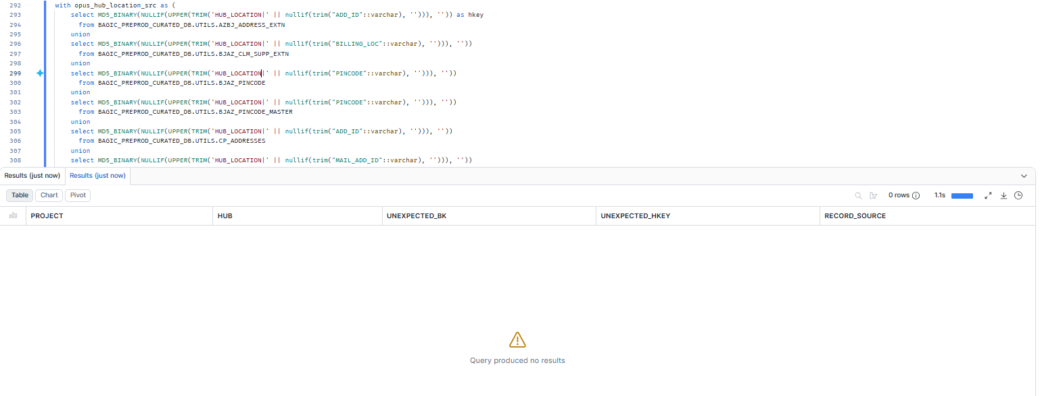

17. OPUS — HUB_POLICY
Project | OPUS
Hub table | HUB_POLICY
Status | Implemented
Pass criteria | 0 rows returned
Result (Pass / Fail / NA) | Pass
Rows returned (count) | 0

Note: Includes the stitched branches: stitch_policy_header (AZBJ_PARTNER_EXTN.EXISTING_POLICY_PID, BJAZ_CTNGY_GC_MEM_DATA.POLICY_REF, CONTRACT_ID of 8 member tables) and stitch_policy_bonus_tracking (adds BJAZ_HLT_ENSURE_MEM_DTLS.CONTRACT_ID), plus the 6 direct stg2_hub_*__policy branches.
SQL query
with opus_hub_policy_src as (
select MD5_BINARY(NULLIF(UPPER(TRIM('HUB_POLICY|' || nullif(trim("EXISTING_POLICY_PID"::varchar), ''))), '')) as hkey
from BAGIC_PREPROD_CURATED_DB.UTILS.AZBJ_PARTNER_EXTN
union
select MD5_BINARY(NULLIF(UPPER(TRIM('HUB_POLICY|' || nullif(trim("POLICY_REF"::varchar), ''))), ''))
from BAGIC_PREPROD_CURATED_DB.UTILS.BJAZ_CTNGY_GC_MEM_DATA
union
select MD5_BINARY(NULLIF(UPPER(TRIM('HUB_POLICY|' || nullif(trim("CONTRACT_ID"::varchar), ''))), ''))
from BAGIC_PREPROD_CURATED_DB.UTILS.BJAZ_CTNGY_PA_MEM_DTLS
union
select MD5_BINARY(NULLIF(UPPER(TRIM('HUB_POLICY|' || nullif(trim("CONTRACT_ID"::varchar), ''))), ''))
from BAGIC_PREPROD_CURATED_DB.UTILS.BJAZ_EC_MEM_DTLS_EXTN
union
select MD5_BINARY(NULLIF(UPPER(TRIM('HUB_POLICY|' || nullif(trim("CONTRACT_ID"::varchar), ''))), ''))
from BAGIC_PREPROD_CURATED_DB.UTILS.BJAZ_HCF_MEMBER_DTLS
union
select MD5_BINARY(NULLIF(UPPER(TRIM('HUB_POLICY|' || nullif(trim("CONTRACT_ID"::varchar), ''))), ''))
from BAGIC_PREPROD_CURATED_DB.UTILS.BJAZ_HC_PART_EXTN
union
select MD5_BINARY(NULLIF(UPPER(TRIM('HUB_POLICY|' || nullif(trim("CONTRACT_ID"::varchar), ''))), ''))
from BAGIC_PREPROD_CURATED_DB.UTILS.BJAZ_HM_MEMBER_DTLS
union
select MD5_BINARY(NULLIF(UPPER(TRIM('HUB_POLICY|' || nullif(trim("CONTRACT_ID"::varchar), ''))), ''))
from BAGIC_PREPROD_CURATED_DB.UTILS.BJAZ_PA_DETL_EXTN
union
select MD5_BINARY(NULLIF(UPPER(TRIM('HUB_POLICY|' || nullif(trim("CONTRACT_ID"::varchar), ''))), ''))
from BAGIC_PREPROD_CURATED_DB.UTILS.BJAZ_SH_MEM_DTLS_EXTN
union
select MD5_BINARY(NULLIF(UPPER(TRIM('HUB_POLICY|' || nullif(trim("CONTRACT_ID"::varchar), ''))), ''))
from BAGIC_PREPROD_CURATED_DB.UTILS.BJAZ_SPP_MEMBER_DTLS
union
select MD5_BINARY(NULLIF(UPPER(TRIM('HUB_POLICY|' || nullif(trim("CONTRACT_ID"::varchar), ''))), ''))
from BAGIC_PREPROD_CURATED_DB.UTILS.BJAZ_HLT_ENSURE_MEM_DTLS
union
select MD5_BINARY(NULLIF(UPPER(TRIM('HUB_POLICY|' || nullif(trim("CONTRACT_ID"::varchar), ''))), ''))
from BAGIC_PREPROD_CURATED_DB.UTILS.BA_HCP_DT_MEM
union
select MD5_BINARY(NULLIF(UPPER(TRIM('HUB_POLICY|' || nullif(trim("CONTRACT_ID"::varchar), ''))), ''))
from BAGIC_PREPROD_CURATED_DB.UTILS.BJAZ_CTNGY_FF_DTLS_EXTN
union
select MD5_BINARY(NULLIF(UPPER(TRIM('HUB_POLICY|' || nullif(trim("POLICY_NUMBER"::varchar), ''))), ''))
from BAGIC_PREPROD_CURATED_DB.UTILS.BJAZ_HCF_MEMBER_DTLS
union
select MD5_BINARY(NULLIF(UPPER(TRIM('HUB_POLICY|' || nullif(trim("POLICY_NUMBER"::varchar), ''))), ''))
from BAGIC_PREPROD_CURATED_DB.UTILS.BJAZ_SPP_MEMBER_DTLS
union
select MD5_BINARY(NULLIF(UPPER(TRIM('HUB_POLICY|' || nullif(trim("CONTRACT_ID"::varchar), ''))), ''))
from BAGIC_PREPROD_CURATED_DB.UTILS.BJAZ_STARPKG_FF_DTLS
union
select MD5_BINARY(NULLIF(UPPER(TRIM('HUB_POLICY|' || nullif(trim("CONTRACT_ID"::varchar), ''))), ''))
from BAGIC_PREPROD_CURATED_DB.UTILS.OCP_INTERESTED_PARTIES
)
select 'OPUS' as project, 'HUB_POLICY' as hub,
h.PARENT_BK as unexpected_bk, h.POLICY_HKEY as unexpected_hkey, h.RECORD_SOURCE
from BAGIC_PREPROD_CURATED_DB.BGIL_DATA_MODEL.HUB_POLICY h
where startswith(h.RECORD_SOURCE, 'OPUS_')
and not exists (select 1 from opus_hub_policy_src s where s.hkey = h.POLICY_HKEY);
Query output (attach / paste below)
Output:
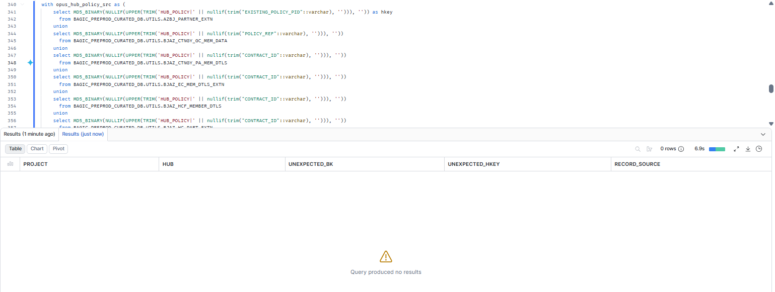

18. OPUS — HUB_PRODUCT
Project | OPUS
Hub table | HUB_PRODUCT
Status | Implemented
Pass criteria | 0 rows returned
Result (Pass / Fail / NA) | Pass
Rows returned (count) | 0

Note: Fed only via stg2_product_definition -> stitch_product_definition. Raw keys resolved from the stitch key_column of each of its 3 sources (single-column keys).
SQL query
with opus_hub_product_src as (
select MD5_BINARY(NULLIF(UPPER(TRIM('HUB_PRODUCT|' || nullif(trim("SCHEME_CODE"::varchar), ''))), '')) as hkey
from BAGIC_PREPROD_CURATED_DB.UTILS.BJAZ_CTNGY_FF_DTLS_EXTN
union
select MD5_BINARY(NULLIF(UPPER(TRIM('HUB_PRODUCT|' || nullif(trim("SCHEME_CODE"::varchar), ''))), ''))
from BAGIC_PREPROD_CURATED_DB.UTILS.BJAZ_CTNGY_PA_MEM_DTLS
union
select MD5_BINARY(NULLIF(UPPER(TRIM('HUB_PRODUCT|' || nullif(trim("PRODUCT_CODE"::varchar), ''))), ''))
from BAGIC_PREPROD_CURATED_DB.UTILS.BJAZ_HM_MEMBER_DTLS
)
select 'OPUS' as project, 'HUB_PRODUCT' as hub,
h.PARENT_BK as unexpected_bk, h.PRODUCT_HKEY as unexpected_hkey, h.RECORD_SOURCE
from BAGIC_PREPROD_CURATED_DB.BGIL_DATA_MODEL.HUB_PRODUCT h
where startswith(h.RECORD_SOURCE, 'OPUS_')
and not exists (select 1 from opus_hub_product_src s where s.hkey = h.PRODUCT_HKEY);
Query output (attach / paste below)
Output:
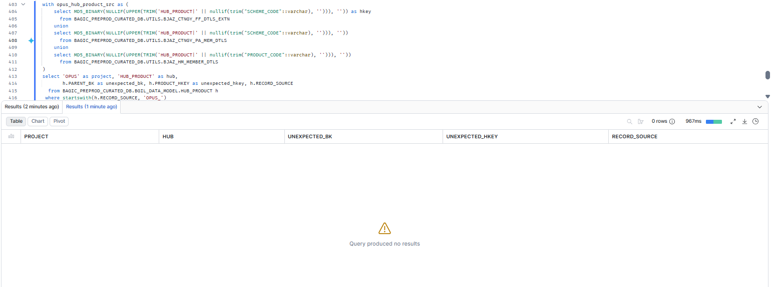

19. OPUS — HUB_RISK_OBJECT
Project | OPUS
Hub table | HUB_RISK_OBJECT
Status | Implemented
Pass criteria | 0 rows returned
Result (Pass / Fail / NA) | Pass
Rows returned (count) | 0

SQL query
with opus_hub_risk_object_src as (
select MD5_BINARY(NULLIF(UPPER(TRIM('HUB_RISK_OBJECT|' || nullif(trim("INS_OBJ_UID"::varchar), ''))), '')) as hkey
from BAGIC_PREPROD_CURATED_DB.UTILS.CLM_INTERESTED_PARTIES
)
select 'OPUS' as project, 'HUB_RISK_OBJECT' as hub,
h.PARENT_BK as unexpected_bk, h.RISK_OBJECT_HKEY as unexpected_hkey, h.RECORD_SOURCE
from BAGIC_PREPROD_CURATED_DB.BGIL_DATA_MODEL.HUB_RISK_OBJECT h
where startswith(h.RECORD_SOURCE, 'OPUS_')
and not exists (select 1 from opus_hub_risk_object_src s where s.hkey = h.RISK_OBJECT_HKEY);
Query output (attach / paste below)
Output:
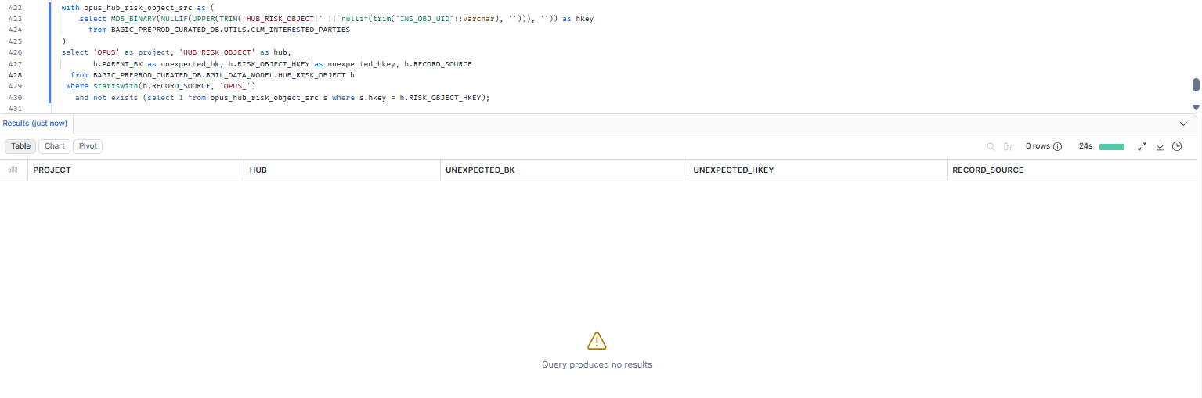

20. MAXIMUS + OPUS — Ownership sweep (shared hubs)
Project | MAXIMUS + OPUS
Hub table | Ownership sweep (shared hubs)
Status | Informational
Pass criteria | 0 rows, or only known other projects
Result (Pass / Fail / NA) | Pass
Rows returned (count) | )

Note: Informational, not part of the pass criterion. Rows whose RECORD_SOURCE is neither MAXIMUS_ nor OPUS_ are not covered by sections 1-19. Expected: 0 rows, or only record sources of other known projects writing the same tables.
SQL query
-- Informational: rows in shared hubs owned by neither project (not covered above).
select hub, RECORD_SOURCE, count(*) as rows_not_covered
from (
select 'HUB_PARTY' as hub, RECORD_SOURCE from BAGIC_PREPROD_CURATED_DB.BGIL_DATA_MODEL.HUB_PARTY
union all select 'HUB_LOCATION', RECORD_SOURCE from BAGIC_PREPROD_CURATED_DB.BGIL_DATA_MODEL.HUB_LOCATION
union all select 'HUB_POLICY', RECORD_SOURCE from BAGIC_PREPROD_CURATED_DB.BGIL_DATA_MODEL.HUB_POLICY
union all select 'HUB_PRODUCT', RECORD_SOURCE from BAGIC_PREPROD_CURATED_DB.BGIL_DATA_MODEL.HUB_PRODUCT
union all select 'HUB_DISTRIBUTION_CHANNEL', RECORD_SOURCE from BAGIC_PREPROD_CURATED_DB.BGIL_DATA_MODEL.HUB_DISTRIBUTION_CHANNEL
)
where not startswith(RECORD_SOURCE, 'MAXIMUS_')
and not startswith(RECORD_SOURCE, 'OPUS_')
group by hub, RECORD_SOURCE
order by hub, RECORD_SOURCE;
Query output (attach / paste below)
Output:
