DM-K2 | Key Checks — No Extra / Unexpected Keys
Hub key reconciliation (hub → RAW source). Pass criterion: 0 rows returned (0 unexpected business keys).

Check Overview
Check ID | DM-K2
Category | Key checks
Sign-off criterion | No extra / unexpected keys
Method | Anti-join: HUB rows of the project → union of every RAW source branch of that hub
Pass criteria / tolerance | 0 unexpected keys
Owner | LUMIQ
Vault location | BAGIC_PREPROD_CURATED_DB.BGIL_DATA_MODEL
Maximus RAW | BAGIC_PROD_MIRROR_DB.MAXI_RAW
Opus RAW (test) | BAGIC_PREPROD_CURATED_DB.UTILS (prod: BAGIC_PROD_MIRROR_DB.OPUS_GG_DWHSTAGE)
Hash key formula | MD5_BINARY(NULLIF(UPPER(TRIM(CAST(<NK> AS VARCHAR))), '')) -- BINARY(16), automate_dv 0.11.5 default
Scope (shared vault) | Hub rows filtered by RECORD_SOURCE prefix: MAXIMUS_ rows against Maximus RAW, OPUS_ rows against Opus RAW. The last section lists rows owned by neither.
Output columns | project, hub, unexpected_bk, unexpected_hkey, RECORD_SOURCE, LOAD_DATETIME

Revision notes
• Regenerated 2026-10-09 from the current opus_partner_dv_dbt and maximus_partner_dv_dbt models; previous results (rows, screenshots, Pass/Fail) are cleared and must be re-run.
• Scope: 10 MAXIMUS hubs + 11 OPUS hubs = 21 project-hub sections (14 physical hub tables).
• OPUS new hubs: HUB_DOCUMENT (3 KYC branches) and HUB_ORG_UNIT (10 KYC branches).
• OPUS HUB_PARTY: CP_PARTNERS plus 17 KYC key branches (PAN:/GSTIN:/LICENCE:/PASSPORT:/VOTER:/CKYC:/CATEGORY:INPUT key forms).
• OPUS HUB_POLICY (27 RAW branches incl. KYC POLICY% field_value and the stitch_policy_header / stitch_policy_bonus_tracking keys), HUB_LOCATION (19 branches incl. stitch_common_address and the KYC composite address keys) and HUB_PRODUCT (stitch_product_definition) are now fully implemented -- no TODO branches remain.
• MAXIMUS: RAW table ..._SIMPLE_PROPERTY_PIVOT_VW (no _2_1 suffix) after the RECORD_SOURCE fix; HUB_PARTY hubfeed branches resolve to 7 RAW keys; HUB_FINANCIAL_ACCOUNT remains NA (account_code not mapped).
• Hash reproduced exactly as automate_dv 0.11.5 does: MD5_BINARY(NULLIF(UPPER(TRIM(CAST(<NK> AS VARCHAR))), '')).
• Excluded (loads nothing): disabled placeholder stg2_hub_bjaz_t_kyc_details__party__kyc_subject; MAXIMUS branch_code (ORG_UNIT) and account_code (FINANCIAL_ACCOUNT) are cast(null) in staging.

Results summary
# | Project | Hub | Status | Result | Rows / diff
1 | MAXIMUS | HUB_PARTY | Implemented
2 | MAXIMUS | HUB_STAKE_CODE | Implemented
3 | MAXIMUS | HUB_LOCATION | Implemented
4 | MAXIMUS | HUB_PAYMENT_INSTRUMENT | Implemented
5 | MAXIMUS | HUB_PRODUCT | Implemented
6 | MAXIMUS | HUB_FINANCIAL_ACCOUNT | NA
7 | MAXIMUS | HUB_DOCUMENT | Implemented
8 | MAXIMUS | HUB_POLICY | Implemented
9 | MAXIMUS | HUB_DISTRIBUTION_CHANNEL | Implemented
10 | MAXIMUS | HUB_ORG_UNIT | Implemented
11 | OPUS | HUB_PARTY | Implemented
12 | OPUS | HUB_AGENT | Implemented
13 | OPUS | HUB_AGREEMENT | Implemented
14 | OPUS | HUB_CLAIM | Implemented
15 | OPUS | HUB_LOCATION | Implemented
16 | OPUS | HUB_PRODUCT | Implemented
17 | OPUS | HUB_DOCUMENT | Implemented
18 | OPUS | HUB_POLICY | Implemented
19 | OPUS | HUB_DISTRIBUTION_CHANNEL | Implemented
20 | OPUS | HUB_ORG_UNIT | Implemented
21 | OPUS | HUB_RISK_OBJECT | Implemented
22 | MAXIMUS + OPUS | Ownership sweep (all hubs) | Informational

Validation Queries

1. MAXIMUS — HUB_PARTY
Project | MAXIMUS
Hub table | HUB_PARTY
Status | Implemented
Pass criteria | 0 rows returned
Result (Pass / Fail / NA) | Pass
Rows returned (count) | 0
Remarks

Note: Hub rows scoped to RECORD_SOURCE 'MAXIMUS_%'. A hit grouped under one RECORD_SOURCE that no longer feeds the hub is a legacy load from a removed feed (classify, do not ignore). 7 RAW key branch(es): BUSINESS_PARTNERS_VW_DATA_PARTY_DETAIL.PARTY_CODE, BUSINESS_PARTNERS_VW_DATA_PARTY_DETAIL_PARTY_ADDRESS.FOREIGN_KEY, BUSINESS_PARTNERS_VW_DATA_PARTY_DETAIL_PARTY_ADDRESS_ADDRESS_PROPERTY_PIVOT_VW.FOREIGN_KEY, BUSINESS_PARTNERS_VW_DATA_PARTY_DETAIL_PARTY_PROPERTY_MULTI_SET_PROPERTY_MULTI_SET_DETAIL_PROPERTY_PIVOT_VW.FOREIGN_KEY, BUSINESS_PARTNERS_VW_DATA_PARTY_DETAIL_PARTY_PROPERTY_SIMPLE_PROPERTY_PIVOT_VW.BAGIC_EMPLOYEE_CODE, BUSINESS_PARTNERS_VW_DATA_PARTY_DETAIL_PARTY_RELATION.FOREIGN_KEY, BUSINESS_PARTNERS_VW_DATA_PARTY_DETAIL_RELATED_PARTY.FOREIGN_KEY. 169 feed branches (incl. every unpivot arm) collapse to 7 RAW key(s): every unpivot branch is a filtered subset of its base stage on the same RAW table and key column.
SQL query
with src as (
-- via hubfeed_party <- stg2_mp__pd
select MD5_BINARY(NULLIF(UPPER(TRIM(CAST('HUB_PARTY|' || (nullif(trim(to_varchar("PARTY_CODE")), '')) AS VARCHAR))), '')) as hkey
from BAGIC_PROD_MIRROR_DB.MAXI_RAW.BUSINESS_PARTNERS_VW_DATA_PARTY_DETAIL
union all
-- via hubfeed_party <- stg2_mp__pd_addr
select MD5_BINARY(NULLIF(UPPER(TRIM(CAST('HUB_PARTY|' || (nullif(trim(to_varchar("FOREIGN_KEY")), '')) AS VARCHAR))), '')) as hkey
from BAGIC_PROD_MIRROR_DB.MAXI_RAW.BUSINESS_PARTNERS_VW_DATA_PARTY_DETAIL_PARTY_ADDRESS
union all
-- via hubfeed_party <- stg2_mp__pd_party_addr_prop_pv
select MD5_BINARY(NULLIF(UPPER(TRIM(CAST('HUB_PARTY|' || (nullif(trim(to_varchar("FOREIGN_KEY")), '')) AS VARCHAR))), '')) as hkey
from BAGIC_PROD_MIRROR_DB.MAXI_RAW.BUSINESS_PARTNERS_VW_DATA_PARTY_DETAIL_PARTY_ADDRESS_ADDRESS_PROPERTY_PIVOT_VW
union all
-- via hubfeed_party <- stg2_mp__pd_prop_msdp_pv (+2 more feed(s) on the same RAW table + key)
select MD5_BINARY(NULLIF(UPPER(TRIM(CAST('HUB_PARTY|' || (nullif(trim(to_varchar("FOREIGN_KEY")), '')) AS VARCHAR))), '')) as hkey
from BAGIC_PROD_MIRROR_DB.MAXI_RAW.BUSINESS_PARTNERS_VW_DATA_PARTY_DETAIL_PARTY_PROPERTY_MULTI_SET_PROPERTY_MULTI_SET_DETAIL_PROPERTY_PIVOT_VW
union all
-- via hubfeed_party <- stg2_mp__pd_prop_sp_pv (+4 more feed(s) on the same RAW table + key)
select MD5_BINARY(NULLIF(UPPER(TRIM(CAST('HUB_PARTY|' || (nullif(trim(to_varchar("BAGIC_EMPLOYEE_CODE")), '')) AS VARCHAR))), '')) as hkey
from BAGIC_PROD_MIRROR_DB.MAXI_RAW.BUSINESS_PARTNERS_VW_DATA_PARTY_DETAIL_PARTY_PROPERTY_SIMPLE_PROPERTY_PIVOT_VW
union all
-- via hubfeed_party <- stg2_mp__pd_rel (+1 more feed(s) on the same RAW table + key)
select MD5_BINARY(NULLIF(UPPER(TRIM(CAST('HUB_PARTY|' || (nullif(trim(to_varchar("FOREIGN_KEY")), '')) AS VARCHAR))), '')) as hkey
from BAGIC_PROD_MIRROR_DB.MAXI_RAW.BUSINESS_PARTNERS_VW_DATA_PARTY_DETAIL_PARTY_RELATION
union all
-- via hubfeed_party <- stg2_mp__pd_relparty (+1 more feed(s) on the same RAW table + key)
select MD5_BINARY(NULLIF(UPPER(TRIM(CAST('HUB_PARTY|' || (nullif(trim(to_varchar("FOREIGN_KEY")), '')) AS VARCHAR))), '')) as hkey
from BAGIC_PROD_MIRROR_DB.MAXI_RAW.BUSINESS_PARTNERS_VW_DATA_PARTY_DETAIL_RELATED_PARTY
)
select 'MAXIMUS' as project, 'HUB_PARTY' as hub,
h.PARENT_BK as unexpected_bk, h.PARTY_HKEY as unexpected_hkey, h.RECORD_SOURCE, h.LOAD_DATETIME
from BAGIC_PREPROD_CURATED_DB.BGIL_DATA_MODEL.HUB_PARTY h
where startswith(h.RECORD_SOURCE, 'MAXIMUS_')
and not exists (select 1 from src s where s.hkey = h.PARTY_HKEY)
order by h.RECORD_SOURCE, unexpected_bk;
Query output (attach / paste below)
Output:
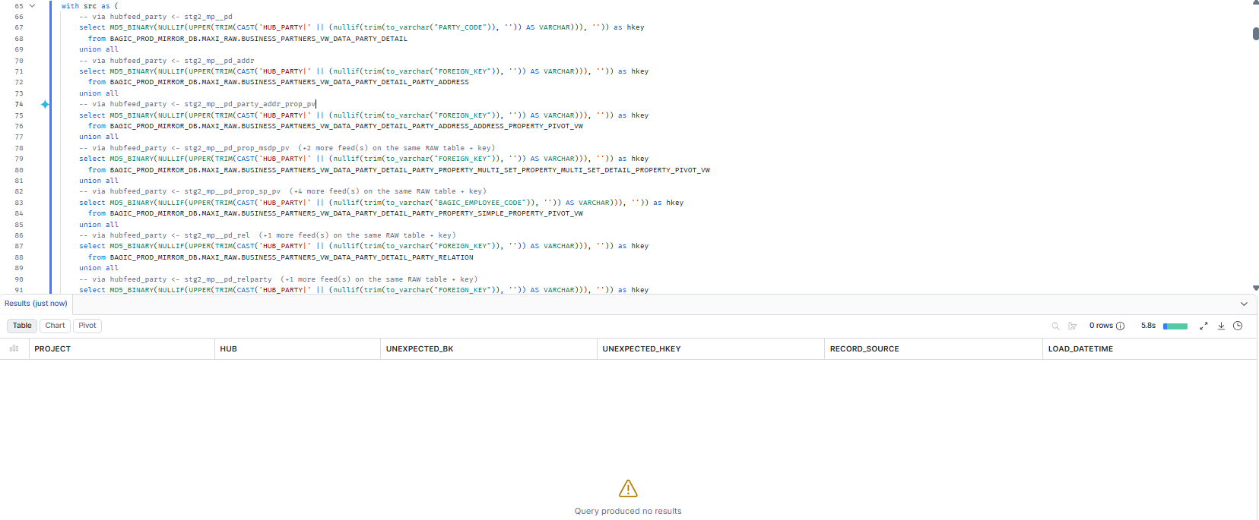

2. MAXIMUS — HUB_STAKE_CODE
Project | MAXIMUS
Hub table | HUB_STAKE_CODE
Status | Implemented
Pass criteria | 0 rows returned
Result (Pass / Fail / NA) | Pass
Rows returned (count) | 0
Remarks

Note: Hub rows scoped to RECORD_SOURCE 'MAXIMUS_%'. A hit grouped under one RECORD_SOURCE that no longer feeds the hub is a legacy load from a removed feed (classify, do not ignore). 1 RAW key branch(es): BUSINESS_PARTNERS_VW_DATA_PARTY_DETAIL_RELATED_PARTY.STAKE_CODE.
SQL query
with src as (
-- via hubfeed_stake_code <- stg2_mp__stake_code
select MD5_BINARY(NULLIF(UPPER(TRIM(CAST('HUB_STAKE_CODE|' || (nullif(trim(to_varchar("STAKE_CODE")), '')) AS VARCHAR))), '')) as hkey
from BAGIC_PROD_MIRROR_DB.MAXI_RAW.BUSINESS_PARTNERS_VW_DATA_PARTY_DETAIL_RELATED_PARTY
)
select 'MAXIMUS' as project, 'HUB_STAKE_CODE' as hub,
h.STAKE_CODE_BK as unexpected_bk, h.STAKE_CODE_HKEY as unexpected_hkey, h.RECORD_SOURCE, h.LOAD_DATETIME
from BAGIC_PREPROD_CURATED_DB.BGIL_DATA_MODEL.HUB_STAKE_CODE h
where startswith(h.RECORD_SOURCE, 'MAXIMUS_')
and not exists (select 1 from src s where s.hkey = h.STAKE_CODE_HKEY)
order by h.RECORD_SOURCE, unexpected_bk;
Query output (attach / paste below)
Output:
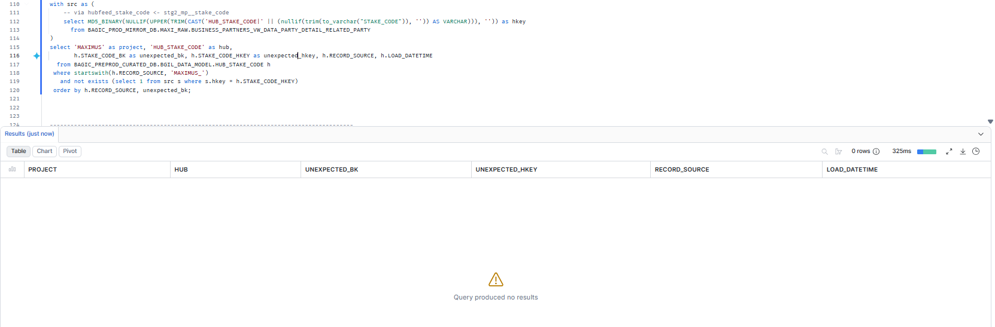

3. MAXIMUS — HUB_LOCATION
Project | MAXIMUS
Hub table | HUB_LOCATION
Status | Implemented
Pass criteria | 0 rows returned
Result (Pass / Fail / NA) | Fail
Rows returned (count) | 351
Remarks

Note: Hub rows scoped to RECORD_SOURCE 'MAXIMUS_%'. A hit grouped under one RECORD_SOURCE that no longer feeds the hub is a legacy load from a removed feed (classify, do not ignore). 3 RAW key branch(es): BUSINESS_PARTNERS_VW_DATA_PARTY_DETAIL_PARTY_ADDRESS.[ADDRESS1+ADDRESS2+ADDRESS3+CITY+DISTRICT+STATE+PINCODE+COUNTRY], BUSINESS_PARTNERS_VW_DATA_PARTY_DETAIL_PARTY_ADDRESS_ADDRESS_PROPERTY_PIVOT_VW.[LAND_MARK+AREA+POST_OFFICE+CITY+STATE+PINCODE], BUSINESS_PARTNERS_VW_DATA_PARTY_DETAIL_PARTY_PROPERTY_SIMPLE_PROPERTY_PIVOT_VW.[OUR_OFFICE_ADDRESS+CURRENT_PERMANENT_OVERSEAS_ADDRESS_LINE_2+CURRENT_PERMANENT_OVERSEAS_ADDRESS_LINE_3+CURRENT_PERMANENT_OVERSEAS_ADDRESS_CITY_TOWN_VILLAGE+CORRESPONDENCE_LOCAL_ADDRESS_DISTRICT+CURRENT_PERMANENT_OVERSEAS_ADDRESS_STATE_UT+LOCAL_ADDRESS_PIN_CODE+CURRENT_PERMANENT_OVERSEAS_ADDRESS_COUNTRY].
SQL query
with src as (
-- via hubfeed_location <- stg2_mp__pd_addr
select MD5_BINARY(NULLIF(UPPER(TRIM(CAST('HUB_LOCATION|' || (case when coalesce(upper(trim(to_varchar(nullif(trim(to_varchar("ADDRESS1")), '')))), upper(trim(to_varchar(nullif(trim(to_varchar("ADDRESS2")), '')))), upper(trim(to_varchar(nullif(trim(to_varchar("ADDRESS3")), '')))), upper(trim(to_varchar(nullif(trim(to_varchar("CITY")), '')))), upper(trim(to_varchar(nullif(trim(to_varchar("DISTRICT")), '')))), upper(trim(to_varchar(nullif(trim(to_varchar("STATE")), '')))), upper(trim(to_varchar(nullif(trim(to_varchar("PINCODE")), '')))), upper(trim(to_varchar(nullif(trim(to_varchar("COUNTRY")), ''))))) is null then null else md5(concat_ws('|', coalesce(upper(trim(to_varchar(nullif(trim(to_varchar("ADDRESS1")), '')))), ''), coalesce(upper(trim(to_varchar(nullif(trim(to_varchar("ADDRESS2")), '')))), ''), coalesce(upper(trim(to_varchar(nullif(trim(to_varchar("ADDRESS3")), '')))), ''), coalesce(upper(trim(to_varchar(nullif(trim(to_varchar("CITY")), '')))), ''), coalesce(upper(trim(to_varchar(nullif(trim(to_varchar("DISTRICT")), '')))), ''), coalesce(upper(trim(to_varchar(nullif(trim(to_varchar("STATE")), '')))), ''), coalesce(upper(trim(to_varchar(nullif(trim(to_varchar("PINCODE")), '')))), ''), coalesce(upper(trim(to_varchar(nullif(trim(to_varchar("COUNTRY")), '')))), ''))) end) AS VARCHAR))), '')) as hkey
from BAGIC_PROD_MIRROR_DB.MAXI_RAW.BUSINESS_PARTNERS_VW_DATA_PARTY_DETAIL_PARTY_ADDRESS
union all
-- via hubfeed_location <- stg2_mp__pd_party_addr_prop_pv
select MD5_BINARY(NULLIF(UPPER(TRIM(CAST('HUB_LOCATION|' || (case when coalesce(upper(trim(to_varchar(nullif(trim(to_varchar("LAND_MARK")), '')))), upper(trim(to_varchar(nullif(trim(to_varchar("AREA")), '')))), upper(trim(to_varchar(nullif(trim(to_varchar("POST_OFFICE")), '')))), upper(trim(to_varchar(nullif(trim(to_varchar("CITY")), '')))), upper(trim(to_varchar(nullif(trim(to_varchar("STATE")), '')))), upper(trim(to_varchar(nullif(trim(to_varchar("PINCODE")), ''))))) is null then null else md5(concat_ws('|', coalesce(upper(trim(to_varchar(nullif(trim(to_varchar("LAND_MARK")), '')))), ''), coalesce(upper(trim(to_varchar(nullif(trim(to_varchar("AREA")), '')))), ''), coalesce(upper(trim(to_varchar(nullif(trim(to_varchar("POST_OFFICE")), '')))), ''), coalesce(upper(trim(to_varchar(nullif(trim(to_varchar("CITY")), '')))), ''), coalesce(upper(trim(to_varchar(nullif(trim(to_varchar("STATE")), '')))), ''), coalesce(upper(trim(to_varchar(nullif(trim(to_varchar("PINCODE")), '')))), ''))) end) AS VARCHAR))), '')) as hkey
from BAGIC_PROD_MIRROR_DB.MAXI_RAW.BUSINESS_PARTNERS_VW_DATA_PARTY_DETAIL_PARTY_ADDRESS_ADDRESS_PROPERTY_PIVOT_VW
union all
-- via hubfeed_location <- stg2_mp__pd_prop_sp_pv
select MD5_BINARY(NULLIF(UPPER(TRIM(CAST('HUB_LOCATION|' || (case when coalesce(upper(trim(to_varchar(nullif(trim(to_varchar("OUR_OFFICE_ADDRESS")), '')))), upper(trim(to_varchar(nullif(trim(to_varchar("CURRENT_PERMANENT_OVERSEAS_ADDRESS_LINE_2")), '')))), upper(trim(to_varchar(nullif(trim(to_varchar("CURRENT_PERMANENT_OVERSEAS_ADDRESS_LINE_3")), '')))), upper(trim(to_varchar(nullif(trim(to_varchar("CURRENT_PERMANENT_OVERSEAS_ADDRESS_CITY_TOWN_VILLAGE")), '')))), upper(trim(to_varchar(nullif(trim(to_varchar("CORRESPONDENCE_LOCAL_ADDRESS_DISTRICT")), '')))), upper(trim(to_varchar(nullif(trim(to_varchar("CURRENT_PERMANENT_OVERSEAS_ADDRESS_STATE_UT")), '')))), upper(trim(to_varchar(nullif(trim(to_varchar("LOCAL_ADDRESS_PIN_CODE")), '')))), upper(trim(to_varchar(nullif(trim(to_varchar("CURRENT_PERMANENT_OVERSEAS_ADDRESS_COUNTRY")), ''))))) is null then null else md5(concat_ws('|', coalesce(upper(trim(to_varchar(nullif(trim(to_varchar("OUR_OFFICE_ADDRESS")), '')))), ''), coalesce(upper(trim(to_varchar(nullif(trim(to_varchar("CURRENT_PERMANENT_OVERSEAS_ADDRESS_LINE_2")), '')))), ''), coalesce(upper(trim(to_varchar(nullif(trim(to_varchar("CURRENT_PERMANENT_OVERSEAS_ADDRESS_LINE_3")), '')))), ''), coalesce(upper(trim(to_varchar(nullif(trim(to_varchar("CURRENT_PERMANENT_OVERSEAS_ADDRESS_CITY_TOWN_VILLAGE")), '')))), ''), coalesce(upper(trim(to_varchar(nullif(trim(to_varchar("CORRESPONDENCE_LOCAL_ADDRESS_DISTRICT")), '')))), ''), coalesce(upper(trim(to_varchar(nullif(trim(to_varchar("CURRENT_PERMANENT_OVERSEAS_ADDRESS_STATE_UT")), '')))), ''), coalesce(upper(trim(to_varchar(nullif(trim(to_varchar("LOCAL_ADDRESS_PIN_CODE")), '')))), ''), coalesce(upper(trim(to_varchar(nullif(trim(to_varchar("CURRENT_PERMANENT_OVERSEAS_ADDRESS_COUNTRY")), '')))), ''))) end) AS VARCHAR))), '')) as hkey
from BAGIC_PROD_MIRROR_DB.MAXI_RAW.BUSINESS_PARTNERS_VW_DATA_PARTY_DETAIL_PARTY_PROPERTY_SIMPLE_PROPERTY_PIVOT_VW
)
select 'MAXIMUS' as project, 'HUB_LOCATION' as hub,
h.PARENT_BK as unexpected_bk, h.LOCATION_HKEY as unexpected_hkey, h.RECORD_SOURCE, h.LOAD_DATETIME
from BAGIC_PREPROD_CURATED_DB.BGIL_DATA_MODEL.HUB_LOCATION h
where startswith(h.RECORD_SOURCE, 'MAXIMUS_')
and not exists (select 1 from src s where s.hkey = h.LOCATION_HKEY)
order by h.RECORD_SOURCE, unexpected_bk;
Query output (attach / paste below)
Output:
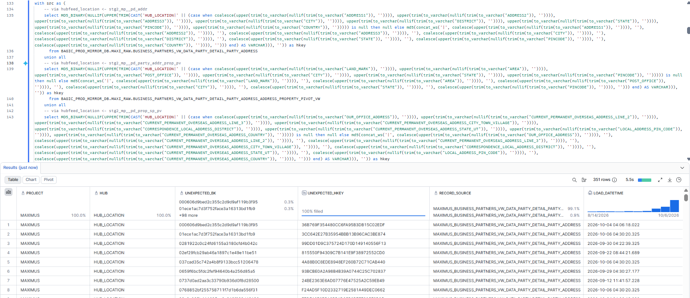

4. MAXIMUS — HUB_PAYMENT_INSTRUMENT
Project | MAXIMUS
Hub table | HUB_PAYMENT_INSTRUMENT
Status | Implemented
Pass criteria | 0 rows returned
Result (Pass / Fail / NA) | Pass
Rows returned (count) | 0
Remarks

Note: Hub rows scoped to RECORD_SOURCE 'MAXIMUS_%'. A hit grouped under one RECORD_SOURCE that no longer feeds the hub is a legacy load from a removed feed (classify, do not ignore). 1 RAW key branch(es): BUSINESS_PARTNERS_VW_DATA_PARTY_DETAIL_PARTY_PROPERTY_MULTI_SET_PROPERTY_MULTI_SET_DETAIL_PROPERTY_PIVOT_VW.FOREIGN_KEY.
SQL query
with src as (
-- via hubfeed_payment_instrument <- stg2_mp__pd_prop_msdp_pv
select MD5_BINARY(NULLIF(UPPER(TRIM(CAST('HUB_PAYMENT_INSTRUMENT|' || ('HUB_PAYMENT_INSTRUMENT|' || nullif(trim(to_varchar("FOREIGN_KEY")), '')) AS VARCHAR))), '')) as hkey
from BAGIC_PROD_MIRROR_DB.MAXI_RAW.BUSINESS_PARTNERS_VW_DATA_PARTY_DETAIL_PARTY_PROPERTY_MULTI_SET_PROPERTY_MULTI_SET_DETAIL_PROPERTY_PIVOT_VW
)
select 'MAXIMUS' as project, 'HUB_PAYMENT_INSTRUMENT' as hub,
h.PARENT_BK as unexpected_bk, h.PAYMENT_INSTRUMENT_HKEY as unexpected_hkey, h.RECORD_SOURCE, h.LOAD_DATETIME
from BAGIC_PREPROD_CURATED_DB.BGIL_DATA_MODEL.HUB_PAYMENT_INSTRUMENT h
where startswith(h.RECORD_SOURCE, 'MAXIMUS_')
and not exists (select 1 from src s where s.hkey = h.PAYMENT_INSTRUMENT_HKEY)
order by h.RECORD_SOURCE, unexpected_bk;
Query output (attach / paste below)
Output:
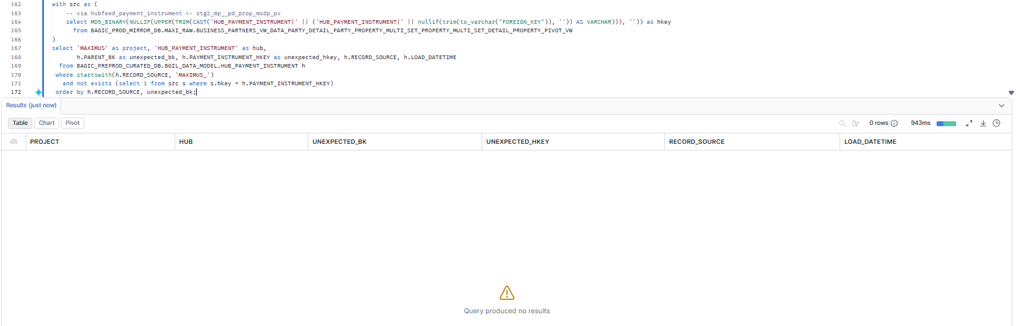

5. MAXIMUS — HUB_PRODUCT
Project | MAXIMUS
Hub table | HUB_PRODUCT
Status | Implemented
Pass criteria | 0 rows returned
Result (Pass / Fail / NA) | Pas
Rows returned (count) | 0
Remarks

Note: Hub rows scoped to RECORD_SOURCE 'MAXIMUS_%'. A hit grouped under one RECORD_SOURCE that no longer feeds the hub is a legacy load from a removed feed (classify, do not ignore). 1 RAW key branch(es): BUSINESS_PARTNERS_VW_DATA_PARTY_DETAIL_PARTY_PROPERTY_SIMPLE_PROPERTY_PIVOT_VW.PRODUCT_CODE.
SQL query
with src as (
-- via hubfeed_product <- stg2_mp__pd_prop_sp_pv
select MD5_BINARY(NULLIF(UPPER(TRIM(CAST('HUB_PRODUCT|' || (nullif(trim(to_varchar("PRODUCT_CODE")), '')) AS VARCHAR))), '')) as hkey
from BAGIC_PROD_MIRROR_DB.MAXI_RAW.BUSINESS_PARTNERS_VW_DATA_PARTY_DETAIL_PARTY_PROPERTY_SIMPLE_PROPERTY_PIVOT_VW
)
select 'MAXIMUS' as project, 'HUB_PRODUCT' as hub,
h.PARENT_BK as unexpected_bk, h.PRODUCT_HKEY as unexpected_hkey, h.RECORD_SOURCE, h.LOAD_DATETIME
from BAGIC_PREPROD_CURATED_DB.BGIL_DATA_MODEL.HUB_PRODUCT h
where startswith(h.RECORD_SOURCE, 'MAXIMUS_')
and not exists (select 1 from src s where s.hkey = h.PRODUCT_HKEY)
order by h.RECORD_SOURCE, unexpected_bk;
Query output (attach / paste below)
Output:
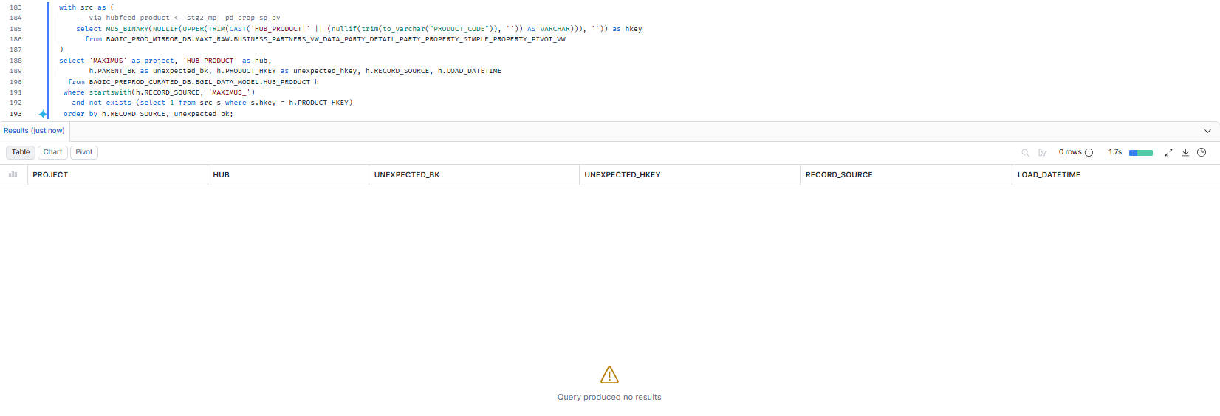

6. MAXIMUS — HUB_FINANCIAL_ACCOUNT
Project | MAXIMUS
Hub table | HUB_FINANCIAL_ACCOUNT
Status | NA
Pass criteria | NA
Result (Pass / Fail / NA) | NA
Rows returned (count)
Remarks

Note: Not applicable: hubfeed_financial_account <- stg2_mp__pd_prop_msdp_pv: key column(s) account_code hard-coded cast(null) in stg_maximus__pd_prop_msdp_pv -> contributes no keys. Re-generate once the key is mapped.
SQL query
-- DM-K2 MAXIMUS HUB_FINANCIAL_ACCOUNT: NA -- hubfeed_financial_account <- stg2_mp__pd_prop_msdp_pv: key column(s) account_code hard-coded cast(null) in stg_maximus__pd_prop_msdp_pv -> contributes no keys
Query output (attach / paste below)
Output:

7. MAXIMUS — HUB_DOCUMENT
Project | MAXIMUS
Hub table | HUB_DOCUMENT
Status | Implemented
Pass criteria | 0 rows returned
Result (Pass / Fail / NA) | Pass
Rows returned (count) | 0
Remarks

Note: Hub rows scoped to RECORD_SOURCE 'MAXIMUS_%'. A hit grouped under one RECORD_SOURCE that no longer feeds the hub is a legacy load from a removed feed (classify, do not ignore). 1 RAW key branch(es): BUSINESS_PARTNERS_VW_DATA_PARTY_DETAIL_DOCUMENT_DETAIL.DOCUMENT_ID.
SQL query
with src as (
-- via hubfeed_document <- stg2_mp__pd_doc
select MD5_BINARY(NULLIF(UPPER(TRIM(CAST('HUB_DOCUMENT|' || (nullif(trim(to_varchar("DOCUMENT_ID")), '')) AS VARCHAR))), '')) as hkey
from BAGIC_PROD_MIRROR_DB.MAXI_RAW.BUSINESS_PARTNERS_VW_DATA_PARTY_DETAIL_DOCUMENT_DETAIL
)
select 'MAXIMUS' as project, 'HUB_DOCUMENT' as hub,
h.PARENT_BK as unexpected_bk, h.DOCUMENT_HKEY as unexpected_hkey, h.RECORD_SOURCE, h.LOAD_DATETIME
from BAGIC_PREPROD_CURATED_DB.BGIL_DATA_MODEL.HUB_DOCUMENT h
where startswith(h.RECORD_SOURCE, 'MAXIMUS_')
and not exists (select 1 from src s where s.hkey = h.DOCUMENT_HKEY)
order by h.RECORD_SOURCE, unexpected_bk;
Query output (attach / paste below)
Output:
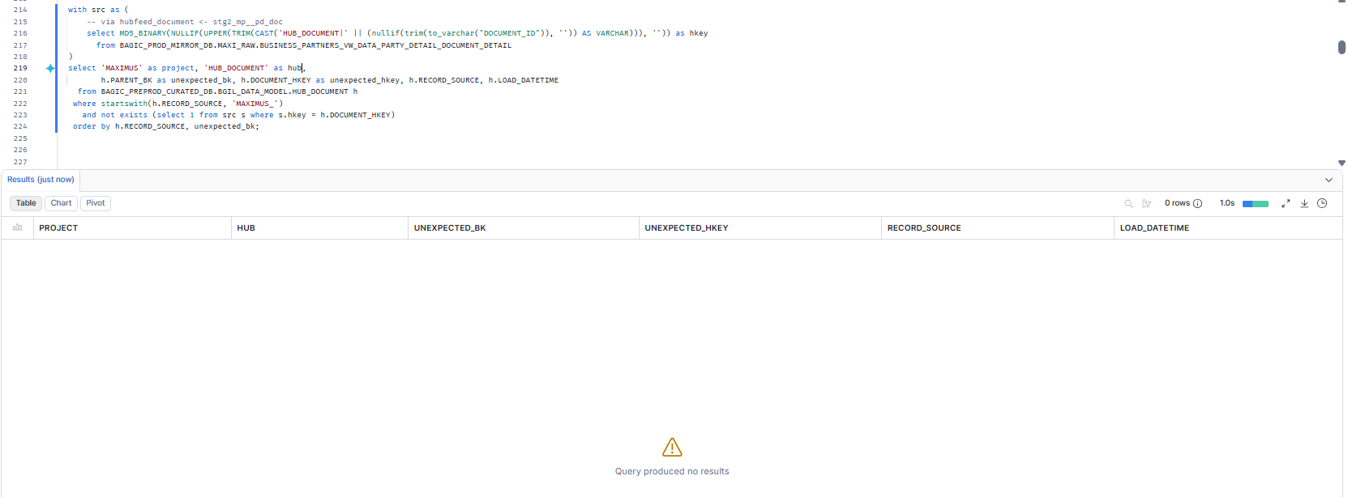

8. MAXIMUS — HUB_POLICY
Project | MAXIMUS
Hub table | HUB_POLICY
Status | Implemented
Pass criteria | 0 rows returned
Result (Pass / Fail / NA) | Pass
Rows returned (count) | 0
Remarks

Note: Hub rows scoped to RECORD_SOURCE 'MAXIMUS_%'. A hit grouped under one RECORD_SOURCE that no longer feeds the hub is a legacy load from a removed feed (classify, do not ignore). 1 RAW key branch(es): BUSINESS_PARTNERS_VW_DATA_PARTY_DETAIL_PARTY_PROPERTY_SIMPLE_PROPERTY_PIVOT_VW.PA_POLICY.
SQL query
with src as (
-- via hubfeed_policy <- stg2_mp__pd_prop_sp_pv
select MD5_BINARY(NULLIF(UPPER(TRIM(CAST('HUB_POLICY|' || (nullif(trim(to_varchar("PA_POLICY")), '')) AS VARCHAR))), '')) as hkey
from BAGIC_PROD_MIRROR_DB.MAXI_RAW.BUSINESS_PARTNERS_VW_DATA_PARTY_DETAIL_PARTY_PROPERTY_SIMPLE_PROPERTY_PIVOT_VW
)
select 'MAXIMUS' as project, 'HUB_POLICY' as hub,
h.PARENT_BK as unexpected_bk, h.POLICY_HKEY as unexpected_hkey, h.RECORD_SOURCE, h.LOAD_DATETIME
from BAGIC_PREPROD_CURATED_DB.BGIL_DATA_MODEL.HUB_POLICY h
where startswith(h.RECORD_SOURCE, 'MAXIMUS_')
and not exists (select 1 from src s where s.hkey = h.POLICY_HKEY)
order by h.RECORD_SOURCE, unexpected_bk;
Query output (attach / paste below)
Output:
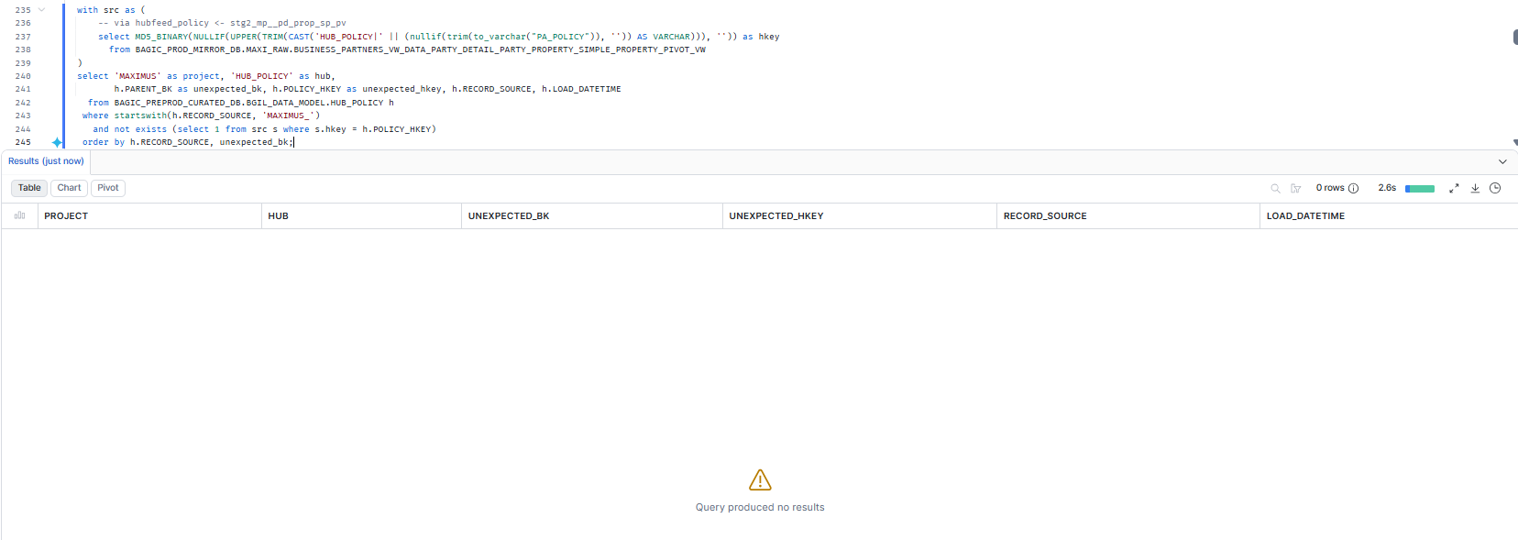

9. MAXIMUS — HUB_DISTRIBUTION_CHANNEL
Project | MAXIMUS
Hub table | HUB_DISTRIBUTION_CHANNEL
Status | Implemented
Pass criteria | 0 rows returned
Result (Pass / Fail / NA) | Pass
Rows returned (count) | 0
Remarks

Note: Hub rows scoped to RECORD_SOURCE 'MAXIMUS_%'. A hit grouped under one RECORD_SOURCE that no longer feeds the hub is a legacy load from a removed feed (classify, do not ignore). 1 RAW key branch(es): BUSINESS_PARTNERS_VW_DATA_PARTY_DETAIL_PARTY_PROPERTY_SIMPLE_PROPERTY_PIVOT_VW.AGENT_CHANNEL.
SQL query
with src as (
-- via hubfeed_distribution_channel <- stg2_mp__pd_prop_sp_pv
select MD5_BINARY(NULLIF(UPPER(TRIM(CAST('HUB_DISTRIBUTION_CHANNEL|' || (nullif(trim(to_varchar("AGENT_CHANNEL")), '')) AS VARCHAR))), '')) as hkey
from BAGIC_PROD_MIRROR_DB.MAXI_RAW.BUSINESS_PARTNERS_VW_DATA_PARTY_DETAIL_PARTY_PROPERTY_SIMPLE_PROPERTY_PIVOT_VW
)
select 'MAXIMUS' as project, 'HUB_DISTRIBUTION_CHANNEL' as hub,
h.PARENT_BK as unexpected_bk, h.DISTRIBUTION_CHANNEL_HKEY as unexpected_hkey, h.RECORD_SOURCE, h.LOAD_DATETIME
from BAGIC_PREPROD_CURATED_DB.BGIL_DATA_MODEL.HUB_DISTRIBUTION_CHANNEL h
where startswith(h.RECORD_SOURCE, 'MAXIMUS_')
and not exists (select 1 from src s where s.hkey = h.DISTRIBUTION_CHANNEL_HKEY)
order by h.RECORD_SOURCE, unexpected_bk;
Query output (attach / paste below)
Output:
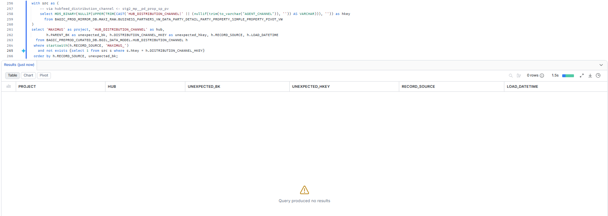

10. MAXIMUS — HUB_ORG_UNIT
Project | MAXIMUS
Hub table | HUB_ORG_UNIT
Status | Implemented
Pass criteria | 0 rows returned
Result (Pass / Fail / NA) | Pass
Rows returned (count) | 0
Remarks

Note: Hub rows scoped to RECORD_SOURCE 'MAXIMUS_%'. A hit grouped under one RECORD_SOURCE that no longer feeds the hub is a legacy load from a removed feed (classify, do not ignore). 1 RAW key branch(es): BUSINESS_PARTNERS_VW_DATA_PARTY_DETAIL_PARTY_PROPERTY_MULTI_SET_PROPERTY_MULTI_SET_DETAIL_PROPERTY_PIVOT_VW.COMPANY. Excluded: hubfeed_org_unit <- stg2_mp__pd_prop_sp_pv: key column(s) branch_code hard-coded cast(null) in stg_maximus__pd_prop_sp_pv -> contributes no keys.
SQL query
with src as (
-- via hubfeed_org_unit <- stg2_mp__pd_prop_msdp_pv
select MD5_BINARY(NULLIF(UPPER(TRIM(CAST('HUB_ORG_UNIT|' || (nullif(trim(to_varchar("COMPANY")), '')) AS VARCHAR))), '')) as hkey
from BAGIC_PROD_MIRROR_DB.MAXI_RAW.BUSINESS_PARTNERS_VW_DATA_PARTY_DETAIL_PARTY_PROPERTY_MULTI_SET_PROPERTY_MULTI_SET_DETAIL_PROPERTY_PIVOT_VW
)
select 'MAXIMUS' as project, 'HUB_ORG_UNIT' as hub,
h.PARENT_BK as unexpected_bk, h.ORG_UNIT_HKEY as unexpected_hkey, h.RECORD_SOURCE, h.LOAD_DATETIME
from BAGIC_PREPROD_CURATED_DB.BGIL_DATA_MODEL.HUB_ORG_UNIT h
where startswith(h.RECORD_SOURCE, 'MAXIMUS_')
and not exists (select 1 from src s where s.hkey = h.ORG_UNIT_HKEY)
order by h.RECORD_SOURCE, unexpected_bk;
Query output (attach / paste below)
Output:
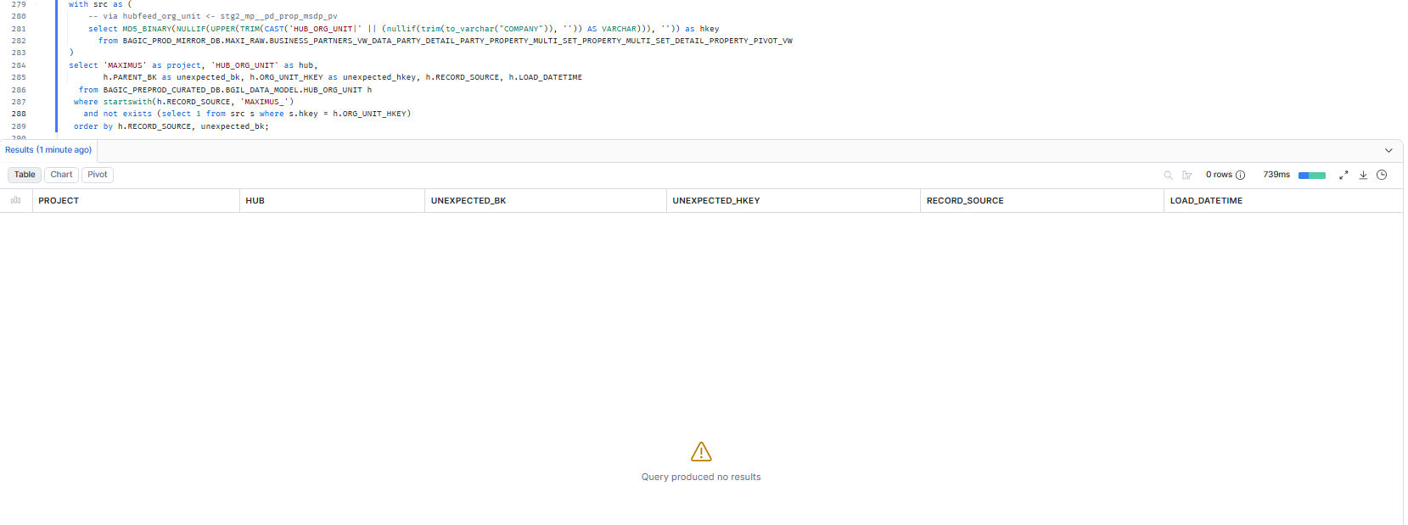

11. OPUS — HUB_PARTY
Project | OPUS
Hub table | HUB_PARTY
Status | Implemented
Pass criteria | 0 rows returned
Result (Pass / Fail / NA) | Pass
Rows returned (count) | 0
Remarks

Note: Hub rows scoped to RECORD_SOURCE 'OPUS_%'. A hit grouped under one RECORD_SOURCE that no longer feeds the hub is a legacy load from a removed feed (classify, do not ignore). 18 RAW key branch(es): CP_PARTNERS.PART_ID, BJAZ_M_KYC_DRIVING_LICENCE.LICENCE_NUMBER, BJAZ_M_KYC_GSTN.GSTIN_NUMBER, BJAZ_M_KYC_PAN.PAN_NUMBER, BJAZ_M_KYC_PASSPORT.PASSPORT_NUMBER, BJAZ_M_KYC_VOTER.VOTER_NUMBER, BJAZ_T_CKYC_OTP.[CATEGORY+INPUT], BJAZ_T_CKYC_PERSONAL_DTLS.CKYC_NO, BJAZ_T_CKYC_REL_PERSION_DTLS.CKYC_NO, BJAZ_T_CKYC_SEARCH.[CATEGORY+INPUT], BJAZ_T_EKYC.[CATEGORY+INPUT], BJAZ_T_KYC_AUTH.[CATEGORY+INPUT], BJAZ_T_KYC_DETAILS.[CATEGORY+INPUT], BJAZ_T_KYC_INCOMING.[SEARCH_CATEGORY+SEARCH_INPUT], BJAZ_T_KYC_NAME_MATCH.[CATEGORY+INPUT], BJAZ_T_KYC_OCR.[FIELD_TYPE+FIELD_VALUE], BJAZ_T_KYC_POA_DOCUMENT.[FIELD_TYPE+FIELD_VALUE], BJAZ_T_KYC_POI_DOCUMENT.[FIELD_TYPE+FIELD_VALUE].
SQL query
with src as (
-- via stg2_hub_cp_partners__party
select MD5_BINARY(NULLIF(UPPER(TRIM(CAST('HUB_PARTY|' || (nullif(trim("PART_ID"::varchar), '')) AS VARCHAR))), '')) as hkey
from BAGIC_PREPROD_CURATED_DB.UTILS.CP_PARTNERS
union all
-- via stg2_hub_bjaz_m_kyc_driving_licence__party
select MD5_BINARY(NULLIF(UPPER(TRIM(CAST('HUB_PARTY|' || (nullif('LICENCE:' || upper(trim(coalesce(nullif(trim("LICENCE_NUMBER"::varchar), ''),''))), 'LICENCE:')) AS VARCHAR))), '')) as hkey
from BAGIC_PREPROD_CURATED_DB.UTILS.BJAZ_M_KYC_DRIVING_LICENCE
union all
-- via stg2_hub_bjaz_m_kyc_gstn__party
select MD5_BINARY(NULLIF(UPPER(TRIM(CAST('HUB_PARTY|' || (nullif('GSTIN:' || upper(trim(coalesce(nullif(trim("GSTIN_NUMBER"::varchar), ''),''))), 'GSTIN:')) AS VARCHAR))), '')) as hkey
from BAGIC_PREPROD_CURATED_DB.UTILS.BJAZ_M_KYC_GSTN
union all
-- via stg2_hub_bjaz_m_kyc_pan__party
select MD5_BINARY(NULLIF(UPPER(TRIM(CAST('HUB_PARTY|' || (nullif('PAN:' || upper(trim(coalesce(nullif(trim("PAN_NUMBER"::varchar), ''),''))), 'PAN:')) AS VARCHAR))), '')) as hkey
from BAGIC_PREPROD_CURATED_DB.UTILS.BJAZ_M_KYC_PAN
union all
-- via stg2_hub_bjaz_m_kyc_passport__party
select MD5_BINARY(NULLIF(UPPER(TRIM(CAST('HUB_PARTY|' || (nullif('PASSPORT:' || upper(trim(coalesce(nullif(trim("PASSPORT_NUMBER"::varchar), ''),''))), 'PASSPORT:')) AS VARCHAR))), '')) as hkey
from BAGIC_PREPROD_CURATED_DB.UTILS.BJAZ_M_KYC_PASSPORT
union all
-- via stg2_hub_bjaz_m_kyc_voter__party
select MD5_BINARY(NULLIF(UPPER(TRIM(CAST('HUB_PARTY|' || (nullif('VOTER:' || upper(trim(coalesce(nullif(trim("VOTER_NUMBER"::varchar), ''),''))), 'VOTER:')) AS VARCHAR))), '')) as hkey
from BAGIC_PREPROD_CURATED_DB.UTILS.BJAZ_M_KYC_VOTER
union all
-- via stg2_hub_bjaz_t_ckyc_otp__party
select MD5_BINARY(NULLIF(UPPER(TRIM(CAST('HUB_PARTY|' || (nullif(upper(trim(coalesce(nullif(trim("CATEGORY"::varchar), ''),''))) || ':' || upper(trim(coalesce(nullif(trim("INPUT"::varchar), ''),''))), ':')) AS VARCHAR))), '')) as hkey
from BAGIC_PREPROD_CURATED_DB.UTILS.BJAZ_T_CKYC_OTP
union all
-- via stg2_hub_bjaz_t_ckyc_personal_dtls__party
select MD5_BINARY(NULLIF(UPPER(TRIM(CAST('HUB_PARTY|' || (nullif('CKYC:' || upper(trim(coalesce(nullif(trim("CKYC_NO"::varchar), ''),''))), 'CKYC:')) AS VARCHAR))), '')) as hkey
from BAGIC_PREPROD_CURATED_DB.UTILS.BJAZ_T_CKYC_PERSONAL_DTLS
union all
-- via stg2_hub_bjaz_t_ckyc_rel_persion_dtls__party
select MD5_BINARY(NULLIF(UPPER(TRIM(CAST('HUB_PARTY|' || (nullif('CKYC:' || upper(trim(coalesce(nullif(trim("CKYC_NO"::varchar), ''),''))), 'CKYC:')) AS VARCHAR))), '')) as hkey
from BAGIC_PREPROD_CURATED_DB.UTILS.BJAZ_T_CKYC_REL_PERSION_DTLS
union all
-- via stg2_hub_bjaz_t_ckyc_search__party
select MD5_BINARY(NULLIF(UPPER(TRIM(CAST('HUB_PARTY|' || (nullif(upper(trim(coalesce(nullif(trim("CATEGORY"::varchar), ''),''))) || ':' || upper(trim(coalesce(nullif(trim("INPUT"::varchar), ''),''))), ':')) AS VARCHAR))), '')) as hkey
from BAGIC_PREPROD_CURATED_DB.UTILS.BJAZ_T_CKYC_SEARCH
union all
-- via stg2_hub_bjaz_t_ekyc__party
select MD5_BINARY(NULLIF(UPPER(TRIM(CAST('HUB_PARTY|' || (nullif(upper(trim(coalesce(nullif(trim("CATEGORY"::varchar), ''),''))) || ':' || upper(trim(coalesce(nullif(trim("INPUT"::varchar), ''),''))), ':')) AS VARCHAR))), '')) as hkey
from BAGIC_PREPROD_CURATED_DB.UTILS.BJAZ_T_EKYC
union all
-- via stg2_hub_bjaz_t_kyc_auth__party
select MD5_BINARY(NULLIF(UPPER(TRIM(CAST('HUB_PARTY|' || (nullif(upper(trim(coalesce(nullif(trim("CATEGORY"::varchar), ''),''))) || ':' || upper(trim(coalesce(nullif(trim("INPUT"::varchar), ''),''))), ':')) AS VARCHAR))), '')) as hkey
from BAGIC_PREPROD_CURATED_DB.UTILS.BJAZ_T_KYC_AUTH
union all
-- via stg2_hub_bjaz_t_kyc_details__party
select MD5_BINARY(NULLIF(UPPER(TRIM(CAST('HUB_PARTY|' || (nullif(upper(trim(coalesce(nullif(trim("CATEGORY"::varchar), ''),''))) || ':' || upper(trim(coalesce(nullif(trim("INPUT"::varchar), ''),''))), ':')) AS VARCHAR))), '')) as hkey
from BAGIC_PREPROD_CURATED_DB.UTILS.BJAZ_T_KYC_DETAILS
union all
-- via stg2_hub_bjaz_t_kyc_incoming__party
select MD5_BINARY(NULLIF(UPPER(TRIM(CAST('HUB_PARTY|' || (nullif(upper(trim(coalesce(nullif(trim("SEARCH_CATEGORY"::varchar), ''),''))) || ':' || upper(trim(coalesce(nullif(trim("SEARCH_INPUT"::varchar), ''),''))), ':')) AS VARCHAR))), '')) as hkey
from BAGIC_PREPROD_CURATED_DB.UTILS.BJAZ_T_KYC_INCOMING
union all
-- via stg2_hub_bjaz_t_kyc_name_match__party
select MD5_BINARY(NULLIF(UPPER(TRIM(CAST('HUB_PARTY|' || (nullif(upper(trim(coalesce(nullif(trim("CATEGORY"::varchar), ''),''))) || ':' || upper(trim(coalesce(nullif(trim("INPUT"::varchar), ''),''))), ':')) AS VARCHAR))), '')) as hkey
from BAGIC_PREPROD_CURATED_DB.UTILS.BJAZ_T_KYC_NAME_MATCH
union all
-- via stg2_hub_bjaz_t_kyc_ocr__party
select MD5_BINARY(NULLIF(UPPER(TRIM(CAST('HUB_PARTY|' || (nullif(upper(trim(coalesce(nullif(trim("FIELD_TYPE"::varchar), ''),''))) || ':' || upper(trim(coalesce(nullif(trim("FIELD_VALUE"::varchar), ''),''))), ':')) AS VARCHAR))), '')) as hkey
from BAGIC_PREPROD_CURATED_DB.UTILS.BJAZ_T_KYC_OCR
union all
-- via stg2_hub_bjaz_t_kyc_poa_document__party
select MD5_BINARY(NULLIF(UPPER(TRIM(CAST('HUB_PARTY|' || (nullif(upper(trim(coalesce(nullif(trim("FIELD_TYPE"::varchar), ''),''))) || ':' || upper(trim(coalesce(nullif(trim("FIELD_VALUE"::varchar), ''),''))), ':')) AS VARCHAR))), '')) as hkey
from BAGIC_PREPROD_CURATED_DB.UTILS.BJAZ_T_KYC_POA_DOCUMENT
union all
-- via stg2_hub_bjaz_t_kyc_poi_document__party
select MD5_BINARY(NULLIF(UPPER(TRIM(CAST('HUB_PARTY|' || (nullif(upper(trim(coalesce(nullif(trim("FIELD_TYPE"::varchar), ''),''))) || ':' || upper(trim(coalesce(nullif(trim("FIELD_VALUE"::varchar), ''),''))), ':')) AS VARCHAR))), '')) as hkey
from BAGIC_PREPROD_CURATED_DB.UTILS.BJAZ_T_KYC_POI_DOCUMENT
)
select 'OPUS' as project, 'HUB_PARTY' as hub,
h.PARENT_BK as unexpected_bk, h.PARTY_HKEY as unexpected_hkey, h.RECORD_SOURCE, h.LOAD_DATETIME
from BAGIC_PREPROD_CURATED_DB.BGIL_DATA_MODEL.HUB_PARTY h
where startswith(h.RECORD_SOURCE, 'OPUS_')
and not exists (select 1 from src s where s.hkey = h.PARTY_HKEY)
order by h.RECORD_SOURCE, unexpected_bk;
Query output (attach / paste below)
Output:
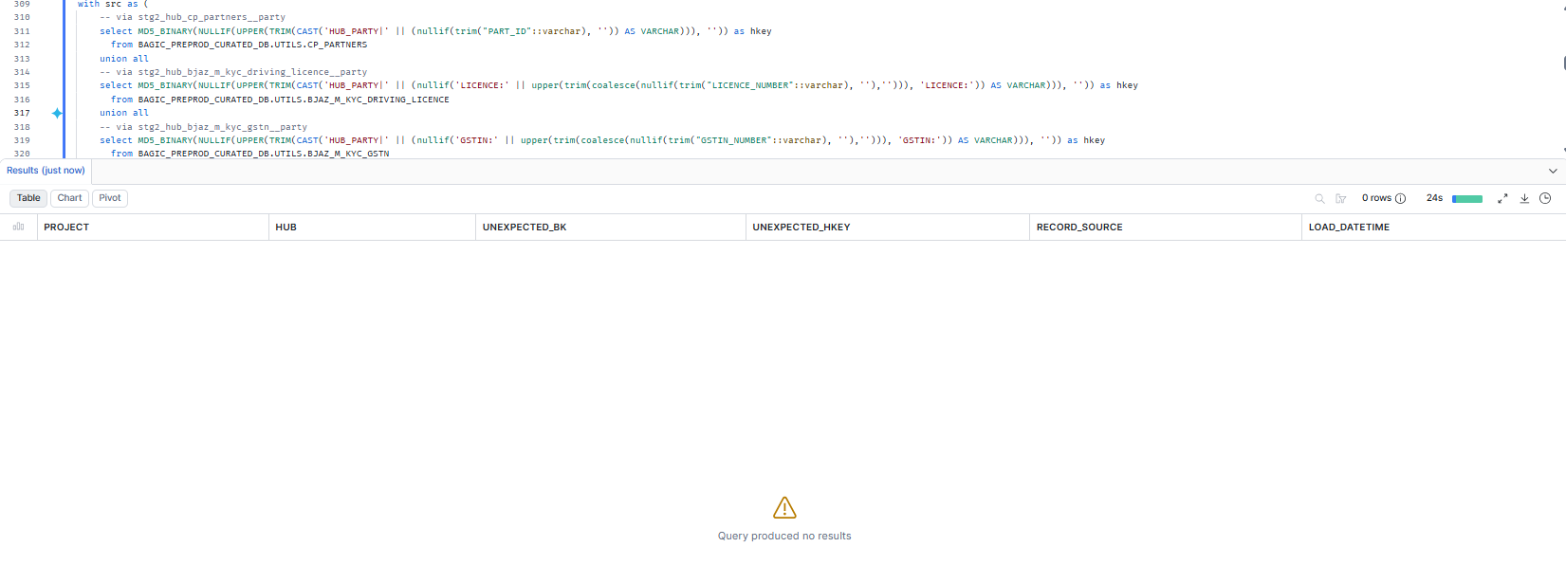

12. OPUS — HUB_AGENT
Project | OPUS
Hub table | HUB_AGENT
Status | Implemented
Pass criteria | 0 rows returned
Result (Pass / Fail / NA) | Pass
Rows returned (count) | 0
Remarks

Note: Hub rows scoped to RECORD_SOURCE 'OPUS_%'. A hit grouped under one RECORD_SOURCE that no longer feeds the hub is a legacy load from a removed feed (classify, do not ignore). 1 RAW key branch(es): BJAZ_INTERMEDIARY.INTERMEDIARY_ID.
SQL query
with src as (
-- via stg2_hub_bjaz_intermediary__agent
select MD5_BINARY(NULLIF(UPPER(TRIM(CAST('HUB_AGENT|' || (nullif(trim("INTERMEDIARY_ID"::varchar), '')) AS VARCHAR))), '')) as hkey
from BAGIC_PREPROD_CURATED_DB.UTILS.BJAZ_INTERMEDIARY
)
select 'OPUS' as project, 'HUB_AGENT' as hub,
h.PARENT_BK as unexpected_bk, h.AGENT_HKEY as unexpected_hkey, h.RECORD_SOURCE, h.LOAD_DATETIME
from BAGIC_PREPROD_CURATED_DB.BGIL_DATA_MODEL.HUB_AGENT h
where startswith(h.RECORD_SOURCE, 'OPUS_')
and not exists (select 1 from src s where s.hkey = h.AGENT_HKEY)
order by h.RECORD_SOURCE, unexpected_bk;
Query output (attach / paste below)
Output:
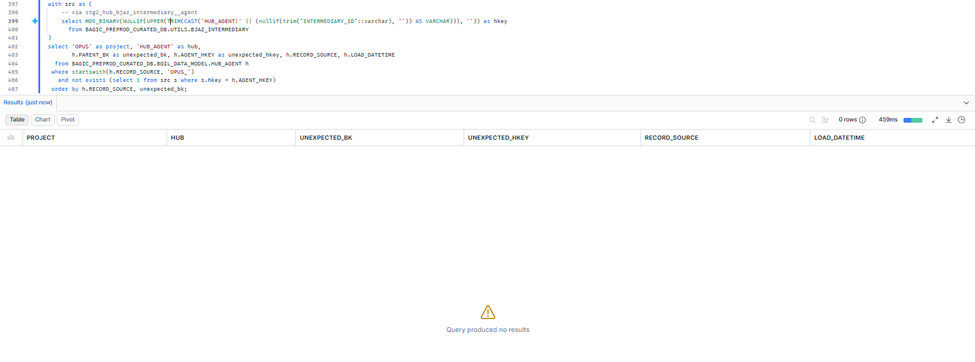

13. OPUS — HUB_AGREEMENT
Project | OPUS
Hub table | HUB_AGREEMENT
Status | Implemented
Pass criteria | 0 rows returned
Result (Pass / Fail / NA) | Pass
Rows returned (count) | 0
Remarks

Note: Hub rows scoped to RECORD_SOURCE 'OPUS_%'. A hit grouped under one RECORD_SOURCE that no longer feeds the hub is a legacy load from a removed feed (classify, do not ignore). 1 RAW key branch(es): BJAZ_INTERMEDIARY.INTERMEDIARY_ID.
SQL query
with src as (
-- via stg2_hub_bjaz_intermediary__agreement
select MD5_BINARY(NULLIF(UPPER(TRIM(CAST('HUB_AGREEMENT|' || (nullif(trim("INTERMEDIARY_ID"::varchar), '')) AS VARCHAR))), '')) as hkey
from BAGIC_PREPROD_CURATED_DB.UTILS.BJAZ_INTERMEDIARY
)
select 'OPUS' as project, 'HUB_AGREEMENT' as hub,
h.PARENT_BK as unexpected_bk, h.AGREEMENT_HKEY as unexpected_hkey, h.RECORD_SOURCE, h.LOAD_DATETIME
from BAGIC_PREPROD_CURATED_DB.BGIL_DATA_MODEL.HUB_AGREEMENT h
where startswith(h.RECORD_SOURCE, 'OPUS_')
and not exists (select 1 from src s where s.hkey = h.AGREEMENT_HKEY)
order by h.RECORD_SOURCE, unexpected_bk;
Query output (attach / paste below)
Output:
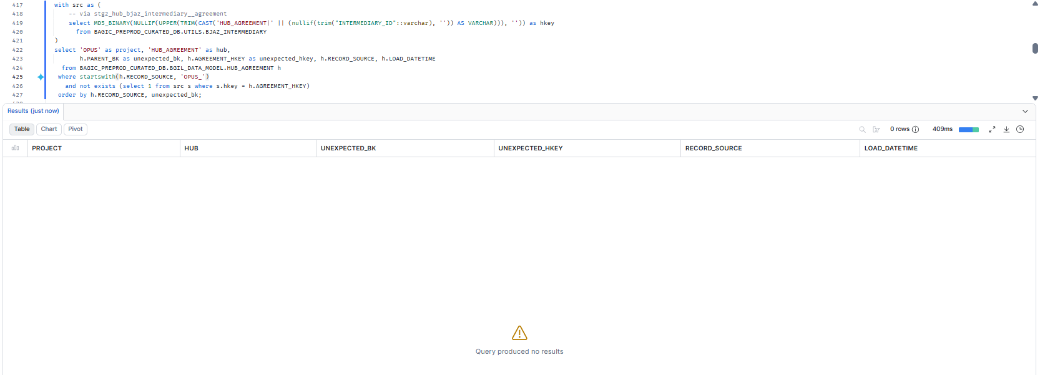

14. OPUS — HUB_CLAIM
Project | OPUS
Hub table | HUB_CLAIM
Status | Implemented
Pass criteria | 0 rows returned
Result (Pass / Fail / NA) | Pass
Rows returned (count) | 0
Remarks

Note: Hub rows scoped to RECORD_SOURCE 'OPUS_%'. A hit grouped under one RECORD_SOURCE that no longer feeds the hub is a legacy load from a removed feed (classify, do not ignore). 1 RAW key branch(es): CLM_INTERESTED_PARTIES.CLAIM_ID.
SQL query
with src as (
-- via stg2_hub_clm_interested_parties__claim
select MD5_BINARY(NULLIF(UPPER(TRIM(CAST('HUB_CLAIM|' || (nullif(trim("CLAIM_ID"::varchar), '')) AS VARCHAR))), '')) as hkey
from BAGIC_PREPROD_CURATED_DB.UTILS.CLM_INTERESTED_PARTIES
)
select 'OPUS' as project, 'HUB_CLAIM' as hub,
h.PARENT_BK as unexpected_bk, h.CLAIM_HKEY as unexpected_hkey, h.RECORD_SOURCE, h.LOAD_DATETIME
from BAGIC_PREPROD_CURATED_DB.BGIL_DATA_MODEL.HUB_CLAIM h
where startswith(h.RECORD_SOURCE, 'OPUS_')
and not exists (select 1 from src s where s.hkey = h.CLAIM_HKEY)
order by h.RECORD_SOURCE, unexpected_bk;
Query output (attach / paste below)
Output:
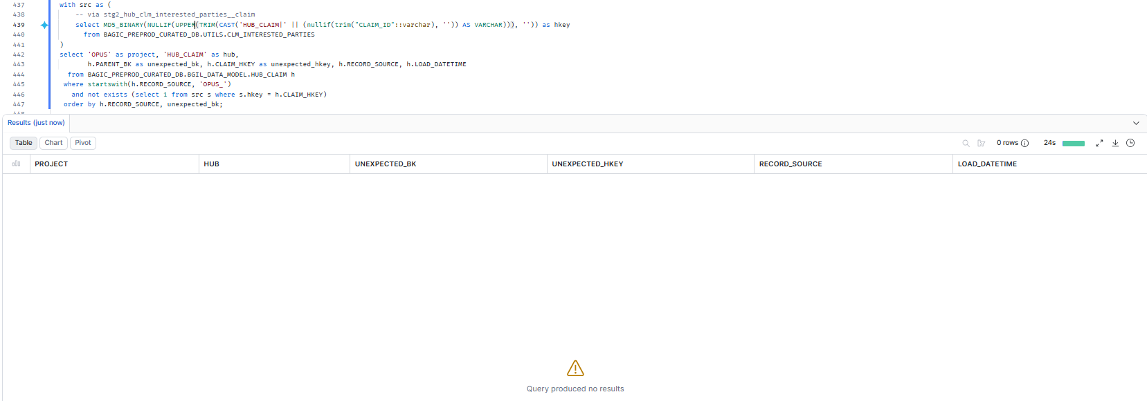

15. OPUS — HUB_LOCATION
Project | OPUS
Hub table | HUB_LOCATION
Status | Implemented
Pass criteria | 0 rows returned
Result (Pass / Fail / NA) | Pass
Rows returned (count) | 0
Remarks

Note: Hub rows scoped to RECORD_SOURCE 'OPUS_%'. A hit grouped under one RECORD_SOURCE that no longer feeds the hub is a legacy load from a removed feed (classify, do not ignore). 19 RAW key branch(es): AZBJ_ADDRESS_EXTN.ADD_ID, BJAZ_CLM_SUPP_EXTN.BILLING_LOC, BJAZ_PINCODE.PINCODE, BJAZ_PINCODE_MASTER.PINCODE, CP_ADDRESSES.ADD_ID, AZBJ_PARTNER_EXTN.MAIL_ADD_ID, BJAZ_CLM_SUPP_EXTN.LOCATION_CODE, BJAZ_CP_ADDRESS_LINK.ADD_ID, CLM_SUPPLIERS.LOC_CODE, CP_PARTNERS.ADD_ID, OCP_INTERESTED_PARTIES.MAILING_ADDRESS_ID, BJAZ_M_KYC_DRIVING_LICENCE.[ADDRESS+STATE+ZIP_CODE], BJAZ_M_KYC_GSTN.BUSINESS_PLACE, BJAZ_M_KYC_VOTER.[STATE+PART_NAME+DISTRICT], BJAZ_T_CKYC_PERSONAL_DTLS.[CORRES_CITY+CORRES_COUNTRY+CORRES_LINE1+CORRES_LINE2+CORRES_LINE3+CORRES_PIN+CORRES_STATE+CORRES_DIST], BJAZ_T_CKYC_PERSONAL_DTLS.[JURI_CITY+JURI_COUNTRY+JURI_LINE1+JURI_LINE2+JURI_LINE3+JURI_STATE+JURI_DIST], BJAZ_T_CKYC_PERSONAL_DTLS.[PERM_CITY+PERM_COUNTRY+PERM_LINE1+PERM_LINE2+PERM_LINE3+PERM_PIN+PERM_STATE+PERM_DIST], BJAZ_T_EKYC.[COUNTRY+HOUSE_NUMBER+PIN_CODE+STATE+STREET+VTC_NAME+LANDMARK+LOCATION+POST_OFFICE+SUB_DISTRICT+DISTRICT], BJAZ_T_KYC_OCR.[BUILDING+COUNTRY_CODE+HOUSE_NUMBER+PIN_CODE+STATE+STREET+LOCATION+POST_OFFICE+DISTRICT]. stitch_common_address is watermark-windowed (inc_job_updated_at); RAW rows with a NULL inc_job_updated_at never reach the hub and will surface as DM-K1 gaps. stitch_kyc_common_address is watermark-windowed (inc_job_updated_at); RAW rows with a NULL inc_job_updated_at never reach the hub and will surface as DM-K1 gaps.
SQL query
with src as (
-- via stg2_common_address <- stitch_common_address
select MD5_BINARY(NULLIF(UPPER(TRIM(CAST('HUB_LOCATION|' || (nullif(trim("ADD_ID"::varchar), '')) AS VARCHAR))), '')) as hkey
from BAGIC_PREPROD_CURATED_DB.UTILS.AZBJ_ADDRESS_EXTN
union all
-- via stg2_common_address <- stitch_common_address
select MD5_BINARY(NULLIF(UPPER(TRIM(CAST('HUB_LOCATION|' || (nullif(trim("BILLING_LOC"::varchar), '')) AS VARCHAR))), '')) as hkey
from BAGIC_PREPROD_CURATED_DB.UTILS.BJAZ_CLM_SUPP_EXTN
union all
-- via stg2_common_address <- stitch_common_address
select MD5_BINARY(NULLIF(UPPER(TRIM(CAST('HUB_LOCATION|' || (nullif(trim("PINCODE"::varchar), '')) AS VARCHAR))), '')) as hkey
from BAGIC_PREPROD_CURATED_DB.UTILS.BJAZ_PINCODE
union all
-- via stg2_common_address <- stitch_common_address
select MD5_BINARY(NULLIF(UPPER(TRIM(CAST('HUB_LOCATION|' || (nullif(trim("PINCODE"::varchar), '')) AS VARCHAR))), '')) as hkey
from BAGIC_PREPROD_CURATED_DB.UTILS.BJAZ_PINCODE_MASTER
union all
-- via stg2_common_address <- stitch_common_address
select MD5_BINARY(NULLIF(UPPER(TRIM(CAST('HUB_LOCATION|' || (nullif(trim("ADD_ID"::varchar), '')) AS VARCHAR))), '')) as hkey
from BAGIC_PREPROD_CURATED_DB.UTILS.CP_ADDRESSES
union all
-- via stg2_hub_azbj_partner_extn__location
select MD5_BINARY(NULLIF(UPPER(TRIM(CAST('HUB_LOCATION|' || (nullif(trim("MAIL_ADD_ID"::varchar), '')) AS VARCHAR))), '')) as hkey
from BAGIC_PREPROD_CURATED_DB.UTILS.AZBJ_PARTNER_EXTN
union all
-- via stg2_hub_bjaz_clm_supp_extn__location
select MD5_BINARY(NULLIF(UPPER(TRIM(CAST('HUB_LOCATION|' || (nullif(trim("LOCATION_CODE"::varchar), '')) AS VARCHAR))), '')) as hkey
from BAGIC_PREPROD_CURATED_DB.UTILS.BJAZ_CLM_SUPP_EXTN
union all
-- via stg2_hub_bjaz_cp_address_link__location
select MD5_BINARY(NULLIF(UPPER(TRIM(CAST('HUB_LOCATION|' || (nullif(trim("ADD_ID"::varchar), '')) AS VARCHAR))), '')) as hkey
from BAGIC_PREPROD_CURATED_DB.UTILS.BJAZ_CP_ADDRESS_LINK
union all
-- via stg2_hub_clm_suppliers__location
select MD5_BINARY(NULLIF(UPPER(TRIM(CAST('HUB_LOCATION|' || (nullif(trim("LOC_CODE"::varchar), '')) AS VARCHAR))), '')) as hkey
from BAGIC_PREPROD_CURATED_DB.UTILS.CLM_SUPPLIERS
union all
-- via stg2_hub_cp_partners__location
select MD5_BINARY(NULLIF(UPPER(TRIM(CAST('HUB_LOCATION|' || (nullif(trim("ADD_ID"::varchar), '')) AS VARCHAR))), '')) as hkey
from BAGIC_PREPROD_CURATED_DB.UTILS.CP_PARTNERS
union all
-- via stg2_hub_ocp_interested_parties__location
select MD5_BINARY(NULLIF(UPPER(TRIM(CAST('HUB_LOCATION|' || (nullif(trim("MAILING_ADDRESS_ID"::varchar), '')) AS VARCHAR))), '')) as hkey
from BAGIC_PREPROD_CURATED_DB.UTILS.OCP_INTERESTED_PARTIES
union all
-- via stg2_kyc_common_address <- stitch_kyc_common_address
select MD5_BINARY(NULLIF(UPPER(TRIM(CAST('HUB_LOCATION|' || (case when nullif(upper(trim(to_varchar(nullif(trim("ADDRESS"::varchar), '')))), '') is not null or nullif(upper(trim(to_varchar(nullif(trim("STATE"::varchar), '')))), '') is not null or nullif(upper(trim(to_varchar(nullif(trim("ZIP_CODE"::varchar), '')))), '') is not null then coalesce(nullif(upper(trim(to_varchar(nullif(trim("ADDRESS"::varchar), '')))), ''), '') || '|' || coalesce(nullif(upper(trim(to_varchar(nullif(trim("STATE"::varchar), '')))), ''), '') || '|' || coalesce(nullif(upper(trim(to_varchar(nullif(trim("ZIP_CODE"::varchar), '')))), ''), '') end) AS VARCHAR))), '')) as hkey
from BAGIC_PREPROD_CURATED_DB.UTILS.BJAZ_M_KYC_DRIVING_LICENCE
union all
-- via stg2_kyc_common_address <- stitch_kyc_common_address
select MD5_BINARY(NULLIF(UPPER(TRIM(CAST('HUB_LOCATION|' || (case when nullif(upper(trim(to_varchar(nullif(trim("BUSINESS_PLACE"::varchar), '')))), '') is not null then coalesce(nullif(upper(trim(to_varchar(nullif(trim("BUSINESS_PLACE"::varchar), '')))), ''), '') end) AS VARCHAR))), '')) as hkey
from BAGIC_PREPROD_CURATED_DB.UTILS.BJAZ_M_KYC_GSTN
union all
-- via stg2_kyc_common_address <- stitch_kyc_common_address
select MD5_BINARY(NULLIF(UPPER(TRIM(CAST('HUB_LOCATION|' || (case when nullif(upper(trim(to_varchar(nullif(trim("STATE"::varchar), '')))), '') is not null then coalesce(nullif(upper(trim(to_varchar(nullif(trim("PART_NAME"::varchar), '')))), ''), '') || '|' || coalesce(nullif(upper(trim(to_varchar(nullif(trim("DISTRICT"::varchar), '')))), ''), '') || '|' || coalesce(nullif(upper(trim(to_varchar(nullif(trim("STATE"::varchar), '')))), ''), '') end) AS VARCHAR))), '')) as hkey
from BAGIC_PREPROD_CURATED_DB.UTILS.BJAZ_M_KYC_VOTER
union all
-- via stg2_kyc_common_address <- stitch_kyc_common_address
select MD5_BINARY(NULLIF(UPPER(TRIM(CAST('HUB_LOCATION|' || (case when nullif(upper(trim(to_varchar(nullif(trim("CORRES_CITY"::varchar), '')))), '') is not null or nullif(upper(trim(to_varchar(nullif(trim("CORRES_COUNTRY"::varchar), '')))), '') is not null or nullif(upper(trim(to_varchar(nullif(trim("CORRES_LINE1"::varchar), '')))), '') is not null or nullif(upper(trim(to_varchar(nullif(trim("CORRES_LINE2"::varchar), '')))), '') is not null or nullif(upper(trim(to_varchar(nullif(trim("CORRES_LINE3"::varchar), '')))), '') is not null or nullif(upper(trim(to_varchar(nullif(trim("CORRES_PIN"::varchar), '')))), '') is not null or nullif(upper(trim(to_varchar(nullif(trim("CORRES_STATE"::varchar), '')))), '') is not null then coalesce(nullif(upper(trim(to_varchar(nullif(trim("CORRES_LINE1"::varchar), '')))), ''), '') || '|' || coalesce(nullif(upper(trim(to_varchar(nullif(trim("CORRES_LINE2"::varchar), '')))), ''), '') || '|' || coalesce(nullif(upper(trim(to_varchar(nullif(trim("CORRES_LINE3"::varchar), '')))), ''), '') || '|' || coalesce(nullif(upper(trim(to_varchar(nullif(trim("CORRES_CITY"::varchar), '')))), ''), '') || '|' || coalesce(nullif(upper(trim(to_varchar(nullif(trim("CORRES_DIST"::varchar), '')))), ''), '') || '|' || coalesce(nullif(upper(trim(to_varchar(nullif(trim("CORRES_STATE"::varchar), '')))), ''), '') || '|' || coalesce(nullif(upper(trim(to_varchar(nullif(trim("CORRES_PIN"::varchar), '')))), ''), '') || '|' || coalesce(nullif(upper(trim(to_varchar(nullif(trim("CORRES_COUNTRY"::varchar), '')))), ''), '') end) AS VARCHAR))), '')) as hkey
from BAGIC_PREPROD_CURATED_DB.UTILS.BJAZ_T_CKYC_PERSONAL_DTLS
union all
-- via stg2_kyc_common_address <- stitch_kyc_common_address
select MD5_BINARY(NULLIF(UPPER(TRIM(CAST('HUB_LOCATION|' || (case when nullif(upper(trim(to_varchar(nullif(trim("JURI_CITY"::varchar), '')))), '') is not null or nullif(upper(trim(to_varchar(nullif(trim("JURI_COUNTRY"::varchar), '')))), '') is not null or nullif(upper(trim(to_varchar(nullif(trim("JURI_LINE1"::varchar), '')))), '') is not null or nullif(upper(trim(to_varchar(nullif(trim("JURI_LINE2"::varchar), '')))), '') is not null or nullif(upper(trim(to_varchar(nullif(trim("JURI_LINE3"::varchar), '')))), '') is not null or nullif(upper(trim(to_varchar(nullif(trim("JURI_STATE"::varchar), '')))), '') is not null then coalesce(nullif(upper(trim(to_varchar(nullif(trim("JURI_LINE1"::varchar), '')))), ''), '') || '|' || coalesce(nullif(upper(trim(to_varchar(nullif(trim("JURI_LINE2"::varchar), '')))), ''), '') || '|' || coalesce(nullif(upper(trim(to_varchar(nullif(trim("JURI_LINE3"::varchar), '')))), ''), '') || '|' || coalesce(nullif(upper(trim(to_varchar(nullif(trim("JURI_CITY"::varchar), '')))), ''), '') || '|' || coalesce(nullif(upper(trim(to_varchar(nullif(trim("JURI_DIST"::varchar), '')))), ''), '') || '|' || coalesce(nullif(upper(trim(to_varchar(nullif(trim("JURI_STATE"::varchar), '')))), ''), '') || '|' || coalesce(nullif(upper(trim(to_varchar(nullif(trim("JURI_COUNTRY"::varchar), '')))), ''), '') end) AS VARCHAR))), '')) as hkey
from BAGIC_PREPROD_CURATED_DB.UTILS.BJAZ_T_CKYC_PERSONAL_DTLS
union all
-- via stg2_kyc_common_address <- stitch_kyc_common_address
select MD5_BINARY(NULLIF(UPPER(TRIM(CAST('HUB_LOCATION|' || (case when nullif(upper(trim(to_varchar(nullif(trim("PERM_CITY"::varchar), '')))), '') is not null or nullif(upper(trim(to_varchar(nullif(trim("PERM_COUNTRY"::varchar), '')))), '') is not null or nullif(upper(trim(to_varchar(nullif(trim("PERM_LINE1"::varchar), '')))), '') is not null or nullif(upper(trim(to_varchar(nullif(trim("PERM_LINE2"::varchar), '')))), '') is not null or nullif(upper(trim(to_varchar(nullif(trim("PERM_LINE3"::varchar), '')))), '') is not null or nullif(upper(trim(to_varchar(nullif(trim("PERM_PIN"::varchar), '')))), '') is not null or nullif(upper(trim(to_varchar(nullif(trim("PERM_STATE"::varchar), '')))), '') is not null then coalesce(nullif(upper(trim(to_varchar(nullif(trim("PERM_LINE1"::varchar), '')))), ''), '') || '|' || coalesce(nullif(upper(trim(to_varchar(nullif(trim("PERM_LINE2"::varchar), '')))), ''), '') || '|' || coalesce(nullif(upper(trim(to_varchar(nullif(trim("PERM_LINE3"::varchar), '')))), ''), '') || '|' || coalesce(nullif(upper(trim(to_varchar(nullif(trim("PERM_CITY"::varchar), '')))), ''), '') || '|' || coalesce(nullif(upper(trim(to_varchar(nullif(trim("PERM_DIST"::varchar), '')))), ''), '') || '|' || coalesce(nullif(upper(trim(to_varchar(nullif(trim("PERM_STATE"::varchar), '')))), ''), '') || '|' || coalesce(nullif(upper(trim(to_varchar(nullif(trim("PERM_PIN"::varchar), '')))), ''), '') || '|' || coalesce(nullif(upper(trim(to_varchar(nullif(trim("PERM_COUNTRY"::varchar), '')))), ''), '') end) AS VARCHAR))), '')) as hkey
from BAGIC_PREPROD_CURATED_DB.UTILS.BJAZ_T_CKYC_PERSONAL_DTLS
union all
-- via stg2_kyc_common_address <- stitch_kyc_common_address
select MD5_BINARY(NULLIF(UPPER(TRIM(CAST('HUB_LOCATION|' || (case when nullif(upper(trim(to_varchar(nullif(trim("COUNTRY"::varchar), '')))), '') is not null or nullif(upper(trim(to_varchar(nullif(trim("HOUSE_NUMBER"::varchar), '')))), '') is not null or nullif(upper(trim(to_varchar(nullif(trim("PIN_CODE"::varchar), '')))), '') is not null or nullif(upper(trim(to_varchar(nullif(trim("STATE"::varchar), '')))), '') is not null or nullif(upper(trim(to_varchar(nullif(trim("STREET"::varchar), '')))), '') is not null or nullif(upper(trim(to_varchar(nullif(trim("VTC_NAME"::varchar), '')))), '') is not null then coalesce(nullif(upper(trim(to_varchar(nullif(trim("HOUSE_NUMBER"::varchar), '')))), ''), '') || '|' || coalesce(nullif(upper(trim(to_varchar(nullif(trim("STREET"::varchar), '')))), ''), '') || '|' || coalesce(nullif(upper(trim(to_varchar(nullif(trim("LANDMARK"::varchar), '')))), ''), '') || '|' || coalesce(nullif(upper(trim(to_varchar(nullif(trim("LOCATION"::varchar), '')))), ''), '') || '|' || coalesce(nullif(upper(trim(to_varchar(nullif(trim("POST_OFFICE"::varchar), '')))), ''), '') || '|' || coalesce(nullif(upper(trim(to_varchar(nullif(trim("SUB_DISTRICT"::varchar), '')))), ''), '') || '|' || coalesce(nullif(upper(trim(to_varchar(nullif(trim("VTC_NAME"::varchar), '')))), ''), '') || '|' || coalesce(nullif(upper(trim(to_varchar(nullif(trim("DISTRICT"::varchar), '')))), ''), '') || '|' || coalesce(nullif(upper(trim(to_varchar(nullif(trim("STATE"::varchar), '')))), ''), '') || '|' || coalesce(nullif(upper(trim(to_varchar(nullif(trim("COUNTRY"::varchar), '')))), ''), '') || '|' || coalesce(nullif(upper(trim(to_varchar(nullif(trim("PIN_CODE"::varchar), '')))), ''), '') end) AS VARCHAR))), '')) as hkey
from BAGIC_PREPROD_CURATED_DB.UTILS.BJAZ_T_EKYC
union all
-- via stg2_kyc_common_address <- stitch_kyc_common_address
select MD5_BINARY(NULLIF(UPPER(TRIM(CAST('HUB_LOCATION|' || (case when nullif(upper(trim(to_varchar(nullif(trim("BUILDING"::varchar), '')))), '') is not null or nullif(upper(trim(to_varchar(nullif(trim("COUNTRY_CODE"::varchar), '')))), '') is not null or nullif(upper(trim(to_varchar(nullif(trim("HOUSE_NUMBER"::varchar), '')))), '') is not null or nullif(upper(trim(to_varchar(nullif(trim("PIN_CODE"::varchar), '')))), '') is not null or nullif(upper(trim(to_varchar(nullif(trim("STATE"::varchar), '')))), '') is not null or nullif(upper(trim(to_varchar(nullif(trim("STREET"::varchar), '')))), '') is not null then coalesce(nullif(upper(trim(to_varchar(nullif(trim("HOUSE_NUMBER"::varchar), '')))), ''), '') || '|' || coalesce(nullif(upper(trim(to_varchar(nullif(trim("BUILDING"::varchar), '')))), ''), '') || '|' || coalesce(nullif(upper(trim(to_varchar(nullif(trim("STREET"::varchar), '')))), ''), '') || '|' || coalesce(nullif(upper(trim(to_varchar(nullif(trim("LOCATION"::varchar), '')))), ''), '') || '|' || coalesce(nullif(upper(trim(to_varchar(nullif(trim("POST_OFFICE"::varchar), '')))), ''), '') || '|' || coalesce(nullif(upper(trim(to_varchar(nullif(trim("DISTRICT"::varchar), '')))), ''), '') || '|' || coalesce(nullif(upper(trim(to_varchar(nullif(trim("STATE"::varchar), '')))), ''), '') || '|' || coalesce(nullif(upper(trim(to_varchar(nullif(trim("PIN_CODE"::varchar), '')))), ''), '') || '|' || coalesce(nullif(upper(trim(to_varchar(nullif(trim("COUNTRY_CODE"::varchar), '')))), ''), '') end) AS VARCHAR))), '')) as hkey
from BAGIC_PREPROD_CURATED_DB.UTILS.BJAZ_T_KYC_OCR
)
select 'OPUS' as project, 'HUB_LOCATION' as hub,
h.PARENT_BK as unexpected_bk, h.LOCATION_HKEY as unexpected_hkey, h.RECORD_SOURCE, h.LOAD_DATETIME
from BAGIC_PREPROD_CURATED_DB.BGIL_DATA_MODEL.HUB_LOCATION h
where startswith(h.RECORD_SOURCE, 'OPUS_')
and not exists (select 1 from src s where s.hkey = h.LOCATION_HKEY)
order by h.RECORD_SOURCE, unexpected_bk;
Query output (attach / paste below)
Output:
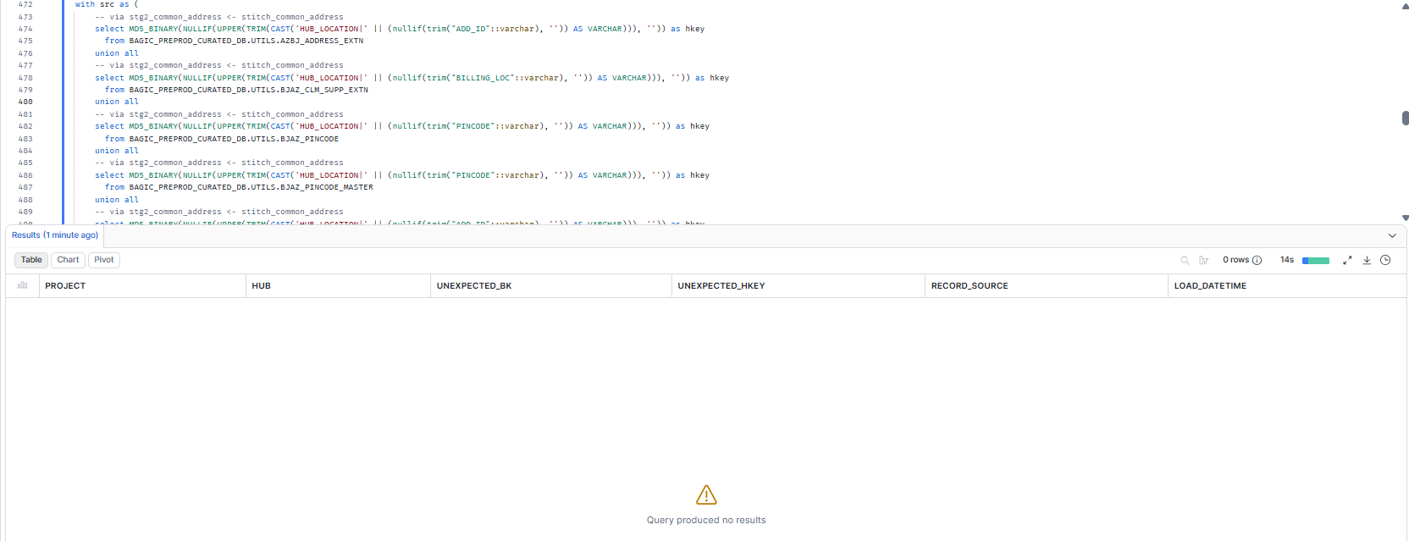

16. OPUS — HUB_PRODUCT
Project | OPUS
Hub table | HUB_PRODUCT
Status | Implemented
Pass criteria | 0 rows returned
Result (Pass / Fail / NA) | Pass
Rows returned (count) | 0
Remarks

Note: Hub rows scoped to RECORD_SOURCE 'OPUS_%'. A hit grouped under one RECORD_SOURCE that no longer feeds the hub is a legacy load from a removed feed (classify, do not ignore). 3 RAW key branch(es): BJAZ_CTNGY_FF_DTLS_EXTN.SCHEME_CODE, BJAZ_CTNGY_PA_MEM_DTLS.SCHEME_CODE, BJAZ_HM_MEMBER_DTLS.PRODUCT_CODE. stitch_product_definition is watermark-windowed (inc_job_updated_at); RAW rows with a NULL inc_job_updated_at never reach the hub and will surface as DM-K1 gaps.
SQL query
with src as (
-- via stg2_product_definition <- stitch_product_definition
select MD5_BINARY(NULLIF(UPPER(TRIM(CAST('HUB_PRODUCT|' || (nullif(trim("SCHEME_CODE"::varchar), '')) AS VARCHAR))), '')) as hkey
from BAGIC_PREPROD_CURATED_DB.UTILS.BJAZ_CTNGY_FF_DTLS_EXTN
union all
-- via stg2_product_definition <- stitch_product_definition
select MD5_BINARY(NULLIF(UPPER(TRIM(CAST('HUB_PRODUCT|' || (nullif(trim("SCHEME_CODE"::varchar), '')) AS VARCHAR))), '')) as hkey
from BAGIC_PREPROD_CURATED_DB.UTILS.BJAZ_CTNGY_PA_MEM_DTLS
union all
-- via stg2_product_definition <- stitch_product_definition
select MD5_BINARY(NULLIF(UPPER(TRIM(CAST('HUB_PRODUCT|' || (nullif(trim("PRODUCT_CODE"::varchar), '')) AS VARCHAR))), '')) as hkey
from BAGIC_PREPROD_CURATED_DB.UTILS.BJAZ_HM_MEMBER_DTLS
)
select 'OPUS' as project, 'HUB_PRODUCT' as hub,
h.PARENT_BK as unexpected_bk, h.PRODUCT_HKEY as unexpected_hkey, h.RECORD_SOURCE, h.LOAD_DATETIME
from BAGIC_PREPROD_CURATED_DB.BGIL_DATA_MODEL.HUB_PRODUCT h
where startswith(h.RECORD_SOURCE, 'OPUS_')
and not exists (select 1 from src s where s.hkey = h.PRODUCT_HKEY)
order by h.RECORD_SOURCE, unexpected_bk;
Query output (attach / paste below)
Output:
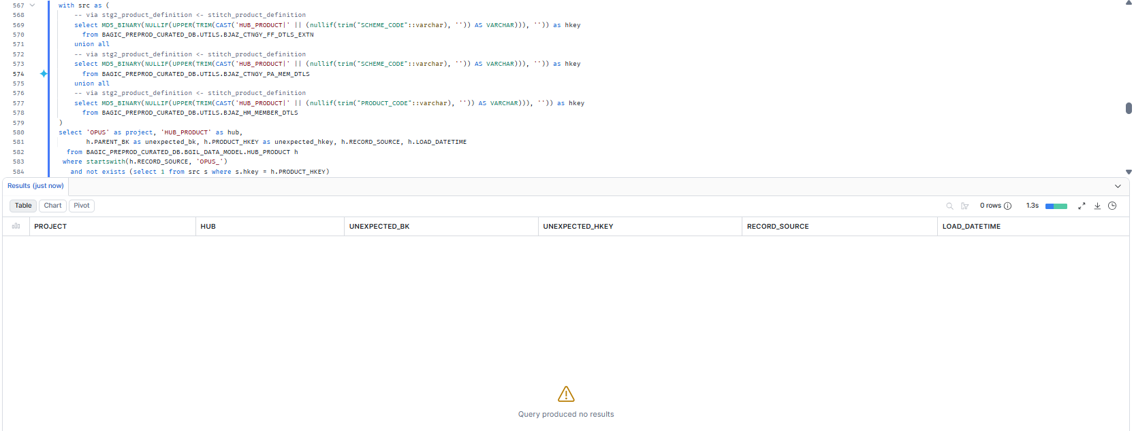

17. OPUS — HUB_DOCUMENT
Project | OPUS
Hub table | HUB_DOCUMENT
Status | Implemented
Pass criteria | 0 rows returned
Result (Pass / Fail / NA) | Pass
Rows returned (count) | 0
Remarks

Note: Hub rows scoped to RECORD_SOURCE 'OPUS_%'. A hit grouped under one RECORD_SOURCE that no longer feeds the hub is a legacy load from a removed feed (classify, do not ignore). 3 RAW key branch(es): BJAZ_T_KYC_OCR.[FIELD_TYPE+FIELD_VALUE+IMAGE_TYPE], BJAZ_T_KYC_POA_DOCUMENT.[DOCS_TYPE+DOCS_NUMBER], BJAZ_T_KYC_POI_DOCUMENT.[DOCS_TYPE+DOCS_NUMBER].
SQL query
with src as (
-- via stg2_hub_bjaz_t_kyc_ocr__document
select MD5_BINARY(NULLIF(UPPER(TRIM(CAST('HUB_DOCUMENT|' || (upper(trim(nullif(trim("FIELD_TYPE"::varchar), ''))) || ':' || trim(nullif(trim("FIELD_VALUE"::varchar), '')) || '#' || upper(trim(nullif(trim("IMAGE_TYPE"::varchar), '')))) AS VARCHAR))), '')) as hkey
from BAGIC_PREPROD_CURATED_DB.UTILS.BJAZ_T_KYC_OCR
union all
-- via stg2_hub_bjaz_t_kyc_poa_document__document
select MD5_BINARY(NULLIF(UPPER(TRIM(CAST('HUB_DOCUMENT|' || (upper(trim(coalesce(nullif(trim("DOCS_TYPE"::varchar), ''),''))) || ':' || upper(trim(coalesce(nullif(trim("DOCS_NUMBER"::varchar), ''),'')))) AS VARCHAR))), '')) as hkey
from BAGIC_PREPROD_CURATED_DB.UTILS.BJAZ_T_KYC_POA_DOCUMENT
union all
-- via stg2_hub_bjaz_t_kyc_poi_document__document
select MD5_BINARY(NULLIF(UPPER(TRIM(CAST('HUB_DOCUMENT|' || (upper(trim(coalesce(nullif(trim("DOCS_TYPE"::varchar), ''),''))) || ':' || upper(trim(coalesce(nullif(trim("DOCS_NUMBER"::varchar), ''),'')))) AS VARCHAR))), '')) as hkey
from BAGIC_PREPROD_CURATED_DB.UTILS.BJAZ_T_KYC_POI_DOCUMENT
)
select 'OPUS' as project, 'HUB_DOCUMENT' as hub,
h.PARENT_BK as unexpected_bk, h.DOCUMENT_HKEY as unexpected_hkey, h.RECORD_SOURCE, h.LOAD_DATETIME
from BAGIC_PREPROD_CURATED_DB.BGIL_DATA_MODEL.HUB_DOCUMENT h
where startswith(h.RECORD_SOURCE, 'OPUS_')
and not exists (select 1 from src s where s.hkey = h.DOCUMENT_HKEY)
order by h.RECORD_SOURCE, unexpected_bk;
Query output (attach / paste below)
Output:
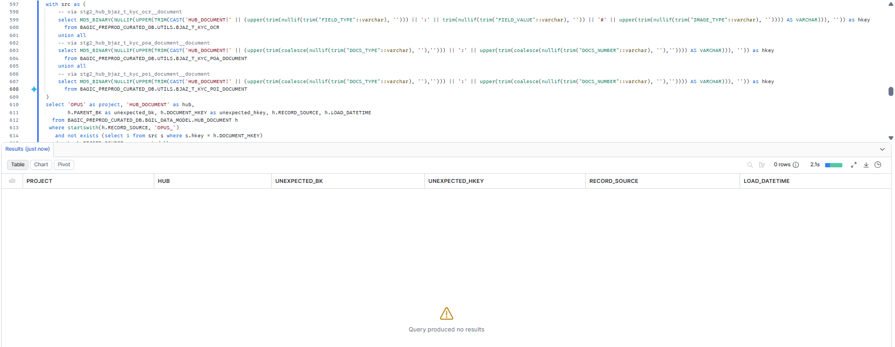

18. OPUS — HUB_POLICY
Project | OPUS
Hub table | HUB_POLICY
Status | Implemented
Pass criteria | 0 rows returned
Result (Pass / Fail / NA) | Pass
Rows returned (count) | 0
Remarks

Note: Hub rows scoped to RECORD_SOURCE 'OPUS_%'. A hit grouped under one RECORD_SOURCE that no longer feeds the hub is a legacy load from a removed feed (classify, do not ignore). 27 RAW key branch(es): AZBJ_PARTNER_EXTN.EXISTING_POLICY_PID, BJAZ_CTNGY_GC_MEM_DATA.POLICY_REF, BJAZ_CTNGY_PA_MEM_DTLS.CONTRACT_ID, BJAZ_EC_MEM_DTLS_EXTN.CONTRACT_ID, BJAZ_HCF_MEMBER_DTLS.CONTRACT_ID, BJAZ_HC_PART_EXTN.CONTRACT_ID, BJAZ_HM_MEMBER_DTLS.CONTRACT_ID, BJAZ_PA_DETL_EXTN.CONTRACT_ID, BJAZ_SH_MEM_DTLS_EXTN.CONTRACT_ID, BJAZ_SPP_MEMBER_DTLS.CONTRACT_ID, BA_HCP_DT_MEM.CONTRACT_ID, BJAZ_CTNGY_FF_DTLS_EXTN.CONTRACT_ID, BJAZ_HCF_MEMBER_DTLS.POLICY_NUMBER, BJAZ_HLT_ENSURE_MEM_DTLS.CONTRACT_ID, BJAZ_SPP_MEMBER_DTLS.POLICY_NUMBER, BJAZ_STARPKG_FF_DTLS.CONTRACT_ID, OCP_INTERESTED_PARTIES.CONTRACT_ID, BJAZ_T_CKYC_OTP.[FIELD_TYPE+FIELD_VALUE], BJAZ_T_CKYC_SEARCH.[FIELD_TYPE+FIELD_VALUE], BJAZ_T_EKYC.[FIELD_TYPE+FIELD_VALUE], BJAZ_T_KYC_AUTH.[FIELD_TYPE+FIELD_VALUE], BJAZ_T_KYC_DETAILS.[FIELD_TYPE+FIELD_VALUE], BJAZ_T_KYC_INCOMING.[FIELD_TYPE+FIELD_VALUE], BJAZ_T_KYC_NAME_MATCH.[FIELD_TYPE+FIELD_VALUE], BJAZ_T_KYC_OCR.[FIELD_TYPE+FIELD_VALUE], BJAZ_T_KYC_POA_DOCUMENT.[FIELD_TYPE+FIELD_VALUE], BJAZ_T_KYC_POI_DOCUMENT.[FIELD_TYPE+FIELD_VALUE]. stitch_policy_header is watermark-windowed (inc_job_updated_at); RAW rows with a NULL inc_job_updated_at never reach the hub and will surface as DM-K1 gaps. stitch_policy_bonus_tracking is watermark-windowed (inc_job_updated_at); RAW rows with a NULL inc_job_updated_at never reach the hub and will surface as DM-K1 gaps.
SQL query
with src as (
-- via stg2_policy_header <- stitch_policy_header
select MD5_BINARY(NULLIF(UPPER(TRIM(CAST('HUB_POLICY|' || (nullif(trim("EXISTING_POLICY_PID"::varchar), '')) AS VARCHAR))), '')) as hkey
from BAGIC_PREPROD_CURATED_DB.UTILS.AZBJ_PARTNER_EXTN
union all
-- via stg2_policy_header <- stitch_policy_header
select MD5_BINARY(NULLIF(UPPER(TRIM(CAST('HUB_POLICY|' || (nullif(trim("POLICY_REF"::varchar), '')) AS VARCHAR))), '')) as hkey
from BAGIC_PREPROD_CURATED_DB.UTILS.BJAZ_CTNGY_GC_MEM_DATA
union all
-- via stg2_policy_header <- stitch_policy_header
select MD5_BINARY(NULLIF(UPPER(TRIM(CAST('HUB_POLICY|' || (nullif(trim("CONTRACT_ID"::varchar), '')) AS VARCHAR))), '')) as hkey
from BAGIC_PREPROD_CURATED_DB.UTILS.BJAZ_CTNGY_PA_MEM_DTLS
union all
-- via stg2_policy_header <- stitch_policy_header (+1 more feed(s) on the same RAW table + key)
select MD5_BINARY(NULLIF(UPPER(TRIM(CAST('HUB_POLICY|' || (nullif(trim("CONTRACT_ID"::varchar), '')) AS VARCHAR))), '')) as hkey
from BAGIC_PREPROD_CURATED_DB.UTILS.BJAZ_EC_MEM_DTLS_EXTN
union all
-- via stg2_policy_header <- stitch_policy_header (+1 more feed(s) on the same RAW table + key)
select MD5_BINARY(NULLIF(UPPER(TRIM(CAST('HUB_POLICY|' || (nullif(trim("CONTRACT_ID"::varchar), '')) AS VARCHAR))), '')) as hkey
from BAGIC_PREPROD_CURATED_DB.UTILS.BJAZ_HCF_MEMBER_DTLS
union all
-- via stg2_policy_header <- stitch_policy_header
select MD5_BINARY(NULLIF(UPPER(TRIM(CAST('HUB_POLICY|' || (nullif(trim("CONTRACT_ID"::varchar), '')) AS VARCHAR))), '')) as hkey
from BAGIC_PREPROD_CURATED_DB.UTILS.BJAZ_HC_PART_EXTN
union all
-- via stg2_policy_header <- stitch_policy_header (+1 more feed(s) on the same RAW table + key)
select MD5_BINARY(NULLIF(UPPER(TRIM(CAST('HUB_POLICY|' || (nullif(trim("CONTRACT_ID"::varchar), '')) AS VARCHAR))), '')) as hkey
from BAGIC_PREPROD_CURATED_DB.UTILS.BJAZ_HM_MEMBER_DTLS
union all
-- via stg2_policy_header <- stitch_policy_header (+1 more feed(s) on the same RAW table + key)
select MD5_BINARY(NULLIF(UPPER(TRIM(CAST('HUB_POLICY|' || (nullif(trim("CONTRACT_ID"::varchar), '')) AS VARCHAR))), '')) as hkey
from BAGIC_PREPROD_CURATED_DB.UTILS.BJAZ_PA_DETL_EXTN
union all
-- via stg2_policy_header <- stitch_policy_header (+1 more feed(s) on the same RAW table + key)
select MD5_BINARY(NULLIF(UPPER(TRIM(CAST('HUB_POLICY|' || (nullif(trim("CONTRACT_ID"::varchar), '')) AS VARCHAR))), '')) as hkey
from BAGIC_PREPROD_CURATED_DB.UTILS.BJAZ_SH_MEM_DTLS_EXTN
union all
-- via stg2_policy_header <- stitch_policy_header (+1 more feed(s) on the same RAW table + key)
select MD5_BINARY(NULLIF(UPPER(TRIM(CAST('HUB_POLICY|' || (nullif(trim("CONTRACT_ID"::varchar), '')) AS VARCHAR))), '')) as hkey
from BAGIC_PREPROD_CURATED_DB.UTILS.BJAZ_SPP_MEMBER_DTLS
union all
-- via stg2_hub_ba_hcp_dt_mem__policy
select MD5_BINARY(NULLIF(UPPER(TRIM(CAST('HUB_POLICY|' || (nullif(trim("CONTRACT_ID"::varchar), '')) AS VARCHAR))), '')) as hkey
from BAGIC_PREPROD_CURATED_DB.UTILS.BA_HCP_DT_MEM
union all
-- via stg2_hub_bjaz_ctngy_ff_dtls_extn__policy
select MD5_BINARY(NULLIF(UPPER(TRIM(CAST('HUB_POLICY|' || (nullif(trim("CONTRACT_ID"::varchar), '')) AS VARCHAR))), '')) as hkey
from BAGIC_PREPROD_CURATED_DB.UTILS.BJAZ_CTNGY_FF_DTLS_EXTN
union all
-- via stg2_hub_bjaz_hcf_member_dtls__policy
select MD5_BINARY(NULLIF(UPPER(TRIM(CAST('HUB_POLICY|' || (nullif(trim("POLICY_NUMBER"::varchar), '')) AS VARCHAR))), '')) as hkey
from BAGIC_PREPROD_CURATED_DB.UTILS.BJAZ_HCF_MEMBER_DTLS
union all
-- via stg2_policy_bonus_tracking <- stitch_policy_bonus_tracking
select MD5_BINARY(NULLIF(UPPER(TRIM(CAST('HUB_POLICY|' || (nullif(trim("CONTRACT_ID"::varchar), '')) AS VARCHAR))), '')) as hkey
from BAGIC_PREPROD_CURATED_DB.UTILS.BJAZ_HLT_ENSURE_MEM_DTLS
union all
-- via stg2_hub_bjaz_spp_member_dtls__policy
select MD5_BINARY(NULLIF(UPPER(TRIM(CAST('HUB_POLICY|' || (nullif(trim("POLICY_NUMBER"::varchar), '')) AS VARCHAR))), '')) as hkey
from BAGIC_PREPROD_CURATED_DB.UTILS.BJAZ_SPP_MEMBER_DTLS
union all
-- via stg2_hub_bjaz_starpkg_ff_dtls__policy
select MD5_BINARY(NULLIF(UPPER(TRIM(CAST('HUB_POLICY|' || (nullif(trim("CONTRACT_ID"::varchar), '')) AS VARCHAR))), '')) as hkey
from BAGIC_PREPROD_CURATED_DB.UTILS.BJAZ_STARPKG_FF_DTLS
union all
-- via stg2_hub_ocp_interested_parties__policy
select MD5_BINARY(NULLIF(UPPER(TRIM(CAST('HUB_POLICY|' || (nullif(trim("CONTRACT_ID"::varchar), '')) AS VARCHAR))), '')) as hkey
from BAGIC_PREPROD_CURATED_DB.UTILS.OCP_INTERESTED_PARTIES
union all
-- via stg2_hub_bjaz_t_ckyc_otp__policy
select MD5_BINARY(NULLIF(UPPER(TRIM(CAST('HUB_POLICY|' || (case when upper(trim(nullif(trim("FIELD_TYPE"::varchar), ''))) like 'POLICY%' then trim(nullif(trim("FIELD_VALUE"::varchar), '')) end) AS VARCHAR))), '')) as hkey
from BAGIC_PREPROD_CURATED_DB.UTILS.BJAZ_T_CKYC_OTP
union all
-- via stg2_hub_bjaz_t_ckyc_search__policy
select MD5_BINARY(NULLIF(UPPER(TRIM(CAST('HUB_POLICY|' || (upper(case when upper(trim(nullif(trim("FIELD_TYPE"::varchar), ''))) like 'POLICY%' then trim(nullif(trim("FIELD_VALUE"::varchar), '')) end)) AS VARCHAR))), '')) as hkey
from BAGIC_PREPROD_CURATED_DB.UTILS.BJAZ_T_CKYC_SEARCH
union all
-- via stg2_hub_bjaz_t_ekyc__policy
select MD5_BINARY(NULLIF(UPPER(TRIM(CAST('HUB_POLICY|' || (upper(case when upper(trim(nullif(trim("FIELD_TYPE"::varchar), ''))) like 'POLICY%' then trim(nullif(trim("FIELD_VALUE"::varchar), '')) end)) AS VARCHAR))), '')) as hkey
from BAGIC_PREPROD_CURATED_DB.UTILS.BJAZ_T_EKYC
union all
-- via stg2_hub_bjaz_t_kyc_auth__policy
select MD5_BINARY(NULLIF(UPPER(TRIM(CAST('HUB_POLICY|' || (upper(case when upper(trim(nullif(trim("FIELD_TYPE"::varchar), ''))) like 'POLICY%' then trim(nullif(trim("FIELD_VALUE"::varchar), '')) end)) AS VARCHAR))), '')) as hkey
from BAGIC_PREPROD_CURATED_DB.UTILS.BJAZ_T_KYC_AUTH
union all
-- via stg2_hub_bjaz_t_kyc_details__policy
select MD5_BINARY(NULLIF(UPPER(TRIM(CAST('HUB_POLICY|' || (upper(case when upper(trim(nullif(trim("FIELD_TYPE"::varchar), ''))) like 'POLICY%' then trim(nullif(trim("FIELD_VALUE"::varchar), '')) end)) AS VARCHAR))), '')) as hkey
from BAGIC_PREPROD_CURATED_DB.UTILS.BJAZ_T_KYC_DETAILS
union all
-- via stg2_hub_bjaz_t_kyc_incoming__policy
select MD5_BINARY(NULLIF(UPPER(TRIM(CAST('HUB_POLICY|' || (case when upper(trim(nullif(trim("FIELD_TYPE"::varchar), ''))) like 'POLICY%' then trim(nullif(trim("FIELD_VALUE"::varchar), '')) end) AS VARCHAR))), '')) as hkey
from BAGIC_PREPROD_CURATED_DB.UTILS.BJAZ_T_KYC_INCOMING
union all
-- via stg2_hub_bjaz_t_kyc_name_match__policy
select MD5_BINARY(NULLIF(UPPER(TRIM(CAST('HUB_POLICY|' || (case when upper(trim(nullif(trim("FIELD_TYPE"::varchar), ''))) like 'POLICY%' then trim(nullif(trim("FIELD_VALUE"::varchar), '')) end) AS VARCHAR))), '')) as hkey
from BAGIC_PREPROD_CURATED_DB.UTILS.BJAZ_T_KYC_NAME_MATCH
union all
-- via stg2_hub_bjaz_t_kyc_ocr__policy
select MD5_BINARY(NULLIF(UPPER(TRIM(CAST('HUB_POLICY|' || (case when upper(trim(nullif(trim("FIELD_TYPE"::varchar), ''))) like 'POLICY%' then trim(nullif(trim("FIELD_VALUE"::varchar), '')) end) AS VARCHAR))), '')) as hkey
from BAGIC_PREPROD_CURATED_DB.UTILS.BJAZ_T_KYC_OCR
union all
-- via stg2_hub_bjaz_t_kyc_poa_document__policy
select MD5_BINARY(NULLIF(UPPER(TRIM(CAST('HUB_POLICY|' || (upper(case when upper(trim(nullif(trim("FIELD_TYPE"::varchar), ''))) like 'POLICY%' then trim(nullif(trim("FIELD_VALUE"::varchar), '')) end)) AS VARCHAR))), '')) as hkey
from BAGIC_PREPROD_CURATED_DB.UTILS.BJAZ_T_KYC_POA_DOCUMENT
union all
-- via stg2_hub_bjaz_t_kyc_poi_document__policy
select MD5_BINARY(NULLIF(UPPER(TRIM(CAST('HUB_POLICY|' || (upper(case when upper(trim(nullif(trim("FIELD_TYPE"::varchar), ''))) like 'POLICY%' then trim(nullif(trim("FIELD_VALUE"::varchar), '')) end)) AS VARCHAR))), '')) as hkey
from BAGIC_PREPROD_CURATED_DB.UTILS.BJAZ_T_KYC_POI_DOCUMENT
)
select 'OPUS' as project, 'HUB_POLICY' as hub,
h.PARENT_BK as unexpected_bk, h.POLICY_HKEY as unexpected_hkey, h.RECORD_SOURCE, h.LOAD_DATETIME
from BAGIC_PREPROD_CURATED_DB.BGIL_DATA_MODEL.HUB_POLICY h
where startswith(h.RECORD_SOURCE, 'OPUS_')
and not exists (select 1 from src s where s.hkey = h.POLICY_HKEY)
order by h.RECORD_SOURCE, unexpected_bk;
Query output (attach / paste below)
Output:
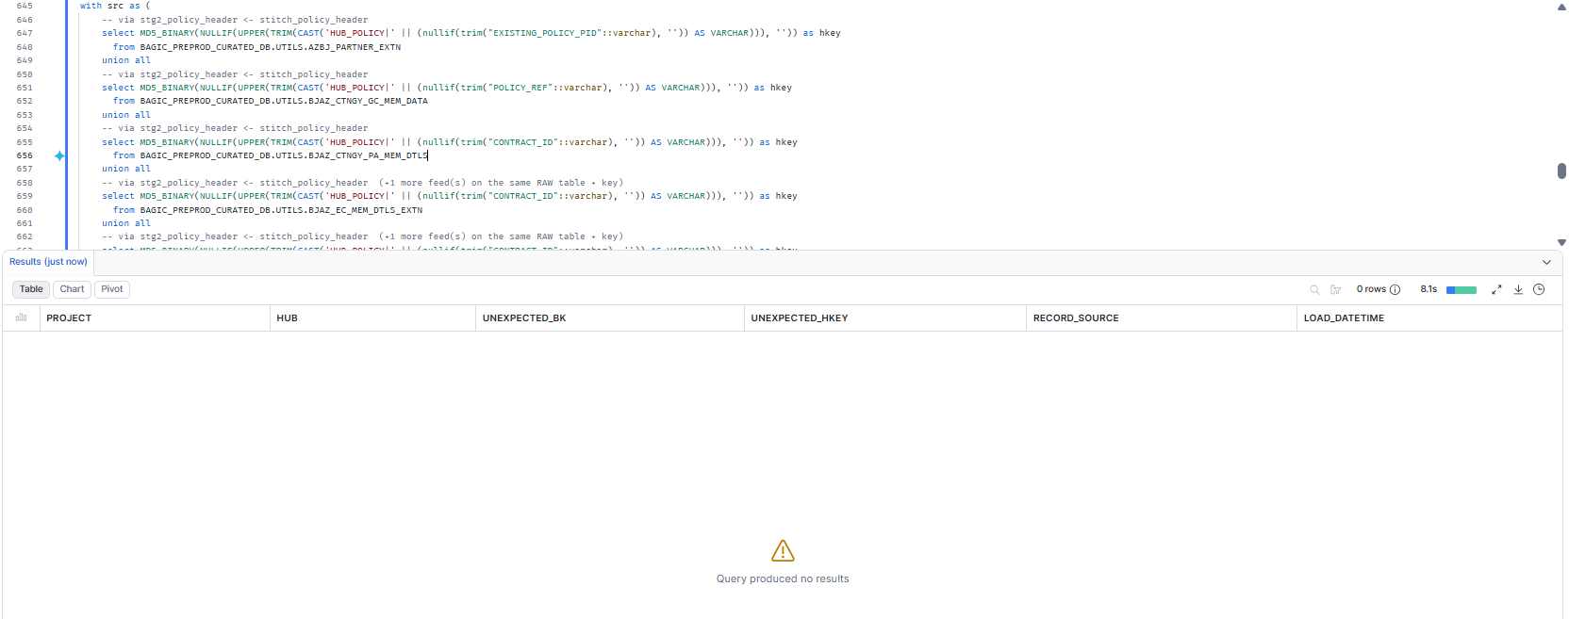

19. OPUS — HUB_DISTRIBUTION_CHANNEL
Project | OPUS
Hub table | HUB_DISTRIBUTION_CHANNEL
Status | Implemented
Pass criteria | 0 rows returned
Result (Pass / Fail / NA) | Pass
Rows returned (count) | 0
Remarks

Note: Hub rows scoped to RECORD_SOURCE 'OPUS_%'. A hit grouped under one RECORD_SOURCE that no longer feeds the hub is a legacy load from a removed feed (classify, do not ignore). 2 RAW key branch(es): BJAZ_INTERMEDIARY.INTERMEDIARY_ID, BJAZ_CLM_SUPP_EXTN.IMD_CODE.
SQL query
with src as (
-- via stg2_hub_bjaz_intermediary__distribution_channel
select MD5_BINARY(NULLIF(UPPER(TRIM(CAST('HUB_DISTRIBUTION_CHANNEL|' || (nullif(trim("INTERMEDIARY_ID"::varchar), '')) AS VARCHAR))), '')) as hkey
from BAGIC_PREPROD_CURATED_DB.UTILS.BJAZ_INTERMEDIARY
union all
-- via stg2_hub_bjaz_clm_supp_extn__distribution_channel
select MD5_BINARY(NULLIF(UPPER(TRIM(CAST('HUB_DISTRIBUTION_CHANNEL|' || (nullif(trim("IMD_CODE"::varchar), '')) AS VARCHAR))), '')) as hkey
from BAGIC_PREPROD_CURATED_DB.UTILS.BJAZ_CLM_SUPP_EXTN
)
select 'OPUS' as project, 'HUB_DISTRIBUTION_CHANNEL' as hub,
h.PARENT_BK as unexpected_bk, h.DISTRIBUTION_CHANNEL_HKEY as unexpected_hkey, h.RECORD_SOURCE, h.LOAD_DATETIME
from BAGIC_PREPROD_CURATED_DB.BGIL_DATA_MODEL.HUB_DISTRIBUTION_CHANNEL h
where startswith(h.RECORD_SOURCE, 'OPUS_')
and not exists (select 1 from src s where s.hkey = h.DISTRIBUTION_CHANNEL_HKEY)
order by h.RECORD_SOURCE, unexpected_bk;
Query output (attach / paste below)
Output:
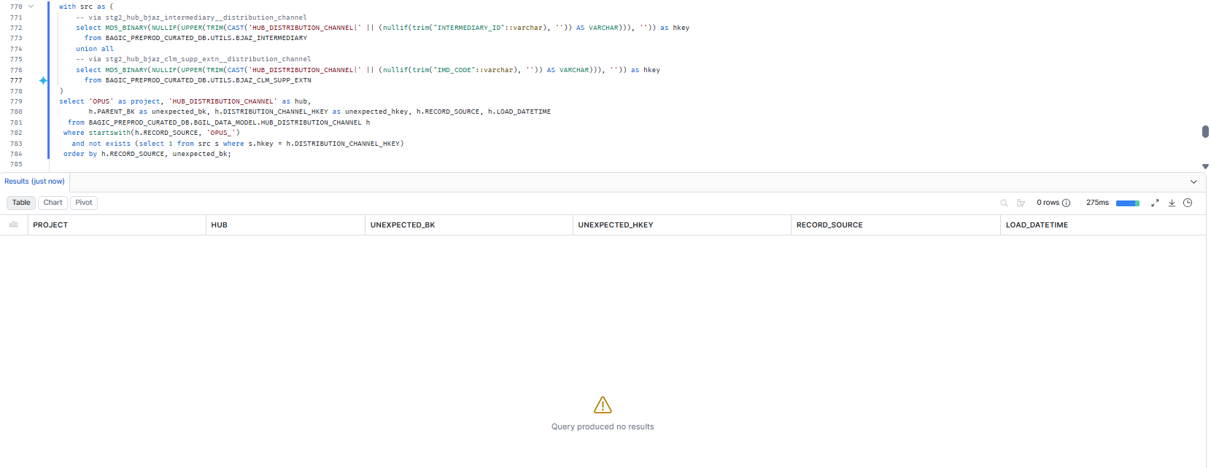

20. OPUS — HUB_ORG_UNIT
Project | OPUS
Hub table | HUB_ORG_UNIT
Status | Implemented
Pass criteria | 0 rows returned
Result (Pass / Fail / NA) | Pass
Rows returned (count) | 0
Remarks

Note: Hub rows scoped to RECORD_SOURCE 'OPUS_%'. A hit grouped under one RECORD_SOURCE that no longer feeds the hub is a legacy load from a removed feed (classify, do not ignore). 10 RAW key branch(es): BJAZ_T_CKYC_OTP.BUSINESS_UNIT, BJAZ_T_CKYC_SEARCH.BUSINESS_UNIT, BJAZ_T_EKYC.BUSINESS_UNIT, BJAZ_T_KYC_AUTH.BUSINESS_UNIT, BJAZ_T_KYC_DETAILS.BUSINESS_UNIT, BJAZ_T_KYC_INCOMING.BUSINESS_UNIT, BJAZ_T_KYC_NAME_MATCH.BUSINESS_UNIT, BJAZ_T_KYC_OCR.BUSINESS_UNIT, BJAZ_T_KYC_POA_DOCUMENT.BUSINESS_UNIT, BJAZ_T_KYC_POI_DOCUMENT.BUSINESS_UNIT.
SQL query
with src as (
-- via stg2_hub_bjaz_t_ckyc_otp__org_unit
select MD5_BINARY(NULLIF(UPPER(TRIM(CAST('HUB_ORG_UNIT|' || (trim(nullif(trim("BUSINESS_UNIT"::varchar), ''))) AS VARCHAR))), '')) as hkey
from BAGIC_PREPROD_CURATED_DB.UTILS.BJAZ_T_CKYC_OTP
union all
-- via stg2_hub_bjaz_t_ckyc_search__org_unit
select MD5_BINARY(NULLIF(UPPER(TRIM(CAST('HUB_ORG_UNIT|' || (upper(trim(nullif(trim("BUSINESS_UNIT"::varchar), '')))) AS VARCHAR))), '')) as hkey
from BAGIC_PREPROD_CURATED_DB.UTILS.BJAZ_T_CKYC_SEARCH
union all
-- via stg2_hub_bjaz_t_ekyc__org_unit
select MD5_BINARY(NULLIF(UPPER(TRIM(CAST('HUB_ORG_UNIT|' || (upper(trim(nullif(trim("BUSINESS_UNIT"::varchar), '')))) AS VARCHAR))), '')) as hkey
from BAGIC_PREPROD_CURATED_DB.UTILS.BJAZ_T_EKYC
union all
-- via stg2_hub_bjaz_t_kyc_auth__org_unit
select MD5_BINARY(NULLIF(UPPER(TRIM(CAST('HUB_ORG_UNIT|' || (upper(trim(nullif(trim("BUSINESS_UNIT"::varchar), '')))) AS VARCHAR))), '')) as hkey
from BAGIC_PREPROD_CURATED_DB.UTILS.BJAZ_T_KYC_AUTH
union all
-- via stg2_hub_bjaz_t_kyc_details__org_unit
select MD5_BINARY(NULLIF(UPPER(TRIM(CAST('HUB_ORG_UNIT|' || (upper(trim(nullif(trim("BUSINESS_UNIT"::varchar), '')))) AS VARCHAR))), '')) as hkey
from BAGIC_PREPROD_CURATED_DB.UTILS.BJAZ_T_KYC_DETAILS
union all
-- via stg2_hub_bjaz_t_kyc_incoming__org_unit
select MD5_BINARY(NULLIF(UPPER(TRIM(CAST('HUB_ORG_UNIT|' || (trim(nullif(trim("BUSINESS_UNIT"::varchar), ''))) AS VARCHAR))), '')) as hkey
from BAGIC_PREPROD_CURATED_DB.UTILS.BJAZ_T_KYC_INCOMING
union all
-- via stg2_hub_bjaz_t_kyc_name_match__org_unit
select MD5_BINARY(NULLIF(UPPER(TRIM(CAST('HUB_ORG_UNIT|' || (trim(nullif(trim("BUSINESS_UNIT"::varchar), ''))) AS VARCHAR))), '')) as hkey
from BAGIC_PREPROD_CURATED_DB.UTILS.BJAZ_T_KYC_NAME_MATCH
union all
-- via stg2_hub_bjaz_t_kyc_ocr__org_unit
select MD5_BINARY(NULLIF(UPPER(TRIM(CAST('HUB_ORG_UNIT|' || (trim(nullif(trim("BUSINESS_UNIT"::varchar), ''))) AS VARCHAR))), '')) as hkey
from BAGIC_PREPROD_CURATED_DB.UTILS.BJAZ_T_KYC_OCR
union all
-- via stg2_hub_bjaz_t_kyc_poa_document__org_unit
select MD5_BINARY(NULLIF(UPPER(TRIM(CAST('HUB_ORG_UNIT|' || (upper(trim(nullif(trim("BUSINESS_UNIT"::varchar), '')))) AS VARCHAR))), '')) as hkey
from BAGIC_PREPROD_CURATED_DB.UTILS.BJAZ_T_KYC_POA_DOCUMENT
union all
-- via stg2_hub_bjaz_t_kyc_poi_document__org_unit
select MD5_BINARY(NULLIF(UPPER(TRIM(CAST('HUB_ORG_UNIT|' || (upper(trim(nullif(trim("BUSINESS_UNIT"::varchar), '')))) AS VARCHAR))), '')) as hkey
from BAGIC_PREPROD_CURATED_DB.UTILS.BJAZ_T_KYC_POI_DOCUMENT
)
select 'OPUS' as project, 'HUB_ORG_UNIT' as hub,
h.PARENT_BK as unexpected_bk, h.ORG_UNIT_HKEY as unexpected_hkey, h.RECORD_SOURCE, h.LOAD_DATETIME
from BAGIC_PREPROD_CURATED_DB.BGIL_DATA_MODEL.HUB_ORG_UNIT h
where startswith(h.RECORD_SOURCE, 'OPUS_')
and not exists (select 1 from src s where s.hkey = h.ORG_UNIT_HKEY)
order by h.RECORD_SOURCE, unexpected_bk;
Query output (attach / paste below)
Output:
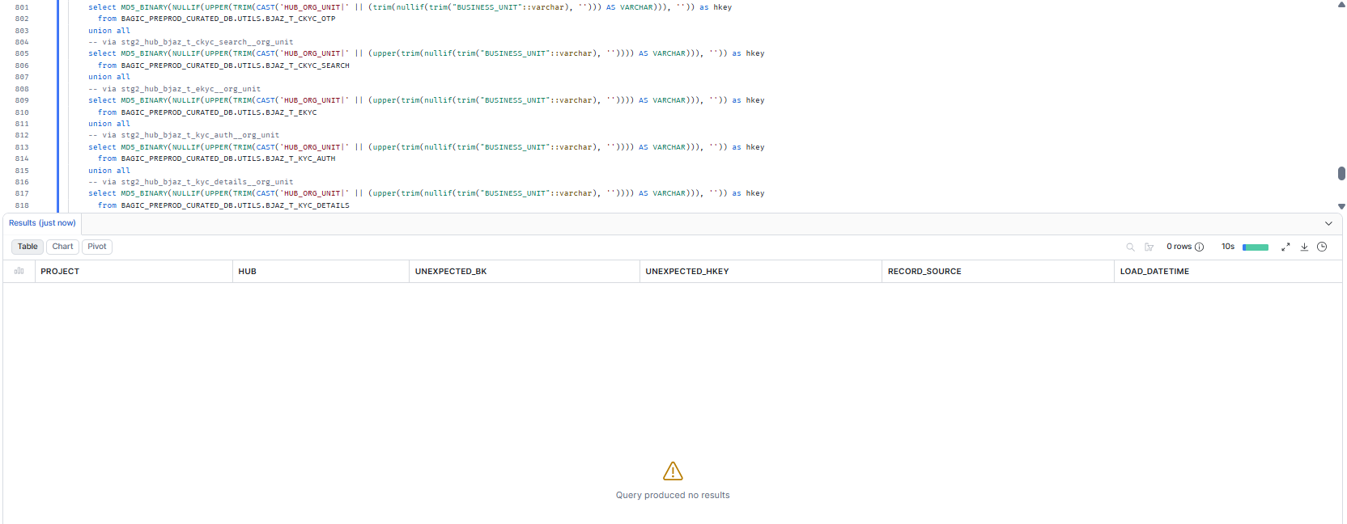

21. OPUS — HUB_RISK_OBJECT
Project | OPUS
Hub table | HUB_RISK_OBJECT
Status | Implemented
Pass criteria | 0 rows returned
Result (Pass / Fail / NA) | Pass
Rows returned (count) | 0
Remarks

Note: Hub rows scoped to RECORD_SOURCE 'OPUS_%'. A hit grouped under one RECORD_SOURCE that no longer feeds the hub is a legacy load from a removed feed (classify, do not ignore). 1 RAW key branch(es): CLM_INTERESTED_PARTIES.INS_OBJ_UID.
SQL query
with src as (
-- via stg2_hub_clm_interested_parties__risk_object
select MD5_BINARY(NULLIF(UPPER(TRIM(CAST('HUB_RISK_OBJECT|' || (nullif(trim("INS_OBJ_UID"::varchar), '')) AS VARCHAR))), '')) as hkey
from BAGIC_PREPROD_CURATED_DB.UTILS.CLM_INTERESTED_PARTIES
)
select 'OPUS' as project, 'HUB_RISK_OBJECT' as hub,
h.PARENT_BK as unexpected_bk, h.RISK_OBJECT_HKEY as unexpected_hkey, h.RECORD_SOURCE, h.LOAD_DATETIME
from BAGIC_PREPROD_CURATED_DB.BGIL_DATA_MODEL.HUB_RISK_OBJECT h
where startswith(h.RECORD_SOURCE, 'OPUS_')
and not exists (select 1 from src s where s.hkey = h.RISK_OBJECT_HKEY)
order by h.RECORD_SOURCE, unexpected_bk;
Query output (attach / paste below)
Output:
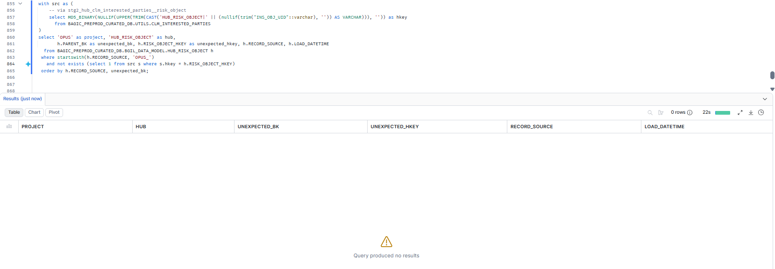

22. MAXIMUS + OPUS — Ownership sweep (all hubs)
Project | MAXIMUS + OPUS
Hub table | Ownership sweep (all hubs)
Status | Informational
Pass criteria | 0 rows, or only record sources of other known projects
Result (Pass / Fail / NA) | Pass
Rows returned (count) | 0
Remarks

Note: Not part of the pass criterion. Rows whose RECORD_SOURCE is neither MAXIMUS_ nor OPUS_ are not covered by the per-hub sections.
SQL query
select hub, RECORD_SOURCE, count(*) as rows_not_covered
from (
select 'HUB_PARTY' as hub, RECORD_SOURCE from BAGIC_PREPROD_CURATED_DB.BGIL_DATA_MODEL.HUB_PARTY
union all select 'HUB_STAKE_CODE' as hub, RECORD_SOURCE from BAGIC_PREPROD_CURATED_DB.BGIL_DATA_MODEL.HUB_STAKE_CODE
union all select 'HUB_LOCATION' as hub, RECORD_SOURCE from BAGIC_PREPROD_CURATED_DB.BGIL_DATA_MODEL.HUB_LOCATION
union all select 'HUB_PAYMENT_INSTRUMENT' as hub, RECORD_SOURCE from BAGIC_PREPROD_CURATED_DB.BGIL_DATA_MODEL.HUB_PAYMENT_INSTRUMENT
union all select 'HUB_PRODUCT' as hub, RECORD_SOURCE from BAGIC_PREPROD_CURATED_DB.BGIL_DATA_MODEL.HUB_PRODUCT
union all select 'HUB_FINANCIAL_ACCOUNT' as hub, RECORD_SOURCE from BAGIC_PREPROD_CURATED_DB.BGIL_DATA_MODEL.HUB_FINANCIAL_ACCOUNT
union all select 'HUB_DOCUMENT' as hub, RECORD_SOURCE from BAGIC_PREPROD_CURATED_DB.BGIL_DATA_MODEL.HUB_DOCUMENT
union all select 'HUB_POLICY' as hub, RECORD_SOURCE from BAGIC_PREPROD_CURATED_DB.BGIL_DATA_MODEL.HUB_POLICY
union all select 'HUB_DISTRIBUTION_CHANNEL' as hub, RECORD_SOURCE from BAGIC_PREPROD_CURATED_DB.BGIL_DATA_MODEL.HUB_DISTRIBUTION_CHANNEL
union all select 'HUB_ORG_UNIT' as hub, RECORD_SOURCE from BAGIC_PREPROD_CURATED_DB.BGIL_DATA_MODEL.HUB_ORG_UNIT
union all select 'HUB_AGENT' as hub, RECORD_SOURCE from BAGIC_PREPROD_CURATED_DB.BGIL_DATA_MODEL.HUB_AGENT
union all select 'HUB_AGREEMENT' as hub, RECORD_SOURCE from BAGIC_PREPROD_CURATED_DB.BGIL_DATA_MODEL.HUB_AGREEMENT
union all select 'HUB_CLAIM' as hub, RECORD_SOURCE from BAGIC_PREPROD_CURATED_DB.BGIL_DATA_MODEL.HUB_CLAIM
union all select 'HUB_RISK_OBJECT' as hub, RECORD_SOURCE from BAGIC_PREPROD_CURATED_DB.BGIL_DATA_MODEL.HUB_RISK_OBJECT
)
where not startswith(RECORD_SOURCE, 'MAXIMUS_')
and not startswith(RECORD_SOURCE, 'OPUS_')
group by hub, RECORD_SOURCE
order by hub, RECORD_SOURCE;
Query output (attach / paste below)
Output:
