Design and Verification of AXI4 Protocol Asynchronous FIFO using UVM

Bhavana Gunjalli Hiremath
Electronics and Communication Engineering
BNM Institute of Technology Bengaluru, India bhavanagunjallihiremath@gmail.com

Smitha Gayathri D
Electronics and Communication Engineering
BNM Institute of Technology Bengaluru, India smithagayathrid@bnmit.in
Manjunath C Shekar
Electronics and Communication Engineering
BNM Institute of Technology
Bengaluru, India manjunathc349@gmail.com
Suhani S Basti
Electronics and Communication Engineering
BNM Institute of Technology Bengaluru, India suhanibasti@gmail.com

ABSTRACT-This paper presents the design and functional verification of an Advanced eXtensible Interface (AXI4-Lite) Slave module, emphasizing protocol compliance and reliable transaction handling within System-on-Chip (SoC) architectures. The AXI4-Lite protocol, a subset of the AMBA AXI4 family, is widely adopted for memory-mapped communication due to its simplicity and deterministic timing. The developed Verilog-based AXI4-Lite Slave supports read and write transactions through the five fundamental channels—address write, write data, write response, address read, and read data—coordinated by a finite state machine (FSM) to ensure valid/ready handshaking and proper sequencing. Functional verification was carried out using Mentor Graphics QuestaSim, where a directed testbench validated correct handshake behavior, data integrity, and timing synchronization between the master and slave. The simulation results confirmed accurate implementation of AXI4-Lite protocol transactions, demonstrating proper assertion of handshake signals (AWVALID/AWREADY, WVALID/WREADY, etc.) and successful read-write data exchange. Future work will extend this design toward a Universal Verification Methodology (UVM)-based environment to enable reusable, coverage-driven verification and facilitate integration into complex FPGA and SoC systems..

Keywords— Advanced eXtensible Interface (AXI4-Lite); Advanced Microcontroller Bus Architecture; Functional Verification; Universal Verification Methodology (UVM); QuestaSim; SoC Design; Protocol Compliance.

- Introduction

The Advanced eXtensible Interface (AXI) is a part of the ARM Advanced Microcontroller Bus Architecture (AMBA) family, widely used in modern System-on-Chip (SoC) and FPGA-based designs to enable high-speed, high-performance communication between master and slave components. The AXI protocol provides separate address, data, and response channels, enabling concurrent read and write operations with minimal latency. It supports burst transactions, out-of-order completion, and multiple outstanding transactions, making it suitable for complex, high-bandwidth systems.
Among its variants, the AXI4-Lite protocol is a simplified version designed for low-complexity, memory-mapped peripheral communication. Unlike the full AXI4 protocol, AXI4-Lite supports only single-beat transfers without bursts, making it ideal for control registers, configuration spaces, and lightweight peripherals within SoC architectures. It maintains the fundamental AXI handshaking mechanism using valid and ready signals for each of the five essential channels — Write Address (AW), Write Data (W), Write Response (B), Read Address (AR), and Read Data (R). This structure ensures deterministic timing, protocol consistency, and efficient interconnection between processing cores and peripheral modules.

In this work, an AXI4-Lite Slave interface is designed and verified at the functional level. The slave module, implemented in Verilog HDL, handles both read and write transactions initiated by the AXI master, ensuring correct sequencing and data integrity through a Finite State Machine (FSM)–based control design. Each channel operates with valid/ready handshaking to prevent data hazards and maintain synchronization across transactions.

Functional verification was performed using the Mentor Graphics QuestaSim simulator. A directed testbench was developed to validate the slave’s functionality, covering write address, write data, write response, and read operations. Waveform analysis and $display-based outputs confirmed correct handshaking, data transfer accuracy, and adherence to the AXI4-Lite protocol timing. The results demonstrated reliable channel coordination and proper FSM transitions under various transaction scenarios.

The next phase of this project focuses on developing a Universal Verification Methodology (UVM)-based verification environment for the AXI4-Lite Slave. The UVM framework will incorporate transaction-level modeling (TLM) interfaces, sequence generation for randomized read/write operations, functional coverage metrics, and reusable Verification IP (VIP) components. This transition from a directed testbench to a UVM-driven verification approach aims to achieve improved automation, scalability, and reusability — aligning with modern verification standards for complex SoC designs.

XXX-X-XXXX-XXXX-X/XX/$XX.00 ©20XX IEEE

- Literature Survey

P. S. Deshmukh and S. B. Raghuwanshi present the design and verification of an AMBA AXI4-Lite Slave interface in Verilog HDL, implementing all five AXI-Lite channels with correct valid/ready handshaking. Simulation-based verification in QuestaSim confirmed accurate read/write operations, serving as a reference for AXI-based peripheral design [1].

R. N. Kulkarni and S. K. Patil demonstrate SystemVerilog-based verification of the AXI4 protocol using a layered testbench, employing both directed and constrained-random stimulus to validate transaction integrity and error responses [2].

N. Gupta, M. Sharma, and R. Jain study the implementation of an AXI4-Lite Master-Slave system in Verilog RTL, verified through waveform analysis. Their work highlights the simplicity of AXI4-Lite for register-mapped peripherals in FPGA-based designs [3].

R. A. Vijay and K. N. Reddy propose a UVM-based methodology for verifying AXI-compliant IPs, introducing reusable components such as sequencers, drivers, monitors, and scoreboards to reduce testbench development time while improving coverage [4].

A. N. Sharma and T. S. Bhat verify an AXI4 Interconnect using UVM, focusing on arbitration, address decoding, and routing across multiple masters/slaves. Their scalable testbench achieved high functional coverage [5].

R. Deepa and D. K. Prakash design and verify an AXI4-Lite memory-mapped peripheral using Verilog/SystemVerilog. FSM-based transaction control ensured proper synchronization, with simulation confirming reliable timing and response operations [6].

K. M. Shailesh and P. D. Rajan implement a reusable UVM-based Verification IP (VIP) supporting AXI4, AXI4-Lite, and AXI-Stream. Their modular approach enhanced reusability and verification efficiency at both IP and system level [7].

H. Singh and S. Verma explore verification of AXI4-Stream using UVM, applying transaction-level modeling and coverage-driven verification to validate continuous streaming and flow control [8].

S. Thomas and J. Mathew present a UVM-based AXI4 protocol verification case study, developing complete reusable agents, a scoreboard, and coverage analysis. Their results highlight automation, modularity, and scalability in SoC verification [9].

S. Ramesh and B. N. Sandeep verify an AXI4-Lite interface using a layered UVM testbench with constrained-random sequences, achieving 100% functional coverage and confirming handshake correctness and transaction ordering [10].

- Methodology

The design and verification of the AXI4 Asynchronous FIFO system were carried out in a structured methodology comprising design creation, testbench development, simulation setup, and verification flow, ensuring compliance with AXI4 protocol behavior across independent clock domains. The overall block diagram of the proposed architecture is shown in Fig. 1.
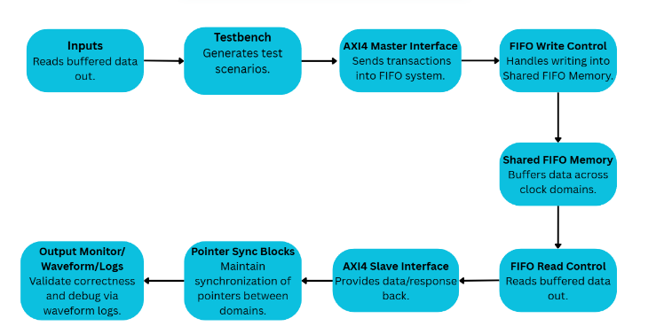
Fig 1. Block Diagram
Fig. 1 illustrates the functional verification flow of the AXI4 Asynchronous FIFO system. The process begins with input generation that feeds buffered data into the system. A testbench then generates various test scenarios, including read/write operations, clock variations, and backpressure conditions. The AXI4 Master Interface drives transactions into the FIFO, while the FIFO Write Control manages write operations and ensures data is stored into the Shared FIFO Memory safely. On the output side, the FIFO Read Control retrieves data, which is then passed to the AXI4 Slave Interface for response generation. Pointer synchronization blocks maintain proper communication between independent write and read clock domains, preventing metastability. Finally, the output monitor validates the correctness of results and aids debugging through waveform logs. This flow highlights the end-to-end process of design validation, covering data transfer, synchronization, and verification feedback.

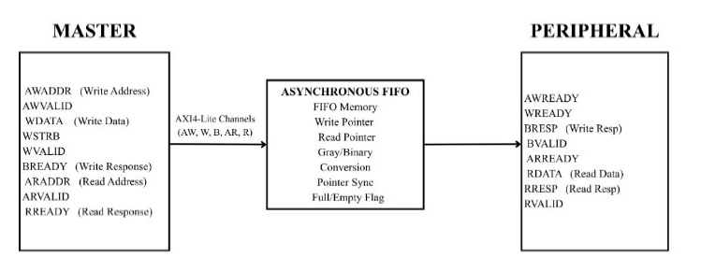
Fig 2. System-Level Representation of AXI4-Lite Asynchronous FIFO

Fig. 2 presents the structural system-level representation of the AXI4 Asynchronous FIFO. On the left, the AXI4-Lite Master generates signals for write and read transactions, including address, data, and handshake signals. In the center, the Asynchronous FIFO block acts as the core bridging element, consisting of FIFO memory, read/write pointers, binary-to-Gray conversion logic, pointer synchronization blocks, and full/empty flag detection. This ensures reliable data transfer across independent clock domains. On the right, the AXI4-Lite Slave (Peripheral) receives and responds with handshake signals, read data, and response codes. This structural diagram emphasizes the modular design approach, showing how the FIFO enables seamless master-slave communication in AXI4 systems despite asynchronous clocking.

- Design Creation

The AXI4 Asynchronous FIFO was modeled in Verilog HDL, consisting of the following key components:
- AXI4 Master Interface: Initiates transactions by generating write addresses, write data, and read requests while maintaining handshake synchronization (VALID/READY). Similar master-side implementations for AXI4-Lite have been reported in [1], [3], highlighting their simplicity for register-mapped peripherals.
- FIFO Write Control: Operates in the wr_clk domain, handling binary/Gray-coded write pointers, full condition detection, and safe data buffering. This approach follows established asynchronous FIFO design practices [6].
- Shared FIFO Memory: A dual-port memory forms the core buffer, enabling safe data transfer between write and read clock domains, effectively decoupling producer and consumer transactions [2], [6].
- FIFO Read Control: Functions in the rd_clk domain, managing binary/Gray-coded read pointers, empty condition detection, and safe data delivery to the slave interface.
- AXI4 Slave Interface: Provides read data (RDATA) and response signals (RRESP), ensuring correct handshake timing during read operations [1], [6].
- Pointer Synchronization Blocks: Gray-coded pointers are synchronized across clock domains using dual flip-flop synchronizers to prevent metastability, a method validated in prior AXI-based FIFO studies [4], [5].

- Testbench Development
A directed SystemVerilog testbench was implemented to validate functionality. The testbench generated AXI transactions (read/write), randomized clock ratios, and introduced backpressure conditions. Similar directed and constrained-random approaches have been emphasized by Kulkarni & Patil [2] and Vijay & Reddy [4], ensuring handshake integrity and robust error detection. Waveform inspection confirmed timing correctness and protocol synchronization, consistent with verification practices in [3], [6].

C. Simulation Setup
The environment was developed in Mentor QuestaSim, following an automated script-based flow for:
- Compilation of design and testbench files.
- Simulation of test scenarios.
- Waveform capture and protocol event logging.
This setup ensured repeatability and efficient debugging, aligning with simulation-based flows adopted in [1], [3], and [6].

D. Verification Flow
Verification was conducted in two phases:
- Write Transaction: AXI master issues a write address and data. The FIFO write control stores data safely across the asynchronous boundary.
- Read Transaction: AXI slave issues a read request. FIFO read control delivers valid data, synchronized via Gray-coded pointers to avoid underflow or metastability.
An output monitor validated received data against expected values. This flow reflects structured AXI verification practices outlined in [4], [5], and [9].

E. Proposed Extension

While directed verification confirmed functional correctness, the framework will be extended into a UVM-based environment. Prior works [4], [7], [9], [10] demonstrate that constrained-random stimulus, coverage-driven analysis, and reusable Verification IP (VIP) significantly enhance scalability, automation, and robustness for AXI-based SoC designs. This proposed extension ensures exhaustive validation of the FIFO system under diverse conditions for real-world SoC integration.
Results And Discussion
The simulation of the AXI4-Lite interface design was conducted using Mentor QuestaSim to validate protocol compliance and data integrity for both read and write transactions. The primary objective was to confirm correct signal handshaking and reliable data transfer prior to integrating asynchronous FIFO functionality.
The testbench sequence began with a reset phase, ensuring the design initialized to a known idle state. Subsequent read and write operations demonstrated complete adherence to AXI4-Lite specifications. The interface correctly managed address, data, and response phases while maintaining synchronization across independent clock domains.

Simulation results confirmed the following key observations:
- Successful write and read transactions were executed at multiple addresses (e.g., 0x100, 0x200), with data patterns such as 0xDEADBEEF accurately written and retrieved, validating end-to-end integrity.
- Handshake signals (awvalid, awready, wvalid, wready, arvalid, arready, rvalid, rready) exhibited proper toggling behavior, confirming reliable communication and timing compliance.
- Response signals (bresp, rresp) consistently indicated “OKAY” status (00), verifying error-free transactions.
- The design effectively managed asynchronous clock domains, with data written under the write clock (wr_clk) being correctly read under the read clock (rd_clk), demonstrating robust FIFO functionality and data coherency.

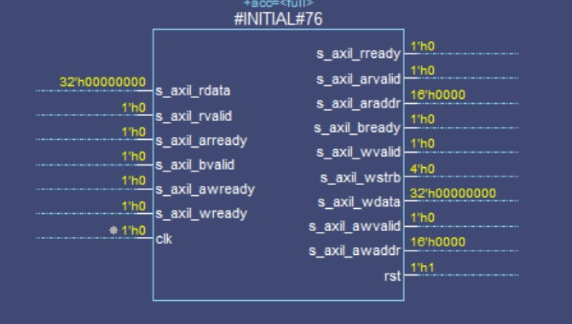
Figure 3: - Initial Signal Dump of AXI4-Lite Slave Module

Figure 3 illustrates the initial signal dump of the AXI4-Lite slave module following reset. The slave remained idle with deasserted control signals and cleared data buses (0x00000000), confirming a proper initialization sequence and readiness for operation.
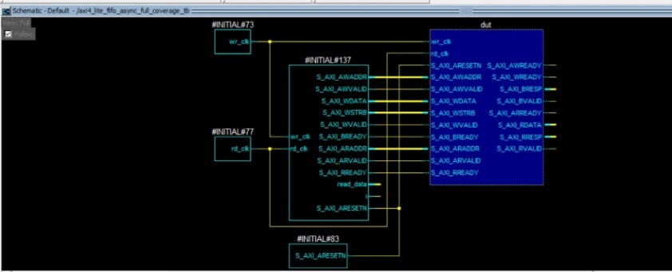
Figure 4: - Schematic of Testbench and DUT Connectivity

Figure 4 presents the testbench and DUT schematic, showing clock, reset, and signal connectivity across all five AXI4-Lite channels—Write Address, Write Data, Write Response, Read Address, and Read Data. Independent wr_clk and rd_clk generators verify asynchronous domain operation within the integrated design.

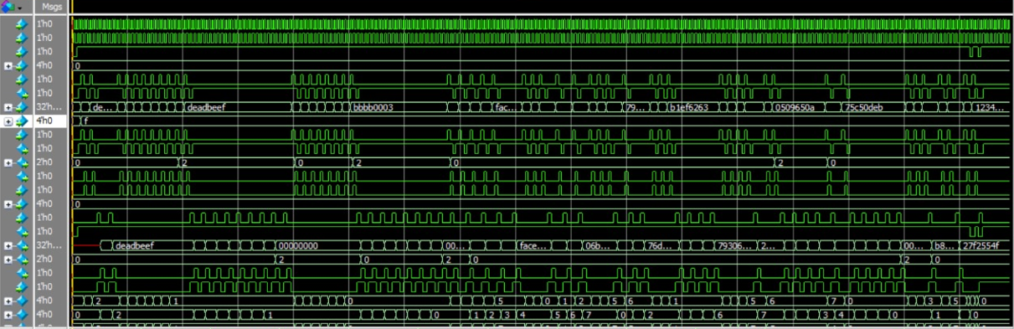
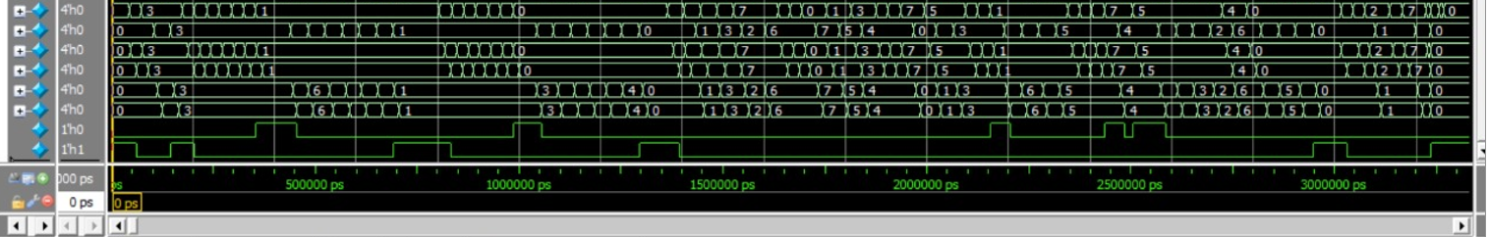
Figure 5: - Waveform of AXI4-Lite Asynchronous FIFO

Figure 5 depicts the waveform of the AXI4-Lite asynchronous FIFO, highlighting functional verification of read and write channels. The write transactions, carrying data such as 0xDEADBEEF, 0xBBBB0003, and 0xFACE1234, were successfully captured by the FIFO and subsequently retrieved in the same order, confirming First-In-First-Out integrity. The handshake synchronization between wvalid/wready and rvalid/rready ensured stable data exchange across asynchronous boundaries. Throughout the simulation, both bresp and rresp maintained “OKAY” responses, and no protocol violations were observed.

The simulation concluded with successful functional verification, demonstrating that the AXI4-Lite asynchronous FIFO design reliably supports multi-clock operation, maintains data integrity, and adheres to all AXI4-Lite protocol specifications.

- Conclusion

The AXI4-Lite interface design was successfully implemented and functionally verified using Verilog HDL. Simulation and waveform analysis carried out in Mentor Graphics QuestaSim confirmed correct adherence to AXI4-Lite protocol specifications, including proper handshaking, data transfer integrity, and response signaling. The directed testbench methodology effectively validated both read and write operations, ensuring reliable communication across asynchronous clock domains with the integrated FIFO structure.
This work demonstrates a complete functional verification flow encompassing design, simulation, and debugging, leading to a verified AXI4-Lite slave interface with asynchronous FIFO capability. The results confirm that the design can reliably manage multi-clock transactions and maintain data coherency, establishing a robust platform for future verification enhancements. As a next step, a UVM-based verification environment will be developed to enable automation, reusability, and coverage-driven testing for more complex AXI-based and SoC-level designs.

- References

[1]. P. S. Deshmukh, S. B. Raghuwanshi, “Design and Verification of AMBA AXI4-Lite Slave Interface Using Verilog HDL,” International Journal of Engineering Research & Technology (IJERT), Vol. 9, Issue 5, 2021.

[2]. R. N. Kulkarni, S. K. Patil, “SystemVerilog Based Verification of AXI4 Protocol Using Layered Testbench Architecture,” International Research Journal of Engineering and Technology (IRJET), Vol. 8, Issue 6, 2021.

[3]. N. Gupta, M. Sharma, R. Jain, “Implementation and Simulation of AXI4-Lite Master-Slave Communication System,” International Journal of Advanced Research in Electrical, Electronics and Instrumentation Engineering (IJAREEIE), Vol. 10, Issue 2, 2022.

[4]. R. A. Vijay, K. N. Reddy, “Functional Verification of AXI Protocol Using Universal Verification Methodology,” International Journal of VLSI Design & Communication Systems (VLSICS), Vol. 12, No. 4, August 2021.

[5]. A. N. Sharma, T. S. Bhat, “Verification of AXI4 Interconnect Using UVM,” International Conference on Electronics, Communication and Aerospace Technology (ICECA), 2022.

[6]. R. Deepa, D. K. Prakash, “Design and Verification of AXI4-Lite Based Memory-Mapped Peripheral Using Verilog HDL,” International Journal of Innovative Science and Research Technology (IJISRT), Vol. 7, Issue 9, 2022.

[7]. K. M. Shailesh, P. D. Rajan, “UVM-Based Reusable Verification IP for AMBA AXI Protocol,” IEEE International Conference on Intelligent Computing and Control Systems (ICICCS), 2023.

[8]. H. Singh, S. Verma, “UVM-Based Verification of AXI4-Stream Interface Using Transaction-Level Modeling,” Journal of Engineering and Applied Sciences (JEAS), Vol. 15, Issue 4, 2021.

[9]. S. Thomas, J. Mathew, “AXI4 Protocol Verification Using Universal Verification Methodology (UVM),” International Journal of Advanced Research in Computer and Communication Engineering (IJARCCE), Vol. 10, Issue 8, 2021.

[10]. S. Ramesh, B. N. Sandeep, “Functional Verification of AXI4-Lite Interface Using Layered UVM Testbench,” International Journal of Electrical and Electronics Research (IJEER), Vol. 11, Issue 3, 2023.
[11]. S. Ramesh, B. N. Sandeep, “Functional Verification of AXI4-Lite Interface Using Layered UVM Testbench,” International Journal of Electrical and Electronics Research (IJEER), Vol. 11, Issue 3, 2023.

[12]. A. N. Sharma, T. S. Bhat, “Verification of AXI4 Interconnect Using UVM,” International Conference on Electronics, Communication and Aerospace Technology (ICECA), 2022.

[13]. R. Deepa, D. K. Prakash, “Design and Verification of AXI4-Lite Based Memory-Mapped Peripheral Using Verilog HDL,” International Journal of Innovative Science and Research Technology (IJISRT), Vol. 7, Issue 9, 2022.

