## CS 5523 Operating Systems

## Home Work 4

**Introduction:**

As part of the Operating Systems course, this report explains how the client-server paradigm and peer-to-peer paradigm is implemented using distributed system using socket programming in java.

**Class Diagram:**

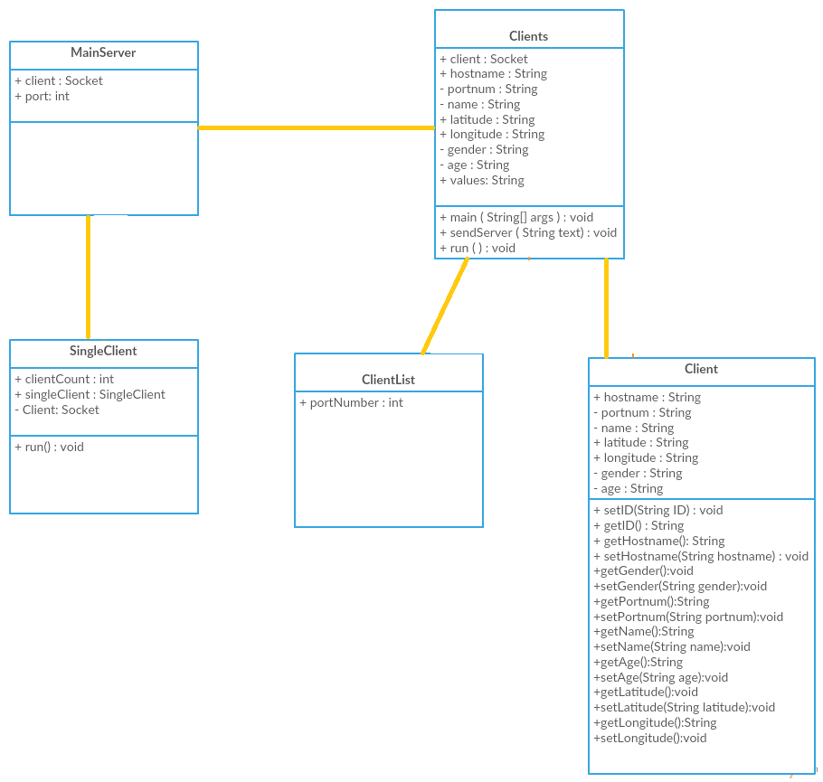

**How to Run the Program:**

1. Open Command Prompt and run the following command

Java MainServer 8012

1. Open another Command Prompt and run the following command

Java client –SH manju.com –SP 8012 -N manju –L 20 20 -S F –A 25

**Output:**

**MainServer.java:**

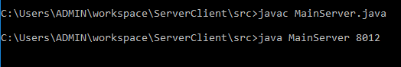

**Clients.java:**



**Usecases:**

1. **go -50 30**



1. **get location**

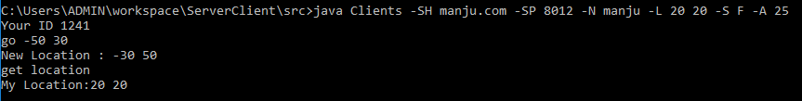

1. **list 30**



1. **send 1276 hello**

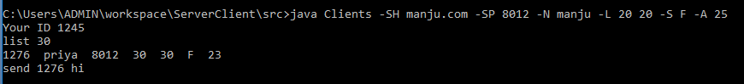



1. **quit**

