WEEK 3 TASK
Advanced Data Analysis and Visualization in Logistics
Exploratory Data Analysis, Visualization, and Operational Insights Using Python

Report Type | Advanced logistics data analysis and visualization
Dataset | Hypothetical logistics shipment dataset
Records | 1,000 simulated shipments
Tools | Python, pandas, NumPy, Matplotlib
Focus | Delivery performance, volume, cost, distance and bottlenecks

1. Objective
The objective of Week 3 is to perform advanced exploratory data analysis (EDA) on logistics data and communicate the results through clear visualizations. The analysis focuses on operational efficiency, shipment volume, delivery time, transportation cost, distance, transport mode and on-time performance. The task extends the Week 2 preprocessing concepts by using a clean analytical dataset to calculate statistics, identify relationships, visualize trends, and derive logistics insights.

2. Hypothetical Logistics Dataset
A hypothetical dataset containing 1,000 shipment records was created to simulate an e-commerce logistics operation. The dataset was designed to contain realistic variation across regions, transport modes, priorities, shipment volumes, distances, delivery times, transportation costs and delivery performance. A small number of missing values were intentionally introduced in delivery time and transport cost so that the Week 3 analysis also demonstrates practical data handling.
Variable | Type | Description
shipment_id | Categorical | Unique shipment identifier
region | Categorical | South, West, North, East or Central
transport_mode | Categorical | Road, Rail or Air
priority | Categorical | Standard or Express
month | Integer | Month number from 1 to 12
shipment_volume_units | Numeric | Number of units in the shipment
distance_km | Numeric | Estimated transportation distance
delivery_time_days | Numeric | Delivery duration in days
transport_cost | Numeric | Transportation cost per shipment
on_time | Binary | 1 for on-time delivery, 0 otherwise

3. Methodology
- Generate a reproducible hypothetical logistics dataset using NumPy and pandas.
- Inspect data types, dimensions, missing values and descriptive statistics.
- Handle intentionally missing numeric values using median imputation for this simulation.
- Calculate central tendency and dispersion measures.
- Analyze distributions and categorical group differences.
- Calculate correlations between numerical logistics variables.
- Create multiple visualizations using Matplotlib.
- Interpret each visualization in terms of operational efficiency, cost and bottlenecks.
- Convert findings into practical logistics recommendations.

4. Exploratory Data Analysis

4.1 Descriptive Statistics
Variable | Mean | Median | Std. Dev. | Minimum | Maximum
shipment_volume_units | 113.87 | 115.00 | 33.07 | 20.00 | 220.00
distance_km | 470.69 | 417.30 | 262.07 | 56.90 | 1600.00
delivery_time_days | 4.58 | 4.51 | 1.24 | 1.50 | 8.65
transport_cost | 53.86 | 48.75 | 23.70 | 25.00 | 150.24
The overall simulated on-time delivery rate is approximately 73.2%. Average delivery time is 4.58 days and the median is 4.51 days. Average transportation cost is 53.86 cost units per shipment.

4.2 Missing-Value Check
The simulation contains 8 missing transport-cost values and 6 missing delivery-time values. For this controlled exercise, median imputation was used so that the visualization stage could operate on a complete numerical table. In a real logistics project, the reason for missingness should be investigated before choosing an imputation strategy.

4.3 Correlation Analysis
Distance and transportation cost have a Pearson correlation of 0.20 in the simulated data, while distance and delivery time have a correlation of 0.68. Correlation is useful for identifying associations, but it should not be interpreted as proof of causation.

5. Visual Analysis

5.1 Delivery Time Distribution – Histogram
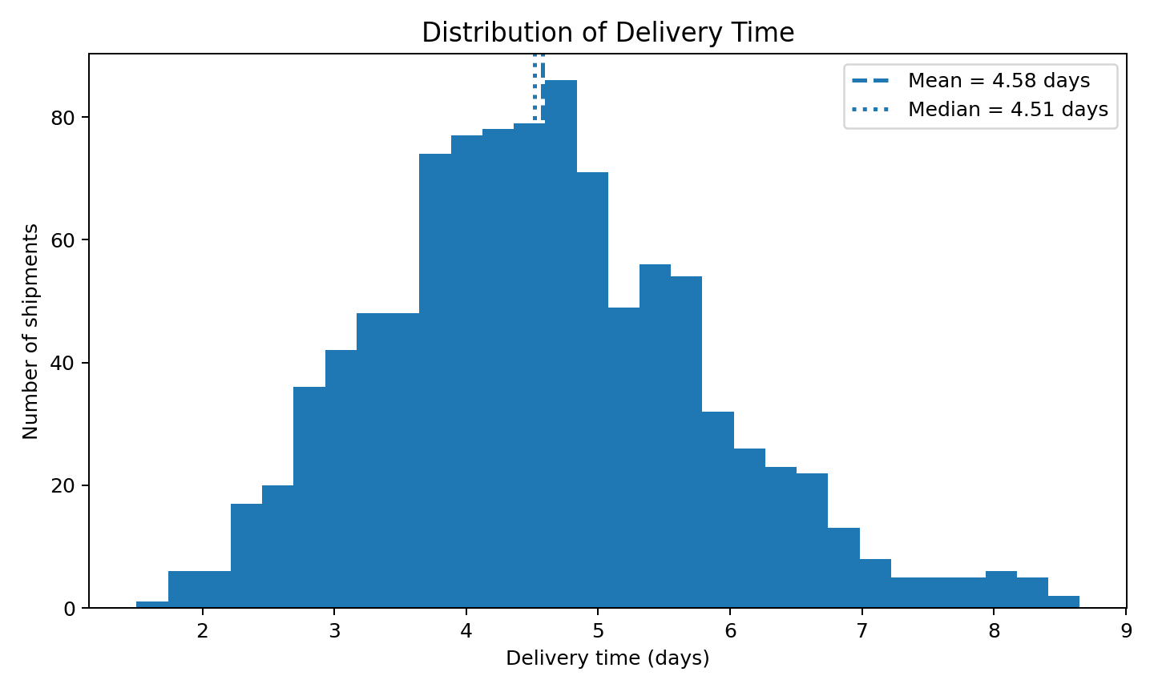
Why this visualization: A histogram is appropriate for understanding the distribution of delivery duration, including its center, spread and possible skew. The mean and median lines make it easier to compare central tendency. In this simulation, the mean delivery time is 4.58 days and the median is 4.51 days.
Operational interpretation: A long right tail would indicate a smaller group of very slow deliveries. Such shipments should be examined by region, distance, transport mode and processing conditions because averages alone can hide problematic cases.

5.2 Transportation Cost by Mode – Box Plot
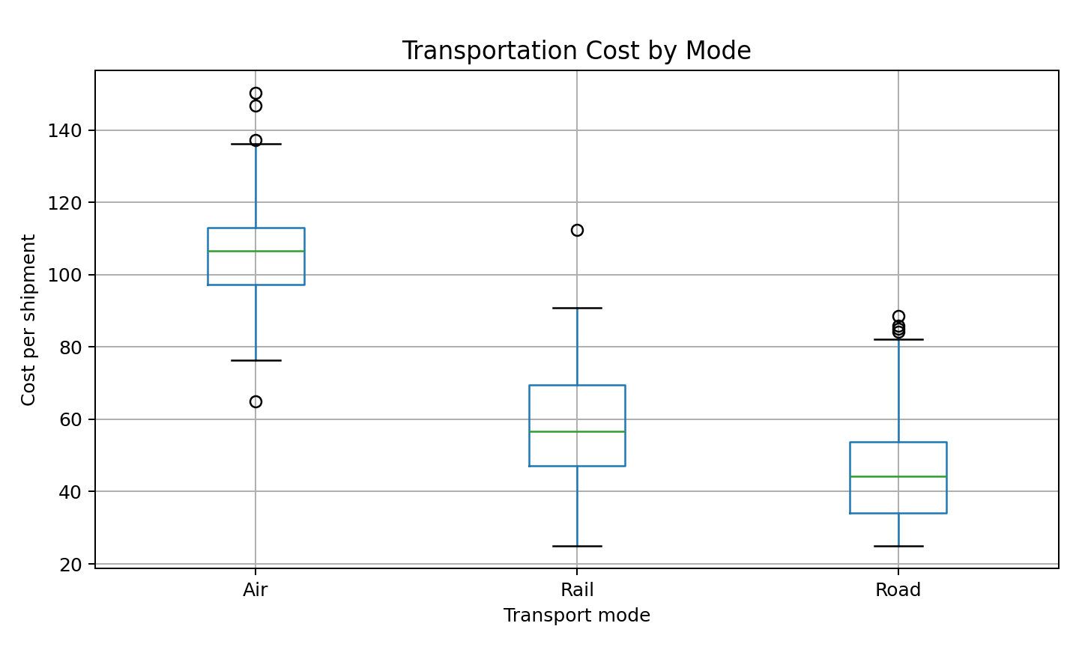
Why this visualization: A box plot compares the center, spread and extreme observations across transport modes. It is useful for detecting whether a mode has consistently higher cost or greater variability.
Operational interpretation: In the simulated dataset, Air has the highest average cost per shipment, while Air has the lowest average delivery time. This illustrates the common logistics trade-off between speed and transportation cost.

5.3 Shipment Volume by Region – Bar Chart
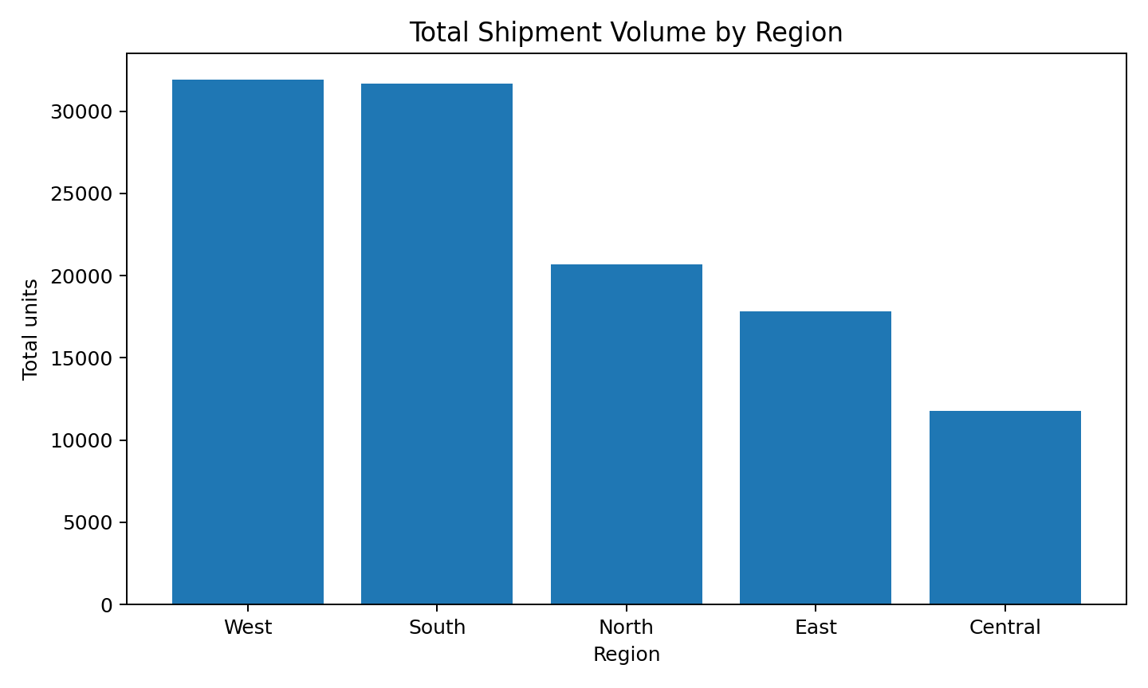
Why this visualization: A bar chart is effective for comparing discrete geographic categories. It makes differences in shipment volume between regions immediately visible.
Operational interpretation: The West region has the highest simulated shipment volume. High-volume regions may require additional vehicle capacity, warehouse coordination, staffing or delivery slots.

5.4 Distance vs Transportation Cost – Scatter Plot
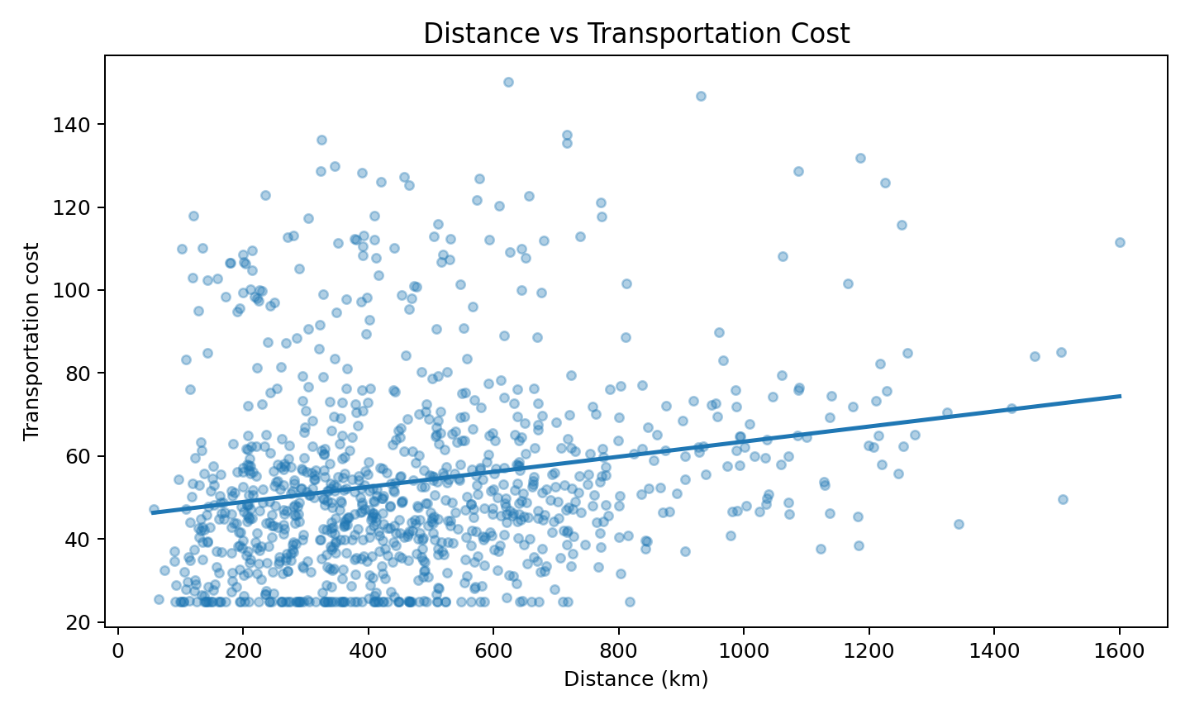
Why this visualization: A scatter plot is appropriate for studying relationships between two continuous variables. The fitted trend line helps summarize the overall direction of the relationship.
Operational interpretation: The simulated distance-cost correlation is 0.20. The upward relationship indicates that longer shipment distances generally increase transportation cost, although transport mode and shipment characteristics also contribute.

5.5 Monthly Delivery-Time Trend – Line Chart
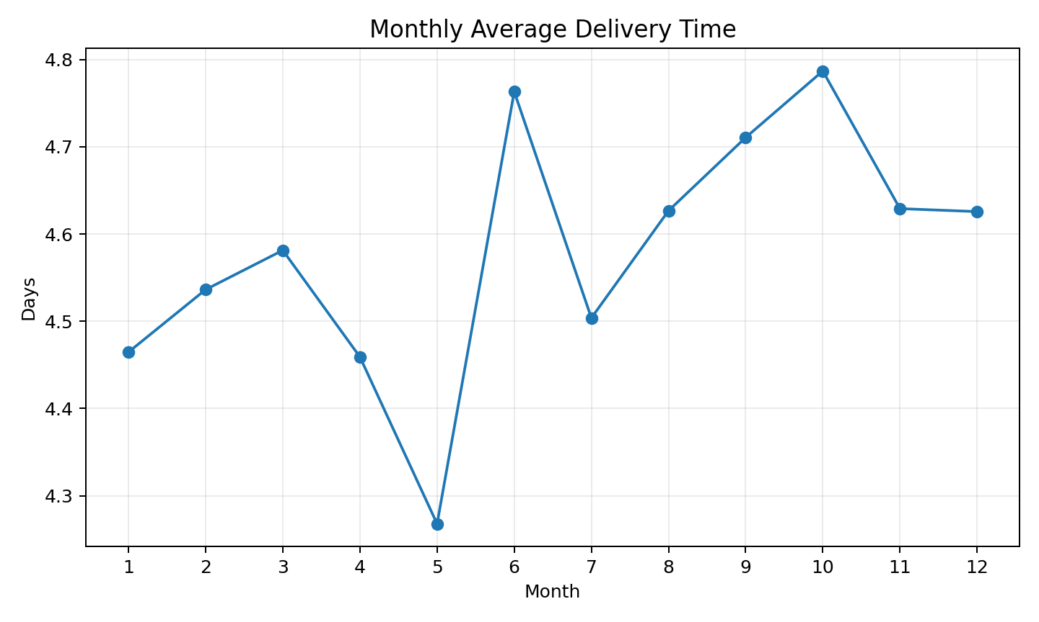
Why this visualization: A line chart is appropriate for ordered time periods because it reveals changes, trends and possible seasonal patterns. Monitoring this chart over real operational data could help detect periods of service deterioration.

5.6 Correlation Matrix
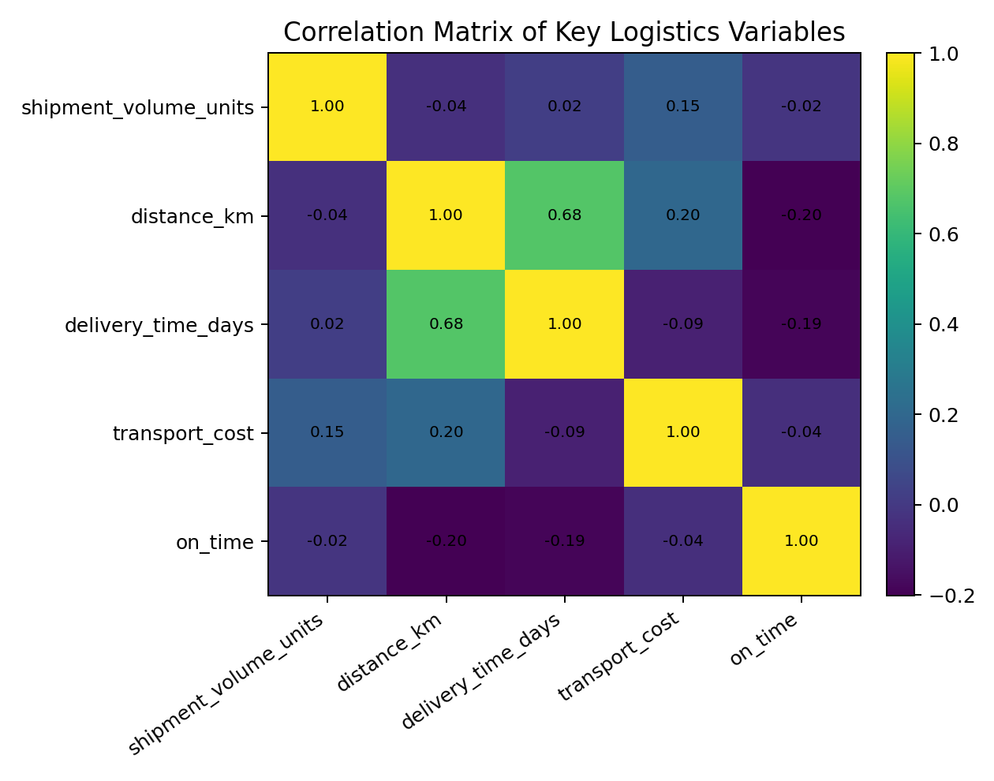
Why this visualization: A correlation matrix provides a compact overview of linear relationships among numerical variables. It can guide feature selection and help identify variables that may contain overlapping information.

6. Comparative Logistics Analysis
Transport Mode | Avg Delivery (days) | Avg Cost | On-Time Rate
Air | 3.73 | 105.95 | 73.0%
Rail | 4.31 | 57.76 | 71.6%
Road | 4.78 | 44.53 | 73.7%

7. Analytical Insights
- Delivery performance: The overall simulated on-time rate is 73.2%, providing a baseline KPI for future comparison.
- Distance effect: The distance-cost correlation of 0.20 indicates that distance is an important cost driver in this simulated operation.
- Delivery time: The mean of 4.58 days versus a median of 4.51 days should be monitored for signs of skew and long-tail delays.
- Regional workload: West has the highest total shipment volume, suggesting that capacity planning should pay particular attention to high-volume regions.
- Mode trade-off: Air has the highest average transportation cost, while Air has the shortest average delivery time in the simulation. This highlights the need to balance service speed against cost.
- Potential bottleneck: North has the lowest simulated on-time rate among regions and should be investigated further by distance, transport mode and shipment priority.

8. Recommendations Based on the Analysis
- Track on-time delivery and average delivery time by region and transport mode rather than relying only on overall averages.
- Investigate long-distance shipments because distance is associated with higher transportation cost in the simulated data.
- Use high-volume regions as a priority for capacity and resource planning.
- Evaluate whether premium transport modes are being used only where their speed advantage justifies their higher cost.
- Create a recurring monthly logistics dashboard to detect changes in delivery time, cost and on-time performance.
- For real-world deployment, combine shipment records with road-network distance, traffic, vehicle capacity, fuel price and weather data.

9. Python Code Examples
import pandas as pd
import matplotlib.pyplot as plt
df = pd.read_csv("week3_hypothetical_logistics_dataset.csv")
# Basic EDA
print(df.info())
print(df.describe())
print(df.isna().sum())
# Handle missing numerical values
df["transport_cost"] = df["transport_cost"].fillna(
df["transport_cost"].median()
)
df["delivery_time_days"] = df["delivery_time_days"].fillna(
df["delivery_time_days"].median()
)
# Distribution
plt.hist(df["delivery_time_days"], bins=30)
plt.xlabel("Delivery time (days)")
plt.ylabel("Shipments")
plt.title("Delivery Time Distribution")
plt.show()
# Group comparison
print(
df.groupby("transport_mode")[
["delivery_time_days", "transport_cost", "on_time"]
].mean()
)
# Correlation
print(
df[
["shipment_volume_units", "distance_km",
"delivery_time_days", "transport_cost", "on_time"]
].corr()
)

10. Visualization Selection Guide
Visualization | Best Used For | Logistics Question
Histogram | Distribution | Are delivery times concentrated or skewed?
Box plot | Group comparison and outliers | Which transport mode has higher cost or variability?
Bar chart | Category comparison | Which region handles the most volume?
Scatter plot | Two-variable relationship | Does distance increase cost?
Line chart | Time trends | Does delivery performance change by month?
Correlation matrix | Multiple numeric relationships | Which variables move together?

11. Limitations
- The dataset is hypothetical and therefore the numerical findings are illustrative rather than evidence about a real logistics company.
- Transportation cost is simulated and does not represent actual fuel prices, carrier contracts or market rates.
- Distance is a simulated continuous variable rather than road-network distance.
- The analysis does not include traffic, weather, vehicle capacity, warehouse inventory or driver schedules.
- Correlation does not establish causation.
- The visual findings should be re-evaluated on real operational data before making business decisions.

12. Conclusion
The Week 3 analysis demonstrates how exploratory data analysis and visualization can convert raw logistics records into interpretable operational information. Descriptive statistics establish the baseline, while histograms, box plots, bar charts, scatter plots, line charts and correlation analysis reveal distribution patterns, cost drivers, workload differences and potential service bottlenecks.
The simulated results indicate that distance, transport mode and regional shipment volume are useful variables for further investigation. The next stage of the project can build on these findings by applying predictive models, delivery-risk classification, clustering and route optimization to support more advanced logistics decision-making.

13. References and Tools
- Python pandas documentation – https://pandas.pydata.org/docs/
- Matplotlib documentation – https://matplotlib.org/stable/
- NumPy documentation – https://numpy.org/doc/
- scikit-learn documentation – https://scikit-learn.org/stable/
- Olist Brazilian E-Commerce Public Dataset – https://www.kaggle.com/olistbr/brazilian-ecommerce

Appendix A – Dataset File
A CSV copy of the 1,000-record hypothetical dataset used to generate the visualizations is included with this submission as week3_hypothetical_logistics_dataset.csv. The random seed is fixed at 42 so the simulation can be reproduced.

