Faculty and admin quick guide
Setting up the site, adding people, assigning activities, grading and managing patient charts
Your college has its own BedsideLab address (for example https://…/c/your-college), with its own look, people, patient charts and activities. The college admin sets the look and creates faculty accounts. Faculty create student accounts, assign activities and grade. Your BedsideLab provider manages your college's plan.

1. What is included
- 33 case-based activities in six units, each with a patient chart, clinical judgment items mapped to the NCSBN Clinical Judgment Measurement Model, a student Word document and a faculty answer key with rationales: 228 items in all (multiple choice, select all that apply, prioritize, matrix, drop-down, highlight, bow-tie and open responses).
- Units: 1 Communication and noticing cues (Cases 1-5), 2 Analyzing cues and prioritizing (6-11), 3 Taking action in acute situations (12-19), 4 Patient-centered care and teaching (20-24, including a two-part shared decision-making case), 5 Mental health, safety and ethics (25-29), 6 Transitions, teams and systems (30-33).
- 32 fictional patients from a 3-day-old newborn to an 86-year-old, in inpatient, emergency and outpatient settings, each with a handoff report students can listen to, notes, nursing assessments, vital signs, results, MAR, orders, history and more.
- Levels: each activity is marked Apply/Analyze or Evaluate/Create.

2. Suggested course plan
- Weeks 1-2: Unit 1, communication and noticing cues.
- Weeks 3-5: Unit 2, analyzing cues and prioritizing.
- Weeks 6-9: Unit 3, taking action in acute situations.
- Weeks 10-11: Unit 4, patient-centered care and teaching.
- Weeks 12-13: Unit 5, mental health, safety and ethics.
- Weeks 14-15: Unit 6, transitions, teams and systems (Case 32 works well as a group activity).

3. Add people (admin and faculty)
- Faculty (admin): Faculty page, name and email, Create faculty account. Share the temporary password privately.
- Students (faculty or admin): Students page, add one, import a class list (CSV: Name, Email, Section, Team), or create a class code students use to sign up themselves.
- Teams for group activities: set a team on the Students page or use Make teams.
- Guests (admin): time-limited, read-only previews of the library and the charts.

4. Assign activities
- Open Activity library, filter by unit, level or tag, tick the activities and click Assign selected.
- Choose the section and the due date. Tick Practice mode if students should see scores, answers and rationales as soon as they save; leave it off for graded work (they see them once you grade).
- Students see the activity under My assignments straight away.
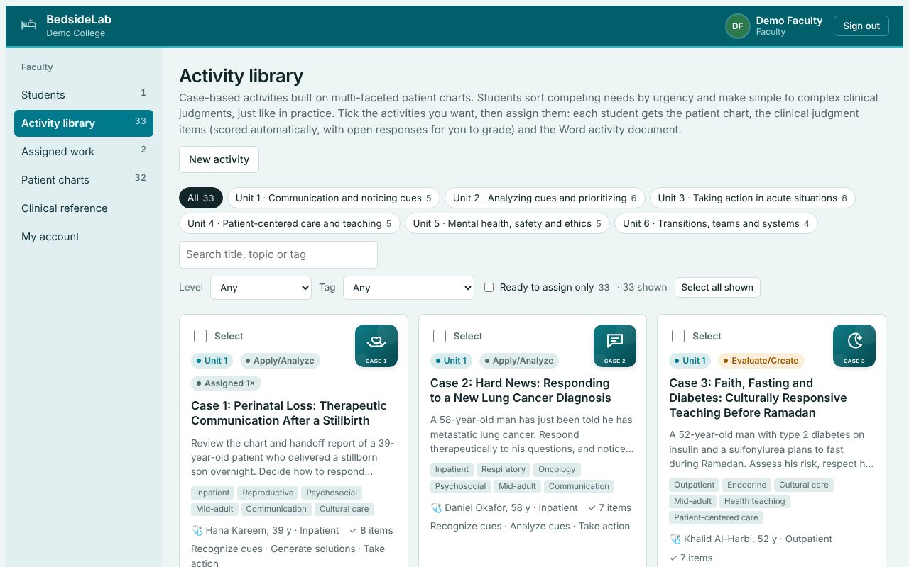
The activity library.

5. Grade
- Open Assigned work, then Submissions. The Answers column shows how many items were answered and the auto-scored points.
- Click Grade. You see the student's document, the answer key, and every item with the student's answer beside the key and rationale.
- BedsideLab suggests a score for the auto-scored items in proportion to the activity's points and shows how many points the open responses are worth. Grade the open responses with the model answers, then enter the total.
- Enter feedback, optionally upload a marked copy, and click Return grade to student. For a team, tick Give this grade to all of the team.
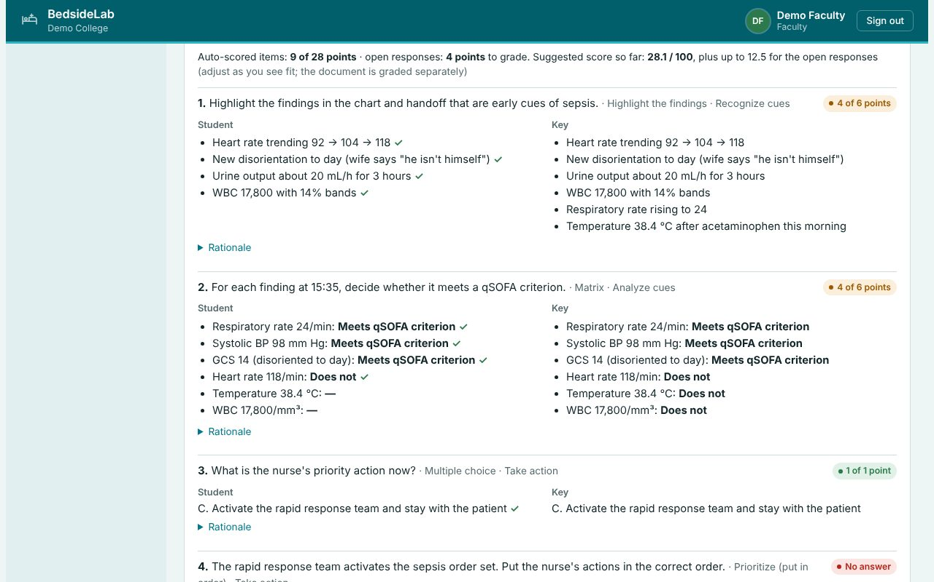
Grading: each answer beside the key and rationale.

6. Edit or write activities
- Edit activity opens the builder: title, unit, level, clinical judgment steps, scenario, the patient chart and the items. Each item has its type, the question, the options and the key, and a rationale. Select-all and highlight keys list option numbers (for example 1, 3, 4); prioritize items are entered in the correct order and shown shuffled; drop-downs use [[choice | *correct | choice]]; bow-ties list conditions, actions and parameters with the correct numbers.
- Click Check items to validate every item before you save.
- Changing a library activity does not change activities already assigned; edit the assignment too if needed.

7. Patient charts
- Patient charts lists every patient. Open opens the chart; Edit shows it as JSON; Duplicate makes a copy to adapt (for example a new set of vital signs for a different scenario).
- New patient chart starts from a template with every section. Use fictional patients only. Editing a built-in chart makes your college's own copy; the built-in items depend on the original data, so review them after changes.

8. Admin: appearance and built-in content
- Appearance: theme, colours, logo, site name and institution, applied to everyone at your college.
- Overview → Built-in content: after an update, click Update built-in content to bring the built-in charts, activities and documents up to date. Accounts, assignments, submissions and grades are not changed.

