Student quick guide
Signing in, the patient chart, answering clinical judgment items and submitting your activities
BedsideLab is where you practise clinical judgment. Each activity has a fictional patient with a full electronic health record (EHR), clinical judgment items you answer in the chart, and a Word activity document. All patients and data are fictional.

1. Sign in
- Open your college's BedsideLab address (for example https://…/c/your-college).
- Sign in with the email and temporary password your faculty gave you, or create your account with a class code (front page, Join a class).
- Choose your own password (at least 8 characters).

2. Open an activity
- Click My assignments and open an activity.
- Click Open patient chart. It opens in a new tab; keep the assignment page open.
- Download the Word activity document. It has the case, a cue worksheet, the items, space for your reasoning and a reflection.
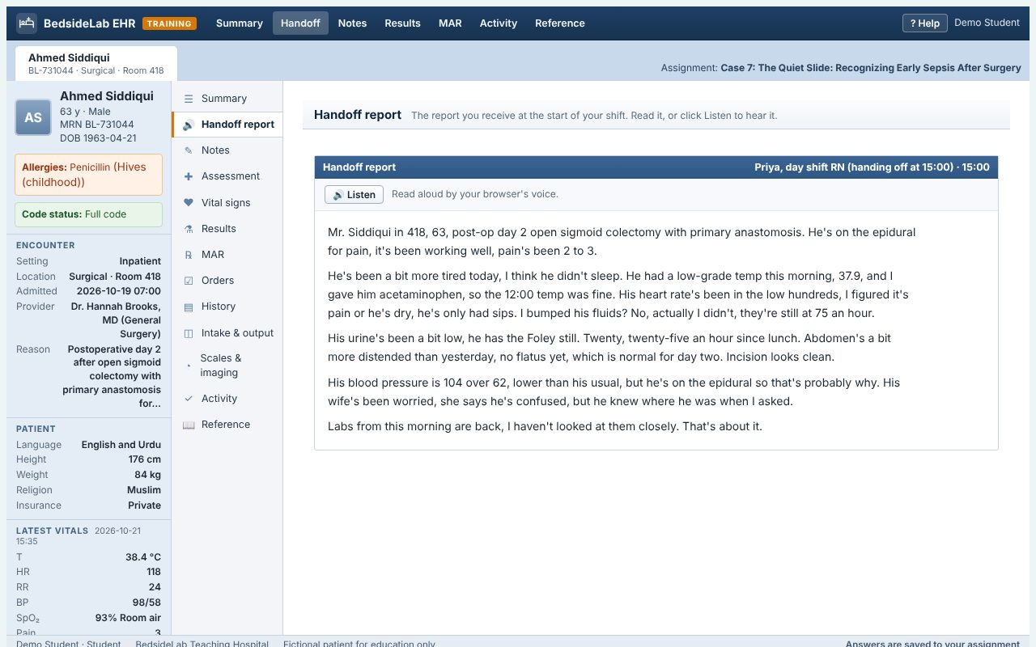
The chart: patient storyboard on the left, chart sections in the middle, the handoff report on the right.

3. Review the chart like a nurse at the start of a shift
- Storyboard (left): name, age, MRN, allergies, code status, alerts, encounter details and the latest vital signs. Check allergies and code status first.
- Handoff report: what the off-going nurse tells you. Click Listen to hear it. Notice what is said, and what is explained away.
- Notes, Assessment, Vital signs, Results, MAR, Orders, History, Intake & output, Scales & imaging, Documents: each part of the record. Flowsheets show trends; abnormal values are flagged (H high, L low, C critical).
- Reference: the clinical judgment model, priority frameworks, SBAR, therapeutic communication and reference ranges.
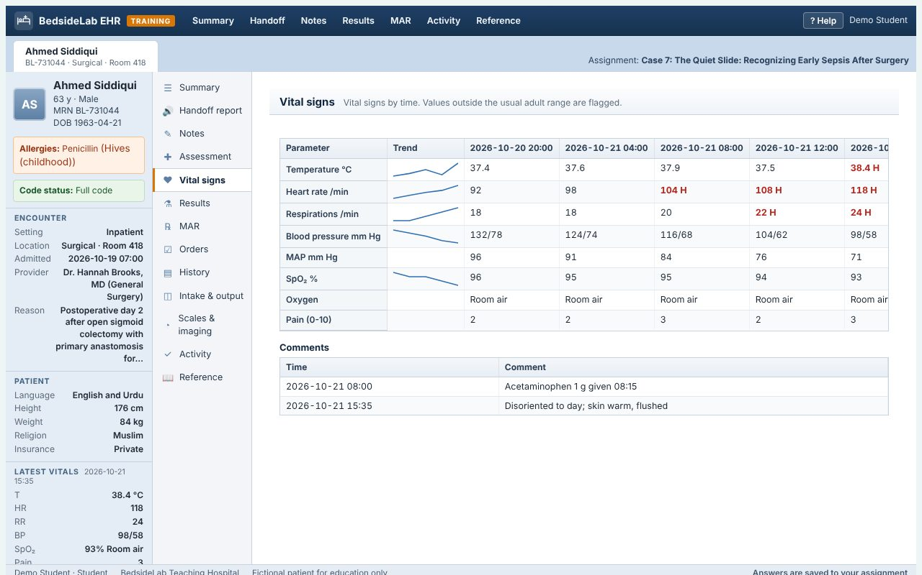
Vital signs flowsheet with trends.

4. Answer the items
- Click Activity. Each item shows how to answer it: choose one, select all that apply, put options in order (use the arrows), tick one column per row (matrix), choose from drop-downs, click findings to highlight them, complete a bow-tie, or write an open response.
- Click Save answers (answers also save automatically a few seconds after you stop). Your answers go to your assignment.
- Objective items are scored automatically. Select-all and highlight items use +/- scoring: a wrong choice cancels a right one. Open responses are graded by your instructor.
- You see your score and the rationales once your work is graded, or straight away if your instructor turned on practice mode.
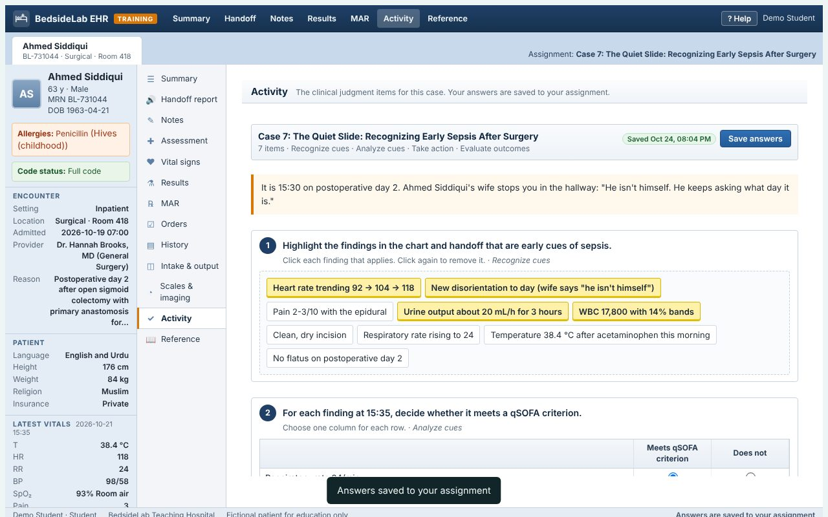
The Activity tab: clinical judgment items beside the chart.

5. Submit
- Complete the activity document: your cues, your reasoning and your reflection.
- Save it with your name in the file name.
- On the assignment page choose the file and click Submit. You can replace it until it is graded.
- Grades, feedback and rationales appear under My grades and in the chart.

Tips
- Always look at trends, not single values.
- Ask: what is expected for this patient, and what is not?
- Prioritize: airway, breathing, circulation; acute before chronic; actual before potential; safety.
- Group activities: one team member submits; the document and saved answers are shared with the team.

