Faculty and admin quick guide
Setting up the site, adding people, assigning coding activities, grading and editing records
Your college has its own CodeLab address (for example https://…/c/your-college), with its own look, people and records. The college admin sets the look and creates faculty accounts. Faculty create student accounts, assign activities, grade work and edit the EHR records. Your CodeLab provider manages your college's plan (student limit and subscription dates).

1. What is included
- 30 activities, each with a Word activity document for students, a faculty answer key and its own fictional EHR record or practice data set.
- Groups: Orientation sessions (2), ICD-10-CM foundations (4), Chapter-specific coding (13), Inpatient coding (4), ICD-10-PCS (2), Coding quality and compliance (2), Billing and reimbursement group activities (3).
- A hospital-style EHR for every record (storyboard, Chart Review with preview pane, results and vital-sign flowsheets, MAR, notes) with a Coding activity where students enter and sequence their codes; codes are checked automatically and saved to the assignment.
- The ICD-10-CM code book: the official CDC/NCHS Tabular List (April 1, 2026 release, FY2026) with all instructional notes, available to everyone at your college and inside every EHR record.
All dates of service in the built-in records are in September 2026, so the FY2026 code set in CodeLab matches them. ICD-10-PCS activities need the PCS Index and Tables from your code books or encoder.

2. Suggested course plan
- Week 1: Practical Session 1 (the coding record and the code book): find information in an office visit, learn the code book, code a simple visit.
- Week 2: Practical Session 2 (index to tabular): the full coding process on an injury, with 7th characters and external cause codes.
- Then the foundations activities (conventions, outpatient rules, uncertain diagnoses, sequelae) before the chapter-specific, inpatient, PCS and quality activities. The stroke case and the coding audit work well as end-of-course assessments.
Run the first session in class: open the EHR on the projector, let the guided tour introduce the screen, open the Code book and search for a term together.

3. Admin: first steps
- Sign in at your college's address with the temporary password from your CodeLab provider, and choose your own password. The sign-in address is shown on the Overview page.
- Appearance: choose a theme, upload your logo, and set the site name and program. Click Save for everyone.
- Faculty: enter each faculty member's name and email. CodeLab shows a temporary password to share.
- Guests: give a visitor read-only access for 1 to 30 days. Guests see the library, the EHR records and the code book, but no students, grades or answer keys.
- After an update, the Built-in content panel on Overview shows whether your built-in records and activities are current.
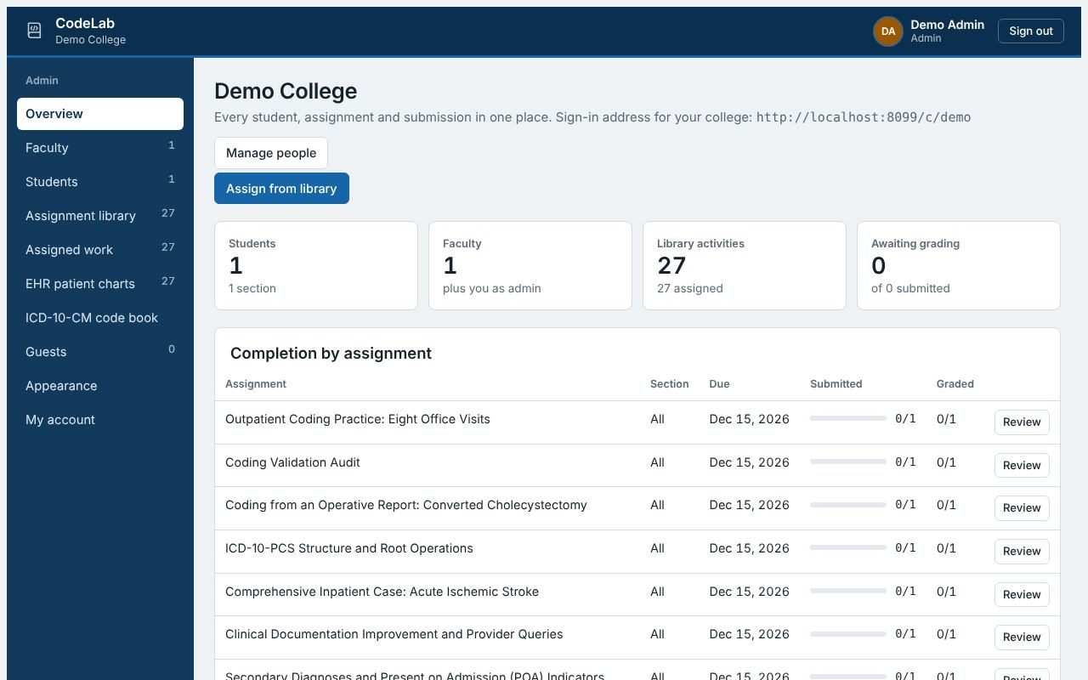
Admin Overview: completion by assignment and the college sign-in address.

4. Add students
- Students page: add one student (name, email, section), or import a class list saved from Excel as CSV with the columns Name, Email, Section.
- Download the temporary passwords as a CSV and share them privately. Students choose their own password at first sign-in.
- Or let students sign up themselves: under Class codes, choose a section, how long the code works and an optional maximum, then Create class code. Share the code, the link (Copy link) or a printed sheet (Print). Students use Join a class on the front page and land in that section. Turn the code off when the class has joined.
- Sections let you assign work to one class only.
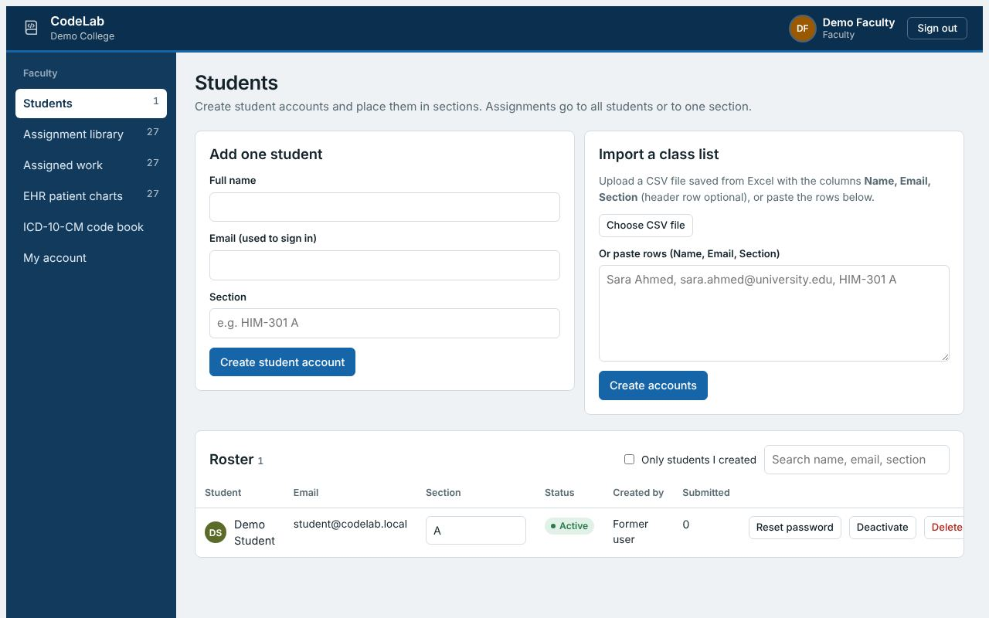
Students page: add one student or import a class list.

5. Teams for group activities
- The Billing and reimbursement (group activities) group has three team activities: an inpatient UB-04 claim, CMS-1500 professional claims, and denial management with an appeal. Each document has team roles and a contribution table.
- On Students, type a team name next to each student, add a Team column to your CSV class list (Name, Email, Section, Team), or use Make teams to split a section into teams of 2-6 automatically.
- For a group activity, one member submits for the team; the submission and the EHR coding are shared with every member. On the grading page, tick Give this grade and feedback to all of Team X to grade the whole team at once.
- Any activity can be made a group activity: edit it and tick Group activity.

6. Assign activities
- Open Assignment library. Filter by group, tag or search.
- Tick each activity you want, then click Assign selected.
- Choose the due date and who receives it (all students or one section), then click Assign.
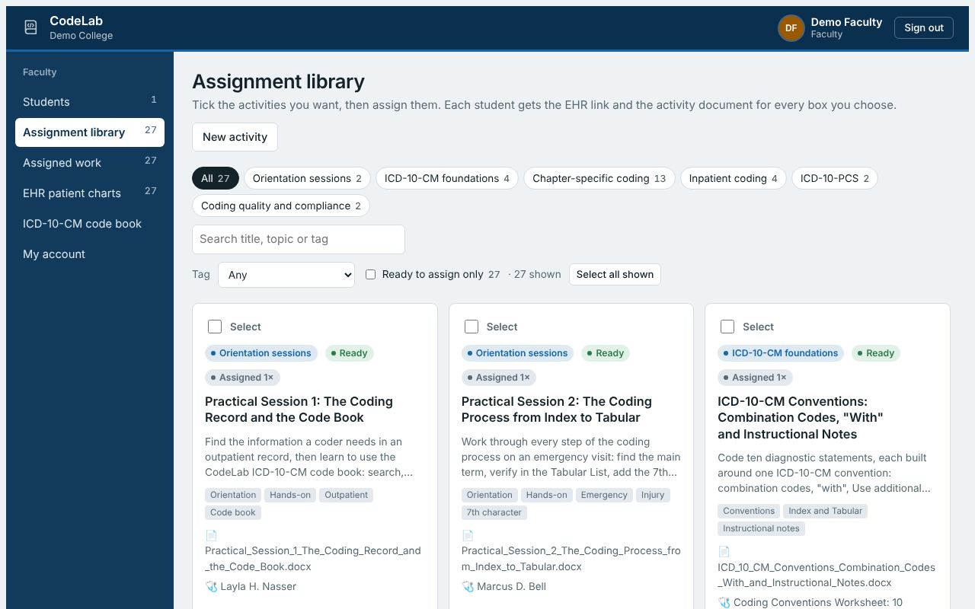
Assignment library: tick activities, then Assign selected.

7. Review and grade
- Assigned work shows each assignment with how many students have submitted.
- Open an assignment to see every student, the number of codes each entered in the EHR, and their document. Click Grade: the student's document, the answer key and the coding summary the student entered in the EHR (with its automatic edit results) are on the same page. Enter the score and feedback, and optionally upload a marked copy.
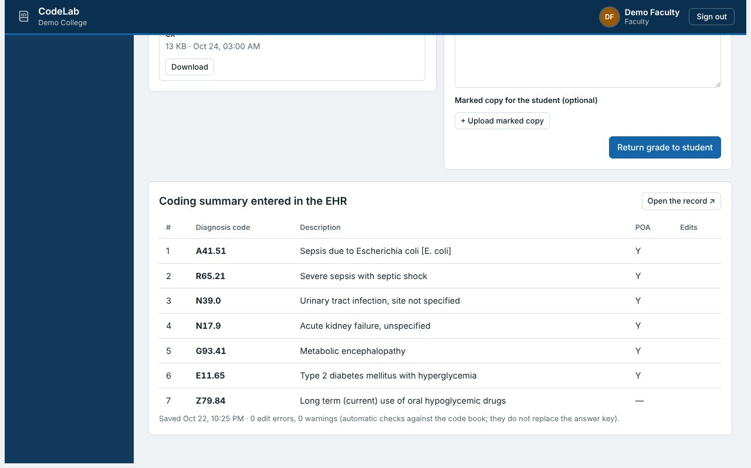
Grading: the score form and the student's coding summary from the EHR.

8. Edit records and activities
- EHR patient charts → Edit (or Edit EHR on a library activity) opens the record editor. Each section is a spreadsheet-style grid; notes, reports and registration details are edited on the same page.
- Use New patient chart to write your own coding cases, and New activity to add your own document and answer key.
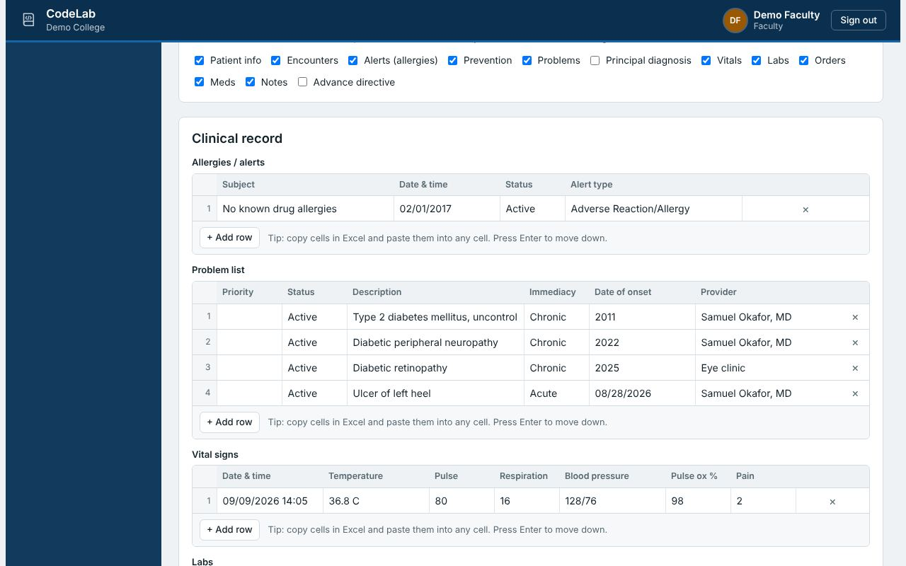
Record editor: each section is an editable grid.
Answer keys match the built-in records and the FY2026 code set. When you change a record, or when a new code set takes effect, update the answer key too. Each key reminds you to verify codes and guideline citations against the current official books.

9. Getting help
- Forgotten passwords: faculty reset student passwords, the admin resets faculty passwords, and your CodeLab provider resets admin passwords.
- Plan questions (student limit, renewal, a paused college): contact your CodeLab provider.

