Online certificate program guide
For independent learners and for the staff who confirm payments, grade practicals and issue certificates
The online certificate program lets anyone take the ICD-10 coding practicals without belonging to a college. Learners register themselves, pay the registration fee (10 USD by default), complete every course practical in the EHR, upload their completed sheets and, once they pass every practical, receive a certificate. Payments and certificates are checked and issued by hand by the program staff.

Part A. For learners
- On the front page click Get certified (or open /register). Enter your full name exactly as it should appear on your certificate, your email, phone, country and a password, accept the terms and click Register and continue to payment.
- On Registration & payment, follow the payment instructions (or the online payment button, if shown) and pay the fee.
- Upload a photo or PDF of your receipt, add the transaction reference and click Send receipt for confirmation. Your status changes to "Receipt received".
- When the program team confirms your payment, My practicals and Progress & certificate appear in the menu. If your payment could not be confirmed you see a note; upload a new receipt to ask again.
- For each practical: download the activity sheet, open the EHR, code the record in the Coding activity, then upload your completed sheet and click Submit.
- Each practical needs the pass mark (70% by default). If a practical shows Not passed: resubmit, read the feedback, correct your sheet and codes, and submit again.
- When every practical is passed, the program team issues your certificate. Download it from Progress & certificate.
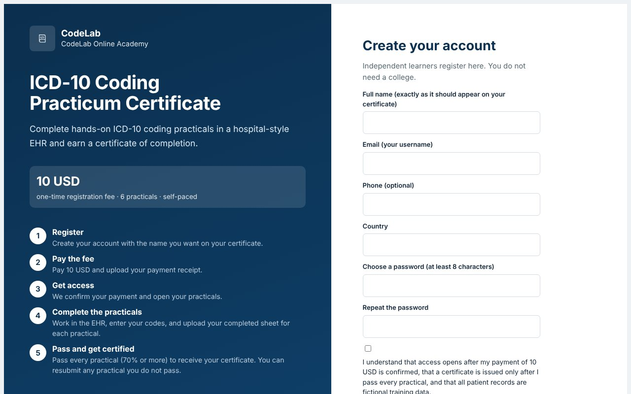
Registration page: the fee, the five steps and the sign-up form.
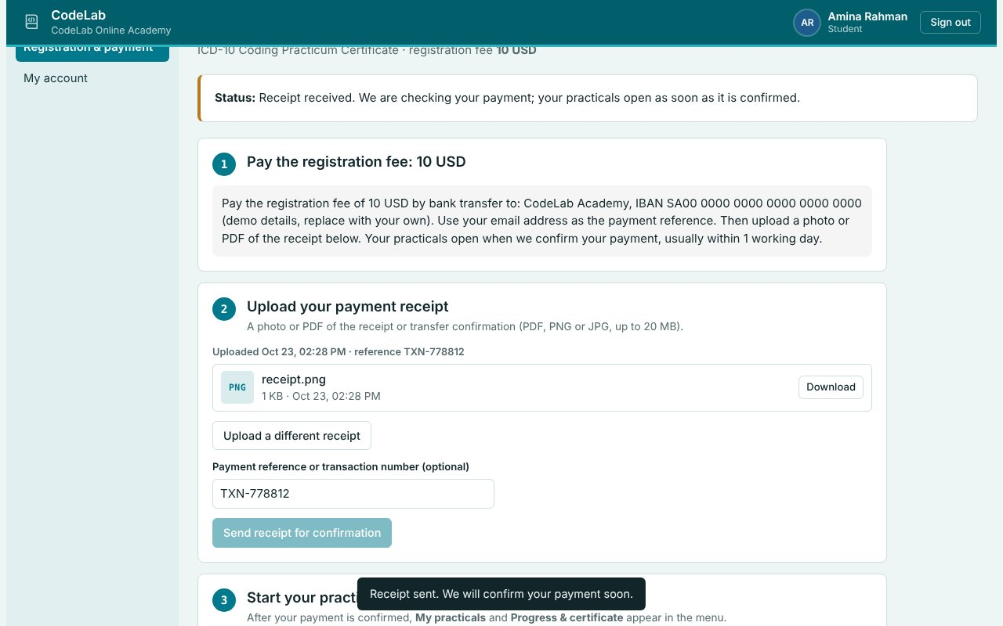
Registration & payment: payment instructions, receipt upload and status.
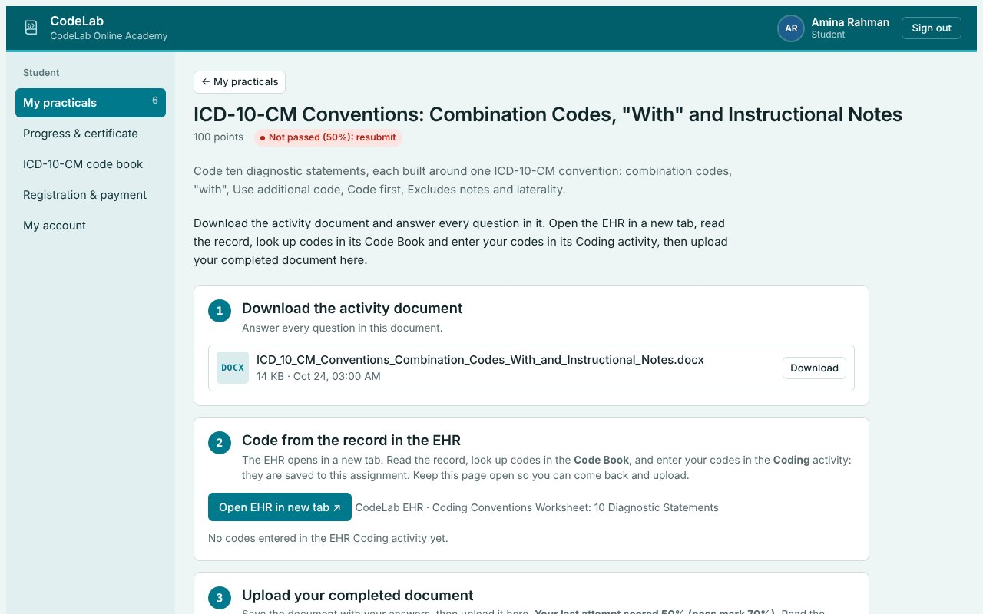
A practical below the pass mark can be corrected and resubmitted.
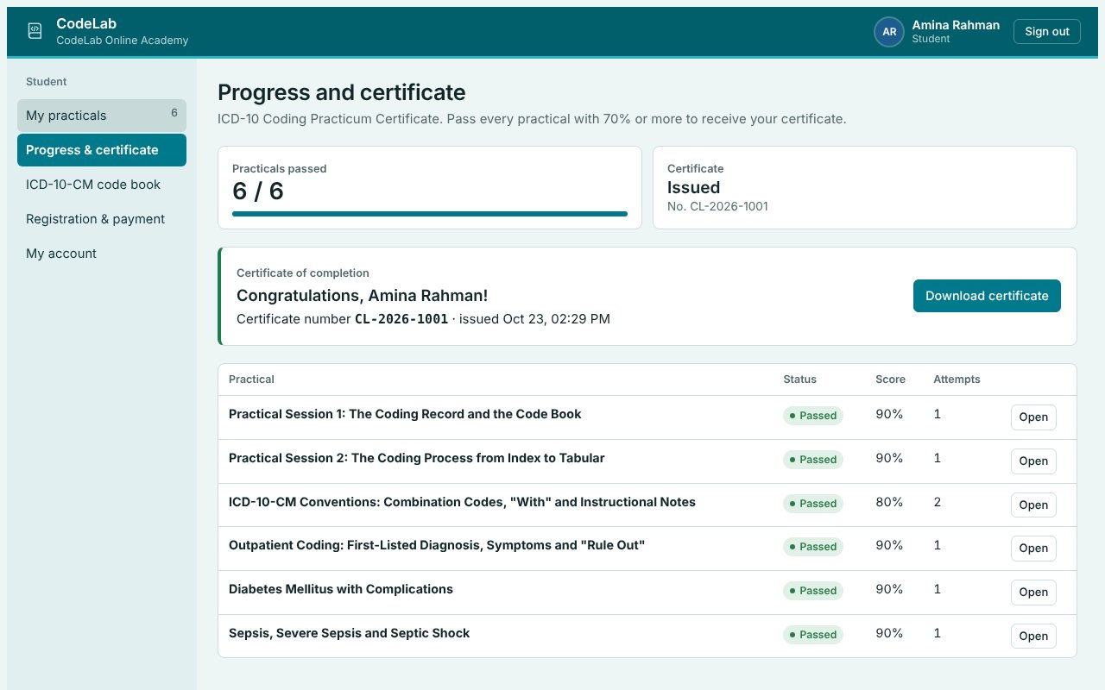
Progress & certificate: every practical, the score, attempts and the certificate download.
Practicals stay hidden until your payment is confirmed. All patient records are fictional training data.

Part B. For program staff
- Registrations → Receipts to check: download each receipt and check it against your bank or payment account. Click Approve to open the learner's practicals, or Reject with a short note the learner will see. Approved learners can be suspended later.
- Grade submitted practicals as usual from Assigned work → Review. A score below the pass mark lets the learner resubmit; their earlier attempt is kept.
- Certificates lists approved learners with their progress. Learners who passed every practical show Eligible. Click Print template to print the ready-made certificate (choose Save as PDF), upload the PDF with Upload PDF, check the certificate number and click Issue twice to confirm. Withdraw removes an issued certificate.
- Program settings (admin): open or close registration, and set the title, fee, currency, pass mark, payment instructions, payment link and the note learners see about certificates. Every activity assigned to All students is a course practical; the due date is optional.
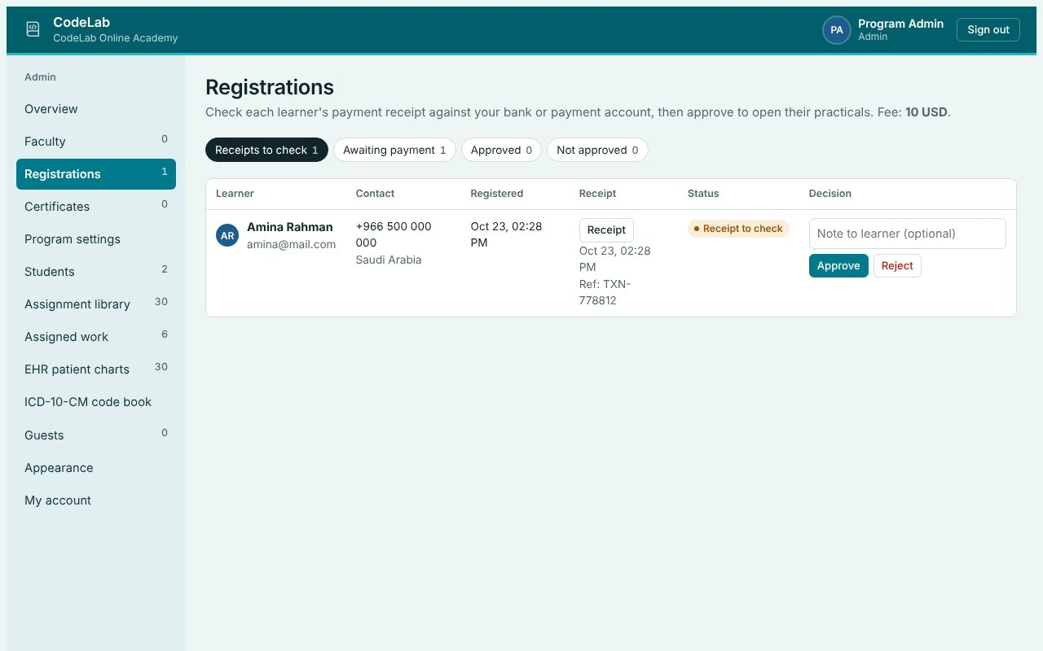
Registrations: receipts to check, with Approve and Reject.
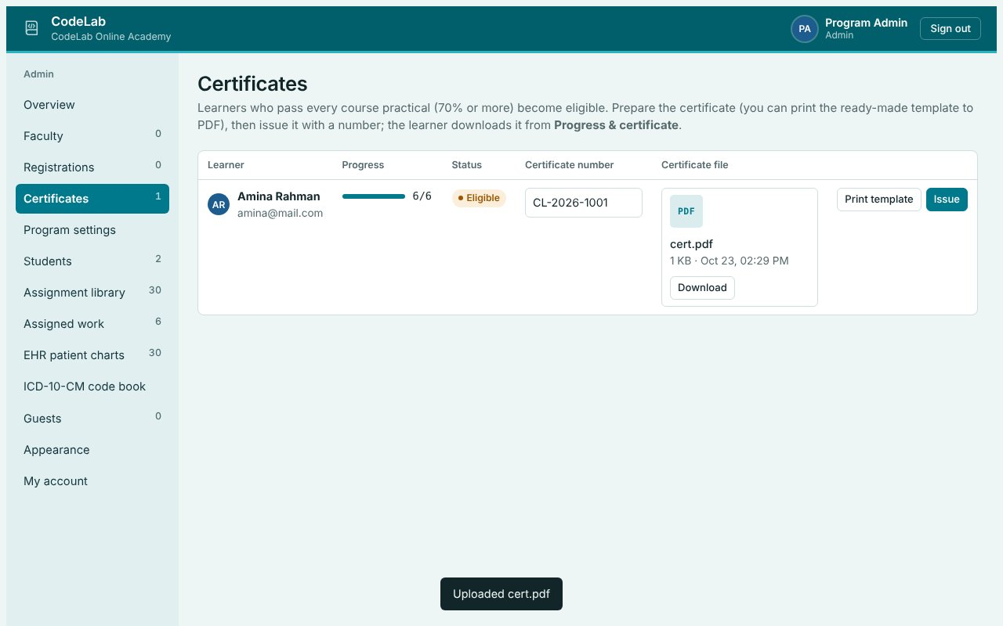
Certificates: eligible learners, certificate number, file and Issue.
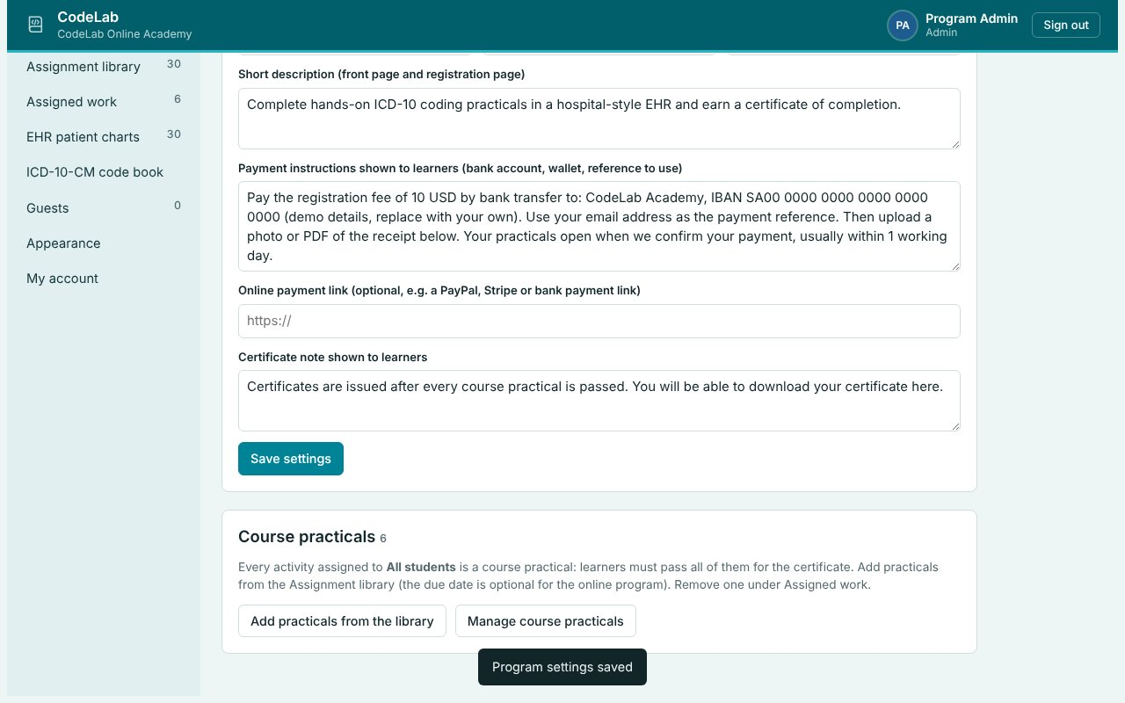
Program settings: registration, fee, pass mark and payment instructions.

