Owner guide
Running CodeLab for several colleges: colleges, plans, renewals, updates and the code book
As the owner you run one CodeLab website for many colleges. Each college has its own web address, look, admins, faculty, students, records and plan. You see each college's numbers (students, faculty, assignments, submissions, last sign-in) but never its students or their work.

1. Add a college
- Open Colleges and fill in Add a college: the name, the web address (for example kfu, giving https://your-site/c/kfu), the admin's name and email, the student limit and the subscription end date.
- Click Create college. CodeLab copies all built-in records and activities into the new college and shows the sign-in address and the admin's temporary password.
- Send the address and password to the college admin privately.
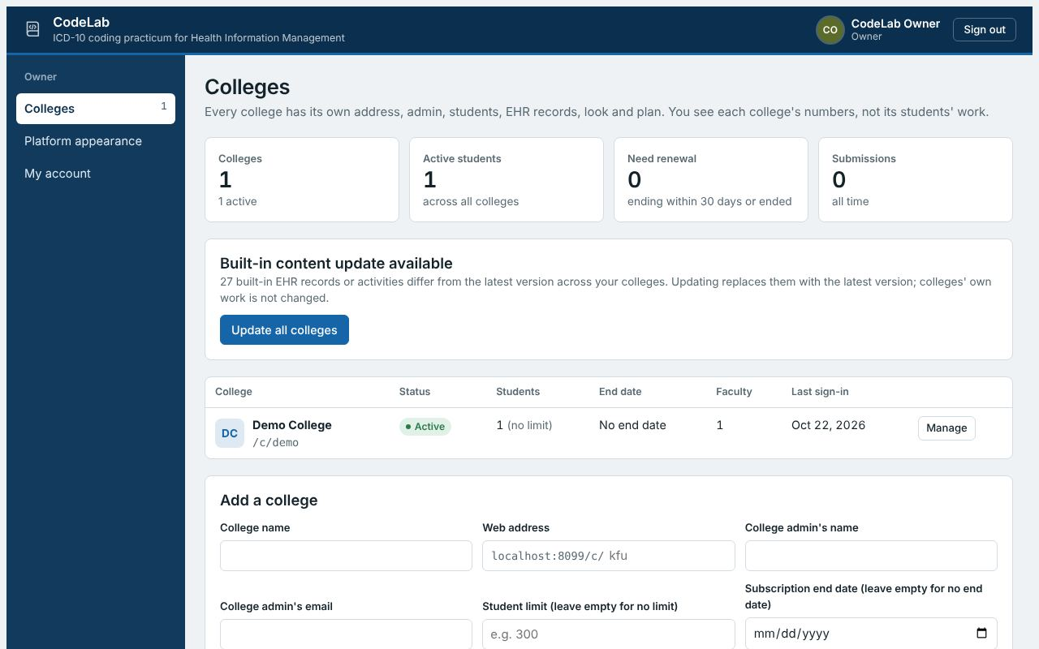
Colleges: every college with its status, students, end date and last sign-in.
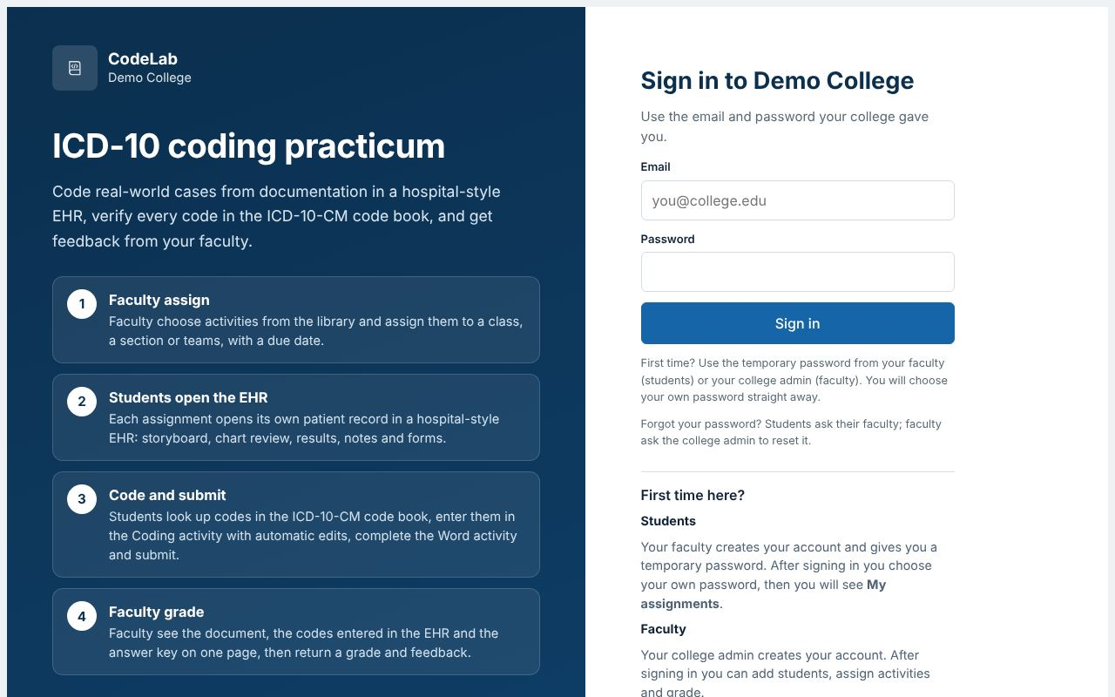
Each college's sign-in page uses its own name, logo and colours.

2. Plans, renewals and pausing
- Student limit: active students only; deactivated students do not count.
- Subscription end date: +1 month, +12 months or a new date. Admins see a reminder 30 days before; afterwards the college is read-only until renewed.
- Pause college signs everyone out and blocks sign-in without deleting anything. Delete college is possible only for a paused college.
- College admins: add another admin or reset an admin's password.
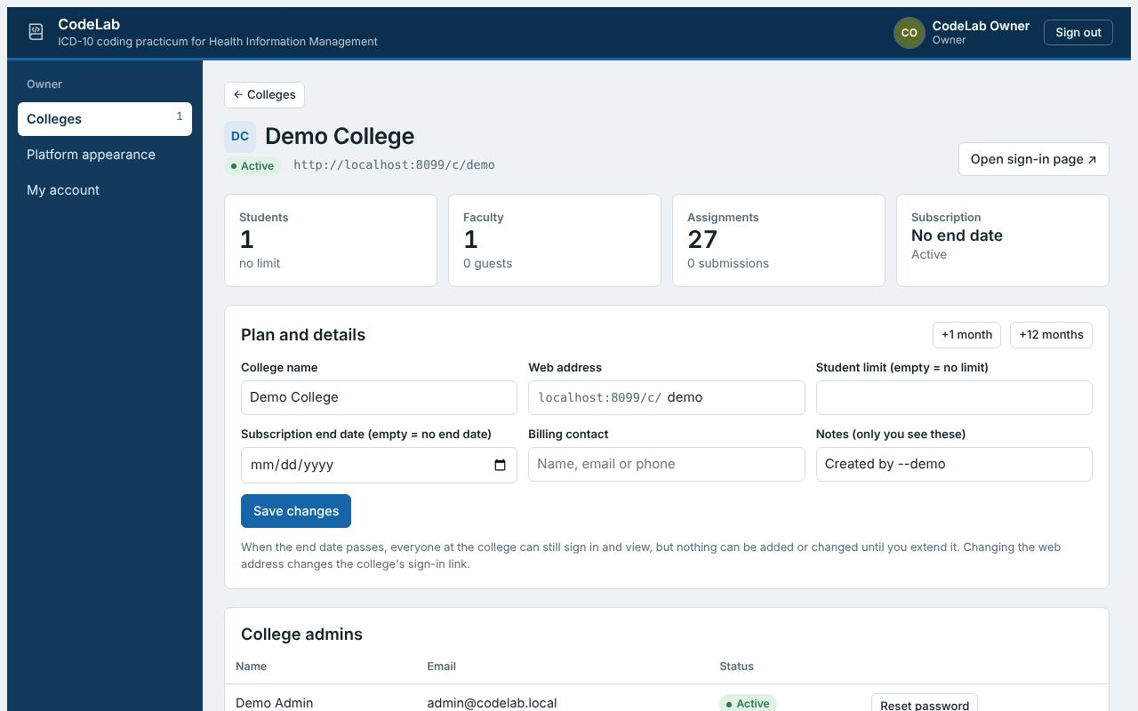
Manage a college: plan, renewal, admins, pause and delete.

3. Updates and the code book
- New built-in activities are added to every college automatically when the server starts, and built-in Word documents are updated for everyone. If corrected records or activities are available, Colleges shows Update all colleges.
- The code book file is public/icd10cm.json, built from the CDC/NCHS ICD-10-CM Tabular List XML (public domain). Each October (and April when there is an update), you can replace it with the new release using the converter described in the README, then restart the server. Update the activities' dates of service and answer keys at the same time.

4. Your own look and account
- Platform appearance sets the look of your owner console and the general sign-in page.
- Forgot your owner password: run node server.js --reset-password your@email on the server.
- Back up the data folder daily: it holds every college's accounts, records, submissions and grades.

