Student quick guide
How to sign in, code from the EHR, use the ICD-10-CM code book and submit your work
CodeLab is a training website for ICD-10 coding practice. It holds fictional patient records (EHR) and the official ICD-10-CM Tabular List as a searchable code book. Your faculty assigns activities; for each one you download a Word document, read the record, assign and verify the codes, and upload your completed document.

1. Create your account or sign in
With a class code: open the CodeLab site, click Join a class, enter the class code from your faculty (or open the link they shared), then enter your name, college email and a password you choose. You go straight to My assignments.
With a temporary password: if your faculty created your account for you, sign in as below.
- Open the sign-in address your faculty gave you.
- Enter your university email and the temporary password from your faculty.
- Choose your own password (at least 8 characters).
Forgot your password? Ask your faculty to reset it. They will give you a new temporary password.

2. Find your assignments
My assignments lists everything to do, with the due date. Finished work moves to Submitted. My grades shows your scores and feedback. ICD-10-CM code book opens the code book on its own page at any time.
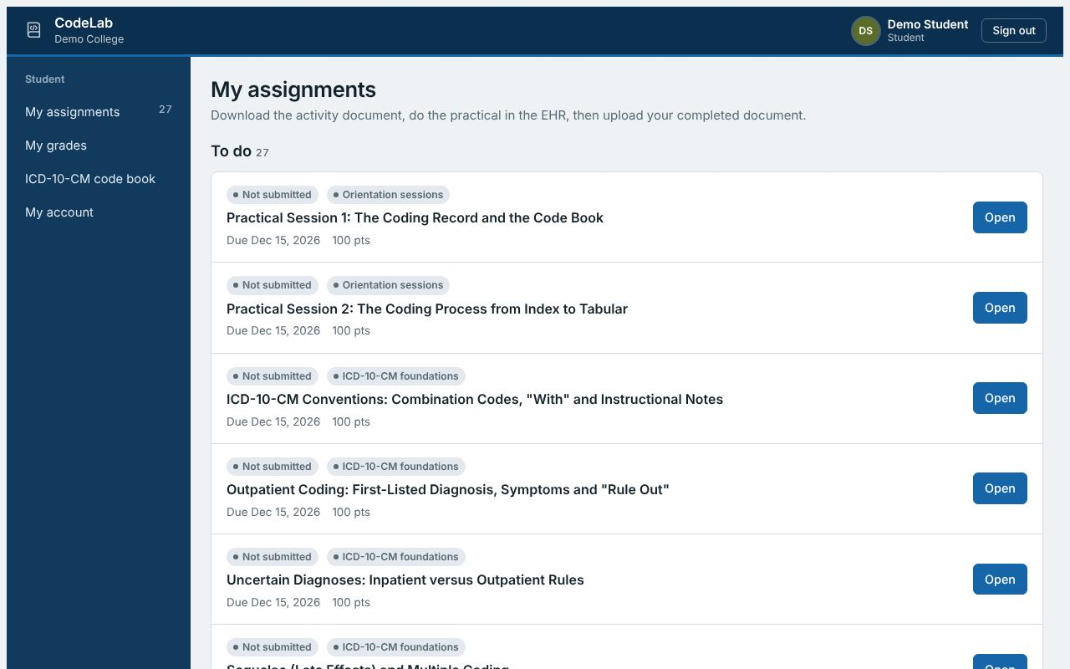
My assignments: open an assignment to start.

3. Complete an assignment in three steps
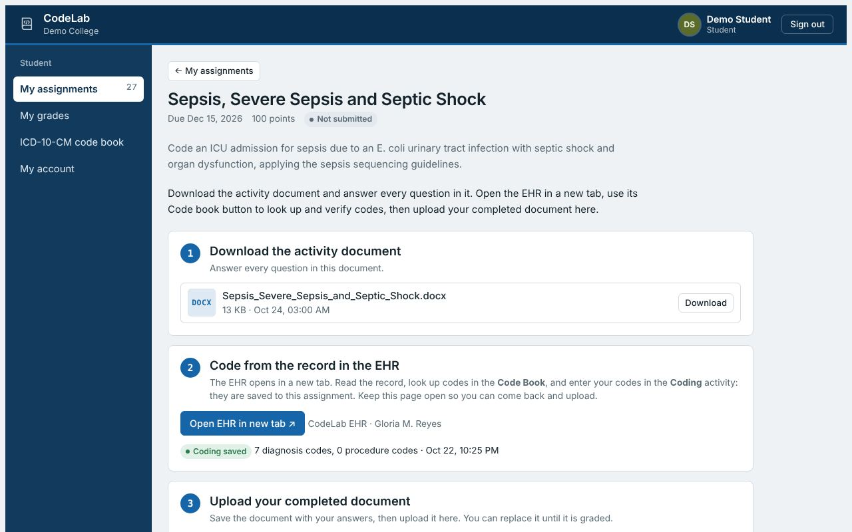
Every assignment page has the same three steps.
- Download the activity document. It contains the scenario and every question. Answer only in this document.
- Open the EHR in a new tab, read the record and enter your codes in its Coding activity. Keep the assignment page open in the first tab so you can come back to upload.
- Upload your completed document (.docx or .pdf) and click Submit. You can replace your file until it is graded.
Save your document with your name in the file name, for example Practical_Session_1_Sara_Ahmed.docx.

4. Read the record in the EHR
The EHR opens in a new tab and is laid out like a hospital EHR workstation. The first time you open it, a short tour shows each part of the screen; use ? Help to see it again.
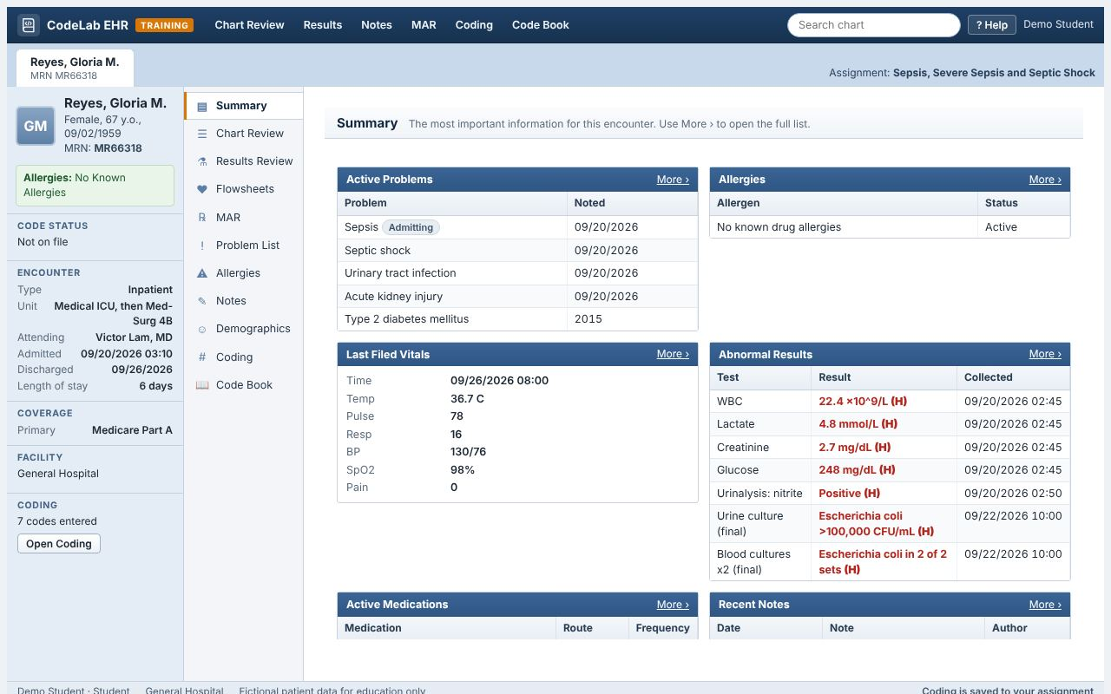
The EHR: storyboard on the left, activities beside it, the selected activity on the right.
- Storyboard (left): the patient's name, age, MRN, allergies, code status, encounter type, admission and discharge dates, length of stay, attending and payer. It stays on screen whatever you open.
- Activities: Summary, Chart Review, Results Review, Flowsheets (vital signs), MAR (medications), Problem List, Allergies, Notes, Demographics, Coding and Code Book. The toolbar at the top has shortcuts to the most used ones.
- Chart Review lists every encounter, note, lab, imaging report, procedure, medication, order and immunization. Click a row to read it in the preview pane below.
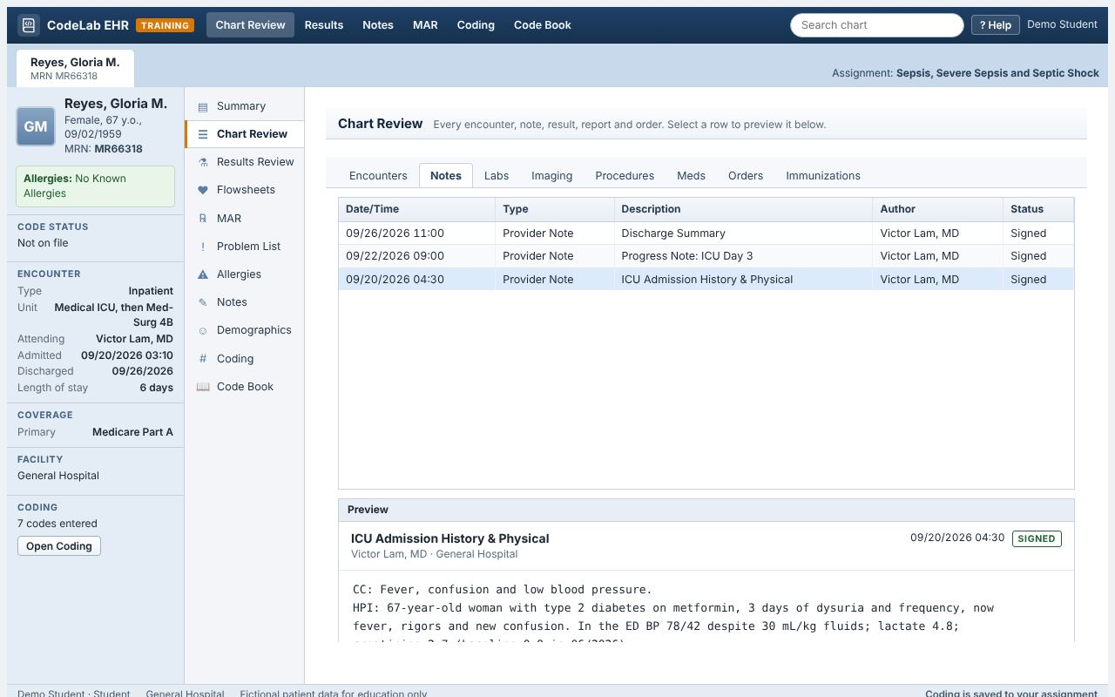
Chart Review: choose a tab, then click a row to preview it.
- Notes hold the provider documentation you code from (H&P, progress notes, operative reports, discharge summary). Code from the provider's documentation, not from the problem list or the lab values.
- Search chart (top right) finds any word or date, including inside notes. Practice data sets have Reports, Notes, Coding and Code Book only.

5. Enter your codes in the Coding activity
Open Coding. This is where you record your final codes, the way a coder abstracts a record in a hospital. Your codes are saved to your assignment automatically (and with the Save coding button), and your faculty sees them when grading.
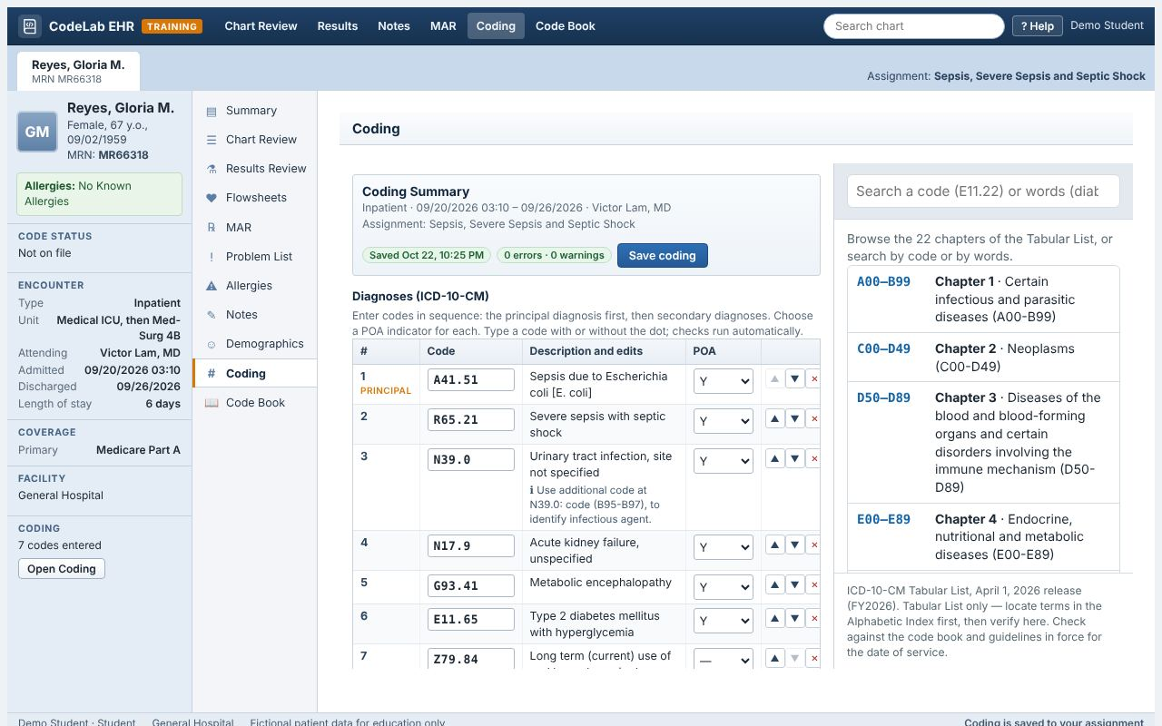
The Coding activity: your code list on the left, the code book on the right.
- Type a code with or without the dot (for example A4151 or A41.51) and press Enter. The description appears and the code is checked.
- Put the codes in sequence: the principal diagnosis (inpatient) or first-listed diagnosis (outpatient) first. Use ▲ ▼ to move a code and ✕ to remove it. For inpatients, choose a POA indicator for every code.
- Edits appear under each code: ✖ errors (not a valid or billable code, missing 7th character, a code that can never be first-listed, a "Code first" order problem), ▲ warnings (Excludes1 conflicts, duplicates, missing POA) and ℹ reminders (Use additional code notes). Edits help you find mistakes; they do not tell you whether a code is right for the documentation.
- Add ICD-10-PCS codes under Procedures, and use Coder comments for queries you would send to the provider.
- In the code book beside your list, search and open a code, then click + Add to diagnoses to add it.

6. Use the code book
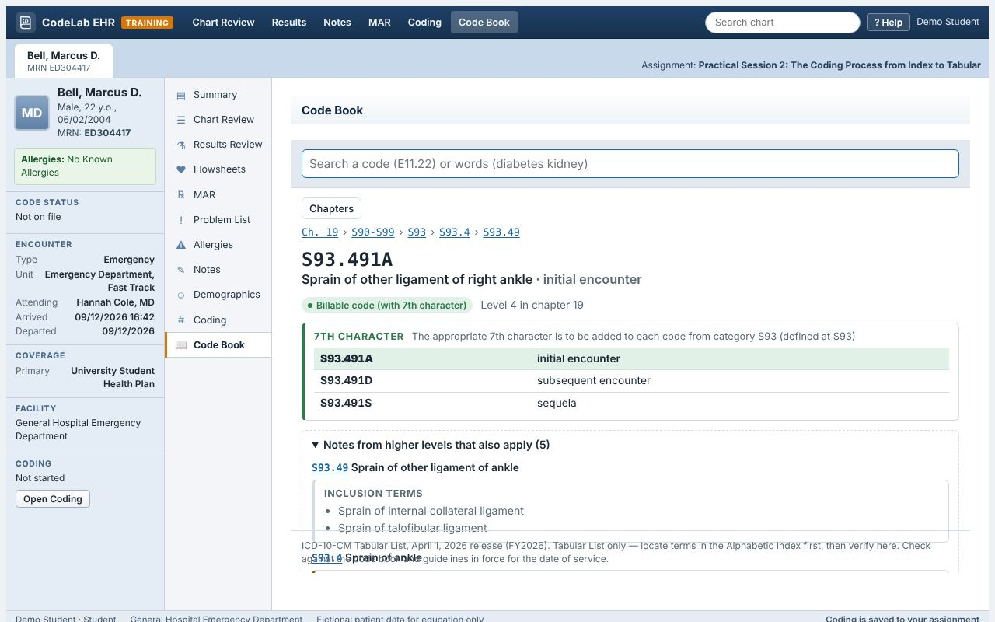
A code with its 7th character, inclusion terms and the notes from higher levels.
- Search by words (for example "sprain ankle") or by code (for example E11.621). Press Enter on a complete code, including a 7th character such as S93.491A, to open it directly.
- Open a code to see its notes: Includes and inclusion terms, Excludes1 (red), Excludes2 (orange), Code first, Use additional code and Code also (blue). Codes inside notes are links. Notes from higher levels lists the notes at the category, block and chapter above, which apply to your code too.
- The green pill tells you the code is billable. "Not billable" means you must choose a more specific code. Needs a 7th character shows the 7th-character table with the complete codes, including X placeholders.
The code book is the Tabular List. Always start in the Alphabetic Index (your printed code book or encoder) with the main term, then verify the code here. Never code from the search results alone.

7. Group activities
Activities marked Group activity (for example the Billing activities) are done in a team. Your faculty places you in a team; the assignment page shows your team members.
- Agree roles using the Team roles table in the document, and fill in the team table at the top.
- One member uploads and submits the team's document. The submission appears for every member, and so do the codes entered in the EHR Coding activity.
- Agree who enters the codes in Coding: if two people edit at the same time, the last one saved is kept.
- Complete the Team contribution table: your faculty may use it to adjust individual marks.

8. Tips for full marks
- Give the full code and its title for every answer, in the correct sequence.
- Say which note, guideline or Index entry decided your answer when the question asks why.
- When a question asks where you found something, name the note or tab (for example "Discharge Summary" or "Labs tab").
- Use only facts from the record. If documentation is missing or unclear, say so and explain whether you would query the provider: that is often the point of the question.

9. Getting help
- "EHR record not found": the link may be out of date. Tell your faculty.
- The file will not upload: use .docx or .pdf, under 20 MB.
- The code book does not load: refresh the page; it downloads about 1 MB the first time.

