Project: Dynamic Form Builder
Task Complete Note
Duration: 2 Days

📁 Project Source Code & Download Instructions
This is my public GitHub repository:
https://github.com/manjurul0992/DynamicFormBuilderQIA.git
To download the Final Task source code from the SecondDays branch, please run the following command:
git clone -b SecondDays https://github.com/manjurul0992/DynamicFormBuilderQIA.git
Alternatively, you can directly browse the repository branch here:
https://github.com/manjurul0992/DynamicFormBuilderQIA/tree/SecondDays?tab=readme-ov-file

📦 Full ZIP Package (With Database)
If you prefer, you can download the complete project including the database using the link below:
https://drive.google.com/file/d/1hI4pVk2uzeZEUVMnoK6qWNgELwItqDI_/view?usp=sharing

1. Add More button to dynamically add multiple dropdown fields.
2.Database Design
3. Form Builder UI.
4. Backend Logic.
5. ADO.NET with store procedure based.
6. Form Validation with jQuery validation.
7. Datatable grid with server site pagination.
8. Grid View with Preview
Bonus Points
1. API Integration: Extra points for using API controllers with proper AJAX calls.
2. View Components: Bonus for dynamically rendering dropdowns using View Components.
Database snippets
https://github.com/manjurul0992/DynamicFormBuilderQIA/blob/SecondDays/SQLQuery1.sql
Result snapshot
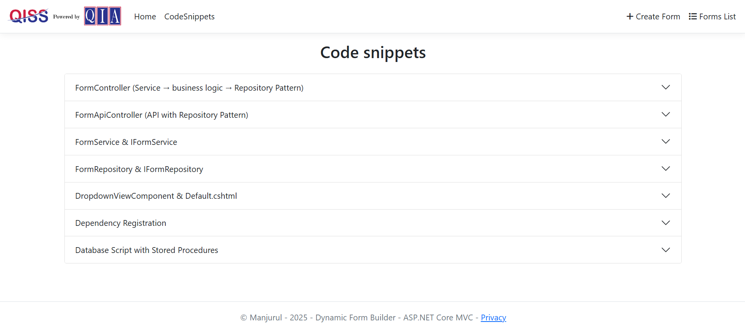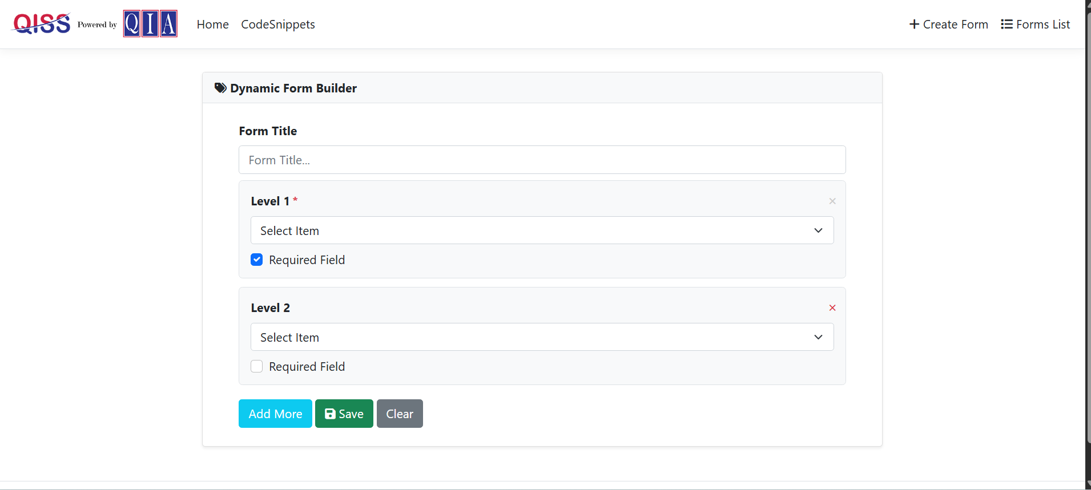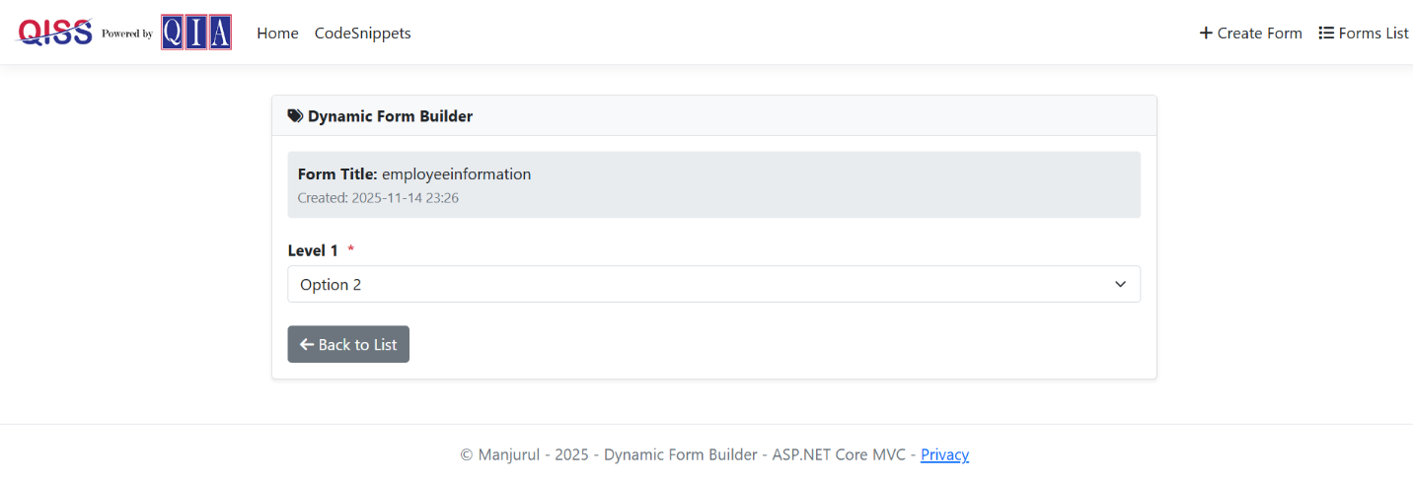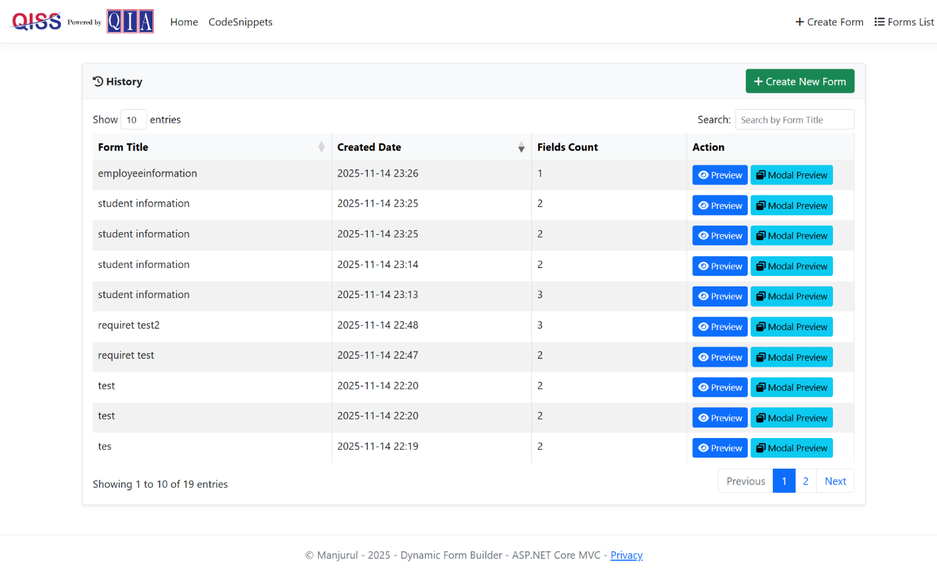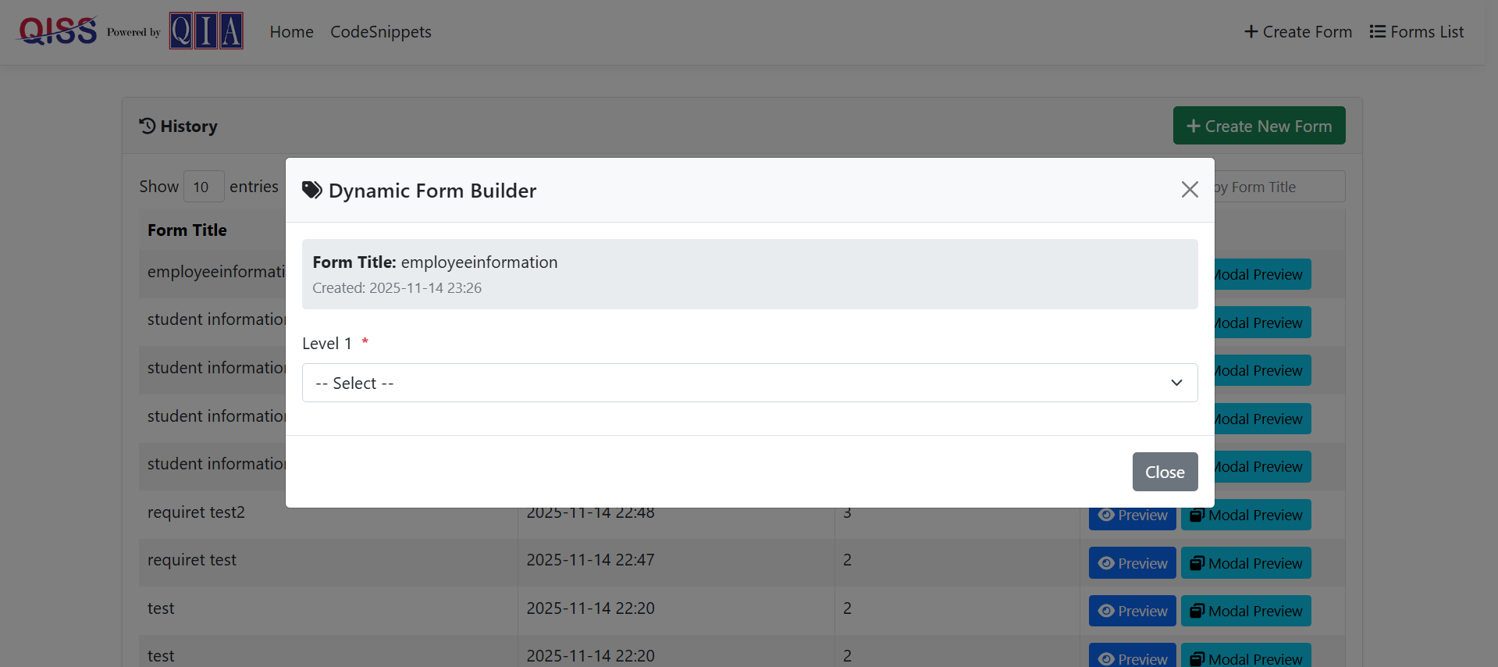
Code snippets
Please see my repository
https://github.com/manjurul0992/DynamicFormBuilderQIA/tree/SecondDays/DynamicFormBuilderQIA

