The name of the project is **‘Calculator’**. The work of Addition , Subtraction , Multiplication , Division , Square and Cube have been done in this project.

In this project an input can be more than 1 digit. User will be allowed to take his or her desired number as input.

It will take two inputs at a time and perform the following instructions: Addition, Subtraction, Multiplication, and Division.

It will take only one input for the following instruction: Square and Cube.

After doing some research got familiarized with the following directive:

**include ‘emu8086.inc’**

In this directive some pre-defined procedures have been defined which make the works easier.

This directive must be written after declaring

**.code**

**main proc**

**include ’emu8086.inc’**

This directive allows to take input more than 2 digit numbers and more. It also allows us to take negative number as input and show output if negative number appear.

The following pre-defined procedure which allows to take large input:

**define_scan_num**

It takes input using CX register & the value is saved in the CX register.

The following pre-defined procedures which allow to show output:

**define_print_num**

**define_print_num_uns**

It displays the value using AX register.

The workflow of addition is given below to make out the work done by the procedures:

**PRINT** "Enter 1st number: "

**call** **scan_num**

mov ax,cx

**PRINTN** ‘ ’

**PRINT** "Enter 2nd number: "

call scan_num

add ax,cx

**PRINTN** ‘’

**PRINT** "Result: Sum is "

The following line is used to print something.

**PRINT ‘’**

**PRINTN ‘ ’ [**For print a new line this is written**]**

In my start level,

**MOV AH, 0 ; clearing the screen**

**INT 10h**

I used this two lines for clearing the screen

The first number have been moved to AX register and after taking second input It remains in CX.

After the line

**add ax,cx**

The two values got added and the result is stored in **ax** register.

It makes the work easier. When the procedures for displaying will be called, the desired value must be in the **AX** register. The desired value is stored in **AX.**

If a user takes 1st number 123 and 2nd number 27,after doing addition the result which will be displayed is 150.

If a user takes two numbers: -120 and 20,the result will be -100.It will be displayed in the screen.

1. **Display Screen:** When the project will be run, the following display will be manifested.

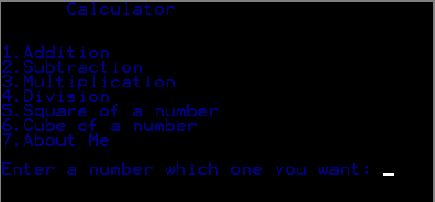

Figure: Display Screen

It will show how many things a user can do and asks a number to perform the thing.

1. **Addition:** If a user takes an input 1,addition of two numbers will be performed after taking two numbers.  
   User will be asked to take two inputs. After taking 1st number enter key will be pressed to finish the input of 1st number and same will be for 2nd number.

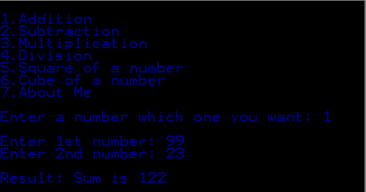

Figure: Addition

User takes 1st input 99 and 2nd input 23.The sum of this two numbers will be 122.

This result will be illustrated.

**Result: Sum is 122**

After showing the result It will ask user that if he or she wishes to use this calculator again or not.

If user presses Y or y, it will show the display screen again.

If user presses N or n, it will exit the program.

1. **Subtraction:** If a user takes an input 2,subtraction of two numbers will be performed after taking two numbers.

User will be asked to take two inputs. After taking 1st number enter key will be pressed to finish the input of 1st number and same will be for 2nd number.

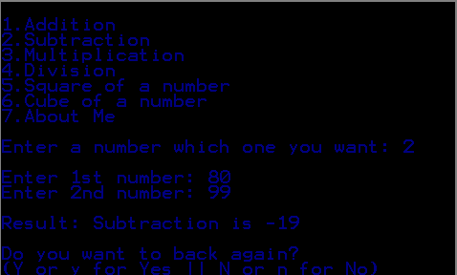

Figure: Subtraction

User takes 1st input 80 and 2nd input 99.The subtraction of this two numbers will be -19.

This result will be illustrated.

**Result: Subtraction is -19**

After showing the result It will ask user that if he or she wishes to use this calculator again or not.

If user presses Y or y, it will show the display screen again.

If user presses N or n, it will exit the program.

1. **Multiplication:** If a user takes an input 3, multiplication of two numbers will be performed after taking two numbers.  
   User will be asked to take two inputs. After taking 1st number enter key will be pressed to finish the input of 1st number and same will be for 2nd number.

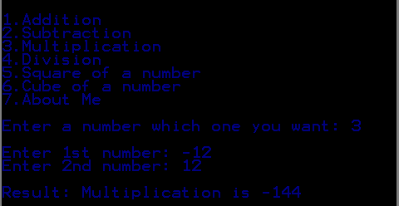

Figure: Multiplication

User takes 1st input -12 and 2nd input 12.The multiplication of this two numbers will be -144.

**Result: Multiplication is -144**

After showing the result It will ask user that if he or she wishes to use this calculator again or not.

If user presses Y or y, it will show the display screen again.

If user presses N or n, it will exit the program.

1. **Division:** If a user takes an input 4, division of two numbers will be performed after taking two numbers.  
   User will be asked to take two inputs. After taking 1st number enter key will be pressed to finish the input of 1st number and same will be for 2nd number.

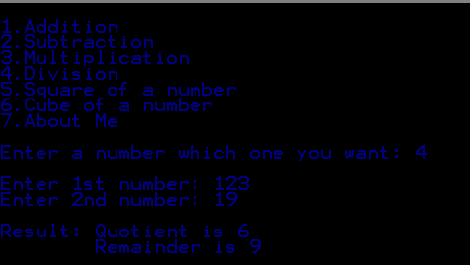

Figure: Division

User takes 1st input 123 and 2nd input 19.

This result will be illustrated.

**Result: Quotient is 6**

**Remainder is 9**

After showing the result It will ask user that if he or she wishes to use this calculator again or not.

If user presses Y or y, it will show the display screen again.

If user presses N or n, it will exit the program.

1. **Square of a number:** If a user takes an input 5, squared of a number will be performed after taking one inputUser will be asked to take one input. After taking 1st number enter key will be pressed to finish the input of 1st number.

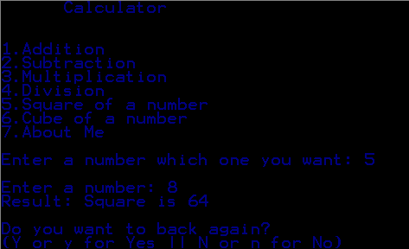

Figure: Square of a number

User takes 1st input 8.The square of 8 will be 64.

This result will be illustrated.

**Result: Square is 64**

After showing the result It will ask user that if he or she wishes to use this calculator again or not.

If user presses Y or y, it will show the display screen again.

If user presses N or n, it will exit the program.

1. **Cube of a number:** If a user takes an input 6, cube of a number will be performed after taking one input.User will be asked to take one input. After taking 1st number enter key will be pressed to finish the input of 1st number.

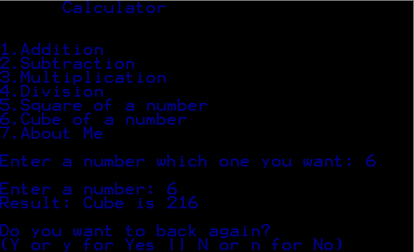

Figure: Cube of a number

User takes 1st input 6. The cube of 6 will be 216.

This result will be illustrated.

**Result: Cube is 216**

After showing the result It will ask user that if he or she wishes to use this calculator again or not.

If user presses Y or y, it will show the display screen again.

If user presses N or n, it will exit the program.