Design File

Title and Authors
- Phase 3
- Shiyang Chen, Chun-Jen Lin, Aniket Bhatt

Purpose of The Phase

This is the document for the Phase 3 of the project. Phase 3 requires to implement RDT 2.2 which sends one file from client side in the form of packets which contains data along with sequence number and checksum; and server receives those packets, including sequence number, checksum, and data.

Code Explanation

We built two programs – one for the sender side and the other for the receiver side.

Sender
There are 11 functions and one main function for the sender. It provides user to send the data without error (Option 1), and with certain percentage of ACK error (Option 2).

- Class STATE: We define the finite state machines in this class (WAIT_CALL_0, WAIT_ACK_0, WAIT_CALL_1, WAIT_ACK_1)
- readFile(): To open the image for transmission.
- data_iter(): To divide the image into chunks and generate packet one at a time. It takes the whole file data as the argument.
- checksum(): This function first convert the chunk to hexadecimal format and then add each hex value to other. We converted the data to hex so that we make sure that the sum is of length 16 bits. It is present in both codes.
- make_pkt(): It will receive chunk and then call checksum function. It will create packet by concatenating the sequence number, checksum value, and chunk. Using struct lib to pack binary data.
- rdt_send(): It will decide which ACK to send, make the packet, and start the transmission process.
- rdt_rcv(): It will receive the ACK from the receiver. For option 2, this will make wrong ACK intentionally.
- make_error(): Make wrong ACK intentionally.
- extract(): Extract the packet from the receiver.
- udt_send(): Start the transmission process. Send one packet a time.
- is_ACK(): Check if the ACK is correct.
- isCorrupt(): Check if the checksum is correct.
- send(): It will run all required functions and send the packets.

Receiver
There are 10 functions and one main function for the receiver. It will receive the data and intentionally change the data bits of the received DATA packet at the receiver.

- Class STATE: We define the finite state machines in this class (WAIT_0 andWAIT_1)
- checksum(): This function first convert the chunk to hexadecimal format and then add each hex value to other. We converted the data to hex so that we make sure that the sum is of length 16 bits. It is present in both codes.
- udt_send(): Send ACK and checksum to sender.
- is_ACK(): Check if the ACK is correct.
- isCorrupt(): Check if the checksum is correct.
- has_seq(): Make new ACK.
- make_pkt(): It will receive chunk and then call checksum function. It will create packet by concatenating the sequence number, checksum value, and chunk.
- rdt_rcv(): It will receive the packet, ACK, checksum from the sender.
- make_error(): Make wrong data bits intentionally.
- extract(): Extract the packet from the sender. Using struct lib to unpack binary data.
- recv(): It will run all required functions, receive the packets, concatenate packets, and save them as “new_image.jpg.”

Execution Example
Option 1

Open the terminal and change the current directory to the desired directory.

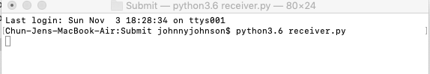

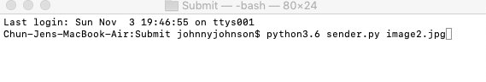
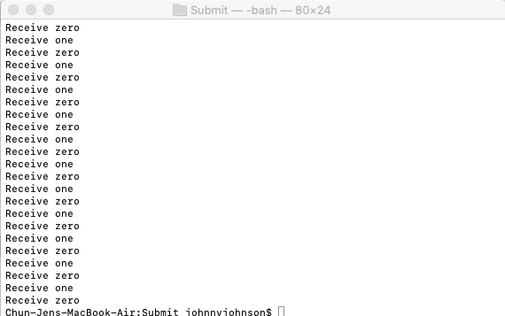

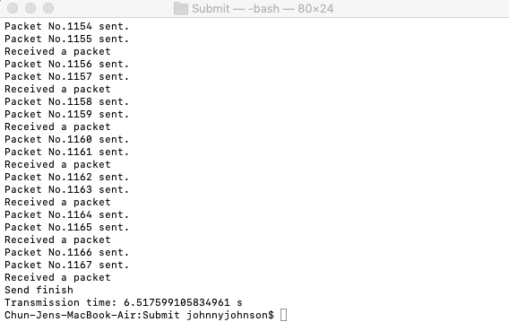

This is the client side which received packets, each packet size. Then it will receive all the packets, assemble them and save it back as new image on the relative folder.

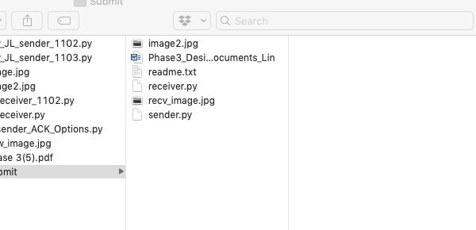

Option 2
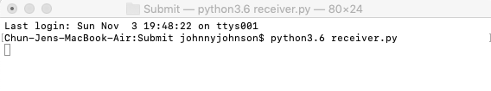
Here we need to enter the % for ACK packet bit-error, for example 20%.
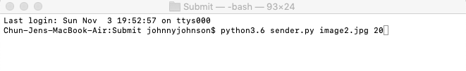
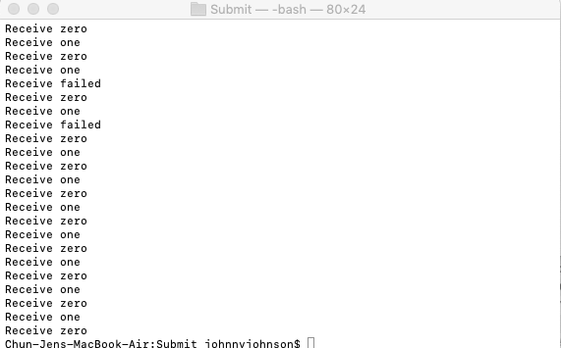

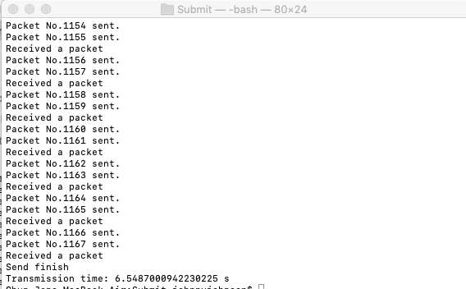

Option 3
Here we need to enter the % for DATA packet bit-error, for example 10%.

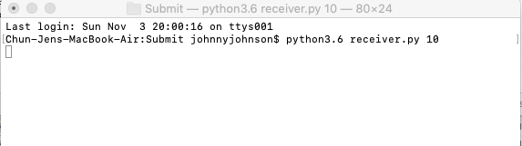

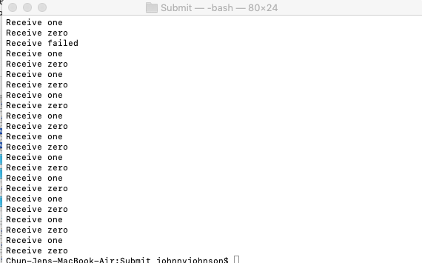

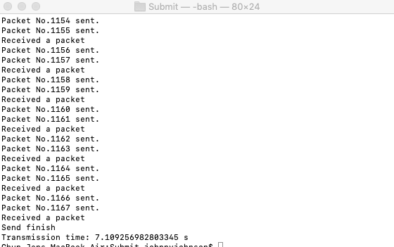

Here is the chart of completion time vs error/loss percentage.

