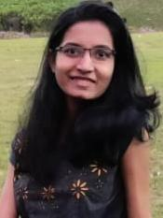
Ms. Manjusha Gopal Katkhede
Computer Engineering Student.
Phone : 91+7083508673
Email : manjushakatkhede.rmds.computer@gmail.com
LinkedIn : manjushak

- Skill Sets :
- Languages : Python( Numpy, Pandas), C, C++, HTML5, CSS,SQL
- Technologies : Django, Machine learning, Data Science
- Platforms : Linux, Windows

- Internship :
Elite Software, Pune. October,2021- December,2021
Python-Django and Web Developer Intern
- Having good experience with Python.
- Learned Django MVC framework for designing APIs.
- Used Python for back-end and HTM, ,CSS, Javascript and Jinja for front-end.
- With the experience of APIs designing practice for editing ready-made templates of django projects.

- Career Objective :
Want to be a Python developer and become part of an enthusiastic work environment ,where I can use my technical skills of Python to accomplish organizational goals and improve Data science skills.

- Academia :

- RMD Sinhgad School of Engineering , Warje,Pune-58. May-2023
B.E. in Computer Engineering | Pursuing .

- Mahilashram High School & Junior College,Karvenagar,Pune-52. March-2019
Higher Secondary-12th class | 77.54% .

- Abhijat High School, Karvenagar ,Pune – 52. March-2017
Secondary - 10th class | 96.80% .

- Strengths :
- Always enthusiast to learn new technical skills
- Versatile.

