**Unit 1: Pitch and Notation**

Ledger Lines

* Ledger lines are like rungs on a ladder: they let us climb higher or lower on the staff. Here’s a great example from Mendelssohn’s *Consolation*. The right hand actually climbs all the way up to the fifth ledger line above the treble staff, while the left-hand plunges to a low E under the fourth ledger line below the bass staff.

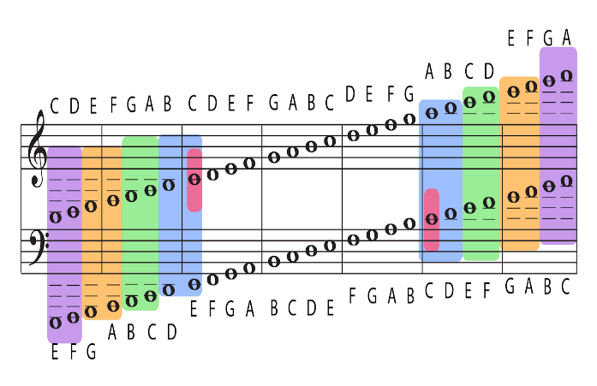

Enharmonic Equivalent

* When a pitch can be spelled more than one way, we call the different spellings enharmonic equivalents.
  + For example, C sharp could also be called D flat. When we look at the piano keyboard, we can see how one black key can have two different names.

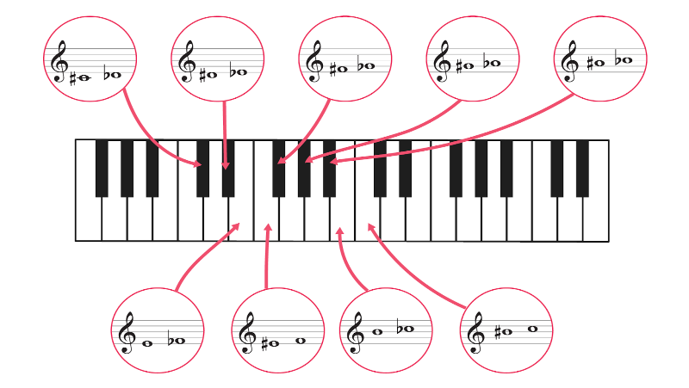

Transposition down an octave

To add some variety or interest to a piece of music, a composer will sometimes move notes or melodies to a higher or lower register. This is called transposition. Transposing notes allows musical material to move between the hands of a pianist or between different instruments in an ensemble. The simplest form of transposition is to move music up or down one octave. Krebs’ Scherzo in C Major is a helpful example of this type of transposition.

Rewriting, NOT transposition

Sometimes, a composer assigns a melodic line to a different instrument or to a different hand but keeps the notes the same. This is not considered transposition, because the actual pitches haven’t changed register. Here’s an example in A flat major.

How to transpose a melody in the same clef

* When you move a melody up or down one octave you are transposing it.
* You can transpose a melody up one octave without changing the clef. Notice the changes in stem directions!

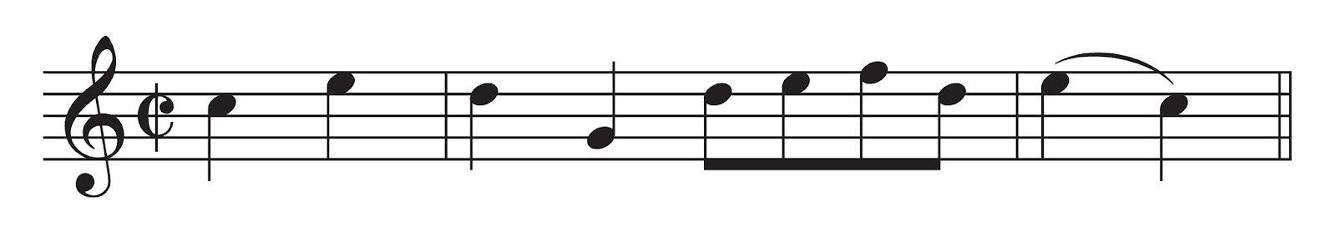

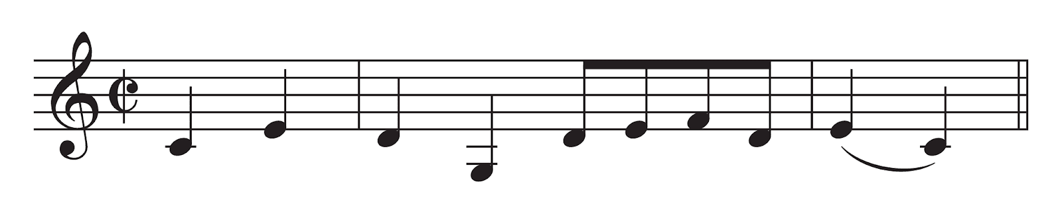

How to transpose a melody up (bass to treble) or down (treble to bass) one octave

* You can transpose the melody down one octave to a different clef.

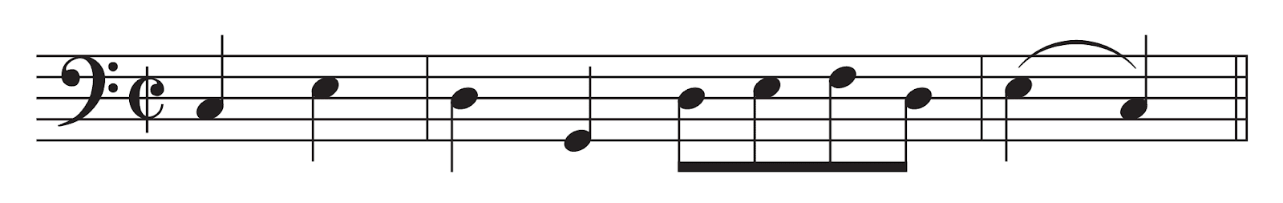

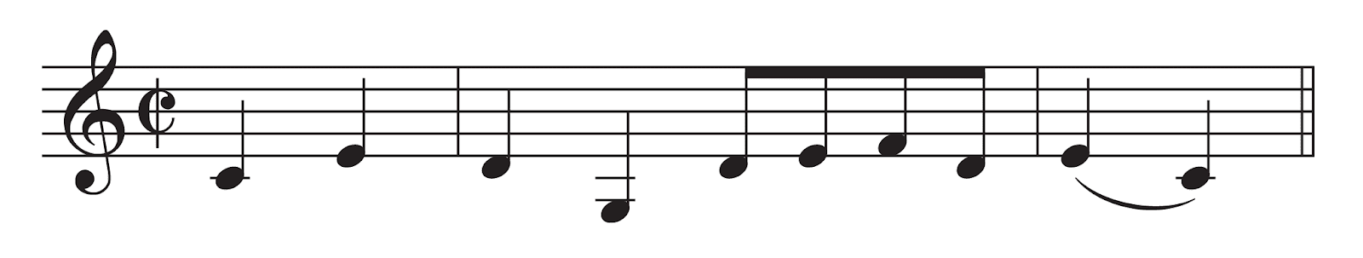

Rewriting a melody

* We can write this melody in the bass clef without changing how it sounds.

