Medicine supply chain

The **medicine supply chain** is a complex network that involves sourcing, manufacturing, distributing, and delivering pharmaceutical products to healthcare providers and consumers.

**Key Stages of the Medicine Supply Chain:**

1. **Sourcing Raw Materials:**
   * Pharmaceutical companies procure raw materials such as chemicals, active pharmaceutical ingredients (APIs), and excipients from suppliers.
2. **Manufacturing:**
   * After sourcing, raw materials are processed into pharmaceutical products in specialized manufacturing facilities.
3. **Quality Control and Packaging:**
   * The medicines undergo rigorous testing to ensure they meet regulatory standards for quality, safety, and efficacy before being packaged.
4. **Distribution:**
   * Finished products are distributed through wholesalers, distributors, and retailers to healthcare providers, hospitals, and pharmacies.
5. **Delivery to Consumers:**
   * Medicines are delivered to end users, either through physical stores, pharmacies, or online platforms.

**Risk Factors in the Medicine Supply Chain:**

1. **Raw Material Dependency:**

* Risk: Shortages or price fluctuations of key raw materials, such as chemicals, active ingredients, and packaging materials.
* Impact: Disruptions in raw material supply can halt manufacturing processes and delay production.
* Solution: Diversifying suppliers to reduce dependency on specific regions or countries. Exploring alternative materials or synthetic substitutes.

2. **Geopolitical Risks:**

* Risk: Trade tensions, political instability, or export restrictions affecting supply chains.
* Impact: Geopolitical risks can lead to trade barriers, affecting the timely import and export of medicines, causing delays and cost increases.
* Solution: Establishing multi-regional sourcing strategies, working with local suppliers, and adapting to new trade policies quickly.

3. **Natural Disasters:**

* Risk: Earthquakes, floods, and other natural events can disrupt manufacturing hubs, warehouses, and transportation networks.
* Impact: Natural disasters can damage facilities, disrupt production, and delay deliveries.
* Solution: Implementing disaster recovery plans, establishing alternative supply routes, and diversifying manufacturing locations to reduce risk exposure.

4. **Logistics and Transportation:**

* Risk: Port congestion, shipping delays, and increased transportation costs.
* Impact: Disruptions in global transportation can cause delays in delivery, resulting in stockouts and unfulfilled customer demands.
* Solution: Investing in advanced logistics solutions, using AI-powered demand forecasting, and exploring local distribution hubs to minimize transportation dependency.

5. **Counterfeit and Fraud Risks:**

* Risk: The entry of counterfeit drugs into the supply chain, especially in developing regions.
* Impact: Counterfeit medicines compromise patient health and damage the reputation of pharmaceutical companies.
* Solution: Blockchain technology to provide end-to-end traceability, implementing serialization for each product, and using anti-counterfeit technologies such as holograms.

6. **Regulatory and Compliance Risks:**

* Risk: Variations in regulatory requirements across different countries and regions.
* Impact: Non-compliance with local regulations can result in delays, fines, and product recalls.
* Solution: Establishing regulatory compliance teams, investing in global compliance tools, and collaborating with local authorities to stay updated on regulations.

7. **Cybersecurity Threats:**

* Risk: Cyberattacks on supply chain data, including sensitive information about pricing, suppliers, and shipment routes.
* Impact: Data breaches can lead to theft of intellectual property, disruption in operations, and reputational damage.
* Solution: Implementing strong cybersecurity protocols, using encryption, and investing in real-time monitoring systems to detect and prevent threats.

8**. Market Volatility:**

* Risk: Sudden shifts in market demand, such as a surge in demand during a pandemic or a sudden drop in demand after the introduction of generic drugs.
* Impact: Rapid demand fluctuations can lead to inventory shortages or surpluses, affecting production efficiency and profitability.
* Solution: Using AI and predictive analytics to forecast demand, implementing just-in-time inventory systems, and maintaining buffer stocks for high-demand items.

**Real-World Case Studies:**

1**. COVID-19 Vaccine Distribution:**

* Challenge: The COVID-19 pandemic led to an unprecedented demand for vaccines, straining the global medicine supply chain.
* Solution: Pharmaceutical companies like Pfizer and Moderna worked with governments and logistics partners to ensure fast-tracked approvals and efficient distribution networks. They used AI-based tools for demand forecasting and advanced logistics to ensure timely deliveries, overcoming challenges like transportation delays and cold storage requirements.

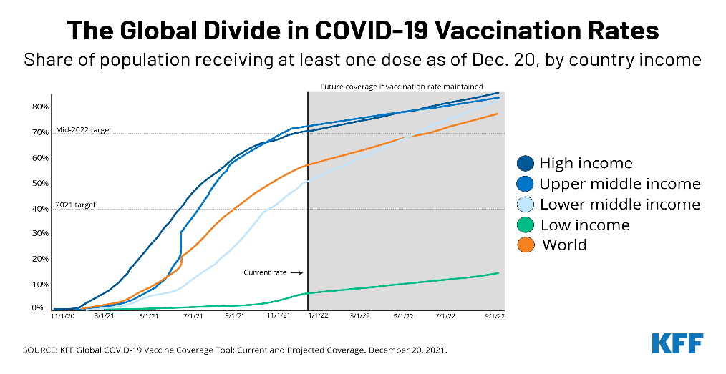

2. **U.S.-China Trade War and Raw Material Shortages:**

* Challenge: The ongoing U.S.-China trade war caused disruptions in the supply of essential raw materials, affecting drug production timelines.
* Solution: Pharmaceutical companies diversified their suppliers by sourcing critical materials from countries outside China. This helped reduce the impact of trade restrictions.

3. **Counterfeit Drugs in Africa:**

* Challenge: The circulation of counterfeit drugs in African markets posed a significant health risk to consumers and a reputation risk to pharmaceutical companies.
* Solution: The industry adopted blockchain-based solutions for track and trace to guarantee the authenticity of medicines. Companies also partnered with trusted distributors to enhance visibility and reduce the risk of counterfeiting.

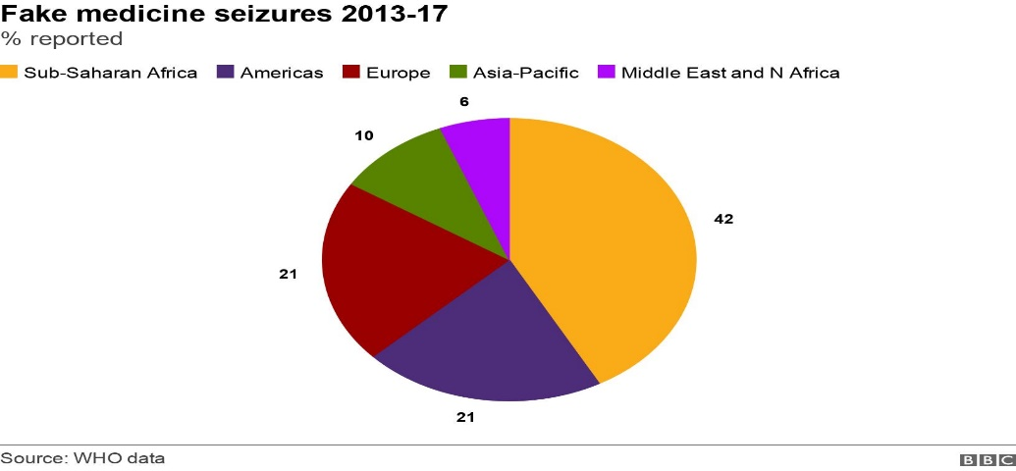

**Future Outlook in the Medicine Supply Chain:**

1. **AI and Automation in Supply Chain Management**:

* Trend: The adoption of AI and machine learning will increase in forecasting demand, optimizing inventory levels, and detecting anomalies in the supply chain.
* Opportunity: Pharmaceutical companies will benefit from real-time tracking and automated decision-making systems to enhance efficiency and reduce human errors.

2. **Blockchain for Transparency and Security:**

* Trend: Blockchain technology will play a significant role in ensuring end-to-end traceability of medicines, making it easier to track the movement of products from manufacturer to consumer.
* Opportunity: Blockchain will help prevent counterfeiting, improve compliance, and increase consumer trust in pharmaceutical products.

3. **Sustainability and Green Supply Chains:**

* Trend: Growing environmental concerns will push pharmaceutical companies to adopt sustainable practices, such as reducing carbon footprints and using eco-friendly packaging.
* Opportunity: Companies can improve their brand image by embracing green supply chains and aligning with global sustainability goals.

4. **Digitalization and Cloud Technologies:**

* Trend: The digital transformation of the pharmaceutical supply chain will continue with the use of cloud platforms for real-time monitoring, communication, and data sharing among stakeholders.
* Opportunity: These technologies will enable better collaboration, faster decision-making, and more resilient supply chains, especially in times of crisis.

5**. E-Commerce and Direct-to-Consumer Models:**

* Trend: Online pharmacies and e-commerce platforms will grow, offering patients the ability to order medications directly from their homes.
* Opportunity: Pharmaceutical companies can expand their reach by integrating with e-commerce platforms and implementing direct-to-consumer delivery models, especially in underserved regions.