Arduino Uno – Lecture Notes

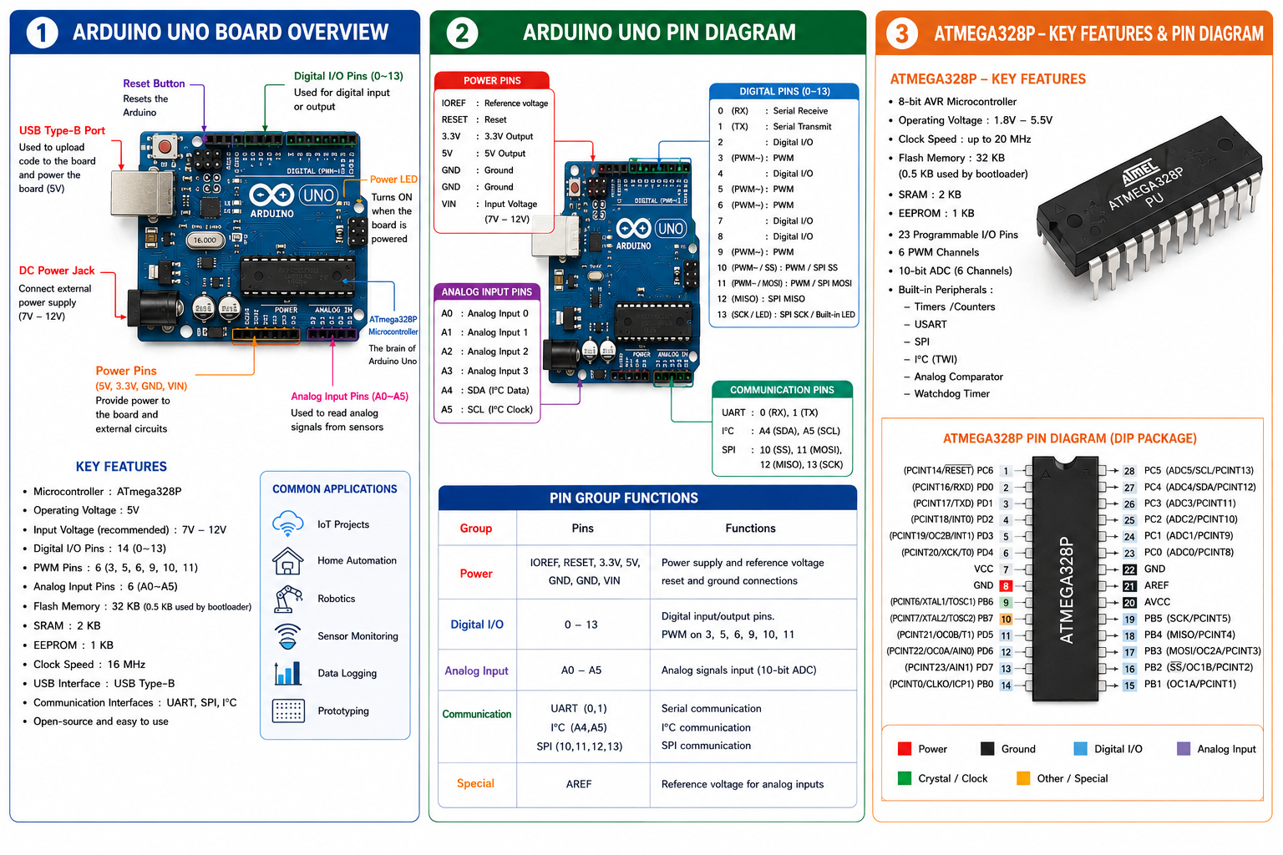
Arduino UNO Components with Abbreviations
Sl. No. | Component | Abbreviation | Full Form | Function | Common Uses
1 | ATmega328P Microcontroller | MCU | Microcontroller Unit | Executes the uploaded program and controls all operations. | IoT, Robotics, Automation
2 | USB Type-B Port | USB | Universal Serial Bus | Uploads programs and supplies 5V power from the computer. | Programming, Serial Communication
3 | DC Power Jack | DC | Direct Current | Connects an external power supply (7–12V). | Standalone projects
4 | Reset Button | RESET | Reset | Restarts the microcontroller and reruns the program. | Debugging, Program Restart
5 | Power LED | LED | Light Emitting Diode | Indicates that the Arduino board is powered ON. | Power indication
6 | TX LED | TX | Transmit | Blinks when serial data is transmitted. | Serial communication
7 | RX LED | RX | Receive | Blinks when serial data is received. | Serial communication
8 | Digital I/O Pins (0–13) | I/O | Input/Output | Reads digital inputs and controls digital outputs. | LEDs, Relays, Switches
9 | PWM Pins | PWM | Pulse Width Modulation | Produces analog-like output using digital pins. | Motor speed and LED brightness control
10 | Analog Input Pins (A0–A5) | ADC | Analog-to-Digital Converter | Reads analog voltages and converts them into digital values. | LDR, Temperature, Gas Sensors
11 | 5V Power Pin | 5V | 5 Volts | Provides regulated 5V output. | Powering sensors and modules
12 | 3.3V Power Pin | 3.3V | 3.3 Volts | Provides regulated 3.3V output. | ESP8266, Bluetooth Modules
13 | Ground Pin | GND | Ground | Common 0V reference for the circuit. | Completing electrical circuits
14 | Voltage Input Pin | VIN | Voltage Input | Receives external voltage supply. | External power source
15 | Analog Reference Pin | AREF | Analog Reference | Provides reference voltage for ADC conversions. | Accurate analog measurements
16 | I/O Reference Pin | IOREF | Input/Output Reference | Indicates the operating voltage of the board (5V). | Arduino Shields
17 | ICSP Header | ICSP | In-Circuit Serial Programming | Used for programming the ATmega328P directly and SPI communication. | Bootloader programming
18 | Voltage Regulator | VR | Voltage Regulator | Converts higher input voltage into stable 5V and 3.3V outputs. | Power regulation
19 | Crystal Oscillator | XTAL | Crystal Oscillator | Generates the 16 MHz clock signal for the microcontroller. | System timing
20 | USB-to-Serial Converter | UART/USB | Universal Asynchronous Receiver Transmitter | Converts USB communication into serial communication. | Uploading programs, Serial Monitor
21 | Female Header Connectors | — | — | Allows connection of jumper wires, sensors, and Arduino shields. | Circuit prototyping

Important Pin Abbreviations
Abbreviation | Full Form | Purpose
USB | Universal Serial Bus | Programming and power supply
MCU | Microcontroller Unit | Main processing unit of Arduino
DC | Direct Current | External power input
LED | Light Emitting Diode | Indicates board and communication status
TX | Transmit | Sends serial data
RX | Receive | Receives serial data
I/O | Input/Output | Reads inputs and controls outputs
PWM | Pulse Width Modulation | Controls motor speed and LED brightness
ADC | Analog-to-Digital Converter | Converts analog voltage to digital values
VIN | Voltage Input | External voltage supply input
GND | Ground | Common reference (0V)
AREF | Analog Reference | Reference voltage for ADC
IOREF | Input/Output Reference | Indicates board operating voltage
ICSP | In-Circuit Serial Programming | Programs the microcontroller directly
XTAL | Crystal Oscillator | Provides clock signal
UART | Universal Asynchronous Receiver Transmitter | Serial communication between Arduino and computer
SPI | Serial Peripheral Interface | High-speed communication with peripherals
I²C | Inter-Integrated Circuit | Two-wire communication protocol
SDA | Serial Data | Data line for I²C communication
SCL | Serial Clock | Clock line for I²C communication
MOSI | Master Out Slave In | SPI data sent from Arduino to peripheral
MISO | Master In Slave Out | SPI data received by Arduino
SCK | Serial Clock | Synchronizes SPI communication
SS | Slave Select | Selects the SPI slave device

ATmega328P Important Pins
Pin | Full Form | Purpose
VCC | Voltage Supply | +5V Power
GND | Ground | 0V Reference
AVCC | Analog VCC | Power for ADC
AREF | Analog Reference | ADC Reference Voltage
XTAL1 | Crystal Input | Connects 16 MHz Crystal
XTAL2 | Crystal Output | Crystal Oscillator
RESET | Reset Pin | Restart Controller
PC0–PC5 | Port C | Analog Inputs
PB0–PB5 | Port B | Digital Pins
PD0–PD7 | Port D | Digital Pins

Common Abbreviations Summary
Abbreviation | Full Form | Purpose
USB | Universal Serial Bus | Programming & Power
I/O | Input/Output | Read or Control Devices
RX | Receive | Receives Serial Data
TX | Transmit | Sends Serial Data
PWM | Pulse Width Modulation | Speed/Brightness Control
ADC | Analog to Digital Converter | Reads Analog Signals
SPI | Serial Peripheral Interface | High-Speed Communication
MOSI | Master Out Slave In | Send SPI Data
MISO | Master In Slave Out | Receive SPI Data
SCK | Serial Clock | SPI Clock Signal
SS | Slave Select | Select SPI Device
I²C | Inter-Integrated Circuit | Two-Wire Communication
SDA | Serial Data | I²C Data Line
SCL | Serial Clock | I²C Clock Line
UART | Universal Asynchronous Receiver Transmitter | Serial Communication
USART | Universal Synchronous/Asynchronous Receiver Transmitter | Advanced Serial Communication
EEPROM | Electrically Erasable Programmable Read Only Memory | Permanent Data Storage
SRAM | Static Random Access Memory | Temporary Memory
VCC | Voltage Common Collector | Positive Supply Voltage
GND | Ground | 0V Reference
VIN | Voltage Input | External Power Input
AREF | Analog Reference | ADC Reference Voltage
AVCC | Analog Voltage Supply | ADC Power Supply
XTAL | Crystal Oscillator | System Clock
TWI | Two Wire Interface | Another Name for I²C

