Welcome Page:

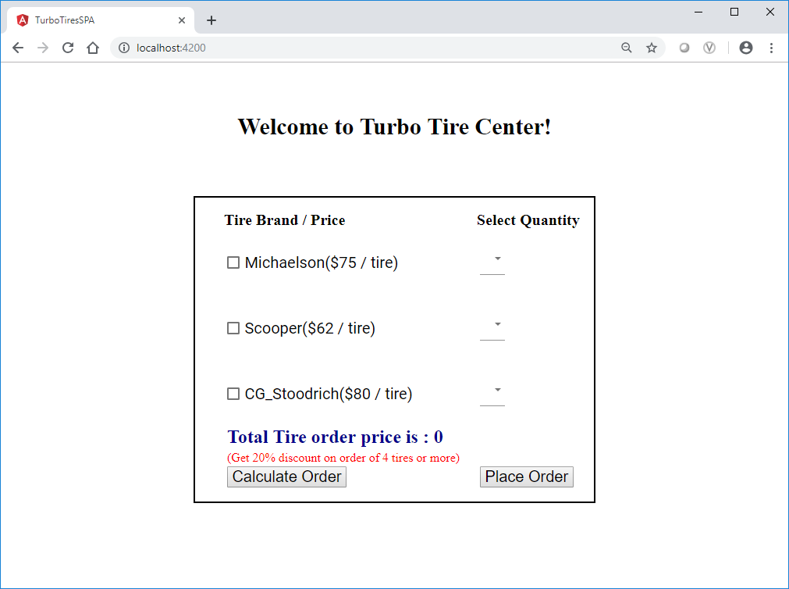

Scenario 1(Calculate price for less than 4 tires):

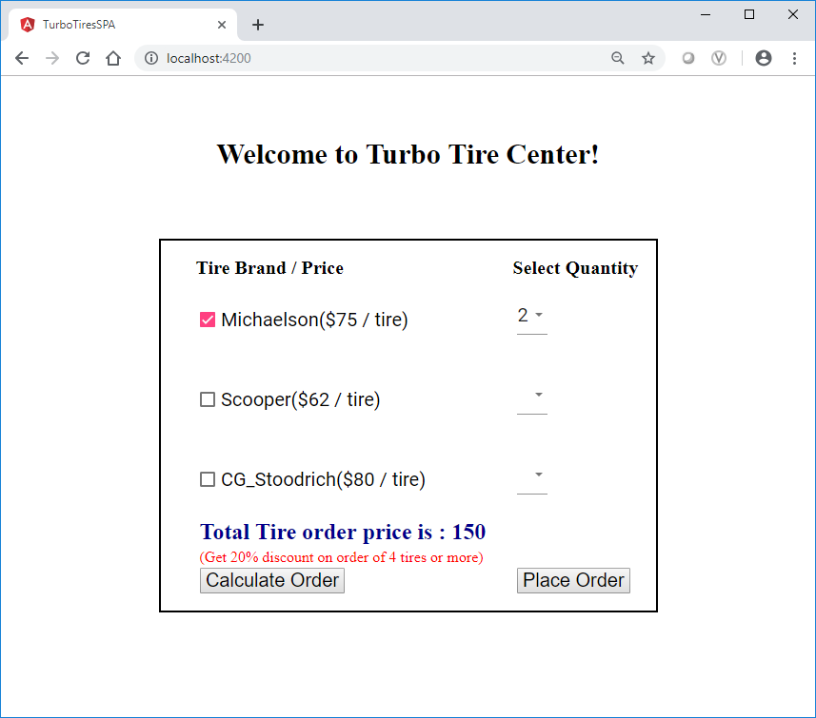

Scenario 2(Calculate price for 4 or more than 4 tires (20% discount applied)):

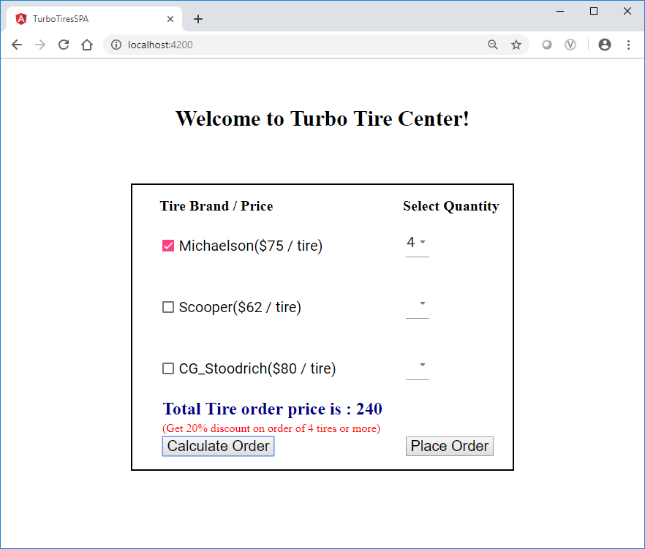

Scenario 3(Calculate price for 2 different tires brand with less than 4 quantity)

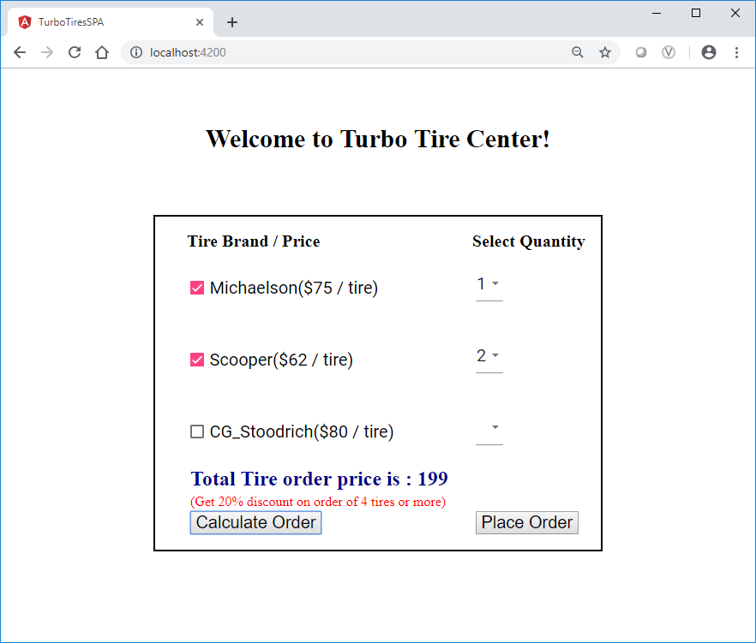

Scenario 4(Calculate price for 2 different tires brand with more than 4 quantity (20% discount applied)

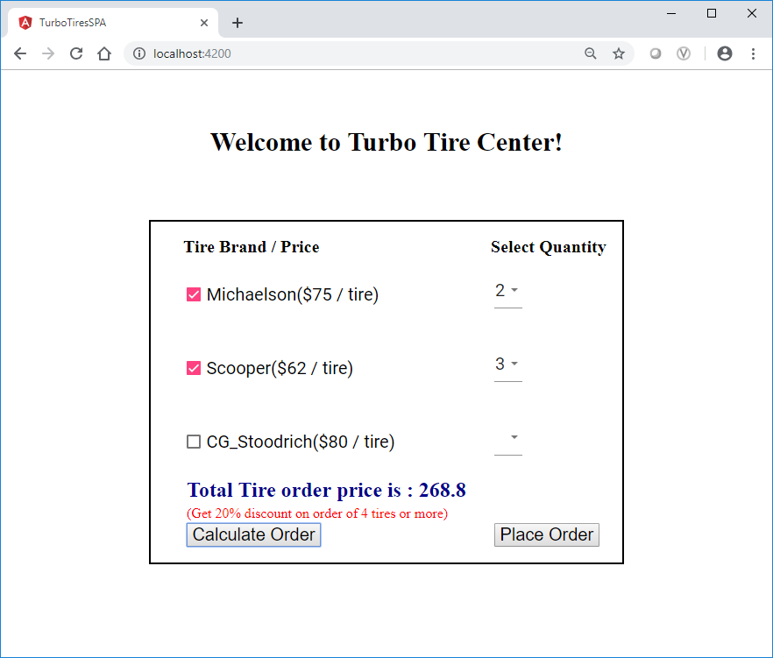

Scenario 5(Calculate price for all tire brands (20% discount applied))

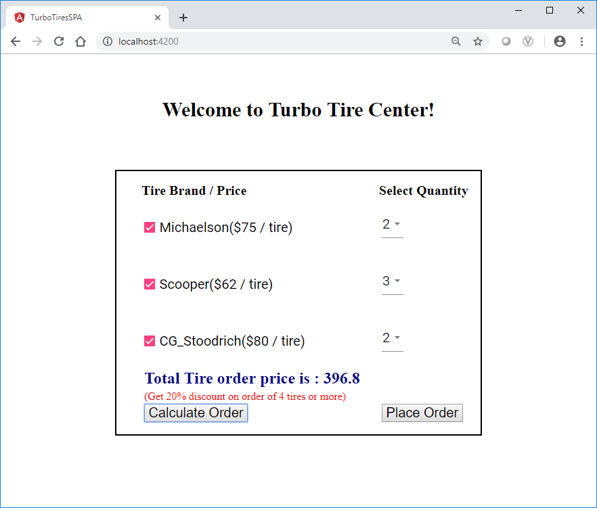

Place order

