18.09.2022

**The Interdependency between Party Isolation and Predictors of Sympathy with**

**Parties of the Radical Right**

Manuel Kleinert

Justus-Liebig University Giessen

Manuel Kleinert,

Justus-Liebig-University of Giessen, Institute of Sociology,

Karl-Glöckner-Str. 21E,

35394 Giessen,Germany

manuel.kleinert@sowi.uni-giessen.de

Word count: ~6600 excl. references

**ABSTRACT**

Radical right-wing populist parties (RRP) have entered most western parliaments. Existing demand-side research of party success has highlighted the crucial role of anti-immigration attitudes and political dissatisfaction as their main drivers of support. Supply-side research often points at the isolation (cordon sanitaire) such parties face in their respective parliament. In this research report, we demonstrate that these perspectives can inform each other and differences in the parliamentary status of the RRP can predict cross-country differences in attitudinal effects. We find that besides direct effects, anti-immigration attitudes and political dissatisfaction vary considerably in their effect on RRP sympathy. This variation coincides with the status of RRP in the respective country. In parliamentary isolation, political dissatisfaction reinforces the effect of anti-immigration attitudes, while it reduces it when the RRP is governing and turns insignificant if the RRP has a history of governing.

**Introduction**

The entry and success of radical right-wing populist parties (RRP) has received profound academic attention from demand-side party research. There is considerable variation in this party family and its electorate. However many studies converge around two particularly important aspects, which predict support for RRPs: anti-immigration attitudes and political dissatisfaction. Anti-immigration attitudes are often described as a core ideology, a lowest common denominator that unites voters behind the party (Roodujin 2018). Consequently, many studies find strong correlations of anti-immigration attitudes and RRP support (Rydgren 2007; Arzheimer 2018). Political dissatisfaction on the other hand is sometimes linked to the theory of ‘protest vote’ (Klein, Heckert et al. 2018). At its core this argument posits that citizens´ disapproval of current politics makes them more likely to support RRPs (Schmitt-Beck 2017; Voogd, Dassonneville 2020). We conceive of political dissatisfaction as a moderator of anti-immigration attitudes in their effect on sympathy for RRPs. This rationale is based on the assumption, that anti-immigration attitudes become more salient as a predictor of party preferences for citizens who are dissatisfied with the incumbent government (Kleinert 2021).

Regarding the supply side, it has been stressed that RRPs face unique challenges in many parliaments. In contrast to mainstream parties, which occasionally switch between opposition status and governing, RRPs are sometimes isolated through a cordon sanitaire imposed on them by the rest of the parliament. Meaning that no other party forms a coalition with them, even rejecting informal bounds and support. An own strand of research is concerned with when and how such strategies are pursued by mainstream parties (Heinze 2018, Karlsson 2021), the effects of such strategies on the RRPs (Rumens and Abts 2010, Pauwels 2011, Jonge 2021, Krause et al. 2022) as well as their effects on mainstream parties (Van de wardt 2015, Schumacher and van Kersbergen 2016, Abou-Chadi 2016, 2020, Gessler and Hunger 2021). However, largely missing are efforts to understand the effects of the parliamentary status of a RRP on citizens´ attitudes and support for these parties on an individual basis (instead of aggregated election results). An exception is the study of Han (2020) who´s findings suggest, that isolation of an RRP in fact increases support among parts of its electorate. In this case, it is especially reinforced for those who harbor authoritarian attitudes.

In this research note, we link demand-side attitudes and supply-side circumstances to explain cross-country differences in supporting the populist radical right. As mentioned, we expect the effect of anti-immigration attitudes to be moderated by a person´s level of political dissatisfaction. We include the supply-side perspective by predicting, that this effect depends on the level of integration of the RRP within the specific national party system. To illustrate these premises, imagine a citizen harboring high levels of anti-immigration attitudes, who is more and more frustrated, that the current government does not take sufficient action in his preferred direction. When looking for alternatives, parties that present themselves as the complete opposite of the incumbents and advocate tough migration policies may seem like a promising alternative. Parties which were previously included in the government may be less appealing as high expectations might have been disappointed bevor. Finally, RRPs who are in government at the moment are obviously not the right choice for someone disappointed with current policies. Isolated parties may therefore profit from their status in the sense that political dissatisfaction boosts the main motive – anti-immigration attitudes – for supporting them. For parties, which had been part of governments in the recent past, this effect becomes less relevant and for currently ruling RRPs, higher levels of political dissatisfaction should not only directly decrease sympathy for this party but also lower the effect of anti-immigration attitudes in predicting sympathy for them.

**Data and analytic strategy**

To test our assumptions, we use large-scale survey data from various sources and countries, collected within the recent and ongoing ‘fourth wave’ (Krause, Cohen et al. 2022) of the European radical right. The Comparative Study of Electoral Systems (CSES; CSES 2021) data set provides researchers with high quality survey data, which has been collected independently during national election campaigns in various countries and was later matched on an item-to-item basis. It provides the test cases of Germany, Sweden, France, Austria, Italy, Finland, Belgium, Norway and Hungary[1]. The RECONNECT survey (abbreviated as REC for this article; Plescia, Wilhelm et al. 2020) took place as a centralized pre- and post-election survey focusing on the European Parliament Election in 2019. The countries covered by this data set are Germany, France, Spain, Denmark, Italy, Poland and Hungary. We use only the first of two waves in this data set, as many items we use were not asked in the second round.

To represent our theoretical constructs, anti-immigration attitudes and political dissatisfaction we used latent and manifest operationalizations. For the CSES data set, we were able to measure anti-immigration attitudes as a latent construct of three indicators. These covered salient and often-employed aspects of immigration. Specifically, the items asked respondents to state their position on three statements, whether immigrants are good for the economy, harm the culture of the host country or increase crime in the host society on a 5-point-Likert-scale.[2] We assessed political dissatisfaction as attitudes towards the ruling government (Torcal 2011), using a single indicator targeting participants´ opinion on the performance of the current government since it took office on a 4-point scale. Our dependent variable is a sympathy scale (“0 strongly dislike” – “10 strongly like”) for the most relevant RRP of the respective country. To identify these RRPs, we referred to all parties mentioned in PopuList (Rooduijn, van Kessel et al. 2019), and then took the one that achieved the greatest vote share in the last election.[3] Note that this item allows the respondents to indicate their general preference for the RRP party irrespective of their voting intentions (Gschwend, Juhl et al. 2018). This is a subtle but beneficial distinction, given that citizens’ voting intentions might plausibly shaped by external factors (e.g., thresholds for parliamentary entry, coalition considerations; see van der Eijk, van der Brug et al. 2006).

For the REC data set, we identified three items capturing respondents’ views on immigration, which we all integrated in our scale. The items were 11-point Likert-scales with verbalized ends. These were “immigrants should adapt to [country]´s customs/immigrants should be free to keep their own cutoms”, “Immigrants do not/take away jobs from [country]s” and “Restrict/Maintain welfare benefits access for immigrants”. Political dissatisfaction asked for the respondents satisfaction with the current national government “to date” on an 11-point scale. The dependent variable in this data set is an item asking: “How probable is it that you will ever vote for [most relevant RRP of country]?” Similar to the sympathy-scale we used for the CSES, we employ a metric-scale here, not a voting indicator, for the above-mentioned reasons. For analyses with both datasets, we also included the same set of common control variables. For a detailed list of these, please refer to table 2 in the appendix.

We employ these cross-sectional, cross-national data sets in structural equation models. These models include definitions of the latent constructs, and the regression of all variables solely on the dependent variable, the respondent´s sympathy for the RRP of the respective country. We also included an interaction term of anti-immigration attitudes and political dissatisfaction in each model and allowed the variances of both constructs to be correlated. To make the results more intuitive and accessible, we plotted the relevant coefficients in a forest plot (Figure 1) separately for each country.

We then grouped the countries by the status of the RRP in their countries at the time of data collection. Each RRP was assigned one of three status levels. The first level is assigned if the party is isolated, or subject to a cordon sanitaire at the time of data collection. In level two, the party was part of government(s) before but not at the time of data collection and level three meant that the party was part of the incumbent government during the field phase. This data was collected manually with reference to the Parlgov data set (Döring, Huber et al. 2022). For detailed documentation please refer to table 1 in the appendix.

**Results**

On the individual level, we find strong support for both our theoretically relevant variables (Figure 1). Anti-immigration attitudes have a positive effect on RRP sympathy in all countries except Poland and Hungary (REC). At first glance, these exceptions come as a surprise, given the strong anti-immigration sentiment these parties (PiS and Fidesz) often express. However, these parties also constitute majority parties in these countries, which are supported by a broad and diverse share of the electorate. Therefore, single issues may be less relevant to their voters. In general, effects of anti-immigration attitudes seem to be stronger in the CSES data set compared to the REC data set. This may be related to the different items included in the measurement of this construct.

Regarding political dissatisfaction, results are more stratified, ranging from strong positive to strong negative effects on RRP sympathy. Nevertheless, it is relatively trivial that we find negative effects for Poland, Hungary, Italy (REC) and Hungary, Norway (CSES), since these countries were governed at least partially by the RRPs we look at. Put differently, it is no surprise that respondents who are satisfied with the all-PiS government in Poland also express sympathy for this party.

We now turn to the interaction/moderating effect of political dissatisfaction and anti-immigration attitudes on RRP sympathy. As the results above already indicated, taking into account the perspective of parliamentary/governing status when interpreting cross-country differences proves valuable. In fact, we find strong support for our theoretical assumption, that political dissatisfaction reinforces or lowers the positive effect of anti-immigration attitudes on sympathy for RRPs depending on the parliamentary status of the party. For our overall sample of countries, RRPs were isolated at the time of the survey in Germany, France and Sweden in the CSES, and in Germany, France and Spain in the REC data. As one can also infer from Figure 2, it is exactly for those – and only those countries – where we find positive (reinforcing) effects of the interaction term. Not part of the current government but of previous, were the RRPs in Austria, Finland, Italy (all CSES) and Denmark (REC). It is this group of countries, for which we find no significant effect of the interaction term. In Norway and Hungary (CSES), Poland, Italy and again Hungary (REC) RRPs were in government at the time of field period. For these countries, political dissatisfaction lowers the effect of anti-immigration attitudes on RRP sympathy.

Particularly interesting are the cases of Italy and Denmark. Italy is the only country for which we can make a comparison between different status´ of the RRP we investigate. Lega was part of previous governments but not of the current when data for the CSES was collected. However, shortly afterwards it constituted a major participant in the government, which hold also during the field phase of the REC data set. This switch from opposition to government benches is reflected in our results as the moderation effect for Italy moves from narrowly insignificant to significantly negative between these two observations. Denmark (REC) appears as a bit odd, fitting our predicted schema only by a narrow margin and showing a negative effect for political dissatisfaction. Meaning that those who were rather satisfied with governmental performance were also more likely to report positive evaluations of the RRP. The respective party, ‘Dansk Folkepartiet’, was not formally part of the government but informally supported a right-wing government during the time of data collection, thereby constituting a unique and exceptional status among the parties in our data sets. Therefore this case fits theoretically as well as empirically between two levels we formally specified (not in government but also not isolated vs. in government).

Taken together, these results indicate that the extent of parliamentary exclusion or inclusion, a supply-side characteristic of the party translates to differences in demand-side predictors of party sympathy. While anti-immigration attitudes – in line with previous research – proves to be a nearly universal explanatory factor for higher RRP sympathy, the results for political dissatisfaction are mixed. As one would expect, sympathizers of an RRP also approve of the government if the RRP is part of it and rather disapprove of it if the RRP is not included in the incumbent administration. However, we also find that these variables influence each other contingent on the parliamentary status of the party. Higher levels of political dissatisfaction increase the salience of anti-immigration attitudes as a reason to support RRPs only in those countries where these parties operate under a cordon sanitaire in parliament. When the party is not isolated but also not part of the current government, these variables are rather independent of each other, resulting in an insignificant moderation term. For countries where the RRP governs, higher dissatisfaction even decreases this issue-related support for a RRP.

**Conclusion**

In this research note we investigated how well-known explanatory demand-side factors of RRP sympathy, anti-immigration attitudes and political dissatisfaction jointly influence each other and how this interaction depends on the parliamentary status of the RRP in question. We use two independent cross-sectional data sets including totaling 15 unique country observations to test our theoretical assumptions. As previous research of the field also highlighted, anti-immigration attitudes are a sound direct predictor of RRP sympathy. Barely surprising, the effect of political dissatisfaction differs dependent on the governmental status of the RRP. However, as one of the first studies, we also investigate how moderating effects may be contingent on the parliamentary status (Han 2020). We find that the reinforcing relationship between political dissatisfaction and anti-immigration attitudes in their effect on RRP sympathy is only positive in countries where the RRP is politically isolated in the parliament (cordon sanitaire). When the party was in government previously, the effect turns insignificant and finally switches to significantly negative when the party is in government.

We used broad and independent data to cross-validate our theoretical argument, however, we also acknowledge caveats in our research design. Our study was based on cross-sectional data only. Therefore, we cannot assess the temporal precedence of our key constructs and all our results should be regarded as merely correlational. Due to the observational character of our data we also cannot exclude the risk that some third undetermined factor is causing the relationships we observe. Nevertheless, we accounted for important control variables known from previous research in order to reduce this potential bias. In addition, this research shares the limitation of many secondary analyses of survey data, such that the indicators available were not ideal for the current research. For example, some constructs were assessed only by single indicators, which might increase the influence of random measurement error. However, despite these shortcomings, we believe that the strong and unequivocal results across all country cases we investigated testifies to the generalizability of our findings.

Our results inform the salient and growing body of research investigating established parties strategies to deal with RRPs in parliament. So far efforts have been concentrated on investigating how isolation, adapting and accompanying strategies of competitors have influenced electoral results on the macro level (Pauwels 2011) and direct trajectories to support of RRPs on the individual demand-side level (Abts 2015). However, with few exceptions (Han 2020; Muis, Brils et al. 2021), previous research lacked to take into account the subgroup level. This is, specifying how such party positions influence different parts of the electorate. We demonstrated, that even the well-established factor anti-immigration attitudes can be substantially less important in predicting RRP sympathy once the level of political dissatisfaction of the respondent and the parliamentary status of the RRP is taken into account. In that sense, future research might be well advised to regard demand and supply side factors impartially and integrate both perspectives in order to arrive at a more comprehensive understanding for support of RRPs.

**FIGURES AND TABLES**

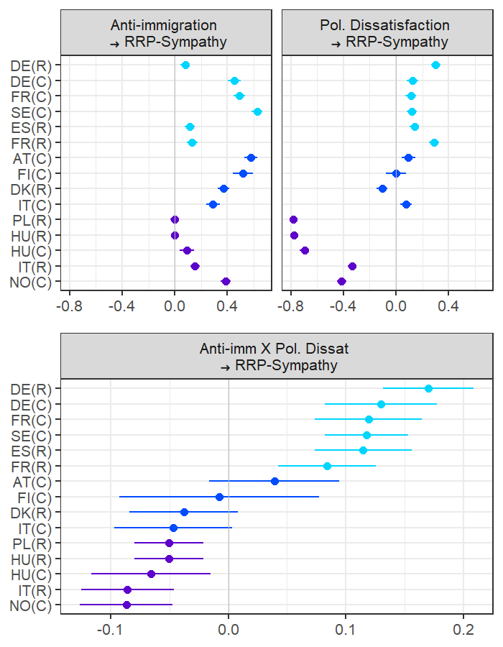

Figure 1: Forest plot visualizing standardized results of multivariate multi-group structural equation models. The plots are separated by variables and grouped by countries within each plot. Letters in parentheses indicate the origin of the data, C for the CSES data set, R for the REC data set. The order of the countries follows the position of the RRP and is furthermore highlighted by colors: light blue denotes countries in which the RRP is isolated, dark blue dots are used for countries in which the RRP was part of a cabinet or supported a minority government before. Purple indicates countries in which the RRP was governing during the fieldwork period.

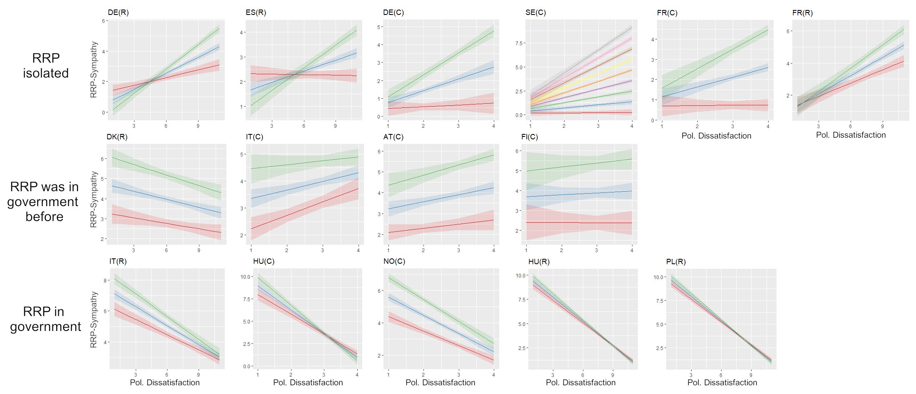

Figure 2: These charts show the effect of dissatisfaction on sympathy for the RRP for different levels of anti-immigration attitudes (blue = arithmetic mean, red = mean -1SD, green = mean +1SD). Letters in parentheses refer to the data set (C for CSES, R for RECONNECT). For Sweden (C) the index of anti-imigration attitudes misses one variable, thus it has only nine levels, which are all displayed by different colors (red = lowest, grey = highest). The countries are grouped in rows by the status of the RRP in the respective country, as indicated at the left of the panels.

|  |  |  |  |  |  |
| --- | --- | --- | --- | --- | --- |
| Country | Data | n | Fieldwork period | RRP in gov. | Notes |
| Austria | CSES | 1203 | 19.10.2017-30.11.2017 | 0 | FPÖ included in government shortly after field period |
| Denmark | REC |  | 02.04.2019-19.04.2019 | 0 | DF supports Conservative-right minority government |
| Finland | CSES | 1598 | 17.04.2019-05.10.2019 | 0 | Ps previously in government |
| France | CSES | 1830 | 09.05.2017-23.05.2017 | -1 | FN in isolation |
| France | REC |  | 03.04.2019-15.04.2019 | -1 | FN in isolation |
| Germany | CSES | 2032 | 25.09.2017-30.11.2017 | -1 | AfD in isolation |
| Germany | REC |  | 04.04.2019-16.04.2019 | -1 | AfD in isolation |
| Hungary | CSES | 1208 | 23.04.2018-05.05.2018 | 1 | Fidesz in government |
| Hungary | REC |  | 03.04.2019-22.04.2019 | 1 | Fidesz in government |
| Italy | CSES | 2001 | 08.03.2018-02.05.2018 | 0 | New Government including RRP (Lega) was formed shortly after field period |
| Italy | REC |  | 04.04.2019-15.04.2019 | 1 | Lega in government |
| Norway | CSES | 1792 | 20.09.2017-16.10.2017 | 1 | FrP in government |
| Poland | REC |  | 02.04.2019-18.04.2019 | 1 | PiS in government |
| Spain | REC |  | 03.04.2019-15.04.2019 | -1 | VOX in isolation |
| Sweden | CSES | 3784 | 10.09.2018-06.11.2018 | -1 | SD in isolation |

Table 1: Table listing countries and status of RRPs at the time of data collection. Variable ‘RRP in government’ was determined based on the Parlgov data set (Döring, Huber et al. 2022).

|  |  |  |
| --- | --- | --- |
|  | RECONNECT | CSES |
| yearborn/  age | W1_Q1b  Age | E2001_Y  Year of birth |
| female | W1_Q2  Male is 1, Female is 2. | E2002  Male is 1, female is 2. Others coded as missing. |
| edu | W1_Q_edu | E2003 |
| rile | W1_Q16  Inverted from original variable. | E3020  Inverted from original variable. |
| unemp | W1_Q75  4 and 5 coded as 1, 0 for else. | E2006  5 coded as 1, 0 for else. Austria: 10 coded as 1. |
| deprivation | W1_Q79 | E2010 |
| anti_immA | W1_Q39_3  Inverted from original variable. | E3005_3 |
| anti_immB | W1_Q39_4  Inverted from original variable. | E3005_4  Inverted from original variable. |
| anti_immC | W1_Q39_9  Inverted from original variable. | E3005_5  Inverted from original variable. Not asked in SE. |
| dissat | W1_Q11  Inverted from original variable. | E3009  Neutral center category in Norway and Finland coded as missing. |
| rrp_sym | W1_Q57_XX_Y  XX is country number (10-70), Y is party number (1-6). For variable-country matching see selected RRPs in Table 3. | E3017_A[-I]  For variable-country matching see selected RRPs in Table 3. |

Table 2: Variables used in analyses by data set.

|  |  |  |  |
| --- | --- | --- | --- |
| Country | Popu-List lists… | CSES variable | RECONNECT variable |
| Austria | FPÖ | E3017_C | - |
|  | BZÖ | - | - |
| Denmark | DF | - | W1_Q57_60_1 |
|  | NB | - | - |
|  | FrP | - | - |
| Finland | Ps (True Finns) | E3017_B | - |
| France | FN/RN | E3017_B | W1_Q57_20_6 |
|  | DLR/DLF | E3017_F | - |
| Germany | AfD | E3017_C | W1_Q57_10_6 |
| Greece | EL | - | - |
|  | LAOS | - | - |
|  | POLAN | - | - |
| Great Britain | UKIP | E3017_E (all missing) | - |
| Hungary | Fidesz | E3017_A | W1_Q57_40_6 |
|  | Jobbik | E3017_B | W1_Q57_40_1 |
|  | Fi+KNDP | - | - |
|  | MIEP | - | - |
|  | MH | - | - |
| Italy | LN | E3017_E | W1_Q57_70_6 |
|  | FdI | E3017_C | W1_Q57_70_5 |
|  | LAM | - | - |
| Norway | FrP | E3017_C | - |
| Poland | PiS | - | W1_Q57_50_4 |
|  | Kukiz`15 | - | W1_Q57_50_5 |
|  | LPR | - | - |
|  | X | - | - |
| Portugal | CH | E3017_G (all missing) | - |
| Spain | VOX | - | W1_Q57_30_5 |
| Sweden | SD | E3017_C | - |
|  | NyD | - | - |
| Switzerland | SVP | E3017_A (all missing) | - |
|  | LdT | E3017_H (all missing) | - |
|  | FPS | - | - |
|  | MCR | - | - |

Table 3: Table of RRPs defined by Popu-List as farright and populist and their availability as sympathy scale in CSES data set. If two were available in CSES, the more relevant with regard to vote share in the latest election was selected (underlined).

**REFERENCES**

Abou-Chadi, Tarik (2016): Niche Party Success and Mainstream Party Policy Shifts – How Green and Radical Right Parties Differ in Their Impact. In *British Journal of Political Science* 46 (2), pp. 417–436. DOI: 10.1017/S0007123414000155.

Abou-Chadi, Tarik; Krause, Werner (2020): The Causal Effect of Radical Right Success on Mainstream Parties’ Policy Positions: A Regression Discontinuity Approach. In *British Journal of Political Science* 50 (3), pp. 829–847. DOI: 10.1017/S0007123418000029.

Abts, Koen (2015): Attitudes Towards a Cordon Sanitaire vis-a-vis Extremist Parties: Instrumental Pragmatism, Affective Reactions, and Democratic Principles. In *ETHICAL PERSPECTIVES* 22 (4), pp. 667–698. DOI: 10.2143/EP.22.4.3127271.

Arzheimer, Kai (2018): Explaining Electoral Support for the Radical Right. In Jens Rydgren (Ed.): The Oxford Handbook of the Radical Right: Oxford University Press (1), pp. 143–165.

Bolin, Niklas; Dahlberg, Stefan; Blombäck, Sofie (2022): The stigmatisation effect of the radical right on voters’ assessment of political proposals. In *West European Politics*, pp. 1–22. DOI: 10.1080/01402382.2021.2019977.

CSES - The Comparative Study of Electoral Systems (2021): CSES module 5 third advance release [dataset and documentation]. July 20, 2021 version.

Döring, Holger; Huber, Constantin; Manow, Philip (2022): Parliaments and governments database (ParlGov): Information on parties, elections and cabinets in established democracies. Development version. Available online at https://www.parlgov.org.

Gessler, Theresa; Hunger, Sophia (2021): How the refugee crisis and radical right parties shape party competition on immigration. In *Political Science Research and Methods*, pp. 1–21. DOI: 10.1017/psrm.2021.64.

Giorgi, Elisabetta de; Dias, António; Dolný, Branislav (2021): New Challenger Parties in Opposition: Isolation or Cooperation? In *Parliamentary Affairs* 74 (3), pp. 662–682. DOI: 10.1093/pa/gsab025.

Han, Kyung Joon (2020): Reacting to Isolation: How the Political Exclusion of Extreme Right-wing Parties Changes the Party Support. In *Representation* 56 (1), pp. 71–87. DOI: 10.1080/00344893.2019.1663906.

Han, Kyung Joon (2021): Radical right success and mainstream parties’ position ambiguity on immigration. In *Acta Politica*. DOI: 10.1057/s41269-021-00227-2.

Heinze, Anna-Sophie (2018): Strategies of mainstream parties towards their right-wing populist challengers: Denmark, Norway, Sweden and Finland in comparison. In *West European Politics* 41 (2), pp. 287–309. DOI: 10.1080/01402382.2017.1389440.

Jonge, Léonie de (2021): The Curious Case of Belgium: Why is There no Right-Wing Populism in Wallonia? In *Government and Opposition* 56 (4), pp. 598–614. DOI: 10.1017/gov.2020.8.

Klein, Markus; Heckert, Fabian; Peper, Yannic (2018): Rechtspopulismus oder rechter Verdruss? In *KZfSS Kölner Zeitschrift für Soziologie und Sozialpsychologie* 70 (3), pp. 391–417. DOI: 10.1007/s11577-018-0564-4.

Kleinert, Manuel (2021): Abgehängt, fremdenfeindlich, oder einfach nur unzufrieden? Entwicklung und Test eines theorieintegrierenden Modells zur Erklärung von Sympathie mit der AfD. In Sonja Schulz, Pascal Siegers, Bettina Westle, Oshrat Hochman (Eds.): (In)Toleranz in der Einwanderungsgesellschaft? Wiesbaden: Springer Fachmedien Wiesbaden, pp. 97–118.

Krause, Werner; Cohen, Denis; Abou-Chadi, Tarik (2022): Does accommodation work? Mainstream party strategies and the success of radical right parties. In *Political Science Research and Methods*, pp. 1–8. DOI: 10.1017/psrm.2022.8.

Loxbo, Karl (2014): Voters' Perceptions of Policy Convergence and the Short-term Opportunities of Anti-immigrant Parties: Examples from Sweden. In *Scandinavian Political Studies* 37 (3), pp. 239–262. DOI: 10.1111/1467-9477.12025.

McDonnell, Duncan; Werner, Annika; Karlsson, Malin (2021): Reputation versus office: Why populist radical right governmental participation has differed between Sweden and Denmark. In *International Political Science Review* 42 (5), pp. 613–630. DOI: 10.1177/01925121211020592.

Muis, Jasper; Brils, Tobias; Gaidytė, Teodora (2021): Arrived in Power, and Yet Still Disgruntled? How Government Inclusion Moderates ‘Protest Voting’ for Far-Right Populist Parties in Europe. In *Government and Opposition*, pp. 1–30. DOI: 10.1017/gov.2021.46.

Pauwels, Teun (2011): Explaining the strange decline of the populist radical right Vlaams Belang in Belgium: The impact of permanent opposition. In *Acta Politica* 46 (1), pp. 60–82. DOI: 10.1057/ap.2010.17.

Plescia, Carolina; Wilhelm, James; Kritzinger, Sylvia; Schüberl, Tanja; Partheymüller, Julia (2020): RECONNECT 2019 European Parliament Election Panel Survey (SUF edition). With assistance of AUSSDA.

Ripoll Servent, Ariadna (2019): The European Parliament after the 2019 Elections: Testing the Boundaries of the 'Cordon Sanitaire'. In *Journal of Contemporary European Research* 15 (4), pp. 331–342. DOI: 10.30950/jcer.v15i4.1121.

Rooduijn, Matthijs (2018): What unites the voter bases of populist parties? Comparing the electorates of 15 populist parties. In *European Political Science Review* 10 (3), pp. 351–368. DOI: 10.1017/S1755773917000145.

Rooduijn, M.; van Kessel, S.; Froio, C.; Pirro, A.; Lange, S. de; Halikiopoulou, D. et al. (2019): The PopuList: An Overview of Populist, Far Right, Far Left and Eurosceptic Parties in Europe. Available online at www.popu-list.org.

Rummens, Stefan; Abts, Koen (2010): Defending Democracy: The Concentric Containment of Political Extremism. In *Political Studies* 58 (4), pp. 649–665. DOI: 10.1111/j.1467-9248.2009.00809.x.

Rydgren, Jens (2007): The Sociology of the Radical Right. In *Annual Review of Sociology* 33 (1), pp. 241–262. DOI: 10.1146/annurev.soc.33.040406.131752.

Schmitt-Beck, Rüdiger (2017): The ‘Alternative für Deutschland in the Electorate’: Between Single-Issue and Right-Wing Populist Party. In *German Politics* 26 (1), pp. 124–148. DOI: 10.1080/09644008.2016.1184650.

Schumacher, Gijs; van Kersbergen, Kees (2016): Do mainstream parties adapt to the welfare chauvinism of populist parties? In *Party Politics* 22 (3), pp. 300–312. DOI: 10.1177/1354068814549345.

van de Wardt, Marc (2015): Desperate Needs, Desperate Deeds: Why Mainstream Parties Respond to the Issues of Niche Parties. In *West European Politics* 38 (1), pp. 93–122. DOI: 10.1080/01402382.2014.945247.

Voogd, Remko; Dassonneville, Ruth (2020): Are the Supporters of Populist Parties Loyal Voters? Dissatisfaction and Stable Voting for Populist Parties. In *Government and Opposition* 55 (3), pp. 349–370. DOI: 10.1017/gov.2018.24.

1. Belgium is also included in this data set. However, preliminary analyses reveal, that some of the parties listed for Belgium by PopuList are negatively related to anti-immigration attitudes, thereby questioning established characteristics of RRPs. We believe that the unique party system of Belgium with its strong regional/autonomy cleavage may overlay the cleavage of immigration and therefore regard it as justified to exclude Belgium from our analyses.
2. For Sweden, the third item was not asked, thus only the former two were used.
3. For a detailed list of all RRPs that were included, see Appendix.