**Roll no 63:**

**Knowledge base 1:**

**Knowledge base 2:**

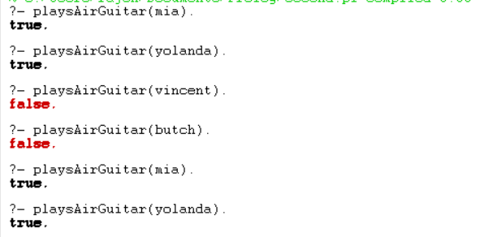

**Knowledge base 3:**

**Knowledge base 4:**

**Knowledge base 5:**

