ISOTP-HIGH level design
Version 02.00
02/08/2022
VERSION HISTORY
Version # | Implemented  By | Revision  Date | Approved  By | Approval  Date | Reason
1.0 | Rohit | 16/03/2020 | Embitel |  | Initial Document Creation
1.5 | Raja Pujitha | 28/07/2020 |  |  | Updated API functions and Flow diagrams to make it a generic TP
2.0 | Raja Pujitha | 2/08/2020 | Ganesh | 2/08/2020 | BaseLined Version

TABLE OF CONTENTS
1. Introduction 3
2. Terminology and Acronyms 3
3. API description 4
3.1 ISOTP Initialization 4
3.2 ISOTP RecEive CallBACk 5
3.3 ISOTP Transmission request 7
3.4 ISOTP Transmission Confirmation Callback 9
3.5 ISOTP Main 11
3.6 ISOTP Get Status 12
3.7 ISOTP ResEt 13
3.8 ISOTP Timer Monitor 14
3.9 ISOTP Perform padding 17
4. API LIST for ISO TP layer 17
5. Conclusion 21

Introduction
ISOTP is designed based on ISO 15765-2: Road Vehicles – Diagnostics on CAN – Part 2: Network layer services. It specifies an unconfirmed network layer communication protocol for the exchange of data between network nodes, e.g. from ECU to ECU or between an external test equipment and an ECU. If the data to be transferred do not fit into a single CAN frame segmentation method is provided.

The ISOTP module provides methods for segmentation, transmission with flow control, and re-assembly operation. The main purpose of this layer is to transfer messages data that may or may not fit in a single CAN frame. Messages that do not fit into a single CAN frame are segmented into multiple parts, where each can be transmitted in a CAN frame.

Terminology and Acronyms
ECU | Electronic Control Unit
ISO | International organization for Standardization
CAN | Controller Area Networks

API description

ISOTP Initialization
HLD ID | Covered SWRS ID | Title
[SWHLD_ISOTP_0001] |  | ISOTP_Init
This function is used to initialize the module.

Function Name | ISOTP_Init
Function Objective | This function is used to initialize the module.
Input Data | Function Parameter  None  Global variables read  None
Output Data | Function Return value  None  Global variables written  None

High Level Design
BEGIN
- Initialize Module.
END

ISOTP RecEive CallBACk
HLD ID | Covered SWRS ID | Title
[SWHLD_ISOTP_0002] |  | ISOTP_RxMsgCbk
This function is used to get receive message callback.

Function Name | ISOTP_RxMsgCbk
Function Objective | This function is used to get Receive message Callback.
Input Data | Function Parameter  - Message ID  - DLC  - Data buffer  - Request Type  Global variables read  None
Output Data | Function Return value  None  Global variables written  None

High Level Design
BEGIN
- This function is used to get Receive message Callback.
END

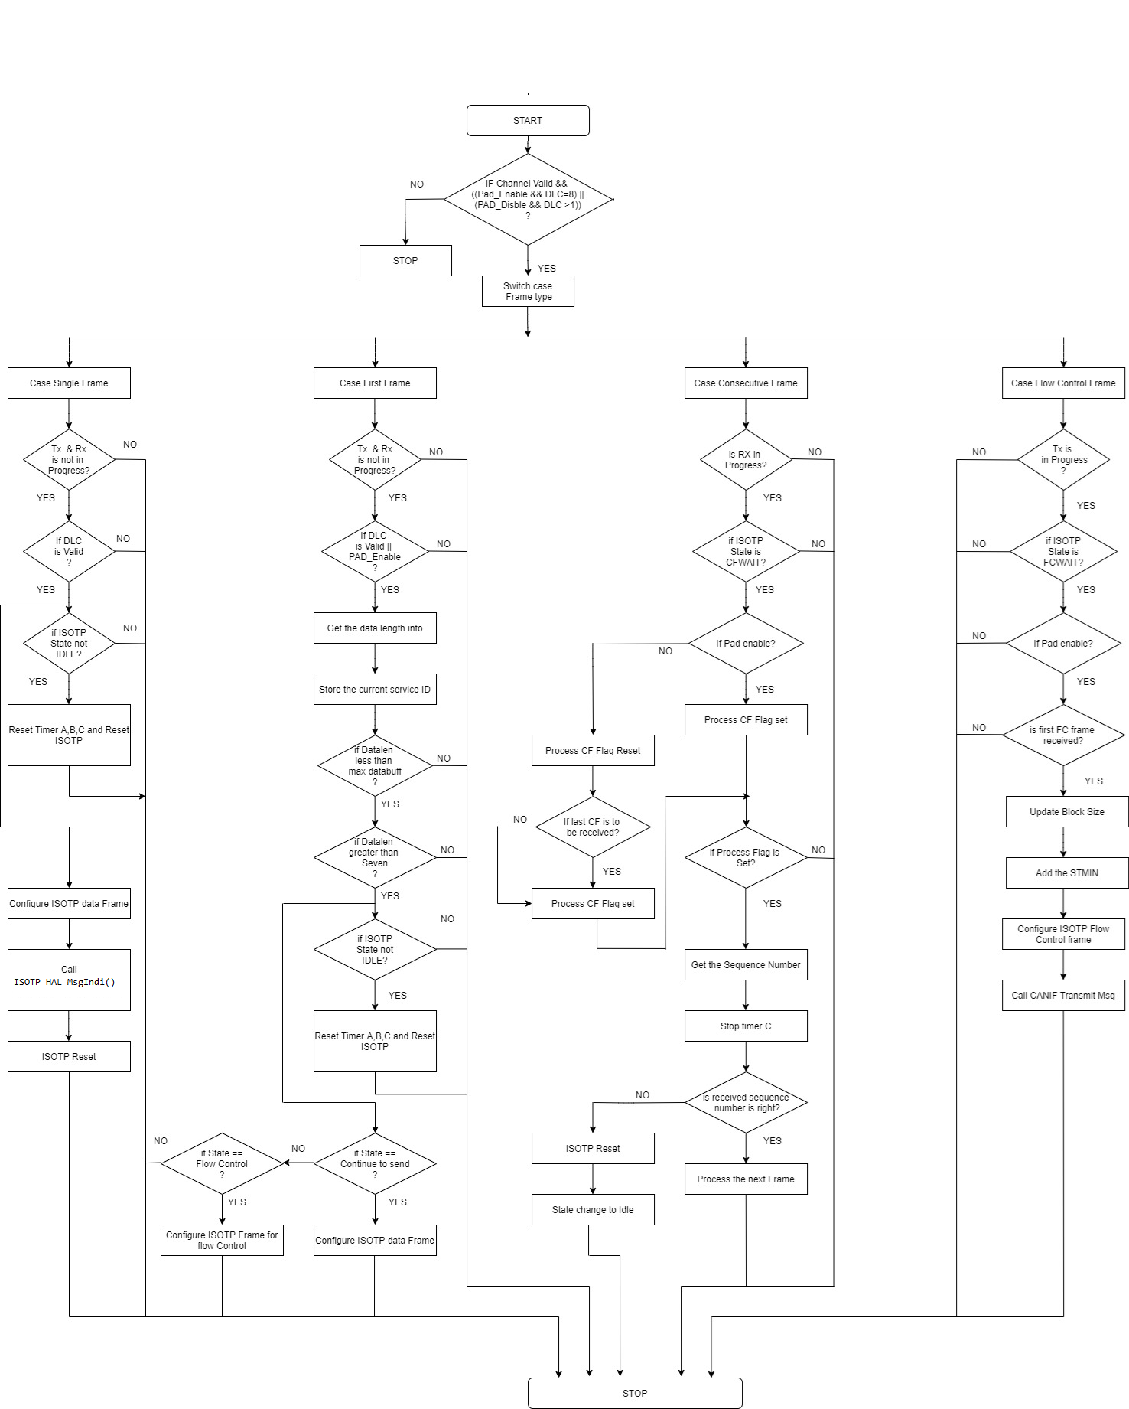
Fig: Flow Chart of ISOTP Receive message Callback.

ISOTP Transmission request
HLD ID | Covered SWRS ID | Title
[SWHLD_ISOTP_0003] |  | ISOTP_TxRequest
This function is used to Transmits either single frame or first frame.

Function Name | ISOTP_TxRequest
Function Objective | This function is used to Transmits either single frame or first frame.
Input Data | Function Parameter  - dataLen  - dataPtr  Global variables read  None
Output Data | Function Return value  ISOTP_TRUE  ISOTP_FALSE  Global variables written  None

High Level Design
BEGIN
- This function is used to Transmits either single frame or first frame.
END

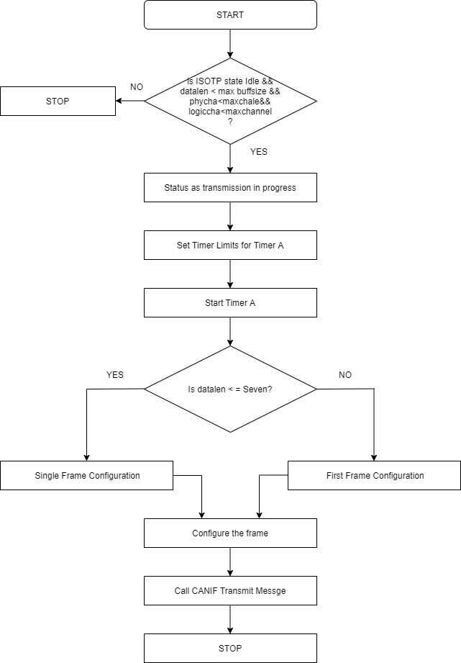
Fig: Flow Chart of ISOTP Transmission Request.

ISOTP Transmission Confirmation Callback
HLD ID | Covered SWRS ID | Title
[SWHLD_ISOTP_0004] |  | ISOTP_TxCnfCbk
This function is used to Transmit call back function of Diagnostic frame.

Function Name | ISOTP_TxCnfCbk
Function Objective | This function is used to Transmit call back function of Diagnostic frame.
Input Data | Function Parameter  None  Global variables read  None
Output Data | Function Return value  None  Global variables written  None

High Level Design
BEGIN
- This function is used to Transmit call back function of Diagnostic frame.
END

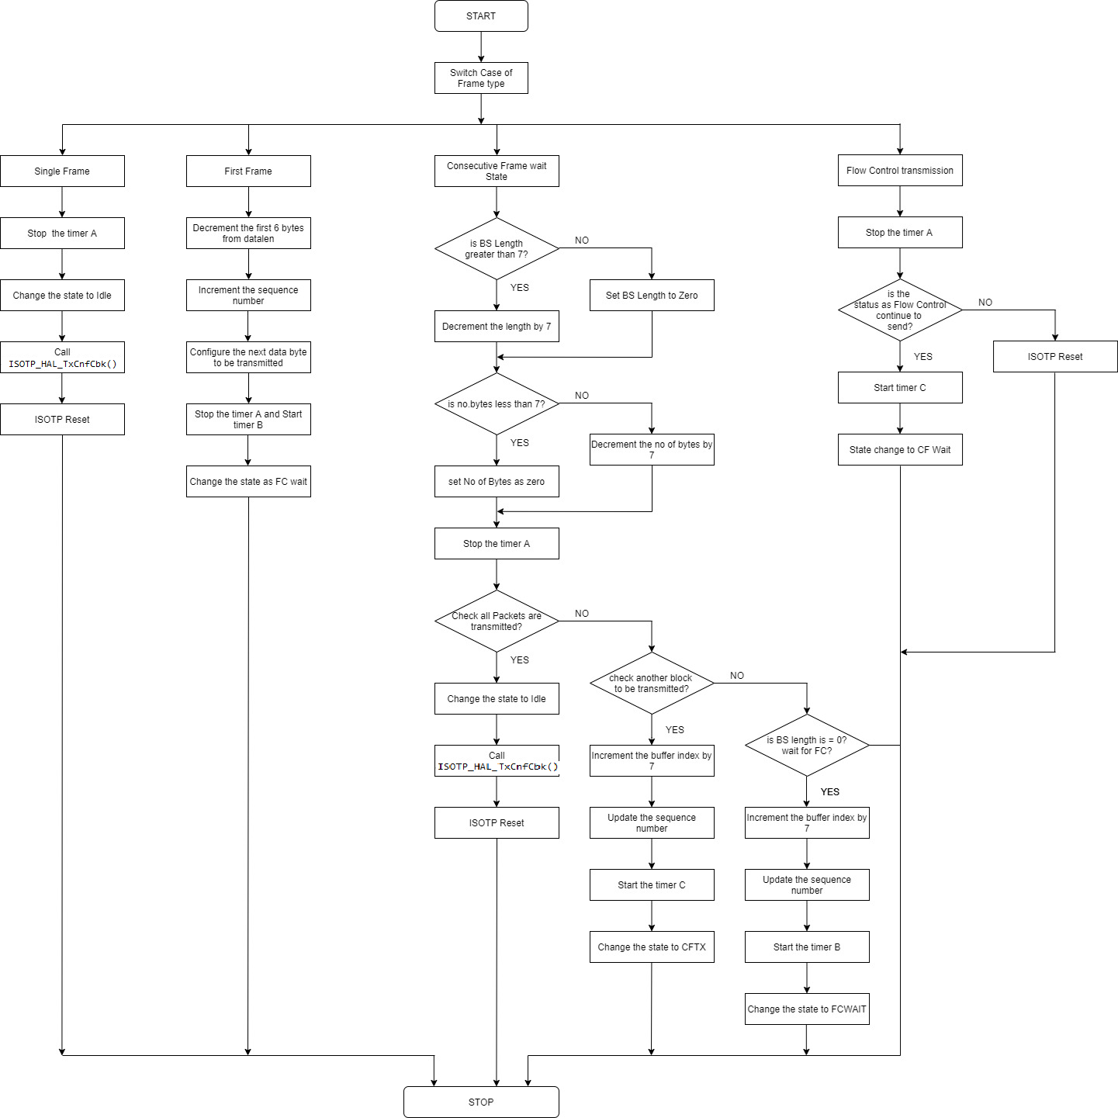
Fig: Flow Chart of ISOTP Transmission Confirmation Callback.

ISOTP Main
HLD ID | Covered SWRS ID | Title
[SWHLD_ISOTP_0005] |  | ISOTP_Main
TP Main function, runs continuously in Background

Function Name | ISOTP_Main
Function Objective | TP Main function, runs continuously in Background
Input Data | Function Parameter  None  Global variables read  None
Output Data | Function Return value  None  Global variables written  None

High Level Design
BEGIN
- TP Main function, runs continuously in Background
END
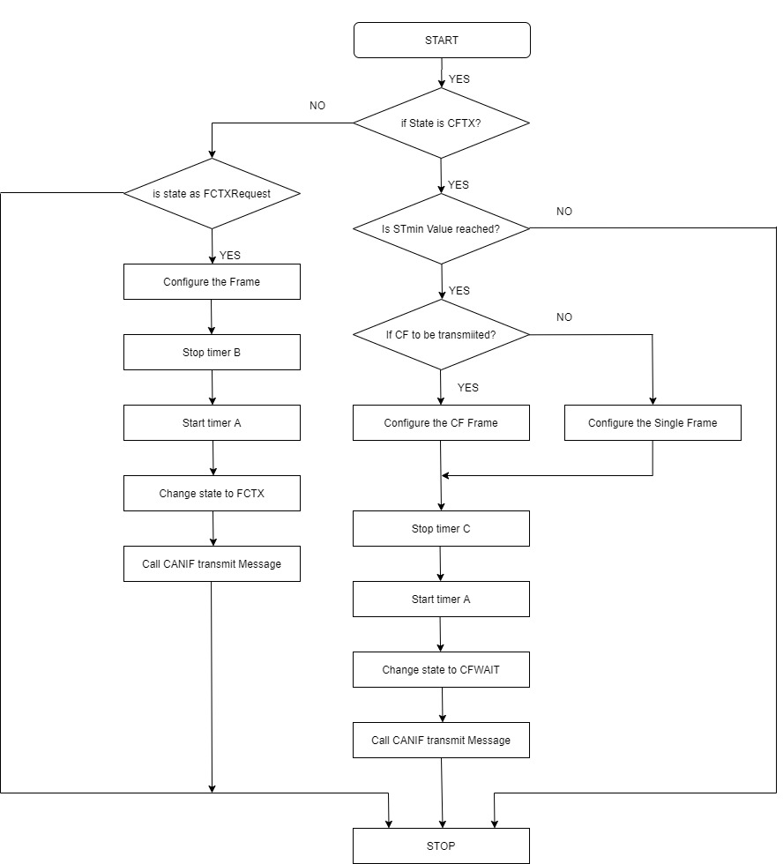
Fig: Flow Chart of ISOTP MAIN Function.

ISOTP Get Status
HLD ID | Covered SWRS ID | Title
[SWHLD_ISOTP_0006] |  | ISOTP_GetStatus
Return the status of ISOTP.

Function Name | ISOTP_GetStatus
Function Objective | Return the status of ISOTP.
Input Data | Function Parameter  None  Global variables read  None
Output Data | Function Return value  None  Global variables written  None

High Level Design
BEGIN
- Return the status of ISOTP.
END

ISOTP ResEt
HLD ID | Covered SWRS ID | Title
[SWHLD_ISOTP_0007] |  | ISOTP_Reset
Resets the required TP parameters.

Function Name | ISOTP_Reset
Function Objective | Resets the required TP parameters.
Input Data | Function Parameter  None  Global variables read  None
Output Data | Function Return value  None  Global variables written  None

High Level Design
BEGIN
- Resets the required TP parameters.
END

ISOTP Timer Monitor
HLD ID | Covered SWRS ID | Title
[SWHLD_ISOTP_0009] |  | ISOTP_TMRMON
Monitors the TP timers.

Function Name | ISOTP_main
Function Objective | Monitors the TP timers.
Input Data | Function Parameter  None  Global variables read  None
Output Data | Function Return value  None  Global variables written  None

High Level Design
BEGIN
- Monitors the TP timers.
END
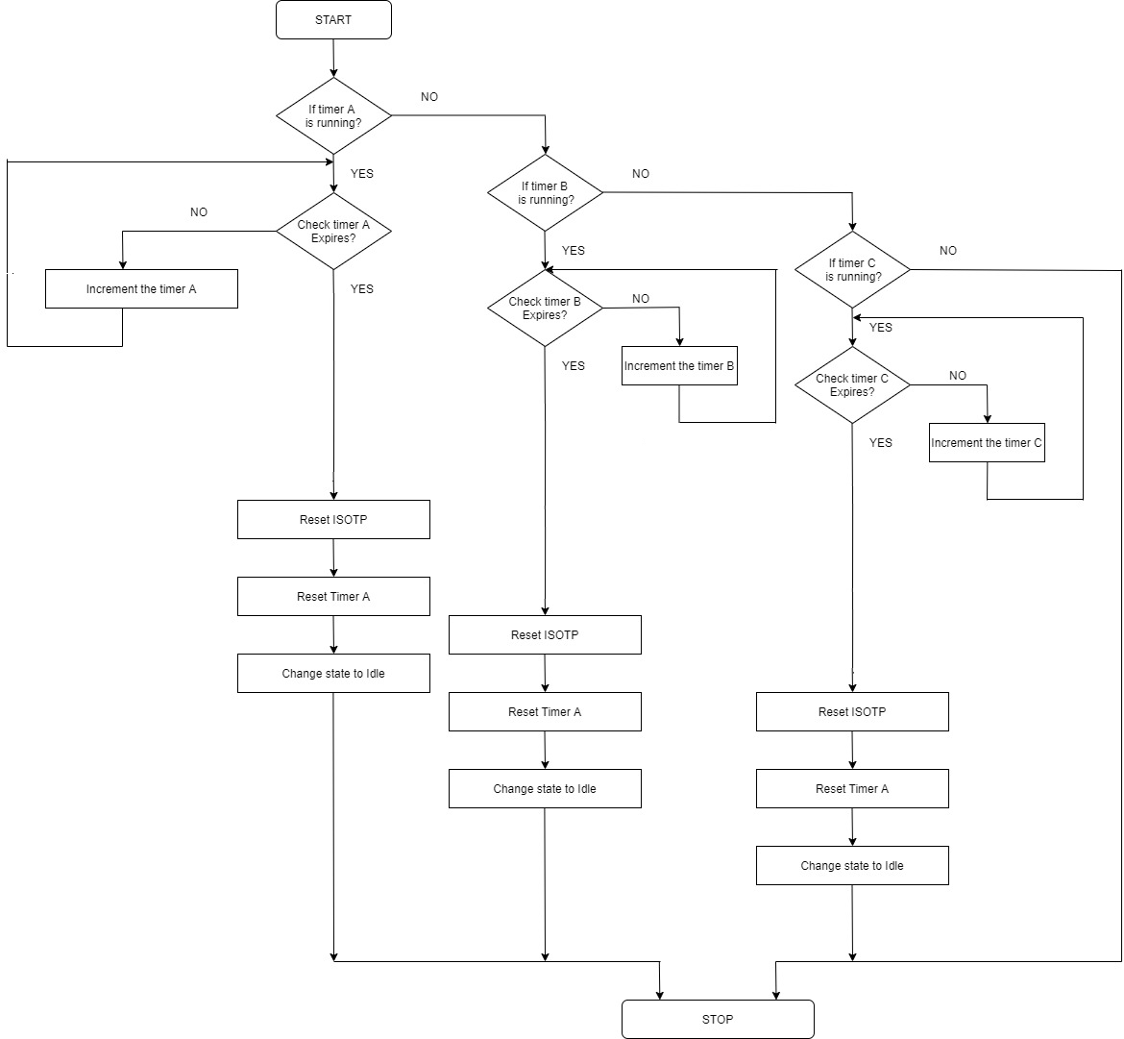

Fig: Flow Chart of ISOTP Timer Monitor Function.

ISOTP Perform padding
HLD ID | Covered SWRS ID | Title
[SWHLD_ISOTP_0011] |  | ISOTP_PrfrmPad
Perform Padding.

Function Name | ISOTP_PerfrmPad
Function Objective | Perform Padding.
Input Data | Function Parameter  - Index  - Message frame  - Pad Value  Global variables read  None
Output Data | Function Return value  None  Global variables written  None

High Level Design
BEGIN
- Perform Padding.
END

API LIST for ISO TP layer

Name | Description
ISOTP_HAL_FFIndi | API invoked by the ISO TP layer upon reception of the first frame of a segmented diagnostic message
ISOTP_HAL_MsgIndi | API invoked by the ISO TP layer upon reception of a complete diagnostic message
ISOTP_HAL_TxCnfCbk | API invoked by the ISO TP layer upon successful transmission of a diagnostic message
ISOTP_HAL_Rst | API invoked by the ISO TP layer when an ongoing transmission or reception is aborted upon detection of an error condition or after successful transmission
ISOTP_TxRequest | API provided by the ISO TP layer which is invoked by the UDS Service Distributor to transmit a diagnostic message
ISOTP_HAL_CANMesgTxnReq_Stub | API stub provided to be replaced by CAN Interface Transmission function

Data Type:
ISOTP_CfgType

Description:
ISOTP_CfgType is a data type used to describe TP messages. It contains frame information, sequence number for segmented frames, number of bytes and a pointer to received data.

Definition:
typedef struct
{
uint8 frmInfo; /* Byte #1 of PCI */
uint8 seqNum; /* Sequence number (for Segmented frames) */
uint16 nBytes; /* total number of bytes */
uint8 tpBuff [ISOTP_BUFFSIZE]; /* data buffer */
}ISOTP_CfgType;
Note: The data type used here is purely dependent on TP stack used since TP implementation is not common. Please refer Integration Notes for modifications to the data type

Data Type:
ISOTP_APP_CfgType

Description:
ISOTP_APP_CfgType is a data type used to describe Application data transmit messages. It contains total number of data to be transmitted and data to be transmitted.

Definition:
typedef struct
{
uint8 * dataPtr; /* pointer to data */
uint16 dataLen; /* total number of bytes */
}ISOTP_App_CfgType;
Note: The data type used here is purely dependent on TP stack used since TP implementation is not common. Please refer Integration Notes for modifications to the data type.

API’s

ISOTP_HAL_FFIndi
Function Prototype:
void ISOTP_HAL_FFIndi (const ISOTP_CfgType *isoTpConfPtr);

Descritpion:
This function should be invoked to indicate that first frame of segmented data (request) is received.

Parameters:
constant Pointer to a type ISOTP_CfgType

Return Value:
void

ISOTP_HAL_MsgIndi
Function Prototype:
void ISOTP_HAL_Msgndi (const ISOTP_CfgType *isoTpConfPtr);

Descritpion:
This function should be invoked to indicate that a new request has been received.
Scenario 1: This Function should be invoked directly, if a request is received in a single frame.
Scenario2: For segmented frames, first ISOTP_HAL_FFIndi is invoked to indicate the first frame is received and after receiving all the frames, ISOTP_HAL_MsgIndi should be invoked to indicate that complete message has been received.

Parameters:
constant Pointer to a type ISOTP_CfgType

Return Value:
void

ISOTP_HAL_ TxCnfCbk
Function Prototype:
void ISOTP_HAL_ TxCnfCbk (void);

Descritpion:
This function should be invoked to indicate that the response has been sent.

Parameters:
void

Return Value:
void

ISOTP_HAL_Rst
Function Prototype:
void ISOTP_HAL_Rst (void);

Descritpion:
This function should be invoked when an ongoing transmission or reception of message is aborted upon detection of an error condition.

Parameters:
void

Return Value:
void

Conclusion

The ISOTP Software tested and Implemented.

