

Software High Level Design
Unified Diagnostic Services (UDS) Protocol Stack

Version: 04.00

Author: Embitel

CONTENTS
History 4
1 Introduction 5
1.1 Scope of this document 5
1.2 Abbreviations 5
1.3 Reference Documents 5
2 Software Overview 6
3 Unified Diagnostic Services 8
3.1 Tester Present Service 11
3.2 Start Diagnostic Session Service 11
3.3 Read Data by Identifier Service 13
3.4 Write Data by Identifier Service 14
3.5 Input Output Control by Identifier Service 15
3.6 Read DTC Information Service 15
3.7 Clear DTC Information Service 16
3.8 Security Access Service 17
3.9 Request Download Service 18
3.10 Transfer Data Service 18
3.11 Transfer Exit Service 21
3.12 ECU Reset Service 21
3.13 Routine Control Service 22
3.14 Control DTC Setting Service 22
3.15 Communication Control Service 23
3.16 Request Upload Service 24
3.17 Link Control Upload Service 24
3.18 Read Memory by Address Service 25
3.19 Read Scaling Data by Identifier Service 26
3.20 Write Memory by Address Service 27
3.21 Dynamically Define Data Identifier Service 28
3.22 Read Data By Periodic Identifier Service 30
3.23 Secure Data Transmission Service 31
3.24 Request File Transfer Service 32
3.25 AccessTimingParameter service 33
3.26 ResponseOnEvent Service 33

History

Revision | Date | Description
V01.00 | 15/12/2015 | Document Creation
V02.00 | 26/03/2018 | Spell Check, Document updated based on Feedback
V03.01 | 28/11/2019 | Added the Response on Event service
V04.00 | 28/11/2019 | Baselined Version

Introduction

Scope of this document
This document describes the High level Design for Unified Diagnostic Services (UDS).

Abbreviations
CAN | Controller Area Network
ECU | Electronic Control Unit
UDS | Unified Diagnostic Service
TP | Transport Protocol

Reference Documents
Sl.No | Reference
1 | ISO 15765-3: Diagnostics on Controller Area Networks (CAN) – Part 3: Implementation of unified diagnostic services (UDS on CAN)
2 | ISO 14229-1: Road vehicles – Unified diagnostic services (UDS) – Part 1: Specification and requirements

Software Overview

Unified Diagnostic services (UDS) protocol stack is designed based on ISO 15765-3: Diagnostics on Controller Area Networks (CAN) – Part 3: Implementation of unified diagnostic services (UDS on CAN) and ISO 14229-1: Road vehicles – Unified diagnostic services (UDS) – Part 1: Specification and requirements. It implements the requirements of diagnostic services which allow a diagnostic tester (client) to control diagnostic functions in an on-vehicle Electronic Control Unit (server).
The UDS protocol stack resides on top of the ISO TP layer (ISO 15765-2). The diagnostic application uses this UDS protocol stack to carry out a specified set of diagnostic services. This facilitates the tester (client) to perform functions such as test, inspection, monitoring, diagnosis and programming of on-board Electronic Control Units (servers).
The below figure provides an overview of the interaction of the UDS protocol stack with other modules.
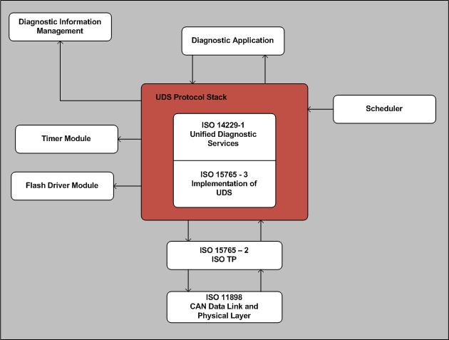Figure 1: Module Overview

Unified Diagnostic Services
Unified Diagnostic Services – Overview
Upon reception of a CAN diagnostic message, this module performs the following:
- Copies the diagnostic service parameters from CAN transport layer buffer to its own service buffer.
- Checks if the service supported and also checks if service is supported in the current session.
- If, service is not supported, then frames a negative response and places a request to CAN transport layer for transmission of response.
- If service is supported, then selects the appropriate diagnostic service depending on the received service identifier (SID), and executes this service.
- Requests the CAN transport layer for transmission of response.
- Performs monitoring of the timers S3 and P2.

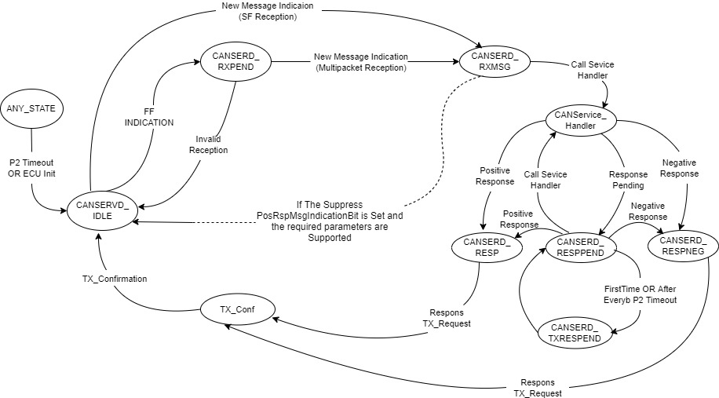
Figure 2: ISOUDS State Machine

ISOUDS: ISOUDS_MsgIndi
- This function is called by the Can Transport layer to indicate that a new message (Single Frame or multi packet) has been received.
- If the state is not in ISOUDS_IDLE or ISOUDS_RXPEND, then the message is ignored.
- Else, if single frame is received, the number of bytes received is read, timer S3 is stopped.
- Data is copied from TP buffer to ISOUDS buffer.
- The state is set to ISOUDS_RXMSG and the timer P2 is started.

ISOUDS: ISOUDS_FFIndi
- This function is called by the Can Transport layer to indicate that the first frame of a new request has been received.
- If the state is not in ISOUDS_IDLE or ISOUDS_RXPEND, then the message is ignored and invalid value (0xFF) is returned.
- If the number of bytes to be received is not equal to expected number of bytes, then the number of bytes (FF_DL) are read, the state is set to ISOUDS_RXPEND, timer S3 is stopped.

ISOUDS: ISOUDS_ Main
- The function runs in a periodic task.
- If the current state is ISOUDS_RXMSG (indicates that a new request has been received), the service identifier(SID) is read from received data, Loops through the Service Configuration Table to check if received SID is configured.
  - If SID is configured and if the SID is supported in the active session, the service function is invoked. The service can have either a positive or negative or response pending response. Based on the service, ISOUDS state can be in ISOUDS_RESP, or ISOUDS_RESPNEG, or ISOUDS_RESPPEND respectively.
  - If SID is not configured or if the SID is not supported in active session, a negative response is sent.
- If the current state is in ISOUDS_RESPPEND, the service function is called again.
- If the current state is in ISOUDS_RESP, timer P2 is stopped, request is placed on the TP layer to transmit the response and the state is set to ISOUDS_TXPEND.
- If the current state is ISOUDS_RESPNEG and if the negative response code is Response Pending (ISOUDS_RCRRP), the state is set to ISOUDS_RESPPEND, an internal function is called to transmit the response pending message. Else, the state is set to ISOUDS_TXPEND an internal function is called to transmit the negative response.
- If the current state is ISOUDS_TXRESPPEND, the state is changed to ISOUDS_RESPPEND.

ISOUDS: ISOUDS_TxCnfCbk
- This function is called by the TP layer after a successful transmission of the response; if the current state is ISOUDS_TXPEND, the function ISOUDS_Rst () is invoked.

ISOUDS: ISOUDS_Rst
- This function resets ISOUDS parameters.

ISOUDS: ISOUDS_Mon
- The function runs in a periodic task.
- If the active session is in default session, the timer S3 will not be running and no timeout checks are done for S3.
- If the active session is not default session and if the timer S3 is running, a check is done for S3 timeout. If timer S3 has timed out, the active session is switched to default session and timer S3 is stopped.
- If timer P2 is running, a check is done for P2 timeout. If timer P2 has timed out, the ISOUDS parameters are reset, the state is reset to ISOUDS_IDLE, and timer P2 is stopped.
- If an ECU Reset was requested due successful response for switch to the programming session, then the stack waits for 100ms (timing is configurable) after sending the positive response, and then executes the RESET function. This will cause an ECU Reset.

Unified Diagnostic Services – Implemented services
Following services in respective sessions are implemented:
SID | Sub Function | Service
$3E | $00 | TesterPresent
$10 | - | StartDiagnosticSession
$22 | - | ReadDataByIdentifier
$2E | - | WriteDataByIdentifier
$2F | - | InputOutputControlByIdentifier
$19 | $02 | ReadDTCInformation
$14 | - | ClearDiagnosticInformation
$85 | - | Control DTC Setting
$28 | - | Communication Control
$11 | $01 | ECU Reset
$34 | - | Request Download
$31 | - | Routine Control
$27 | - | Security Access
$36 | - | Transfer Data
$37 | - | Transfer Exit
$35 | - | Request Upload
$87 | $01, $02, $03 | Link Control
$23 | - | Read Memory By Address
$24 | - | Read Scaling Data By Id
$3D | - | Write Memory By Address
Table 1: Services Table
Note: All the services can be configured to be activated in any of the Diagnostic sessions

Tester Present Service

ISOUDS_TstrPrsnt - Functionality
- This Service will be invoked by ISOUDS stack upon reception of Tester Present Request message.
- This service responds with positive response, if the length of the request message and the sub function parameters are valid.
- This service responds with negative response, if the length of the request message is not valid or the sub function parameter is not valid.

ISOUDS_TstrPrsnt - NRC
Following Negative Response Codes(NRCs) are implemented for this service:
NRC | NRC Description | Further comments
$13 | incorrectMessageLengthOrInvalidFormat | Invalid message Length
$12 | subFunctionNotSupported | Sub function other than $00 requested
Table 2: Tester Present Service NRC Table

Start Diagnostic Session Service

ISOUDS_StrtDiagSess - Diagnostic Session Transition
- This service implements the response to the Session Control diagnostic service request.
- The following sessions are implemented in:
- $01 – Default Session
- $02 – Programming Session
- $03 – Extended Diagnostic Session
- When a start diagnostic session request with parameter $01 is received, then the default session is started and a positive response indicating the same is sent.
- When a start diagnostic session request with parameter $03 is received, then the extended diagnostic session is started and a positive response indicating the same is sent. In case the active session is in extended diagnostic session, and if no diagnostic service request or no tester present service request is received within 5000 ms then the active session is changed to default session.
- When start diagnostic session request with parameter $02 is received, then the ECU prepares to jump into Boot loader. Jump to boot is via an ECU RESET.
- The below figure provides an overview of the possible diagnostic session transitions between the implemented sessions:
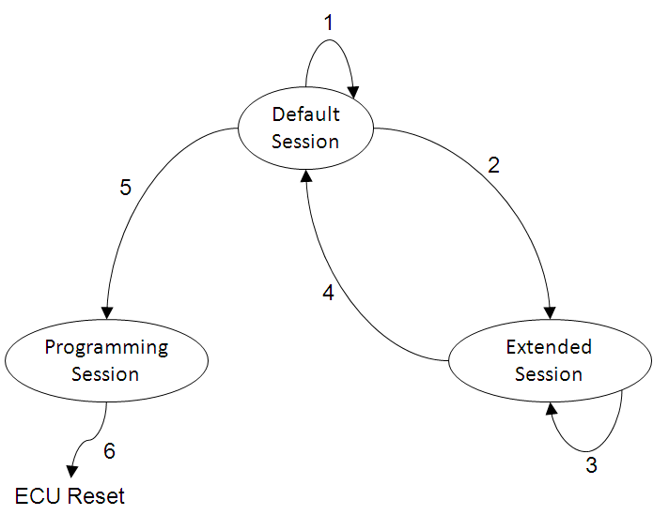
Figure 3: Diagnostic session transition

No. | Transition | Description
1 | transition from default session to default session | In this case, the default session is reinitialized completely. An entry interface for default session will reset all settings achieved during the extended session. E.g. Reset S3 Timer.
2 | transition from default session to extended diagnostic session | In this case, an entry interface for extended session will perform all activities necessary for the start of extended diagnostic session. E.g. restart of S3 Timer.
3 | transition from extended diagnostic session to extended diagnostic session | Handled similar to the Transition No. 2
4 | transition from extended diagnostic session to default session | Handled similar to the Transition No. 1
5 | transition from default session to programming session | In this case, a response pending NRC is first transmitted; ECU performs a soft reset and enters the loader software. A positive response is transmitted only after entry into the programming session
6 | transition from programming session to default | A request for default session from programming session (handled in the loader software) will trigger an ECU reset

ISOUDS_StrtDiagSess – NRC
Following Negative Response Codes(NRCs) are implemented for this service:
NRC | NRC Description | Further comments
$12 | subFunctionNotSupported | If the sub-function is not $01, $02 or $03
$13 | incorrectMessageLengthOrInvalidFormat | If sub-function is missing in request
$22 | conditionsNotCorrect | Conditions not correct to switch session
Table 3: Start Diagnostic Session Service NRC Table

Read Data by Identifier Service

ISOUDS_RdDaByID
- This service can be implemented in default session ($01) or in extended diagnostic session ($03).
- This service is used to read the data record values (DREC) from a memory location specified by data identifier (DID).
- The request message contains one or more two-byte data identifier values.
- Upon reception of a ReadDataByIdentifier request, a single positive response is sent containing the data identifiers and their data record values.
- The maximum number of data identifiers that can be simultaneously requested is dependent on the size of the Can TP buffer i.e. the total size of the response should fit into the Can TP buffer.

ISOUDS_RdDaByID - NRC
Following Negative Response Codes(NRCs) are implemented for this service:
NRC | NRC Description | Further comments
$13 | incorrectMessageLengthOrInvalidFormat | Invalid message Length
$31 | requestOutOfRange | None of the requested DIDs are supported by the device. OR More than the necessary limit of DIDs requested OR Did Not Supported in Active Session
$33 | securityAccessDenied | Security Access Denied
$22 | conditionsNotCorrect | Conditions Not Correct to Read
Table 4: Read Data By Identifier Service NRC Table

Write Data by Identifier Service

ISOUDS_WrDaByID
- This service is used to write data into a memory location specified by a data identifier.
- Upon reception of the WriteDataByIdentifier service request with a valid data Identifier (DID) and data record (DREC), the data record value is written into an internal memory location specified by DID and a positive response is sent.

ISOUDS_WrDaByID - NRC
Following Negative Response Codes(NRCs) are implemented for this service:
NRC | NRC Description | Further comments
$13 | incorrectMessageLengthOrInvalidFormat | Invalid message length
$31 | requestOutOfRange | Requested DID not supported OR  Invalid data after DID in request.
$33 | securityAccessDenied | Security Access Denied
$22 | conditionsNotCorrect | Action failure with DID
$72 | generalProgrammingFailure | Error while writing to a memory location
Table 5:Write Data By Identifier Service NRC Table

Input Output Control by Identifier Service

ISOUDS_IOCtrlByID
- This service implements the response to the InputOutputControlByIdentifier service request.
- Upon request, the IO-control parameters are checked for conformance i.e. valid message length, security and valid IO data identifier.
- A positive response is sent after performing the required operation.

ISOUDS_IOCtrlByID - NRC
Following Negative Response Codes(NRCs) are implemented for this service:
NRC | NRC Description | Further comments
$13 | incorrectMessageLengthOrInvalidFormat | Invalid Message length
$31 | requestOutOfRange | Requested ID not supported. OR  Invalid IO control parameter. OR  Invalid control state.
$33 | securityAccessDenied | Security Access Denied
Table 6: IO Control By Identifier Service NRC Table

Read DTC Information Service

ISOUDS_RdDTCInf
- This service implements the response to the ReadDTCInformation service request.
- Only the subfunction reportDTCbyStatusmask ($02) is implemented in this service.
- This service with subfunction $02 is used to retrieve a list of DTCs which satisfy a status mask.
- Upon reception of the ReadDTCInformation service request with subfunction reportDTCByStatusMask and DTC Status Mask, a list of DTCs and corresponding statuses matching the DTC status mask is sent as response.
- In case none of the DTC’s status matches the DTC status mask then no DTC is sent as part of the response.

ISOUDS_RdDTCInf - NRC
Following Negative Response Codes(NRCs) are implemented for this service:
NRC | NRC Description | Further comments
$13 | incorrectMessageLengthOrInvalidFormat | Invalid Message length
$12 | subFunctionNotSupported | Sub function other than $02 requested
Table 7: Read DTC Information Service NRC Table

Clear DTC Information Service

ISOUDS_ClrDTC
- This service implements the response to the Clear Diagnostic Information service request.
- ClearDiagnosticInformation service request with status $FFFFFF is implemented.
- Upon reception of the ClearDiagnosticInformation service request with status $FFFFFF, the Application erases/resets all the supported status bits of the DTCs and sends a positive response.

ISOUDS_ClrDTC - NRC
Following Negative Response Codes(NRCs) are implemented for this service:
NRC | NRC Description | Further comments
$13 | incorrectMessageLengthOrInvalidFormat | Invalid Message length
$31 | requestOutOfRange | status value other than $FFFFFF
$22 | Conditions Not Correct | Clear not accepted
Table 8: Clear DTC Information Service NRC Table

Security Access Service

ISOUDS_SA – Security Access
- This service is used to unlock ECU Security.
- During ECU initialization security state is set ECU_LOCK state
- To gain security access the Tool first sends Security Access Request Service ID $27, with sub-function $01 (requestSeed)
- The ECU generates a Secret Seed. This Security Seed is sent as response.
- The tool receives the Security Seed, computes a Secret Key.
- The Security Key is again sent to ECU using Security Access Request Service ID $27, with sub-function $02 (sendKey)
- Upon reception of the Security Key, if this number matches the previously used random generated number, then security state is set to Unlocked; else security state is set to Locked.

ISOUDS_SA – NRC
Following Negative Response Codes(NRCs) are implemented for this service:
NRC | NRC Description | Further comments
$12 | subFunctionNotSupported | If the sub-function is not 0x01 or 0x02
$13 | incorrectMessageLengthOrInvalidFormat | If sub-function is missing in request, OR  If sub-function is 0x02 and not enough bytes is received
$22 | conditionsNotCorrect | Not applicable
$24 | requestSequenceError | If 0x01 is NOT preceded for 0x02 (i.e. no key comparison without seed generation)
$31 | requestOutOfRange | Not applicable as the sub-function 0x01 does not need any parameters
$35 | invalidKey | Received KEY does not match the ECU KEY
$36 | exceededNumberOfAttempts | Not applicable
$37 | requiredTimeDelayNotExpired | Not applicable
Table 9: Security Access Service NRC Table

Request Download Service

ISOUDS_ReqDwnld – Request Download
- This Service is used to initiate Application software download.
- Upon Request Download service request is received, a check is done for valid data format identifier.
- The service also checks for validity of Memory address from where flash has to start and number bytes to be flashed is validated.
- This service, then responds with a positive response indicating that transfer data is allowed to write into flash memory.
- This service responds with negative response, if currently transfer data is in progress.

ISOUDS_ReqDwnld – NRC
Following Negative Response Codes(NRCs) are implemented for this service:
NRC | NRC Description | Further comments
$13 | incorrectMessageLengthOrInvalidFormat | Invalid message length
$22 | conditionsNotCorrect | A download/Upload data is already in progress (i.e. a transfer is active
$31 | requestOutOfRange | Invalid data format identifier OR address length format identifier OR  Invalid address or size is received
$33 | securityAccessDenied | ECU Security is Locked
$70 | uploadDownloadNotAccepted | Download cannot be accepted
Table 10: Request Download Service NRC Table

Transfer Data Service

ISOUDS_TrnsfrDa – Transfer Data
- Data to be flashed can be transferred to ECU from tool or ECU Data can be transmitted from the ECU to tool.
- Data transfer is allowed only if a request download or request upload was executed previously
- If a download or upload transfer is active, then new transfer is not allowed until the active transfer is finished or exit
- A state machine is used to handle the interaction between download, upload and transfer services
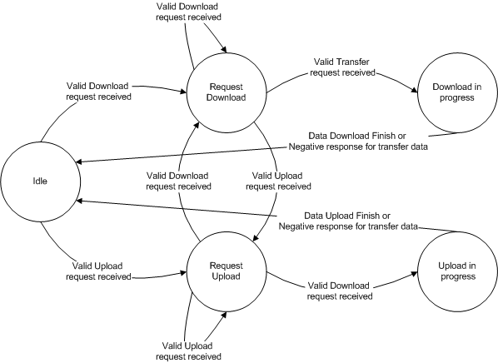
Figure 4: Transfer Data Service State Machine
Service behavior after a successful Request Download service:
- The data received with this service is written into flash using flash write service
- Since Flash write takes more time than the UDS response time (50ms); the service first submits the data received for flash-write. If flash write request was accepted then a response pending (NCR $78) is transmitted as an initial response
- Once a flash-write was accepted, the service continuously checks for flash-write completion status.
- A positive response is given after flash-write was successful, else a negative response is issued
- Service would maintain counters (byte counter and sequence counter) to keep track of data transferred, and any invalid data transfer will generate a negative response
- After all data is transferred the transfer is considered exit
- An active transfer can be cancelled using a transfer exit service

Service behavior after a successful Request Upload service:
- The data is read from the specified address
- A positive response is sent after read was successful, else a negative response is issued
- Service would maintain counters (byte counter and sequence counter) to keep track of data transferred, and any invalid data transfer will generate a negative response
- After all data is transferred the transfer is considered exit
- An active transfer can be cancelled using a transfer exit service

ISOUDS_TrnsfrDa – NRC
Following Negative Response Codes(NRCs) are implemented for this service:
NRC | NRC Description | Further comments | Transfer Data
$13 | incorrectMessageLength  OrInvalidFormat | If the sequence counter is missing in request (i.e. only the SID is received), Or  Only SID and sequence counter are received (but no transferable data) | Exit Transfer Data
$24 | requestSequenceError | 1. If a transfer data is requested before request download/request upload service is executed  2. If the request download/ upload service is active, but the server has received all data as determined by memory size parameter in the request download / upload service | Not applicable
$71 | transferDataSuspended | When the transferable data received is more than the remaining bytes to be transferred (if sequence number is OK) | Pause Transfer Data
$72 | generalProgrammingFailure | When a flash-write fails | Not applicable
$73 | wrongBlockSequenceCounter | When the sequence number received does not match the expected sequence number | Pause Transfer Data
$92 | voltageTooHigh | Not applicable | Not applicable
$93 | voltageTooLow | Not applicable | Not applicable
Table 11: Transfer Data Service NRC Table
A Pause Transfer Data implies the data transfer can continue from where it had stopped, however an Exit Transfer Data implies that the state is reset to Idle and all counters for the transfer are reset to 0 (so a new request download is mandatory to start a transfer).

Transfer Exit Service

ISOUDS_TrnsfrExit – Transfer Exit
- Any active transfer can be exit using this service
- The transfer data state is reset to Idle and all counters for the transfer are reset to 0

ISOUDS_TrnsfrExit – NRC
Following Negative Response Codes(NRCs) are implemented for this service:
NRC | NRC Description | Further comments
$13 | incorrectMessageLengthOrInvalidFormat | Not applicable
$24 | requestSequenceError | If Transfer Data state is in Idle (i.e. no active transfer)
Table 12: Transfer Exit Service NRC Table

ECU Reset Service

ISOUDS_ECUReset – ECU Reset
- This service causes ECU to RESET
- Subfunction $03 – Soft Reset is supported
- A positive response is sent and then ECU is RESET

ISOUDS_ECUReset – NRC
Following Negative Response Codes(NRCs) are implemented for this service:
NRC | NRC Description | Further comments
$12 | subFunctionNotSupported | $03 is the only supported sub-function, any other request will result in this NRC
$13 | incorrectMessageLengthOrInvalidFormat | Sub function parameter missing in request
$22 | conditionsNotCorrect | A download/Upload data is already in progress (i.e. a transfer is active
$33 | securityAccessDenied | ECU Security is Locked
Table 13: ECU Reset Service NRC Table

Routine Control Service

ISOUDS_RtnCtrl – Routine Control
- This service responds to the routine control service request
- Upon service request, based on the routine ID and the sub-function parameter ($01, $02, or $03), the appropriate routine action (i.e. start, stop or request-results respectively) is invoked, and an appropriate response is sent

ISOUDS_RtnCtrl – NRC
Following Negative Response Codes(NRCs) are implemented for this service:
NRC | NRC Description | Further comments
$12 | subFunctionNotSupported | Routine-control type is not start/stop/get results
$13 | incorrectMessageLengthOrInvalidFormat | Routine-ID and routine-control type are missing in request
$22 | conditionsNotCorrect | Conditions not correct to start/stop/get results
$24 | requestSequenceError | Request for stop /get results without start routine
$31 | requestOutOfRange | Routine-ID is invalid
$33 | securityAccessDenied | Security Access Denied
$72 | GeneralProgrammingFailure | Not applicable
Table 14: Routine Control Service NRC Table

Control DTC Setting Service

ISOUDS_CntrlDTCSetting – Control DTC Setting
- This service is used to stop or resume the setting of DTCs in the server.
- Upon service request, based on the DTC settings ($01, $02), the appropriate settings is set and a positive response is sent.

ISOUDS_CntrlDTCSetting – NRC
Following Negative Response Codes(NRCs) are implemented for this service:
NRC | NRC Description | Further comments
$12 | subFunctionNotSupported | DTC Setting Type is not ON / OFF
$13 | incorrectMessageLengthOrInvalidFormat | Invalid Message length
$22 | conditionsNotCorrect | Conditions not correct for DTC Setting
$31 | requestOutOfRange | Not Applicable
Table 15: Control DTC Setting Service NRC Table

Communication Control Service

ISOUDS_CommCtrl – Communication Control
- This service is used to switch on/off the transmission and/or the reception of certain messages in the server.
- Upon service request, based on the control type ($00, $01, $02 and $03) and based on the communication type, the appropriate action is taken and a positive response is sent.

ISOUDS_CommCtrl – NRC
Following Negative Response Codes(NRCs) are implemented for this service:
NRC | NRC Description | Further comments
$12 | subFunctionNotSupported | Control type is not $00, $01, $02 or $03
$13 | incorrectMessageLengthOrInvalidFormat | Incorrect message length
$22 | conditionsNotCorrect | Conditions not correct to disable or enable of transmission or reception
$31 | requestOutOfRange | Communication type is not valid
Table 16: Communication Control Service NRC Table

Request Upload Service

ISOUDS_ReqUpld – Request Upload
- This Service is used to initiate data transfer from Server (ECU) to Client (Tester).
- Upon Request Upload service request is received, a check is done for valid data format identifier.
- The service also checks for validity of Memory address from where data has to be read and number bytes to be read is validated.
- This service, then responds with a positive response indicating that transfer data is allowed to transfer data from Server (ECU) to Client (Tester).
- This service responds with negative response, if currently transfer data is in progress.

ISOUDS_ReqUpld – NRC
Following Negative Response Codes(NRCs) are implemented for this service:
NRC | NRC Description | Further comments
$13 | incorrectMessageLengthOrInvalidFormat | Invalid message length
$22 | conditionsNotCorrect | A download/upload data is already in progress (i.e. a transfer is active)
$31 | requestOutOfRange | Invalid data format identifier OR address length format identifier OR  Invalid address or size is received
$33 | securityAccessDenied | ECU Security is Locked
$70 | uploadDownloadNotAccepted | Upload cannot be accepted
Table 17: Request Upload Service NRC Table

Link Control Upload Service

ISOUDS_LinkCntrl – Link Control
- This Service is used to control the communication control link baud rate between the Client and the Server for the exchange of diagnostic data.
- The baud rate transition is split into two steps.
  - The Client verifies if the transition can be performed and informs the server about the baud rate to be used. On receiving the request, server verifies, if the transition to desired baud rate can be performed or not. If yes, then server sends a positive response, else sends negative response.
  - On receiving the positive response for the previous step, the client sends another request for transitioning to the specified baud rate in the previous step. Server, after receiving the request, changes the baud rate. Note: There will not be any response from the server for this request, since one might have transitioned to the new baud rate while the other is still need to transition to new baud rate.
- This service responds with negative response, if server cannot transition to the specified baud rate.

ISOUDS_LinkCntrl – NRC
Following Negative Response Codes(NRCs) are implemented for this service:
NRC | NRC Description | Further comments
$13 | incorrectMessageLengthOrInvalidFormat | Invalid message length
$22 | conditionsNotCorrect | Criteria for baud rate transition is not met
$31 | requestOutOfRange | The requested fixed baud rate or specific baud rate is invalid
$33 | subFunctionNotSupported | Sub Function Not Supported
$70 | requestSequenceError | client requests the transition of the baud rate without a preceding verification step which specifies the baud rate to transition to
Table 18: Link Control Service NRC Table

Read Memory by Address Service

ISOUDS_RdMemByAddr
- This service can be implemented in default session ($01) or in extended diagnostic session ($03).
- This service is used to read the data from a specified Address.
- The request message contains memory address from where the data has to be read and also the number of bytes to be read.
- The request message contains one byte addressAndLengthFormatIdentifier, which specifies the length of memory address and memory size parameter.
- Upon reception of a Read Memory by Address request, a single positive response is sent containing the data.
- The maximum number of data that can be transmitted is dependent on the size of the Can TP buffer i.e. the total size of the response should fit into the Can TP buffer.

ISOUDS_RdMemByAddr - NRC
Following Negative Response Codes(NRCs) are implemented for this service:
NRC | NRC Description | Further comments
$13 | incorrectMessageLengthOrInvalidFormat | Invalid message Length
$31 | requestOutOfRange | 1. Memory address is invalid  2. Memory size parameter is greater than maximum value supported by server  3. addressAndLengthFormatIdentifier is invalid
$33 | securityAccessDenied | Security Access Denied
$22 | conditionsNotCorrect | Conditions Not Correct to Read
Table 19: Read Memory By Address Service NRC Table

Read Scaling Data by Identifier Service

ISOUDS_RdScDaByID
- This service can be implemented in default session ($01) or in extended diagnostic session ($03).
- This service is used to read scaling data record information from the server specified by data identifier.
- The request message contains one data identifier.
- Upon reception of a Read Scaling Data by Identifier request, a single positive response is sent containing scaling data record information.

ISOUDS_RdScDaByID - NRC
Following Negative Response Codes(NRCs) are implemented for this service:
NRC | NRC Description | Further comments
$13 | incorrectMessageLengthOrInvalidFormat | Invalid message Length
$31 | requestOutOfRange | 1. Requested data identifier is invalid  2. No Scaling information is available for requested data identifier
$33 | securityAccessDenied | Security Access Denied
$22 | conditionsNotCorrect | Conditions Not Correct to Read
Table 20: Read Scaling Data By Identifier Service NRC Table

Write Memory by Address Service

ISOUDS_WrMemByAddr
- This service can be implemented in default session ($01) or in extended diagnostic session ($03).
- This service is used to write data into a specified Address.
- The request message contains memory address to where the data has to be written and also the number of bytes to be written.
- The request message contains one byte addressAndLengthFormatIdentifier, which specifies the length of memory address and memory size parameter.
- A Positive response is sent, if data is successfully written into the location, else a negative response is sent.

ISOUDS_WrMemByAddr - NRC
Following Negative Response Codes(NRCs) are implemented for this service:
NRC | NRC Description | Further comments
$13 | incorrectMessageLengthOrInvalidFormat | Invalid message Length
$31 | requestOutOfRange | 1. Memory address is invalid  2. Memory size parameter is greater than maximum value supported by server  3. addressAndLengthFormatIdentifier is invalid
$33 | securityAccessDenied | Security Access Denied
$22 | conditionsNotCorrect | Conditions Not Correct to Write
$72 | generalProgrammingFailure | Server detects and error while writing to a memory location
Table 21: Write Memory By Address Service NRC Table

Dynamically Define Data Identifier Service

ISOUDS_DynDefiDtaIDSer
- The DynamicallyDefineDataIdentifier service allows the client to dynamically define in a server a data identifier that can be read via the ReadDataByIdentifier service at a later time.
- The intention of this service is to provide the client with the ability to group one or more data elements into a data superset that can be requested via the ReadDataByIdentifier or ReadDataByPeriodicIdentifier service.
- The definition of the dynamically defined data identifier can either be done via a single request message or via multiple request messages.
- This service also provides the ability to clear an existing dynamically defined data record. Requests to clear a data record shall be positively responded to if the specified data record identifier is within the range of valid dynamic data identifiers supported by the server.

ISOUDS_DynDefiDtaIDSer - NRC
Following Negative Response Codes(NRCs) are implemented for this service:
NRC | NRC Description | Further comments
$12 | Sub-functionNotSupported | Sub-Function parameter is Not Supported.
$13 | incorrectMessageLengthOrInvalidFormat | Invalid message Length
$22 | conditionsNotCorrect | The operating conditions of the server are not met to perform the required action.
$31 | requestOutOfRange | 1. Any data identifier (dynamicallyDefinedDataIdentifier or any sourceDataIdentifier) in the request message is not supported/invalid.  2. The positionInSourceDataRecord was incorrect (less than 1, or greater than maximum  allowed by server).  3. Any memory address in the request message is not supported in the server.  4. The specified memory Size was invalid.  5. The amount of data to be packed into the dynamic data identifier exceeds the maximum  allowed by the server.  6. The specified addressAndLengthFormatIdentifier is not valid.  7. The total length of a dynamically defined periodicDataIdentifier exceeds the maximum  length that fits into a single frame of the data link used for transmission of the periodic  response message.
$33 | securityAccessDenied | 1. Any data identifier (dynamicallyDefinedDataIdentifier or any sourceDataIdentifier) in the  request message is secured and the server is not in an unlocked state.  2. Any memory address in the request message is secured and the server is not in an  unlocked state.
Table 22:Dynamically Define Data Identifier NRC Table

Read Data By Periodic Identifier Service

ISOUDS_RdDtaByPerId
- The ReadDataByPeriodicIdentifier service allows the client to request the periodic transmission of data record values from the server identified by one or more periodicDataIdentifiers.
- The client request message contains one or more 1-byte periodicDataIdentifier values that identify data record(s) maintained by the server.
- The initial positive response message, which indicates that the server accepts the service and subsequent periodic data response messages, which include periodicDataIdentifier data.
- Upon receiving a ReadDataByPeriodicIdentifier request other than stop Sending the server shall check whether the conditions are correct to execute the service.

ISOUDS_RdDtaByPerId - NRC
Following Negative Response Codes(NRCs) are implemented for this service:
NRC | NRC Description | Further comments
$13 | incorrectMessageLengthOrInvalidFormat | Invalid message Length
$31 | requestOutOfRange | 1. None of the requested periodicDataIdentifier values are supported by the device.  2. None of the requested periodicDataIdentifiers are supported in the current session  3. The specified transmissionMode is not supported by the device.  4. The requested dynamicDefinedDataIdentifier has not been assigned yet  5. The client exceeded the maximum number of periodicDataIdentifiers allowed to be scheduled  Concurrently.
$33 | securityAccessDenied | if at least one of the periodicDataIdentifier is secured and the server is not in an unlocked state.
$22 | conditionsNotCorrect | Conditions Not Correct to Write
Table 23: Read Data By Periodic Identifier NRC Table

Secure Data Transmission Service

ISOUDS_SDTSrv
- The purpose of this service is to transmit data that is protected against attacks from third parties - which could endanger data security.
- The SecuredDataTransmission service is applicable if a client intends to use diagnostic services defined in this document in a secured mode.
- A secured mode in this context means that the data transmitted is protected by cryptographic methods.

ISOUDS_SDTSrv - NRC
Following Negative Response Codes(NRCs) are implemented for this service:
NRC | NRC Description | Further comments
$13 | incorrectMessageLengthOrInvalidFormat | Invalid message Length
$38-$4F | reservedByExtendedDataLinkSecurityDocument | Range of values is reserved by extended data link security.
Table 24: Secure Data Transmission Service NRC Table

Request File Transfer Service

ISOUDS_ReqFileTrans
- The requestFileTransfer service is used by the client to initiate a file data transfer from either the client to the server or from the server to the client (download or upload).
- This service is intended as an alternative solution to the RequestDownload and RequestUpload service supporting data upload and download functionality if a server implements a file system for data storage.
- This service also includes functionality for deleting files or directories on the server's file system.

ISOUDS_ ReqFileTrans - NRC
Following Negative Response Codes(NRCs) are implemented for this service:
NRC | NRC Description | Further comments
$13 | incorrectMessageLengthOrInvalidFormat | Invalid message Length
$31 | requestOutOfRange | 1. The specified dataFormatIdentifier is not valid.  2. The specified modeOfOperation is not valid.  3. The specified fileSizeParameterLength is not valid.  4. The specified filePathAndNameLength is not valid.  5. The specified fileSizeUncompressed is not valid.  6. The specified fileSizeCompressed is not valid.  7. The specified filePathAndName is not valid.
$33 | securityAccessDenied | If the server is secure (for server’s that support the SecurityAccess service) when a request for this service has been received.
$22 | conditionsNotCorrect | Server receives a request for this service while in the process of downloading or uploading data or other conditions to be able to execute this service are not met.
$70 | uploadDownloadNotAccepted | Indicates that an attempt to download to a server's memory cannot be accomplished due to some fault conditions.
Table 25: Request File Transfer Service NRC Table

AccessTimingParameter service
ISOUDS_AccessTimingParameter
- The AccessTimingParameter service is used to read and change the default timing parameters of a communication link for the duration this communication link is active.

ISOUDS_AccessTimingParameter - NRC
Following Negative Response Codes(NRCs) are implemented for this service:
NRC | NRC Description | Further comments
$12 | sub-functionNotSupported | Sub function not suppoted
$13 | incorrectMessageLengthOrInvalidFormat | Invalid message Length
$31 | requestOutOfRange | 1. The specified dataFormatIdentifier is not valid.  2. The specified modeOfOperation is not valid.  3. The specified fileSizeParameterLength is not valid.  4. The specified filePathAndNameLength is not valid.  5. The specified fileSizeUncompressed is not valid.  6. The specified fileSizeCompressed is not valid.  7. The specified filePathAndName is not valid.
$22 | conditionsNotCorrect | Server receives a request for this service while in the process of downloading or uploading data or other conditions to be able to execute this service are not met.
Table 26: Access Timing Parameter Service NRC Table

ResponseOnEvent Service
ISOUDS_RespOnEvent
- ResponseOnEvent service requests a server to start or stop transmission of responses on a specified event.

- NRC
Following Negative Response Codes(NRCs) are implemented for this service:
NRC | NRC Description | Further comments
$12 | sub-functionNotSupported | Sub function not suppoted
$13 | incorrectMessageLengthOrInvalidFormat | Invalid message Length
$31 | requestOutOfRange | 1. The specified dataFormatIdentifier is not valid.  2. The specified modeOfOperation is not valid.  3. The specified fileSizeParameterLength is not valid.  4. The specified filePathAndNameLength is not valid.  5. The specified fileSizeUncompressed is not valid.  6. The specified fileSizeCompressed is not valid.  7. The specified filePathAndName is not valid.
$22 | conditionsNotCorrect | Server receives a request for this service while in the process of downloading or uploading data or other conditions to be able to execute this service are not met.
Table 27: Response on Event Service NRC Table

