A Contrastive Study of Korean and Malay Morphological Causatives:

With Focus on Malay Causative Types and Applications to Working

Space Design

Research Study June 6, 2025

1. **Introduction**

## Purpose and Necessity of the Study

Morphological causatives are linguistic constructions that express causal relationships between two events, where one event (the cause) brings about another event (the result). This study aims to conduct a comprehensive contrastive analysis of Korean and Malay causatives, with specific focus on explaining Malay causatives across lexical, morphologi- cal, and periphrastic types, contextualized within working space design and cross-cultural communication.

In many languages, causative constructions are formed morphologically by adding specific affixes to verb stems, altering the verb’s argument structure to indicate that an agent causes another participant to undergo a change or perform an action. Understand- ing morphological causatives is crucial for linguists, as it reveals syntactic and semantic frameworks of different languages and sheds light on cognitive processes in language com- prehension and production.

## Research Objectives

This study has the following objectives:

1. To provide a detailed explanation of Malay causative types: lexical, morphological, and periphrastic
2. To conduct a contrastive analysis with Korean morphological causatives
3. To examine the productivity and constraints of causative formations in both lan- guages
4. To explore implications for working space design and cross-cultural communication

## Methodology

This research employs a qualitative comparative approach, analyzing morphological causative constructions in Korean and Malay through:

1. Literature review of existing studies on causatives in both languages
2. Collection and analysis of causative examples from authentic sources
3. Systematic comparison of formation patterns and semantic properties
4. Application of findings to working space design contexts

# Theoretical Background

## Concept and Definition of Causative

Causative refers to a grammatical expression in which one entity induces or influences another to perform a specific action. In other words, causative denotes the process or state in which an action is brought about by someone or something other than the agent

of the action. It is realized through morphological and syntactic means across various languages, and the manner of expression can differ depending on the language.

Comrie (1989) emphasized the importance of distinguishing between ”cause” and ”agent” in linguistic analysis. According to his research, the causative structure plays a crucial role in clarifying the difference between the subject’s intention and the actual action performed.

## Formal Types of Causatives

Causative verbs indicate that someone or something causes an action to occur. Languages employ various strategies to express causation, categorized into three main types:

### Lexical Causatives

Lexical causatives represent a fundamental way languages encode causation, where the causative meaning is embedded within the verb’s core meaning. Examples include:

ˆ Korean: 죽이다 (to kill)

ˆ Malay: membunuh (to kill)

ˆ English: kill (vs. die)

### Morphological Causatives

Morphological causatives are formed by adding morphemes to a non-causative verb stem. This process includes various modifications such as prefixation, suffixation, infixation, or vowel alternation. Examples:

ˆ Korean: 먹다 (to eat) 먹이다 (to feed)

ˆ Malay: tidur (to sleep) menidurkan (to put to sleep)

### Periphrastic Causatives

Periphrastic causatives involve separate words, typically auxiliary verbs, to express cau- sation. Examples:

ˆ Korean: -게 하다 construction

ˆ Malay: suruh (to order/make someone do)

ˆ English: make, have, get, let + verb

# Korean Morphological Causatives

## The Concept of Korean Morphological Causatives

In Korean, morphological causatives are formed by attaching specific suffixes to verb stems to express the meaning that the subject causes someone or something else to

perform an action or undergo a change of state. These causative suffixes include -이,

-히, -리, -기, -우, -구, -추, and their use is largely dependent on the phonological and

morphological characteristics of the original verb.

## Formation and Characteristics

The formation of Korean morphological causatives involves:

1. **Low Productivity**: Unlike languages with regular causative formation, Korean utilizes a variety of suffixes with unpredictable distributions, limiting their applica- tion to a restricted set of verbs.
2. **Strong Lexical Constraint**: The selection of a specific causative suffix is primarily determined by the individual verb’s lexical properties rather than any predictable rule.
3. **Semantic Flexibility**: Korean causatives can express both direct causation and broader meanings, as seen in examples like 먹이다 (to feed/to raise).

Table 1: Korean Morphological Causative Suffixes

|  |  |  |
| --- | --- | --- |
| **Suffix** | **Example** | **Translation** |
| -이 | 먹다 먹이다 | eat feed |
| -히 | 앉다 앉히다 | sit seat |
| -리 | 울다 울리다 | cry make cry |
| -기 | 신다 신기다 | wear make wear |
| -우 | 자다 재우다 | sleep put to sleep |
| -구 | 솟다 솟구다 | rise make rise |
| -추 | 맞다 맞추다 | fit adjust |

# Malay Causatives

## Lexical Causatives

Malay lexical causatives are verbs that inherently encode causation without additional morphology.

### Characteristics

ˆ Causative meaning is part of the verb’s core semantics

ˆ Often contrasted with non-causative counterparts

ˆ Represent the most direct form of causation

### Examples

ˆ *membunuh* (to kill) vs. *mati* (to die)

ˆ *memecahkan* (to break something) vs. *pecah* (to be broken)

ˆ *menumbuhkan* (to grow something) vs. *tumbuh* (to grow)

## Morphological Causatives

Malay morphological causatives are formed by adding affixes, primarily the *meN-...-kan*

circumfix, to a base form. This process is highly productive and rule-based.

### Formation

The prefix *meN-* undergoes phonological changes based on the initial sound of the base verb:

Table 2: Phonological Adaptations of *meN-* Prefix

|  |  |  |
| --- | --- | --- |
| **Prefix Form** | **Environment** | **Example** |
| me- | l, r, m, w, y | *layar* *melayar* (to sail) |
| mem- | b, p, f | *pukul* *memukul* (to hit) |
| men- | c, j, d, t, z | *tari* *menari* (to dance) |
| meng- | vowels, g, k | *ajar* *mengajar* (to teach) |
| meny- | s, sy | *sapu* *menyapu* (to sweep) |
| menge- | monosyllabic roots | *bom* *mengebom* (to bomb) |

The suffix *-kan* is then added to indicate causation or benefaction.

### Examples

ˆ *pakai* (wear) *memakaikan* (to dress someone)

ˆ *tidur* (sleep) *menidurkan* (to put to sleep)

ˆ *baca* (read) *membacakan* (to read to/for someone)

### Productivity

The morphological causative formation applies productively to:

ˆ Verbs: *tulis* (write) *menuliskan* (to write for)

ˆ Adjectives: *bersih* (clean) *membersihkan* (to clean)

ˆ Numerals: *satu* (one) *menyatukan* (to unite)

### Application to Numerals

A unique feature is the semantic extension to numerals:

ˆ *menyatukan*: to unite/make into one (e.g., *menyatukan bangsa* - unite the nation)

ˆ *menduakan*: to betray/make secondary (e.g., *menduakan pasangan* - betray one’s partner)

## Periphrastic Causatives

Malay periphrastic causatives employ multi-word constructions using auxiliary verbs.

### Common Periphrastic Verbs

ˆ **suruh**: To order or make someone do something

* + - * *Dia suruh saya pergi* (He ordered me to go)
      * *Saya suruh dia makan* (I ordered him to eat)

ˆ **buat**: To make or cause something to happen

* + - * *Saya buat dia menangis* (I made him cry)
      * *Cerita itu buat saya ketawa* (That story made me laugh)

### Usage Contexts

Periphrastic causatives are preferred when:

ˆ Emphasizing the causer’s agency (e.g., task delegation)

ˆ In informal or conversational contexts

ˆ Expressing indirect causation

Contrast with morphological causatives which are typically used for:

ˆ Technical documentation and instructions

ˆ Expressing direct, embedded causation

ˆ Formal written contexts

# Contrastive Analysis

## Similarities

1. **Functional Equivalence**: Both languages possess systems that produce causative verbs expressing the concept of causing an action.
2. **Morphological Strategy**: Both languages use affixation to modify verb meanings and derive causative forms.
3. **Argument Structure Change**: In both languages, causativization typically in- creases valency by introducing a causer argument.

## Differences

### Semantic Flexibility

Korean demonstrates greater semantic flexibility where a single causative form can express multiple related meanings:

ˆ Korean: 먹이다 can mean both ”to feed” and ”to raise/nurture”

ˆ Malay: Requires distinct verbs (memberi makan vs. memelihara/menternak)

Table 3: Productivity Comparison

|  |  |  |
| --- | --- | --- |
| **Feature** | **Korean** | **Malay** |
| Number of markers | 7 suffixes | 1 circumfix (with variants) |
| Predictability | Low (lexically constrained) | High (phonologically rule-based) |
| Applicability | Limited to specific verbs | Broad (verbs, adjectives, numerals) |
| Regularity | Irregular | Highly regular |

### Morphological Productivity

* + 1. **Suffix Selection**

ˆ **Korean**: Suffix selection is unpredictable and must be memorized for each verb

ˆ **Malay**: Consistent use of meN-...-kan with predictable phonological variations

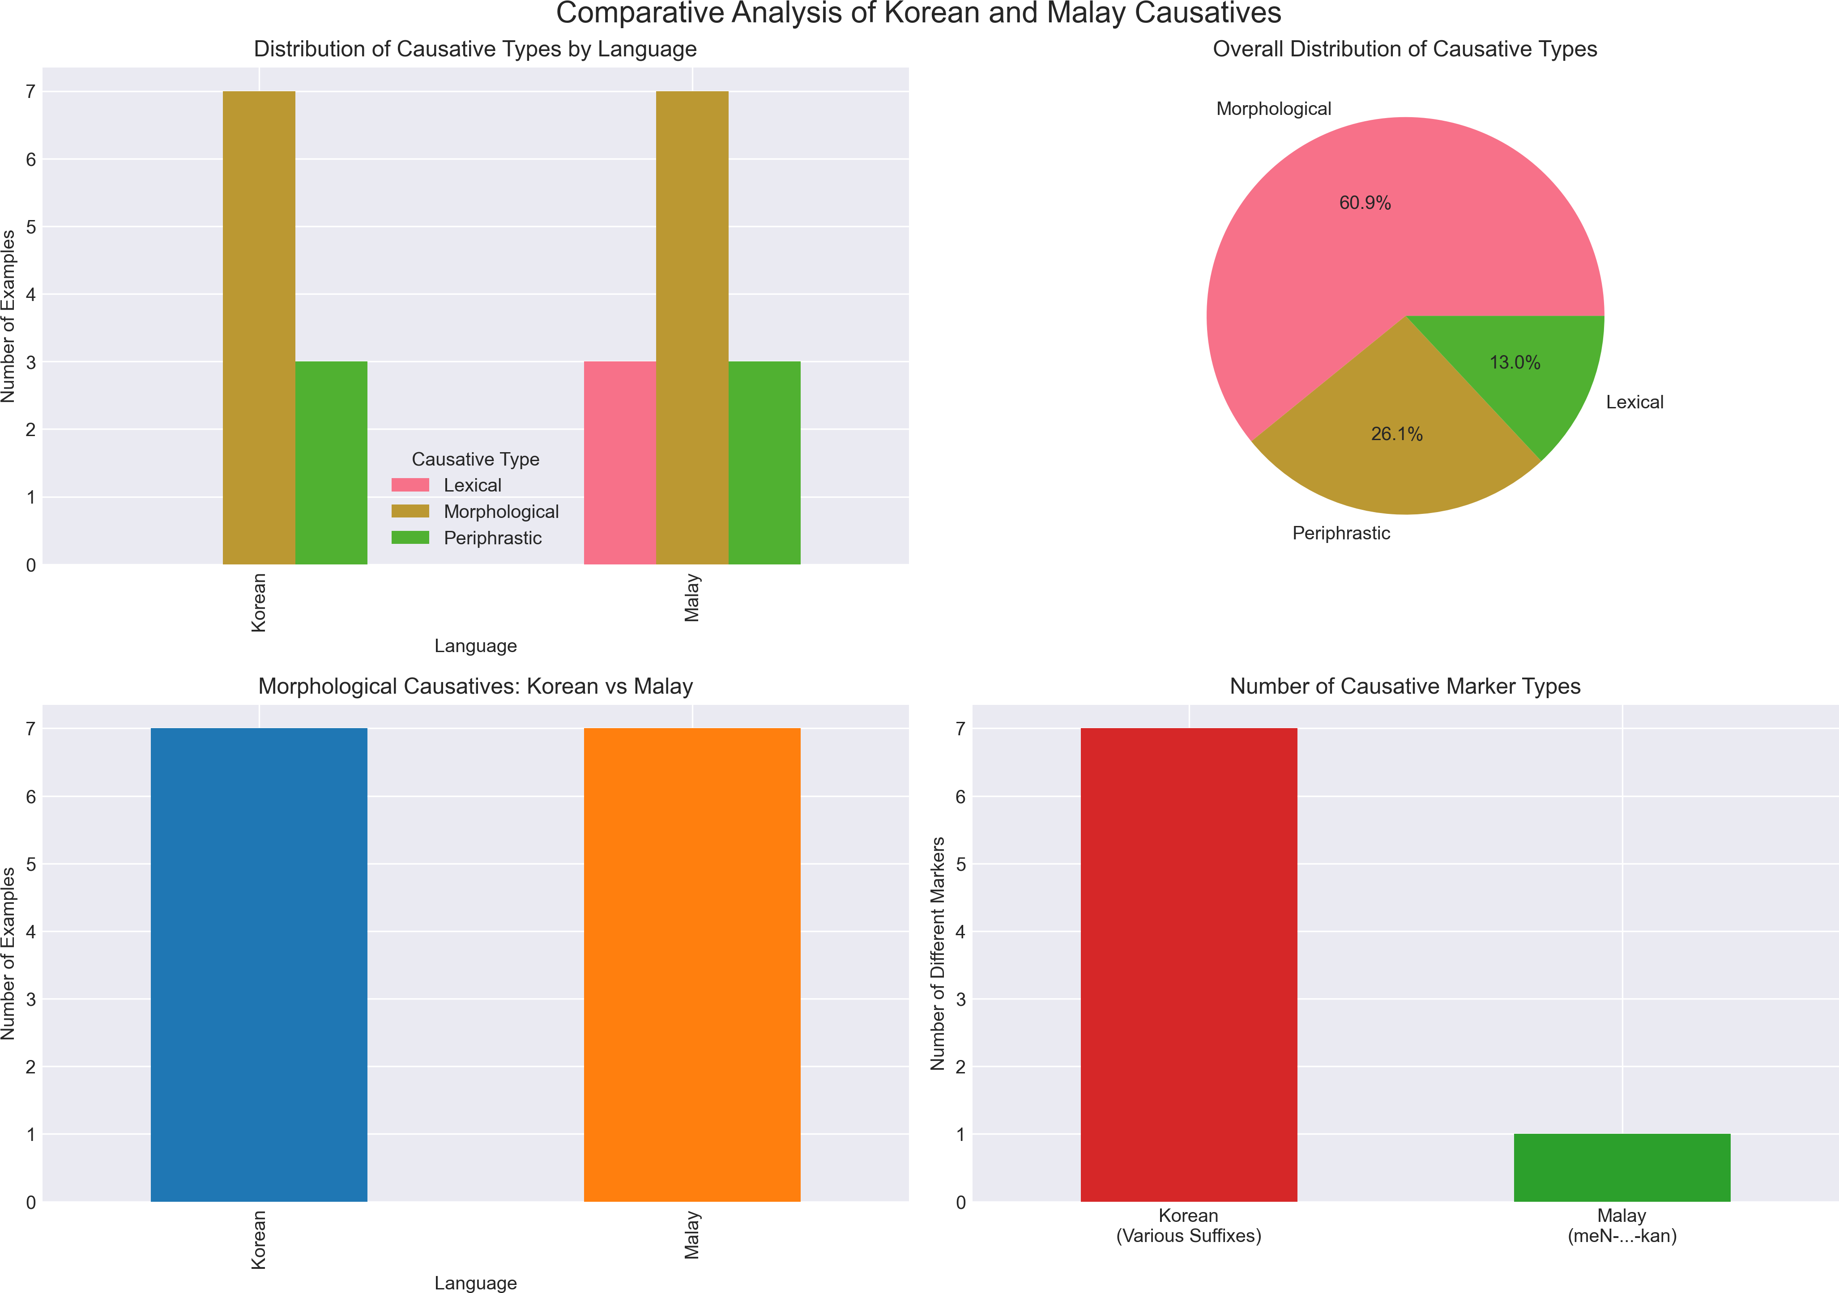

Figure 1: Comparative Analysis of Causative Types

# Implications for Working Space Design

## Cross-Cultural Communication

The differences in causative expression have significant implications for working space design and cross-cultural communication:

1. **Clarity in Instructions**: Malay’s predictable causative system may facilitate clearer task delegation in multilingual work environments.
2. **Semantic Precision**: Korean’s semantic flexibility requires careful contextualiza- tion in design briefs and collaborative projects.

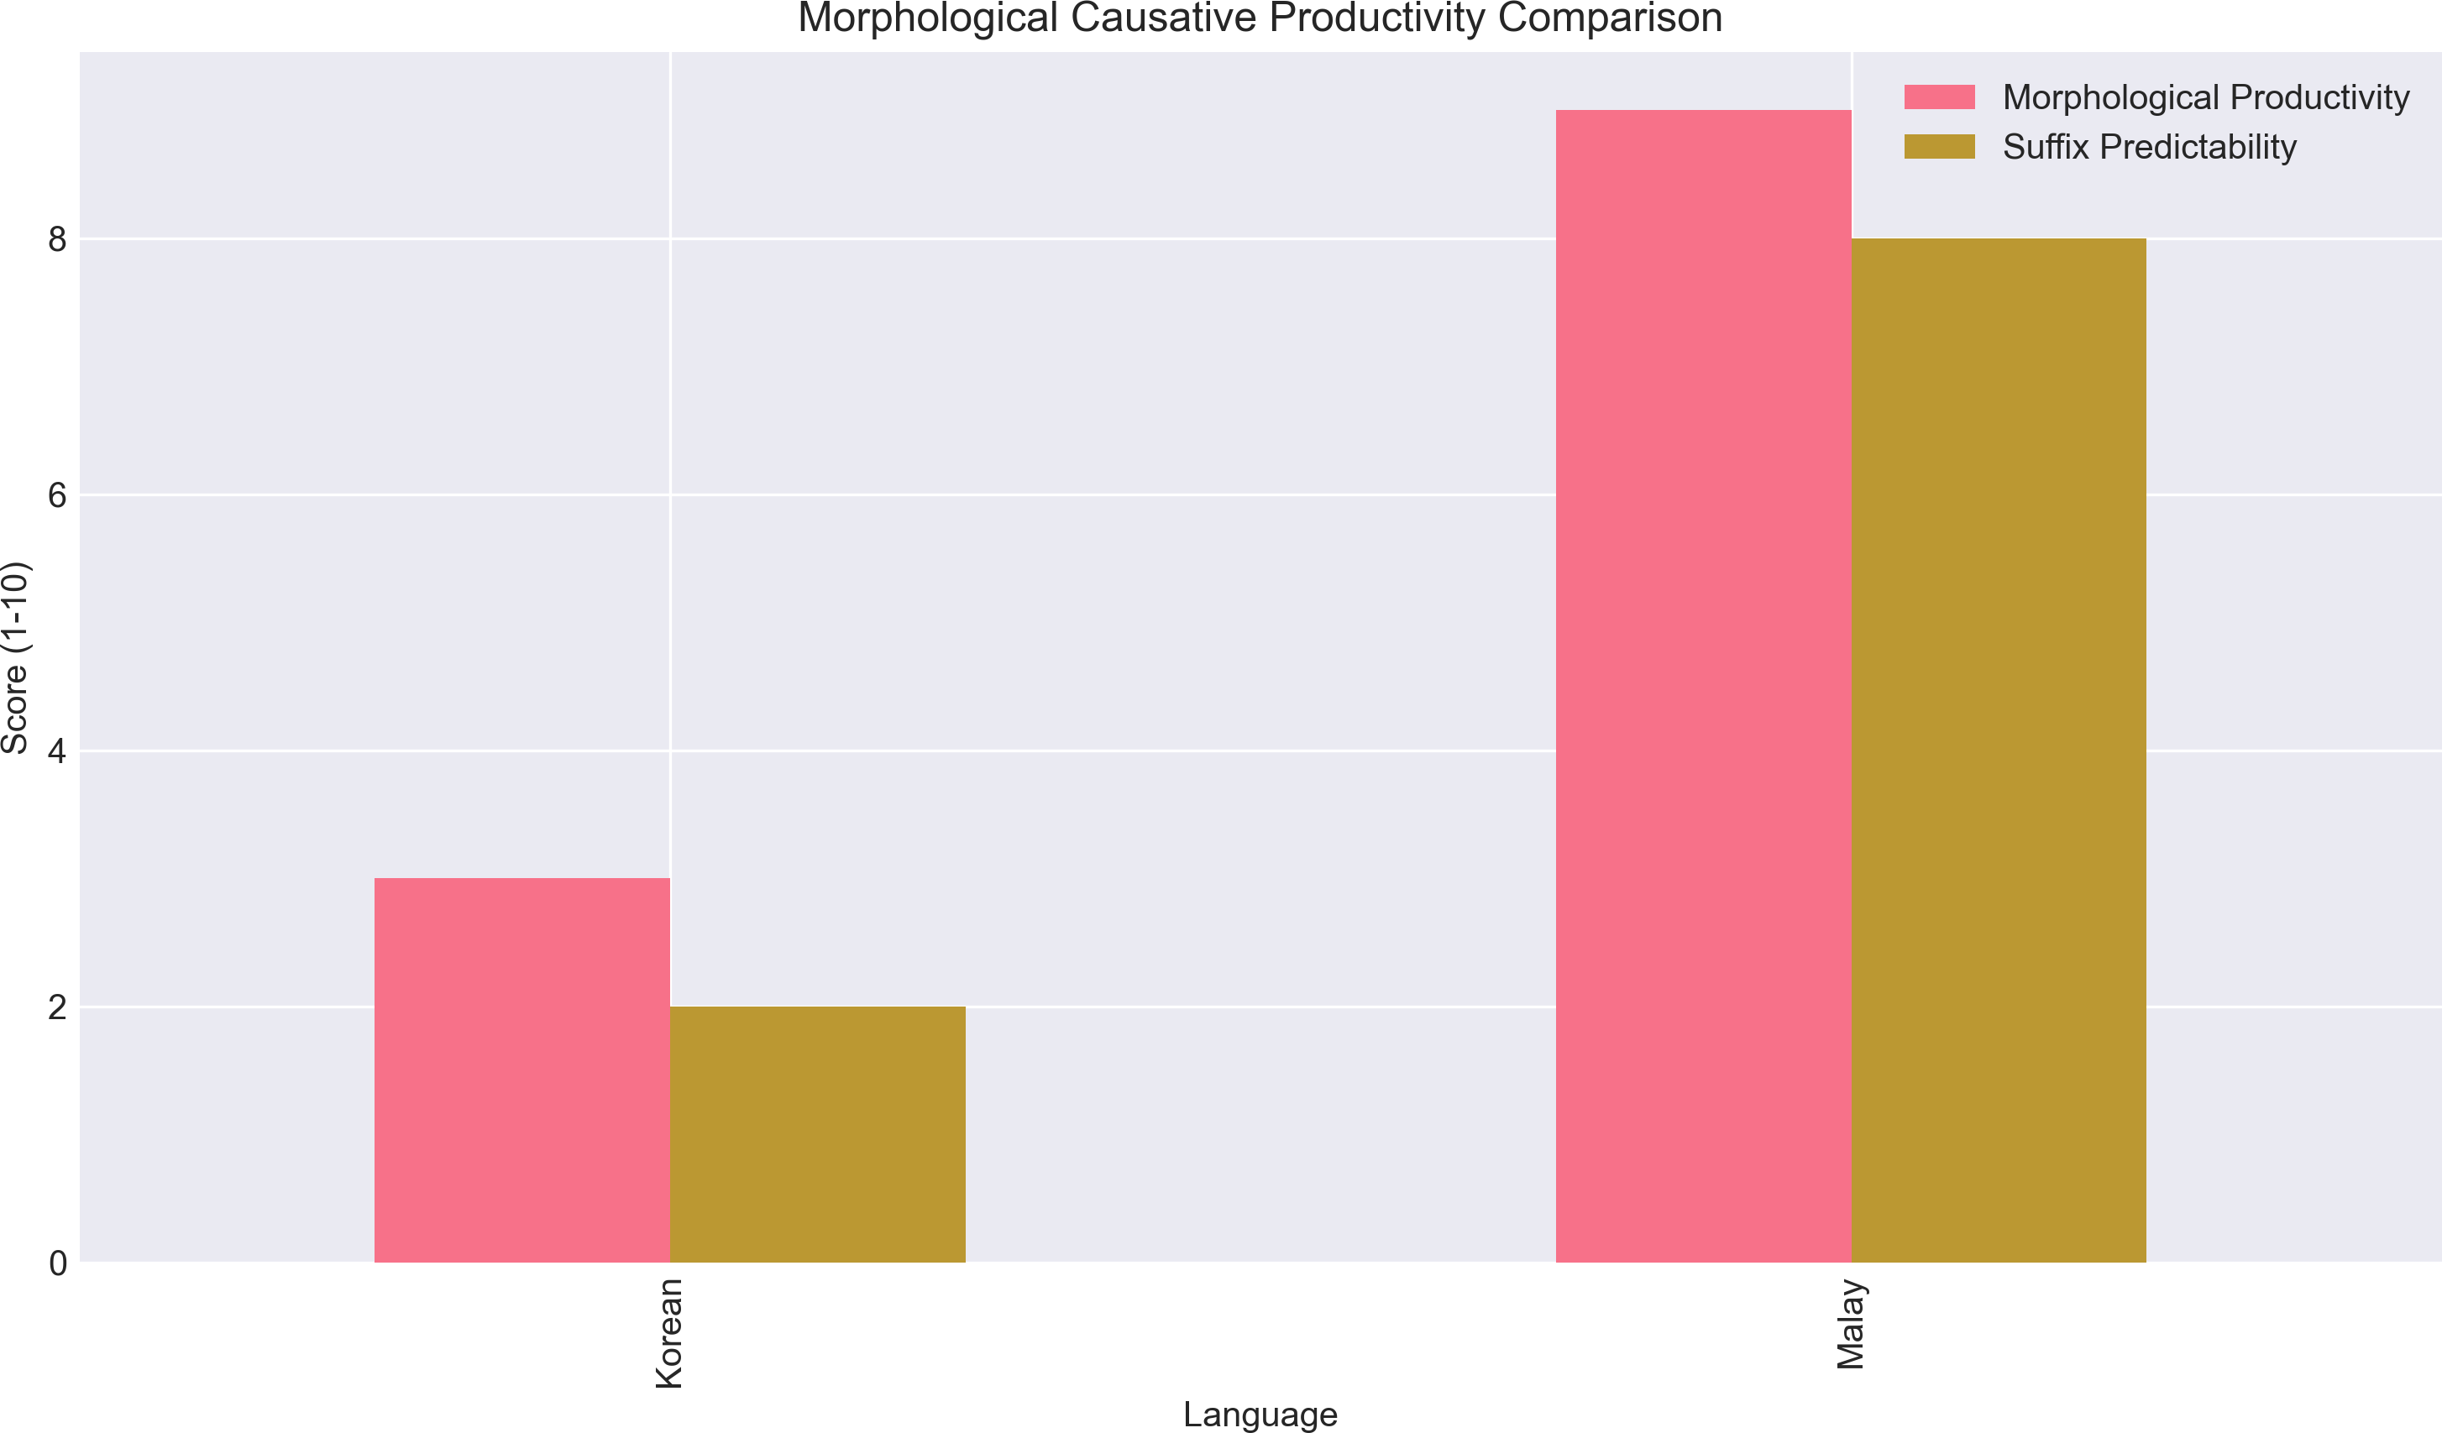

Figure 2: Morphological Productivity Comparison

1. **Learning Curves**: The low productivity of Korean causatives presents challenges for Malay speakers learning Korean for professional purposes.

## Design Applications

1. **Interface Design**: Understanding causative structures helps in creating intuitive command structures in bilingual software interfaces.
2. **Documentation**: Technical documentation must account for different ways of ex- pressing causation to ensure clarity.
3. **Team Collaboration**: Awareness of linguistic differences in expressing agency and causation improves team dynamics in Korean-Malay collaborative environments.

# Conclusion

This contrastive study reveals that while Korean and Malay share the fundamental lin- guistic feature of morphological causatives, they differ significantly in their implemen- tation. Korean’s system, characterized by multiple suffixes with low productivity and strong lexical constraints, contrasts sharply with Malay’s highly productive and pre- dictable meN-...-kan construction.

The key findings include:

1. Malay demonstrates higher morphological productivity in causative formation
2. Korean exhibits greater semantic flexibility within individual causative forms
3. Both languages supplement morphological causatives with periphrastic construc- tions
4. The differences have practical implications for cross-cultural communication and working space design

Understanding these linguistic differences is crucial for:

ˆ Language educators developing targeted teaching strategies

ˆ Designers creating multilingual interfaces and documentation

ˆ Professionals working in Korean-Malay bilingual environments Future research could explore:

ˆ The acquisition patterns of causatives by L2 learners

ˆ The role of causative structures in professional discourse

ˆ Computational modeling of causative formation in both languages

# References

1. Comrie, B. (1989). *Language Universals and Linguistic Typology*. University of Chicago Press.
2. Dixon, R.M.W. (2000). A typology of causatives: form, syntax and meaning. In Dixon,

R.M.W. & Aikhenvald, A.Y. (eds.), *Changing Valency: Case Studies in Transitivity*, 30-83. Cambridge University Press.

1. Sato, Y. (2023). Morphosyntactic behavior of Korean morphological causative con- structions. *Journal of East Asian Linguistics*, 32(2), 145-178.
2. Yusuf, S. & Mulyadi, M. (2021). Malay causative constructions: A morphological perspective. *Indonesian Journal of Applied Linguistics*, 11(1), 89-102.